FÓRMULASCN_10_02_CO



CN_10_02_formula01

EQ: \vec{a},\vec{v},\vec{r}



CN_10_02_formula02

EQ: \Delta t=t_{final}-t_{inicial}



CN_10_02_formula03

EQ: \Delta t=t-t_{0}



CN_10_02_formula04

EQ: \Delta \vec{x}=x-x_{0}

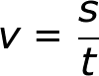

CN_10_02_formula05

EQ: v=\frac{s}{t}

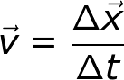

CN_10_02_formula06

EQ: \vec{v}=\frac{\Delta \vec{x}}{\Delta t}

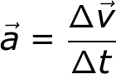

CN_10_02_formula07

EQ: \vec{a}=\frac{\Delta \vec{v}}{\Delta t}

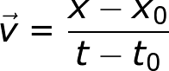

CN_10_02_formula08

EQ: \vec{v}=\frac{x-x_0}{t-t_0}

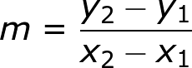

CN_10_02_formula09

EQ: m=\frac{y_2-y_1}{ x_2-x_1}

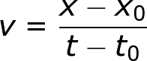

CN_10_02_formula10

EQ: v=\frac{x-x_0}{ t-t_0}



CN_10_02_formula11

EQ: \vec{a}=\frac{\Delta\vec{v}}{\Delta\vec{t}}=\frac{(-50\;km/h)-(0\; km/h)}{5s}=\frac{-50\; km/h}{5s}=-2,78 m/s^2



CN_10_02_formula12

EQ: \vec{a}=\frac{\Delta\vec{v}}{\Delta\vec{t}}=\frac{(0\;km/h)-(50\; km/h)}{5s}=\frac{-50\; km/h}{5s}=-2,78 m/s^2

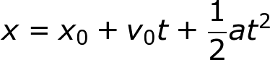

CN_10_02_formula13

EQ: x=x_0+v_0t+\frac{1}{2}at^2



CN_10_02_formula14

Quitar la t

EQ: v^2=v^{2}_{0}+2a(x-x_0)

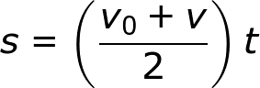

CN_10_02_formula15

EQ: s=\left (\frac{v_0+v}{2} \right )t

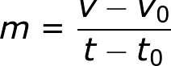

CN_10_02_formula16

Cambiar la m por una a

EQ: a=\frac{v-v_0}{ t-t_0}

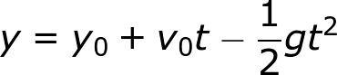

CN_10_02_formula17

EQ: y=y_0+v_0t-\frac{1}{2}gt^2



CN_10_02_formula18

(Quitar la primera t solo dejar v0)

EQ: v=v_0+at



CN_10_02_formula19

EQ: v=v_0-gt



CN_10_02_formula20

EQ: v^2=v^{2}_0-2g(y-y_0)