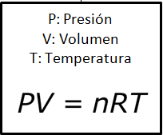

CN_10_08_FORMULA01



CN_10_08_FORMULA02