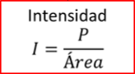

CN_11_02_FORMULA01

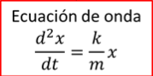

CN_11_02_FORMULA02



CN_11_02_FORMULA03



CN_11_02_FORMULA04

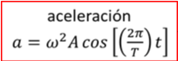

CN_11_02_FORMULA05