

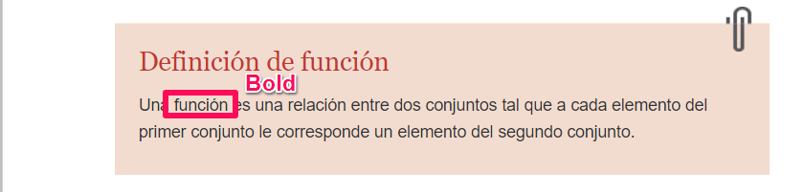

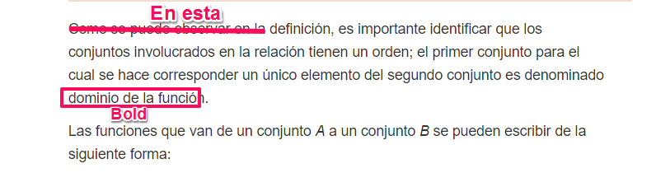

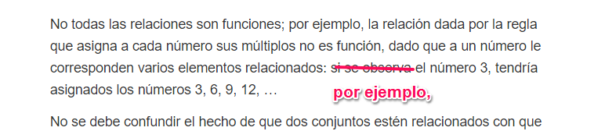

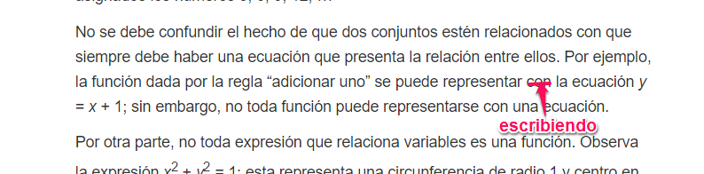

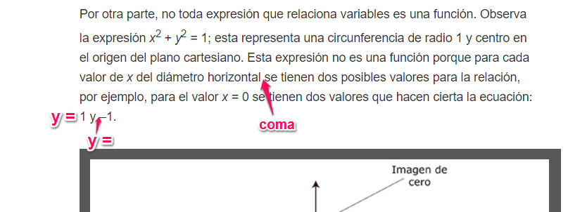

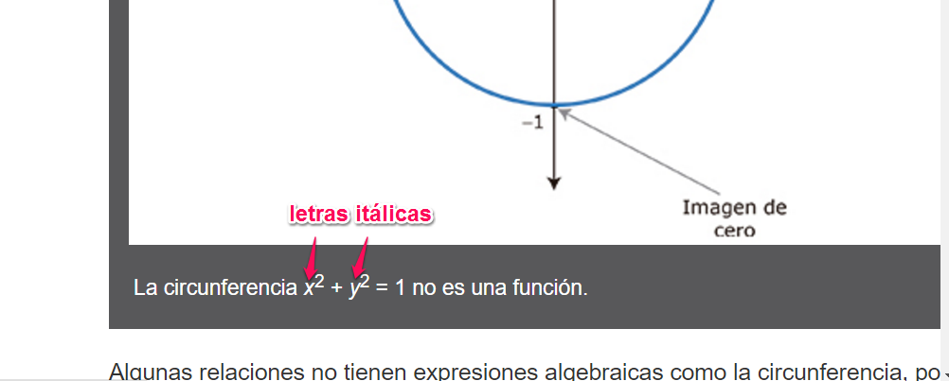

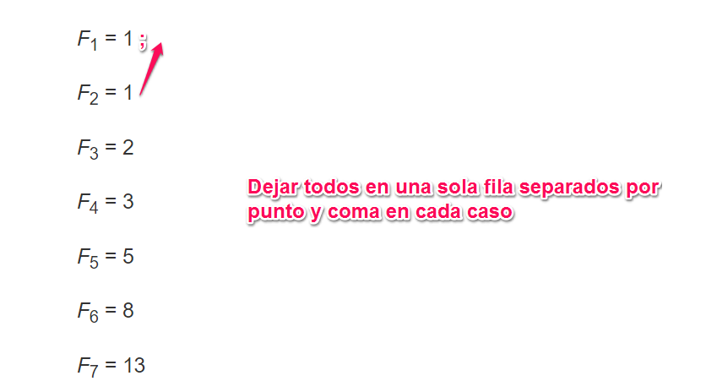

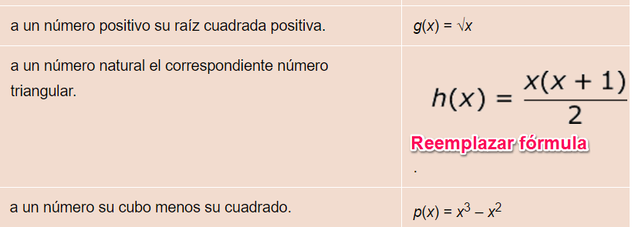

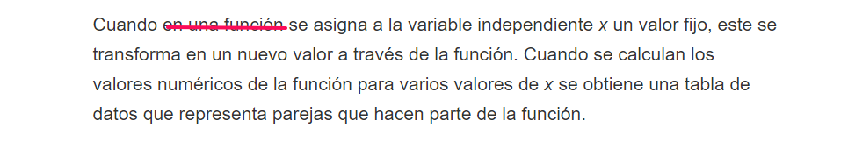

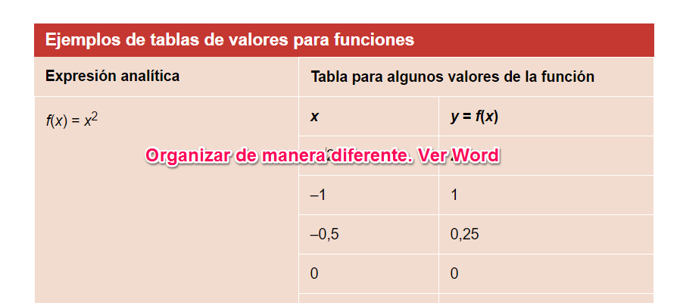

|  |  |  |  |  |  |  |  |  |
| --- | --- | --- | --- | --- | --- | --- | --- | --- |
| **Algunos valores de la función *f*(*x*)** | | | | | | | | |
| ***x*** | –√2 | –1 | –0,5 | 0 | 1 | 1,4142 | 2 | 3 |
| ***f*(*x*) = *x*2** | 2 | 1 | 0,25 | 0 | 1 | 1, 999 | 4 | 9 |

|  |  |  |  |  |  |  |  |  |
| --- | --- | --- | --- | --- | --- | --- | --- | --- |
| **Algunos valores de la función *gx*)** | | | | | | | | |
| ***x*** | 0 | 0,25 | 2 | 4 | 9 | 36 | 50 | 100 |
| ***g*(*x*) = √x** | 0 | 1 | √x | 2 | 3 | 6 | √50 | 10 |

|  |  |  |  |  |  |  |  |  |
| --- | --- | --- | --- | --- | --- | --- | --- | --- |
| **Algunos valores de la función *h*(*x*)** | | | | | | | | |
| ***x*** | 1 | 2 | 3 | 4 | 8 | 15 | 16 | 25 |
| ***C:\Users\Lzambrano\Documents\GitHub\Matematicas\fuentes\contenidos\grado10\guion01\FOrmulas_10-01\FQ_MA_10_01_CO_001.gif***  **FQ\_MA\_10\_01\_CO\_001\_A** | 1 | 3 | 6 | 10 | 36 | 120 | 136 | 325 |

|  |  |  |  |  |  |  |  |  |
| --- | --- | --- | --- | --- | --- | --- | --- | --- |
| **Algunos valores de la función *p*(*x*)** | | | | | | | | |
| ***x*** | –4 | –1 | 0 | 0,5 | 1 | 2 | 3 | 7 |
| ***p*(*x*) = x 3 – *x*2** | 48 | –2 | 0 | –0,125 | 0 | 4 | 18 | 294 |

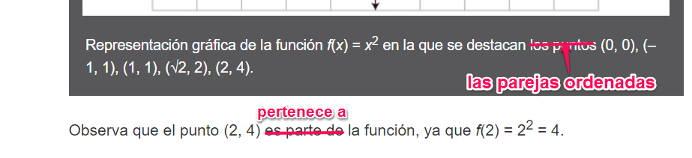

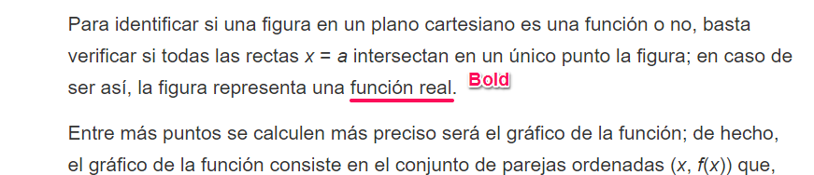

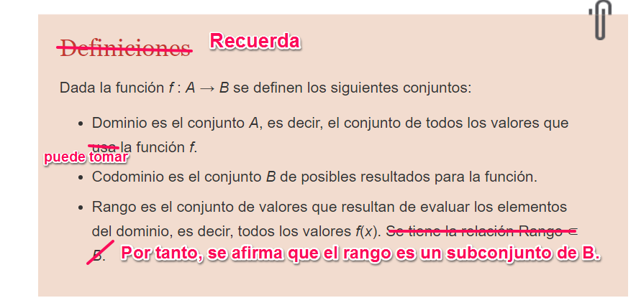

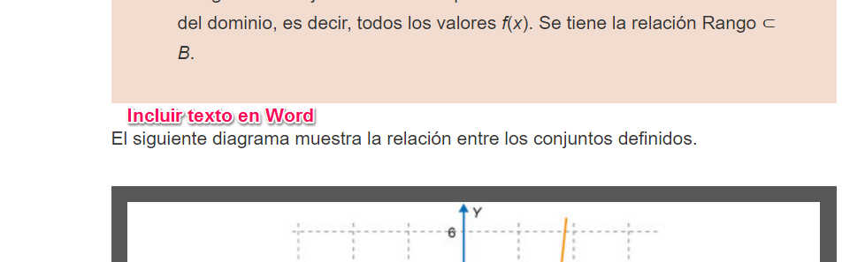

Si *f* es una función de variable real, su dominio y su rango o recorrido son subconjuntos de los números reales, o iguales a este conjunto numérico.

