SOLICITUD GRÁFICA ma_11_01_rec220

**A**.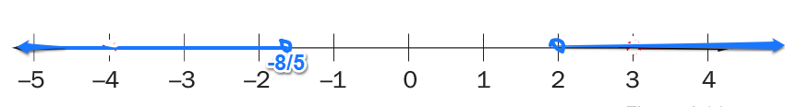

Representar el intervalo (-α, -8/5) ⋃ (2, α)

**B**.

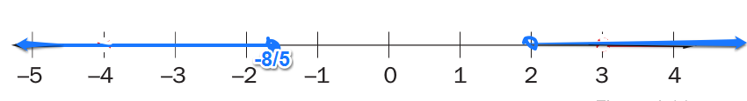

Representar el intervalo (-α, -8/5] ⋃ (2, α)

**C**.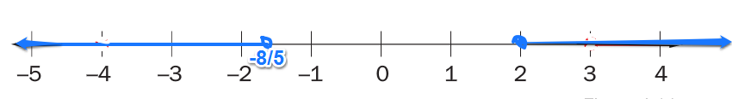

Representar el intervalo (-α, -8/5) ⋃ [2, α)

**D.**

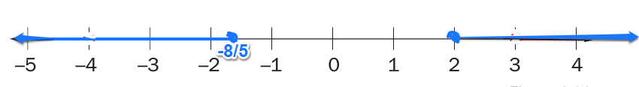

Representar el intervalo (-α, -8/5] ⋃ [2, α)