Information Technology

We live in an era full of sophistication and everything is very practical. Everyone is racing to create new things that can make their work easier. This includes the rapid development of IT worldwide. Information Technology is a technology used to process data by processing, acquiring, organizing, storing, and manipulating data in various ways to produce high-quality information. The information referred to is accurate, relevant, and timely, and is used for personal, business, and governmental purposes. This information is strategically valuable and can be used in decision-making.

Information technology is a very broad field, in general technology can be divided into several groups, such as information systems, networks and data communications, cybersecurity, software development, databases, AI and machine learning, cloud computing, internet of things (IoT), and human computer interaction (HCI).

Information technology has various functions that can be used in many fields, for example:

1. Telecommunication

The development of technology means we can receive information more easily and faster. For example, in the past, if you wanted to exchange news, you had to write a letter, but now you can use a handphone.



1. Business

In the business world, technological developments are very beneficial for producers because currently there are many online marketplaces, thereby minimizing capital. Apart from that, transactions and marketing strategies are easier.



1. Education

Learning is not only done offline, but can also be done online. Due to the development of technology, online learning is more easily accessible, for example e-learning and chatgpt.

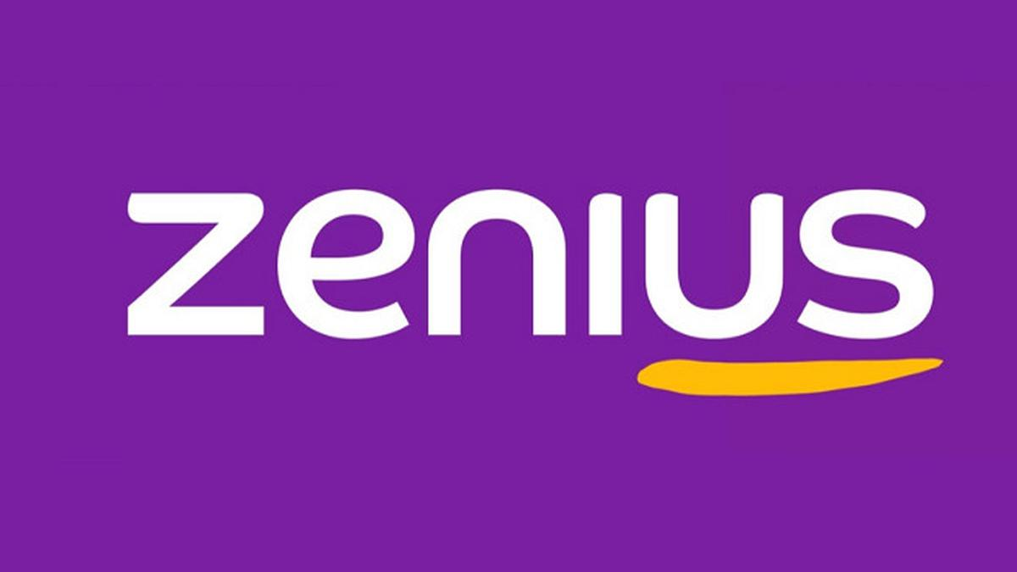

1. Health

In the health sector, technology can make it very easy for hospital staff to archive patient data. Apart from that, now there is also technology for consulting health problems online.





1. Banking

Because of technology, transactions or managing documents are now easier, for example e-banking and we can creating accounts online.





Because information technology is a field that continues to develop, so every year there will be a new trend, in 2024 the trend itself will be:

1. AI

Artificial Intelligence (AI) is a branch of computer science that aims to create machines or software that can perform tasks that typically require human intelligence. These tasks include learning from experience, recognizing patterns, solving problems, understanding natural language, and making decisions. Essentially, AI enables computers to mimic human cognitive functions and improve their performance over time through data and experience.

1. Cybersecurity

Cybersecurity is the practice of protecting computers, networks, and data from unauthorized access, attacks, or damage. It involves using various tools and strategies to safeguard information and systems from hackers, viruses, and other digital threats. The goal is to keep sensitive data safe and ensure that systems run smoothly and securely.

1. Virtual Reality

Virtual Reality is a technology that combines the real and virtual worlds so that users can interact with a virtual world simulated by a computer.

Technology is something that continues to develop and as time goes by many problems can be solved more quickly and easily using technology, while information is data that has been processed in such a way that it can become valid information. Information technology itself is divided into various fields and can be useful in these fields. The biggest impact of technology is in the business sector, one of the results of technological developments is the existence of e-commerce, for example Shopee, Lazada, Bukalapak, etc. In Indonesia itself, Shopee is the number 1 most popular e-commerce site.

Shopee is an e-commerce platform that provides an easy, safe and fast online shopping experience. Shopee was launched in 2015 and is the first platform in Southeast Asia and Taiwan to offer online buying and selling transactions via mobile phone. Shopee uses a B2C (Business to Customer). Shopee was created to take advantage of opportunities in the rapidly growing e-commerce market and meet the needs of consumers who are looking for a practical way to buy goods and services without having to go to a shop in person.

Shopee provides various features, including:

1. Shopee Live & Shopee Video

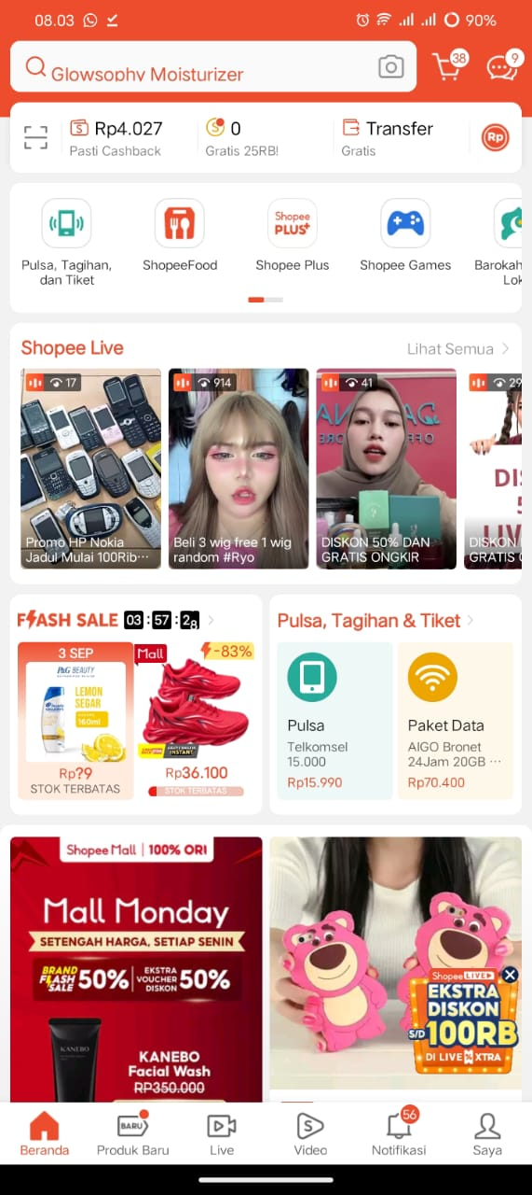

1. Shopee Game



1. Shopee Pay

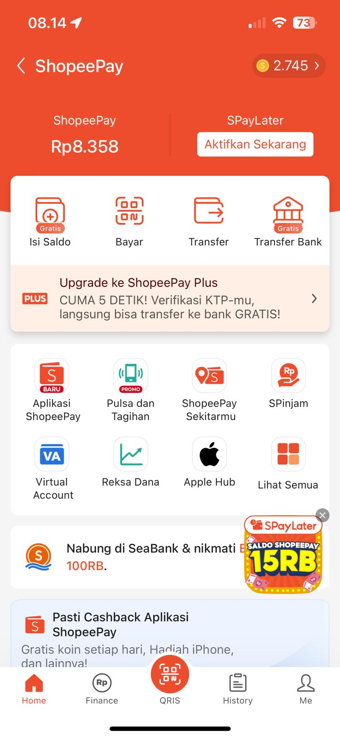

1. Shopee Food

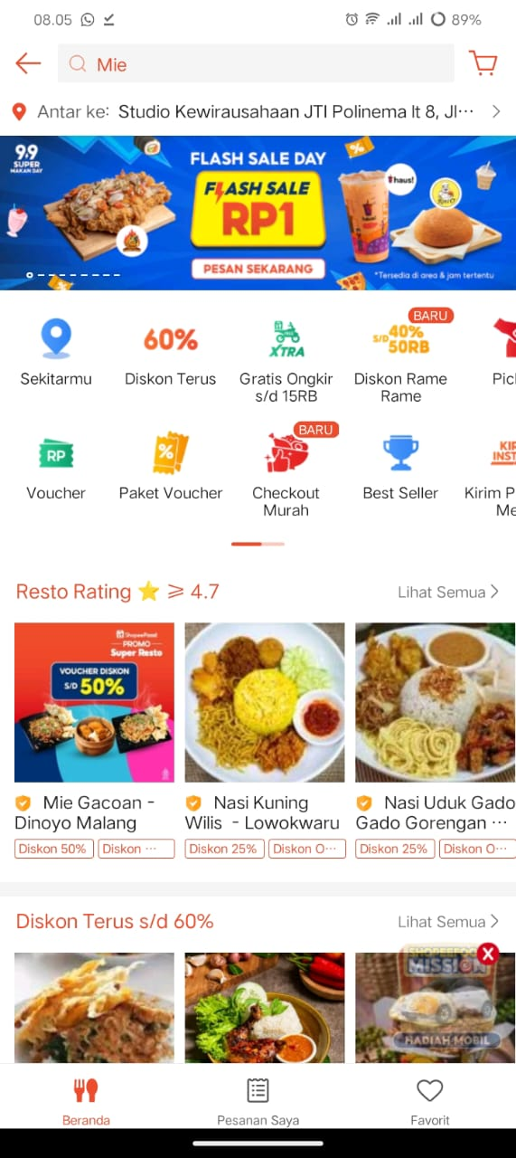

1. Voucher



1. Shopee chart

