Essay 1: A hybrid model integrating deep learning with investor sentiment analysis
for stock price prediction （Nan Jing, Zhao Wu, Hefei Wang）
Hybrid model: sentiment analysis + deep learning
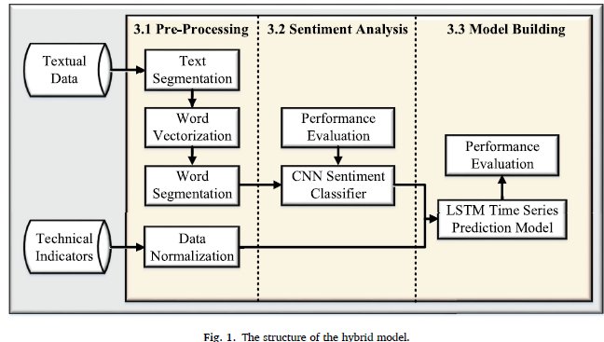
Step 1: Calculate sentiment factor using classification based on Convolutional Neural Network
Step 2: Build a prediction model using LSTM Neural Network, with investor sentiment factor and technical indicators as inputs.
Textual data: Eastmoney forums （东方财富，中文文本）
Market: Six industries from Shanghai SSE with market value>￥1080b
Technical indicators: scaled to [0,1]
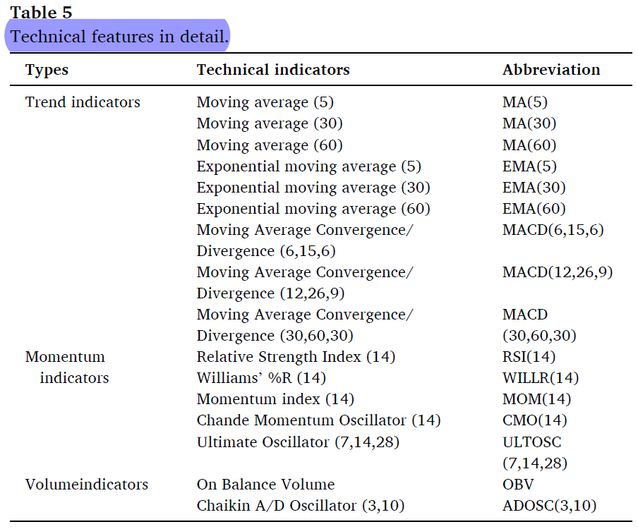
Sentiment Analysis Model based on CNN:下表为其它相关研究中的情感分析具体情况
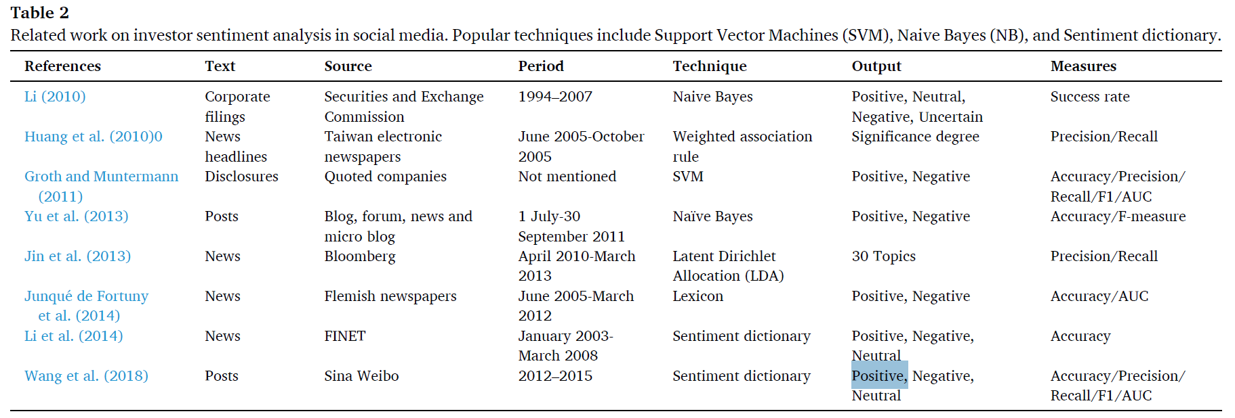
Convolutional Layer: Obtain a feature map.
Max-pooling layer: Extract the most important features.
Full-connected layer: Use soft-max classifier to obtain the classification result.
For classification tasks, the most commonly used measures are precision and recall rates.
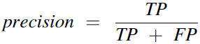
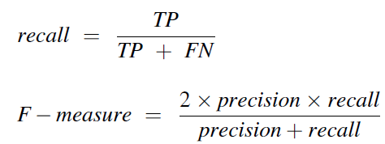
TP represents the “true positive”, which means the total number of positive samples which are correctly predicted. FP and FN stand for the “false positive” and the “false negative”, which mean the total number of samples that incorrectly predicted in the positive class and the negative class respectively.
Here use F-measure, the harmonic average of precision and recall rates.
Calculate daily sentiment factor.
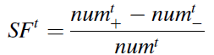
The data in a labelled training set is used to construct a sentiment classifier.
Four other classifiers: Support Vector Machines (SVM), Naive Bayes (NB), Recurrent Neural Networks (RNN), and Long Short-Term Memory (LSTM) Neural Network
Stock prediction model based on LSTM Neural Network:
下表为其他研究中的股票预测模型具体情况
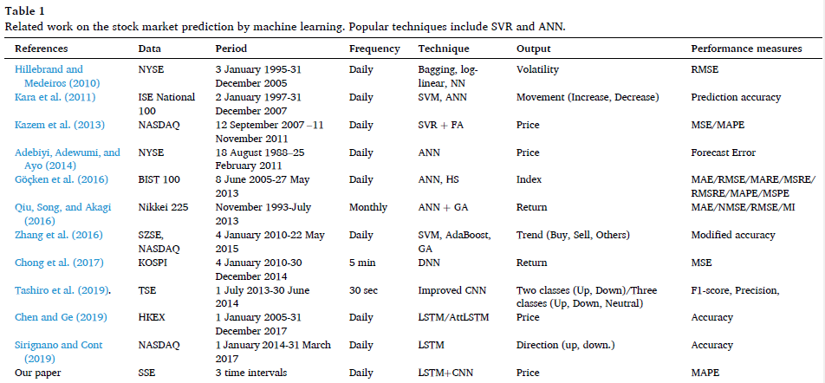
Time series prediction model combining sentiment factor and technical indicators.
Inputs: sentiment factors and technical indicators
Output: one-day-ahead closing price
Hyperparameter: Layers size, Hidden units size, Learning rate, Epochs size, and Batch size
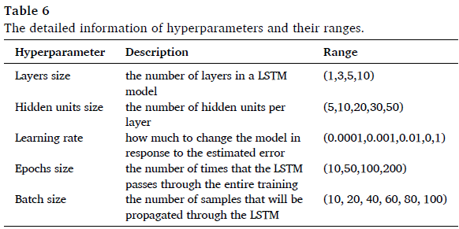
Prediction model evaluation: MAPE, ̂yt and yt represent the predicted and the actual closing prices respectively, and n is the total number of predictions.
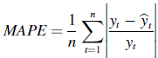

Essay 2: Sentiment analysis on social media for stock movement prediction
Thien Hai Nguyena, Kiyoaki Shiraia, Julien Velcin
Stock Universe: 18 stocks from US market
Textual data: Yahoo Finance Message board dataset (labelled five classes: “Strong Buy”, “Buy”, “Hold”, “Sell”, “Strong Sell”)
Prediction Model: SVM + linear kernel
Six sets of features used to assess the effectiveness of sentiment analysis:
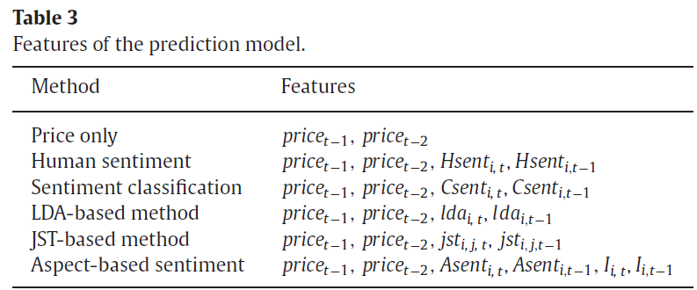
Price only(4.1): used as a baseline
Human sentiment(4.2): Use only labelled messages; Hsent is the percentage of the number of messages belonging to the sentiment class i at transaction date t.
Sentiment Classification(4.3): Also use non-labelled messages. Classify them with a classification model trained by annotated sentiments on the training dataset. Csent is similar to Hsent, but calculated including both human annotated and classified sentiments.
LDA-based method(4.4): Discover topics. （documents are represented as random mixtures over latent topics, where each topic is characterized by a distribution over words.）Ida: probabilities of the topic i for the transaction date t In LDA model. There is only one document specific topic distribution for each document.
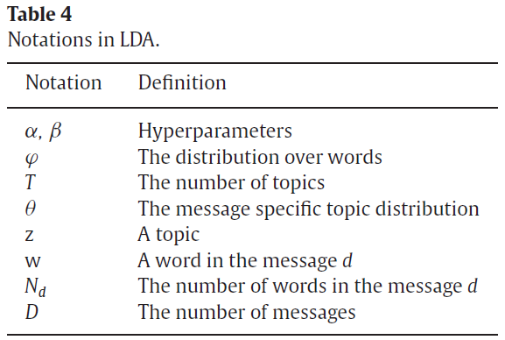
JST-based method(4.5): Extract pairs of topic-sentiment using JST model. Consider the mixtures of hidden topics and sentiments. Each document in JST is associated with S sentiment labels. Each of the labels is associated with a document specific topic distribution with the same number of topics. jst: joint probabilities of the sentiment i and j for the transaction date t.
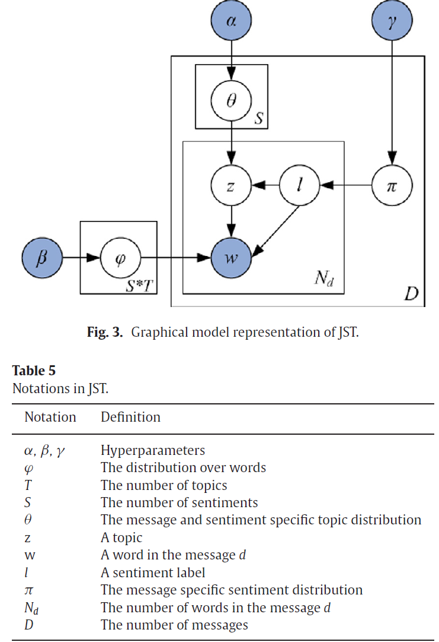
Aspect-based sentiment(4.6): Extract pairs of topic-sentiment using Aspect-based model. Each message is represented as a list of topics and their corresponding sentiment values. Topic: Consecutive nouns in the sentence. Extract topics and eliminate rare topics; extract sentiment values based on the topic list. (identify opinion words with sentiment scores on SentiWordNet). 计算每个topic和每个transaction date的sentiment value（即当topic、当transaction date的平均值）
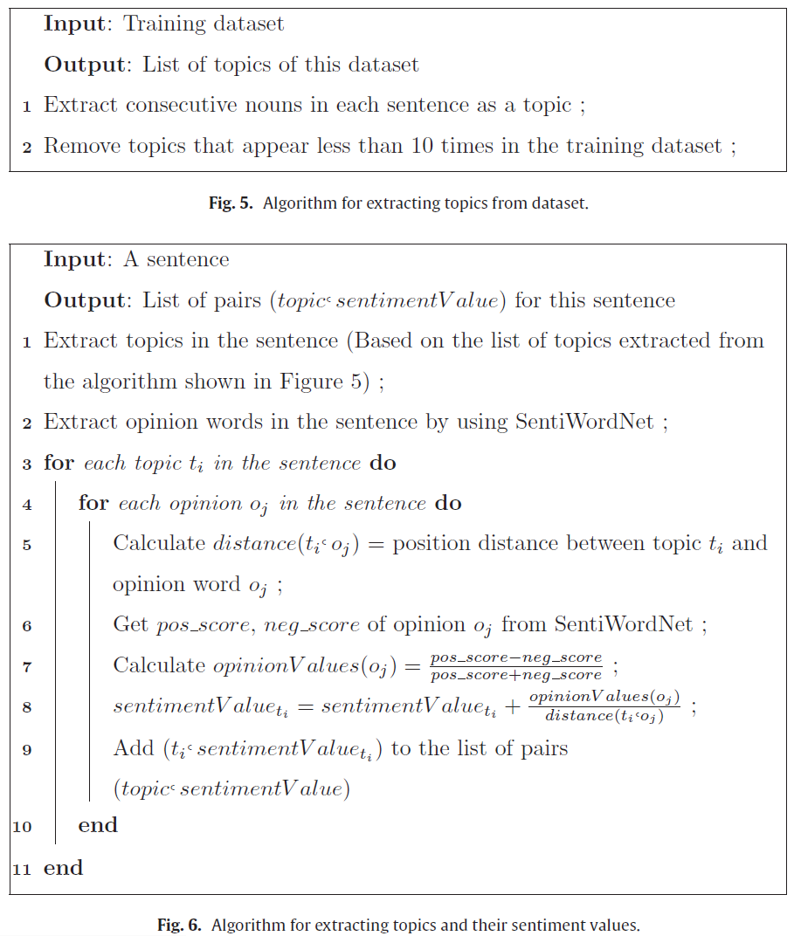
Asent: sentiment values of topic I at transaction date t
Topics的importance I:
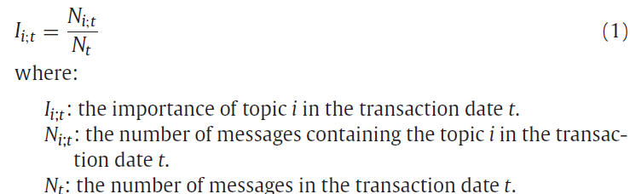

Accuracy Evaluation: True results proportion in the test set. 结果显示Aspect-based sentiment feature最好。
