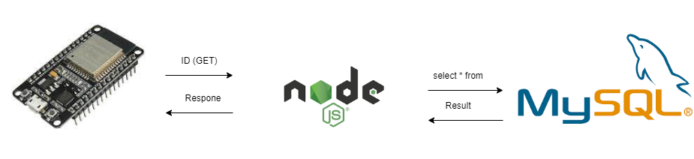

If id available



Result



Else id is not found in database

Result

