ESP32 Co-Processor
STM32 OTA Firmware Updater
PlatformIO + ESP-IDF | XModem Protocol

Overview
This project enables an ESP32 to act as a co-processor that remotely updates the firmware of an STM32 microcontroller via XModem protocol over UART. The ESP32 opens a Wi-Fi Access Point and serves a web interface for uploading the STM32 .bin file, then handles the full bootloader entry sequence and XModem transfer automatically.

System Architecture

Component | Role
ESP32 | Wi-Fi AP + HTTP server + XModem transmitter
STM32 (target) | Custom XModem bootloader receiver
PC / Phone | Connects to ESP32 AP, uploads .bin via browser
SPIFFS | Temporary storage for firmware binary on ESP32

Hardware Connections

ESP32 GPIO | STM32 Pin | Function | Notes
GPIO 32 | PA0 (BOOT0) | Bootloader trigger | HIGH = enter bootloader
GPIO 33 | NRST | Reset | Active LOW pulse
GPIO 17 (TX) | PA10 USART1 RX | UART data | 115200 baud
GPIO 16 (RX) | PA9 USART1 TX | UART data | 115200 baud
GND | GND | Common ground | Required

Warning: Do NOT use GPIO 25/26 — these are DAC1/DAC2 on ESP32 and will cause resets during boot.
GPIO 34, 35, 36, 39 are input-only and cannot be used for output signals.

Project Structure

stm32_ota/
├── platformio.ini # PlatformIO config
├── partitions.csv # Custom flash partition table
├── sdkconfig.esp32dev # ESP-IDF SDK config
└── src/
├── main.c # App main: AP + HTTP server
├── stm32_updater.c # XModem transmitter + GPIO control
└── stm32_updater.h # Public API

Configuration

platformio.ini

[env:esp32dev]
platform = espressif32
board = esp32dev
framework = espidf
board_build.partitions = partitions.csv
monitor_speed = 115200

partitions.csv

Name | Type | SubType | Offset | Size
nvs | data | nvs | 0x9000 | 0x6000
phy_init | data | phy | 0xF000 | 0x1000
factory | app | factory | 0x10000 | 0x180000
spiffs | data | spiffs | 0x190000 | 0x60000

SPIFFS partition is 384 KB — sufficient for STM32 firmware binaries up to 256 KB.

Wi-Fi Access Point

Parameter | Value
SSID | ESP32-STM32-OTA
Password | 12345678
IP Address | 192.168.4.1
Security | WPA2-PSK

Pin Definitions (stm32_updater.h)

#define STM32_BOOT_PIN GPIO_NUM_32 // PA0 bootloader trigger
#define STM32_NRST_PIN GPIO_NUM_33 // NRST reset
#define STM32_UART_PORT UART_NUM_2
#define STM32_UART_TX GPIO_NUM_17
#define STM32_UART_RX GPIO_NUM_16
#define STM32_UART_BAUD 115200

Timing Parameters

Define | Value | Description
RESET_ASSERT_MS | 20 ms | NRST low pulse width
BOOT_SETUP_MS | 10 ms | PA0 setup time before reset
BOOTLOADER_READY_MS | 3500 ms | Wait for STM32 bootloader NAK_INIT_DELAY (3000 ms) + margin
XMODEM_TIMEOUT_MS | 3000 ms | Per-byte receive timeout (matches STM32 side)
XMODEM_MAX_RETRY | 10 | Max block retransmit attempts

Operation

Bootloader Entry Sequence
The ESP32 enters the STM32 custom bootloader using the following hardware sequence:

1. Assert PA0 (BOOT0) HIGH → GPIO32 = 1
2. Assert NRST LOW → GPIO33 = 0 (20 ms)
3. Release NRST HIGH → GPIO33 = 1
4. Wait 3500 ms → STM32 bootloader sends NAK
5. Flush UART RX buffer → discard any garbage bytes
6. Begin XModem handshake

XModem Transfer
- Protocol: XModem with 8-bit checksum (classic mode)
- Block size: 128 bytes
- Padding: last block padded with 0x1A (SUB character)
- Block numbers wrap: 0xFF -> 0x00 automatically (uint8_t)
- File is streamed from SPIFFS — no large RAM buffer required

Bootloader Exit Sequence
1. De-assert PA0 (BOOT0) → GPIO32 = 1 (already high, no change)
2. Assert NRST LOW → GPIO33 = 0 (20 ms)
3. Release NRST HIGH → GPIO33 = 1
STM32 boots into application

Web Upload Flow

PC/Phone ──Wi-Fi──► ESP32 AP (192.168.4.1)
│
HTTP POST /upload (.bin file)
│
Save to SPIFFS /spiffs/stm32fw.bin
│
stm32_enter_bootloader()
│
XModem stream SPIFFS → STM32 UART
│
stm32_exit_bootloader()
│
HTTP response: 'Flash success!'

Usage

Build and Flash ESP32

# Build
pio run

# Flash ESP32 firmware
pio run --target upload

# Monitor serial output
pio device monitor

Update STM32 Firmware

- Power on ESP32
- Connect PC or phone to Wi-Fi: "ESP32-STM32-OTA" / password: "12345678"
- Open browser and navigate to http://192.168.4.1
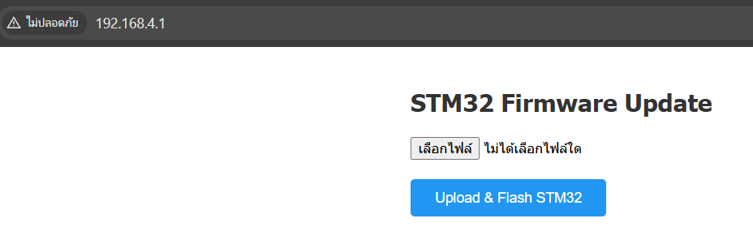
- Select the STM32 .bin file and click Upload & Flash STM32
- Wait 10-30 seconds for transfer to complete
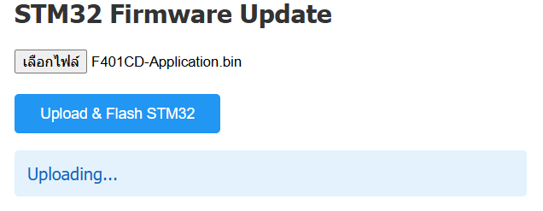
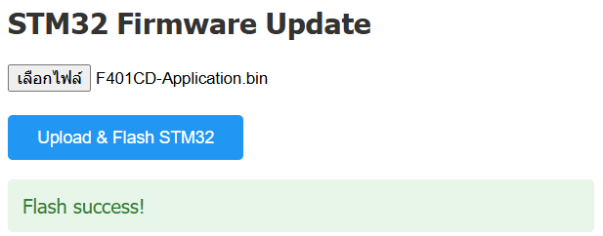
- Browser shows "Flash success!" — STM32 reboots into new firmware

Memory Optimization
The firmware binary is never loaded entirely into RAM. SPIFFS streaming keeps memory usage minimal:

Buffer | Size | Location
HTTP chunk buffer | 512 bytes | Stack (temporary)
XModem block buffer | 128 bytes | Stack (per block)
XModem packet | 131 bytes | Stack (per block)
SPIFFS file handle | ~100 bytes | Heap
Firmware binary (old) | 256 KB static | Removed — was cause of DRAM overflow

STM32 Custom Bootloader Requirements
The STM32 must be running a custom bootloader (not ST system bootloader) with the following characteristics:

Parameter | Value
UART peripheral | USART1 (huart1)
Baud rate | 115200
XModem mode | Checksum (classic) — sends NAK 0x15
NAK_INIT_DELAY | 3000 ms after reset
XMODEM_TIMEOUT_MS | 3000 ms per byte
XMODEM_MAX_RETRIES | 3
APP_START_ADDR | 0x08004000 (Sector 1)
BOOT0 trigger | PA0 = HIGH at reset

Troubleshooting

Symptom | Cause | Fix
ESP32 resets in boot loop | GPIO 25/26 conflict with DAC | Use GPIO 32/33 instead
DRAM overflow at link | 256 KB static fw_buf in BSS | Stream from SPIFFS, no static buffer
Garbage handshake bytes | BOOTLOADER_READY_MS too short | Set to 3500 ms (>= NAK_INIT_DELAY)
Block 1 always NAK/CAN | TX/RX lines swapped | Verify ESP TX -> STM32 RX wiring
Timeout on all handshake bytes | Wrong baud rate or UART port | Check 115200 baud, UART_NUM_2
IllegalInstruction panic | uart_driver_install called twice | Guard with uart_is_driver_installed()

API Reference

stm32_updater.h

Function | Description
void stm32_hw_init(void) | Initialize GPIO (BOOT0, NRST) and UART2. Call once in app_main().
esp_err_t stm32_enter_bootloader(void) | Assert BOOT0, pulse NRST, wait for bootloader ready.
esp_err_t stm32_exit_bootloader(void) | De-assert BOOT0, pulse NRST to reboot into application.
esp_err_t stm32_ota_from_spiffs(const char *path) | Full OTA sequence: enter bootloader, XModem stream from file, exit bootloader.

Dependencies
- ESP-IDF 5.x (via PlatformIO espressif32 platform)
- esp_wifi — Wi-Fi Access Point
- esp_http_server — HTTP upload server
- esp_spiffs / esp_vfs_spiffs — Filesystem for firmware storage
- driver/uart — UART2 for STM32 communication
- driver/gpio — BOOT0 and NRST control

