

Darshan University

A Project Report on

“Bank Management System”

Under the subject

Software Engineering (2301CS405)

B. Tech, Semester – IV

Computer Science & Engineering Department

Submitted By
Student Name: Aum Faldu | Enrollment No.: 23010101076
Academic Year
(2024-2025)
Internal Guide  Prof. R. B. Gondaliya  Darshan University | Dean-DIET  Dr. Gopi Sanghani  Darshan University

 | Computer Science & Engineering Department  Darshan University

DECLARATION

We hereby declare that the SRS, submitted along with the Software Engineering (2301CS405) for entitled “Bank Management System” submitted in partial fulfilment for the Semester-4 of Bachelor Technology (B. Tech) in Computer Science and Engineering (CSE) Department to Darshan University, Rajkot, is a record of the work carried out at Darshan University, Rajkot under the supervision of R. B. Gondaliya and that no part of any of report has been directly copied from any students’ reports, without providing due reference.

(Aum Faldu)

Student’s Signature

Date: __________

 | Computer Science & Engineering Department  Darshan University

CERTIFICATE

This is to certify that the SRS on “Bank Management System” has been satisfactorily prepared by Aum Faldu (23010101076) under my guidance in the fulfillment of the course Software Engineering (2301CS405) work during the academic year 2024-2025.

Internal Guide  Prof. R. B. Gondaliya  Darshan University |  | Dean-DIET  Dr. Gopi Sanghani  Darshan University

Acknowledgement
I wish to express my sincere gratitude to my project guide Prof. R. B. Gondaliya and all the faculty members for helping me through my project by giving me the necessary suggestions and advices along with their valuable co- ordination in completing this work.

I also thank my parents, friends and all the members of the family for their precious support and encouragement which they had provided in completion of my work. In addition to that, I would also like to mention the Darshan University personals who gave me the permission to use and experience the valuable resources required for the project from the University premises.

Thus, in conclusion to the above said, I once again thank the faculties and members of Darshan University for their valuable support in completion of the project.

Thanking You
Aum Faldu

ABSTRACT
The Bank Management System (BMS) is a sophisticated software application crafted to streamline banking operations with exceptional efficiency. It amalgamates core banking functionalities, offering seamless access to services for both users and administrators. BMS ingeniously abstracts intricate financial operations, rendering them through a user-friendly interface that caters to various stakeholders, including account holders and bank employees. Through the BMS, users can perform essential tasks such as money transfers, balance inquiries, and account management, while administrators can efficiently oversee operations like interest calculations, customer database maintenance, and transaction monitoring. One of the key strengths of the BMS lies in its foundation on object-oriented programming principles, with a particular focus on abstraction. This principle plays a crucial role in concealing the complexities of implementation from the end-users. For example, when a customer views their account balance, they interact with a simple interface that masks the underlying processes involving complex database queries and calculations. Similarly, transactions and fund transfers, although powered by sophisticated algorithms, are presented as straightforward interactions on the platform.
This approach to abstraction is not only about ease of use but also significantly enhances security. Users can confidently interact with the system, knowing their sensitive data is securely processed without any exposure to the intricate underlying mechanisms. Abstraction in BMS ensures that users experience a simplified, efficient, and secure environment for managing their financial activities. Additionally, the BMS leverages the concept of modularity to enhance its functionality. Modularity involves compartmentalizing the system into distinct components or modules. Each module operates independently, which allows developers to update or enhance specific features without causing disruptions to the entire system. This compartmentalization facilitates easier maintenance and scalability of the software. For instance, a module responsible for handling transactions can be updated to incorporate new features or improve performance without affecting modules that manage other functionalities like customer records or interest calculations. By isolating each function within its module, BMS ensures that any changes or enhancements are localized, thereby reducing the risk of errors or system downtime. This design philosophy makes the BMS not only robust but also flexible and adaptable to future needs and technological advancements. In summary, the Bank Management System (BMS) encapsulates the intricate details of banking operations into an intuitive and user-friendly interface. This abstraction layer benefits both users and developers by ensuring efficient, secure, and user-friendly financial management. Users enjoy a seamless experience where complex operations are simplified, and their data is kept secure. Meanwhile, developers benefit from a modular structure that facilitates easy updates and maintenance, ensuring the system remains up-to-date and efficient without significant downtime. The success of a BMS is measured by its ability to provide reliable, secure, and efficient banking operations. Its design principles, grounded in abstraction and modularity, contribute significantly to achieving these goals. For users, it means an effortless way to manage their financial affairs, while for banks, it translates into an operationally efficient system that can adapt to the evolving needs of the financial sector. As technology continues to evolve, the principles embedded in the design of BMS ensure that it remains a critical tool in the efficient management of banking operations, delivering value to both users and administrators alike. In essence, the BMS is a testament to the power of software engineering principles in creating systems that are both powerful and user centric. By abstracting the complexities and employing a modular design, it provides a platform that is not only effective in its current form but is also poised for future enhancements and scalability, making it an indispensable component of modern banking infrastructure.

Table of Contents
List of Figures I
List of Tables II
1 Introduction: 1
2 Functional Requirement 3
2.1 For Customers: 3
2.2 For Bank Employees: 4
2.3 For Administrators: 5
2.4 For Loan Officers: 5
3 Non-Functional Requirement 6
4 Design and Implementation Constraints 7
4.1 Activity diagram and Swimlane diagram 8
4.2 Sequence diagram 11
4.3 State diagram 12
4.4 Class diagram 13
4.5 Data flow diagram 14
4.5.1 Context diagram (level-0) 14
4.5.2 DFD Level-1 14
4.5.3 DFD Level-2 15
5 External interface requirement (Screens) 16
5.1 Screen-1: Registration Form 16
5.2 Screen-2: Login Form 17
5.3 Screen-3: Add borrower book 18
6 Database design 19
6.1 List of Tables 19
7 Stories and Scenario 20
7.1 Story-1: Add New Book in Library Catalogue 20
7.1.1 Scenario# S1.1 20
7.1.2 Scenario# S1.2 20
7.1.3 Scenario# S1.3 20
7.2 Story-2: Search Book 21
7.3 Story-3: Manage due date for borrowed book 21
7.4 Story-4: Renew book 21
7.5 Story-5: Generate a report on book usage and availability 21
8 Test cases 22
9 References 26

List of Figures

Figure 4 Use case diagram for bank management system 7
Figure 4.1-1 Activity diagram for loan services 8
Figure 4.1-2 Activity diagram for customer registration………………………………………………………………………………. 9
Figure 4.1-2 Swimlane diagram for loan services 10
Figure 4.2-1 Sequence diagram for Loan services 11
Figure 4.2-2 Sequence diagram for Customer Registration 11
Figure 4.3 State diagram of loan services 12
Figure 4.4 Class diagram for Bank management system 13
Figure 4.5.1 Context diagram for Bank management system 14
Figure 4.5.2 DFD level-1 for Bank management system 14
Figure 2.6-3 DFD level-2 for Issue book 9
Figure 3.1-1 Screen-1: Registration Form 10
Figure 3.2-1 Screen-2: Login Form 11
Figure 3.3-1 Screen-3: Add borrower book 12

List of Tables

Table 3.1-1 Screen element of Registration form 10
Table 3.2-1 Screen element of Login form 11
Table 3.3-1 Screen element of Add borrower book 12
Table 4.1-1 Table: Book 13
Table 4.1-2 Table: Borrower 13
Table 4.1-3 Table: Staff 13
Table 4.1-4 Table: Student 13

Introduction:
A Bank Management System (BMS) is an integral part of modern banking infrastructure, designed to handle the complexities of financial transactions, customer data management, and regulatory compliance. It provides a centralized platform for banks to manage their operations, enhancing efficiency, security, and customer satisfaction. In today's fast-paced financial environment, the BMS is indispensable. It allows customers to access banking services through various channels such as ATMs, online platforms, and mobile apps, while helping banks streamline their internal processes, such as ledger maintenance, account reconciliation, and loan processing. By offering a centralized system, the BMS ensures that all financial operations are handled smoothly and efficiently, thereby improving the overall banking experience for both customers and employees.
The BMS is designed to be comprehensive, encompassing multiple modules that address a variety of functionalities. One of the primary modules is Customer Management, which handles customer details, account types, and the services provided to them. This module ensures that customer data is accurately maintained and easily accessible, facilitating efficient service delivery. Another critical module is Transaction Handling, which records various types of transactions, such as deposits, withdrawals, and transfers. This module ensures that all transactions are processed smoothly and recorded accurately, maintaining the integrity of financial records.
Loan Management is another essential module within the BMS, facilitating loan applications, approvals, and tracking repayments. This module ensures that both the bank and customers can monitor loan statuses effectively, making the loan management process more transparent and efficient. Additionally, the BMS incorporates robust Security Features that implement strong authentication mechanisms, data encryption, and fraud detection protocols to protect both customers and the bank. With increasing cyber threats, these security measures are crucial in safeguarding sensitive financial information and preventing unauthorized access.
Regulatory Compliance is a significant aspect of the BMS, ensuring that the system adheres to government and financial regulations. This module provides a safe and legal framework for banking operations, protecting the bank from potential legal issues and building trust with customers by assuring them that their data and transactions are secure. The implementation of a Bank Management System brings numerous benefits to both banks and customers. Enhanced Customer Experience is one such benefit, allowing customers to enjoy round-the-clock access to banking services, ensuring convenience and satisfaction. With online and mobile banking platforms, customers can manage their accounts from anywhere at any time, providing unparalleled flexibility and accessibility.
Operational Efficiency is significantly improved with the implementation of a BMS. Automation reduces the need for manual tasks, leading to fewer errors and more streamlined processes. This efficiency allows employees to focus on more strategic tasks rather than routine administrative work, enhancing overall productivity. Data Security is another critical benefit, as sensitive financial data is protected through advanced security protocols, safeguarding customer information and preventing potential fraud. Scalability is also a vital feature of the BMS, ensuring that the system can grow in line with the increasing demands of the bank and its customer base. The modular design allows for easy updates and enhancements without disrupting the entire system, making it adaptable to future needs.
Object-oriented programming principles, particularly abstraction, play a crucial role in the BMS. Abstraction hides the complexities of implementation from the end-users, ensuring a smooth and intuitive experience. For example, when a customer views their account balance, they interact with a simple interface that masks the underlying processes involving complex database queries and calculations. Similarly, transactions and fund transfers, although powered by sophisticated algorithms, are presented as straightforward interactions on the platform. This abstraction ensures that users can confidently interact with the system without needing to understand the underlying technical details.
Modularity is another fundamental principle in the design of the BMS. By compartmentalizing functions into distinct modules, the system becomes more manageable and scalable. Developers can update or enhance specific features without disrupting the entire system, facilitating easier maintenance and scalability. For instance, if the loan management module needs an update, it can be done independently without affecting the transaction handling or customer management modules. This modular approach ensures that the BMS can adapt to the bank's evolving needs and technological advancements.
Enhancing security and ensuring regulatory compliance are critical aspects of the BMS. Strong authentication, data encryption, and fraud detection measures protect both customers and the bank from cyber threats. Regulatory compliance ensures that the system adheres to various government and financial regulations, providing a safe and legal framework for banking operations. Compliance with regulations not only protects the bank from legal issues but also builds trust with customers, assuring them that their data and transactions are secure.
The Bank Management System encapsulates the intricate details of banking operations into an intuitive and user-friendly interface. This abstraction benefits both users and developers, ensuring efficient, secure, and user-friendly financial management. Users experience a seamless and convenient way to manage their financial activities, while developers benefit from a system that is easy to maintain and scalable. In essence, the BMS is a cornerstone of modern banking, driving innovation and operational excellence. It enables banks to offer better services to customers, streamline their internal processes, and stay compliant with regulations. As technology continues to evolve, the principles embedded in the design of the BMS ensure that it remains a critical tool in the efficient management of banking operations, delivering value to both users and administrators alike.
Looking to the future, Bank Management Systems will continue to evolve and adapt to new challenges and opportunities. With advancements in technology such as artificial intelligence and blockchain, BMS can become even more efficient and secure. AI can help in predictive analysis and personalized customer services, while blockchain can enhance transaction security and transparency. The integration of these advanced technologies will further improve the functionalities of BMS, making banking operations even more efficient and secure. Additionally, as customer expectations continue to rise, BMS will need to offer more innovative and personalized services to meet these demands.
In conclusion, a Bank Management System (BMS) is an essential component of modern banking infrastructure. It provides a centralized platform that enhances the efficiency, security, and customer satisfaction of banking operations. By leveraging object-oriented programming principles and modularity, BMS ensures that complex financial operations are simplified and securely managed. The benefits of implementing a BMS include enhanced customer experience, improved operational efficiency, robust data security, and scalability. As technology advances, the role of BMS will become even more critical in driving innovation and operational excellence in the banking sector. The future holds immense potential for BMS to evolve and adapt, ensuring that it continues to be a cornerstone of modern banking.

Functional Requirement

For Customers:
1.Account Management: Users can open new accounts, view account details, and close accounts.
2.Transaction Processing: The system supports deposits, withdrawals, and fund transfers between accounts.
3.Loan Services: Customers can apply for loans, and the system tracks approvals and repayments.
4.Statement Generation: Users can request detailed account statements for specific periods.
5.Password Management: Users can reset passwords securely through multi-step verification.
6.ATM Locator: Displays nearby ATMs based on the user’s location.
7.Notifications: Sends SMS or email notifications for account activities and updates.
8.Recurring Payments: Users can set up and manage recurring payment schedules.
9.Transaction History: Displays a comprehensive history of all account transactions.
10.Currency Exchange: Facilitates currency conversion and displays exchange rates.
11.Mobile Banking: Offers a dedicated mobile application for seamless access to banking services.
12.Account Alerts: Notifies users of low balance, overdrafts, or unusual activity.
13.Nomination Update: Allows users to add or update nominee details.
14.Branch Locator: Helps users find branches near their location.
15.Spending Analytics: Offers tools to analyze spending patterns and generate reports.
16.Multi-Currency Accounts: Supports accounts in multiple currencies.
17.Joint Account Management: Facilitates co-owned accounts with access permissions.
18.Transaction Limits: Allows users to set daily or monthly transaction limits.
19.Promotional Offers: Displays special offers and discounts for services.
20.Budget Planning: Provides tools for users to plan and track budgets.
21.Digital Vault: Offers secure storage for important digital documents.
22.Tax Certificate Download: Allows users to generate and download tax-related documents.
23.Virtual Banking Assistance: Provides AI-powered chatbots for assistance.
24.Bill Payment: Enables utility and credit card bill payments directly from the account.
25.Cheque Book Requests: Allows users to order or cancel cheque books.
26.Financial Goals: Lets users set and track savings goals.
27.E-Statements: Sends periodic account statements electronically.
28.Live Currency Updates: Displays real-time currency exchange rates.
29.Fund Investments: Allows users to invest in mutual funds or fixed income products.
30.Interest Rate Updates: Notifies users of changes in applicable interest rates.
31.Personalized Dashboard: Provides a customizable interface for users.
32.Cardless Cash Withdrawals: Supports cash withdrawals via mobile app without using a card.
33.Expense Categorization: Automatically categorizes transactions for better financial tracking.
34.Loan Calculator: Helps users estimate EMIs for loans.
35.Cross-Bank Transactions: Supports payments and transfers to accounts in other banks.
36.User Profile Management: Lets users update their profile information, like address and phone number.

For Bank Employees:
1.Customer Support: Integrated chat or messaging systems to handle user queries.
2.Loan Services: Managing loan applications, approvals, and monitoring repayments.
3.Customer Feedback: Collects and manages user feedback for service improvement.
4.Fixed Deposit Management: Enables the creation and management of fixed deposits.
5.Cheque Book Requests: Processing cheque book orders and cancellations.
6.Audit Trail: Maintains a detailed record of all system actions for compliance.
7.Role-Based Access: Assigns permissions based on user roles (e.g., admin, customer).
8.Secure Messaging: Provides an encrypted platform for user-to-bank communication.
9.Promotional Offers: Displays special offers and discounts for services.

For Administrators:
1.User Authentication: Provides secure login and authentication for all users.
2.Security Features: Implementing and managing data encryption and fraud detection protocols.
3.Regulatory Compliance: Ensuring adherence to financial regulations such as GDPR and PCI DSS.
4.Data Backup: Regular backups to prevent data loss.
5.Logging and Monitoring: The system must provide detailed logs for auditing purposes.
6.Interest Calculator: Provides tools to calculate interest on savings, loans, and deposits.
7.Card Management: Supports activation, blocking, and replacement of debit and credit cards.
8.Overdraft Facilities: Allows eligible users to access overdraft options.
9.Biometric Authentication: Supports fingerprint or facial recognition for login.
10.Transaction Limits: Allows users to set daily or monthly transaction limits.
11.Fraud Detection: Monitors for unusual activities and sends alerts.
12.Personalized Dashboard: Provides a customizable interface for users.
13.Cross-Bank Transactions: Supports payments and transfers to accounts in other banks.
14.Expense Categorization: Automatically categorizes transactions for better financial tracking.

For Loan Officers:
1.Loan Services: Customers can apply for loans, and the system tracks approvals and repayments.
2.Loan Eligibility: Provides eligibility criteria and application guidelines for loans.
3.Loan Calculator: Helps users estimate EMIs for loans.
4.Interest Rate Updates: Notifies users of changes in applicable interest rates.
5.Spending Analytics: Offers tools to analyze spending patterns and generate reports.

Non-Functional Requirement
1. Scalability: The system should handle an increasing number of users and transactions.
2. Performance: All transactions should be processed within a maximum of 2 seconds.
3. Reliability: The system must ensure 99.9% uptime to avoid disruptions.
4. Security: Data should be encrypted during storage and transmission.
5. Usability: The interface should be intuitive and user-friendly for customers and staff.
6. Maintainability: The system should allow easy updates and integration of new features.
7. Portability: The system must support multiple platforms, including mobile and desktop devices.
8. Compliance: Adherence to financial regulations such as GDPR and PCI DSS.
9. Data Backup: Regular backups should be maintained to prevent data loss.
10. Logging and Monitoring: The system must provide detailed logs for auditing purposes.

Design and Implementation Constraints
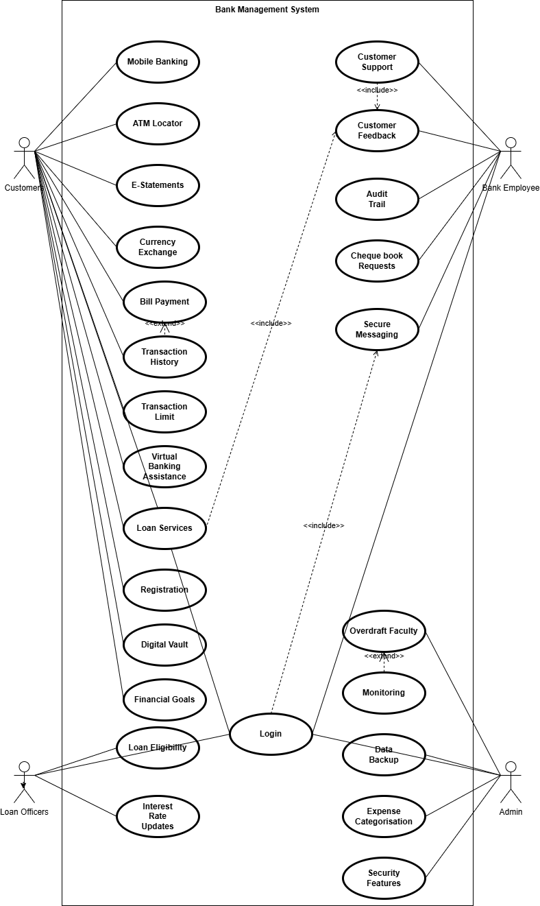
Use case diagram Figure 4 for Bank Management System

Activity diagram and Swimlane diagram

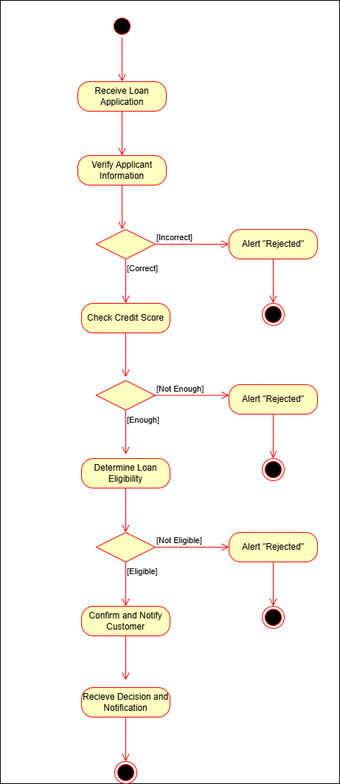

Figure 4.1-1 Activity diagram for Loan Services

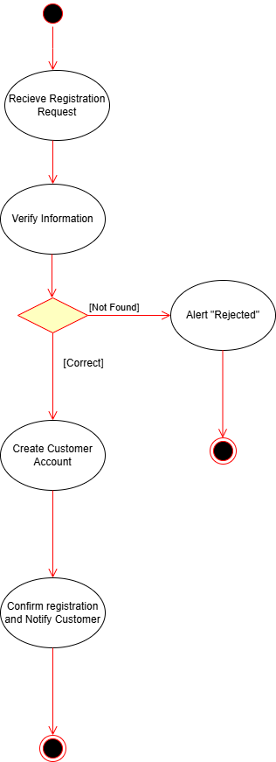

Figure 4.1-2 Activity diagram for Customer Registration

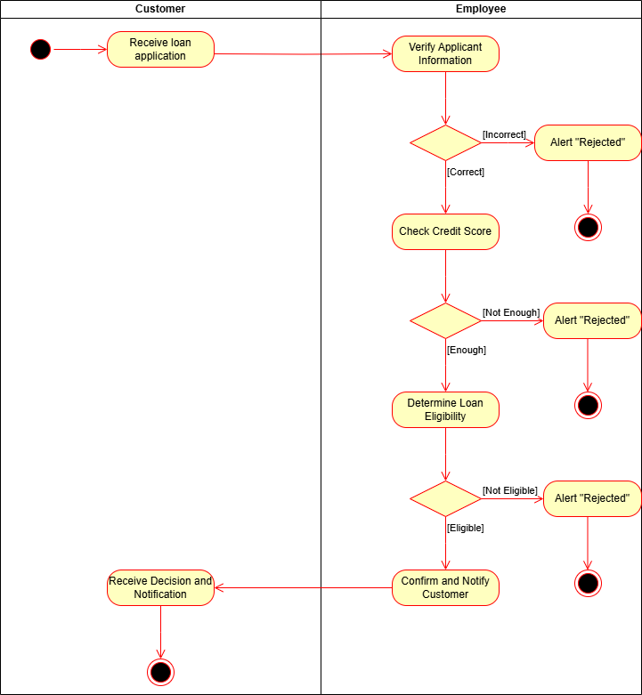
Figure 4.1-2 Swimlane diagram for Loan Services

Sequence diagram

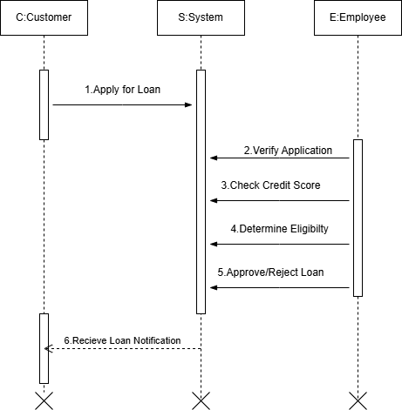

Figure 4.2-1 Sequence diagram Loan Services
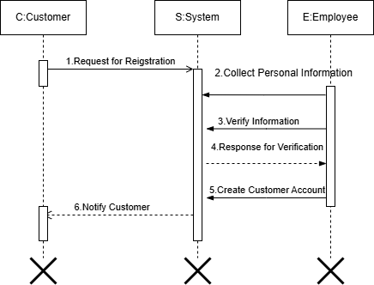
Figure 4.2-2 Sequence diagram for Customer Registration

State diagram

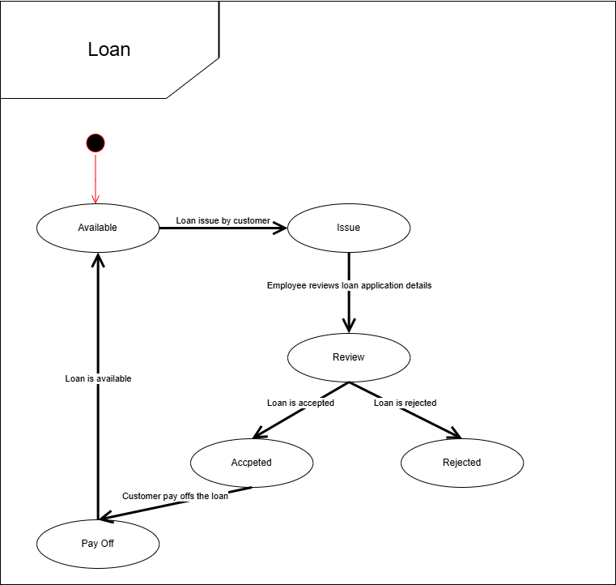

Figure 4.3 State diagram of Loan Services

Class diagram

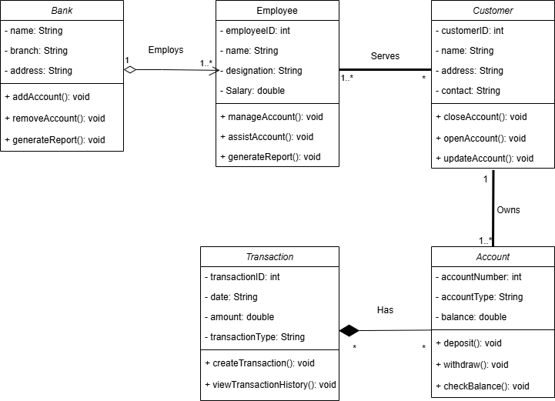
Figure 4.4 Class diagram for Bank management system

Data flow diagram

Context diagram (level-0)
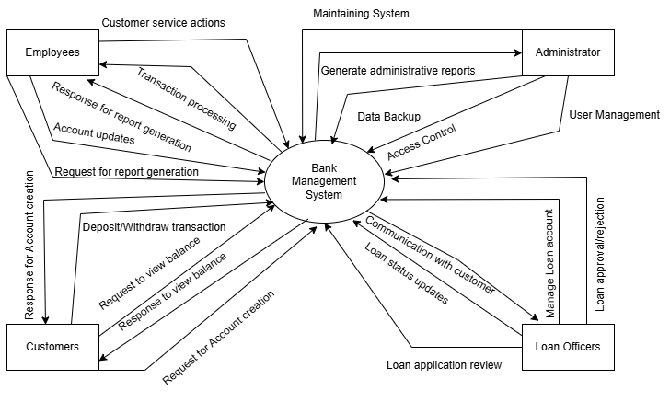
Figure 4.5.1 Context diagram for Bank management system

DFD Level-1
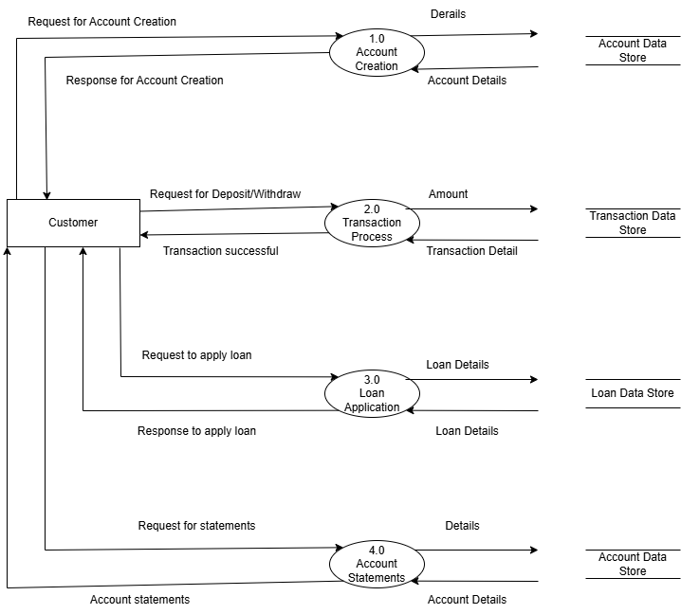
Figure 4.5.2 DFD level-1 for Bank management system

DFD Level-2
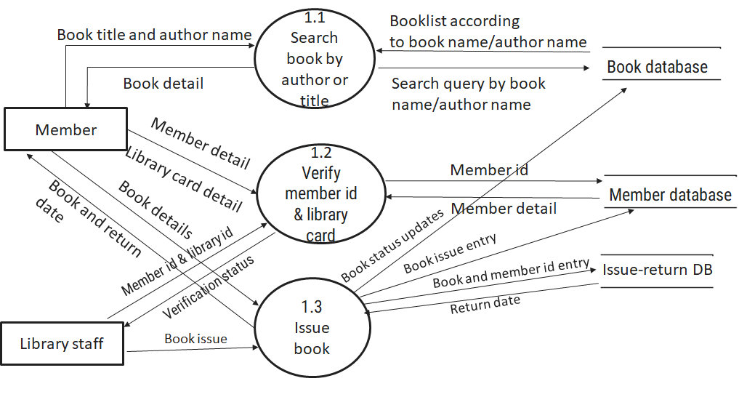
Figure 2.6-3 DFD level-2 for Issue book

External interface requirement (Screens)

Screen-1: Registration Form
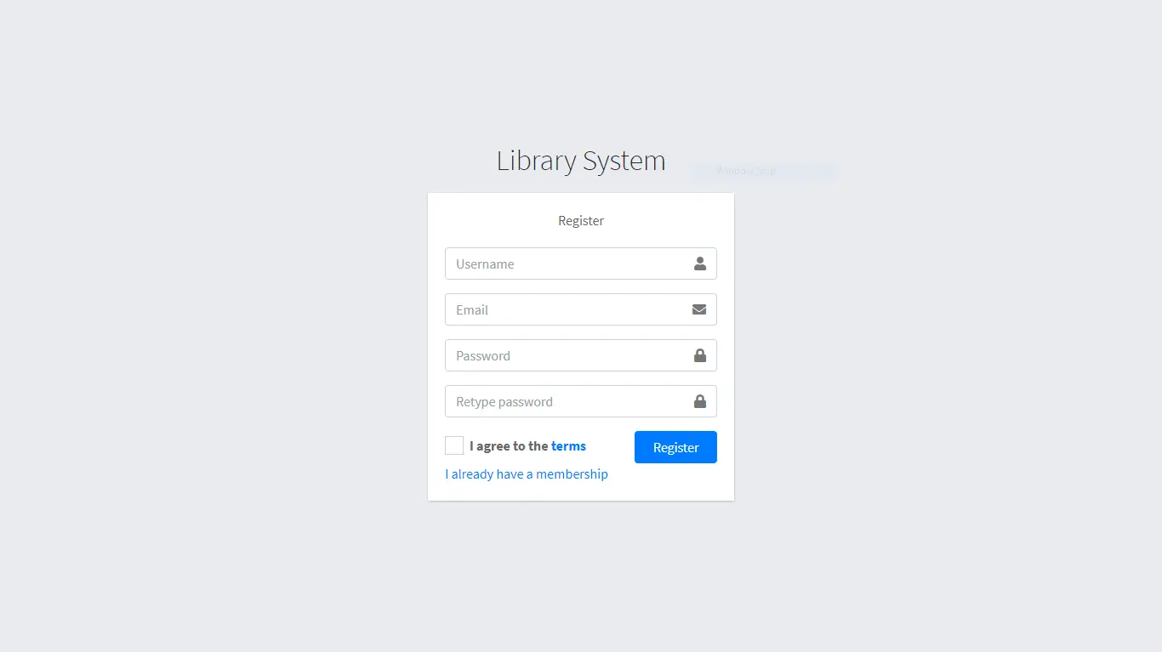
Figure 3.1-1 Screen-1: Registration Form

Purpose: This form will allow the target end-users to register in the system. To register , the following information will be encoded in the system.

Table 3.1-1 Screen element of Registration form
Sr. | Screen Element | Input Type | O/M | 1/N | Description
1 | Username | Textbox | M | 1 | Username field should be editable and accept the Username.
2 | Email | Textbox | M | 1 | Email field should be editable and accept the email with proper format.
3 | Password | Password | M | 1 | Password field should be editable and accept the password and display as star or dot.
4 | Retype password | Password | M | 1 | Retype Password field should be editable and accept the password and display as star or dot.
5 | I agree to the terms | Checkbox | M | 1 | Checkbox for accepting terms and condition.
6 | I already have a membership | Link | ------ | ------ | Link for navigate to login page for registered user.
7 | Register | Button | ------ | ------ | Register is a button for store the entered data into database.

Screen-2: Login Form
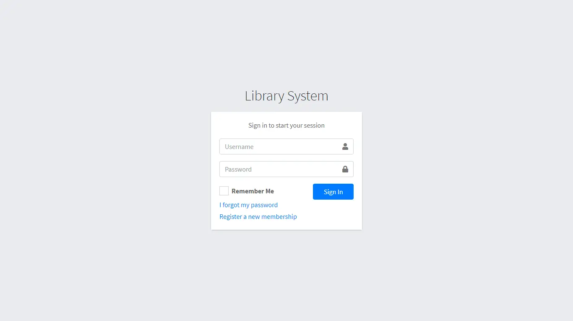
Figure 3.2-1 Screen-2: Login Form
Purpose: This form will be used by the system’s users to access records and features of the system. The users will input the correct combination of their username and password to be able to login to the system.

Table 3.2-1 Screen element of Login form
Sr. | Screen Element | Input Type | O/M | 1/N | Description
1 | Username | Textbox | M | 1 | Username field should be editable and accept the Username.
2 | Password | Password | M | 1 | Password field should be editable and accept the password and display as star or dot.
3 | Remember Me | Checkbox | M | 1 | Saving login credentials through remember me checkbox
4 | I forgot my password | Link | ------ | ------ | Link for navigate to Forgot password page for allows users to recover password.
5 | Register a new membership | Link | ------ | ------ | Link for navigate to membership registration.
6 | Sign in | Button | ------ | ------ | Login button navigates to another page even if valid login credentials.

Screen-3: Add borrower book
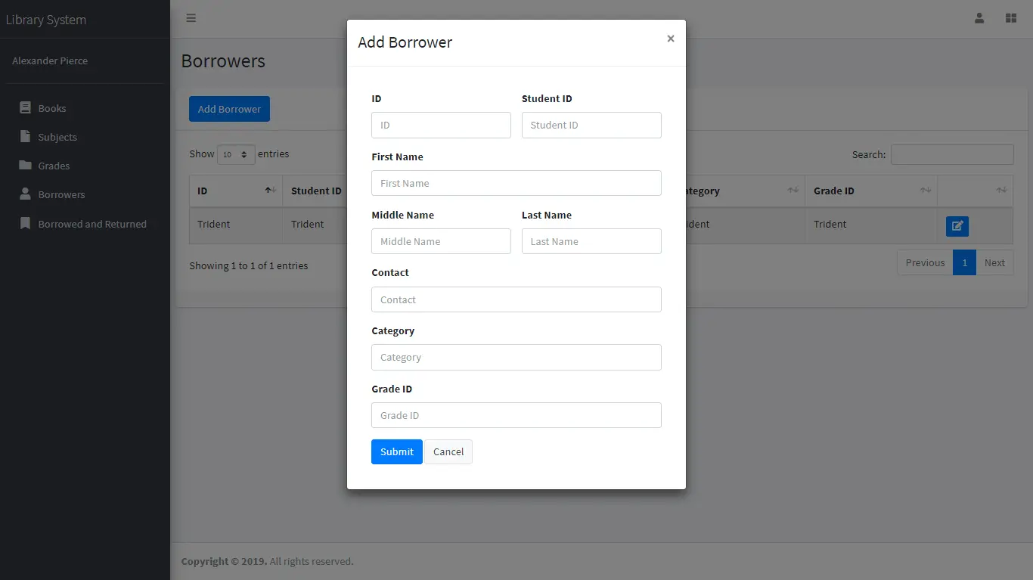
Figure 3.3-1 Screen-3: Add borrower book

Purpose: This module will allow the system administrator to add, edit, update or delete borrowers of book. The admin can add borrower information and manage it.

Table 3.3-1 Screen element of Add borrower book
Sr. | Screen Element | Input Type | O/M | 1/N | Description
1 | Borrower ID | Textbox | M | 1 | Borrower ID field should be editable and fill autogenerated Borrower ID.
2 | Student ID | Textbox | M | 1 | Student ID field should be editable and accept Student barcode id.
3 | First Name | Textbox | M | 1 | First Name field should be editable and accept only string as a borrower first name.
4 | Middle Name | Textbox | O | 1 | Middle Name field should be editable and accept only string as a borrower middle name.
5 | Last Name | Textbox | M | 1 | Last Name field should be editable and accept only string as a borrower last name.
6 | Contact | Textbox | M | 1 | Contact field should be editable and accept only 10-digit mobile number.
7 | Grade Id | Textbox | O | 1 | Auto fetch detail from the database if proper student id is entered.
8 | Submit | Button | ----- | ----- | Submit is a button for store the entered data into database.
9 | Cancel | Button | ----- | ----- | Cancel is a button for close add borrower dialog.

Database design

List of Tables
- Book
- Borrower
- Student
- Staff

Table 4.1-1 Table: Book
Column | Data Type | Null | Keys & Constrains | Default Value & Description
BookID | int | NN | PK (Auto Increment)
BookName | varchar(100) | NN
ISBN | varchar(100) | AN
Publication_year | int | AN
Language | varchar(50) | AN

Table 4.1-2 Table: Borrower
Column | Data Type | Null | Keys & Constrains | Default Value & Description
BorrowerID | int | NN | PK (Auto Increment)
BookID | varchar(100) | NN | FK | Reference of Book Table
BorrowedFromDate | DateTime | AN
BorrowedToDate | DateTime | AN
ActualReturnDate | DateTime | AN
IssuedBy | int | NN | FK | Reference of Student and Staff Table

Table 4.1-3 Table: Staff
Column | Data Type | Null | Keys & Constrains | Default Value & Description
StaffID | int | NN | PK (Auto Increment)
StaffName | varchar(100) | AN
IsAdmin | Boolean | AN
Designation | varchar(100) | AN

Table 4.1-4 Table: Student
Column | Data Type | Null | Keys & Constrains | Default Value & Description
StudentID | int | NN | PK (Auto Increment)
StudentName | varchar(100) | AN
Gender | varchar(100) | AN
DOB | DateTime | AN
Department | varchar(100) | AN
Contact | number(10,0) | AN

Stories and Scenario

Story-1: Add New Book in Library Catalogue

Story # S1 | : | As a Librarian,  I want to add a new book in library catalogue  So that everyone can easily find and borrow it.
Priority | : | High
Estimate | : | XL
Reason | : | The addition of a new book to the library catalogue is crucial for ensuring that the library's collection is up-to-date and accessible to everyone.

Scenario# S1.1
Scenario# S1.1 | : | Adding a New Book with Valid Information
Prerequisite | : | Librarian is logged in to the Library management system.
Acceptance Criteria | : | Given: The Librarian is navigated to the library catalog management page. Valid book information, including title, author, ISBN, and other relevant details is added.  When:  The librarian selects the "Add New Book" option  And The librarian enters valid book details  The librarian clicks the "Save" button to add the book to the catalog.  Then the system successfully adds the book to the catalog and the librarian receives a confirmation message with the book's identification number.

Scenario# S1.2
Scenario# S1.2 | : | Adding a New Book with Invalid Information.
Prerequisite | : | The librarian is logged into the library management system.
Acceptance Criteria | : | Given: The librarian is on the library catalogue management page  When: The librarian selects the "Add New Book" option and the librarian enters an incomplete or incorrect book details and librarian clicks the "Save" button to add the book to the catalogue.  Then the system displays error messages for the incorrect or missing information and the book is not added to the catalogue.

Scenario# S1.3
Scenario# S1.3 | : | Attempting to Add a Duplicate Book
Prerequisite | : | The librarian is logged into the library management system and the librarian is on the library catalogue management page
Acceptance Criteria | : | Given: The book information, including title, author, ISBN, and other relevant details, is available and the book with the same ISBN is already in the catalogue.  When: User Clicks on “Add book” button. Enter a number of copies with the same book detail mentioned in the field.  Then: Generate unique book id, barcode and spine label for various book of same title.

Story-2: Search Book
Story # S2 | : | As a Librarian or member,  I want to search for books by title, author, or keyword,  So that I can quickly find books that match my interests.
Priority | : | High
Estimate | : | M
Reason | : | Implementing a search functionality is essential for enhancing the user experience, as it allows librarian and member to efficiently discover and access the library's resources.

Story-3: Manage due date for borrowed book
Story # S3 | : | As Librarian,  I want to manage due dates for borrowed books  So that I can ensure that books are returned on time and avoid overdue fines.
Priority | : | High
Estimate | : | M
Reason | : | Proper due date management is crucial for maintaining the library's collection and ensuring that books are available for all members.

Story-4: Renew book
Story # S3 | : | As Librarian,  I want to renew a book that I have borrowed  So that I can extend my borrowing period if needed.
Priority | : | Medium
Estimate | : | M
Reason | : | Book renewal functionality is a convenience feature for librarian, allowing them to keep a book for an extended period if no one else has requested it.

Story-5: Generate a report on book usage and availability
Story # S3 | : | As Librarian,  I want to generate reports on library usage and book availability  So that I can make informed decisions about library’s books.
Priority | : | Medium
Estimate | : | L
Reason | : | Reporting functionality helps librarians track the usage of library resources and make data-driven decisions to improve services and collections.

Test cases
Project Name: | EMI Calculator | Test Designed by: | P. U. Jadeja
Module Name: | Login | Test Designed date: | 01-10-2023
Release Version: | 1.0 | Test Executed by: | R. B. Gondaliya
 |  | Test Execution date: | 15-01-2023

Pre-condition: Web application should be accessible
Test Case ID | Test Title | Test Type | Description | Test Case ID
TC_001 | Login to web application with valid credential | Functional | Login to Library management system web application through valid credential | TC_001
TC_002 | Login to web application with invalid credential | Functional | Login to Library management system web application through invalid credential | TC_002
TC_003 | Varify login page elements | GUI | varify that all elements are availabe on login page | TC_003

Test Case Title | Login to web application with valid credential
Test Type | Functional
Test Priority | High
Pre-condition | Web application should be accessible

Test Step | Test Case Description | Expected Result | Actual Result | Status | Comment | Data | BUG ID
1 | Access Web application URL | The site launched properly | Site launched successfully | Pass |  | https://accounts.google.com/ServiceLogin
2 | Enter valid Username in username field | Username field should be editable and accept the Username | Username input accepted | Pass |  | Username:  Rbgondaliya@gmail.com
3 | Enter valid Password in Password field | Password field should be editable and accept the password and display as star or dot | Password input displayed in dot and accepted | pass |  | Password:  rbgondaliya
4 | Enter valid captcha code in captch field | Captch field should editable and accept captcha and captcha is case sensitive | Captcha input accepted | Pass | Step required when human action validation perform | get captcha from image which is near by captcha field
5 | Click on login button | User should login into site and navigated to dashboard | User navigated to dashboard and username should br display in top of the right side. | pass

Test Case Title | Login to web application with invalid credential
Test Type | Functional
Test Priority | Medium
Pre-condition | Web application should be accessible

Test Step | Test Case Description | Expected Result | Actual Result | Status | Comment | Data | Bug ID
1 | Verify that User is not able to Login with invalid Username and invalid Password | Should be display an error message enter wrong username or password | Display an error of wrong username and password | Pass
2 | Verify that User is not able to Login with Valid Username and invalid Password | Should be display an error message enter wrong password | Display an error of wrong password | Pass
3 | Verify that User is not able to Login with invalid Username and Valid Password | Should be display an error message User not found | Display an error Username not found | Pass
4 | Verify that User is not able to Login with blank Username or Password | Set required field validation message for Username and Password | Display an error of wrong username and password | Fail | Not performa a validation function fix it |  | Bug_002

Test Case Title | Varify login page elements
Test Type | GUI
Test Priority | Medium
Pre-condition | Web application should be accessible

Test Step | Test Case Description | Expected Result | Actual Result | Status | Comment | Data | Bug ID
1 | Launch application with the given url | The site launched properly | Site launched successfully | Pass |  | https://accounts.google.com/ServiceLogin
2 | Verify that the login screen contains elements such as Username, Password, Sign in button, Remember password check box, Forgot password link, and Create an account link. | All listed control displayed properly on the page | Login page loaded successfully | Pass
3 | Verify that cursor is focused on “Username” text box on the page load | Cursor is focused in Username textbox | Cursor focus in Username textbox | Pass
4 | Verify that tab functionality is working properly or not | When tab pressed cursor move in next control | Cursor moving in next control | Pass
5 | Verify that all the fields such as Username, Password has a valid placeholder | All text fields have proper placeholder | All text fields have proper placeholder | Pass
6 | Verify that the labels float upward when the text field is in focus or filled (In case of floating label) | When field is focused or filled, label display on top of the filled | When field is focus or filled, label display on top of the filled | Pass | step required when fields with floating label
7 | verify that forgot password link working properly | when click on forgot password load forgot passworg page | forgot password link not working | Fail

References

- http://www.w3schools.com/html/html_intro.asp
- https://www.w3schools.com/php/default.asp
- https://www.javatpoint.com/uml

