Assignment (Search/Sort)

Om Gupta 214047

Q.1 Write python programs to perform sorting of numbers in ascending order:

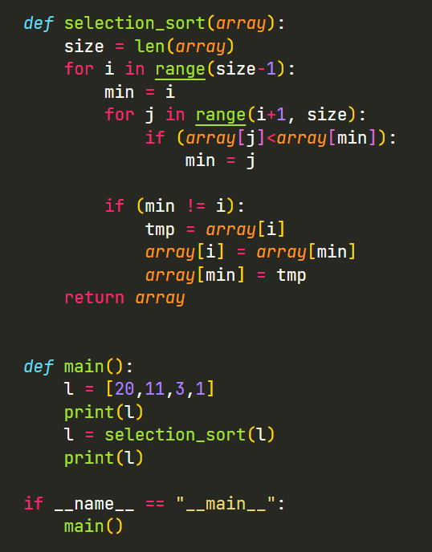a) Selection Sort

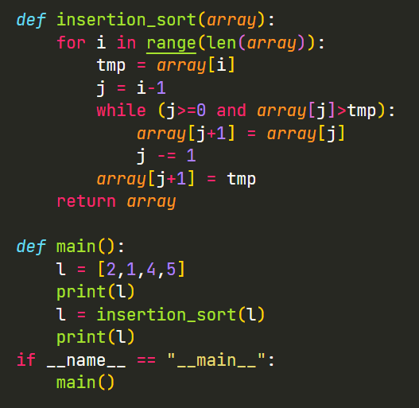b) Insertion Sort

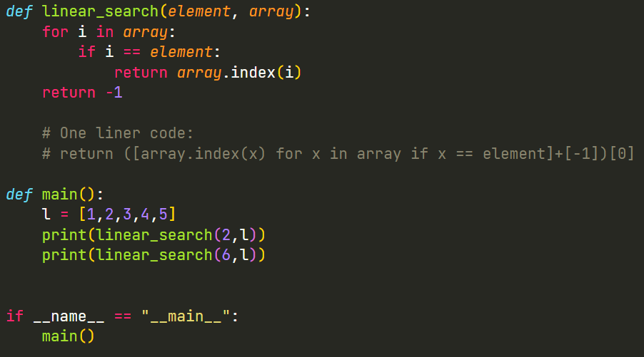Q.2 Write python programs to perform the searching using following methods:  
 a) Linear Search

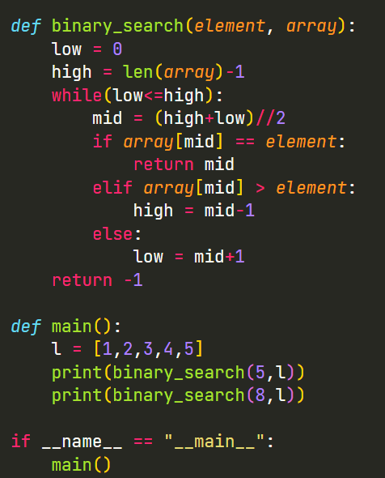b) Binary search