

SCHOOL OF ADVANCED TECHNOLOGY

ICT - Applications & Programming

Computer Engineering Technology – Computing Science

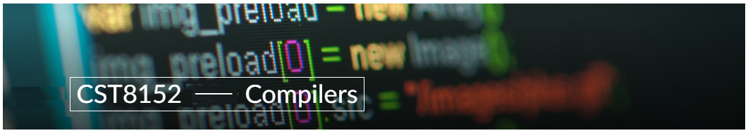

A21
Model Definitions (RE/Automaton)

Lab Professor / Lab Session:
[Lab Prof Name / Lab Session]

Team:
[Aum Patel] - Id: [041103623] / [Sakoondeep Singh] - Id: [041093515]

Language Name [Mobile]

This template is suggested (not mandatory) to answer A11 Specification.

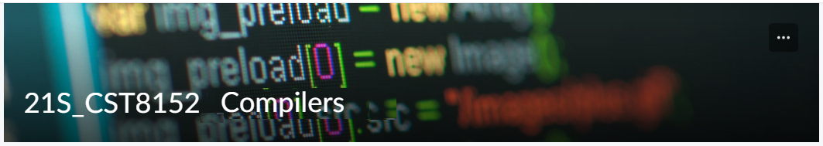

MODEL TASK FOR ASSIGNMENT 2.1 – YOUR LANGUAGE

- Note: This task is part of the Assignment 2 from Compilers Course. Any problem, contact your lab professor.

Task 1: Language Symbols (2.0 marks)

List examples: Define main symbols to be used:
- Special symbols (ex: “{“, “(“, “<=”, etc.)
- Comments
- Variables
- Functions
- Literals (numbers, strings)
- Keywords
- Datatypes

Answer:

Special Symbols – ‘{ ’ , ‘ } ’, ‘( ’ , ‘)’, ‘<’ , ‘>’, ‘-’ , ‘_’, ‘=’, ‘/’ , ‘*’, ‘ ” ’, ‘ ’ ‘, ‘\’, ‘n’,.

Comments :
SLC : # blab la bal
MLC : /* bla bla bla */

Variables:
Ex – thisIsVariable ,var1

Rule:-

-Should start with letters or _(U) and if possible can end with digits.
-Cannot be a reserved keyword of R.
-If variable name starts with period(.) it cannot end with a digit.

Functions:
functionName<-function(num)
{/* function body*/}

Rule:-
Define function name(variables) and use the notation followed by arrow and keyword function<- keyword function then pass parameters separated by commas.

Body- Enclosed in curly braces{}; executes upon calling the function.
Return- Impilcitly returns the last evaluated expression unless return() is explicitly used.

Parameters:
Default Valuee : They can have default values.IF not passed, default is used.
Multipynumbers<- function(num1,num2=10){
return(num1*num2)
}
Scope:
Local variable- Accessible only within the function.
Global Varaible- Accessible anywhere.

Literals(number ,strings):

Numbers:
-Int:0,13,12,2134
-Float:3.14,9.8

Strings:’Hell0’, “Yes , it works.”

Rule :
-For int : Sequence of digits
-For floats : Sequence of digits separated by one single dot.
-For strings : Sequence of chars between single quotes or double quotes.

Keywords:
if, else, while, for, break, next, repeat, NULL, TRUE,FLASE, function, Inf, NA, in,

Datatypes: int ,float, String

Task 2: RE – Regular Expression (3.0 mark)

Lexeme Classes: Define the classes to be used in your regular expression:

Answer:

L (letters) :{ ‘A’-‘Z’ | ‘a’-‘z’}
D (digits) : {‘0’-‘9’}
H (hastag): {‘#’}
I(dash):{-}
E (enter): {‘\n’}
U (underscore):{‘ _’}
S (Slash) : {‘/’}
A (asterisks): {‘*’}
P(period): {‘.’}
LTS={‘<’}
RTS={‘>’}
O ={‘(‘}
C ={‘)’}
Q (single quotes):{ ‘ }
R (double quotes): { “ }
X(other) : ^[L.D.H.E.U.S.A.P.LTS.RTS.O.C.Q.R]

Define the RE to be used for: variables, literals and keywords:

Answer:
* Comments:
SLC :H [^E]*E
MLC : SA(^[AS]*[AS]

* Variables:
VID( Variable Identifier) :L(L|D|U)*

* Methods:
MID( Method Identifier): L(L|D|U)*

* Literals:
- Numbers
-Int : D+
-Float : D*PD+
- Strings
-R(^R)*R
-Q(^Q)*Q

* Keywords:
L+ ={ “if”, “else”, “while”, “repeat” , “for”, “function” , “in”, “next” , “break” , “TRUE”, “FLASE"

Task 3: TD – Transition Diagram (3.0 marks)

Activity: Starting from the previous lexeme classes and obeying the RE, it is possible to define the automata for your language:

Answer (draw / copy image of the automata):

Ta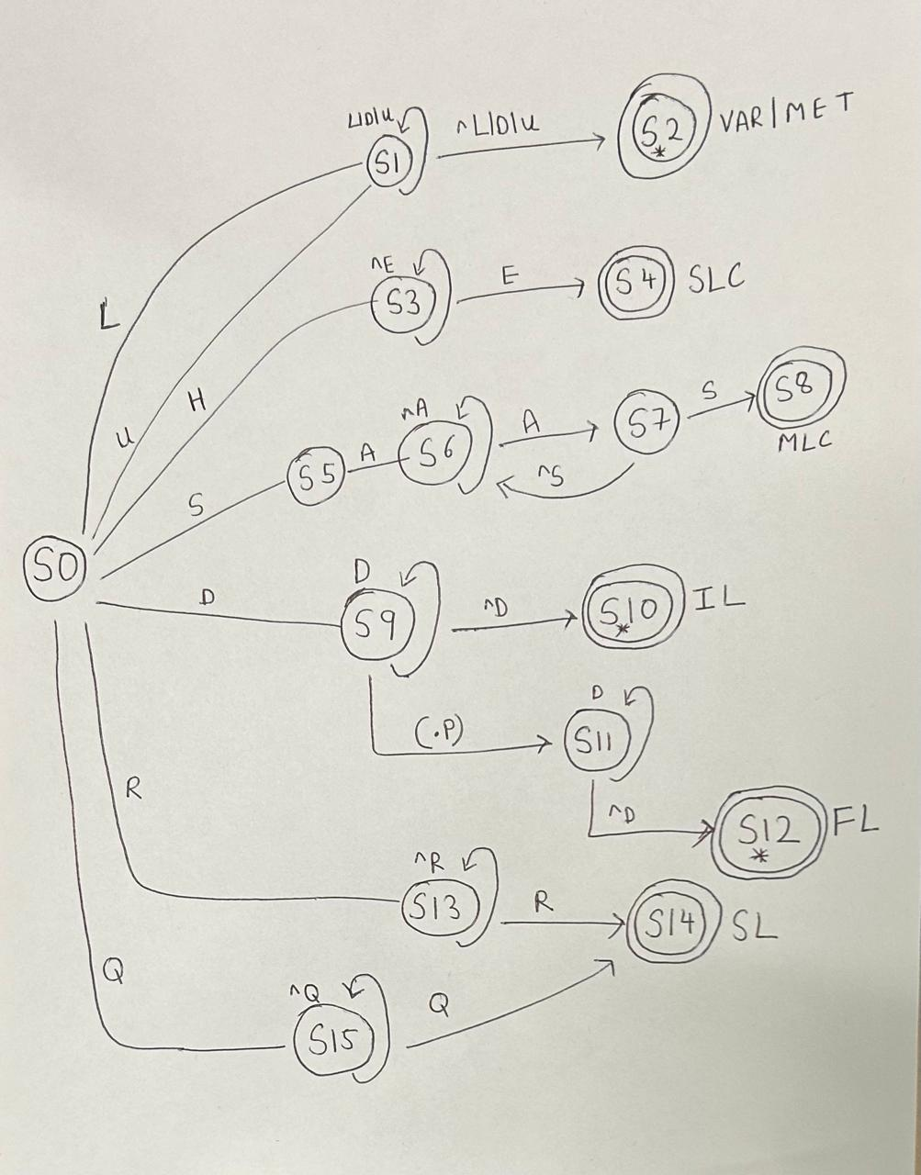

Task 4: TT – Transition Table (2.0 marks)

Activity: Now, it is possible to define the TT for these lexemes:

Answer (Transition Table):

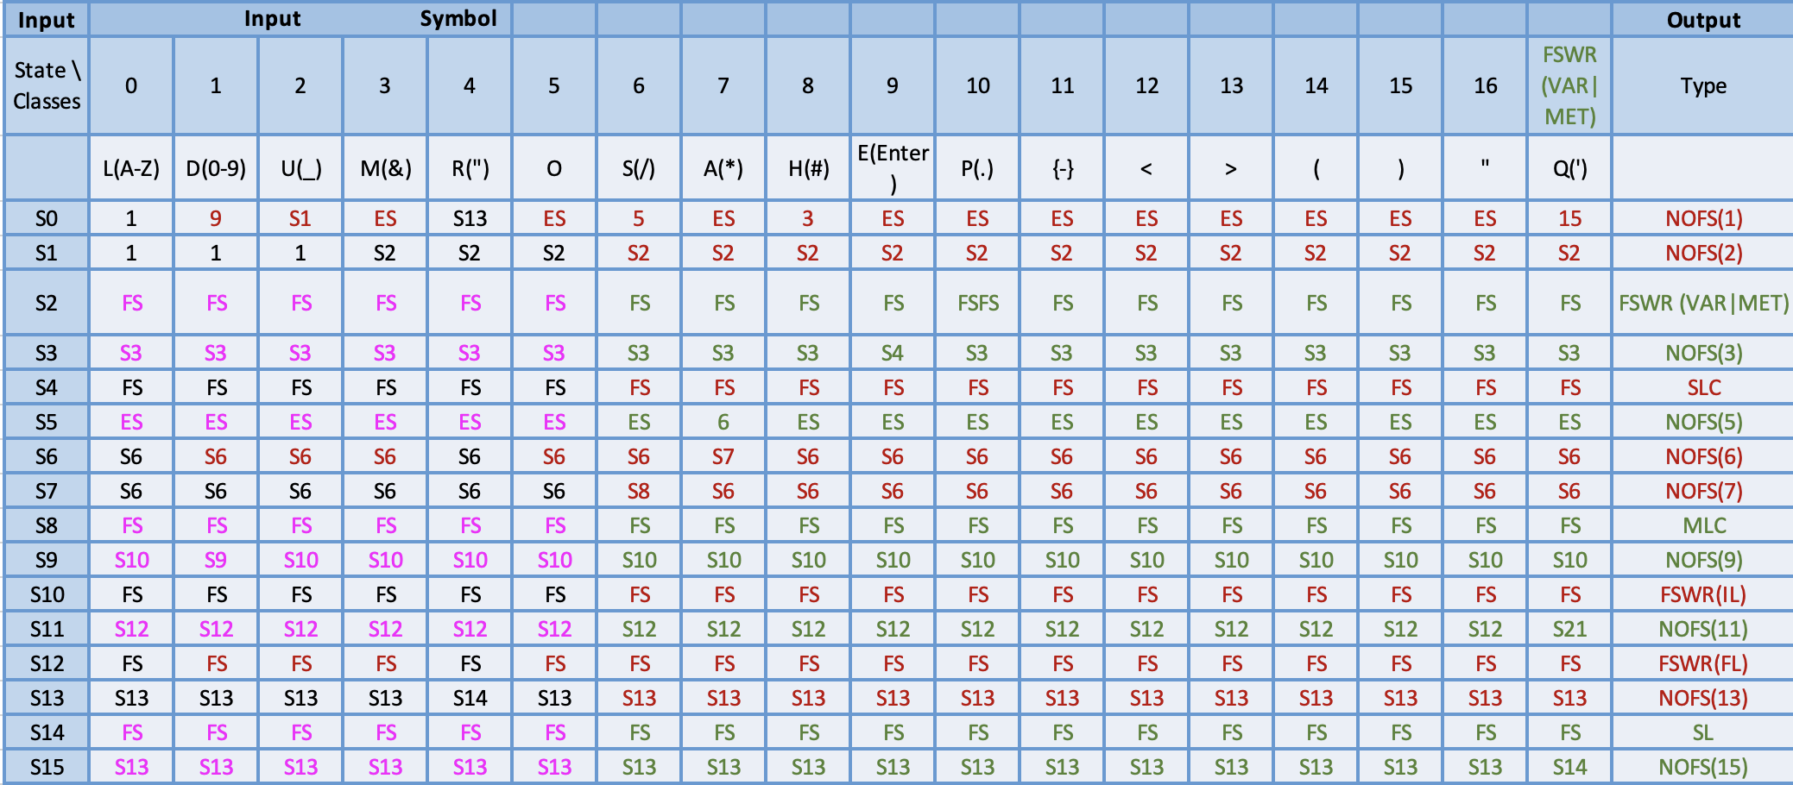

Update: Jun 1st 2024.

Adapted from resources developed by Prof. Svillen Ranev (Algonquin College, 2019)

