🏏 IPL Analytics Dashboard
A Streamlit-based interactive analytics dashboard for exploring IPL cricket data (2008–2024).
The application provides data analysis, visual insights, and machine learning predictions including:
- Season statistics
- Venue impact analysis
- Head-to-head comparisons
- Orange & Purple cap tracking
- Player career analytics
- Match outcome prediction
- Score prediction
- Best Playing XI recommender
- Fantasy team generator
This project demonstrates Data Science, Data Visualization, and Machine Learning using Python.

📊 Features
1️⃣ Season Insights
Analyze IPL seasons using statistics like:
- Total runs scored per season
- Total wickets per season
- Top batsmen of each season
- Top bowlers of each season

2️⃣ Venue Impact & Toss Analysis
Understand how stadiums influence match outcomes.
Features:
- Average first innings score per venue
- Toss winner impact on match results

3️⃣ Head-to-Head Team Comparison
Compare any two IPL teams across seasons.
Includes:
- Total wins comparison
- Win percentage
- Total runs across matches
- Top wicket-takers in those matches

4️⃣ Orange Cap & Purple Cap Tracker
Track the best performers in IPL history.
Displays:
- Top run scorers (Orange Cap race)
- Top wicket takers (Purple Cap race)
- Season-wise leaders

5️⃣ Player Career Tracker
Analyze any IPL player's career performance.
Shows:
- Season-wise runs
- Season-wise wickets
- Batting style
- Bowling style

6️⃣ Match Outcome Predictor
Machine Learning model that predicts which team will win a match based on:
- Teams playing
- Venue
- Toss winner
Model Used:
Random Forest Classifier

7️⃣ Score Predictor
Predicts first innings score range for a match using:
- Venue
- Batting team
- Bowling team
Model Used:
Random Forest Regressor

8️⃣ Best Playing XI Recommender
Automatically selects the best team lineup based on:
- Batting performance
- Bowling performance
- All-rounder contribution

9️⃣ Fantasy Team Recommender
Generates an optimal fantasy cricket team based on:
- Budget
- Player value score
- Historical performance

🧠 Machine Learning Models Used
Model | Purpose
Random Forest Classifier | Predict match winner
Random Forest Regressor | Predict first innings score
Libraries used:
- scikit-learn
- pandas
- numpy
- plotly
- seaborn

📂 Dataset
The dashboard uses the following datasets:
IPL_BallByBall2008_2024(Updated).csv
team_performance_dataset_2008to2024.csv
Players_Info_2024.csv
ipl_teams_2024_info.csv
They contain:
- Ball-by-ball IPL data
- Team performance records
- Player information
- Team details

⚙️ Installation
1️⃣ Clone the repository
git clone https://github.com/yourusername/IPL-Analytics-Dashboard.git
cd IPL-Analytics-Dashboard

2️⃣ Install dependencies
pip install pandas numpy matplotlib seaborn scikit-learn streamlit plotly joblib

3️⃣ Run the application
streamlit run dashboard2.py
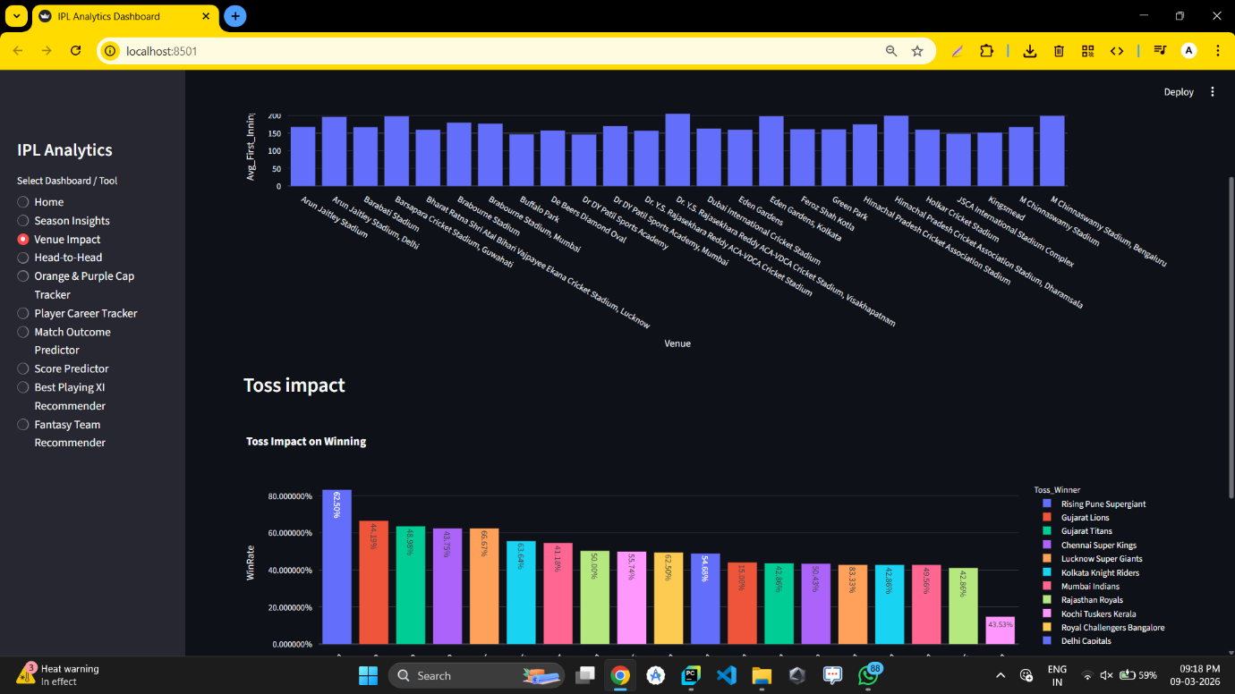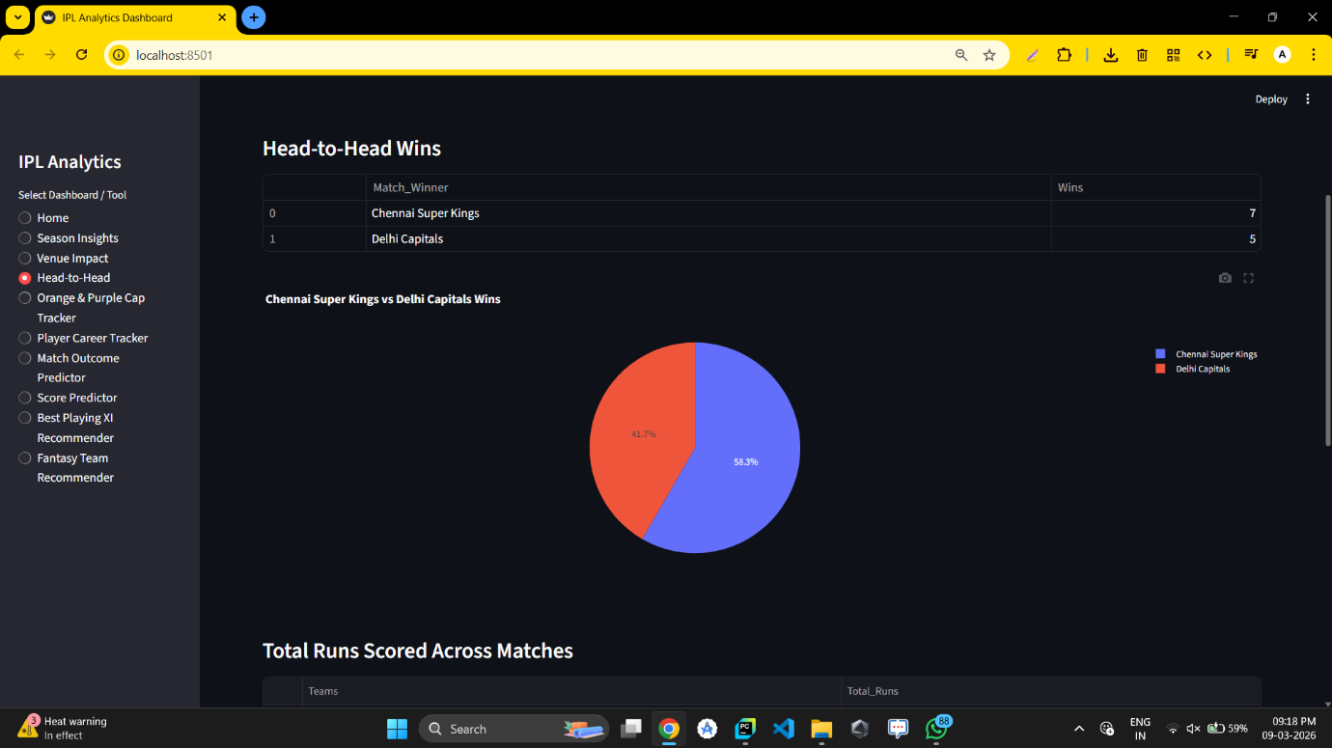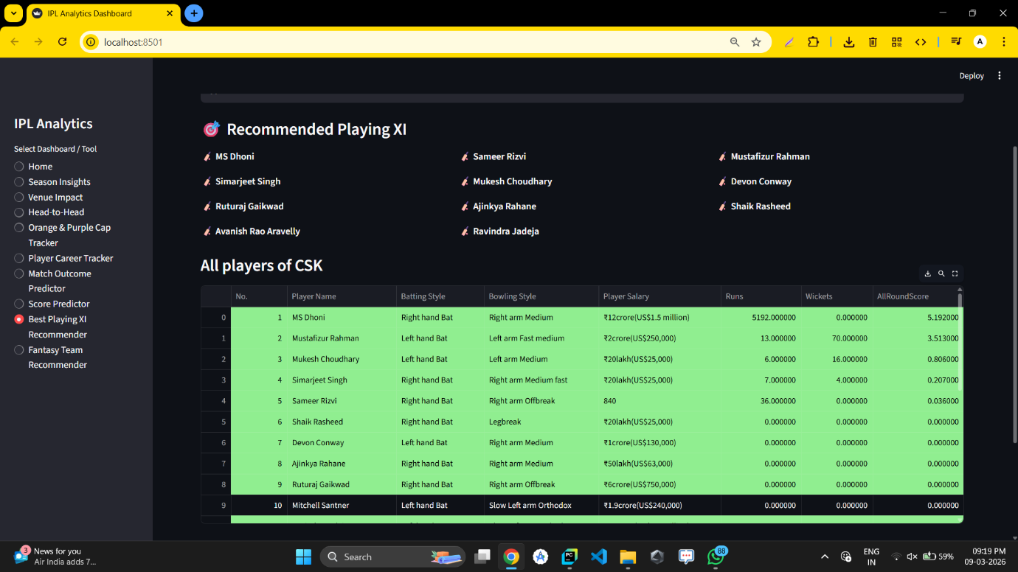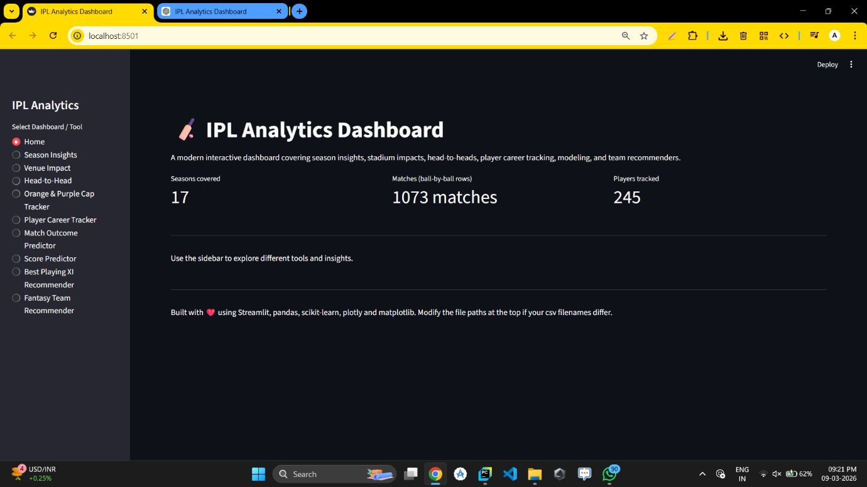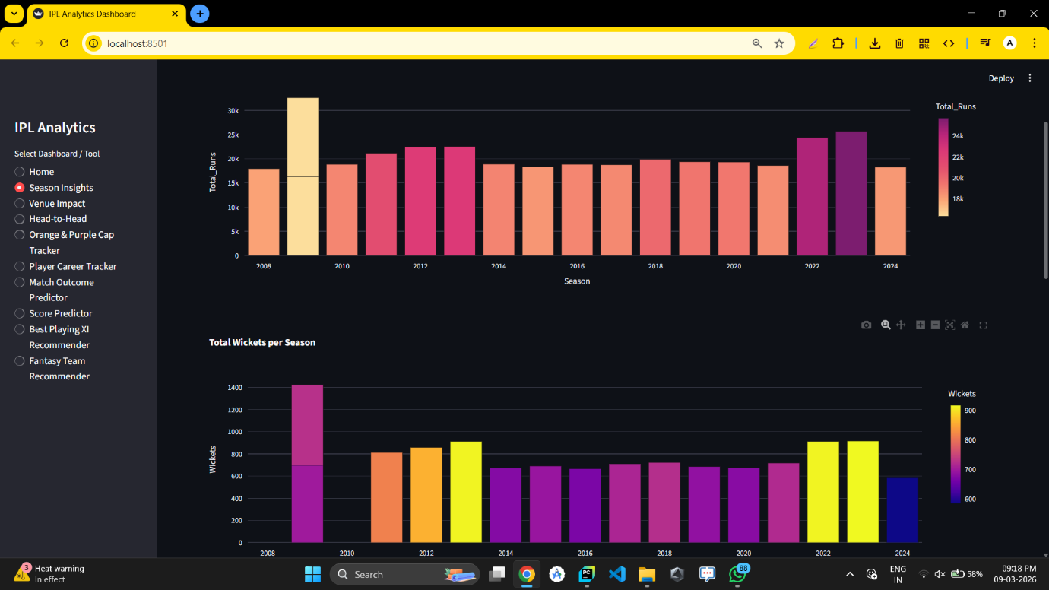

🎯 Learning Outcomes
This project demonstrates:
- Data cleaning and preprocessing
- Data visualization
- Feature engineering
- Machine learning model training
- Model deployment using Streamlit
- Interactive dashboards

