AI-Powered Database Intelligence System
Natural Language → Intelligent SQL → Real Database Insights

Project Overview
An AI-powered database assistant capable of dynamically connecting to real databases, understanding schemas, generating SQL queries from natural language, and returning intelligent responses using LangChain, Groq, Llama 3, FastAPI, Angular, and MySQL.

System Architecture
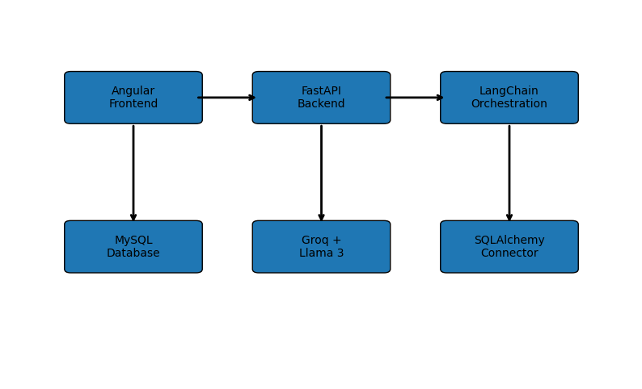

Workflow
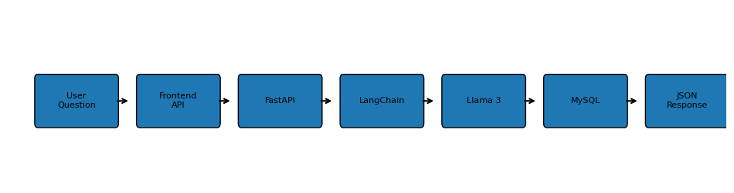

Core Features
- Natural Language to SQL generation
- Dynamic MySQL database connection
- AI-powered schema understanding
- Relationship inference without foreign keys
- Secure query validation
- Multi-table JOIN generation
- Compact schema architecture for security
- FastAPI + Angular full-stack architecture

Tech Stack
Layer | Technology
Frontend | Angular
Backend | FastAPI
AI Framework | LangChain
LLM Provider | Groq
AI Model | Llama 3
Database | MySQL
ORM | SQLAlchemy

Example Query Flow
1. User asks a question in plain English.
2. Angular frontend sends API request.
3. FastAPI backend receives request.
4. LangChain reads database schema.
5. Llama 3 generates SQL query.
6. MySQL executes SQL query.
7. Backend returns JSON response.
8. Angular displays result table.

Security Features
- Sensitive columns filtered from prompts
- Compact schema system prevents row leakage
- Dangerous SQL keywords blocked
- Environment variable protection using .env

Future Improvements
- PostgreSQL support
- MSSQL support
- AI-generated dashboards
- Streaming AI responses
- Semantic schema embeddings
- Vector memory integration

Conclusion
This project demonstrates how modern LLMs can be integrated with real database systems to create intelligent data interaction platforms capable of conversational querying and automated SQL reasoning.

