**Cascading Style Sheets (CSS)**

Normally we write HTML using 3 types.

* Class
* ID
* Elements

ID should be unique but CLASS can be used at multiple places.

We use Hash for ID

DOT for CLASS

Only name for any specific ELEMENT(div, p, li, ol etc).

div{ }

.class{ }

#id{ }

----- we call these as **CSS Selector** ---

**SELECTORS** are Patterns used to select the element(s) you want to style.

1. all **UL** immediately after **H3** . Also known as **JASON SIBLINGS**.

**h3 + ul {**

border: 5px dotted purple;

}

1. all **ANCOR** inside **LIST**

**li a{**

color: red;

}

1. all ***LIST*** inside UL with **ATTRIBUTE** (id=”few”)

**ul li[** id="few" **]** {

color: teal;

}

**li a [**href="https://www.newyorker.com/"**]**{

color: blue;

border: 3px orchid dashed;}

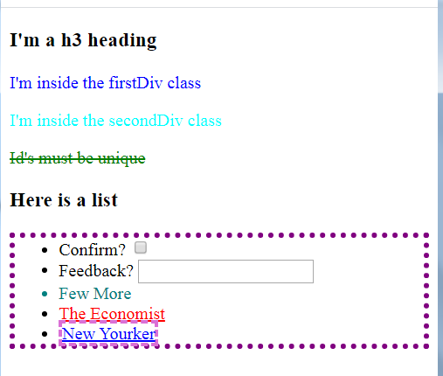

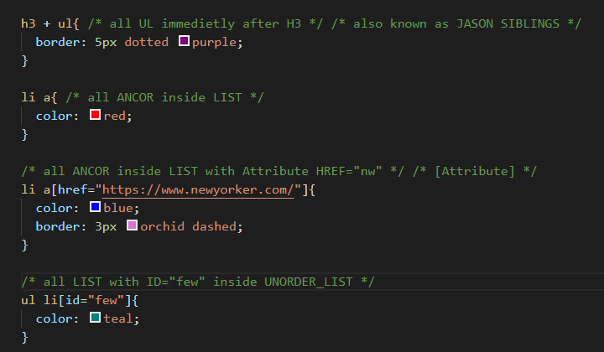

**Specificity**

Specificity defines the hierarchy of CSS styling and what types of tags overrule others.