**Cascading Style Sheets (CSS)**

Normally we write HTML using 3 types.

* Class
* ID
* Elements

ID should be unique but CLASS can be used at multiple places.

We use Hash for ID

DOT for CLASS

Only name for any specific ELEMENT(div, p, li, ol etc).

div{ }

.class{ }

#id{ }

----- we call these as **CSS Selector** ---

**SELECTORS** are Patterns used to select the element(s) you want to style.

1. all **UL** immediately after **H3** . Also known as **JASON SIBLINGS**.

**h3 + ul {**

border: 5px dotted purple;

}

1. all **ANCOR** inside **LIST**

**li a{**

color: red;

}

1. all ***LIST*** inside UL with **ATTRIBUTE** (id=”few”)

**ul li[** id="few" **]** {

color: teal;

}

**li a [**href="https://www.newyorker.com/"**]**{

color: blue;

border: 3px orchid dashed;}

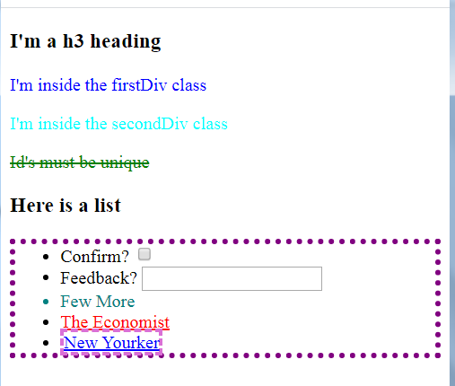

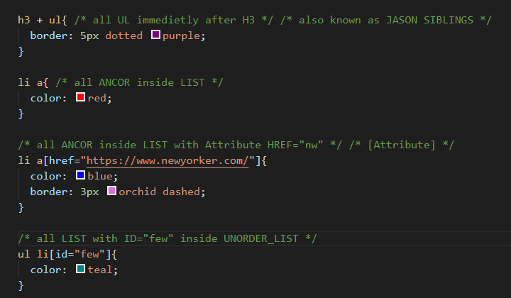

**Fonts**

** **EM:** Relative to the font-size of the element (2em means 2 times the size of the current font). (1em = 16px)

**Some Properties:**

* font-family: Arial;
* text-align: center;
* font-family: monospace;
* font-style: italic;
* font-weight: bold;

**Font List:**

* https://en.wikipedia.org/wiki/List_of_typefaces_included_with_macOS
* https://en.wikipedia.org/wiki/List_of_typefaces_included_with_Microsoft_Windows

**Find Fonts:**

* https://www.cssfontstack.com/
* https://fonts.google.com/
* <https://fontlibrary.org/>

**Box Model**

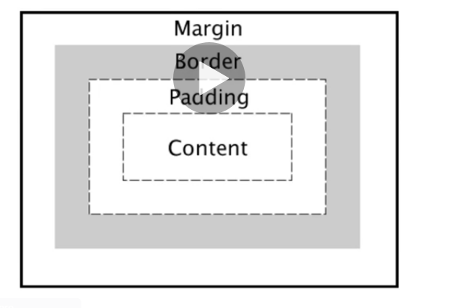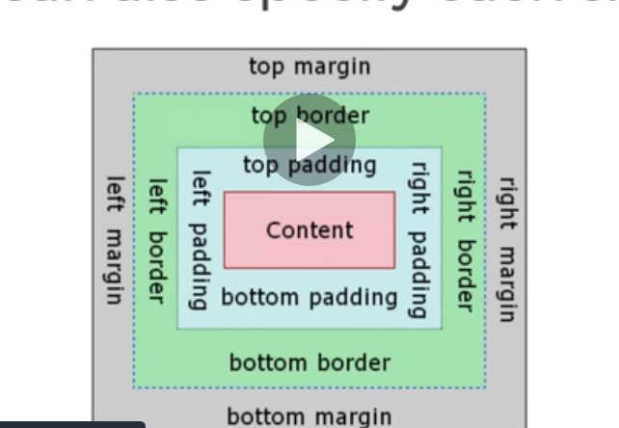

** If you want to Center Align for whole Box you should use Margin or Padding = Auto;

** margin: 10px 20px 30px 40px; // top-right-bottom-left

**Color Palette:**

* <https://coolors.co/>