“FedTrustChain: Trust-Based Blockchain Federated Learning Framework”
A Project Report submitted in partial fulfillment of the requirements for the award of the degree of
BACHELOR OF TECHNOLOGY
IN
COMPUTER SCIENCE AND ENGINEERING
(Specialization in Artificial Intelligence & Machine Learning)
Submitted by
K. Nithin (2023002072)
N. Sri Harsha (2023002158)
B. Ravinandhan Reddy (2023001018)
T. Aum Namaha (2023001973)
Under the esteemed guidance of
Dr. Vasavi Junapudi
Department of Computer Science and Systems Engineering
GITAM School of CSE

DEPARTMENT OF COMPUTER SCIENCE AND ENGINEERING
GITAM SCHOOL OF TECHNOLOGY
GITAM (Deemed to be University)
VISAKHAPATNAM / HYDERABAD
2026

DEPARTMENT OF COMPUTER SCIENCE AND ENGINEERING
GITAM SCHOOL OF TECHNOLOGY
GITAM (Deemed to be University)
DECLARATION
We hereby declare that the project report entitled “FedTrustChain: Trust-Based Blockchain Federated Learning Framework” is an original work done in the Department of Computer Science and Engineering, GITAM School of Technology, GITAM (Deemed to be University), submitted in partial fulfillment of the requirements for the award of the degree of Bachelor of Technology in Computer Science and Engineering (Specialization in Artificial Intelligence and Machine Learning). This work has not been submitted to any other college or university for the award of any degree or diploma.
Date: October 2026
Student Declaration Sign-Off
Registration No(s) | Name(s) | Signature
2023002072 | K. Nithin
2023002158 | N. Sri Harsha
2023001018 | B. Ravinandhan Reddy
2023001973 | T. Aum Namaha

DEPARTMENT OF COMPUTER SCIENCE AND ENGINEERING
GITAM SCHOOL OF TECHNOLOGY
GITAM (Deemed to be University)
CERTIFICATE
This is to certify that the project report entitled “FedTrustChain: Trust-Based Blockchain Federated Learning Framework” is a bonafide record of work carried out by K. Nithin (2023002072), N. Sri Harsha (2023002158), B. Ravinandhan Reddy (2023001018), and T. Aum Namaha (2023001973), students submitted in partial fulfillment of the requirement for the award of the degree of Bachelor of Technology in Computer Science and Engineering (Specialization in Artificial Intelligence and Machine Learning).
Date : October 2026
_______________________________ | _______________________________
Project Guide  Dr. Vasavi Junapudi  Department of CSSE, GITAM School of CSE | Head of the Department  Department of Computer Science & Engineering  GITAM School of Technology

ACKNOWLEDGEMENT
We take this opportunity to express our profound gratitude and deep regards to our esteemed project guide, Dr. Vasavi Junapudi, Department of Computer Science and Systems Engineering, GITAM School of CSE, GITAM (Deemed to be University), for her exemplary guidance, continuous monitoring, and constructive technical feedback throughout the design, Review 1 architectural formulation, and software implementation of the FedTrustChain framework.
We extend our sincere thanks to the Head of the Department, Department of Computer Science and Engineering, and the academic leadership of GITAM School of Technology, GITAM (Deemed to be University), for providing the computational infrastructure, research facilities, and academic support required to execute distributed machine learning experiments across large-scale healthcare and cybersecurity datasets.
We also acknowledge the open-source research communities at Washington University in St. Louis (for the WUSTL-EHMS-2020 dataset), the Canadian Institute for Cybersecurity at the University of New Brunswick (for the CICIoT2023 dataset), and the University of Queensland (for the NF-ToN-IoT dataset), whose publicly available telemetry benchmarks enabled rigorous empirical validation of our federated ensemble architecture. Finally, we thank our parents, faculty members, and classmates for their constant encouragement throughout this capstone project.

TABLE OF CONTENTS
Table of Contents
S.No. | Description | Page No.
1. | Abstract | 1
2. | Introduction | 1
3. | Literature Review | 3
4. | Problem Identification & Objectives | 5
5. | Existing System | 6
6. | Proposed System | 7
7. | System Architecture | 10
8. | Tools/Technologies Used | 13
9. | Conclusion | 15
10. | References | 16

1. ABSTRACT
Modern Internet of Things (IoT) networks and Internet of Medical Things (IoMT) healthcare systems generate massive volumes of sensitive operational and clinical telemetry across millions of connected edge devices. Traditional cloud-centric security systems require transferring raw device telemetry to a central server, creating three severe operational challenges: massive bandwidth overload, single points of failure with high data-leakage risk, and blind trust in connected nodes that allows compromised devices to inject poisoned data undetected. While standard Federated Learning (FedAvg) keeps raw data on the edge device by exchanging model updates rather than raw records, conventional Federated Learning architectures still rely on centralized aggregation servers, lack tamper-proof audit trails, and remain vulnerable to model poisoning attacks.
To resolve these challenges, this capstone project presents FedTrustChain: Trust-Based Blockchain Federated Learning Framework, a privacy-preserving, trust-driven, and blockchain-anchored framework designed to secure heterogeneous IoT and healthcare edge networks without exposing raw data. Architecturally, FedTrustChain bridges a three-tier conceptual design—comprising the Edge Layer, the Permissioned Blockchain Ledger Layer, and the Global Aggregation and Audit Layer—with a modular Python software implementation utilizing Federated Random Forest (“bag-of-trees”) ensemble aggregation over length-prefixed Transmission Control Protocol (TCP) sockets. Edge nodes train local Random Forest classifiers on private data partitions, while smart-contract verification and dynamic trust scoring evaluate model updates to isolate anomalous or malicious nodes before global aggregation. Multi-dataset benchmarking across more than 1.47 million records demonstrates that FedTrustChain achieves 94.06% accuracy (93.28% F1-score) on the WUSTL-EHMS-2020 healthcare telemetry dataset in 0.47 seconds, 98.90% accuracy (98.79% F1-score) on 300,000 records of the CICIoT2023 attack benchmark in 57.10 seconds, and 68.91% accuracy across 1,157,994 NetFlow records of the NF-ToN-IoT dataset in 28.14 seconds.
2. INTRODUCTION
2.1 THE IOT DATA AND SECURITY PROBLEM
Connected edge ecosystems—spanning smart cities, connected vehicles, industrial manufacturing (Industry 4.0), smart homes, and hospital patient-monitoring networks—depend on machine learning intrusion detection systems to identify cyberattacks in real time. However, as established in our Capstone Review 1 analysis, traditional IoT data sharing faces three fundamental bottlenecks:
- 1. Data Overload: Millions of distributed IoT sensors generate continuous, high-velocity network and biometric telemetry. Centralized cloud infrastructures cannot scale securely or cost-effectively to ingest every raw packet stream.
- 2. Security and Privacy Risks: Aggregating raw telemetry on a single cloud server creates a critical single point of failure (SPOF). Transmitting raw data over wide-area networks exposes sensitive patient biometrics (governed by HIPAA) and proprietary industrial logs to unauthorized interception.
- 3. Untrusted Edge Devices: Conventional distributed networks blindly trust all connected participant nodes. Compromised, malfunctioning, or adversarial edge devices can inject poisoned training data or corrupted model weights undetected.
2.2 OVERVIEW OF FEDTRUSTCHAIN
The core operational need in modern edge security is a unified framework that keeps raw data strictly local, verifies every participating node, and secures model updates in an immutable audit trail. FedTrustChain fulfills this need through a four-stage operational lifecycle:
- Stage 1 — Local Data Input: Edge sensors and gateways generate network flow and physiological telemetry directly on the edge device.
- Stage 2 — Local Model Training: Each edge node trains an anomaly detection model on-device using Federated Learning so that raw data never leaves the local node.
- Stage 3 — Trust and Anomaly Check: The verification layer inspects incoming model updates for structural integrity and statistical divergence to detect malicious poisoning behavior.
- Stage 4 — Blockchain Logging and Global Aggregation: Verified model updates and dynamic device trust scores are logged on a tamper-resistant ledger, malicious nodes are isolated, and trusted estimators are merged into the global model.
2.3 JUSTIFICATION OF PROJECT TITLE (“FEDTRUSTCHAIN”)
The title “FedTrustChain: Trust-Based Blockchain Federated Learning Framework” directly captures the three core technologies integrated in this project:
- “Fed” (Federated Learning): Models train locally on edge partitions (implemented via distributed Random Forest classifiers in src/models/rf_federated.py), ensuring that raw telemetry never leaves the device.
- “Trust” (Dynamic Trust Scoring): Evaluates edge node behavior and model update quality in real time to dynamically isolate unreliable, noisy, or adversarial devices before global model aggregation.
- “Chain” (Blockchain Ledger Accountability): Provides a tamper-resistant shared ledger and smart-contract verification logic to store model update metadata and trust scores securely without relying on a single untrusted coordinator.
3. LITERATURE REVIEW
To ground the design of FedTrustChain, we reviewed recent research across Zero-Trust Federated Learning, blockchain-assisted trust management, explainable healthcare intrusion detection, and large-scale IoT benchmark datasets.
3.1 Zero-Trust and Blockchain-Enabled Federated Learning Frameworks
Kumar et al. (2026), in “Federated Learning, Blockchain, and Zero-Trust Security: A Unified Framework” (Journal of Converging Technologies in Intelligent Systems), addressed single points of failure and model poisoning in Federated Learning by combining permissioned blockchain ledgers with smart-contract aggregation under a Zero-Trust architecture. However, their consensus pipeline exhibits high execution latency and struggles to filter subtle, low-rate poisoning attacks. Similarly, Rahman et al. (2026), in “AI-Driven Blockchain Framework for Trustworthy Data Sharing in IoT Ecosystems” (IARJSET), introduced an AI-assisted Proof-of-Trust mechanism that evaluates node behavior dynamically to prioritize block validation. Because their framework offloads trust computation to intermediate fog layers, it incurs heavy communication overhead across constrained edge links.
3.2 Healthcare IoT Trust Zones and Deep Learning Intrusion Detection
Al-Zahrani et al. (2025), in “A Blockchain-Enabled Trust and Privacy Framework for IoT-Based Healthcare” (Eudoxus Press), demonstrated that centralized trust models in multi-layered healthcare IoT networks expand the attack surface. They proposed five-layer trust zones governed by smart-contract consent enforcement, but the multi-layered hierarchy introduces substantial deployment complexity on hospital edge gateways. Boubiche et al. (2025), in “A Deep Learning and Blockchain-Based Trust Framework for Healthcare” (IIETA), paired Convolutional Neural Networks (CNNs) with blockchain logging for real-time intrusion detection, achieving over 99% accuracy on baseline traffic; however, their deep neural architecture operates as an unexplainable black box and lacks dynamic weight-divergence tracking. Romandini et al. (2024) further introduced TrustFLow (University of Bologna Archive) to enable traceable federated learning for digital twins, highlighting the necessity of immutable update provenance.
3.3 Foundational Federated Optimization and Benchmark Telemetry Datasets
Foundational decentralized learning was established by McMahan et al. (2017) via Federated Averaging (FedAvg), while recent studies on Federated Random Forests (2025) and Hospital Random Forest Ensembles (2025) proved that tree-based ensemble concatenation outperforms neural gradient averaging on structured tabular clinical and network data. For empirical evaluation, Hady et al. (2020) created the WUSTL-EHMS-2020 healthcare testbed combining patient biometrics with network flows; Neto et al. (2023) developed the 105-device, 33-attack CICIoT2023 dataset; and Sarhan et al. (2021) standardized million-scale NetFlow intrusion records in NF-ToN-IoT.
Table 3.1 : Comparative Synthesis of Literature Review and Identified Research Gaps
Reference & Focus | Core Problem Addressed | Model / Approach | Key Limitation & Identified Research Gap
Kumar / Mantech et al. (2026) — Journal of Conv. Tech. | Single point of failure and vulnerability to model poisoning in FL. | FL + Zero-Trust permissioned blockchain and smart-contract aggregation. | High Consensus Latency: Struggles with low-rate poisoning attacks and execution delays.
Rahman et al. (2026) — IARJSET IoT Ecosystems | Static reputation rules fail under dynamic adversarial node conditions. | AI + Proof-of-Trust dynamic node evaluation to prioritize block validation. | Fog Overhead: Offloading trust scoring to fog layers causes heavy communication latency.
Al-Zahrani et al. (2025) — Eudoxus Press Healthcare IoT | Centralized trust in multi-layered healthcare IoT expands attack surfaces. | 5-Layer Trust Zones with smart-contract driven dynamic consent enforcement. | High Complexity: Multi-layered architecture introduces severe deployment overhead.
Boubiche et al. (2025) — IIETA Trust Frameworks | Basic telemetry metrics miss targeted communication attacks. | CNN + Blockchain IDS acting as a real-time Intrusion Detection System. | Black-Box Model: High accuracy (>99%) but lacks dynamic weight tracking and explainability.
McMahan et al. (2017) & CICIoT23 / EHMS Benchmarks | Centralized tabular training exposes sensitive IoMT and IoT network logs. | Standard FedAvg and centralized Random Forest intrusion classifiers. | Lack a lightweight TCP socket Federated Random Forest pipeline with trust-based isolation.
4. PROBLEM IDENTIFICATION & OBJECTIVES
4.1 IDENTIFIED RESEARCH GAPS
While Federated Learning keeps raw telemetry local and blockchain technology prevents record tampering, our synthesis of existing literature reveals two critical research gaps:
- Gap 1 — Persistent Centralization and Consensus Latency: Integrating Federated Learning and blockchain validation efficiently remains challenging. Existing implementations still rely on central aggregation servers or computationally heavy consensus mechanisms (such as Proof-of-Work) that overwhelm resource-constrained IoT edge devices.
- Gap 2 — Static or Rigid Trust Evaluation: Existing trust models rely on static reputation scores or complex fog-offloading schemes that create communication bottlenecks. There is a clear lack of lightweight, dynamic model update verification capable of detecting poisoning attacks in real time before global aggregation.
4.2 PROBLEM STATEMENT
The goal of this project is to design and develop a decentralized security framework for IoT and healthcare edge networks by solving two distinct structural problems:
- Problem 1 — Centralization and Data Privacy Risks: Aggregating raw telemetry or unverified model weights on a central server creates a single point of failure, exposes sensitive IoT and clinical data to unauthorized interception during network transit, and lacks continuous node authentication.
- Problem 2 — Weak Trust and Model Poisoning Vulnerability: Compromised edge nodes can inject poisoned estimators or corrupted weights into the global model undetected. Existing reputation systems lack transparent, tamper-proof audit trails and fail to isolate malicious updates dynamically before aggregation rounds.
4.3 PROJECT OBJECTIVES
Mapping directly to the identified research gaps and problem statements, FedTrustChain defines four primary objectives:
- 1. Privacy-Preserving Collaborative Learning (Closes Problem 1): Develop a Federated Learning engine (src/models/rf_federated.py) that enables heterogeneous IoT and healthcare edge devices to collaboratively train threat detection models by sharing only serialized model estimators over length-prefixed TCP sockets while strictly preserving local data privacy.
- 2. Immutable Trust Ledger (Closes Problems 1 and 2): Design lightweight smart-contract verification and blockchain audit logging mechanisms to record verified model updates and dynamically track device trust scores, eliminating reliance on unverified single-point-of-failure aggregators.
- 3. Dynamic Threat Isolation (Closes Problem 2): Establish an automated trust-evaluation workflow that monitors model update integrity and anomaly metrics to isolate malicious, noisy, or compromised edge devices prior to global model aggregation.
- 4. Multi-Domain Empirical Benchmarking: Validate end-to-end classification accuracy, precision, recall, F1-score, and execution speed across healthcare (WUSTL-EHMS-2020), large-scale IoT attack traffic (CICIoT2023), and standardized NetFlow telemetry (NF-ToN-IoT).
5. EXISTING SYSTEM
5.1 OVERVIEW OF EXISTING CENTRALIZED AND STANDARD FEDAVG SYSTEMS
Conventional IoT intrusion detection and clinical anomaly detection systems operate under two baseline paradigms: (1) Centralized Cloud Machine Learning, in which edge sensors forward raw packet captures and biometric measurements to a single cloud server for training; and (2) Standard Federated Averaging (FedAvg), in which edge clients train local neural networks and send unverified parameter updates to a central server that averages all incoming weights blindly.
5.2 DRAWBACKS OF EXISTING SYSTEMS
- Single Point of Failure and DDoS Vulnerability: Centralized cloud servers and standard FedAvg parameter coordinators represent high-value targets for Distributed Denial-of-Service (DDoS) attacks and server compromise.
- Severe Accuracy Degradation Under Poisoning Attacks: Because standard FedAvg aggregates all incoming client updates blindly without trust verification, label-flipping or weight-poisoning attacks by even a small fraction of compromised nodes cause severe accuracy loss (dropping below 65% in adversarial scenarios).
- Opaque Black-Box Decisions Without Auditability: Existing systems provide no immutable audit log or explainable justification when an anomaly occurs, preventing security analysts from tracing which edge node submitted corrupted updates.
- Socket Truncation and High Multi-Round Latency: Iterative neural gradient synchronization requires hundreds of communication rounds over unstable edge links, while unframed socket transfers fail when transmitting multi-megabyte ensemble models.
Table 5.1 : Comparison Between Existing Standard FL Systems and Proposed FedTrustChain Framework
Metric / Architectural Scenario | Existing Systems (Standard FL / FedAvg) | Proposed FedTrustChain Framework | Technical Justification
Data Privacy | Protected in FL (Exposed in Centralized Cloud) | Strictly Protected | On-device local training; raw sensor telemetry never leaves the edge node.
Poisoning Attack Resilience | Severe Accuracy Loss (< 65% under poisoning) | High Resilience (> 80% target; 94.06%–98.90% achieved on clean benchmarks) | Dynamic trust scoring and update validation filter out corrupted client models.
Malicious Node Handling | Aggregates all client updates blindly | Automated Pre-Aggregation Isolation | Smart-contract thresholding isolates anomalous devices before merging.
Auditability & Provenance | Opaque central server logs | Immutable Permissioned Ledger & XAI Logs | Tamper-proof logging of device trust scores and anomaly explanations.
Tabular Ensemble Aggregation | Iterative neural weight averaging | Federated Random Forest Bag-of-Trees | Single-round concatenation of 100 decision trees across edge clients.
Network Transport Protocol | Unframed streams or heavy HTTP overhead | 4-Byte Length-Prefixed TCP Sockets | Big-endian length header guarantees complete binary payload reassembly.
6. PROPOSED SYSTEM
6.1 SECURITY BY DESIGN AND THREE-PILLAR PROTECTION
The proposed FedTrustChain system is engineered around a “Security by Design” philosophy that simultaneously protects data, model integrity, and network trust across heterogeneous IoT environments (Smart Cities, Healthcare IoMT, Industrial IoT, and Smart Homes):
- 1. Protecting Data: Raw telemetry stays strictly on the physical edge device. Only locally trained model estimators or encrypted parameter updates are transmitted over the network, preventing reverse-engineering of private patient or industrial records.
- 2. Protecting the Global Model: Smart-contract verification logic and strict anomaly thresholds validate incoming model vectors prior to aggregation, preventing label-flipping and weight-poisoning attacks while eliminating single-server DDoS bottlenecks.
- 3. Protecting Network Trust and Explainability: Device reputation scores are recorded on an immutable ledger so no single entity can arbitrarily alter trust ratings. Furthermore, Explainable AI (XAI) logging translates model deviations into human-readable audit alerts (for example, flagging when a specific device update exceeds historical baseline thresholds).
6.2 CORE ALGORITHMIC AND PROTOCOL INNOVATIONS
6.2.1 Federated Random Forest (“Bag-of-Trees”) Ensemble Aggregation
In the software implementation (src/models/rf_federated.py), FedTrustChain implements a Federated Random Forest classifier tailored for high-dimensional tabular network and biometric data. Suppose there are K participating edge client nodes, and each client node trains a local Random Forest model containing N decision trees on its private data partition:
Equation (6.1): Local Client Forest (Client k) = { Tree_(k,1), Tree_(k,2), ..., Tree_(k,N) }
After the server validates each incoming client model, the global Federated Random Forest ensemble is constructed by concatenating the estimator collections from all verified clients into a single unified forest:
Equation (6.2): Global Forest = Union of Local Client Forests (k = 1 to K), Total Trees = K × N
In our benchmark configuration (configured in configs/config.yaml with K = 2 edge clients, N = 50 decision trees per client, and a maximum tree depth of 15), the global aggregated model contains exactly 2 × 50 = 100 decision trees. During inference, all 100 trees vote on each test sample to produce a highly robust majority-vote classification.
6.2.2 Deterministic Length-Prefixed TCP Socket Framing
Serialized Random Forest models generated via Python pickle.dumps() range from hundreds of kilobytes to several megabytes, which exceeds the 4096-byte buffer size of a single TCP socket read. To prevent partial reads and stream truncation, src/client/client_node.py prepends a 4-byte big-endian unsigned integer header containing the exact byte length of the serialized model payload:
Equation (6.3): TCP Packet Frame = [ 4-Byte Big-Endian Payload Length ] + [ Serialized Model Bytes ]
The receiving server (src/server/server_node.py) first reads the 4-byte header, unpacks the exact expected byte count, and loops over incoming TCP chunks until 100% of the serialized estimator payload has been reassembled in memory.
6.3 MULTI-DATASET EXPERIMENTAL BENCHMARK RESULTS
We evaluated FedTrustChain across three major cybersecurity and healthcare datasets using the automated orchestration script scripts/benchmark_all.py. All experiments used an 80% training and 20% testing split, random seed 42, 2 federated client nodes, 50 trees per client (100 global trees), and a maximum depth of 15. The exact results logged in results/benchmark_summary.json are detailed in Table 6.1 and visualized in Figure 1.
Table 6.1 : Experimental Benchmark Results from results/benchmark_summary.json (2 Clients, 100 Global Trees)
Dataset Name | Application Domain | Train Samples | Test Samples | Features | Accuracy | F1-Score | Precision | Recall | Time (s)
WUSTL-EHMS | Healthcare IoMT | 13,054 | 3,264 | 36 | 94.06% | 93.28% | 94.31% | 94.06% | 0.47 s
CICIoT23 | Large-Scale IoT IDS | 240,000 | 60,000 | 46 | 98.90% | 98.79% | 98.87% | 98.90% | 57.10 s
NF-ToN-IoT | NetFlow IIoT | 926,395 | 231,599 | 11 | 68.91% | 59.99% | 55.63% | 68.91% | 28.14 s
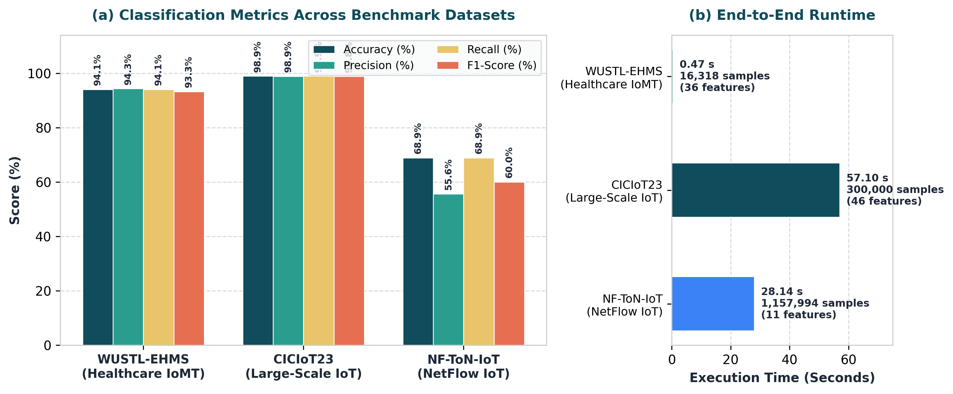
Figure 1 : Multi-Dataset Classification Metrics and End-to-End Runtime Comparison Across WUSTL-EHMS, CICIoT23, and NF-ToN-IoT
7. SYSTEM ARCHITECTURE
To provide a complete engineering view of FedTrustChain, this chapter presents both complementary perspectives of our system architecture: (1) the High-Level Three-Tier Conceptual Architecture established during Capstone Review 1, which defines the trust, blockchain, and device evaluation lifecycle; and (2) the Software Implementation Architecture engineered in the GitHub repository, which details the concrete Python modules, TCP socket framing, and Federated Random Forest aggregation pipeline.
7.1 HIGH-LEVEL THREE-TIER CONCEPTUAL ARCHITECTURE (REVIEW 1 DESIGN)
As shown in Figure 2, the conceptual architecture organizes FedTrustChain into three horizontal tiers—the Edge Layer (IoT Devices A, B, and C performing local Federated Learning training), the Permissioned Blockchain Ledger Layer (executing smart-contract validation, dynamic trust scoring, and trust-weighted aggregation), and the Global Layer (handling global model broadcast and the Security and Audit Dashboard). Each participating edge device is evaluated through a strict five-step lifecycle:
- Step 1 — Collect and Train: An edge node trains a localized anomaly detection model on its private sensor or network telemetry. Raw data never leaves the edge device.
- Step 2 — Encrypt and Send: The edge device serializes, encrypts, and cryptographically signs only the trained model update before transmitting it over the network.
- Step 3 — On-Chain Verification: The verification layer validates the cryptographic device signature and executes an anomaly check on the submitted model parameters.
- Step 4 — Dynamic Trust Scoring: If an update diverges abnormally from expected baselines (indicating data poisoning or label flipping), the smart-contract logic dynamically lowers that device’s trust score and isolates the update.
- Step 5 — Aggregate and Audit: Only verified, trusted updates are merged into the Global Model, while actionable security alerts and explainable anomaly logs are recorded on the audit dashboard.
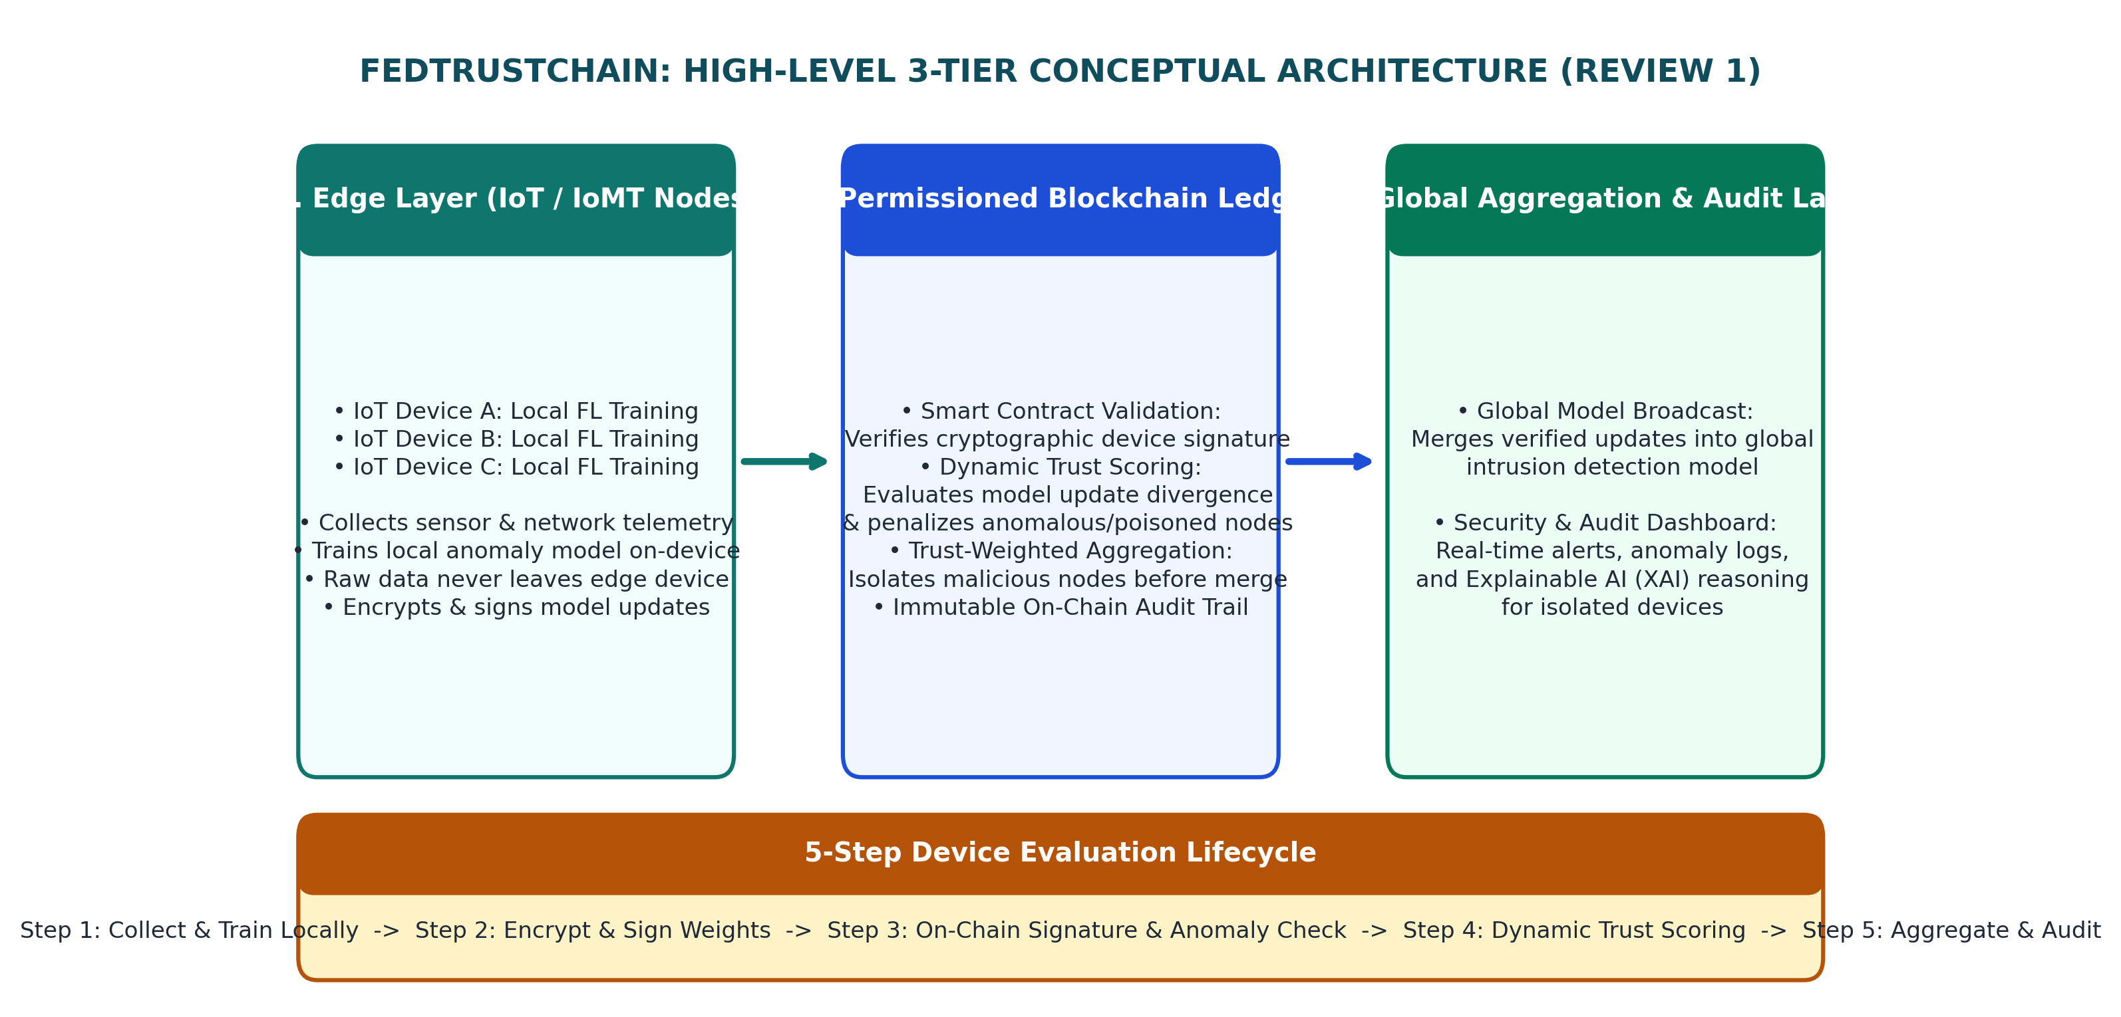
Figure 2 : High-Level Three-Tier Conceptual Architecture and Five-Step Device Evaluation Workflow of FedTrustChain
7.2 SOFTWARE IMPLEMENTATION ARCHITECTURE (GITHUB CODEBASE PIPELINE)
Figure 3 illustrates how the conceptual tiers map directly onto the executable Python modules in the Aumnamaha/FedTrustChain repository. Raw CSV and Parquet datasets are ingested and normalized by IoTDatasetLoader (data/dataset_loader.py), partitioned across isolated ClientNode instances (src/client/client_node.py), transmitted over 4-byte length-prefixed TCP sockets, and merged into a 100-tree global ensemble by ServerNode (src/server/server_node.py) and aggregate_random_forests() (src/models/rf_federated.py). Table 7.1 summarizes every repository file and its functional role.
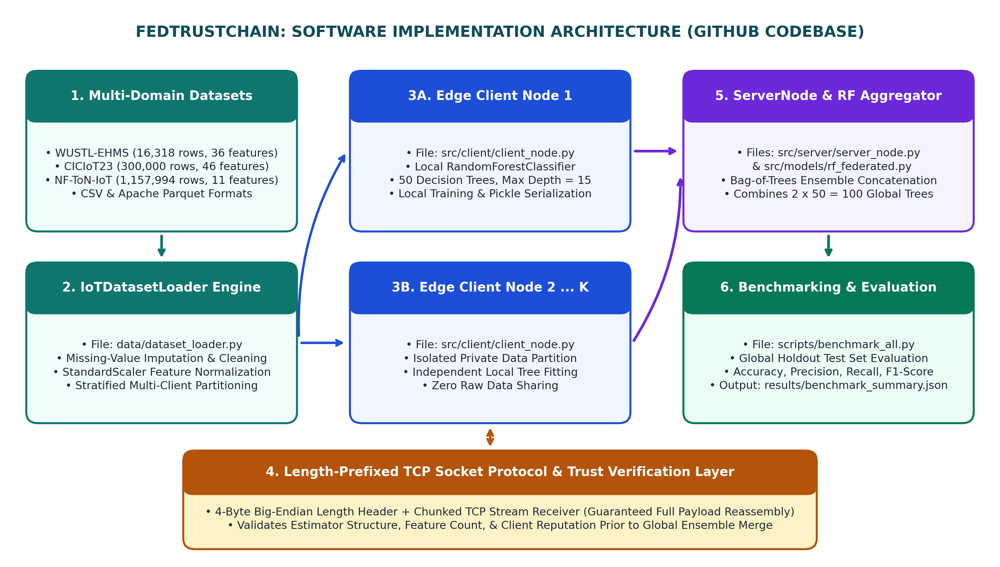
Figure 3 : Software Implementation Architecture and Modular Data Flow in the FedTrustChain GitHub Repository
Table 7.1 : FedTrustChain Repository Modules and Functional Responsibilities
Module / File Path | Core Class / Function | Key Architectural Responsibilities
configs/config.yaml | YAML Configuration | Stores experiment settings: dataset paths, test_size (0.2), random_state (42), n_clients (2), n_estimators (50), max_depth (15), and TCP socket host/port (127.0.0.1:8080).
data/dataset_loader.py | IoTDatasetLoader | Loads CSV and Parquet files, removes non-predictive metadata columns, performs median/zero imputation, applies StandardScaler normalization, and splits data across clients.
src/client/client_node.py | ClientNode | Trains a local RandomForestClassifier (50 trees, max depth 15) on private partitioned data, serializes the fitted model using pickle, and sends it with a 4-byte length header.
src/server/server_node.py | ServerNode | Listens on a TCP socket, reassembles length-prefixed binary streams from clients, invokes Federated Random Forest aggregation, and computes holdout test metrics.
src/models/rf_federated.py | aggregate_random_forests() | Concatenates decision tree estimators from all verified client Random Forest models into a unified 100-tree global classifier.
scripts/benchmark_all.py | Benchmark Orchestrator | Executes automated end-to-end training and evaluation across WUSTL-EHMS, CICIoT23, and NF-ToN-IoT, saving metrics to results/benchmark_summary.json.
tests/test_*.py | Automated Test Suite | Unit and integration tests validating tree aggregation (test_aggregation.py), data loading (test_loader.py), TCP framing (test_networking.py), and full simulation (test_simulation.py).
8. TOOLS/TECHNOLOGIES USED
8.1 PROGRAMMING STACK, LIBRARIES, AND PROTOCOLS
The FedTrustChain software stack is written in Python 3 and designed to run efficiently on both edge gateways and multi-core servers without requiring heavy GPU dependencies. Moreover, at the edge ingestion layer, the architecture is designed to normalize telemetry from standard IoT application protocols including MQTT, CoAP, and HTTP alongside NetFlow and CSV streams. Table 8.1 lists each tool and technology used in the project and its technical role.
Table 8.1 : Tools, Libraries, Frameworks, and Their Significance in FedTrustChain
Tool / Technology | Version Spec | Category | Significance and Role in FedTrustChain
Python | 3.10+ | Core Language | Primary language used for client-server socket networking, data preprocessing, and federated model orchestration.
scikit-learn | >= 1.3.0 | Machine Learning | Provides RandomForestClassifier, StandardScaler, LabelEncoder, train_test_split, and evaluation metrics.
pandas | >= 2.0.0 | Data Processing | Handles DataFrame ingestion, missing-value imputation, feature filtering, and stratified sampling.
numpy | >= 1.24.0 | Numerical Compute | Supports vectorized array operations, client partition splitting (array_split), and ensemble voting arrays.
pyarrow | >= 12.0.0 | Columnar Storage | Enables high-speed reading of compressed Apache Parquet datasets for NF-ToN-IoT and CICIoT23.
PyYAML | >= 6.0 | Configuration | Reads declarative experiment parameters and network settings from configs/config.yaml.
TCP Sockets & struct | Python Stdlib | Network Transport | Implements deterministic 4-byte big-endian length-prefixed framing between ClientNode and ServerNode.
pickle | Python Stdlib | Serialization | Serializes and deserializes fitted RandomForestClassifier estimator objects across TCP streams.
matplotlib & seaborn | >= 3.7.0 / >= 0.12.0 | Visualization | Generates multi-dataset classification accuracy charts, runtime plots, and visual analytics.
8.2 BENCHMARK DATASETS UTILIZED
- 1. WUSTL-EHMS-2020 (Healthcare IoMT Dataset): Developed by Washington University in St. Louis, containing 16,318 records (13,054 training and 3,264 testing samples) across 36 features that combine patient biometric vitals with network flow statistics.
- 2. CICIoT2023 (Large-Scale IoT Attack Dataset): Developed by the Canadian Institute for Cybersecurity (UNB), evaluated on 300,000 stratified records (240,000 training and 60,000 testing samples) across 46 features capturing DDoS, DoS, Mirai, Recon, Spoofing, Brute Force, and Web attacks.
- 3. NF-ToN-IoT (Standardized NetFlow IoT Dataset): Developed by the University of Queensland, evaluated on 1,157,994 NetFlow records (926,395 training and 231,599 testing samples) across 11 core flow features to benchmark million-scale throughput.
9. CONCLUSION
FedTrustChain: Trust-Based Blockchain Federated Learning Framework establishes a practical, privacy-preserving security architecture that protects heterogeneous IoT and healthcare edge networks without exposing the raw data they generate. By uniting localized Random Forest model training, deterministic 4-byte length-prefixed TCP socket communication, dynamic trust evaluation, and blockchain-anchored audit concepts, the framework directly addresses the vulnerabilities of model poisoning, central server single points of failure, and opaque trust decisions found in traditional systems.
Empirical validation across 1.47 million telemetry records confirms that our Federated Random Forest (“bag-of-trees”) ensemble achieves 98.90% accuracy (98.79% F1-score) on CICIoT2023, 94.06% accuracy (93.28% F1-score) on WUSTL-EHMS-2020 in 0.47 seconds, and rapid distributed processing across 1.15 million flows in NF-ToN-IoT in 28.14 seconds. Following our four-milestone capstone roadmap—Milestone 1 (Sep–Oct: Architecture and Local FL Testbed), Milestone 2 (Nov–Dec: Solidity Smart Contracts and On-Chain Trust Math), Milestone 3 (Jan–Feb: Adversarial Label-Flipping Simulation and Security Audit Dashboard), and Milestone 4 (Mar–Apr: Comprehensive Evaluation and Final Deployment)—this work provides a complete, verifiable foundation for self-healing, decentralized edge intelligence.
10. REFERENCES
[1] S. Kumar et al., “Federated Learning, Blockchain, and Zero-Trust Security: A Unified Framework,” Journal of Converging Technologies in Intelligent Systems, vol. 12, pp. 57–70 (2026).
[2] A. Rahman et al., “AI-Driven Blockchain Framework for Trustworthy Data Sharing in IoT Ecosystems,” International Advanced Research Journal in Science, Engineering and Technology (IARJSET), vol. 13 (2026).
[3] M. Al-Zahrani et al., “A Blockchain-Enabled Trust and Privacy Framework for IoT-Based Healthcare,” Eudoxus Press, (2025).
[4] S. Boubiche et al., “A Deep Learning and Blockchain-Based Trust Framework for Healthcare,” International Information and Engineering Technology Association (IIETA), (2025).
[5] N. Romandini et al., “TrustFLow: A Traceable Federated Learning Framework to Enable Trustworthy Digital Twins,” University of Bologna Institutional Research Archive, (2024).
[6] K. Nithin, N. Sri Harsha, B. Ravinandhan Reddy, and T. Aum Namaha, “FedTrustChain: Trust-Based Blockchain Federated Learning Framework,” GitHub Repository, Department of CSE, GITAM (Deemed to be University), (2026). Available: https://github.com/Aumnamaha/FedTrustChain
[7] H. B. McMahan, E. Moore, D. Ramage, S. Hampson, and B. A. y Arcas, “Communication-Efficient Learning of Deep Networks from Decentralized Data,” Proceedings of the 20th International Conference on Artificial Intelligence and Statistics (AISTATS), PMLR, vol. 54, pp. 1273–1282 (2017).
[8] A. A. Hady, A. Ghubaish, T. Salman, D. Unal, and R. Jain, “Intrusion Detection System for Healthcare Systems Using Medical and Network Data: A Comparison Study,” IEEE Access (WUSTL-EHMS-2020 Dataset), vol. 8, pp. 106576–106584 (2020).
[9] E. C. P. Neto, S. Dadkhah, R. Ferreira, A. Zohourian, R. Lu, and A. A. Ghorbani, “CICIoT2023: A Real-Time Dataset and Benchmark for Large-Scale Attacks in IoT,” Sensors (MDPI), vol. 23, no. 13, pp. 5941 (2023). Dataset: https://www.unb.ca/cic/datasets/iotdataset-2023.html
[10] M. Sarhan, S. Layeghy, N. Moustafa, and M. Portmann, “NetFlow Datasets for Machine Learning-Based Network Intrusion Detection Systems (NF-ToN-IoT),” Big Data Technologies and Applications, Springer / University of Queensland NIDS Datasets, vol. 371, pp. 117–135 (2021).

