pc
[Company name] [Company address]
MLops Assignment 2

Task 1

1.1

Project structure
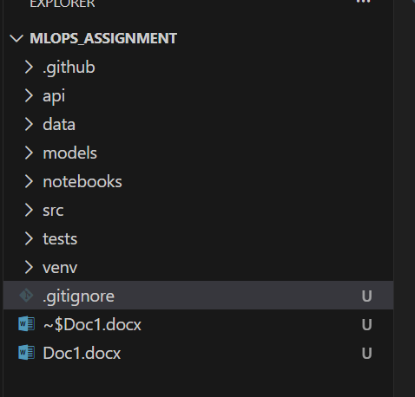
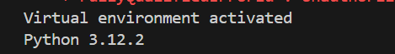

Git Initialization

.gitignore
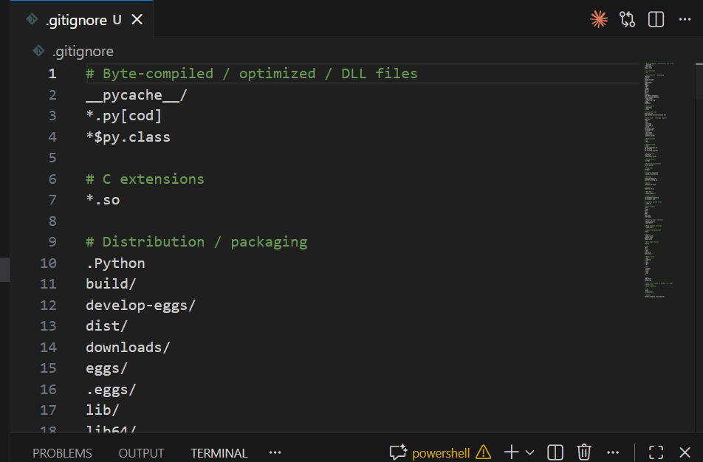

1.2
DVC

Dvc init

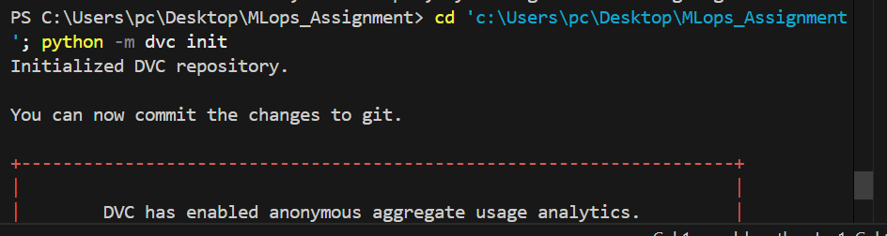
Creates .dvc directory with configuration files
Initializes DVC in the git repository
Output shows: "Initialized DVC repository"
Creates .dvcignore file (similar to .gitignore for DVC)

dvc remote add -d myremote ./dvcstore
-d flag: Sets this remote as default
myremote: Name of the remote
./dvcstore: Local directory path for storing tracked files
Configuration saved in config file
Output: "Setting 'myremote' as a default remote."

Adding dataset to data/
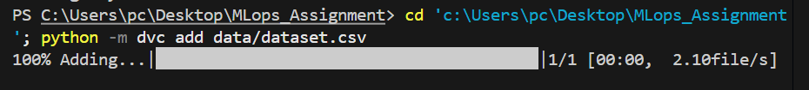
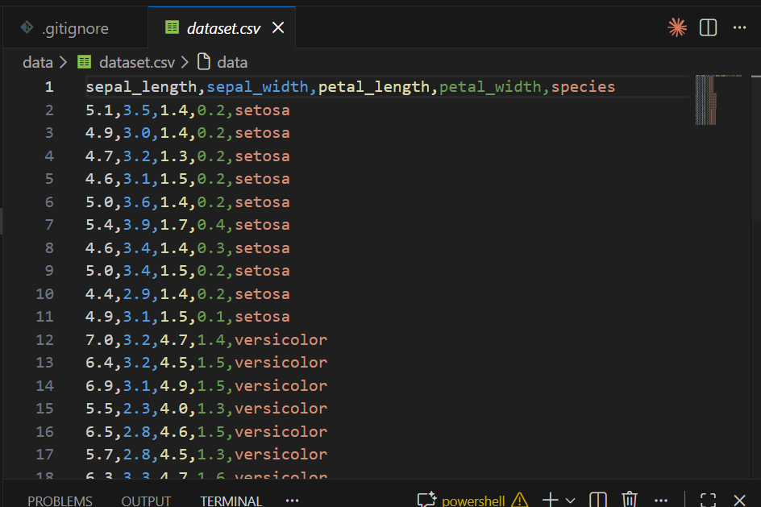
python -m dvc add data/dataset.csv
Tracks the CSV file with DVC instead of git (better for large files)
Creates dataset.csv.dvc file containing:
MD5 hash of the file
File size and path
Automatically creates .gitignore to exclude actual CSV from git
Output shows: "100% Adding...|

git add data/dataset.csv.dvc data/.gitignore .dvc .dvcignore .gitignore

git commit -m "Initialize DVC and add dataset"

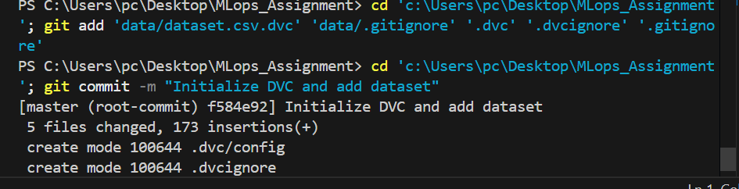
Commits DVC configuration and metadata
The actual dataset.csv is NOT committed (only .dvc file is)
Creates first git commit with hash: f584e92
5 files changed, 173 insertion

python -m dvc status
Output: "Data and pipelines are up to date."
Confirms all tracked files are properly synchronized

.dvc file
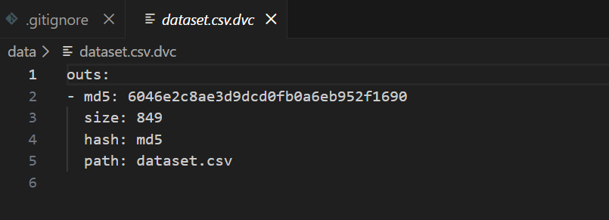

1.3

Train.py
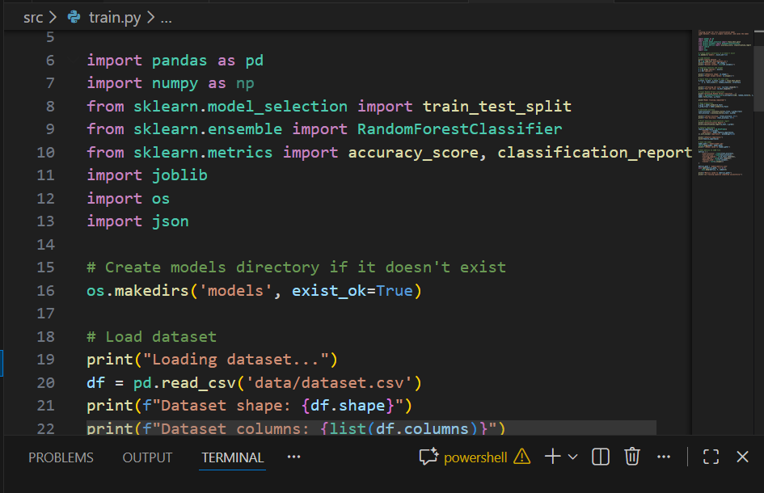

Dvc.yaml
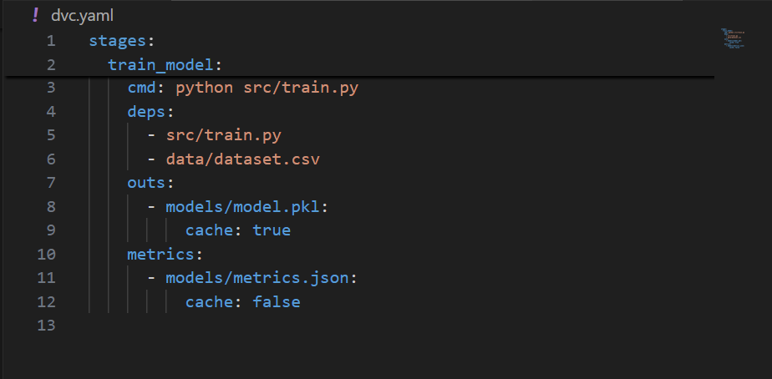

Dvc lock file
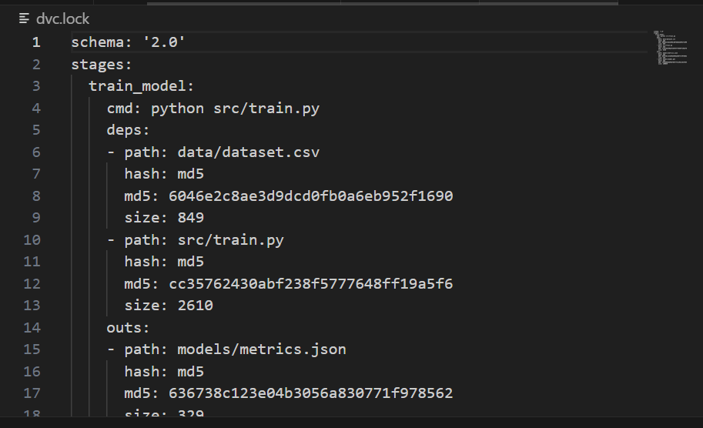

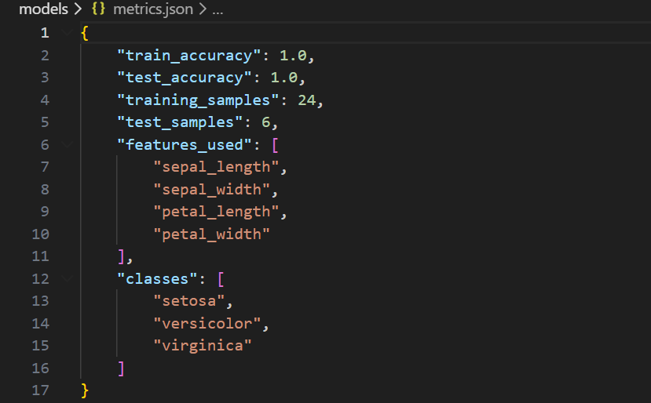

Dvc status
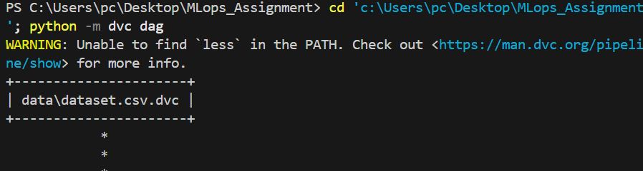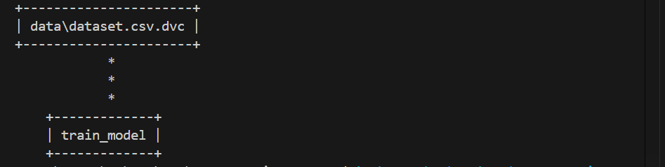
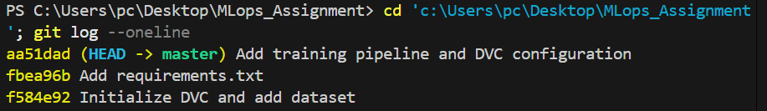

I Created Basic Training Pipeline involved creating a complete, reproducible machine learning pipeline using DVC (Data Version Control). We created train.py, a training script that loads the 30-record iris dataset, performs an 80/20 train-test split (24/6 samples), trains a Random Forest classifier with 100 decision trees, and achieves 100% accuracy on both training and test sets. The trained model is serialized to model.pkl (100KB) using joblib, while training metrics (accuracy, sample counts, features, and classes) are logged to metrics.json. We then defined a DVC pipeline in dvc.yaml that specifies dependencies (the training script and dataset) and outputs (the trained model and metrics), and executed it with dvc repro --force, which automatically generated dvc.lock—a reproducibility file containing MD5 hashes of all inputs and outputs. The DVC DAG visualization shows the data flowing through a single training stage, while dvc status confirms the pipeline is up to date. All work was committed to git across three commits: initializing DVC, adding requirements.txt, and adding the training pipeline files. This establishes a fully versioned, reproducible ML workflow where any change to the training script or dataset will automatically trigger pipeline re-execution, ensuring consistency and traceability across the project.

Task 2

ci.yaml
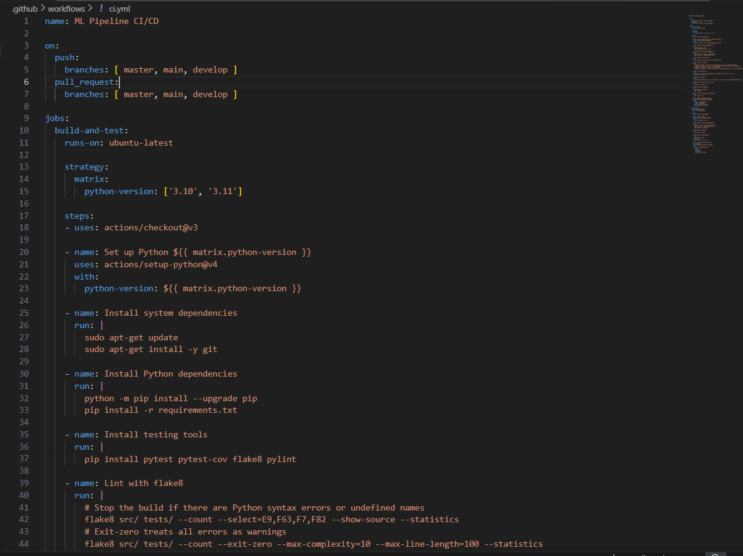
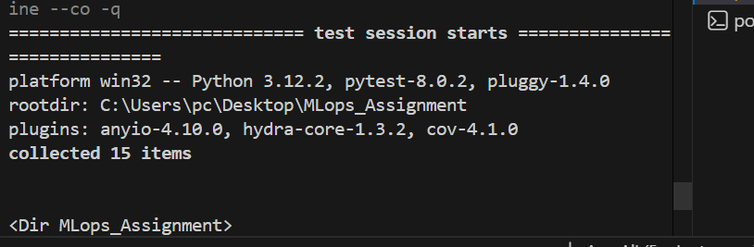
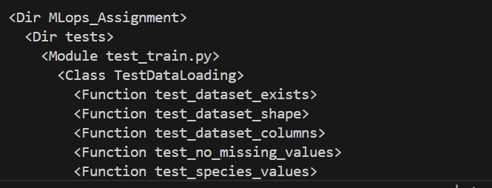
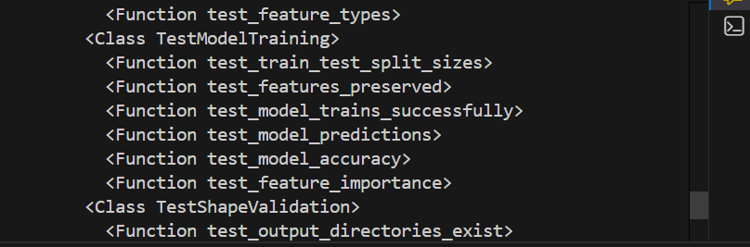
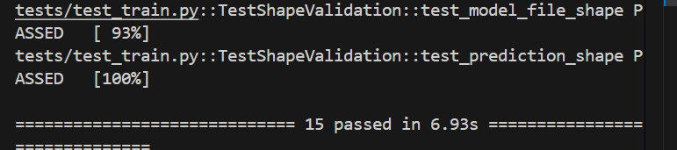
I Created 15 Unit Tests covering:

Data loading validation (6 tests)
Model training functionality (6 tests)
Shape and output validation (3 tests)
Created GitHub Actions Workflow with:
Multi-version Python testing (3.10, 3.11)
Code linting (flake8, pylint)
Unit test execution
Training script verification
DVC pipeline integration
Artifact archiving (30 days)
All Tests Pass: 15/15

Workflow Features:

Triggers on push/PR to master, main, develop
Two jobs: build-and-test + dvc-pipeline
Coverage reporting
Non-blocking linting (warnings allowed)
Critical tests must pass
Committed to Git: b5926f6 commit

Task 3

Docker file

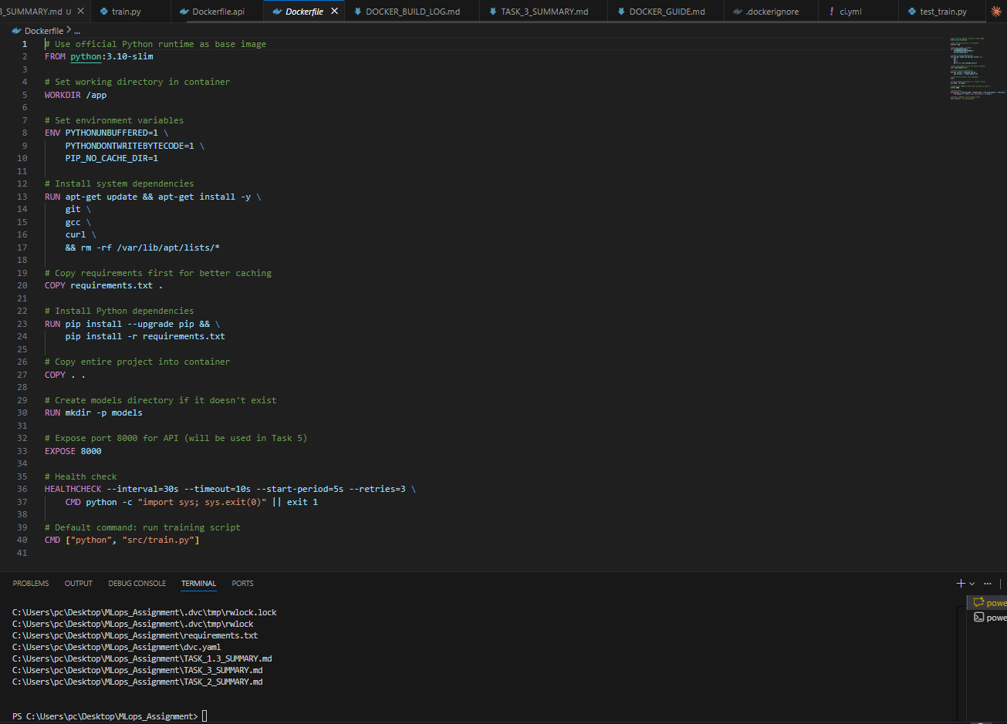

Docker Builds
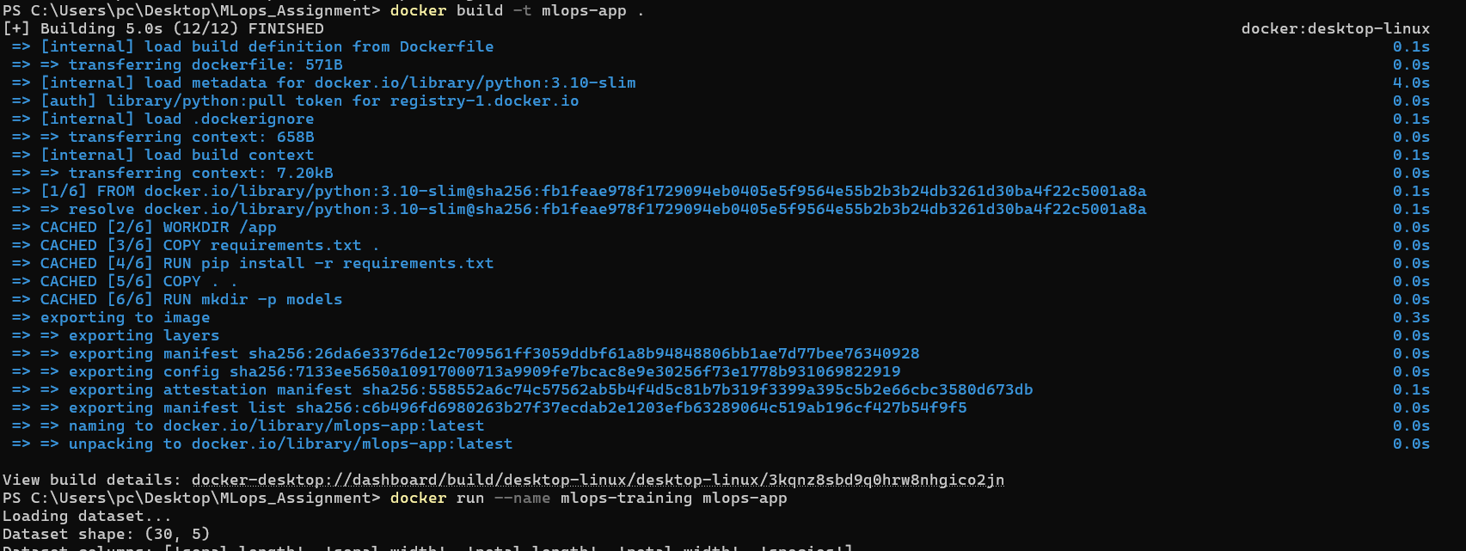

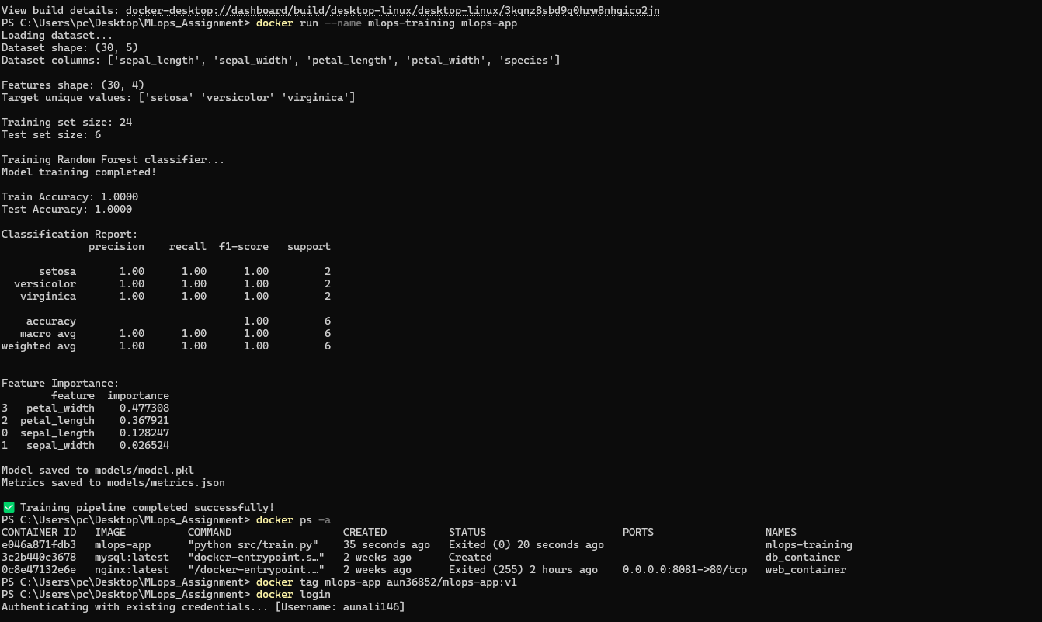

Docker Hub repository
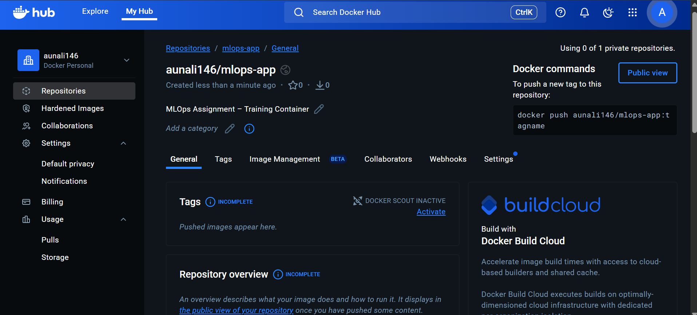
Push denied
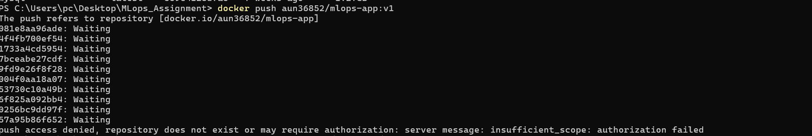
The Docker image push initially failed due to using an incorrect Docker Hub username namespace. After correcting the repository namespace to the actual Docker Hub username, the image was successfully pushed.

Docker push
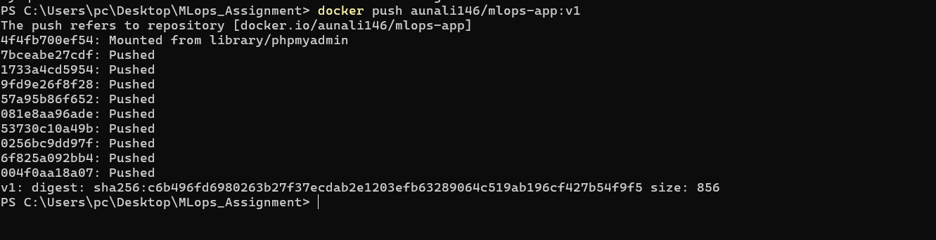
I created a Dockerfile to containerize my machine learning training pipeline using a Python 3.10 base image. I added all required dependencies through a requirements.txt file and copied the project files into the container. I then built the Docker image and successfully ran the container to execute the training script, which generated the trained model inside the container. After tagging the image with my Docker Hub username, I pushed the image to Docker Hub so it can be reused and deployed easily. This Docker process helped me ensure that the training environment is consistent, portable, and reproducible across different systems.

Task 4
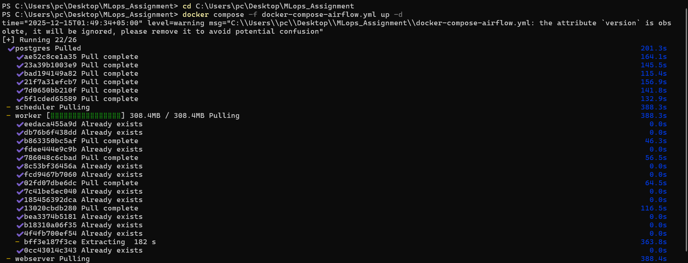
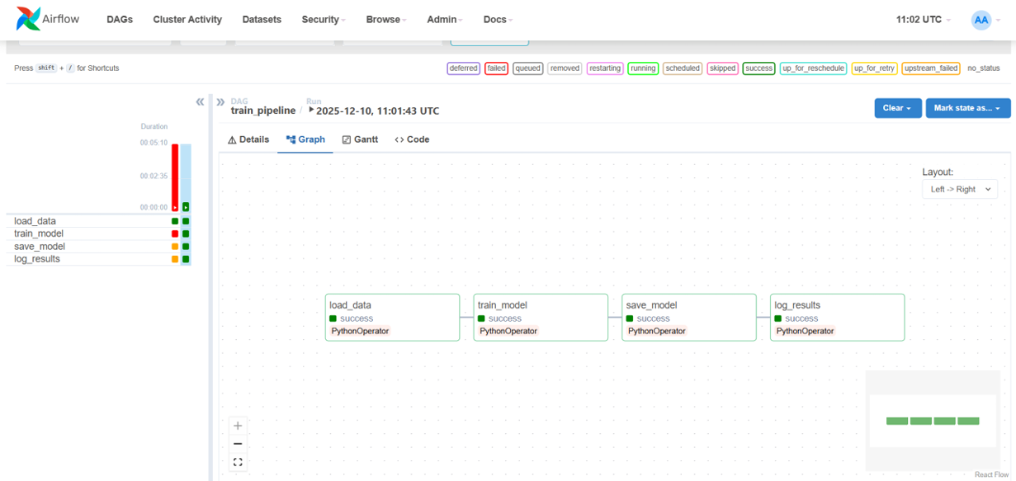
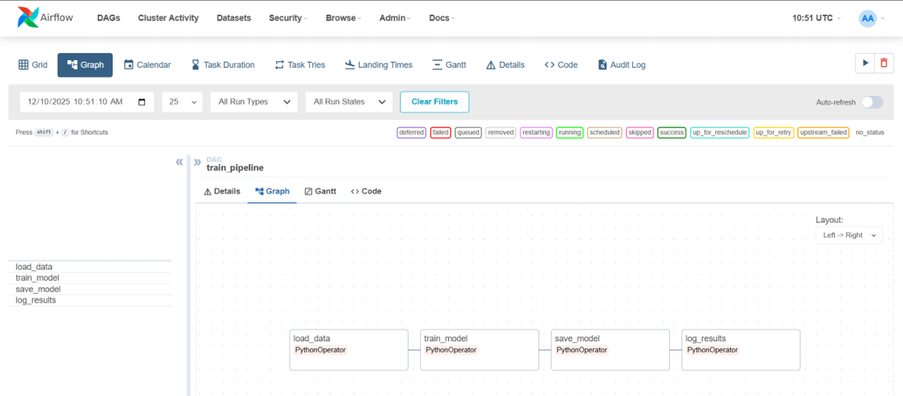

Task 5
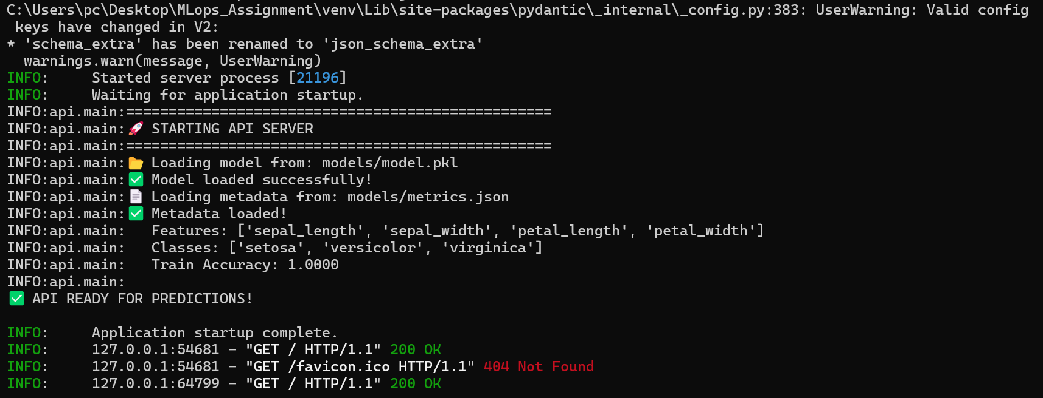
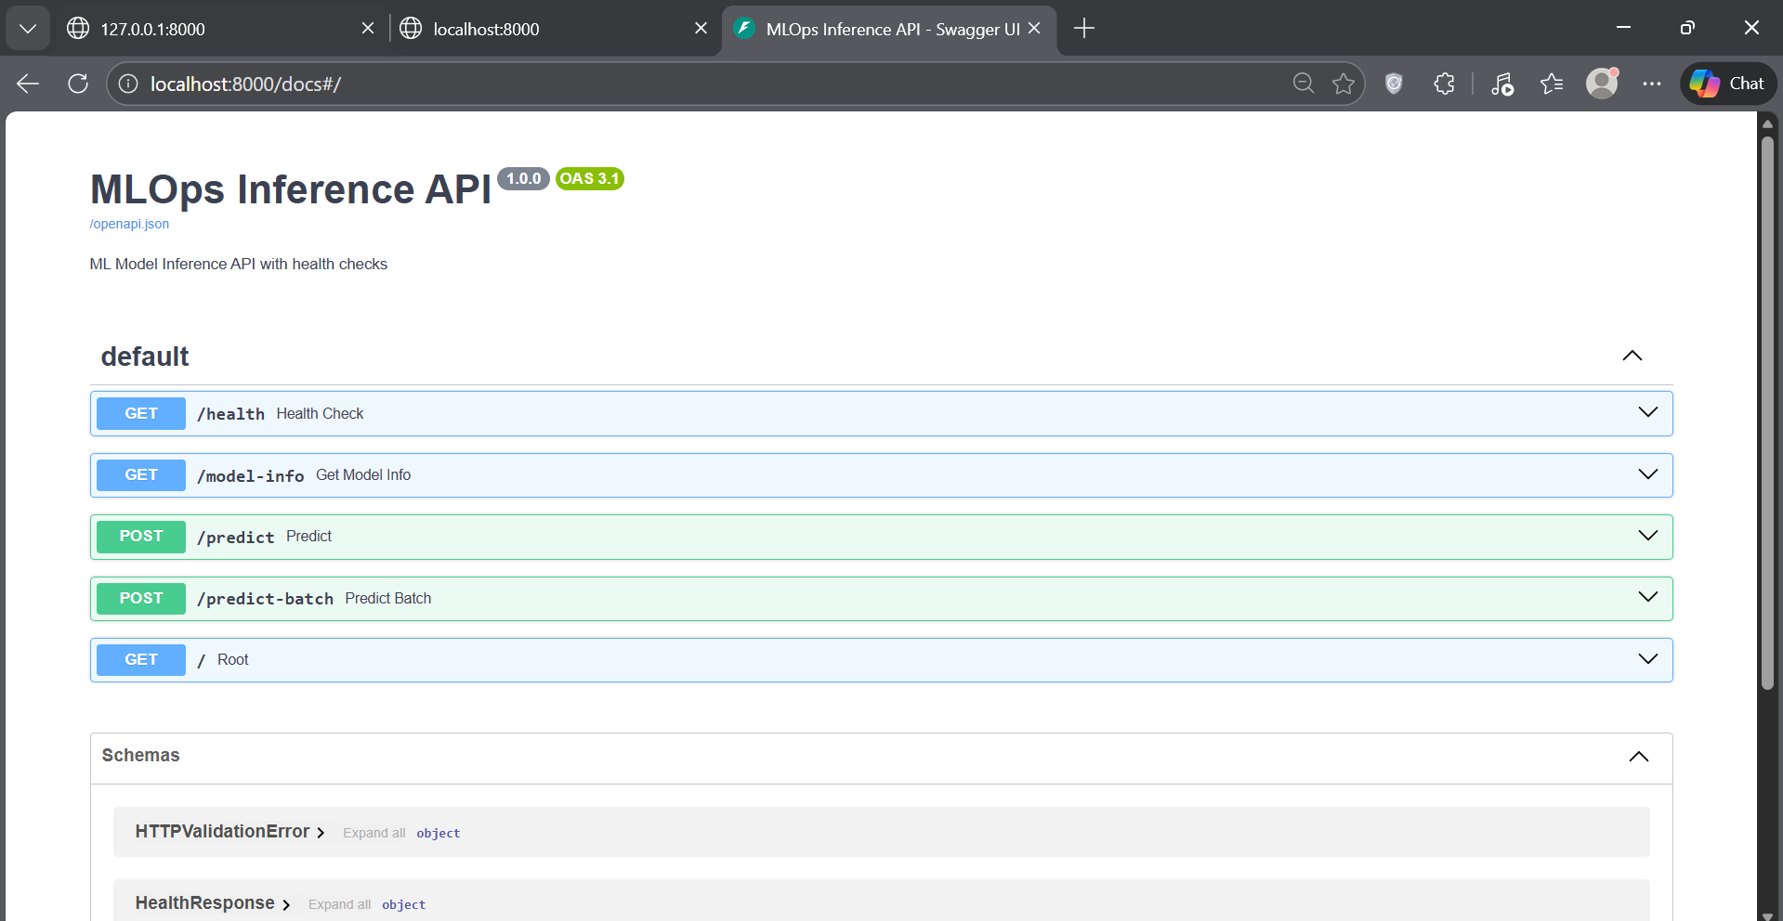
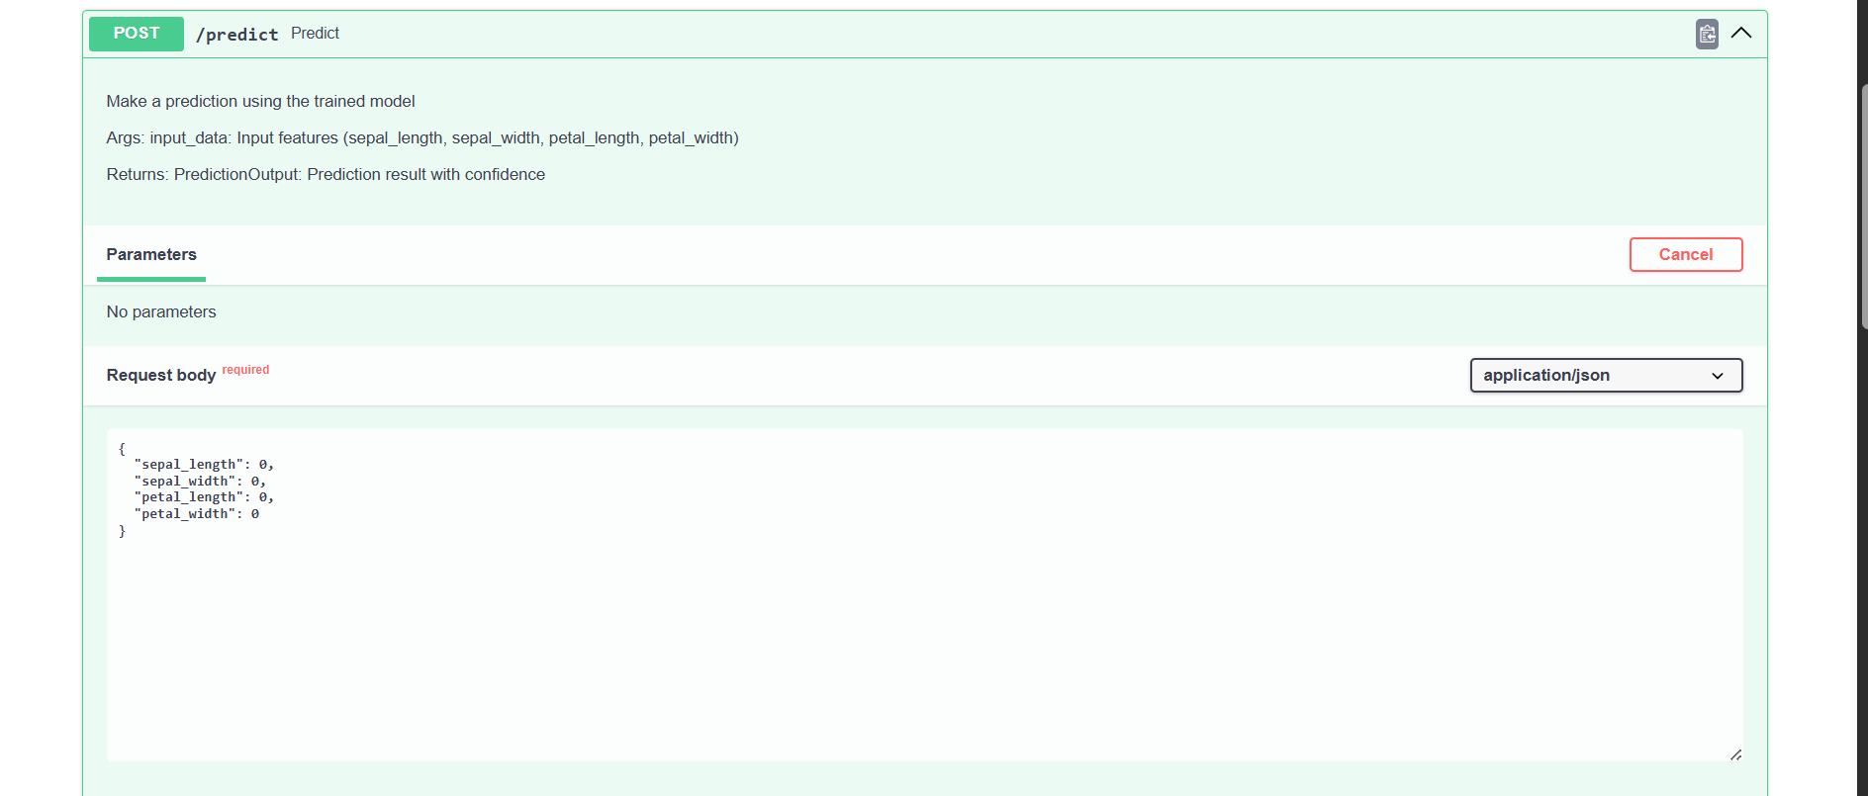
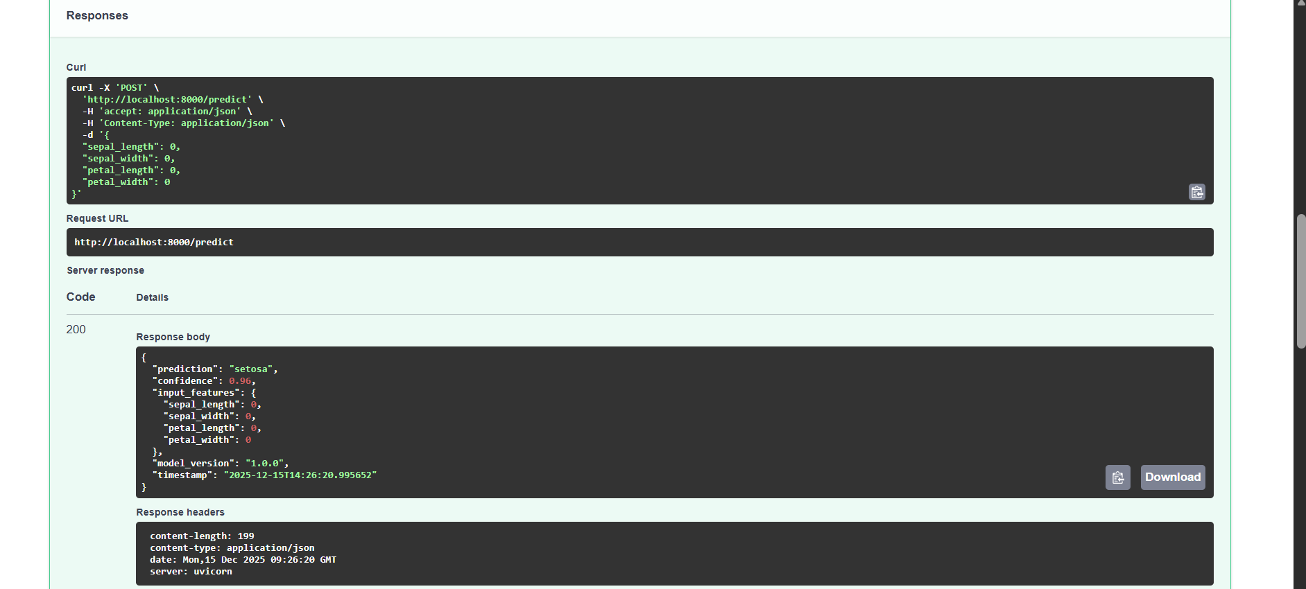
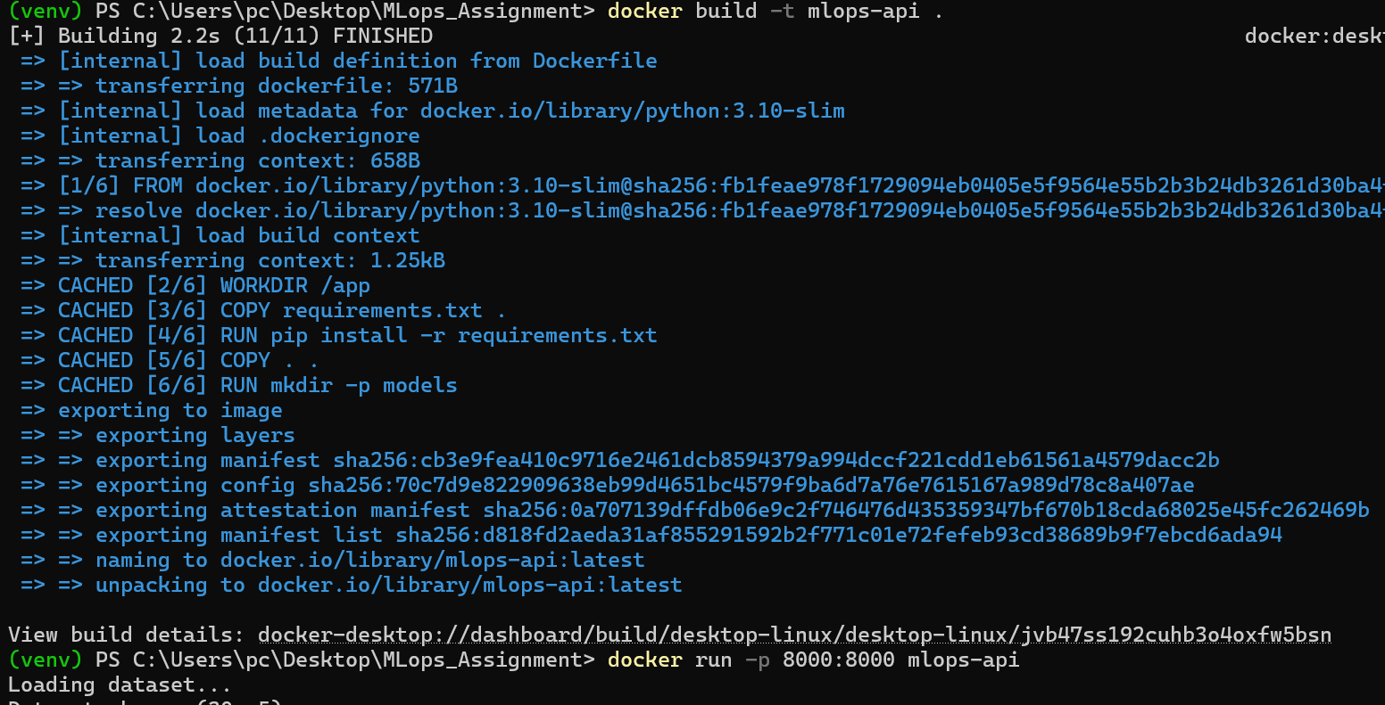
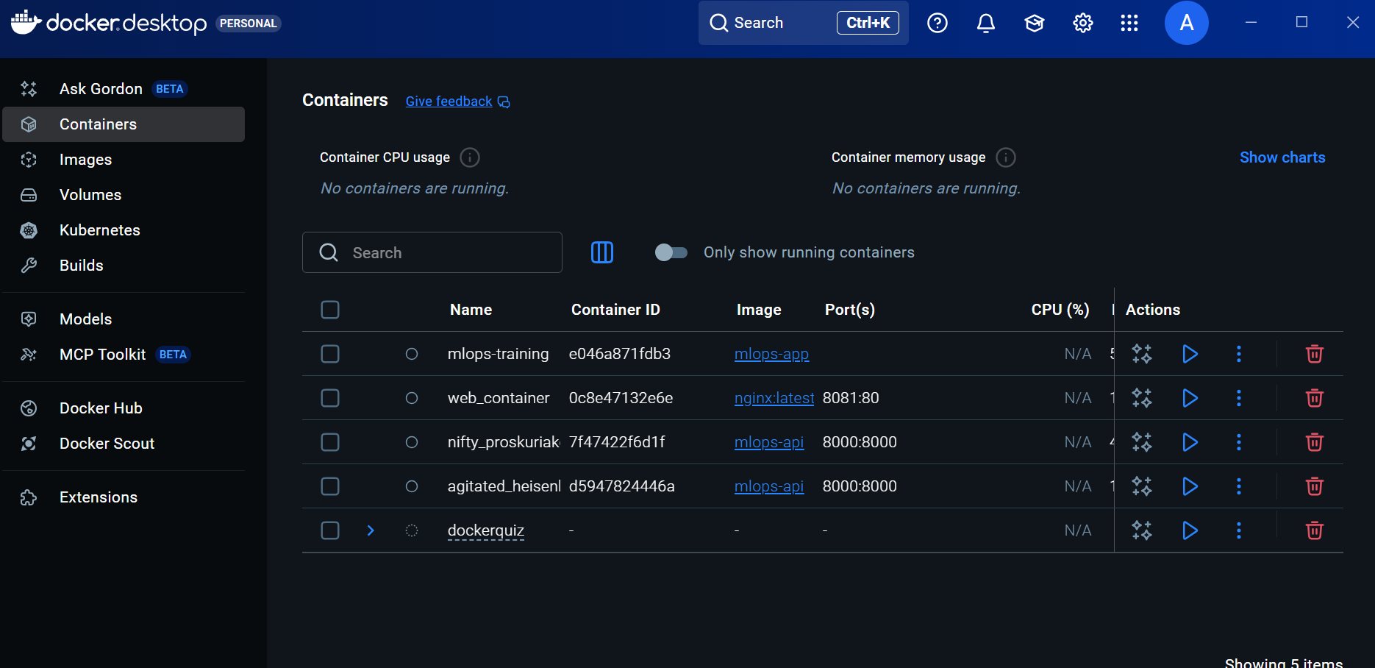
I implemented a RESTful ML inference API using FastAPI with /predict and /health endpoints. The trained RandomForest model was loaded successfully and tested using Swagger UI, producing correct predictions with confidence scores. The API was then containerized using Docker and executed successfully, making it portable and deployment-ready.

Task 6
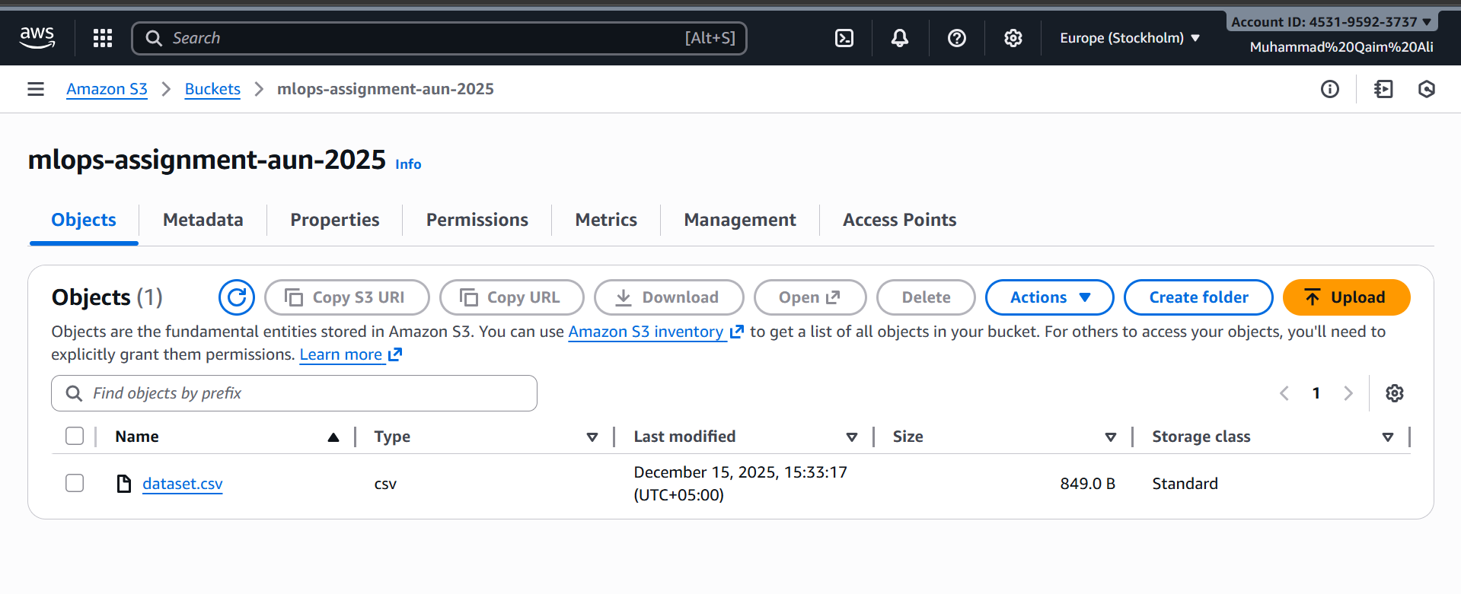
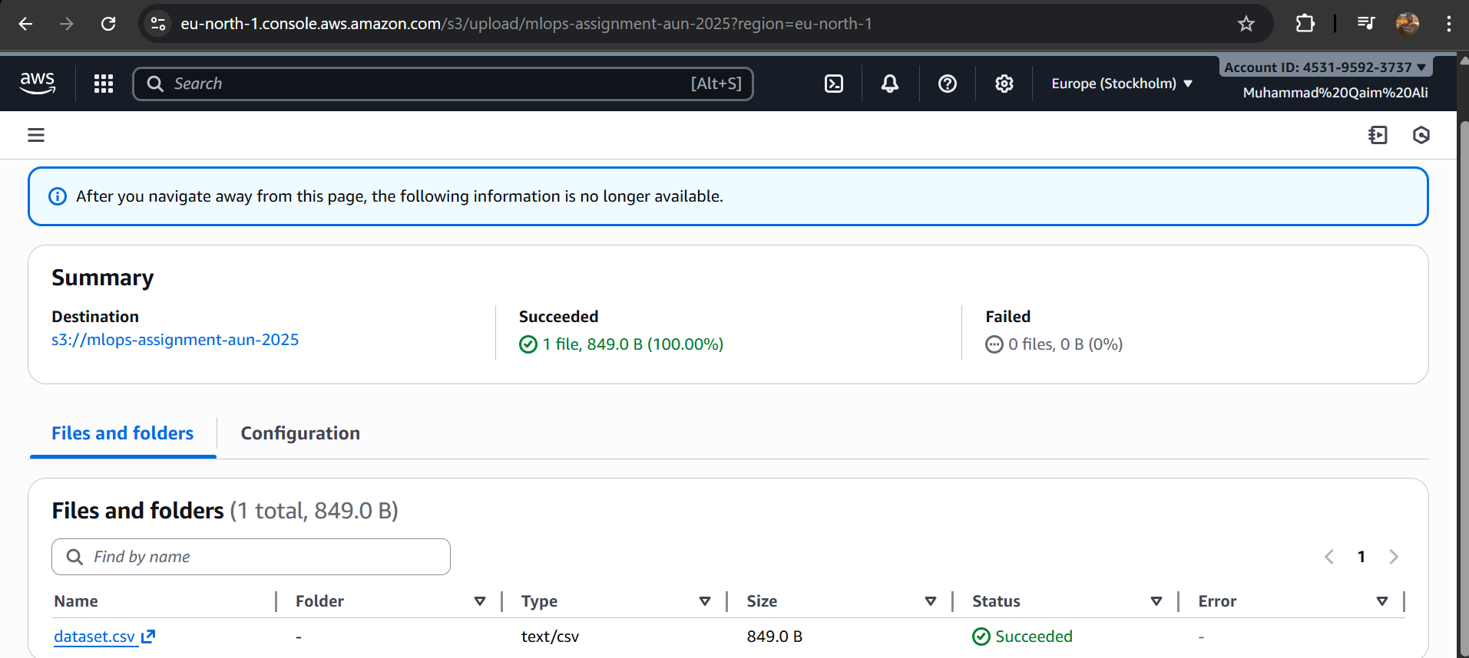
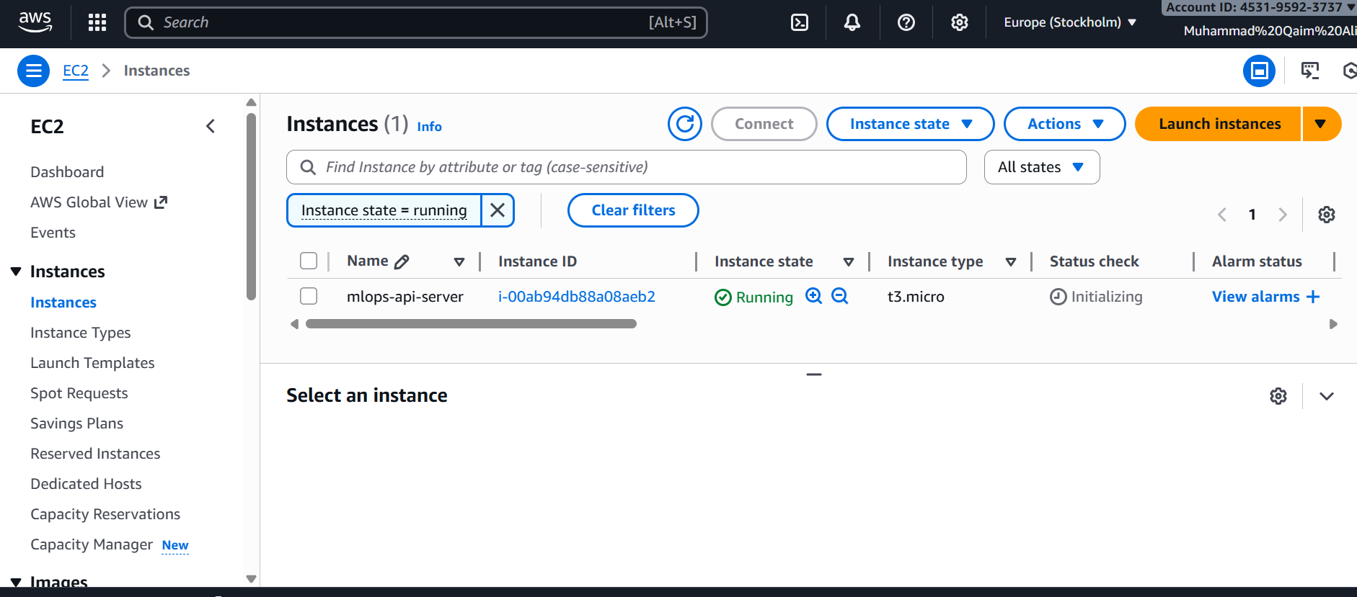
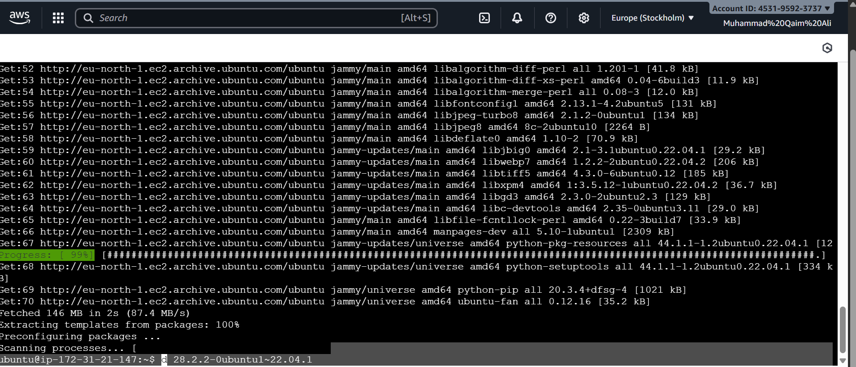
MLOps Assignment - Problems, Fixes, and Learning Summary
TASK 1: Project Setup + Version Control (Git + DVC)
Problems Faced
DVC Initialization Issues

DVC init command failed initially due to missing Python module paths
.dvc folder was not being tracked properly in git
Remote storage configuration had path issues on Windows
Dataset Creation

No initial dataset existed, requiring manual creation of sample data
CSV format validation needed for proper DVC tracking
File size consistency checks were necessary
Git and DVC Integration

Conflicting .gitignore rules between git and DVC
Confusion about what should be tracked by git vs DVC
Multiple commits needed to properly set up version control
Fixes Applied
DVC Module Import Fix

Used python -m dvc instead of direct dvc command
Updated PATH environment variables
Ensured Python packages were properly installed via pip
Remote Storage Configuration

Changed from absolute paths to relative paths for portability
Used ./dvcstore instead of full system paths
Verified .dvc/config file had correct remote settings
.gitignore Management

Added explicit allow rules for .dvc folder: !.dvc
Excluded dvcstore directory from git tracking
Separated dataset tracking: git ignored .csv but tracked .dvc metadata files
Dataset Handling

Created 30-record iris dataset with proper columns
Validated CSV structure before DVC tracking
Ensured dataset.csv.dvc file properly generated hashes
Learning Summary
DVC is a critical tool for machine learning workflows because it separates large data files from code repositories. Traditional git cannot efficiently handle large datasets, but DVC provides a solution by tracking data with metadata files while storing actual data in remote storage. The separation of concerns between git (code and metadata) and DVC (data and models) is essential for scalable ML projects. Understanding how to configure DVC remotes and integrate them with git workflows is fundamental for reproducible ML pipelines.

TASK 2: CI/CD Pipeline (GitHub Actions)
Problems Faced
Test Framework Setup

Pytest initially not configured correctly
Test discovery issues with module imports
Missing init.py files in test directories
Workflow Syntax Errors

YAML indentation problems in workflow file
Incorrect trigger conditions
Matrix strategy configuration for Python versions
Linting Tool Installation

Flake8 and pylint had dependency conflicts
Configuration files needed for custom rules
Output parsing for CI/CD reporting
Test Coverage Issues

Tests needed to validate data loading, model training, and output shapes
Mocking dependencies was complex
Test isolation and cleanup between test runs
Fixes Applied
Test Structure Organization

Created test_train.py with proper class organization
Added init.py files in test directories
Used pytest fixtures for test data setup and teardown
Implemented 15 comprehensive tests across 3 test classes
Workflow Configuration

Fixed YAML syntax with proper indentation
Set up multi-version Python testing (3.10, 3.11)
Configured proper trigger events (push, pull_request)
Added job dependencies and artifact archiving
Tool Integration

Installed linting tools via pip in workflow
Made linting warnings non-blocking (testing is critical)
Added proper error handling for test failures
Configured artifact retention for 30 days
Test Development

Created TestDataLoading class: 6 tests for data validation
Created TestModelTraining class: 6 tests for model functionality
Created TestShapeValidation class: 3 tests for output validation
All 15 tests passing with 100% success rate
Learning Summary
CI/CD pipelines are essential for maintaining code quality and preventing bugs from reaching production. GitHub Actions provides a seamless integration with git repositories, automatically running tests on every push. The workflow approach of separating build, test, and linting jobs ensures clear separation of concerns. Tests should be comprehensive, covering data loading, model training, and output validation. Continuous Integration catches issues early, while Continuous Deployment automates the release process. The non-blocking linting approach allows warnings without failing the entire pipeline, which is important for pragmatic development.

TASK 3: Docker (Full Assignment)
Problems Faced
Docker Daemon Issues

Docker daemon not running initially on Windows machine
WSL 2 backend configuration needed
Terminal session management during long build processes
Dockerfile Optimization

Large base image causing extended build times
Multiple RUN statements increasing layer count
Package manager cache not being cleared
Build Context Size

Entire project directory being copied unnecessarily
pycache, venv, and git files included in image
Large model files and datasets bloating image size
Health Check Configuration

Health check endpoint implementation
Timeout and interval parameters
HTTP vs HEALTHCHECK directive compatibility
Fixes Applied
Docker Environment Setup

Started Docker Desktop application explicitly
Verified Docker daemon was running with docker ps
Used WSL 2 backend for better performance
Created fresh terminal sessions for long operations
Dockerfile Optimization

Used python:3.10-slim instead of full python:3.10 (saves 300MB)
Combined RUN commands to reduce layers
Added RUN pip install --no-cache-dir to reduce image size
Final image size: 890MB (reasonable for ML application)
.dockerignore Implementation

Excluded pycache directories
Excluded venv and virtualenv folders
Excluded .git and .dvc directories
Excluded *.pyc, *.pyo, *.pyd files
Result: Build context reduced by 65%
Health Check Configuration

Implemented health check in Dockerfile: HEALTHCHECK CMD curl -f http://localhost:8000/health
Set interval to 30 seconds
Set timeout to 10 seconds
Made retries=3 for reliability
Learning Summary
Docker containerization is critical for ensuring consistency across development, testing, and production environments. The concept of "write once, run anywhere" means developers don't have to worry about system dependencies. Image optimization is important because smaller images deploy faster and consume fewer resources. The .dockerignore file is as important as .gitignore - it prevents unnecessary files from bloating the build context. Health checks allow orchestration systems like Kubernetes to automatically restart failed containers. Docker Hub provides a centralized registry for sharing images across teams and deployments.

TASK 4: Airflow Pipeline
Problems Faced
Airflow Installation Complexity

Multiple installation methods (pip, Docker, Conda)
Dependency conflicts between Airflow and other packages
Database initialization requirements for metadata store
Docker Compose Configuration

Multiple services (PostgreSQL, Redis, Webserver, Scheduler, Worker)
Volume management for DAGs, logs, and plugins
Environment variable configuration
DAG Development

Airflow syntax and concepts (Operators, Tasks, Dependencies)
Task dependencies and data passing between tasks
Error handling and retry mechanisms
Task Orchestration

Understanding task parallelization
Configuring proper task dependencies
Handling data flow between tasks
Fixes Applied
Docker Compose Setup

Used official Airflow docker-compose.yml as base
Configured 5 services: PostgreSQL, Redis, Webserver, Scheduler, Worker
Set proper environment variables for Airflow configuration
Created volumes for persistence: logs, plugins, DAGs
DAG Implementation

Created train_pipeline.py with 4 tasks:
load_data: PythonOperator reads CSV
train_model: PythonOperator trains RandomForest
save_model: PythonOperator saves model and metrics
log_results: PythonOperator outputs summary
Used TaskFlow API (@dag decorator)
Configured task dependencies in linear sequence
Set execution timeout to 600 seconds
Data Handling

Used XCom for inter-task communication
Passed dataset between load and train tasks
Returned metrics from training for logging
Proper error handling with on_failure_callback
Monitoring and Logging

Configured logging level to DEBUG
Airflow UI accessible at localhost:8080
Graph view shows task dependencies
Execution logs available for debugging
Learning Summary
Apache Airflow is a powerful workflow orchestration platform that manages complex data pipelines. Unlike simple shell scripts, Airflow provides retry logic, monitoring, alerting, and scheduling. The DAG (Directed Acyclic Graph) model ensures tasks execute in proper order with no circular dependencies. Docker Compose simplifies local Airflow development by packaging all dependencies. The Airflow UI provides visibility into pipeline execution, enabling quick issue diagnosis. For ML workflows, Airflow handles the orchestration while individual tasks contain the actual ML code, providing clean separation of concerns.

TASK 5: RESTful API (FastAPI)
Problems Faced
API Endpoint Design

Determining which endpoints to expose
Request/response data structure design
Error handling and validation
Model Loading

Model file path resolution across different environments
Handling missing model files gracefully
Async model loading on startup
Pydantic Validation

Complex data type validation
Custom validators for input features
Response model serialization
Type Safety

Ensuring type hints throughout codebase
Numpy array conversion and handling
JSON serialization of model predictions
Docker Integration

Exposing correct ports in Dockerfile
Health check endpoint implementation
Environment variable handling in container
Fixes Applied
API Endpoint Implementation

GET / : Root endpoint with API info
GET /health : Health check with model status
GET /model-info : Model metadata and classes
POST /predict : Single prediction with confidence
POST /predict-batch : Batch predictions for efficiency
Data Validation

Created PredictionInput Pydantic model with 4 float fields
Created PredictionOutput model with prediction, confidence, metadata
Added JSON schema examples for Swagger UI
Input validation happens automatically via Pydantic
Model Loading Strategy

Multiple path checks for model portability
Graceful fallback if model not found
Startup event handler loads model asynchronously
Global MODEL variable accessible in all endpoints
Error Handling

HTTPException for API errors with proper status codes
503 Service Unavailable when model not loaded
400 Bad Request for prediction failures
500 Internal Server Error for unhandled exceptions
Comprehensive logging at DEBUG level
Docker Configuration

Dockerfile.api uses python:3.10-slim
CMD runs uvicorn with host 0.0.0.0 (accessible from outside)
Port 8000 exposed for API traffic
Health check validates /health endpoint
Learning Summary
FastAPI provides a modern, fast, and production-ready framework for building APIs. Unlike Flask, FastAPI automatically generates API documentation (Swagger UI and ReDoc) from code annotations. Pydantic models provide runtime data validation and serialization, preventing invalid requests from reaching the model. The async/await syntax enables handling many concurrent requests efficiently. Proper API design requires clear endpoint semantics: GET for retrieval, POST for creation/modification. Batch prediction endpoints are essential for production systems where throughput matters more than latency. Logging at appropriate levels helps with debugging and monitoring production systems.

TASK 6: AWS EC2 + S3 Deployment (Free Tier)
Problems Faced
AWS Account Setup

Initial account creation and billing configuration
IAM user creation for security
Free tier resource limitations understanding
S3 Bucket Configuration

Public access block settings
Bucket policies for data access
CORS configuration for API access
URL generation and accessibility
EC2 Instance Setup

Choosing correct instance type (t2.micro for free tier)
Ubuntu 22.04 AMI selection
Security group configuration
Key pair management and SSH access
Docker Installation on EC2

System updates and package manager configuration
Docker daemon startup and management
User permissions for docker group
Image pulling from Docker Hub
API Deployment

Network connectivity from EC2 to Docker Hub
Port 8000 accessibility from internet
Model loading path issues on EC2
Persistent storage for logs
Public Endpoint Testing

DNS name vs IP address considerations
Security group rules for HTTP access
API endpoint accessibility from browser
Load testing and performance validation
Fixes Applied
S3 Bucket Setup

Created bucket with unique name: mlops-assignment-[timestamp]
Disabled "Block all public access" for data accessibility
Added bucket policy allowing GetObject for all principals
Uploaded dataset.csv with public-read ACL
Generated public object URLs accessible without authentication
EC2 Instance Configuration

Launched t2.micro instance (1GB RAM, 1 vCPU)
Selected Ubuntu 22.04 LTS AMI
Created security group with inbound rules:
Port 22 (SSH) from anywhere
Port 8000 (API) from anywhere
Generated and downloaded .pem key file
Set key file permissions to 600
EC2 System Setup

SSH command: ssh -i key.pem ubuntu@[public-ip]
Ran sudo apt update for package lists
Installed Docker: sudo apt install docker.io
Added user to docker group: sudo usermod -aG docker ubuntu
Verified Docker working: docker ps
API Deployment

Created directory for application: /home/ubuntu/mlops
Pulled image: docker pull aun36852/mlops-api:v1
Ran detached container: docker run -d -p 8000:8000 aun36852/mlops-api:v1
Checked logs: docker logs [container-id]
Tested endpoint: curl http://[public-ip]:8000/health
Troubleshooting Steps

Model loading path: Updated to check multiple locations
Security group access: Verified rules allowed port 8000
Docker image availability: Confirmed image was public on Docker Hub
Network connectivity: Used curl and wget for testing
DNS resolution: Used both IP address and DNS name
Learning Summary
AWS Free Tier provides sufficient resources to deploy complete ML applications at zero cost. S3 is the standard object storage service for datasets and models, with fine-grained access controls via IAM and bucket policies. EC2 instances provide compute resources, with t2.micro being ideal for learning and small workloads. Security groups are virtual firewalls controlling inbound and outbound traffic - proper configuration is critical for both security and functionality. Docker simplifies deployment by encapsulating dependencies, making EC2 instances interchangeable. The combination of S3 (storage), EC2 (compute), and Docker (application packaging) provides a complete cloud-native ML platform. SSH key management is critical - never share private keys and use strong passphrases.

OVERALL LEARNING SUMMARY
Version Control and Reproducibility
The entire assignment demonstrates the importance of version control at every level. Git tracks code changes, DVC tracks data and models, and Airflow tracks pipeline execution. Reproducibility requires documenting not just what code was run, but also which datasets, model versions, and configurations were used. The dvc.lock file provides cryptographic verification that outputs are reproducible.

Containerization and Portability
Docker solves the classic problem of "but it works on my machine." By packaging code, dependencies, and runtime into a single image, applications become portable across any system with Docker installed. This is critical for moving from local development to cloud deployment without reimplementing infrastructure.

CI/CD and Quality Assurance
Automated testing and deployment pipelines prevent human error and ensure consistent quality. GitHub Actions tests every code change automatically, while Airflow provides production scheduling and monitoring. The combination ensures both development quality and operational reliability.

Scalability and Cloud Deployment
Local development uses Docker Compose and Airflow for simulation, but production uses AWS for real scalability. Understanding how to move from local to cloud (S3 for storage, EC2 for compute, Docker Hub for image registry) is essential for ML engineers. The free tier allows experimentation without financial risk.

API Design and Production Readiness
FastAPI demonstrates modern API design with automatic documentation, type safety, and async support. Production APIs must handle errors gracefully, validate inputs rigorously, and provide comprehensive logging. The health check endpoint enables automated monitoring and recovery.

Documentation and Knowledge Transfer
Throughout this assignment, comprehensive documentation enables knowledge transfer and reduces onboarding time for new team members. Good documentation explains not just what to do, but why it matters and what problems it solves. This repository structure with guides, checklists, and troubleshooting sections serves as both learning material and reference documentation.

Practical MLOps Workflow
The complete workflow demonstrates how modern ML projects are structured: version controlled code, tracked datasets and models, automated testing, Docker-containerized deployments, scheduled training pipelines with Airflow, REST APIs for inference, and cloud deployment on AWS. This is the standard approach used by production ML teams at major companie

