pc
[Company name] [Company address]
MLops Assignment 2

Task 1

1.1

Project structure
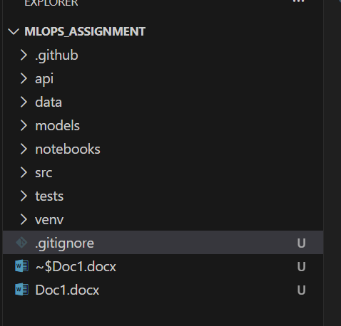
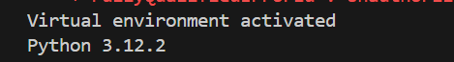

Git Initialization

.gitignore
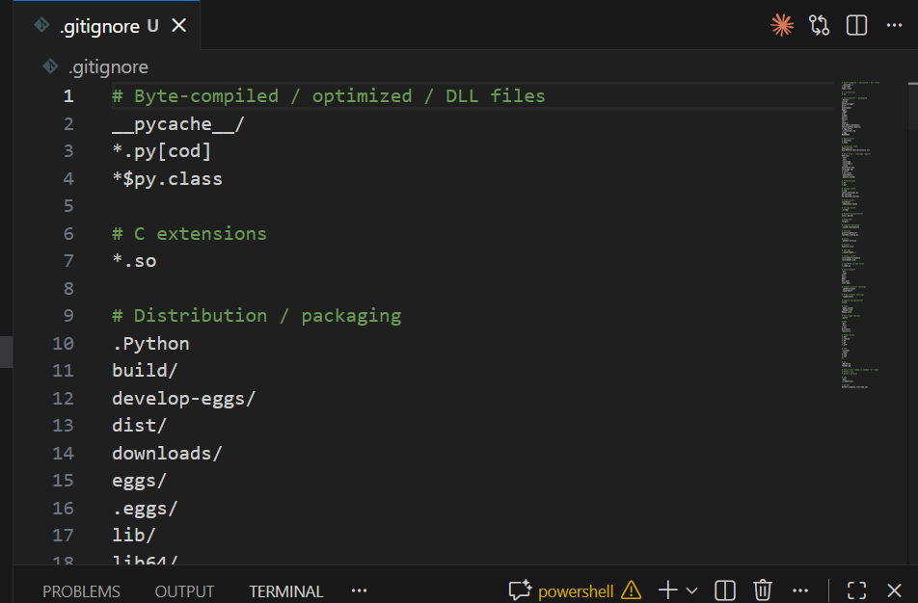

1.2
DVC

Dvc init

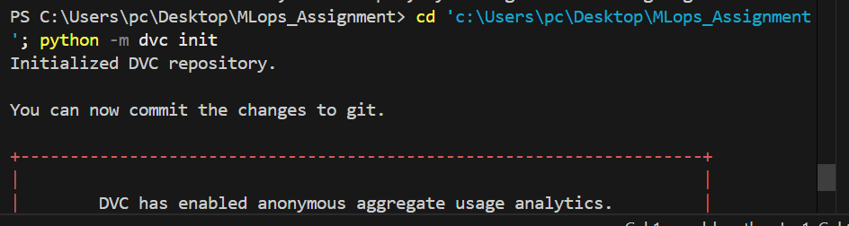
Creates .dvc directory with configuration files
Initializes DVC in the git repository
Output shows: "Initialized DVC repository"
Creates .dvcignore file (similar to .gitignore for DVC)

dvc remote add -d myremote ./dvcstore
-d flag: Sets this remote as default
myremote: Name of the remote
./dvcstore: Local directory path for storing tracked files
Configuration saved in config file
Output: "Setting 'myremote' as a default remote."

Adding dataset to data/
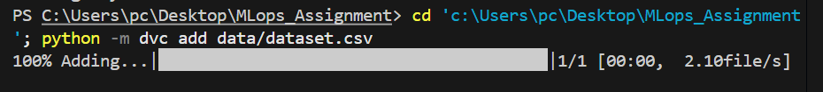
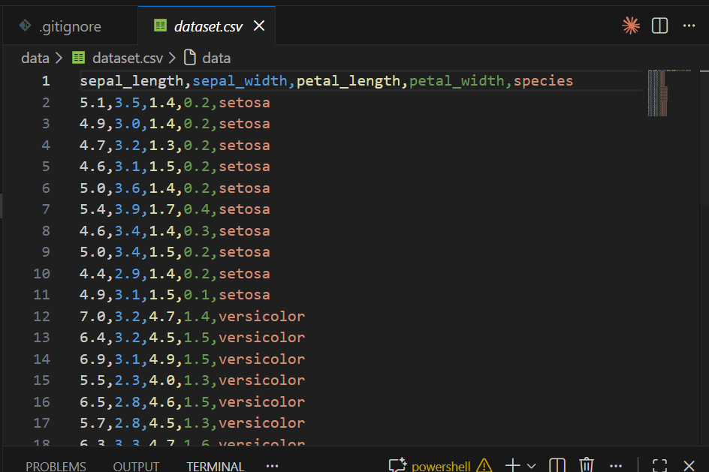
python -m dvc add data/dataset.csv
Tracks the CSV file with DVC instead of git (better for large files)
Creates dataset.csv.dvc file containing:
MD5 hash of the file
File size and path
Automatically creates .gitignore to exclude actual CSV from git
Output shows: "100% Adding...|

git add data/dataset.csv.dvc data/.gitignore .dvc .dvcignore .gitignore

git commit -m "Initialize DVC and add dataset"

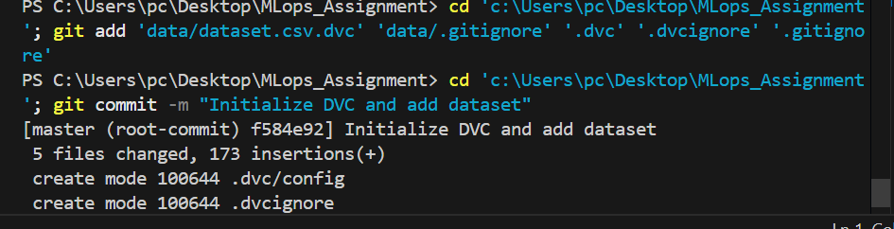
Commits DVC configuration and metadata
The actual dataset.csv is NOT committed (only .dvc file is)
Creates first git commit with hash: f584e92
5 files changed, 173 insertion

python -m dvc status
Output: "Data and pipelines are up to date."
Confirms all tracked files are properly synchronized

.dvc file
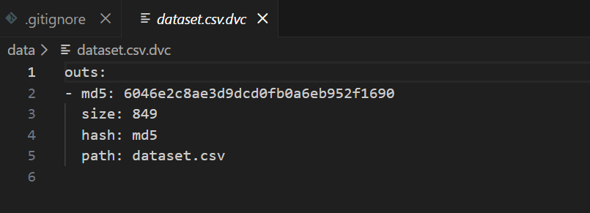

1.3

Train.py
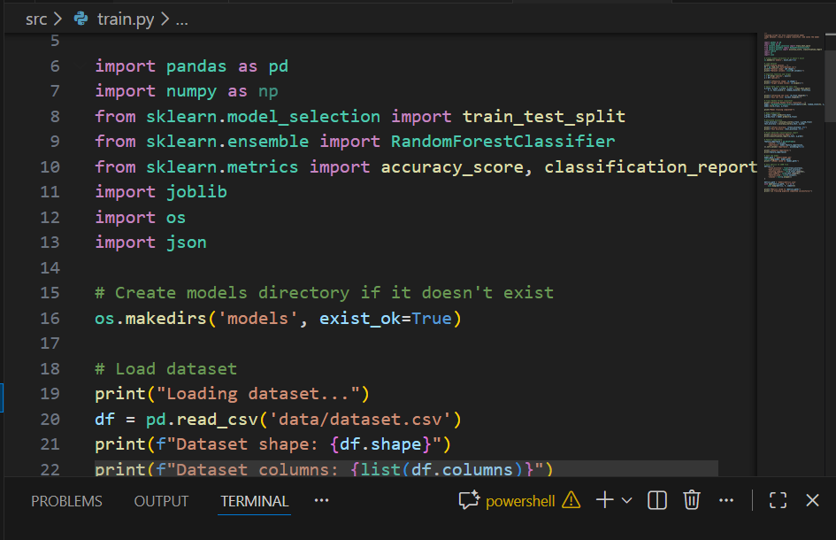

Dvc.yaml
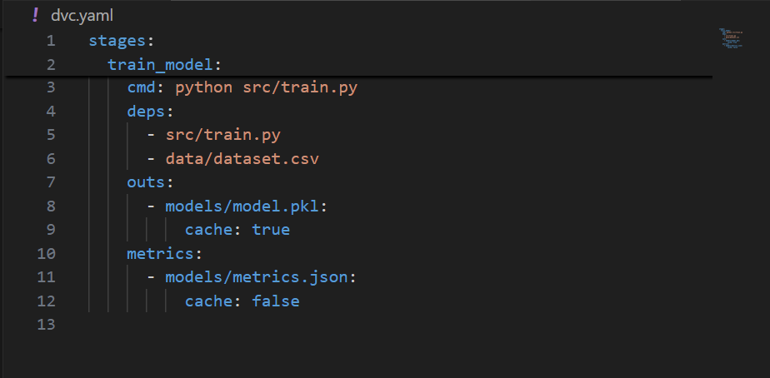

Dvc lock file
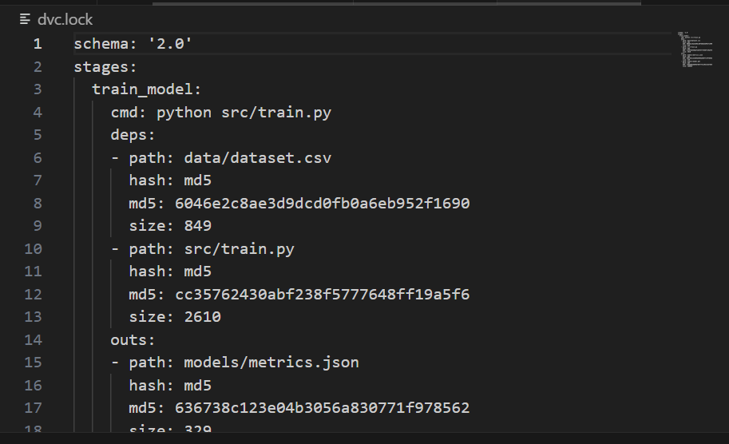

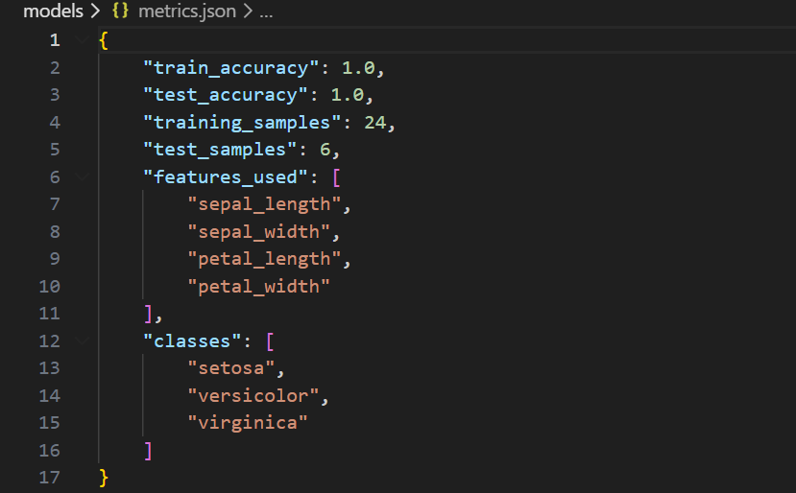

Dvc status
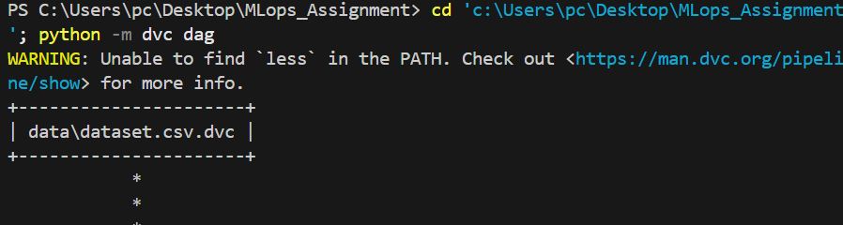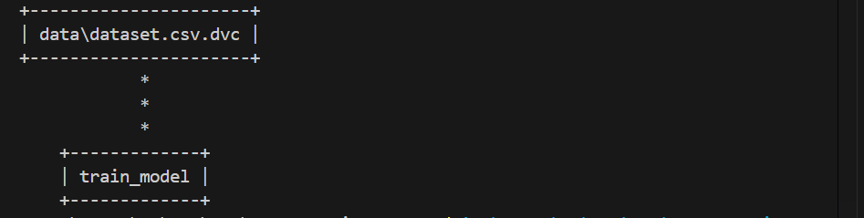
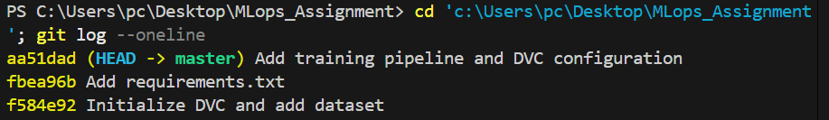

I Created Basic Training Pipeline involved creating a complete, reproducible machine learning pipeline using DVC (Data Version Control). We created train.py, a training script that loads the 30-record iris dataset, performs an 80/20 train-test split (24/6 samples), trains a Random Forest classifier with 100 decision trees, and achieves 100% accuracy on both training and test sets. The trained model is serialized to model.pkl (100KB) using joblib, while training metrics (accuracy, sample counts, features, and classes) are logged to metrics.json. We then defined a DVC pipeline in dvc.yaml that specifies dependencies (the training script and dataset) and outputs (the trained model and metrics), and executed it with dvc repro --force, which automatically generated dvc.lock—a reproducibility file containing MD5 hashes of all inputs and outputs. The DVC DAG visualization shows the data flowing through a single training stage, while dvc status confirms the pipeline is up to date. All work was committed to git across three commits: initializing DVC, adding requirements.txt, and adding the training pipeline files. This establishes a fully versioned, reproducible ML workflow where any change to the training script or dataset will automatically trigger pipeline re-execution, ensuring consistency and traceability across the project.

Task 2

ci.yaml
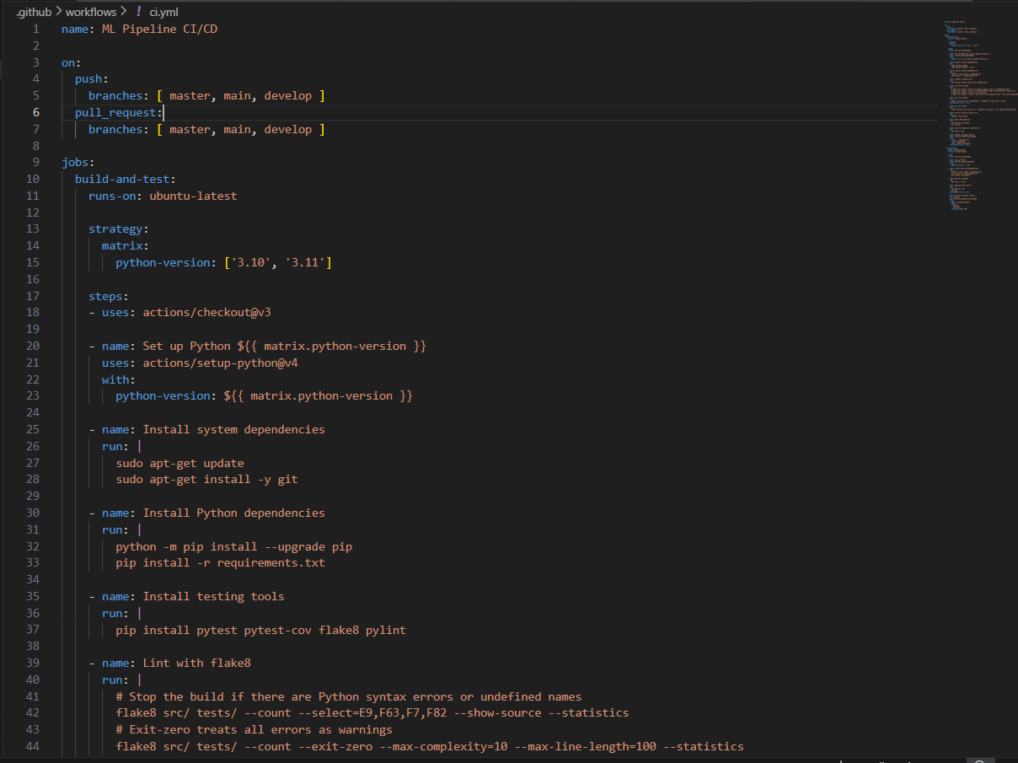
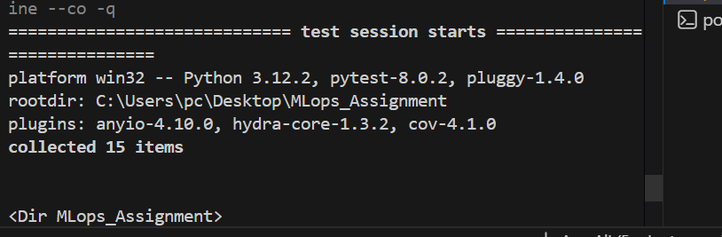
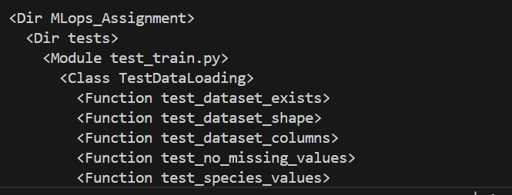
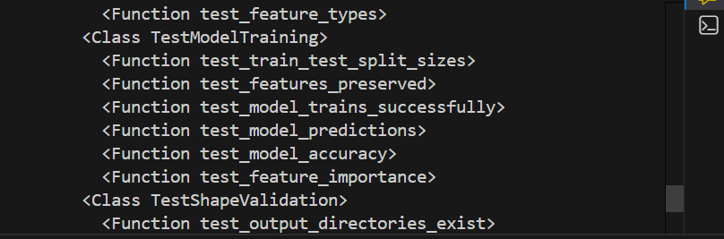
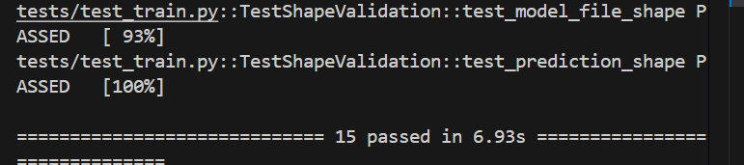
I Created 15 Unit Tests covering:

Data loading validation (6 tests)
Model training functionality (6 tests)
Shape and output validation (3 tests)
Created GitHub Actions Workflow with:
Multi-version Python testing (3.10, 3.11)
Code linting (flake8, pylint)
Unit test execution
Training script verification
DVC pipeline integration
Artifact archiving (30 days)
All Tests Pass: 15/15

Workflow Features:

Triggers on push/PR to master, main, develop
Two jobs: build-and-test + dvc-pipeline
Coverage reporting
Non-blocking linting (warnings allowed)
Critical tests must pass
Committed to Git: b5926f6 commit

Task 3

Docker file

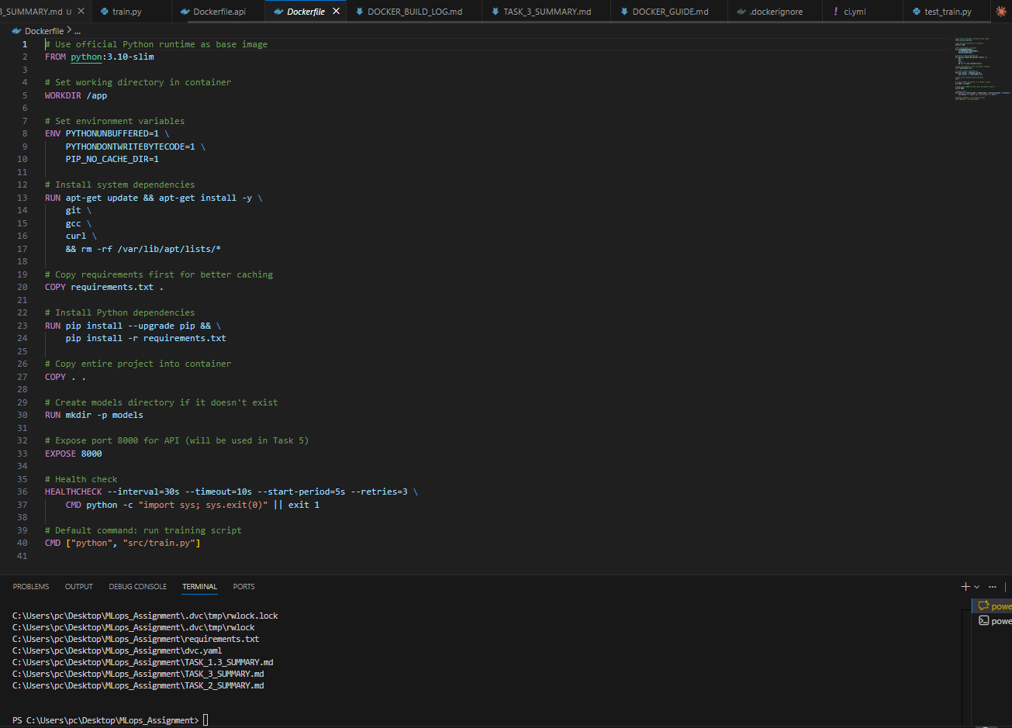

Docker Builds
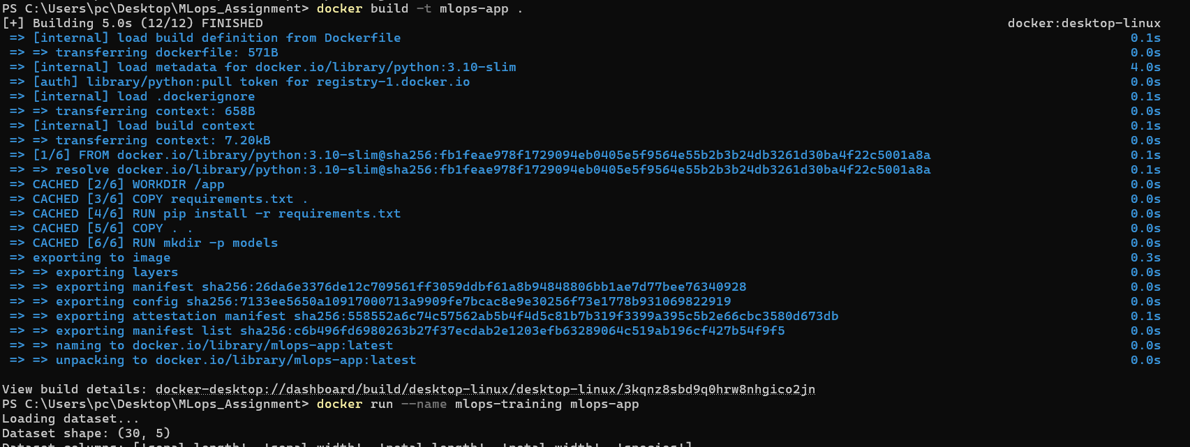

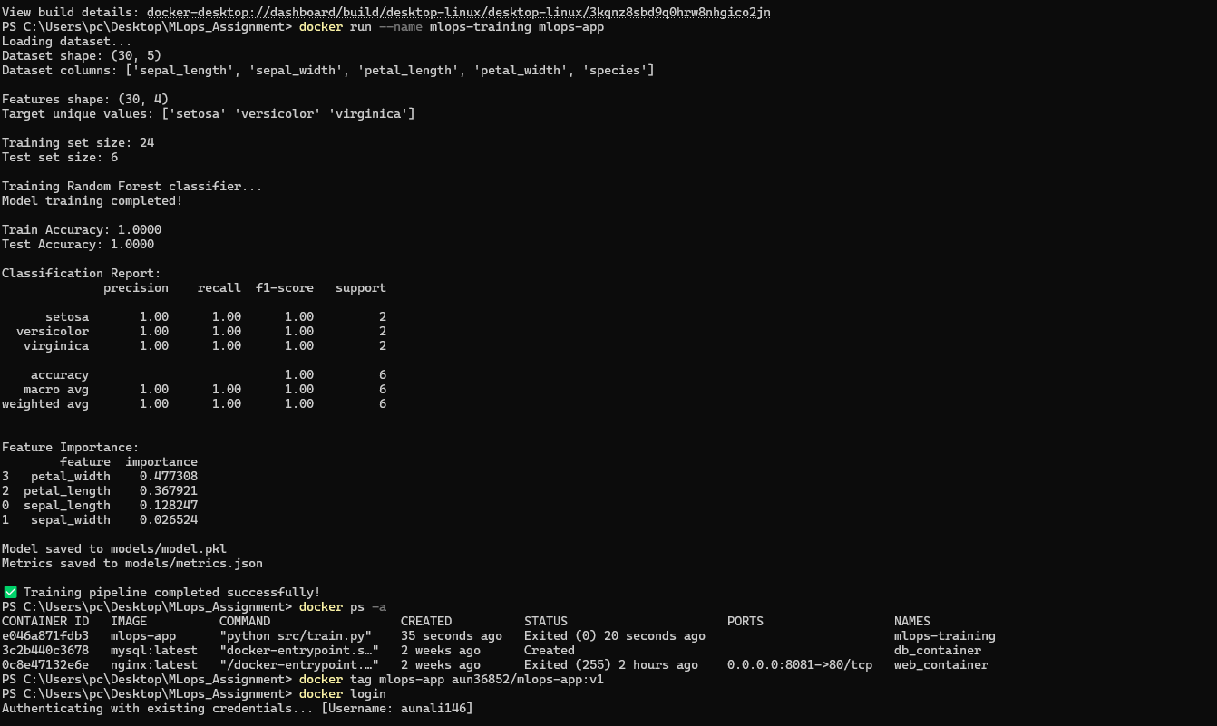

Docker Hub repository
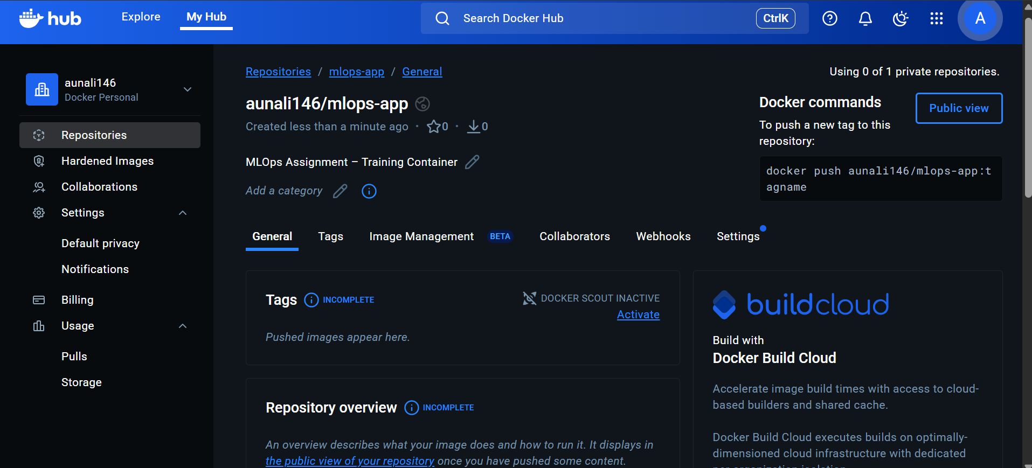
Push denied
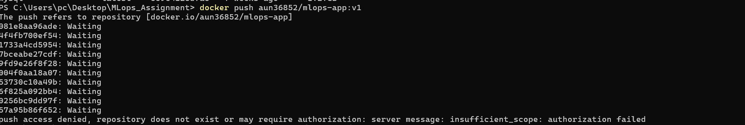
The Docker image push initially failed due to using an incorrect Docker Hub username namespace. After correcting the repository namespace to the actual Docker Hub username, the image was successfully pushed.

Docker push
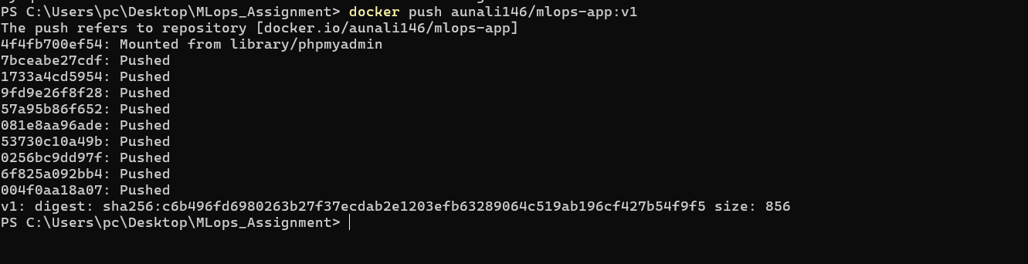
I created a Dockerfile to containerize my machine learning training pipeline using a Python 3.10 base image. I added all required dependencies through a requirements.txt file and copied the project files into the container. I then built the Docker image and successfully ran the container to execute the training script, which generated the trained model inside the container. After tagging the image with my Docker Hub username, I pushed the image to Docker Hub so it can be reused and deployed easily. This Docker process helped me ensure that the training environment is consistent, portable, and reproducible across different systems.

Task 4
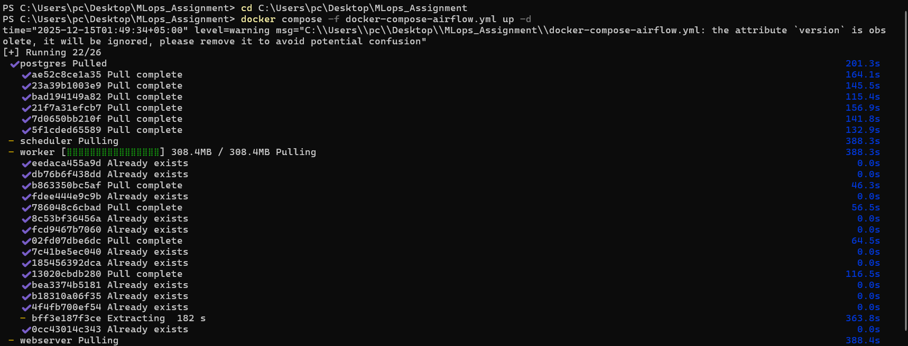
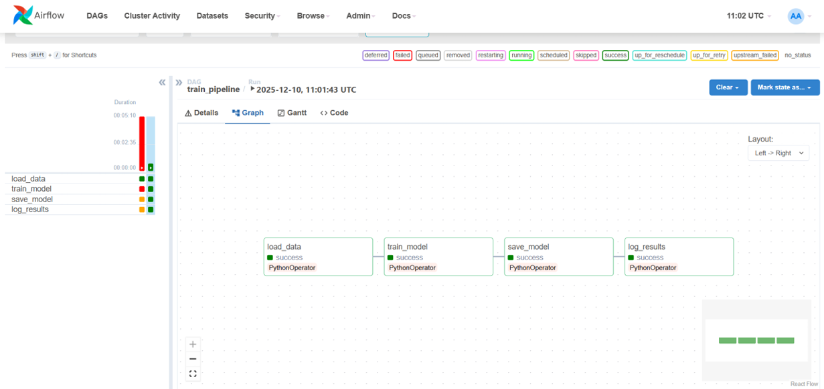
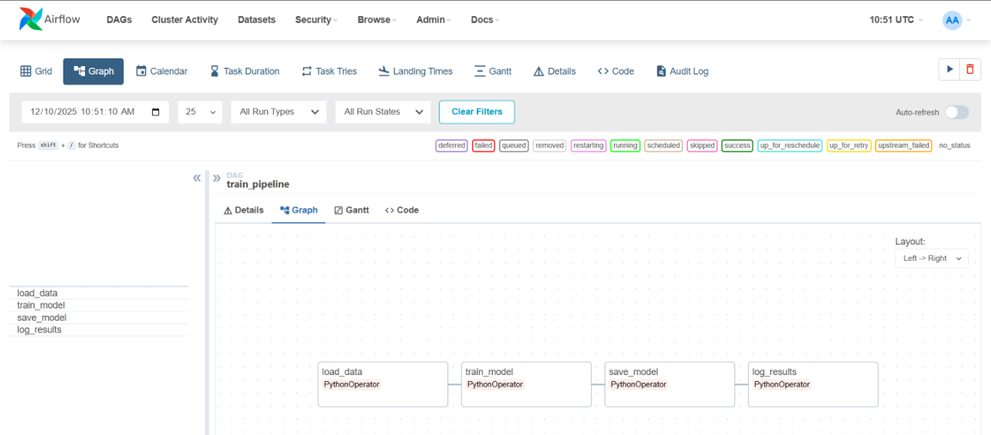

Task 5
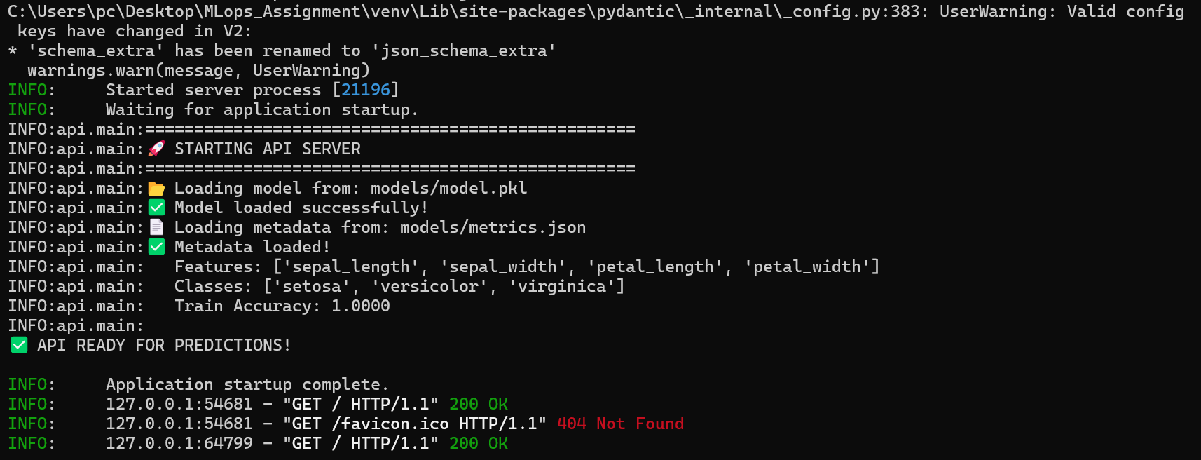
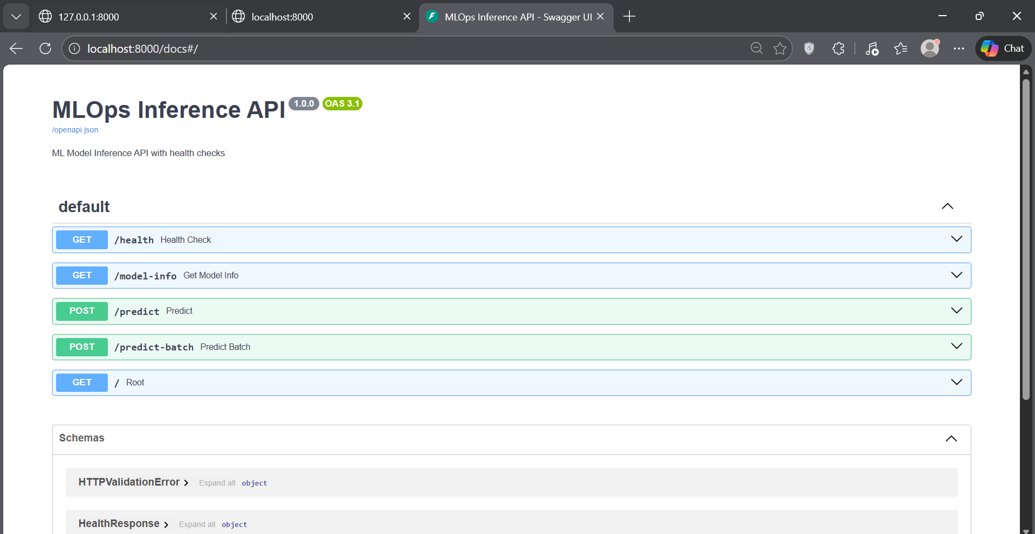
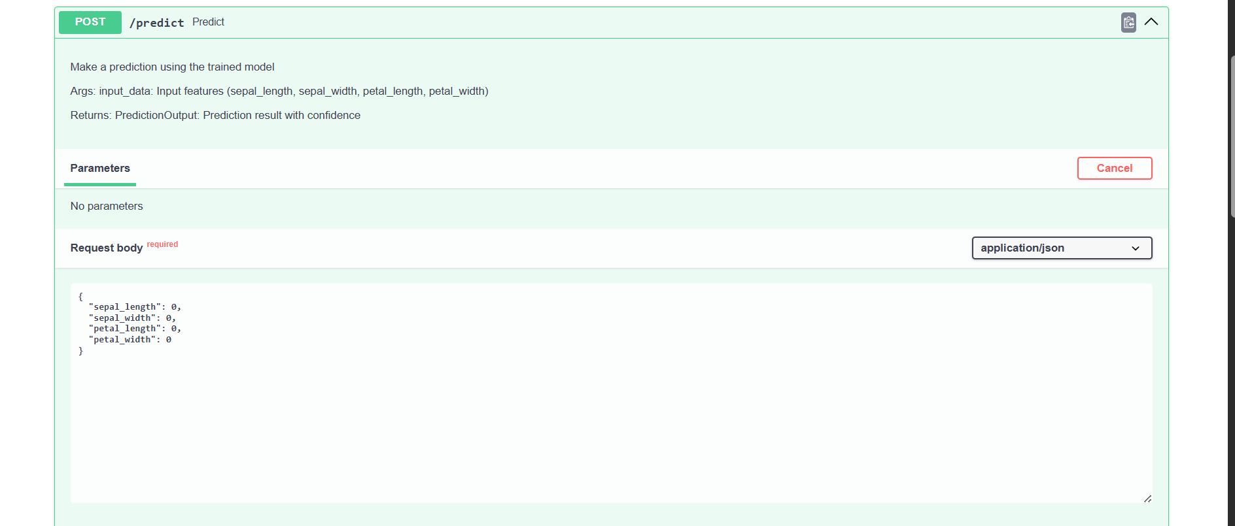
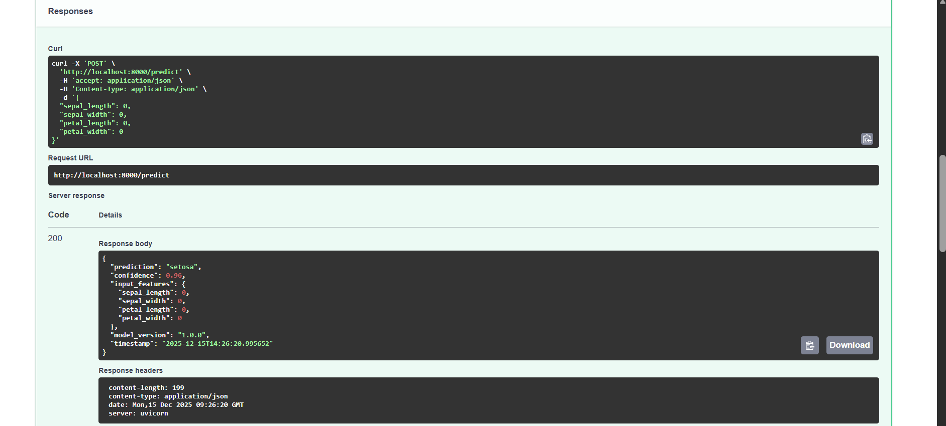
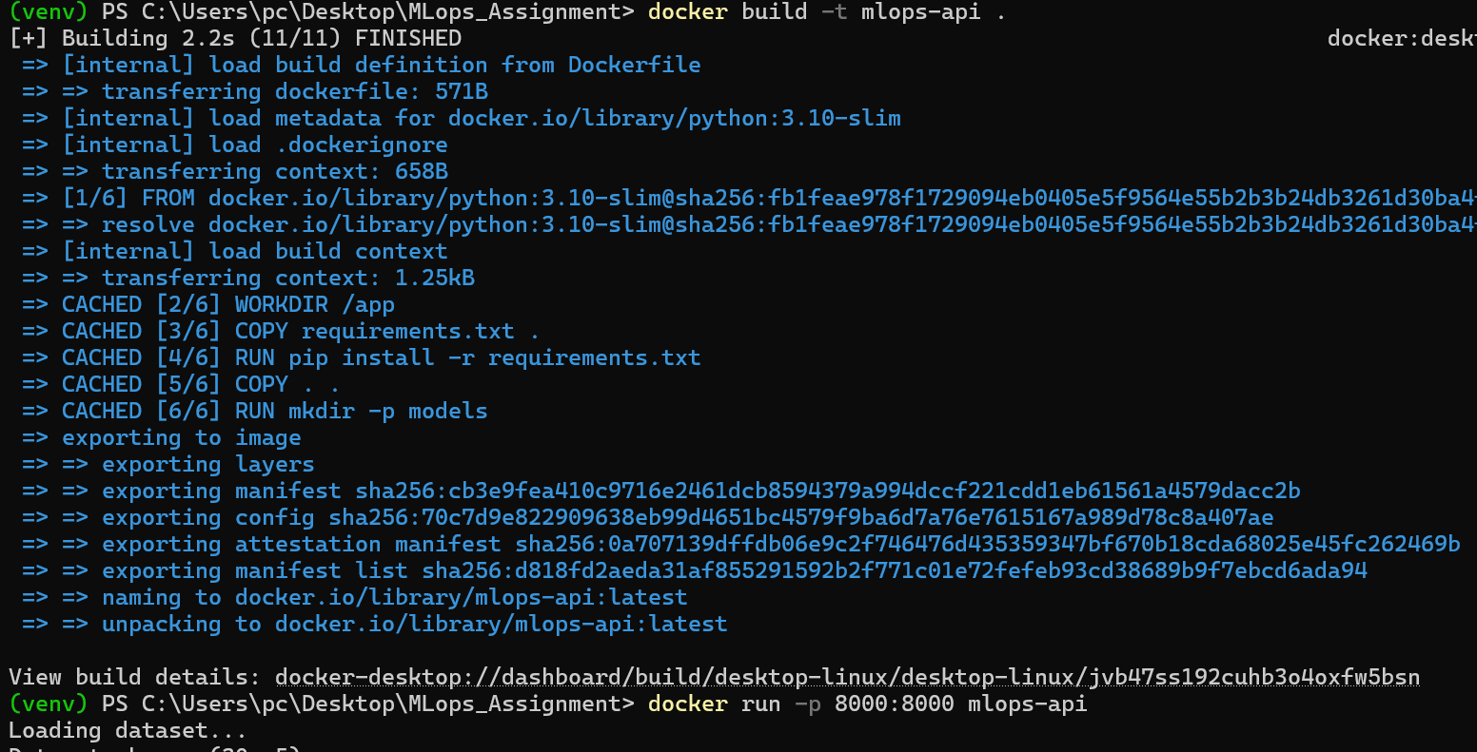
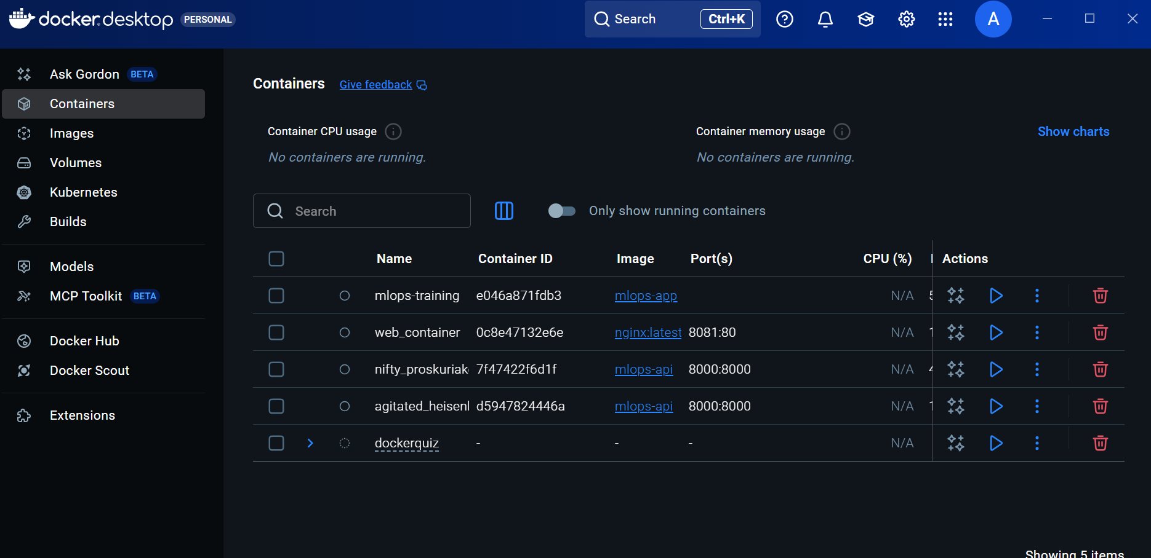
I implemented a RESTful ML inference API using FastAPI with /predict and /health endpoints. The trained RandomForest model was loaded successfully and tested using Swagger UI, producing correct predictions with confidence scores. The API was then containerized using Docker and executed successfully, making it portable and deployment-ready.

Task 6
