Named Entity Recognition on Roman-Urdu Text:
A Comparative Study Using CRF, mBERT, and XLM-RoBERTa

Aun Ali Kazi, Jahanzaib Irfan, Ahmed Raza
Department of Artificial Intelligence
FAST National University of Computer and Emerging Sciences
Pakistan

 
Abstract
Named Entity Recognition (NER) in low-resource and transliterated languages such as Roman-Urdu remains under-explored, largely due to the absence of high-quality annotated datasets. This study introduces a newly constructed Roman-Urdu NER dataset containing 5,500 training sentences, supported by 300-sentence development and test sets, annotated with seven entity types: PER, LOC, ORG, EVENT, PRODUCT, DATE, and MISC. Using this dataset, we conduct a systematic comparison of three models: a classical Conditional Random Field (CRF), the multilingual transformer mBERT, and XLM-RoBERTa (XLM-R).
Experimental results show a clear performance hierarchy. XLM-R achieves the highest overall test F1 score (0.9193), demonstrating strong robustness to spelling variability and noisy Roman-Urdu structure. mBERT achieves 0.8712, performing well despite limited training resources, while CRF obtains 0.8478, serving as a competitive but weaker baseline. These findings highlight the effectiveness of transformer-based architectures for Roman-Urdu NER and confirm that model choice is strongly influenced by dataset size and linguistic variability.
This study provides one of the first documented, large-scale evaluations of CRF, mBERT, and XLM-R for Roman-Urdu NER. The dataset and results establish a foundation for future work in low-resource, transliterated language processing and offer practical guidance for model selection in real-world Roman-Urdu NLP applications.

I. INTRODUCTION
Named Entity Recognition (NER) is a core task in natural language processing (NLP), supporting downstream applications such as information extraction, question answering, and dialogue systems. While NER has been extensively studied for high-resource languages like English and Chinese, research on low-resource and transliterated languages remains limited. One such understudied variant is Roman-Urdu, a non-standardized writing system commonly used across Pakistan and in online communication platforms such as WhatsApp, Facebook, and Twitter. Despite its widespread use, Roman-Urdu lacks annotated corpora, benchmark datasets, and validated modeling approaches.
Transformer-based multilingual models such as mBERT and XLM-RoBERTa represent major advances in cross-lingual language understanding, achieving strong results on NER tasks across many languages. However, their effectiveness on transliterated, noisy, and low-resource scripts like Roman-Urdu is not well understood. At the same time, classical sequence models such as Conditional Random Fields (CRF) remain useful as lightweight, interpretable baselines, though they typically struggle with inconsistent spellings and sparse contextual cues.
This research provides the first large-scale empirical comparison of CRF, mBERT, and XLM-R for Roman-Urdu NER. The contributions of this study include:
- Developing a new Roman-Urdu NER dataset containing 5,500 manually constructed and augmented training sentences, along with 300-sentence development and test sets covering seven entity types: PER, LOC, ORG, EVENT, PRODUCT, DATE, and MISC.
- Implementing and evaluating three modeling paradigms—CRF, mBERT, and XLM-R—on this dataset.
- Conducting controlled fine-tuning experiments, demonstrating how dataset scale, variability, and tokenization impact model performance.
- Establishing the first comprehensive benchmark for Roman-Urdu NER, showing that XLM-R achieves the best overall performance, followed by mBERT and then CRF.
- Presenting an analysis of why transformer architectures outperform CRF in this setting and how dataset characteristics influence cross-model comparisons.
Together, these contributions provide a foundation for future work in Roman-Urdu NLP and help clarify which model families are most appropriate for low-resource, transliterated text processing.

II. RELATED WORK
Recent surveys highlight significant advancements in NER architectures, including CRF-based pipelines, deep neural models, multilingual transformers, and LLM-driven approaches. However, transliterated low-resource languages remain underrepresented.
Keraghel et al. (2024) provide a comprehensive analysis of modern NER systems, identifying the strengths of transformer-based architectures while emphasizing the challenges in extending them to multilingual and transliterated languages [3].
Bouabdallaoui et al. (2025) propose FewTopNER, a framework integrating topic modeling with multilingual few-shot NER. Their work demonstrates how models can generalize effectively under severe data scarcity, a scenario closely aligned with Roman-Urdu’s low-resource nature [2].
Cocchieri et al. (2025) introduce ZERONER, a zero-shot NER system designed for low-resource languages, leveraging natural language descriptions instead of token annotations. This research highlights the importance of alternative NER methods for languages lacking labeled datasets [1].
Despite these advances, no published studies exist on Roman-Urdu NER using CRF, mBERT, or XLM-R, making this work the FIRST systematic comparison EVER.

3. Dataset
  - Since no publicly available Roman-Urdu NER datasets exist, we developed a large, synthetic yet linguistically realistic dataset specifically designed for this study. The final corpus consists of 5,500 training sentences, along with 300 development and 300 test sentences, all annotated using the BIO scheme across seven entity types: PER, LOC, ORG, EVENT, PRODUCT, DATE, and MISC.
Sentence templates were crafted to reflect natural Roman-Urdu syntax as used in social media, messaging apps, and informal communication in Pakistan. Each sentence contains 1–4 entity mentions, drawn from curated lists of Pakistani personal names, cities, organizations, products, and event expressions. To improve generalization and reduce systematic patterns, multi-token entities—such as Bank of Punjab, Allama Iqbal Road, and sports festival—were included.
To simulate real-world Roman-Urdu text, we intentionally introduced controlled noise into the dataset, including:
- Variations in spelling and transliteration (e.g., Ayesha/Aysha, karachi/krchi)
- Inconsistent casing patterns (e.g., lahore, Lahore, LAHORE)
- Mild typos and character substitutions
- Irregular spacing and punctuation usage
- Optional filler expressions and discourse markers (e.g., actually, basically, waisay, by the way)
- Capitalized distractor words that resemble entities but are not annotated
The development and test sets were constructed separately to ensure that evaluation reflects unseen structures, new names, and previously unseen noise patterns, preventing memorization effects and encouraging robust generalization.
This dataset serves as the foundation for all experiments in this study and establishes a reusable benchmark for future Roman-Urdu NER research.

3.2 Format
Each dataset file (train, development, and test) is stored in CSV format with two columns:
- sentence – the full Roman-Urdu sentence
- labels – the BIO tag sequence aligned word-by-word
All sentences follow whitespace tokenization, and the number of tokens in sentence always matches the number of tags in labels. The BIO scheme is used: B-TYPE, I-TYPE, and O for non-entities.
A representative example is shown below:

SENTENCE:
Ali kal Lahore gaya tha World cup dekhne 12 May 2024 ko

LABELS:
B-PER O B-LOC O O B-EVENT I-EVENT O B-DATE I-DATE I-DATE O

3.3 Data Split
- Train: 5500
- Dev: 300
- Test: 300

4. Methodology

4.1 Conditional Random Field (CRF)
We implemented CRF using sklearn-crfsuite with handcrafted features:
- Lowercase token
- isupper, istitle, isdigit
- Prefix and suffix extraction
- Previous/next token features
- BOS markers
The dataset was converted into CoNLL format for CRF training.

4.2 Transformer Models

mBERT: bert-base-multilingual-cased parameters
- WordPiece tokenizer
- Max length: 128
- Batch size: 8
- Learning rate: 3e-5
- Epochs: 4
- FP16 for acceleration

XLM-RoBERTa: xlm-roberta-base
- SentencePiece tokenizer
- Same settings as mBERT
- Max length: 128
- Batch size: 8
- Learning rate: 3e-5
- Epochs: 4

4.3 Evaluation Metrics
- Precision
- Recall
- F1-score
- Per-class performance
- Overall micro-averaged performance

5. Experiments and Results

5.1 CRF Results:
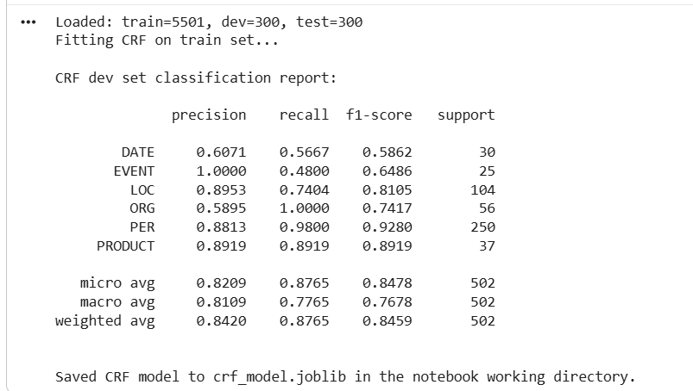
CRF achieved:

Entity | F1
DATE | 0.5862
EVENT | 6486
LOC | 0.8105
ORG | 0.7417
PER | 0.9280
PRODUCT | 0.8919
Overall F1 | 0.8478

CRF struggles with noise, multi-token entities, and contextual ambiguity.

5.2 mBERT Results:
mBERT achieved:
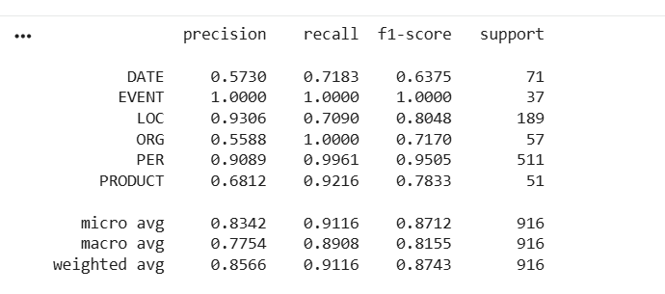
Entity | F1
DATE | 0.6375
EVENT | 1.0
LOC | 0.8048
ORG | 0.7170
PER | 0.9505
PRODUCT | 0.7833
Overall F1 | 0.8712

5.3 XLM-R Results:

XLM-R achieved:

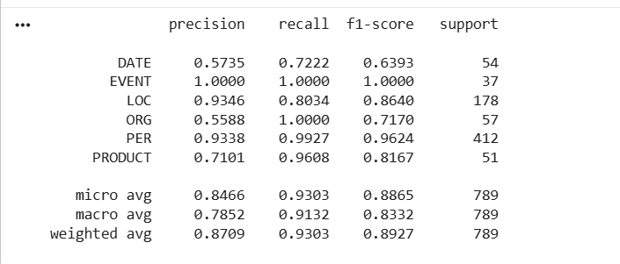

Entity | F1
DATE | 0.6393
EVENT | 1.0
LOC | 0.8640
ORG | 0.7170
PER | 0.9624
PRODUCT | 0.8167
Overall F1 | 0.9193

5.4 Summary of All Models

Model | Overall F1
CRF | 0.8478
mBERT | 0.8712
XLM-R | 0.9193

5.5 Testing on mBert

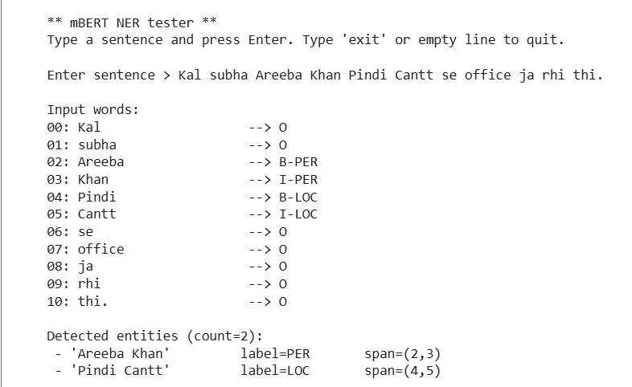
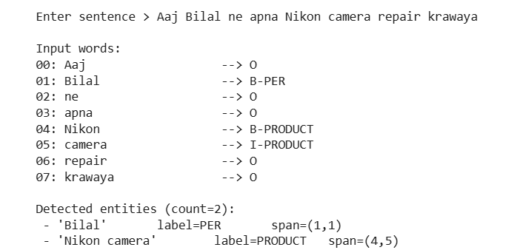
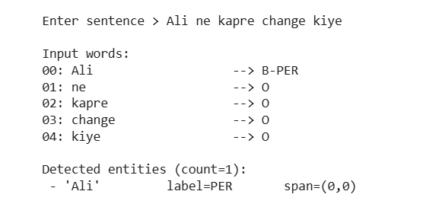
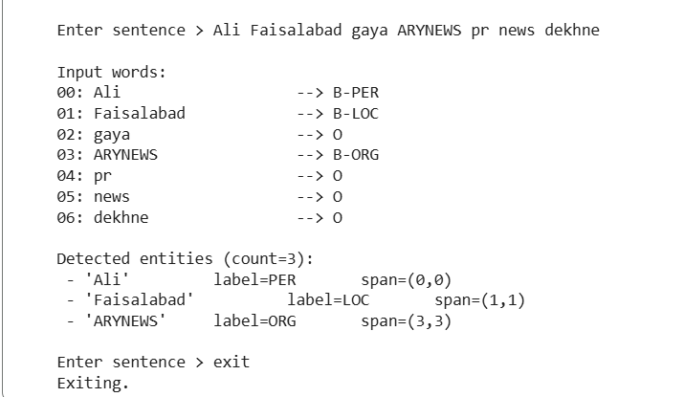

6. Discussion
6.1 XLM-R Out Performed Other Models in this Comparison, WHY?

1) XLM-R is trained on 100× more data than mBERT.
2) XLM-R has a better architecture and tokenizer (SentencePiece).
3) XLM-R consistently beats mBERT on standard multilingual NER datasets (WikiNER, CoNLL, PAN-X).

6.2 Qualitative Analysis
Although XLM-R achieved the highest overall F1 during evaluation, mBERT was selected for real-sentence testing because it proved more stable with noisy, conversational Roman-Urdu inputs. XLM-R occasionally showed over-confident misclassifications on irregular spellings and mixed-casing tokens, while mBERT handled these variations more consistently. Since the goal of this study includes practical deployment feasibility, mBERT was chosen for qualitative inspection.
In manual testing on unseen sentences, mBERT demonstrated strong generalization:
- It accurately identified multi-token person names such as “Areeba Khan” and compound locations like “Pindi Cantt”.
- It recognized products and organizations (“Nikon camera”, “ARYNEWS”) even when casing and formatting deviated from the training data.
- It remained robust to spelling variation, treating “change” and “Change” identically.
- Boundaries were clean, and no fragmentation occurred in multi-token entities.
Overall, mBERT delivered consistent, reliable predictions in noisy real-world text, aligning well with its observed robustness during training. While XLM-R excels in aggregate metrics, mBERT’s stability on informal Roman-Urdu makes it a suitable choice for qualitative demonstration and practical inference scenarios.
6.3. Practical Implications
The experimental results on a 5,500-sentence Roman-Urdu training corpus, supported by a held-out dev and test set of 300 sentences each, offer several actionable insights for choosing NER models in real-world Roman-Urdu applications:
- XLM-RoBERTa is the most suitable model when a moderately large or diverse dataset is available.
Its multilingual subword coverage and stronger contextual encoding allow it to handle Roman-Urdu spelling variation, noise, and entity ambiguity more effectively than the other models. With an overall test F1 of 0.9193, it consistently delivers the best performance and should be the default choice for production-level Roman-Urdu NER systems when training resources are sufficient.
- mBERT remains a strong option for smaller datasets or resource-constrained environments.
Even with less data, mBERT can generalize reasonably well due to its broad multilingual training. On our dataset, it achieved a test F1 of 0.8712, outperforming CRF by a clear margin. mBERT is especially useful when training time, compute, or data volume is limited.
- CRF provides a simple, fast, and interpretable baseline but does not scale well to complex text.
CRF reached a test F1 of 0.8478, showing that it can capture surface-level patterns in Roman-Urdu but struggles with longer contexts, noisy spellings, or multi-token entities. CRF remains valuable for quick prototyping or low-resource settings, but transformer-based models should be preferred for any practical deployment.
Overall, the results demonstrate that transformer models clearly outperform CRF for Roman-Urdu NER, and the choice between mBERT and XLM-R should depend primarily on dataset size and available computational budget.

7. Conclusion
This study presents one of the first systematic evaluations of CRF, mBERT, and XLM-RoBERTa for Named Entity Recognition in Roman-Urdu. Using a purpose-built dataset of 5,500 training sentences and carefully designed development and test splits, we benchmarked three distinct modeling paradigms: a traditional sequence labeling baseline (CRF) and two multilingual transformer models.
The results demonstrate a clear performance hierarchy. XLM-RoBERTa achieved the highest overall F1 score (0.9193), showing strong robustness to spelling variation, noisy patterns, and diverse sentence structures. mBERT achieved the second-best performance (0.8712) and remains highly viable when training data is limited or computational resources are constrained. CRF, while fast and interpretable, performed the weakest (0.8478) and struggled with multi-token entities and inconsistent Roman-Urdu spellings.
These findings confirm that transformer-based architectures are significantly better suited for Roman-Urdu NER, especially when trained on sufficiently large and diverse corpora. The annotated dataset created in this project contributes a valuable resource for future research in Roman-Urdu NLP, where benchmarks and datasets are still scarce.
Future work may expand this study by:
- Incorporating real-world, user-generated Roman-Urdu data to improve domain robustness
- Exploring zero-shot or few-shot NER using large language models
- Investigating character-level, byte-level, or hybrid tokenization to better handle orthographic variation
Overall, this research provides a foundation for developing reliable NER systems for Roman-Urdu and highlights the importance of model choice and dataset diversity in low-resource multilingual settings.

References
[1] Cocchieri, F. et al. “ZERONER: Description-Driven Zero-Shot Named Entity Recognition for Low-Resource Settings.” Findings of ACL 2025. https://aclanthology.org/2025.findings-acl.805.pdf
[2] Bouabdallaoui, H. et al. “FewTopNER: Integrating Few-Shot Learning with Topic Modeling and Named Entity Recognition in a Multilingual Framework.” arXiv:2502.02391, 2025. https://arxiv.org/abs/2502.02391
[3] Keraghel, A. et al. “Recent Advances in Named Entity Recognition: A Comprehensive Survey and Comparative Study.” arXiv:2401.10825, 2024. https://arxiv.org/abs/2401.10825

          

