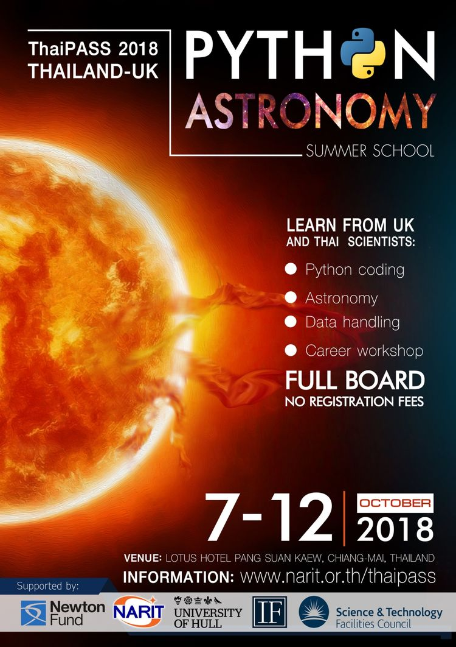

Welcome to ThaiPASS 2018

Welcome to the Thailand-UK Python Astronomy Summer School (ThaiPASS). The aim of this week-long school is to help you learn and understand how to use Python, a powerful object-based programming language, through the data-based subject of Astronomy. You will have a chance to use a mixture of real observational data from a telescope, as well as the chance to produce models of the physics behind the objects we observe in the night sky.