SE- 231077_ AunAli Karim

ASSIGNMENT-1

[DSA-THEORY]

|  |
| --- |
| **Q2. Briefly describe the notions of**   1. **a) The complexity of an algorithm** 2. **b) The space-time tradeoff of algorithms** |

The complexity of an algorithm:

“The complexity of an algorithm refers to the amount of resources, such as time and space, required to solve a particular problem using that algorithm. The time complexity of an algorithm is typically measured using big O notation, which describes the upper bound of the time required as a function of the input size. A more complex algorithm may require more time and/or space to solve a problem, but it may also provide more accurate or efficient solutions in certain cases. Therefore, it is important to consider the trade-offs between algorithmic complexity and problem-solving effectiveness when selecting or designing an algorithm.”

1. The space-time tradeoff of algorithms:

“The space-time tradeoff of algorithms refers to the relationship between the time and space requirements of an algorithm as it solves a particular problem. The space-time tradeoff can be influenced by various factors, such as the data structures used, the order of operations, and the presence of recursion or iteration. For example, an algorithm that uses a recursive approach may require more space to store the function call stack, but it may also be able to solve the problem more quickly by taking advantage of the divide-and-conquer strategy.”

**Q3©: Why understanding memory address calculations is important in programming, particularly in systems where memory is limited.**

1. It allows computer to access and manage data efficiently.
2. Memory address help organize memory, allocate space, and track available memory.
3. Ensure optimal performance but also prevents software crashes and vulnerabilities.
4. Understanding how to calculate and manipulate memory addresses is critical for tasks such as dynamic memory allocation, deallocation, and avoiding memory leaks.
5. Understanding how data is laid out in memory helps in optimizing access patterns, minimizing cache misses, and improving overall execution speed. This is particularly important in performance-critical applications.

* **Question 1[A,BC]:**

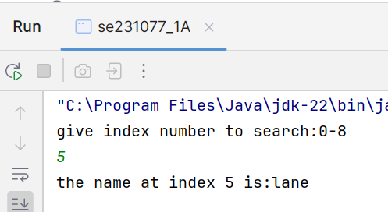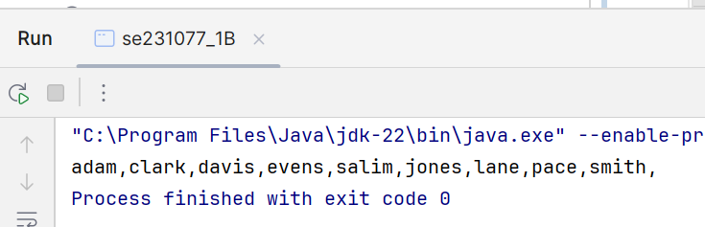

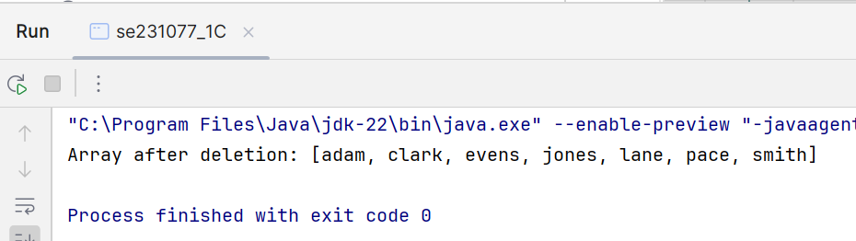

* **Question 3[A,B]:**

