LIBRARY MANAGEMENT SYSTEM

PROGRAMMING I
PROJECT DOCUMENTATION
Submitted By
Aung Hpone Myint
Louie Poland

Date: 12.06.2026

Table of Contents
Table of Contents 2
1. Application Description 3
2. Project Deliverables 3
3. Requirement Specifications 3
4. Conceptual Framework 4
4.1 Class Diagram 4
4.2 System Flowchart 5
5. Classes, Methods and Additional Features 6
5.1 Classes 6
5.2 Methods 8
5.3 Additional Features 9
6. Constraints and Strategies 9
6.1 Constraint 1: Team Collaboration and Version Control 9
6.2 Managing Multiple Classes 9
6.3 Manging Book Availability 9
6.4 Recording Transactions 10
6.5 Error Handling and Input Validation 10
7. Application Screenshots 10
8. Testing Summary 15
9. Conclusion 16

GitHub Repository Link: https://github.com/Aung-Data/LibraryManagementApp.2.git

1. Application Description
This project is a C# console-based Library Management System developed for the Programming One final project. The purpose of the application is to help a library manage books, members, and borrowing/returning transactions through a simple menu-driven interface.
The system supports two types of users: Admin and Member. The Admin user can manage books and library members by viewing, searching, adding, removing, and editing records. The Member user can log in to view available books, search for books, borrow books, and return books.
The application was developed using object-oriented programming principles. The main objects in the system are represented using classes such as Person, Member, Book, and Transaction. The system also uses generic lists such as List<Book>, List<Member>, and List<Transaction> to store data while the program is running.
The project demonstrates important programming concepts including encapsulation, inheritance, polymorphism, abstraction, menu-driven design, input checking, and basic transaction recording.

2. Project Deliverables
The final project delivers the following components:
- A fully functional C# console-based Library Management System
- Admin login and member login functionality
- Book management features including add, edit, search, remove, and display
- Member management features including add, edit, search, remove, and display
- Borrow and return book functionality
- Transaction recording system
- UML Class Diagram
- System Flowchart
- GitHub repository containing source code and version history
- Project documentation and testing evidence

3. Requirement Specifications
The Library Management System was developed to satisfy the following requirements:
- User Authentication
  - The system provides separate login functions for Admin and Member users
- Menu-Driven Interface
  - The system uses separate menus for both Admin and Member users to access the different features of the application
- Book Management
  - The application allows the admin to add, search, edit, remove and display the available books
- Member Management
  - The system permits the admin to add, search, edit, remove and display the member records
- Search Functionality
  - Both admin and member can search the desired book by means of book ID
- Borrow and Return Functionality
  - Member users can borrow their desired book(s) as well as can return the borrowed book(s) by using this function of the application
- Recording the Transactions
  - All of the borrowing and returning books are recorded as transactions by the application management system
- Error Handling
  - The application can validate user input and check for the invalid operations before running the actions
- Exit and Logout
  - The system allows the user to exit the application safely or return to the login menu when the user desires

4. Conceptual Framework
It is a high-level design. The Library Management System was designed by using Object-Oriented Programming Principles and Menu-Driven Structure. This program consists of five main classes such as Program, Book, Person, Member and Transaction.
The Person class acts as a Parent class for Member and stores common personal information. The Member class inherits from Person class and contains additional information related to member. The Book class stores information about books available in the library, while the Transaction class records borrowing and returning activities. For the overall control, the Program class plays the main role which contains program flow, user authentication, menu navigation, and method execution.
The Library Management System uses the generic collection including Member and Book Lists to store the application data while it is running by the user.

4.1 Class Diagram
The figure 1 represents the Class Diagram of the Library Management System. It shows the relationships between the classes of the application. The Member class inherits from the Person class showing inheritance feature and code reuse. The Book class manages information about library resources, while the Transaction class records borrowing and returning activities. The Program class coordinates interactions between all system components.
This diagram also demonstrates the object-oriented programming concepts by using
- Encapsulation through private fields and public properties
- Inheritance through the Member class inheriting from Person
- Polymorphism through the overridden DisplayDetails() method
- Abstraction through the separation of functionality into individual classes and methods

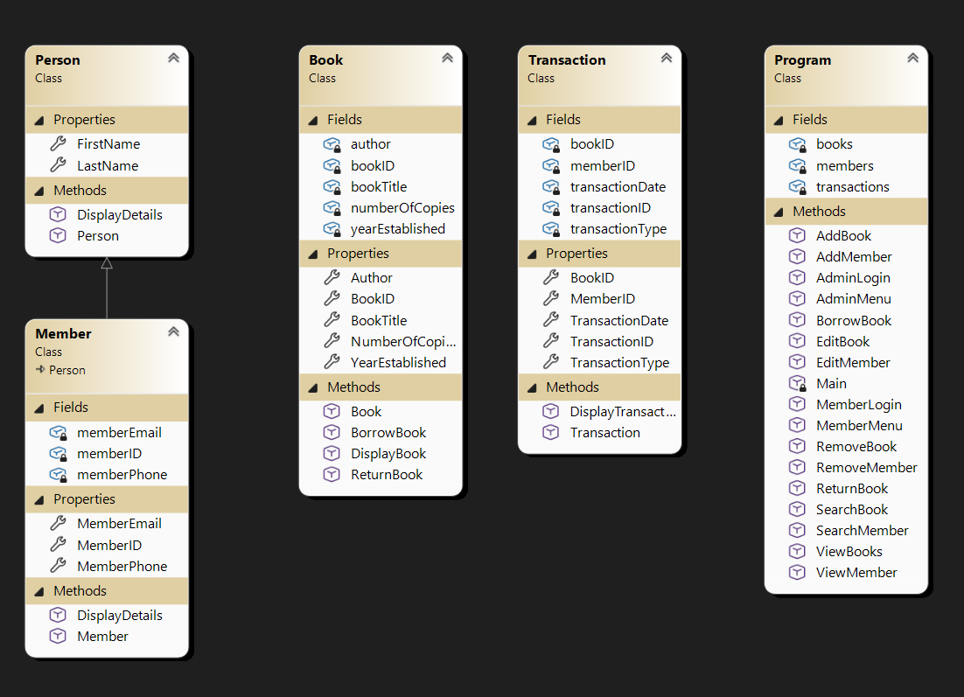
Figure 1: Class Diagram of Library Management System

4.2 System Flowchart
This flowchart of the figure 2 illustrates the overall workflow of the Library Management System by using Flowgorithm application. As a user authentication, the system firstly allows the user to select either Admin Login, Member Login, or Exit. After successful authentication, Admin users can manage books and members, while Member users can only view, search, borrow, and return books. The application terminates when the user selects the Exit option.
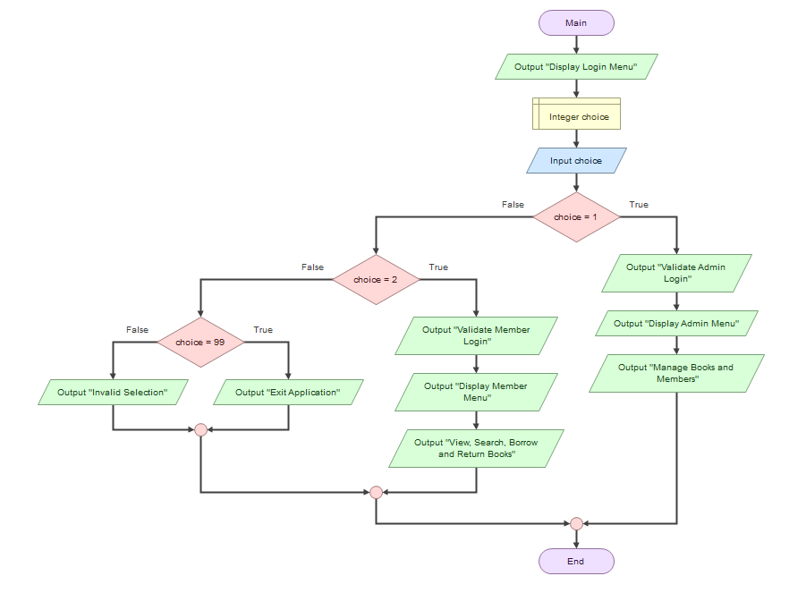
Figure 2: High-Level Flowchart of the Library Management System

5. Classes, Methods and Additional Features
In this section, all the created classes, methods and additional features for the Library Management Application are going to be explained.

5.1 Classes
There are altogether five classes in this application. They are Program, Member, Person, Book, and Transaction classes.

5.1.1 Person Class
The Person class acts as the base class of the Member class. It stores common information that can be shared by other classes in the future.
- Properties
- FirstName
- LastName
- Methods
- DisplayDetails()
The Person class demonstrates inheritance by allowing the Member class to reuse common attributes and methods.

5.1.2 Member Class
The Member class inherits from the Person class and stores information about library members. It overrides the DisplayDetails() method from the Person class to display member-specific information.
- Properties
  - MemberID
  - MemberEmail
  - MemberPhone
  - FirstName (Inherited)
  - LastName (Inherited
- Methods
  - DisplayDetails()

5.1.3 Book Class
The Book class stores information about books available in the library. It manages book information and updates the number of available copies when books are borrowed or returned.
- Properties
  - BookID
  - BookTitle
  - Author
  - YearEstablished
  - NumberOfCopies
- Methods
  - DisplayBook()
  - BorrowBook()
  - ReturnBook()

5.1.4 Transaction Class
The Transaction class records borrowing and returning activities. It provides a record of all borrowing and returning transactions performed within the system.
- Properties
  - TransactionID
  - BookID
  - MemberID
  - TransactionType
  - TransactionDate
- Methods
  - DisplayTransaction()

5.1.5 Program Class
The Program class controls the overall flow of the application. It is responsible for user authentication, menu navigation, book management, member management, and transaction management. The Program class coordinates interactions between all other classes.

5.2 Methods
There are several methods to run this application appropriately. Most of the methods are built under Program class as it controls overall flow of the application.
- Main()
  - Starts the application and displays the login menu.
- AdminLogin()
  - Validates the administrator username and password.
- MemberLogin()
  - Validates the member username and password.
- AdminMenu()
  - Displays the administrator menu and allows access to book and member management functions.
- MemberMenu()
  - Displays the member menu and allows book searching, borrowing, and returning.
- ViewBooks()
  - Displays all books stored in the system.
- SearchBook()
  - Searches for a book using its Book ID.
- AddBook()
  - Allows the administrator to add a new book.
- EditBook()
  - Allows the administrator to update existing book details.
- RemoveBook()
  - Allows the administrator to remove a book from the system.
- ViewMember()
  - Displays all registered members.
- SearchMember()
  - Searches for a member using Member ID.
- AddMember()
  - Allows the administrator to add a new member.
- EditMember()
  - Allows the administrator to update member information.
- RemoveMember()
  - Allows the administrator to remove a member from the system.
- BorrowBook()
  - Allows members to borrow books if copies are available.
- ReturnBook()
  - Allows members to return books and updates the available copy count.

5.3 Additional Features
The Library Management System includes several additional features that improve usability and reliability:
- Separate login interfaces for Admin and Member users.
- Case-insensitive searching for books and members.
- Transaction recording for borrowing and returning activities.
- Automatic update of available book copies.
- Confirmation messages for successful operations.
- Error handling for invalid selections and missing records.
- Menu-driven navigation for ease of use.
- Object-oriented design using encapsulation, inheritance, abstraction, and polymorphism.

6. Constraints and Strategies
During the development of the Library Management System, several constraints and challenges were encountered. Appropriate strategies were applied to overcome these issues and successfully complete the application.

6.1 Constraint 1: Team Collaboration and Version Control
The project was developed as a team project using GitHub. Two developers such as Aung and Louie were working on the same files occasionally resulted in merge conflicts and version control issues.
GitHub was used to manage source code versions and synchronise changes between team members. Merge conflicts were resolved by comparing local and remote versions and selecting the correct implementation before committing updates.

6.2 Managing Multiple Classes
The application required several classes including Person, Member, Book, Transaction, and Program. Managing the interaction between these classes while maintaining a clear structure was challenging.
Object-oriented programming principles were applied to separate responsibilities between classes. Each class was designed to manage its own data and behaviour, improving code organisation, readability, and maintainability.

6.3 Manging Book Availability
When a book is borrowed or returned, the number of available copies must be updated correctly. Incorrect updates could result in inaccurate library records. BorrowBook() and ReturnBook() methods were implemented within the Book class. These methods automatically update the NumberOfCopies property whenever a borrowing or return transaction occurs.

6.4 Recording Transactions
The system needed to maintain a record of borrowing and returning activities. Managing this information separately from book and member records increased the complexity of the design.
A Transaction class was created to store transaction information including Transaction ID, Book ID, Member ID, Transaction Type, and Transaction Date. This allowed all borrowing and returning activities to be tracked independently.

6.5 Error Handling and Input Validation
Users may enter incorrect IDs, invalid menu selections, or attempt operations on records that do not exist.
Validation checks were implemented before performing operations such as searching, editing, removing, borrowing, and returning. Appropriate error messages are displayed when invalid input is detected.

7. Application Screenshots
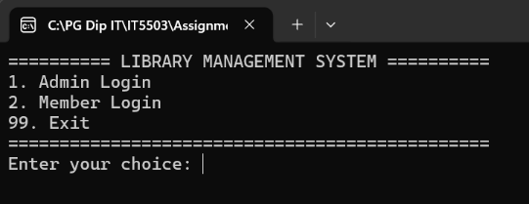
The Login Menu is the first screen displayed when the Library Management System starts. It allows users to select between Admin Login, Member Login, or Exit. The menu acts as the entry point to the application and directs users to the appropriate functions based on their selection.
Figure 3: Login Menu Functionality
Figure 4 demonstrates successful administrator authentication and access to the Admin Menu. After entering valid login credentials, the administrator is presented with a range of management functions including viewing, searching, adding, editing, and removing books and members. The Admin Menu serves as the primary interface for maintaining library records.
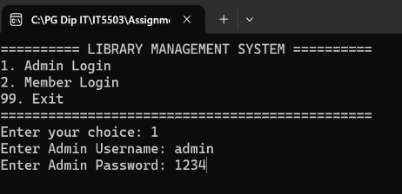
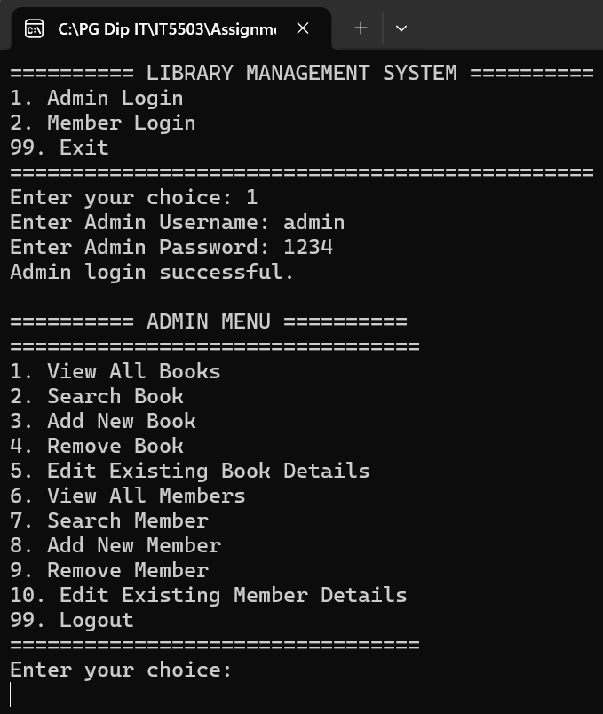

Figure 4: Admin Login and Admin Menu Functionality
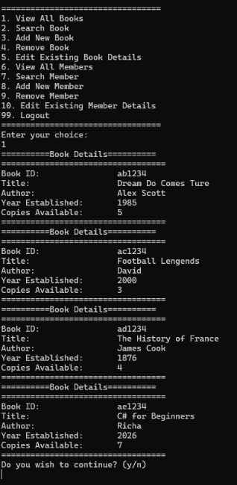
Figure 5 screenshot demonstrates the View All Books functionality of the Library Management System. All books currently stored in the system are displayed along with their details, including Book ID, Title, Author, Year Established, and Available Copies. This feature allows users to view the complete library collection and check book availability before borrowing.
Figure 5: View All Books Functionality
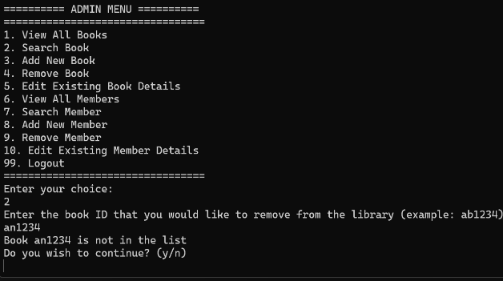
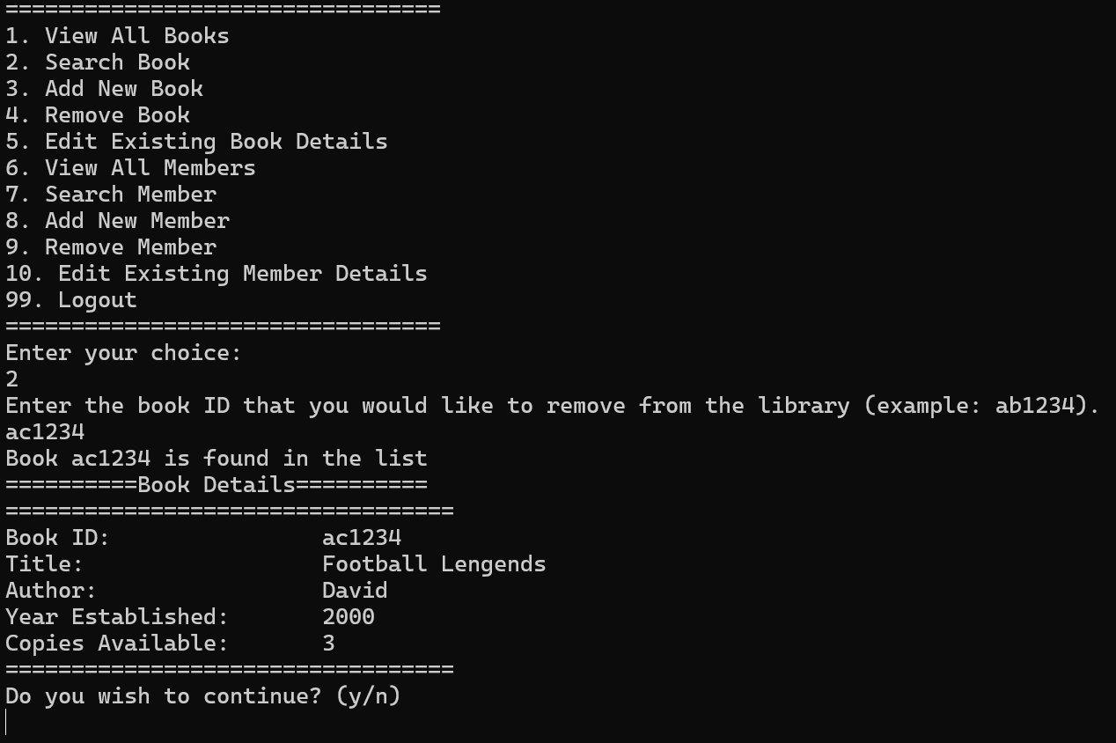
This screenshot demonstrates the Search Book functionality. Users can search for a book by entering its Book ID. If the book exists in the system, the book details including Book ID, Title, Author, Year Established, and Available Copies are displayed. It also demonstrates the system's error handling capability when searching for a book that does not exist in the library collection. After entering a Book ID that is not stored in the system, an appropriate message is displayed to inform the user that the requested record could not be found. This feature enables quick retrieval of book information.

Figure 6: Search Book Functionality
Figure 7 demonstrates the Add New Book functionality. The administrator enters the Book ID, Title, Author, Year Established, and Number of Available Copies. After the information is entered successfully, the system confirms that the new book has been added to the library collection.

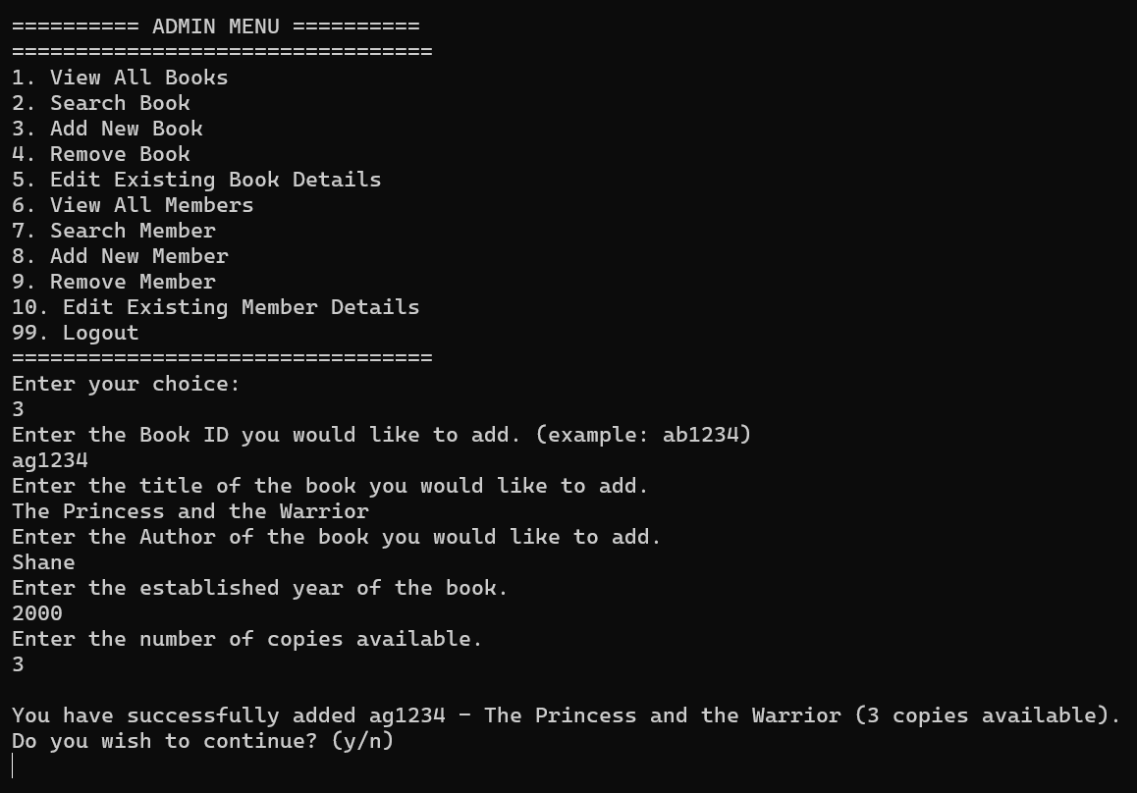
Figure 7: Add New Book Functionality
Figure 8 demonstrates the Remove Book functionality. The administrator enters the Book ID of the book to be removed. The system displays the book details and requests confirmation before deletion. Once confirmed, the selected book is successfully removed from the library collection.
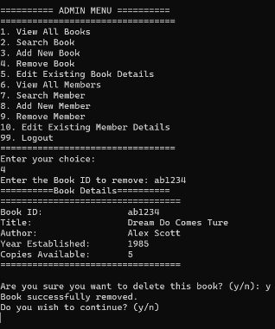
Figure 8: Remove Book Functionality
Figure 9 demonstrates the Edit Existing Book Details functionality. The administrator first views the current book information and then enters updated values. After the modifications are saved, the system displays a confirmation message and shows the updated book details. This feature allows administrators to maintain accurate and up-to-date book records. In this screenshot, the admin wanted to edit the Name of the book from “Lengends” to “Legends” and added more copies to the store.
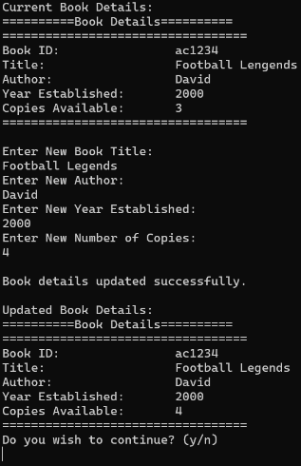

Figure 9: Edit Book Functionality

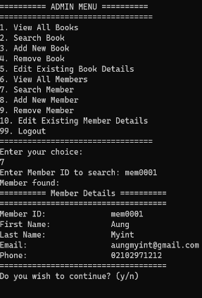
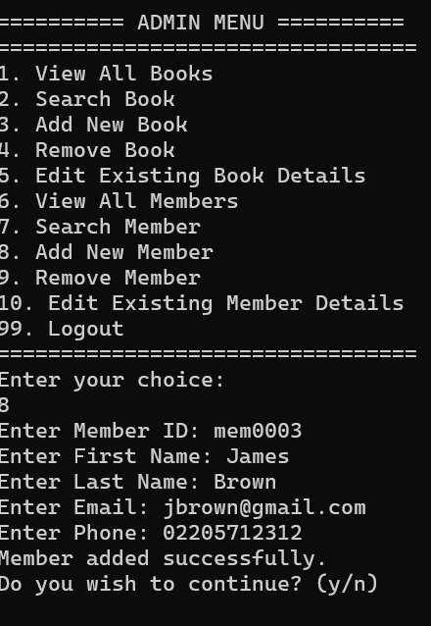
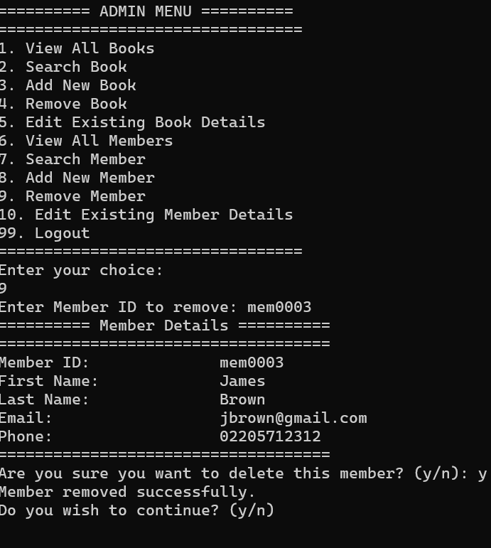
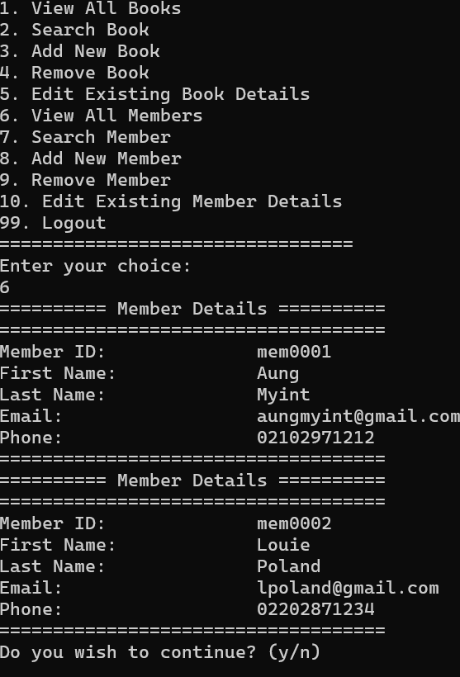
Figure 10 screenshots demonstrate the member management functions available to administrators. The system allows administrators to view all registered members, search for a member using a Member ID, add new members, and remove existing members after confirmation. These features help maintain accurate membership records within the library system.
Figure 10: Member Management Functions
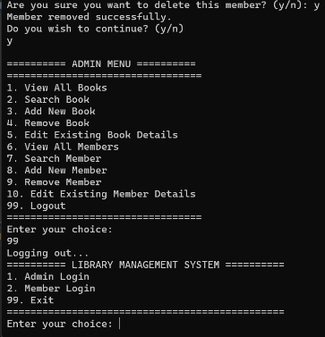
Figure 11 shows the Logout functionality. When the administrator selects the logout option, the system exits the Admin Menu and returns to the main login screen. This allows another user to log in or the application to be closed safely.
Figure 11: Logout Functionality
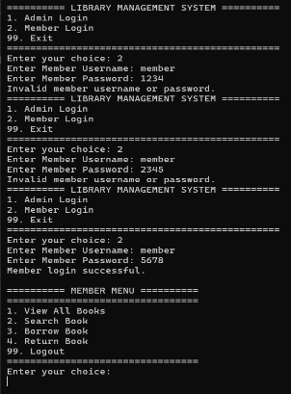
Figure 12 demonstrates the Member Login functionality. The system validates the username and password entered by the user and displays an error message when invalid credentials are provided. After successful authentication, the Member Menu is displayed, allowing members to view books, search books, borrow books, and return books. It also shows that if the member username and password are not matching, the system will not allow the user to login.
Figure 12: User Authentication and Access Control Functionality
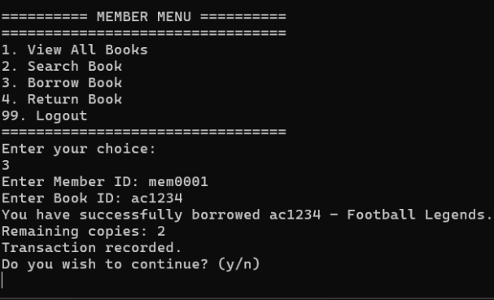
Figure 13 shows the Borrow Book functionality available to library members. After entering a valid Member ID and Book ID, the system processes the borrowing request, decreases the number of available copies, and displays a confirmation message. The transaction is also recorded in the system to maintain an accurate borrowing history. This feature ensures that book availability and borrowing records remain up to date.
Figure 13: Book Borrowing and Transaction Recording Functionality
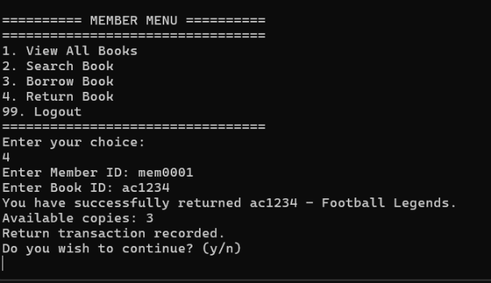
Figure 14 shows the Return Book functionality available to library members. After entering a valid Member ID and Book ID, the system processes the returning request, increases the number of available copies, and displays a confirmation message. The transaction is also recorded in the system to maintain an accurate borrowing history. This feature ensures that book availability and returning records remain up to date.
Figure 14: Book Returning and Transaction Recording Functionality
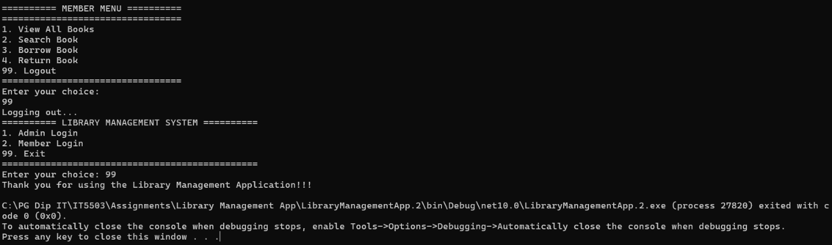
This figure explains the application exit process. When a member selects the Logout option, the system returns to the main login menu. From the main menu, users can either log in again or select the Exit option to close the application. Upon exiting, a confirmation message is displayed before the program terminates successfully.
Figure 15: Exiting the Application Functionality

8. Testing Summary
Testing was conducted on all major functions of the Library Management System, including user authentication, book management, member management, borrowing, returning, and transaction recording. The results show that all tested functions performed as expected and produced the correct outcomes. No critical errors were identified during testing, indicating that the application meets the specified functional requirements.
Test Case | Expected Result | Actual Result | Pass/Fail
Admin Login (Valid Credentials) | Admin Menu displayed | Admin Menu displayed successfully | Pass
Admin Login (Invalid Credentials) | Error message displayed | Error message displayed correctly | Pass
Member Login (Valid Credentials) | Member Menu displayed | Member Menu displayed successfully | Pass
Search Existing Book | Book details displayed | Book details displayed correctly | Pass
Search Non-Existing Book | Error message displayed | Error message displayed correctly | Pass
Add Book | Book added successfully | Book added successfully | Pass
Remove Book | Book removed successfully | Book removed successfully | Pass
Edit Book | Book details updated | Book details updated successfully | Pass
Add Member | Member added successfully | Member added successfully | Pass
Remove Member | Member removed successfully | Member removed successfully | Pass
Borrow Book | Copies reduced and transaction recorded | Book borrowed successfully and transaction recorded | Pass
Return Book | Copies increased and transaction recorded | Book returned successfully and transaction recorded | Pass

9. Conclusion
The Library Management System was successfully developed using C# and object-oriented programming principles. The application provides secure authentication for both administrators and members, together with book management, member management, borrowing, returning, and transaction recording functionality. The project demonstrates the application of encapsulation, inheritance, abstraction, and polymorphism within a practical software solution. Through the development process, valuable experience was gained in program design, testing, debugging, version control using GitHub, and software documentation. The completed system satisfies the project requirements and provides a solid foundation for future enhancements.

