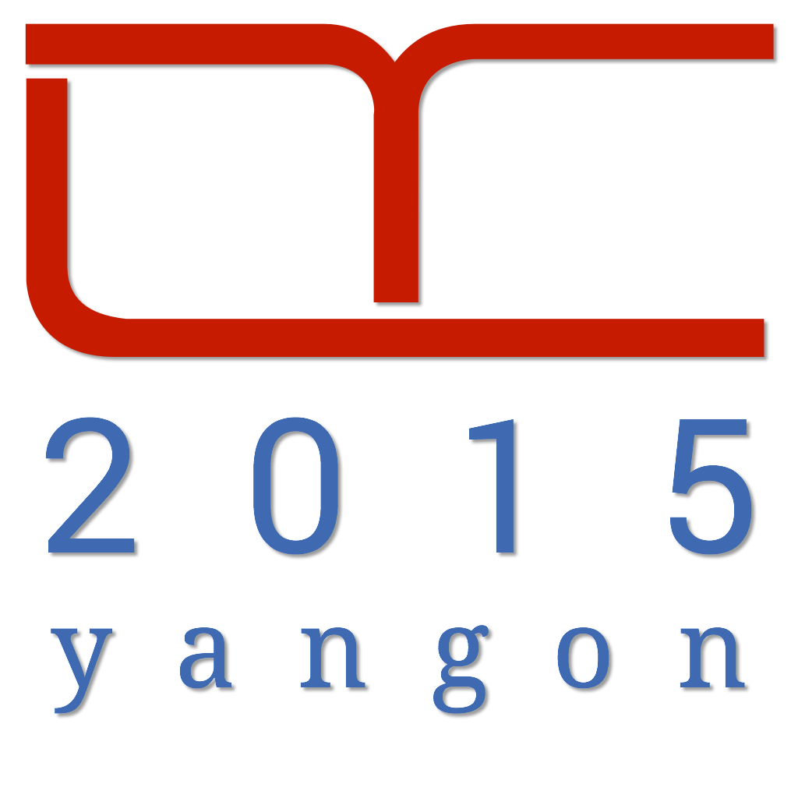
Myanmar Computer Professionals Association

Call for Proposals

2015 Developer Conference ( DevCon-Yangon 2015)
November 21st – 22nd, 2015

The 5th Developer Conference in Myanmar will be held on November 21st – 22nd, 2015 at the MICT Park, Hlaing University Campus, Yangon, Myanmar. The conference is opened to all IT professionals who are involved in any kind of software and software related solution development; including but not limited to web applications, mobile applications, consumer applications, corporate applications, cloud computing, game programming, educational software, device drivers, natural language development, database design and administration, software testing, machine automation, character and voice recognition, image processing, data mining and processing, and security related software.

This year theme is “experience means everything”.

Digital products and services create great experiences for the Users. Users buys the experience through product and services. DevCon 2015 highlights tools, processes and skills in creating better experiences for the User.
The 2015 Developer Conference Working Group (DevCon-WG) invites all interested parties to submit proposals for the DevCon 2015-Yangon conference sessions. The presenting speaker must be a Software-industry Exposed Person (SEP), meaning any individual with substantial software related experiences. The topic delivered should aim to have noteworthy impact on the audiences. In general, the DevCon-WG would like to see the content of the presentation to be under the following areas:

- Project Management
- Quality Assurance
- Mobile
(4) Web
(5) Internet Of Things
(6) Cloud
(7) User Experience

Key Dates:

Date | Deadline for
5/10/2015 | Presentation Proposal Form (Title and Abstract Only)
20/10/2015 | Acceptance Notification
25/10/2015 | Speaker Bio + Profile Picture
1/11/2015 | Presentation Material Submission
21/11/2015 | DevCon-Yangon 2015 Opening

Submission Process:
Requests for speaker/topic and presentation proposals (see appendix) could be submitted via e-mail, or fax. Forms can also be downloaded from (http://www.devconmyanmar.org/2015/). Speakers must submit a 150 word speaker bio together with a profile picture.
Proposal Types:
Three types of proposals are expected from our developer communities.
- Proposal to present:
Any SEP (Software Exposed Person) can request to be speaker in DevCon-Yangon 2015. Please fill up the Presentation Proposal Form and submit to the working group.
- Proposal to present (Lightning Talk):
If you intend to do a lightning talk (time limit 10 minutes) at the conference please fill up the Presentation Proposal Form, check the 'Lightning Talk' box, and submit to the working group.

Review and selection Process:
DevCon 2015-Working Group will categorize and select a list of topics and presentations. The DevCon-WG reserved the right for final decision on the selections. The selected presentation list (title and presenter) will be published by October 20th. The selected presenters must prepare and submit the full presentation no later than November 1st.

Speaker Deck / Presentation Slides
Slides can be submitted in any of the following digital format: PowerPoint, Keynote, Impress, PDF, or HTML5. The conference organizers will provide a projector with VGA input only. Speakers may incorporate optional demonstrations, tools, images, and motion pictures for their sessions. These should be well tested in advance to save time for both organizers and the audience. Please be reminded that it is the speaker’s responsibility to bring a computer for their presentations.

Total time allocation for each session is 50 minutes, of which 35-45 minutes time allocation for presentation, and additional 10-15 minutes for questions and answers.
Lightning Talks:
Send completed proposal via email or fax to
The Developer Conference Working Group, MCPA Office
Email: office@mcpamyanmar.org

Address: Building(9), Ground Floor, MICT Park, Hlaing University Campus, Yangon, Myanmar
Phone: (95)-1- 652276 Fax: (95)-1- 652276
Proposal Deadline: October 5th, 2015
There will be 5 to 6 lightning talk sections arranged for an hour period in each of the conference room in each conference day. The time limit is set at 8 minutes. The format is free talk, but speaker may choose to put up pre-submitted materials on the projector. The aim is to be short but effective knowledge sharing. Q & A sessions may follow after the talks are over if time permits.

PRESENTATION PROPOSAL ( Deadline: 5/10/2015)
SPEAKER INFORMATION
NAME
E-MAIL
PHONE(s)
ORGANIZATION / POSITION : (or provide additional short profile / linkedin ID)

CURRENT CITY / COUNTRY :

TOPIC INFORMATION
TITLE
LIGHTNING TALK (mark this if presentation is a 10min lightning talk) [ ]
Abstract (200 words or less)

Android 5.0 Lollipop is the biggest update of Android to date, introducing an all new visual style, improved performance, and much more. Android 5.0 Lollipop also extends across screens big and small, including phones, tablets, wearables, TVs and cars, to give your users access to information when they need it most.
To get you started on developing and testing on Android 5.0 Lollipop, I’ll talk about some of the developer highlights.

CO-SPEAKERS (if any)
CO-SPEAKER– A
NAME
E-MAIL |  |  | PHONE
CO-SPEAKER – B
NAME
E-MAIL |  |  | PHONE

SPEAKER / TOPIC PROPOSAL ( Deadline: 5/10/2015)
REQUESTER INFORMATION
NAME
E-MAIL
PHONE(s)
SUGGESTED SPEAKER INFORMATION
NAME
E-MAIL
PHONE(s)
ORGANIZATION / POSITION : (or provide additional short profile / linkedin ID)

CURRENT CITY / COUNTRY :

SUGGESTED TOPIC INFORMATION
TITLE
LIGHTNING TALK (mark this if presentation is a 8 min lightning talk) [ ]
Abstract (200 words or less)

