Curriculum Vitae
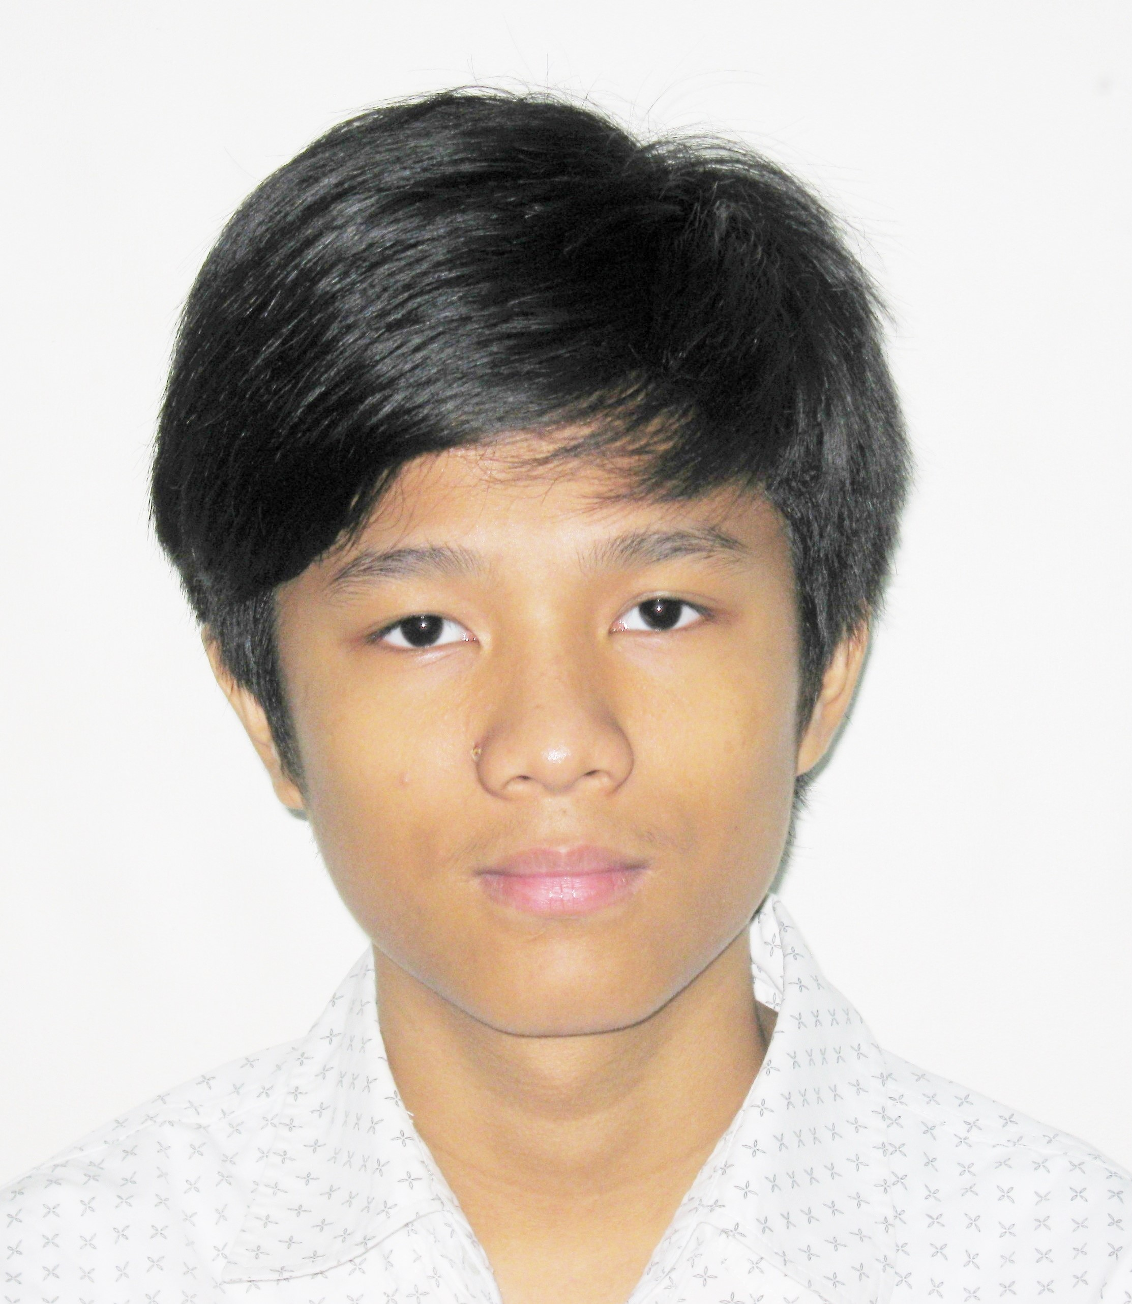
Name : Aung Kaung Myat Htun
Sex : Male
Date of Birth : 07 June 2000
Nationality : Myanmar
Religion : Buddhist
Marital Status : Single
Address : No.11.A (GF, L) South Horse Race Course Rd,
Tamwe Tsp, Yangon, Myanmar.
Contact No. : HP: 09.40481 0453, & 09.77853 0451
E mail : aungkaungmyathtun@gmail.com

Educational Qualification
2017 to date : 4th Year B.CSc (Computer Studies) (University of Computer Studies, Myanmar)

Professional Trainings
March 2020 – Nov 2020 : Cs50 Introduction to Computer Science (Harvard University)
Nov 2019 - Feb 2020 : Professional Web Developer (Fairway Technology)
Nov 2018 - Jan 2019 : Professional Web Design (Intelligent Programming & Language Academy)
Aug – Oct 2016 : Advanced Microsoft (KMD Computer)
Apr – July 2016 : Adobe Photoshop & Illustrator (KMD Computer)

Language Ability : English & Myanmar (Moderate)
Computer skill : Html5, Css, Bootstrap, Javascript, Php, Mysql

Working Experience(s)
2019 to Date Created Websites: - Travel Tour Website (Using Html, css, Bootstrap , javascript)
: Book Store Project (Using Html , css , Bootstarp , javascript , php)
: Online Shopping Project (Using Html , css , Bootstarp , javascript , php)
2020 to Date Created Website : Coffee Shop (Using Html, css , Bootstrap, javascript , python, cms(flask)

I hereby certify above statements are true and correct.

Aung Kaung Myat Htun
No. 11 A (GF, L) South Horse Race Course Road, Tamwe Tsp, Yangon, Myanmar

Tel: (01) 9549 418 E mail: aungkaungmyathtun@gmail.com

