Software Requirements Specification

for

PathSG
Version 1.4 approved
Prepared by Aung Khant
SC2006_SCSL_Team2
09.11.2026

Table of Contents
Table of Contents 1
Revision History 2
1. Introduction 3
1.1 Purpose 3
1.2 Document Conventions 3
1.3 Intended Audience and Reading Suggestions 3
1.4 Product Scope 3
1.5 References 3
2. Overall Description 4
2.1 Product Perspective 4
2.2 Product Functions 4
2.3 User Classes and Characteristics 4
2.4 Operating Environment 5
2.5 Design and Implementation Constraints 5
2.6 User Documentation 5
2.7 Assumptions and Dependencies 5
3. External Interface Requirements 6
3.1 User Interfaces 6
3.2 Hardware Interfaces 7
3.3 Software Interfaces 7
3.4 Communications Interfaces 8
4. System Features 8
4.1 Detailed School Directory & Profile Viewer 8
4.2 User Account & Privacy-Centric Student Profile Management 13
4.3 Education Roadmap Generator & Manager 19
4.4 User School Review System 27
4.5 Admin Manual Database Update 32
4.6 Admin School Database Export 36
4.7 Home Page 37
5. Other Nonfunctional Requirements 38
5.1 Performance Requirements 38
5.2 Safety Requirements 39
5.3 Security Requirements 39
5.4 Software Quality Attributes 41
5.5 Business Rules 41
6. Other Requirements 42
Appendix A: Data Dictionary 42
Appendix B: Conceptual Class Diagram 42
Appendix C: Design Class Diagram 43
Appendix D: Dialog Map 43
Appendix E: System Architecture Diagram 43
Appendix F: User Guide & Admin Guide 43
Appendix G: UI Mockup 43
Appendix H: UI Screenshots 44

Revision History
Name | Date | Reason For Changes | Version
Aung Khant | 4th Sep 2026 | Initial Software Requirements (Functional and Non-functional requirements) | 1.0
Aung Khant | 5th Sep 2026 | Add new functional requirements (Section 4.5) | 1.1
Aung Khant | 15th Sep 2026 | Update section 4 and 5 with to be more detail, restructure to table | 1.2
Aung Khant | 25th Oct 2026 | Complete Section 1, 2, 3 and 6  Update feature 4.5 to Admin manual database update  Add new feature 4.6  Update Section 5 to align with added feature | 1.3
Aung Khant | 9th Nov 2026 | Add rate limiting on requirements  Update requirements for the addition of map display  Update References and Appendix to add relevant documents  Add Home Page as a separate functional requirement (Section 4.7)  Align the wording with the latest app behaviour (distance slider range, review limits, admin file handling, preschool data) | 1.4

Introduction

Purpose
The purpose of this Software Requirements Specification (SRS) is to detail the functional and non-functional requirements for the PathSG (School Information System), Version 1.4. This document covers the entire scope of the system, including the consolidated school directory, user profile management, community review system, and the automated education roadmap generator.

Document Conventions
Bold text is used to highlight key terms and system features. Requirements are organized by specific feature modules and are assigned unique trace IDs (e.g., REQ-1.1, PERF-1) so they can be easily tracked throughout the development and testing phases.

Intended Audience and Reading Suggestions
This document is intended for a varied audience, including software developers, project managers, system administrators, and software testers. It is also suitable for stakeholders representing the end-users (parents and students in Singapore).

- Developers and Testers should focus heavily on Section 4 (System Features) and Section 5 (Nonfunctional Requirements).

- Project Managers and Stakeholders are advised to start with Section 1 and Section 2 to grasp the product's vision and overall scope before moving on to specific details.

Product Scope
PathSG is a web-based platform designed to help parents and students in Singapore plan their educational journeys efficiently. Currently, finding school information requires browsing multiple different sources. The core objective of PathSG is to provide a single, consolidated place where users can search, filter, and view every school in Singapore.

The application allows users to get a general idea of schools, view offered subjects/courses, and check historical admission benchmarks. Beyond acting as a directory, the system aims to help students understand what they are working towards by generating personalized educational roadmaps. Based on a student's academic scores, location, and career/subject interests, the platform creates step-by-step pathways to help them achieve their future goals.

References
- Data Dictionary (Appendix A)
- Conceptual Class Diagram (Appendix B)
- Design Class Diagram (Appendix C)
- Dialog Map (Appendix D)
- System Architecture Diagram (Appendix E)
- User Guide (Appendix F)
- UI Mockup (Appendix G)
- App website (PathSG)

Overall Description

Product Perspective
PathSG is a self-contained web application designed to consolidate educational data across Singapore into a single, accessible platform. It eliminates the need for parents and students to visit multiple different websites to research schools, courses, and entry requirements. The system operates as a standalone web portal comprising a frontend user interface and a backend server handling business logic, API calls, and local database management.

Product Functions
The major functions of PathSG include:

- School Directory & Profile Viewer: Search, filter, and sort schools by tier, proximity, courses, and view detailed profiles containing fees, entry benchmarks, and financial aid.

- Home Page: the landing page that explains what PathSG helps with. It introduces the main journey from school search to roadmap planning, lists the main features, and offers sign-in or account creation.
- Account & Student Profile Management: Secure registration and login, management of educational targets, academic scores, residential postal code, and saving bookmarked schools.

- Education Roadmap Generator: Generation of customized multi-stage academic pathways (both Rule-Based and AI-Generated) tailored to the user's location and academic standing. The user can choose whether the Rule-Based Plan prioritizes grade or distance.

- User School Review System: A community-driven feature allowing authenticated users to read, submit, edit, and delete reviews for individual schools.

- Admin Database Update: An administrative panel to manually upload, parse, and synchronize the local database with the latest school datasets via CSV files.

User Classes and Characteristics
Guest Users: General visitors who can browse the school directory, view detailed school profiles, and read community reviews. They cannot generate roadmaps or leave reviews.

Authenticated Users: The primary target audience. They have personal accounts allowing them to save their postal code and academic scores, bookmark schools, generate and save educational roadmaps, and submit reviews.

Administrators: Technical or administrative staff responsible for system upkeep. They have exclusive access to the Admin Panel to update and export the system's database using external datasets.

Operating Environment
Cloud & Deployment: The application operates on a cloud-based infrastructure and is containerized using Docker. This ensures a stable, scalable, and consistent hosting environment across both development and production.

Client-Side: Users access the application entirely via standard web browsers over the internet. It is fully functional on the latest stable versions of Google Chrome, Mozilla Firefox, and Apple Safari. The interface is fully responsive, supporting devices ranging from mobile phones (minimum width 375px) to desktop monitors (up to 1920px).

Server-Side: The backend runs within its Docker environment using a FastAPI framework, interacting with a local SQLite database for data storage and persistence.

Design and Implementation Constraints
External Data Dependency: The application's ability to function accurately relies heavily on external data. Because school information and benchmarks frequently change, the system is constrained by the quality and freshness of the datasets obtained from data.gov.sg. Inaccurate or outdated source data will directly affect the reliability of the directory and roadmap generation.

Privacy Strictness: The system is explicitly prohibited from collecting Personally Identifiable Information (PII) such as real names, exact dates of birth, or NRIC/FIN numbers.

Frameworks: The frontend must be developed using VueJS, and the backend using FastAPI.

Database Constraints: A local SQLite database is utilized, meaning database updates are handled via bulk transaction uploads by an administrator rather than automated live-syncing with external databases.

User Documentation
The system will be accompanied by a simple user guide. This document will provide straightforward, step-by-step instructions to help users easily navigate the platform, set up their profiles, and generate their educational roadmaps.

Assumptions and Dependencies
Proximity and Distance Calculation: The system does not rely on a live external mapping API (such as Google Maps) for distance calculations. A 6-digit postal code is mapped by its first two digits to one of 28 Singapore postal districts, and distance is the straight-line (Haversine) distance from that district’s centre. A postal code that cannot be located is rejected with an error message. Schools with no known location are ranked last.

AI Roadmap Generation: The AI-Generated Plan is highly dependent on the availability and responsiveness of the OpenAI API. The system assumes that by sending a prompt containing a filtered subset of valid schools (the schools of the chosen stage), the OpenAI service returns school IDs. The backend keeps only IDs that exist in the database, so the plan is limited to the schools that were sent.

School Data Source: The system depends on the availability of official school datasets from data.gov.sg. It assumes the CSV files keep the column headers the parser recognises, so the Admin upload and parsing functions keep working. The admin uploads the ten required dataset kinds (secondary, primary, CCAs, general, MOE, SDP, subjects, programmes, financial aid and scholarships) and may add the optional benchmarks file. A kind that is not uploaded keeps its last upload, or the bundled copy when none exists.

Map Display: Map pictures (tiles) are loaded from the OneMap service, so maps need OneMap to be available. If OneMap is down, the maps will not draw, but all other features keep working.

External Interface Requirements

User Interfaces
PathSG is used through a web browser. Every page shares the same layout and the same standard components.

Common layout and standards

- Header: shown on every page. It has the PathSG logo and the main menu: Directory, Roadmap, Saved, My Profile, Admin Panel, and Log in / Log out. Guests only see Directory, Roadmap and Log in. The Admin Panel link only appears for administrators. On phones, the menu collapses into a single menu button.

- Notice banner: a short message under the header (for example, “Roadmap saved to your profile.”). It disappears when the user moves to another page.
- Pop-up dialogs: used for confirmations (delete roadmap, overwrite roadmap, delete review) and for serious errors. They can be closed with a button or the Esc key.
- Error messages: shown in red, next to the field that has the problem. The wording follows the messages in Section 4.
- Loading states: a spinner is shown while data loads. The roadmap page shows the rule-based and AI plans separately, so a slow AI plan does not block the other.
- Responsive design: works from 375px (phones) to 1920px (desktop), with touch targets of at least 44px in the mobile menu.
- Keyboard and accessibility: all buttons and fields can be used with the keyboard and show a visible focus outline. Form fields have labels, and error messages are announced to screen readers.
- Style: one colour theme and one font (Public Sans) across all pages, built from shared components.
- Maps: the school profile page has a mini map, and each roadmap plan panel has its own map. Maps resize to fit screens from 375px to 1920px and show a credit to the map provider.
- Ranking controls: the Rule-Based Plan panel has a Rank by option (Distance or Grade) and an About button. The distance slider appears only when Grade is selected.

Relevant figures can be found in Appendix H.

Hardware Interfaces
PathSG has no direct connection to any special hardware. It does not use sensors, cameras, printers or other devices. All hardware access goes through the user’s web browser and operating system.

User devices: any phone, tablet, laptop or desktop that can run a supported browser (Chrome, Firefox or Safari). Input is by keyboard, mouse or touch.

File selection (administrators): the Admin Panel reads CSV files from the administrator’s computer, using the browser’s file picker or drag and drop.

Server: the system runs in Docker containers on a cloud host. It only needs normal server resources (CPU, memory, network, and disk for the SQLite database and uploaded CSV files). No special hardware is required.

Software Interfaces
Component | Detail | Purpose
Web browser | Latest Chrome, Firefox, Safari | Runs the PathSG frontend.
Frontend | Vue 3, TypeScript, Vite, Pinia, Vue Router, Tailwind CSS | User interface, page navigation, state handling.
Backend | Python 3.14, FastAPI, Uvicorn | REST API and business logic.
Database | SQLite via SQLAlchemy, with Alembic for schema changes | Stores users, profiles, schools, reviews, bookmarks and roadmaps.
Data processing | pandas | Reads and cleans the uploaded CSV files.
Security libraries | bcrypt, PyJWT | Password hashing and session tokens.
OpenAI API | Chat Completions, model set by the OPENAI_MODEL setting | Generates the AI roadmap.
Docker and nginx | Docker containers, nginx web server | Deployment. nginx serves the frontend and forwards /api requests to the backend.
Leaflet + OneMap | Leaflet map library, OneMap map tiles (Singapore Land Authority) | Draws the school and roadmap maps.

Data going in and out

Frontend ↔ Backend: JSON requests and responses. The data includes login details, profile, school search results, bookmarks, reviews and roadmaps.

Backend → OpenAI: a prompt containing the student’s stage, score, postal code and a list of candidate schools. The username is never sent. OpenAI returns a list of school IDs, and the backend keeps only valid ones.

Administrator → Backend: the raw school CSV files, uploaded as a multipart form. These are downloaded by the administrator from data.gov.sg beforehand. The system does not fetch them automatically.

Communications Interfaces
Protocol: the browser and server communicate over HTTP, with HTTPS used in deployment. The API follows REST and sends JSON. File uploads use multipart/form-data.

Same-origin setup: in deployment, nginx forwards /api/ requests to the backend, so the browser talks to one address. Cross-origin requests are limited to the one configured frontend address (CORS).

Authentication: protected requests carry an Authorization: Bearer <access token> header. Access tokens expire after 5 minutes. A single-use refresh token (valid for 7 days) gets a new pair when the access token expires.

Security: passwords are hashed (bcrypt) before storage. Refresh tokens are stored only as hashes. All text inputs sent to the server are validated and cleaned on the backend. Traffic should go over HTTPS so that passwords and tokens are encrypted in transit.

OpenAI: The backend calls the OpenAI API over HTTPS with a 14-second timeout, so the backend gives up before the 15-second limit in PERF-7. A failure returns HTTP 503, and a timeout returns HTTP 504. The browser shows the same fixed AI error message for every failure.

Map tiles: the browser loads map tiles directly from the OneMap service over HTTPS. These requests do not go through nginx or the PathSG backend.

System Features

Detailed School Directory & Profile Viewer

Description and Priority
Description: A centralized directory allowing users to search, filter, sort, and view comprehensive institutional profiles and entry benchmarks across Singapore's educational spectrum (Primary, Secondary, Polytechnic, JC, and University).
Priority: High.

Stimulus/Response Sequences

Main Flow: Search and View Profile

- User Action: The user navigates to the School Directory page and selects an educational tier (e.g., Primary, Secondary, Tertiary, University).
- System Response: The system displays the appropriate search bar, filter panel, and a paginated list (10 items per page) of default school profiles for that tier.
- User Action: The user enters keyword search criteria or adjusts filter parameters (e.g., distance, available course, governance type); the list updates as the user types or chooses, so there is no separate Search button.

- System Response: The system queries the database, updates the result list in real-time, and displays summary cards for matching institutions. The summary card displays school name, school logo and location.
- User Action: The user clicks on a specific school summary card.
- System Response: The system loads and renders the detailed school profile page, presenting sections for institution metadata, course tracks, fees, financial aid, scholarships, and historical entry benchmarks. The detailed school profile page also shows a mini map with a pin at the school’s location and a house pin at the centre of the reference postal code’s district.

Alternative Flow: Invalid/Zero Match Search

- User Action: The user enters a search query or filter combination that matches no institutions in the database.

- System Response: The system displays the message "No schools match your search criteria. Try clearing filters or adjusting your search keywords." and provides a "Reset All Filters" button.

Alternative Flow: Malformed Search Input

- User Action: The user inputs special symbols or invalid syntax into the text search bar.

- System Response: The system removes disallowed characters and searches the remaining text. Input with fewer than 2 characters shows "Enter at least 2 characters to search.", and input with no letters or numbers shows "Search must include letters or numbers. Symbols and code syntax are ignored." When characters were removed, the system shows "Unsupported characters were removed. Letters, numbers, spaces, hyphens, periods and apostrophes only." and searches the rest.

Functional Requirements
Unique ID | Requirement Title | Description
REQ-1.1 | Keyword Search & Input Criteria | The system shall allow users to search for schools using a text search input that matches query strings against stored school attributes.  - Searchable Attributes: The search query shall match against the following school attributes:  - Official school name (e.g., "Raffles Institution", "Ngee Ann Polytechnic")  - Official school acronym/abbreviation (e.g., "RI", "NAP", "NUS")  - Offered courses or diploma/degree programme titles (e.g., "Computing", "Bachelor of Science in Nursing")  - Minimum Character Threshold: The search input shall require at least 2 characters before a search runs (for example, "N" does not run a search, whereas "NY" or "NUS" does). Symbols are removed from the input rather than rejected, and input made only of symbols does not run a search.  - Acceptable Inputs: The search input shall accept strings containing letters (A-Z, a-z), numbers (0-9), single spaces, hyphens, periods, and apostrophes.  - Unacceptable Inputs: The system shall not run a search for input that fails the validation rules below. The keyword is checked in the browser and is never sent to the server:  - Inputs under 2 characters long (e.g., "A", "1").  - Strings consisting purely of whitespace (e.g., " ").  Strings with no letters or numbers, such as symbols only (e.g., ";--", "***"). Text that mixes symbols with letters or numbers (e.g., "<script>") is not rejected: the symbols are removed and the remaining text is searched, with the notice shown in the Malformed Search Input flow.
REQ-1.2 | Tier Selection | The system shall provide single-select options allowing users to filter the directory by educational tier: Primary, Secondary, Post-Secondary/Tertiary, or University.
REQ-1.3 | Governance/Type Filter | The system shall allow users to filter institutions by governance status: Government, Government-Aided, Independent, Specialised, or Specialised Independent.
REQ-1.4 | Course/Programme Filter | The system shall allow users to search for tertiary institutions by course, diploma or degree title (e.g., "Computing", "Nursing"). The titles searched are those in the school dataset. Field-of-study groups (e.g., STEM, Business, Healthcare) are not offered, because the dataset does not classify courses by field.
REQ-1.5 | Distance Proximity Filter | The system shall allow users to filter schools within specific radial boundaries (e.g., within 1 km or within 2 km) relative to a valid 6-digit Singapore postal code. The directory offers Any distance, 1 km, 2 km and 5 km. Until a postal code is saved in the user’s profile, the filter starts from a sample postal code (556000), which the user may replace.
REQ-1.6 | Sorting Controls | The system shall allow users to sort search results by:  - Alphabetical Order (A–Z, Z–A)  - Proximity Distance (Ascending)
REQ-1.7 | School Identity Information | For every selected institution, the system shall display:  - The official school’s name as a text string (e.g., “Nanyang Technological University”).  - School’s badge/logo as image.  - School’s governance type as a text string.
REQ-1.8 | Location Information | For every selected institution, the system shall display:  - Full physical address as a formatted text string including street name and building number (e.g., “50 Nanyang Ave, Singapore 639798”).  - Valid 6-digit postal code as a numeric string (e.g., “639798”).  - Nearest MRT as a text string specifying the station name and, where the school dataset gives it, the line code (e.g., “Pioneer (EW28)”).  - Nearest bus services as a text string listing the bus service numbers the school dataset gives for the school (e.g., “965, 964, 913”). The dataset has no bus stop names or stop codes.
REQ-1.9 | Course & Curriculum List | For every selected institution, the system shall display a list of all offered tracks, diplomas, degrees, or subject combinations.
REQ-1.10 | School Fee Display | The system shall display an itemized fee breakdown per course grouped strictly by applicant citizenship status: Singapore Citizen, Permanent Resident, and International Student.
REQ-1.11 | Financial Assistance Display | The system shall list available financial aid programs (e.g., MOE FAS, MOE Tuition Grant, Higher Education Bursary, institutional fee waivers) applicable to the displayed institution or course.
REQ-1.12 | Scholarship Display | The system shall display available internal and external scholarships applicable to the school or course, including explicit eligibility requirements.
REQ-1.13 | Historical Entry Statistics | The system shall display multi-year historical entry data, including Polytechnic/University 10th and 90th percentile GPAs, JAE Cut-Off Points (L1R5/ELR2B2), and PSLE AL score ranges. The figures come from the optional benchmarks file of the school dataset (REQ-5.3); a school without figures shows “Not available”. Until a benchmarks file is loaded, only the primary Phase 2B places taken and the 2017 secondary PSLE T-score cut-off are shown.
REQ-1.14 | Zero-Results Behavior | If a search/filter query yields zero results, the system shall display a user-friendly text notification: "No schools match your search criteria. Try clearing filters or adjusting your search keywords."
REQ-1.15 | Filter Reset Trigger | The system shall provide a single-click "Reset All Filters" control on the search interface that restores all inputs to default settings and reloads the full school list.
REQ-1.16 | School Location Map | The school profile page shall show a mini map with a pin at the school’s location and, when the reference postal code can be located, a house pin at the centre of that code’s postal district, the point the distance is measured from. If the school has no location data, the system shall show the text “Not available” in place of the map. A map that fails to load shall not stop the rest of the profile page from displaying.

User Account & Privacy-Centric Student Profile Management

Description and Priority
Description: A secure account and profile management system that allows users to persist personalized settings, store academic performance benchmarks, enter residential location parameters, and manage bookmarked schools without compromising student identity or privacy.
Priority: High.

Stimulus/Response Sequences

Main Flow 1: Secure Account Registration & Login

- User Action: The user accesses the registration form, inputs a unique username, enters a password, and clicks "Create Account".

- System Response: The system validates password complexity, hashes the password on the backend, creates the account and automatically logs the user in.

Alternative Flow: Username Containing Special Characters

- User Action: The user attempts registration using a username that includes special characters or symbols (e.g., user*name, john#1).

- System Response: The system blocks the submission and displays an inline error message: "Username cannot contain special characters. Please use only letters and numbers." If the username is longer than 36 characters, the server rejects it with: "Username must be between 1 and 36 characters long and contain only letters and numbers."

Alternative Flow: Invalid Password Submission

- User Action: The user attempts registration with a password that fails complexity rules (e.g., under 8 characters, missing numbers or special characters).

- System Response: The system blocks registration and displays explicit inline error messages: "Password must be at least 8 characters long and contain at least one number and one special character."

Alternative Flow: Too Many Login Attempts

- User Action: The user makes more than 5 login attempts for the same username and client IP address within 5 minutes.

- System Response: The system blocks further login attempts and displays an inline error message: “Too many login attempts. Please wait a few minutes and try again.”

Alternative Flow: Unknown Username
- User Action: The user submits a username that has no account.
- System Response: The system blocks the login and displays an inline error message: “No account exists with this username. Please check your username or create a new account.”

Alternative Flow: Incorrect Password
- User Action: The user submits a correct username with the wrong password.
- System Response: The system blocks the login and displays an inline error message: “The password entered is incorrect. Please try again.”

Main Flow 2: Configuring Academic & Location Profile Parameters

- User Action: The user navigates to Profile Settings and selects an upcoming transition stage under "Target Education Level".

- System Response: The system dynamically re-renders the profile page to display only the academic result fields relevant to the selected transition level.

- User Action: The user inputs their previous academic score (e.g., PSLE AL, O-Level L1R5, or Poly GPA) and their 6-digit Singapore residential postal code, then clicks "Save Profile".

- System Response: The system validates data types and ranges, stores the profile data, and sets the 6-digit postal code as the default reference point for all system proximity calculations.

Alternative Flow: Out-of-Range Grade

- User Action: The user inputs an out-of-range academic score (e.g., Poly GPA of 4.5 or PSLE AL of 35).

- System Response: The system prevents form submission and displays inline error messages beginning “Invalid academic score!”, followed by the rule broken, for example “PSLE AL must be a whole number from 4 to 32.”, “GPA must be between 0.00 and 4.00.” or “Rank points must be between 0 and 90.”

Alternative Flow: Invalid Postal Code

- User Action: The user inputs an invalid 6-digit postal code (e.g., fewer than 6 digits).

- System Response: The system prevents form submission and displays explicit inline error messages: “Please enter a valid 6-digit Singapore postal code." If the code has the right format but cannot be located, the system shows “This postal code could not be located. Please check it and try again.”

Main Flow 3: Managing Bookmarked Schools

- User Action: While browsing school profiles, an authenticated user clicks the "Bookmark" icon on a school summary card or detail page.

- System Response: The system adds the bookmarked school to the user's saved list and updates the visual state of the bookmark button.

- User Action: The user opens their "Saved Schools List" dashboard.

- System Response: The system retrieves and displays quick-view bookmark cards for all saved schools, showing institution metadata, primary entry benchmarks, and calculated physical distance (in km) from the user's saved postal code.

- User Action: The user clicks the "Remove" control on a bookmarked school card.

- System Response: The system removes the school from the dashboard and updates the saved list in real-time.

Functional Requirements
Unique ID | Requirement Title | Description
REQ-2.1 | Credential Authentication | The system shall allow users to register, log in, and log out using a unique Username and Password combination.
REQ-2.2 | Username Character Rule | The system shall restrict usernames strictly to alphanumeric characters (letters A-Z, a-z, and digits 0-9), disallowing spaces, symbols, and special characters. Usernames shall be between 1 and 36 characters long. Uniqueness shall be checked without regard to letter case, so a username that differs only in case from an existing one is rejected. Logging in shall also ignore the letter case of the username.
REQ-2.3 | Password Complexity Rules | The system shall enforce password security rules requiring a length of 8 to 36 printable ASCII characters, containing at least one numeric digit (0-9) and at least one special character (e.g., !@#$%^&*).
REQ-2.4 | Password Encryption | The system shall hash all user passwords on the backend database before storing using a secure cryptographic hashing algorithm.
REQ-2.5 | Strict PII Prohibition | The system shall explicitly exclude fields for personally identifiable information; it shall not collect, request, or store real names, age, exact dates of birth, or national identification numbers (NRIC/FIN).
REQ-2.6 | Target Education Level Selection | The system shall provide a single-select input field for Target Education Level.
REQ-2.7 | Dynamic Academic Field Rendering | The system shall dynamically render previous academic result fields based on the chosen Target Education Level:  - Primary Track: Displays options for "None" or "Kindergarten completion".  - Secondary Track: Displays a numerical input for PSLE Aggregate Achievement Level (AL) score.  - Post-Secondary Track: Displays numerical inputs for Net/Gross GCE O-Level L1R5 or ELR2B2 aggregate scores.  - University Track: Displays numerical inputs for Polytechnic Cumulative GPA or GCE A-Level Rank Points (RP).
REQ-2.8 | Academic Score Range Validation | The system shall validate submitted academic scores against strict boundary rules prior to saving:  - PSLE Aggregate AL must be an integer between 4 and 32 inclusive, and must be entered when the target level is Secondary.  - GCE O-Level L1R5 must be an integer between 2 and 54 inclusive. GCE O-Level ELR2B2 must be a whole number of 0 or more.  - Polytechnic Cumulative GPA must be a floating-point number between 0.00 and 4.00 inclusive.  - GCE A-Level Rank Points (RP) must be a number between 0 and 90 inclusive. For the Post-Secondary and University tracks, at least one of the listed scores must be entered.
REQ-2.9 | Postal Code Entry & Validation | The system shall require users to input a Singapore residential postal code, validated strictly as a 6-digit numeric string.
REQ-2.10 | Default Proximity Anchor | The system shall store the validated 6-digit postal code in the user profile and automatically set it as the default origin point for all automated distance and radius calculations across the system.
REQ-2.11 | Bookmark Persistence | The system shall allow logged-in users to save individual school profiles to a dedicated "Saved Institutions List" associated with their user profile.
REQ-2.12 | Bookmark Dashboard Display | The system shall provide a dedicated profile dashboard section displaying all saved institutions.
REQ-2.13 | Bookmark Card Content | Each Quick-View Bookmark Card shall display:  - Official School Name & Badge/Logo  - School Governance Type (e.g., Government, Independent)  - Calculated physical distance in kilometers (km) measured from the user's saved 6-digit postal code (the card says “Add postal code” when none is saved)  - Entry benchmark of the school’s tier, where the school dataset has one: the primary places taken up to Phase 2B, or the 2017 secondary PSLE T-score cut-off. Post-Secondary and University cards show “Not available”; their multi-year figures are on the school profile (REQ-1.13)
REQ-2.14 | One-Click Bookmark Removal | The system shall provide a single-click removal control on each bookmark card that immediately deletes the school from the user's Saved Schools List.
REQ-2.15 | Duplicate Username Prevention | If a user attempts to register with a username that already exists in the database, the system shall block registration and display an error message: "This username is already taken. Please choose a different username."
REQ-2.16 | Invalid Postal Code Notification | If an invalid postal code format is entered, the system shall display an error message: "Please enter a valid 6-digit Singapore postal code." If the code has the right format but cannot be located, the system shall display: "This postal code could not be located. Please check it and try again."
REQ-2.17 | Session Auth Error Handling | If an unauthenticated user attempts to access profile configuration endpoints or view saved bookmarks, the system shall redirect the user to the login page.
REQ-2.18 | Invalid Username Character Error Handling | If a user enters a username containing special characters during registration, the system shall prevent account creation and display an error message: "Username cannot contain special characters. Please use only letters and numbers." If the username is longer than 36 characters, the server rejects it with: "Username must be between 1 and 36 characters long and contain only letters and numbers."
REQ-2.19 | Login Rate Limiting | The system shall allow a maximum of 5 login attempts per username and client IP address within any 5-minute period. Each attempt that is allowed counts, whether it succeeds or fails; attempts rejected by the limit do not count. Further attempts for that account in that period shall be rejected with HTTP 429 and the error message: “Too many login attempts. Please wait a few minutes and try again.”

Education Roadmap Generator & Manager

Description and Priority
Description: A planning tool that generates customized multi-stage academic pathways for users based on their selected target education transition stage. The system simultaneously computes a stage-specific Rule-Based Plan and an AI-Generated Plan, allowing users to compare, save, manually edit, and delete their education roadmaps. Once the plans are shown, the user can choose what the Rule-Based Plan prioritizes (grade or distance) and set a distance limit; only the Rule-Based Plan is ranked again.
Priority: High.

Stimulus/Response Sequences

Main Flow 1: Pre-selection & Dual Roadmap Generation

- User Action: The authenticated user navigates to the roadmap page.

- System Response: The system retrieves the user's saved information, such as postal code, current education level and current education result (if any).

- System Response: The system pre-selects the target transition stage based on retrieved user’s information.

- User Action: The user clicks the "Generate Roadmap" button.
- System Response: The system executes the stage-specific rule set and displays the Rule-Based Plan within 2 seconds while rendering an asynchronous loading state for the AI plan.

- System Response: The system completes backend AI module execution and displays the AI-Generated Plan within 15 seconds.
- System Response: The system displays a map inside the Rule-Based Plan panel and a separate map inside the AI-Generated Plan panel. Each map shows a pin for the user’s postal code and a numbered pin for each recommended school.
- System Response: Once the Rule-Based Plan is displayed, for stages that have both options the system shows a “Rank by” choice (Distance or Grade) inside the Rule-Based Plan panel. Grade is selected by default. When Grade is selected, the system also shows an “Acceptable distance” slider (1 km to 19 km in 1 km steps, then Any distance at the top end of the slider, which sets no limit).
- User Action: The user changes the “Rank by” choice or the distance slider.
- System Response: The system re-ranks the Rule-Based Plan using the new choice and updates only that panel. The AI-Generated Plan is not requested again or changed.

Alternative Flow: Missing Postal Code Precondition

- User Action: The user attempts to generate a roadmap, but no postal code is stored in their profile.

- System Response: The system halts execution and displays a popup notification: "Missing Profile Information: Please enter your postal code in your profile before generating a roadmap." This error message also includes a direct link to the Profile page.

Alternative Flow: No School Within Acceptable Distance

- User Action: The user sets an acceptable distance where no school is close enough.

- System Response: The Rule-Based Plan panel shows: “No schools are within X km of [postal code]. Try a larger distance.” The “Save Roadmap” button is disabled for that plan.

Alternative Flow: AI Generation Engine Timeout or Error

- User Action: The user clicks "Generate Roadmap" to initiate pathway creation.

- System Response: The system renders the Rule-Based Plan within 2 seconds, completely unaffected by any backend status of the AI engine.

- System Response: If the AI engine encounters an internal API error, timeout, failure or exceeds the 15 seconds threshold, the system renders a failure state strictly inside the AI plan panel displaying an error message, “Unable to generate AI recommendation at this time. Please try again.” and a "Retry AI Generation" button. The same message is shown for every AI failure, including timeouts and rate-limit responses.

- User Action: The user clicks the "Retry AI Generation" button.

- System Response: The system re-initiates the AI API call asynchronously without re-triggering the Rule-Based Plan or reloading the page.

Alternative Flow: AI Generation Rate Limit Reached

- User Action: The user requests more than 10 AI roadmap generations within 5 minutes (including retries).

- System Response: The system rejects the AI request with HTTP 429. The Rule-Based Plan is not affected. The AI plan panel shows the standard message “Unable to generate AI recommendation at this time. Please try again.” with the “Retry AI Generation” button.

Main Flow 2: Saving a Generated Roadmap with Overwrite Handling

- User Action: The user selects either the Rule-Based Plan or AI-Generated Plan and clicks "Save Roadmap".

- System Response: If there is no existing roadmap saved, the system stores the complete roadmap structure under the user's authenticated profile dashboard.

- System Response: If an existing roadmap is detected, the system displays a confirmation dialog warning that the current roadmap will be overwritten.

- User Action: The user confirms the overwrite.

- System Response: The system replaces the stored record in the database and displays confirmation notification.

Main Flow 3: Viewing Saved Roadmap

- User Action: The user navigates to the roadmap page.

- System Response: The system queries the database and renders the user's saved roadmap displaying the target transition stage, selected school choices, and action controls ("Generate Roadmap", "Edit Roadmap", and "Delete Roadmap"). The saved roadmap is also shown on a map with the same pins.

Alternative Flow: Empty Saved Roadmap View

- User Action: The user navigates to the roadmap page but has no saved roadmap.

- System Response: The system renders an empty state view displaying a "Generate Roadmap" button.

Main Flow 4: Manually Editing a Saved Roadmap

- User Action: The user navigates to a saved roadmap on their profile dashboard and selects "Edit Roadmap".

- System Response: The system renders dropdown selection controls for each school choice node populated from the schools that are valid for that stage.

- User Action: The user modifies the school choices and clicks "Save Changes".

- System Response: The system checks the choices against the schools allowed for the stage, updates the database record, and displays the updated roadmap.

Alternative Flow: Cancel Edit Action

- User Action: The user clicks "Cancel" while in roadmap editing mode.

- System Response: The system discards all modified school choices and restores the original saved roadmap view.

Main Flow 5: Deleting a Saved Roadmap

- User Action: The user clicks the " Delete Roadmap" control on a saved roadmap card within their dashboard.

- System Response: The system displays a confirmation dialog modal.

- User Action: The user confirms the deletion.

- System Response: The system deletes the roadmap record from the database and renders the empty state roadmap view.

Alternative Flow: Cancel Delete Action

- User Action: The user clicks "Cancel" on the deletion confirmation dialog.

- System Response: The system closes the dialog modal without deleting the saved roadmap record.

Functional Requirements
Unique ID | Requirement Title | Description
REQ-3.1 | Dual Recommendation Generation | The system shall generate two distinct academic roadmap recommendations, one Rule-Based Plan and one AI-Generated Plan, upon user submission of a target education level.
REQ-3.2 | Stage-Specific Rule Set Logic | The system shall apply dedicated and distinct rule logic for each educational transition stage that has a Rule-Based Plan, accounting for differing institutional entry requirements:  - No School -> Preschool (no Rule-Based Plan; AI-Generated Plan only; the school dataset has no preschools, so this plan lists no school until preschool data is loaded)  - Preschool -> Primary School (P1 Registration proximity & rules; ranked by distance only)  - Primary School -> Secondary School (PSLE AL score against each school’s cut-off)  - Secondary School -> Post-Secondary (O-Level L1R5 for JC and ELR2B2 for Polytechnic/ITE, against each school’s latest JAE cut-off points)  - Post-Secondary -> Autonomous University (no Rule-Based Plan; AI-Generated Plan only)  Within each stage that has a Rule-Based Plan, the rule logic shall follow the ranking priority chosen by the user (REQ-3.19).
REQ-3.3 | AI Roadmap Generator | The system shall invoke an AI generation module to compute an alternative customized academic roadmap based on the user's stored academic and location profile.
REQ-3.4 | Roadmap Saving | The system shall allow logged-in users to save generated roadmaps (either Rule-Based or AI-Generated) to their profile dashboard.
REQ-3.5 | Manual Roadmap Customization | The system shall allow users to manually edit saved roadmaps by modifying individual school nodes.
REQ-3.6 | Roadmap Deletion | The system shall provide a deletion control allowing users to permanently remove saved roadmaps from their account profile dashboard.
REQ-3.7 | AI Generation Fault Isolation | The system shall execute the AI recommendation engine asynchronously and independently from the Rule-Based Plan generation, ensuring that any AI API error, failure, or timeout does not block, delay, or impact the rendering of the Rule-Based Plan. If the Rule-Based Plan itself fails, the panel shows “Unable to generate the rule-based plan at this time. Please try again.” with a Retry button.
REQ-3.8 | AI Error Messaging | If the AI recommendation engine fails to respond or encounters an internal API error, the system shall display an explicit error message within the AI roadmap panel: "Unable to generate AI recommendation at this time. Please try again." The same message is shown for timeouts and rate-limit responses, because the panel does not display the server’s detail text.
REQ-3.9 | AI Generation Retry Control | The system shall provide an interactive "Retry AI Generation" control within the AI roadmap section upon an error state, enabling the user to manually re-trigger the AI generation request without affecting the displayed Rule-Based Plan.
REQ-3.10 | Single Saved Roadmap Constraint | The system shall restrict each user account strictly to a maximum of one saved roadmap at any given time.
REQ-3.11 | Overwrite Confirmation Dialog | If a user attempts to save a new roadmap while an existing roadmap is already saved, the system shall display a confirmation dialog requiring explicit user confirmation before overwriting the stored record.
REQ-3.12 | Profile Postal Code Precondition Check | Prior to initiating roadmap generation, the system shall verify the presence of a valid 6-digit postal code in the user profile; if missing, the system shall display a popup notification directing the user to complete their profile setup.
REQ-3.13 | Dropdown Selection for Roadmap Customization | During roadmap editing, the system shall present school choice modifications as dropdown selector menus populated strictly from validated, allowable institutional entries.
REQ-3.14 | Edit Action Cancellation | The system shall provide cancellation control during roadmap editing, allowing users to exit the workflow without storing modifications.
REQ-3.15 | Deletion Action Cancellation | The system shall provide cancellation control during roadmap deletion, allowing users to exit the workflow without removing database record.
REQ-3.16 | Empty State Navigation | If no saved roadmap exists in the user account, the system shall render an empty state screen with a prominent "Generate Roadmap" action button.
REQ-3.17 | AI Generation Rate Limiting | The system shall allow a maximum of 10 AI roadmap generation requests per user account within any 5-minute period. Each “Generate Roadmap” and “Retry AI Generation” request counts. Further requests shall be rejected with HTTP 429. The AI-Generated Plan panel shows the standard message “Unable to generate AI recommendation at this time. Please try again.” and the Retry AI Generation button, because the panel does not display the server’s rate-limit text. Rule-Based Plan generation shall not be limited by this rule.
REQ-3.18 | Roadmap Map Display | The system shall show one map in the Rule-Based Plan panel and one map in the AI-Generated Plan panel. Each map shall show:  • One pin for the user’s postal code.  • One numbered pin for each recommended school (1st, 2nd, 3rd choice), matching the order in the plan list.  Schools with no location data shall not be pinned and shall be listed under the map as “location not available”. The map shall not delay the plan list, and a failed map shall not affect the plan. Pins shall have text labels for screen readers.
REQ-3.19 | Ranking Priority Selection | The system shall let the user choose what the Rule-Based Plan prioritizes: Distance or Grade. Grade shall be the default. The choice shall be offered only for stages that have both options (Primary → Secondary and Secondary → Post-Secondary). For P1 Registration, the plan shall be ranked by distance only. Preschool and University stages have no Rule-Based Plan (REQ-3.2); only the AI-Generated Plan is produced for them.
REQ-3.20 | Distance Priority Logic | When Distance is chosen, the system shall rank schools by straight-line distance from the user’s postal code location, nearest first. The academic score shall not be used. Schools with no known location shall be ranked last.
REQ-3.21 | Grade Priority Logic | When Grade is chosen, the system shall rank schools by how well they fit the user’s academic result, and rank schools that fit equally well by distance. If the profile holds no result for the chosen stage (for example when the user picks a stage other than the profile’s target stage), every school counts as fitting equally well and the plan is ordered by distance.
REQ-3.22 | Acceptable Distance Limit | When Grade is chosen, the system shall let the user set the furthest acceptable distance from the postal code, from 1 km to 19 km in 1 km steps, or to “Any distance” (the top end of the slider, which sets no limit). Schools beyond the limit, and schools with no known location, shall be left out before ranking. The limit shall not change how a score is compared with the cut-offs.
REQ-3.23 | Plan Re-ranking Isolation | When the user changes the ranking priority or the distance limit, the system shall re-rank only the Rule-Based Plan, without reloading the page or the AI-Generated Plan. The slider shall re-rank when released, not while it is being dragged.
REQ-3.24 | Empty Result Message | If no school meets the distance limit, the system shall display “No schools are within X km of [postal code]. Try a larger distance.” and shall not allow that empty plan to be saved.
REQ-3.25 | Ranking Explanation | The system shall provide an “About” control in the Rule-Based Plan panel that opens a dialog explaining how the plan is ranked for the chosen stage. The dialog shall close with a button or the Esc key.

User School Review System

Description and Priority
Description: A community review module that allows authenticated users to submit, edit, and delete their written reviews on individual school profile pages, which are then displayed to all users viewing the institution.
Priority: Medium.

Stimulus/Response Sequences

Main Flow 1: Submitting a School Review

- User Action: An authenticated user navigates to a school detail page, types a written review into the review text area, and clicks "Submit Review".

- System Response: The system removes HTML tags, trims spaces and checks the length, then stores the review in the database, and refreshes the review section to display the newly posted review.

Alternative Flow: Unauthenticated Review Attempt

- User Action: An unauthenticated guest user attempts to submit a review.

- System Response: The system blocks submission and displays an inline warning modal: "Please log in or create an account to post a review."

Alternative Flow: Real-Time Input Length Limit Enforcement

- User Action: The user types into the review text area on the frontend.

- System Response: The system updates a live word counter below the text box in real-time (e.g., "40 / 200 words").

- User Action: The user reaches the maximum limit of 200 words.

- System Response: The frontend keeps only the first 200 words in the text box, so words beyond the limit are dropped.

Main Flow 2: Viewing Reviews for a School

- User Action: The user (guest or authenticated) navigates to a school profile page.

- System Response: The system retrieves all reviews for the school and displays each review showing the reviewer's username, submission timestamp, and review content sorted from newest to oldest.

Alternative Flow: Existing User Review Detection

- User Action: An authenticated user navigates to a school profile page they have already reviewed.

- System Response: The system detects the existing review and displays the review card with "Edit Review" and "Delete Review" controls instead of rendering a new submission form.

Alternative Flow: Empty School Reviews State

- User Action: A user navigates to a school profile page that has no reviews.

- System Response: The system displays an empty state notification panel stating: "No reviews yet".

Main Flow 3: Editing an Existing Review

- User Action: The authenticated user clicks the "Edit Review" button on their existing review.

- System Response: The system converts the display into an editable text area populated with the user's existing review text and displays a live word counter.

- User Action: The user modifies the text and clicks "Update Review".

- System Response: The system cleans and validates the text, updates the review record in the database, then refreshes the view.

- User Action: If the user clicks the "Cancel" button instead, the system discards all modified changes and reverts to the saved review view.

Main Flow 4: Deleting an Existing Review

- User Action: The authenticated user clicks the "Delete Review" button on their existing review.

- System Response: The system displays a deletion confirmation dialog modal.

- User Action: The user confirms the deletion.

- System Response: The system deletes the review record from the database and refreshes the view to display the default review submission form.

- User Action: If the user cancels the confirmation dialog, the system closes the dialog modal without deleting the record.

Functional Requirements
Unique ID | Requirement Title | Description
REQ-4.1 | Review Submission | The system shall allow authenticated logged-in users to submit text reviews for any listed school profile.
REQ-4.2 | Real-Time Frontend Text Boundary Enforcement | The system shall enforce word count boundaries on the review text area component directly on the frontend using the following rules:  - Upper Limit (Maximum Cap): The text area shall restrict input to a maximum of 200 words by keeping only the first 200 words in the text box, so words beyond the limit are dropped. The backend also rejects any review over 200 words with the message: “Review text must not exceed 200 words.”  - Live Counter Display: The interface shall display a real-time word counter immediately adjacent to the text box showing the number of words used out of the 200 allowed (for example “40 / 200 words”).
REQ-4.3 | Review Display | The system shall display all user reviews (a review appears as soon as it is saved; there is no approval step) on the corresponding school profile page, showing the reviewer's username, submission timestamp, and review text body.
REQ-4.4 | Input Sanitization | The system shall remove HTML tags from all review text on the backend, then trim leading and trailing spaces before storing the review. Text that is blank after this cleaning is rejected.
REQ-4.5 | Authentication Guard | The system shall restrict review creation endpoints strictly to authenticated user sessions, returning HTTP 401 Unauthorized for unauthenticated requests.
REQ-4.6 | Empty Submission Error | If a user attempts to submit a review containing only whitespace characters, the system shall block submission and display an error message: "Review text cannot be blank or consist entirely of spaces."
REQ-4.7 | Edit Review Capability | The system shall allow authenticated users to edit their own submitted reviews by clicking an "Edit Review" button, which populates the text area with their existing text and submits changes via an "Update Review" button.
REQ-4.8 | Edit Cancellation | The system shall provide a "Cancel" button during review editing that discards all unsaved modifications and restores the original review text display.
REQ-4.9 | Delete Review with Confirmation | The system shall allow authenticated users to delete their own reviews by clicking a "Delete Review" button, requiring confirmation via a confirmation dialog before permanently removing the record from the database.
REQ-4.10 | Single Review Limit & Control Visibility | The system shall enforce a restriction of one review per school per user account, displaying the user's existing review with "Edit Review" and "Delete Review" action buttons only on the review created by that authenticated user. A second review for the same school is rejected with the message: “You have already reviewed this school.”
REQ-4.11 | Empty Review State Display | The system shall display a clear empty state message stating "No reviews yet" whenever a selected school profile contains zero posted reviews.
REQ-4.12 | Database Unreachable Exception Handling | If the backend database is unreachable during review retrieval, creation, editing, or deletion, the system shall capture the failure and display a generic error message, inline in the review section (as a notice banner when a delete fails): "Unable to complete your request at this time. Please try again later."

Admin Manual Database Update

Description and Priority
Description: An administrative management feature that allows authenticated system administrators to manually refresh the local school database. The administrator downloads the latest school datasets from external sources (such as data.gov.sg) in CSV format, uploads the CSV file to the Admin Panel, and clicks “Update Dataset”. The system then parses, standardizes, and writes the CSV records into the local school database.
Priority: High.

Stimulus/Response Sequences

Main Flow: Manual Data Update from CSV

- User Action: The administrator obtains the latest school dataset from the relevant external source(s) and saves it as a CSV file outside the system.

- User Action: The administrator navigates to the Admin Panel.

- System Response: The system displays a CSV file upload control and an “Update Dataset” button.

- User Action: The administrator selects one or more CSV files using the upload control or by dragging them onto it.

- System Response: The system checks each file (a .csv file that is not empty), leaves out any that fail with a note naming the file, and displays the names of the files selected. The 20 MB size limit is checked for each file when the update starts.

- User Action: The administrator clicks the “Update Dataset” button.

- System Response: The system disables the upload control and the button to prevent duplicate submissions.

- System Response: The system reads the uploaded CSV file and parses the raw records.

- System Response: The system standardizes the parsed records into the target database schema format.

- System Response: The system creates a single transaction block to bulk write the processed records to the database, adding new schools and updating existing ones.

- System Response: The system commits the transaction, re-enables interaction with the controls, and displays the success message: “Database updated successfully with the latest Singapore school data”.

Alternative Flow: No File Selected

- User Action: The administrator attempts to update the database without selecting a CSV file.

- System Response: The system does not start the update and displays an inline error message: “Please select a CSV file before updating the database.”

Alternative Flow: Invalid File

- User Action: The administrator selects a file that is not a CSV file or is empty, or starts an update with a file that exceeds the maximum file size of 20 MB.

- System Response: A file that is not a .csv file or is empty is left out of the list with a note (“<name> is not a CSV file, so it was left out.” or “<name> is empty, so it was left out.”). A file over the size limit is rejected without processing when the update starts, with the inline error message: “Invalid file. Please upload a non-empty .csv file within the size limit.”

Alternative Flow: Data Parsing or Standardization Failure

- User Action: The administrator clicks the “Update Dataset” button with a CSV file whose contents cannot be processed (e.g., missing required columns, malformed rows, or unexpected value formats).

- System Response: The system aborts the update, rolls back any pending changes, re-enables interaction with the controls, and displays a popup error message: “Database Update Failed: Unable to process dataset format. Please check source data and try again.”

Alternative Flow: Local Database Unreachable

- User Action: The administrator clicks the “Update Dataset” button while the local database is unavailable.

- System Response: The system aborts the update, re-enables interaction with the controls, and displays a popup error message: “Database Update Failed: Unable to connect to local database. Please try again later.”

Alternative Flow: Update Already Running
- User Action: The administrator clicks “Update Dataset” while another update is still running.
- System Response: The system does not start a second update and shows beside the form: “A database update is already running. Please wait for it to finish.”

Functional Requirements
Unique ID | Requirement Title | Description
REQ-5.1 | Admin Upload & Update Controls | The system shall provide a CSV file upload control and an “Update Dataset” button on the Admin Panel, accessible strictly to authenticated administrator accounts.
REQ-5.2 | Control Interaction Locking | Upon execution of the database update, the system shall immediately disable further interaction with the file upload control and the “Update Dataset” button until the process completes or terminates.
REQ-5.3 | CSV File Upload | The system shall allow administrators to upload a school dataset in CSV format (.csv), previously downloaded by the administrator from external sources such as data.gov.sg. The system shall display the name of the selected file and shall allow the administrator to replace it before starting the update. The system shall recognise each file by its column headers, accepting the ten required dataset kinds (secondary, primary, CCAs, general, MOE, SDP, subjects, programmes, financial aid and scholarships) and the optional benchmarks file. A kind that is not uploaded keeps its last upload, or the bundled copy when none exists. The system shall not fetch data from external endpoints automatically.
REQ-5.4 | Data Parsing & Standardization | The system shall parse the raw CSV records and standardize them into the target database schema format (including trimming text, handling empty values, converting numeric fields, and splitting list fields) prior to storing.
REQ-5.5 | Bulk Write Transaction Safety | The system shall execute bulk database writes within a single transaction block, ensuring that if any error occurs during parsing, standardizing, or writing, the entire update is rolled back leaving existing records unchanged. New schools shall be added and existing schools (matched by their unique school identifier) shall be updated.
REQ-5.6 | Success Banner Notification | Upon successful commit of the updated records, the system shall display the exact notification text: “Database updated successfully with the latest Singapore school data”.
REQ-5.7 | Role-Based Access Control | The system shall restrict access to the file upload and database update functionality strictly to authenticated accounts with the “Admin” role on the Admin Panel. For compatibility, the server also lets accounts whose usernames are listed in its ADMIN_USERNAMES setting run the dataset update through the older POST /school-api/admin/refresh route; those accounts do not receive the Admin Panel or the export.
REQ-5.8 | Missing or Invalid File Handling | If the administrator attempts to update without a selected file, the system shall not start the update and shall display the error message: “Please select a CSV file before updating the database.” If a selected file is not a .csv file or is empty, the system shall leave it out of the list and name it in a note. If a file exceeds the maximum file size of 20 MB, the system shall reject it without processing when the update starts and display the error message: “Invalid file. Please upload a non-empty .csv file within the size limit.”
REQ-5.9 | Parsing Error Abort Handling | If an error occurs while parsing or standardizing the CSV records (including missing required columns or malformed rows), the system shall abort the transaction update, re-enable control interaction, and display a popup error message: “Database Update Failed: Unable to process dataset format. Please check source data and try again.”
REQ-5.10 | Database Unreachable Exception Handling | If the local database becomes unreachable during the update sequence, the system shall capture the exception and display a popup error message: “Database Update Failed: Unable to connect to local database. Please try again later.”
REQ-5.16 | Update Status Display | The Admin Panel shall show the date of the last successful update, the number of records in the database, and whether an update is running (Idle or Update running). The running state is shown for an update started from the same browser session; an update started by another administrator is refused with “A database update is already running. Please wait for it to finish.” While an update runs, the “Update Dataset” button shall read “Updating dataset…”, and the panel shall state that an update completes within 10 seconds and commits as one transaction.

Admin School Database Export

Description and Priority
Description: An administrative management feature that allows authenticated system administrators to export the entire current local database of schools into a CSV file. This export includes every column and detail associated with the schools (e.g., identity, location, courses, fees, financial aid, benchmarks) while strictly excluding any user or review data.
Priority: Medium.

Stimulus/Response Sequences

Main Flow: Exporting the School Database

- User Action: The administrator navigates to the Admin Panel and clicks the "Export Database" button.

- System Response: The system queries the database to retrieve all current school records and all associated details.

- System Response: The system formats the retrieved data into a CSV file named pathsg_schools_YYYYMMDD.csv (using the date of export in Singapore time, UTC+8).

- System Response: The system initiates a direct download of the CSV file to the administrator's local machine.

Alternative Flow: Database Unreachable or Empty

- User Action: The administrator clicks the "Export Database" button.

- System Response: If the database is completely empty or currently unreachable, the system aborts the export and displays a popup error message: "Export Failed: Unable to retrieve school data at this time."

Functional Requirements
Unique ID | Requirement Title | Description
REQ-5.11 | Admin CSV Export Control | The system shall provide an "Export Database" button on the Admin Panel, accessible strictly to authenticated administrator accounts.
REQ-5.12 | Comprehensive School Data Extraction | Upon triggering the export, the system shall query the local database and extract every column and detail associated with the school records.
REQ-5.13 | User Data Exclusion | The system shall strictly exclude all user account data, saved roadmaps, and community reviews from the school data export.
REQ-5.14 | CSV Generation and Naming | The system shall format the extracted records into a CSV (.csv) file format and automatically name the file pathsg_schools_YYYYMMDD.csv corresponding to the date of export in Singapore time (UTC+8).
REQ-5.15 | File Download | The system shall automatically initiate the file download of the generated CSV to the administrator's local machine via the browser.

Home Page

Description and Priority
Description: A landing page that introduces PathSG and conveys what the application helps with: helping parents and students in Singapore compare schools, check entry requirements and benchmarks, and plan education pathways with roadmaps. It is the default page of the web application and is open to guests and signed-in users alike.
Priority: Medium.

Stimulus/Response Sequences

Main Flow: Viewing the Home Page
- User Action: The user opens PathSG at its root address or selects the PathSG logo in the header.
- System Response: The system displays the Home Page with a heading and short introduction stating what PathSG helps with, the route from school search to roadmap, the main features, a privacy statement (no real names, birth dates or NRIC numbers; an account needs only a username and a password), and a welcome panel offering sign-in and account creation to guests.

Functional Requirements
Unique ID | Requirement Title | Description
REQ-7.1 | Home Page Purpose | The system shall provide a Home Page at the root address that conveys what PathSG helps with: comparing schools, checking entry requirements and benchmarks, and planning education pathways with roadmaps. The page shall show the main route from school search to roadmap and the main features.
REQ-7.2 | Home Page Access & Privacy | The Home Page shall be available to guests and signed-in users without signing in. It shall state that no real names, birth dates or NRIC numbers are collected, that an account needs only a username and a password, and what the postal code is used for, and shall offer sign-in or account creation to guests.

Other Nonfunctional Requirements

Performance Requirements
Unique ID | Requirement Title | Description
PERF-1 | School Profile Page Loading | The system shall load and render the complete detailed school profile page within 2 seconds after a user selects a school from the directory.
PERF-2 | Dynamic Form Rendering | The system shall update and render dynamic academic input fields on the user profile within 1 second after a user selects or changes their Target Education Level.
PERF-3 | Proximity Distance Calculation | The system shall compute distance matrix values and render all items in the Saved Institutions List within 2 seconds when a logged-in user accesses their dashboard.
PERF-4 | Directory Search & Filter Execution | The system shall execute database search queries and display matching school results within 2 seconds after a user submits keyword or filter criteria.
PERF-5 | Authentication Response Time | The system shall process user authentication requests (login and account creation) and return a status response within 1 second.
PERF-6 | Rule-Based Roadmap Response Time | The system shall calculate and display the Rule-Based Plan within 2 seconds after the user initiates generation.
PERF-7 | AI-Generated Roadmap Response Time | The system shall complete processing and display the AI-Generated Plan within 15 seconds after the user initiates generation.
PERF-8 | Admin Database Update Execution Time | The system shall complete parsing, standardization, and the database write of the uploaded CSV file within 10 seconds after an administrator clicks the Update Dataset button.
PERF-9 | Admin School Data CSV Export Generation Time | The system shall query, format, and initiate the download of the CSV export file within 5.0 seconds of the administrator clicking the export button.

Safety Requirements
Unique ID | Requirement Title | Description
SAFE-1 | Local Database Data Persistence | The system shall back up the SQLite database file on the server once every 24 hours to prevent data loss resulting from application crashes or server restarts. The seven most recent backups shall be kept. A backup shall also be taken when the server starts if the newest backup is older than 24 hours.

Security Requirements
Unique ID | Requirement Title | Description
SEC-1 | PII Exclusion Enforcement | The system shall not store or process personally identifiable information (PII), explicitly excluding real names, age, exact birth dates, and national identity numbers (NRIC/FIN).
SEC-2 | Password Complexity Enforcement | The system shall enforce password complexity rules requiring a length of 8 to 36 printable ASCII characters, including at least one numeric digit (0-9) and one special character (e.g., !@#$%^&*).
SEC-3 | Backend Password Hashing | The system shall hash user passwords prior to storing in the SQLite database.
SEC-4 | Input Sanitization | The system shall validate and clean the text inputs it receives (credentials, profile fields, reviews, roadmap choices and uploaded files) on the FastAPI backend, remove HTML tags from review text, and use parameterised database queries to prevent SQL injection and cross-site scripting (XSS) attacks. The directory search keyword is cleaned in the browser (REQ-1.1) and is never sent to the server, because the directory is searched in a tier list the browser has already fetched.
SEC-5 | Session Token Authentication | The system shall handle user sessions using JSON Web Tokens (JWT). A short-lived access token (expires after 5 minutes) shall be sent in the Authorization: Bearer header of each protected request. A single-use refresh token (valid for 7 days, stored on the server only as a hash) shall be used to get a new token pair when the access token expires. The frontend shall keep the tokens in browser session storage, so the session ends when the browser tab is closed. If a refresh token is rejected, the system shall log the user out and ask them to log in again.
SEC-6 | Admin School Data Export Access Authorization | The system shall strictly restrict the export API endpoint to authenticated accounts with the "Admin" role, immediately rejecting unauthorized requests.
SEC-7 | Request Rate Limiting | The system shall limit repeated requests on login (5 attempts per username and client IP address per 5 minutes) and AI roadmap generation (10 requests per user account per 5 minutes) to reduce password guessing and misuse of the paid AI service. See REQ-2.19 and REQ-3.17.

Software Quality Attributes
Unique ID | Requirement Title | Description
QUAL-1 | Usability - Responsive Layout | The VueJS frontend interface shall render correctly without broken elements or horizontal scrolling across screen resolutions ranging from mobile (minimum width 375px) to desktop (up to 1920px).
QUAL-2 | Usability - Error Transparency | The system shall display clear, actionable error messages directly adjacent to invalid form fields within 0.3 seconds of client-side validation failure.
QUAL-3 | Maintainability - Modular Architecture | The codebase shall maintain clear separation of concerns, utilizing FastAPI routers for backend API endpoints and VueJS components for user interface modules.
QUAL-4 | Reliability - System Availability | The system shall maintain an uptime of at least 95% during the student testing and demonstration period.
QUAL-5 | Portability - Cross-Browser Compatibility | The web application shall be fully functional and render consistently on the latest stable versions of Google Chrome, Mozilla Firefox, and Apple Safari browsers.
QUAL-6 | Usability - Asynchronous Rendering | The frontend interface shall render the Rule-Based Plan as soon as it is computed (within 2 seconds) without waiting for the AI generation process.
QUAL-7 | Usability - Isolated Error Handling | If the AI roadmap generation fails, the system shall retain the current page state without refreshing or reloading the web page, displaying the error message strictly within the designated AI recommendation panel box.

Business Rules
Unique ID | Requirement Title | Description
BR-1 | Citizenship-Based Fee Tiering | The system shall display itemized course fees categorized strictly into three distinct tiers based on citizenship status: Singapore Citizen, Permanent Resident, and International Student.
BR-2 | Authenticated Session Requirement for Bookmarks | The system shall allow bookmark management functions (adding, viewing, and deleting saved schools) only to users who are logged in with a valid authenticated session.
BR-3 | Academic Score Input Constraints | The system shall enforce academic score boundaries based on Singapore's official scoring frameworks (e.g., PSLE AL between 4 and 32, Polytechnic GPA between 0.00 and 4.00).
BR-4 | Postal Code Anchor Standard | The system shall restrict postal code inputs to valid 6-digit numeric Singapore postal codes to serve as the default origin point for all proximity calculations.
BR-5 | Admin Database Access | Only user accounts granted administrator privileges shall be authorized to upload datasets and execute database update operations.
BR-6 | School Review Ownership | Users may only submit one review per school profile from a single account to prevent spamming.

Other Requirements
Appendix A: Data Dictionary
Data_Dictionary_PathSG.pdf
If the above can’t be opened, the file can be found within supporting document folder.

Appendix B: Conceptual Class Diagram
Class Diagram (Conceptual).jpg
If the above can’t be opened, the file can be found within supporting document folder.

Appendix C: Design Class Diagram
Class Diagram (Design).jpg
If the above can’t be opened, the file can be found within supporting document folder.

Appendix D: Dialog Map
PathSG_Dialog_Map.pdf
If the above can’t be opened, the file can be found within supporting document folder.

Appendix E: System Architecture Diagram
System_Architecture_Diagram.png
If the above can’t be opened, the file can be found within supporting document folder.

Appendix F: User Guide & Admin Guide
PathSG_User_Guide_Users.pdf

PathSG_User_Guide_Admin.pdf
If the above can’t be opened, the file can be found within supporting document folder.

Appendix G: UI Mockup
UI Mockup Walkthrough.pdf
This is the UI Mockup that was done before working on the application. There are some differences as we try to make improvement to our final solution.

If the above can’t be opened, the file can be found within supporting document folder.

Appendix H: UI Screenshots
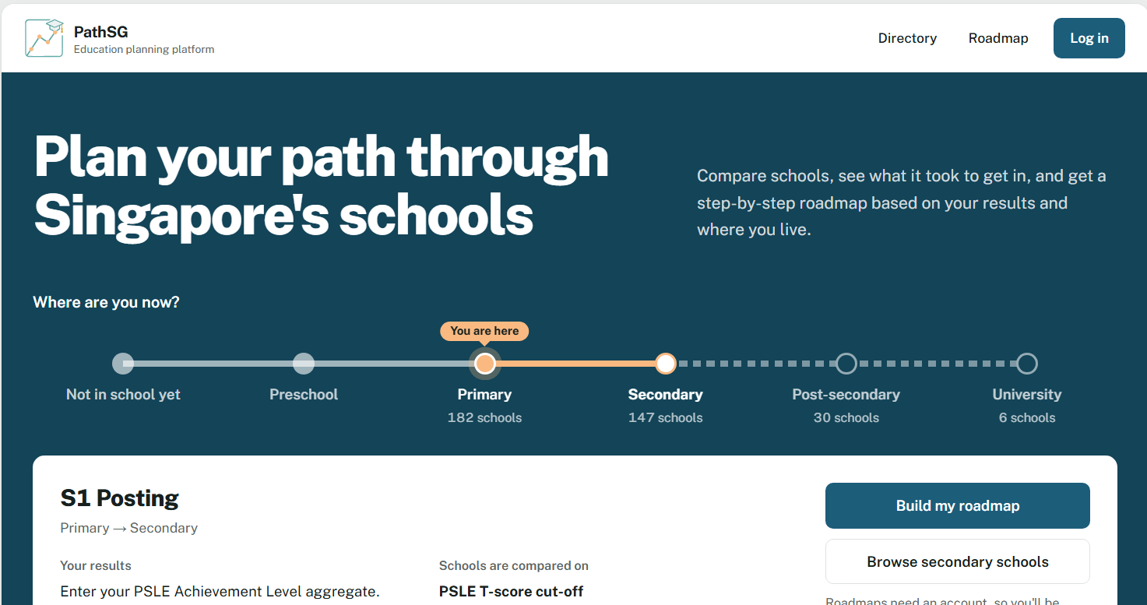
Figure 1: Home Page as a guest (root address), showing the hero heading, route, feature list, privacy panel and welcome panel.

Figure 2: Header as a guest (Directory, Roadmap, Log in).

Figure 3: Header as a signed-in student (Directory, Roadmap, Saved, My Profile, username and Log out).

Figure 4: Header as an administrator (the same as Figure 3, plus the Admin Panel link).

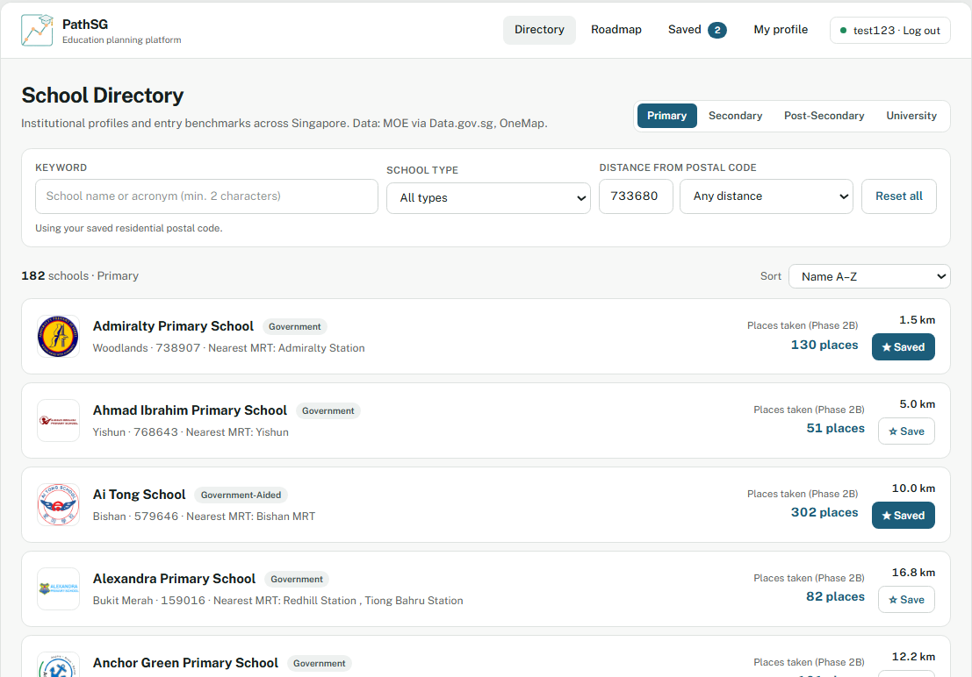
Figure 5: School Directory with a tier selected: search bar, filter panel.
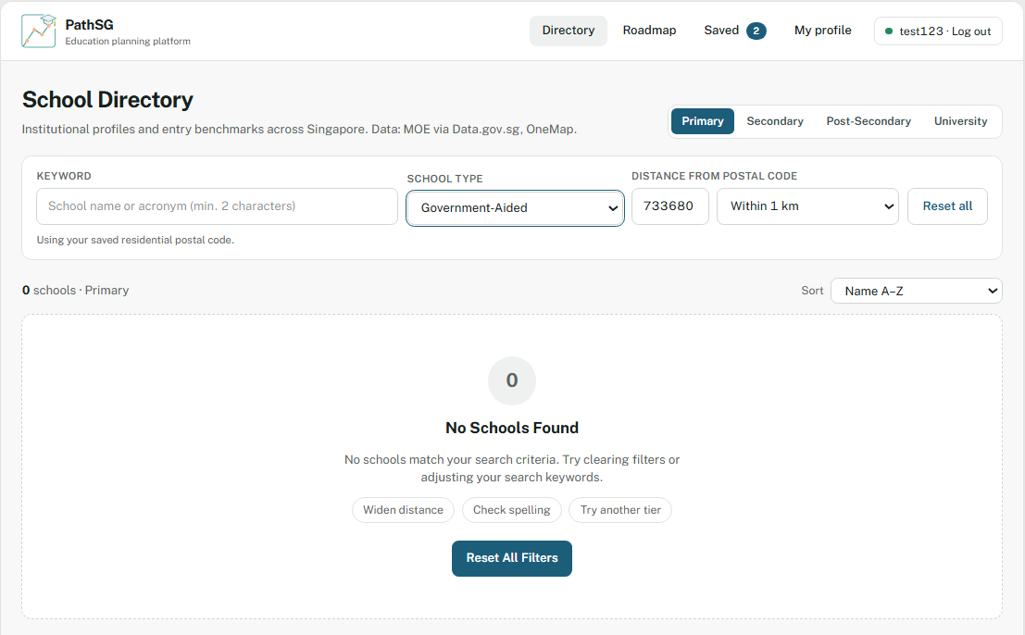
Figure 6: Directory “No schools Found” empty state with the Reset All Filters button.
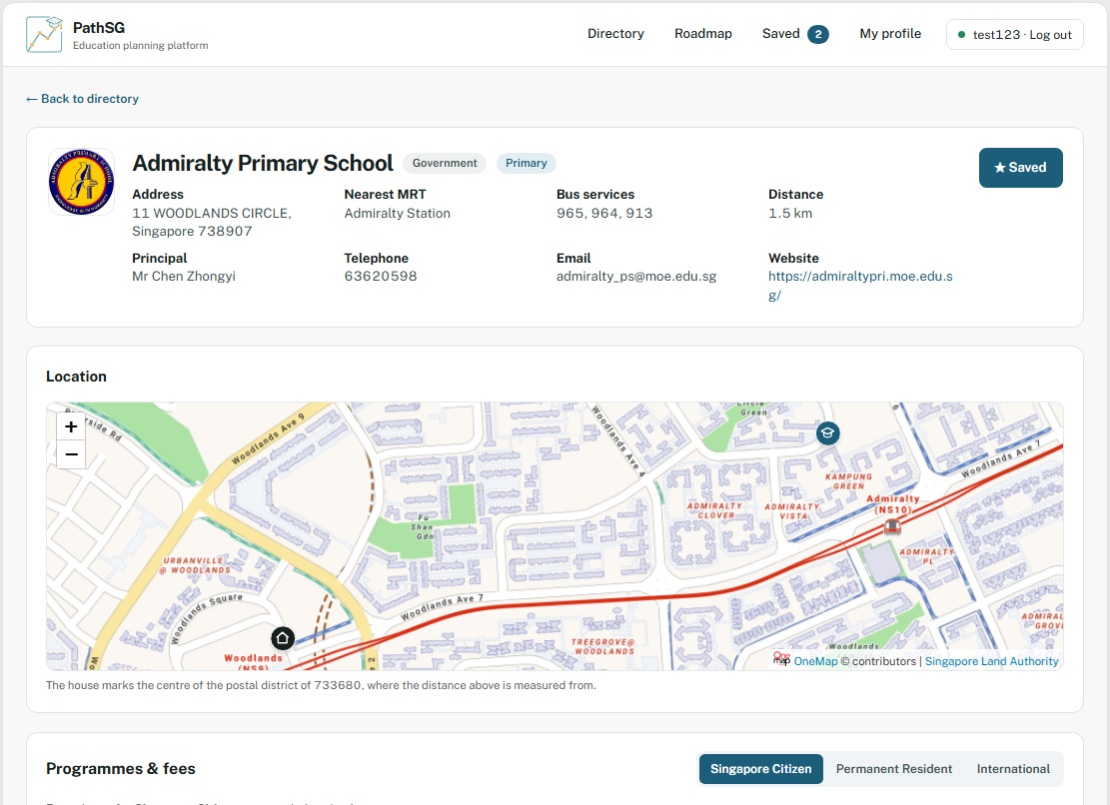
Figure 7: School profile page: identity, location map with the house marker, benchmarks, fees and financial aid.
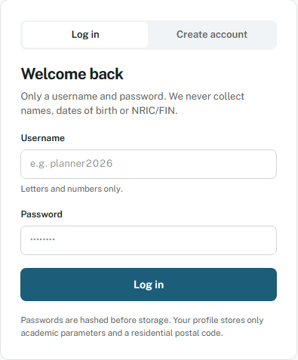
Figure 8: Login and sign-up card.
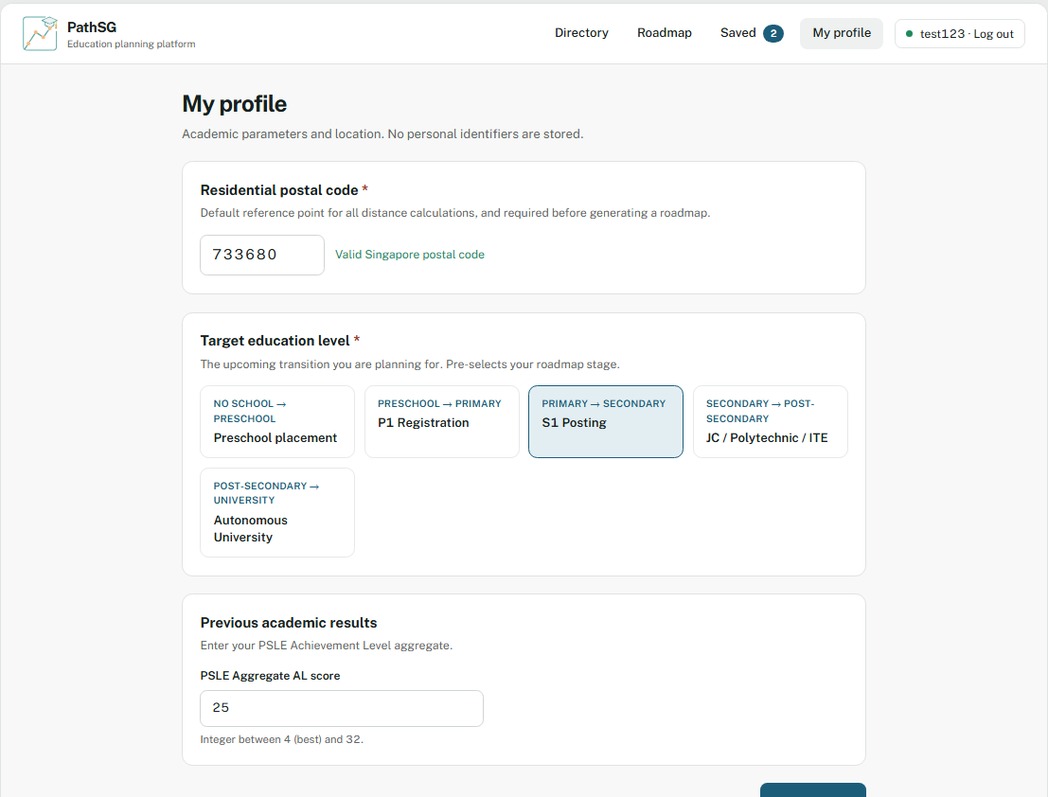
Figure 9: Profile Settings, showing the Target Education Level selector and academic and postal code fields.

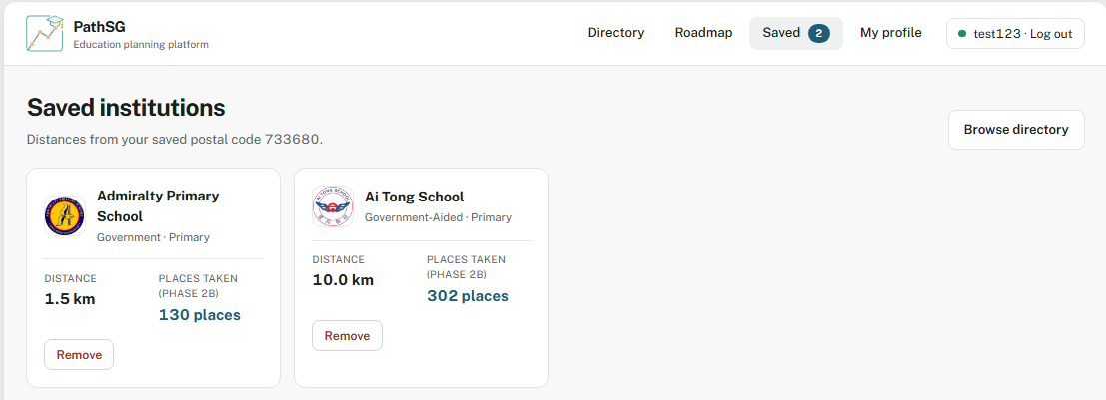
Figure 10: Saved Schools page with bookmark cards and distances.
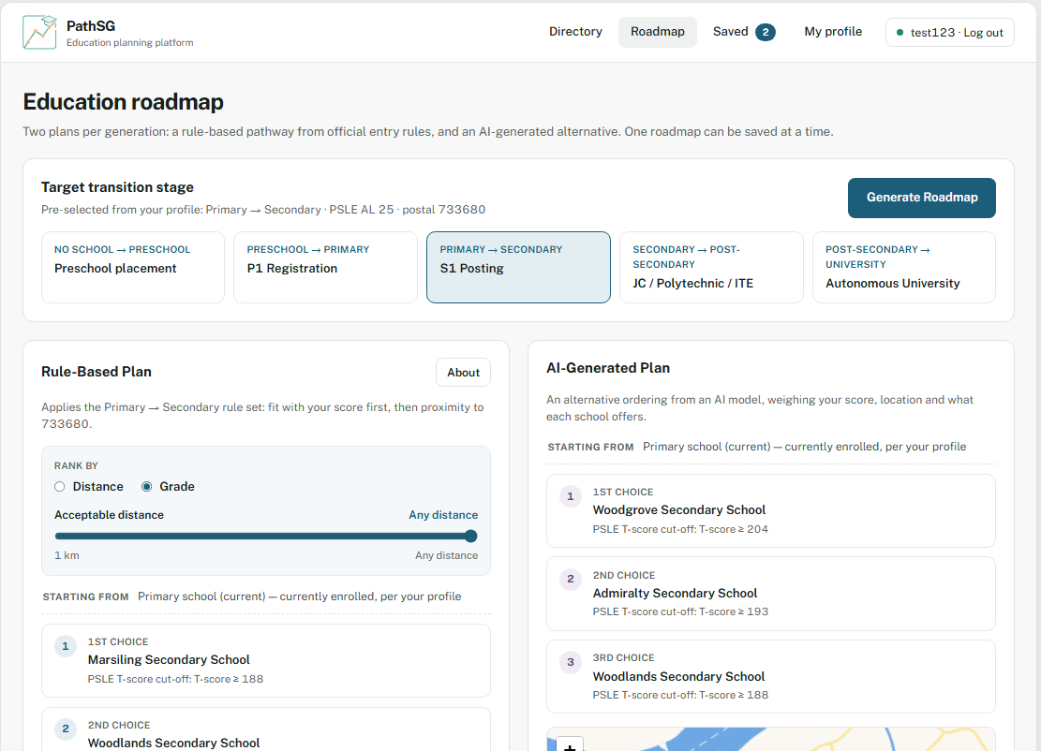
Figure 11: Roadmap page with the Rule-Based Plan panel, including the “Rank by” control and the distance slider (Grade selected).
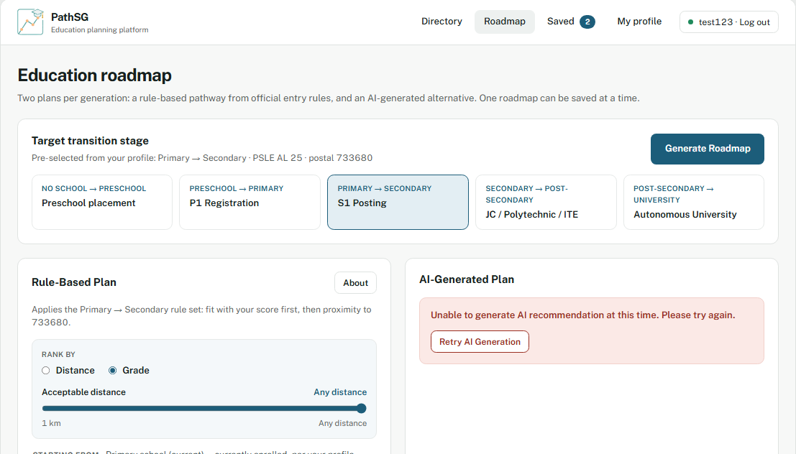
Figure 12: AI-Generated Plan panel showing the error state with the Retry AI Generation button.

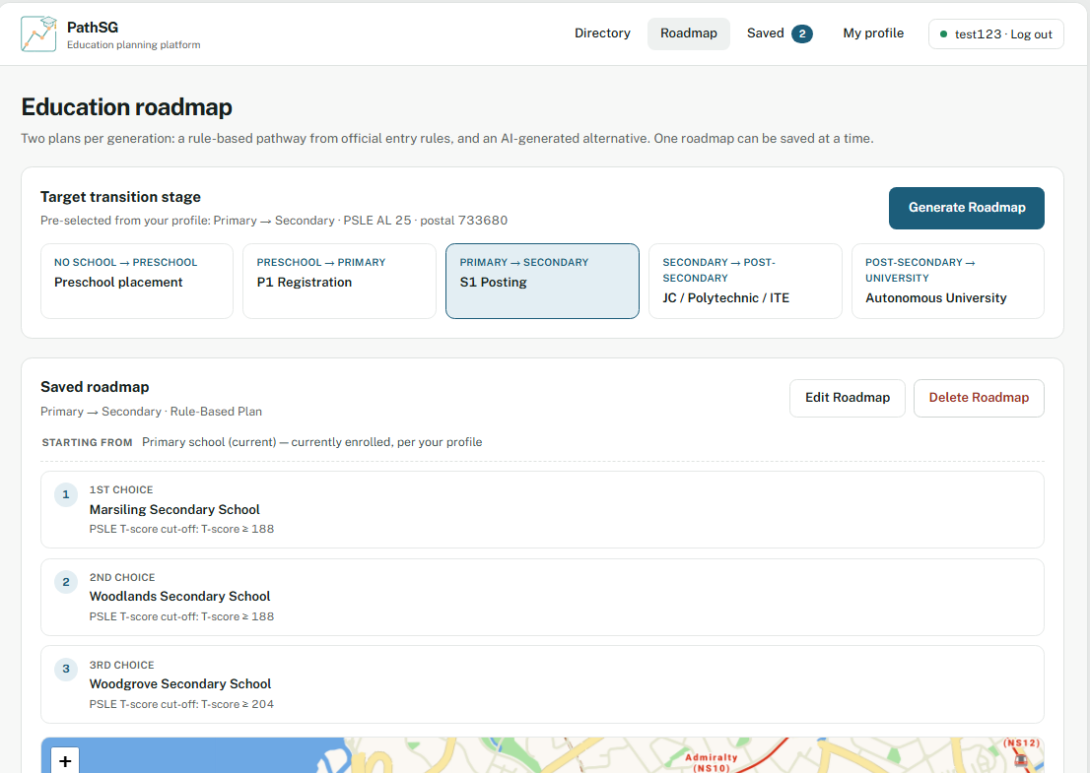
Figure 13: Saved roadmap view with Edit Roadmap and Delete Roadmap controls.

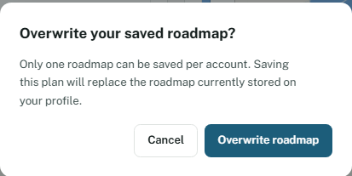
Figure 14: Overwrite roadmap confirmation dialog.

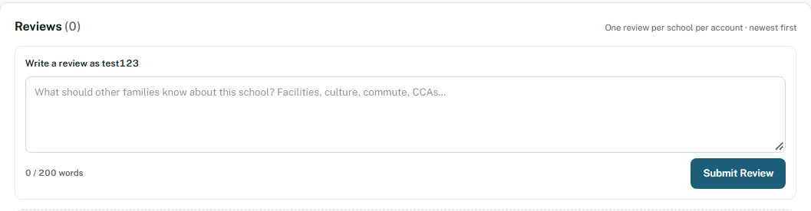
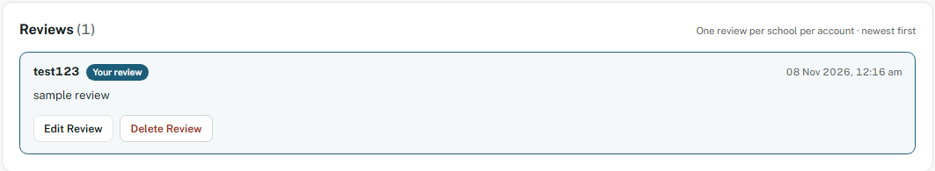
Figure 15: School review section: submission form with the word counter, and an existing review with Edit Review and Delete Review.

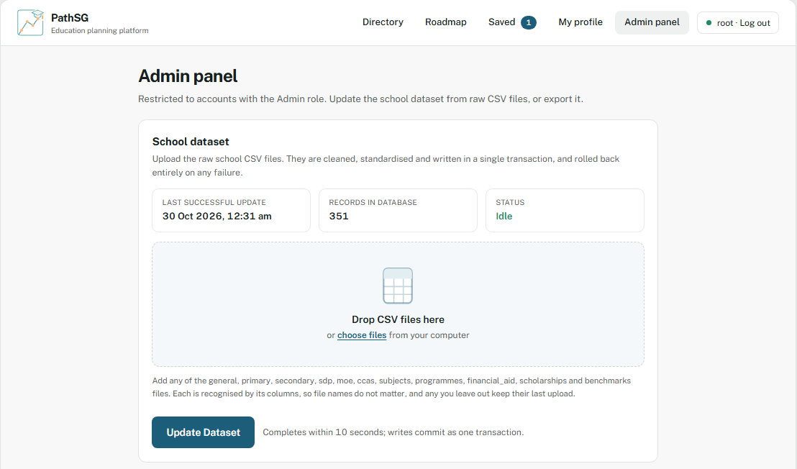
Figure 16: Admin Panel dataset update: status tiles, CSV drop zone and the Update Dataset button.
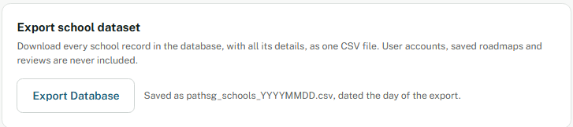
Figure 17: Admin Panel export panel (Export Database).

