PathSG User Guide
For students and parents
Version 2.0 · 9 November 2026 · Prepared by SC2006 SCSL Team 2
Open PathSG at https://pathsg.robothanzo.dev/

1. What PathSG does
PathSG helps you find schools in Singapore and plan the next step in education. You can compare schools, see entry figures and fees, and build an education roadmap.
- Without an account: search schools, view school profiles and read reviews.
- With a free account: save schools, set up your profile, generate and save a roadmap, and write reviews.
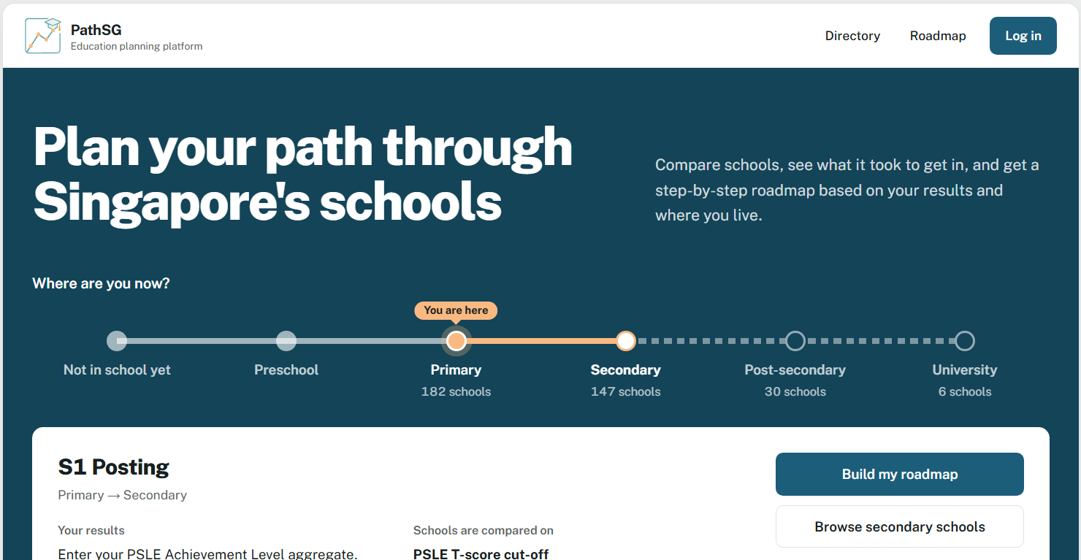
[Figure 1: The Home page, the first page you see when you open PathSG.]

2. Create an account
- Click Log in at the top right.
- Click Create account at the top of the box.
- Enter a username and a password.
- Click Create account. You are logged in and taken to My profile.

Account rules
- Username: letters and numbers only, 1 to 36 characters. No spaces or symbols.
- Password: 8 to 36 characters from a standard keyboard (letters, numbers and symbols, no accented letters), with at least one number and one special character (for example !, @, #).
- Usernames are not case-sensitive, when you create an account or log in. "Jane" and "jane" count as the same name. Passwords are case-sensitive.
- Do not use your real name or NRIC/FIN. PathSG never asks for them.
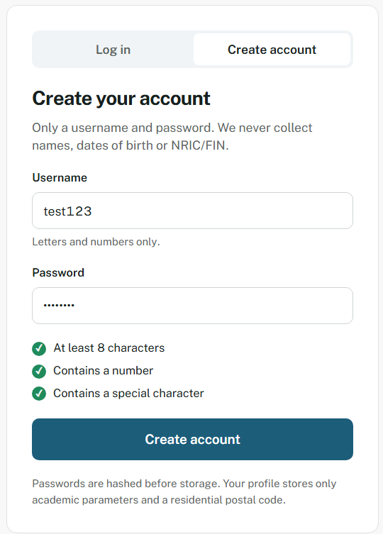
[Figure 2: The Create account box with the password checklist. A green tick shows each rule you have met.]

3. Log in and log out

Log in
- Click Log in at the top right.
- Make sure Log in is selected at the top of the box.
- Enter your username and password.
- Click Log in.
If you try to log in more than 5 times in 5 minutes with the same username, PathSG blocks further attempts. Every attempt counts, whether or not it succeeds. Wait a few minutes and try again.
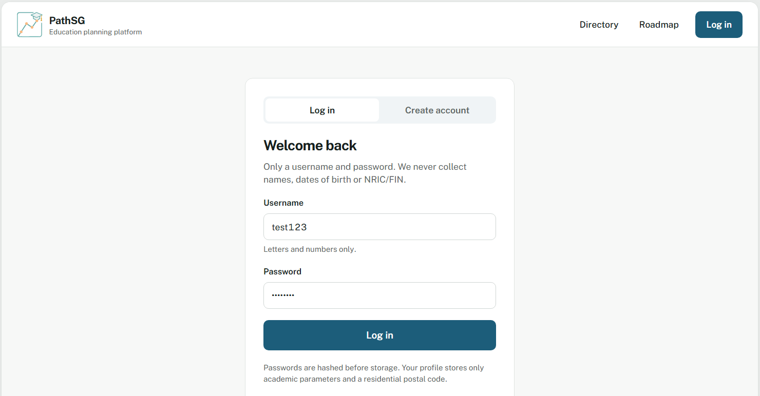
[Figure 3: The Log in box.]

Log out
Click Log out at the top right, next to your username. Always log out on a shared computer.

4. Find a school
- Click Directory in the menu.
- Choose a level: Primary, Secondary, Post-Secondary or University.
- Type a school name or course in Keyword. Enter at least 2 characters.
- Narrow the list with School type, Course or programme or Distance from postal code.
- Choose a sort order: Name A–Z, Name Z–A or Distance (nearest first).
The list updates as you type or choose. Each page shows 10 schools. Use Previous and Next to move between pages.
- Distance is a straight-line estimate from the centre of your postal-code area. It is not a walking or travel distance.
- If you are logged in, PathSG uses the postal code from your profile. Until you save one, the postal box starts with a sample code (556000); type your own to see distances from your home.
- Letters, numbers, spaces, hyphens, full stops and apostrophes are allowed. Other symbols are removed.
- Click Reset All Filters to see the full list again.

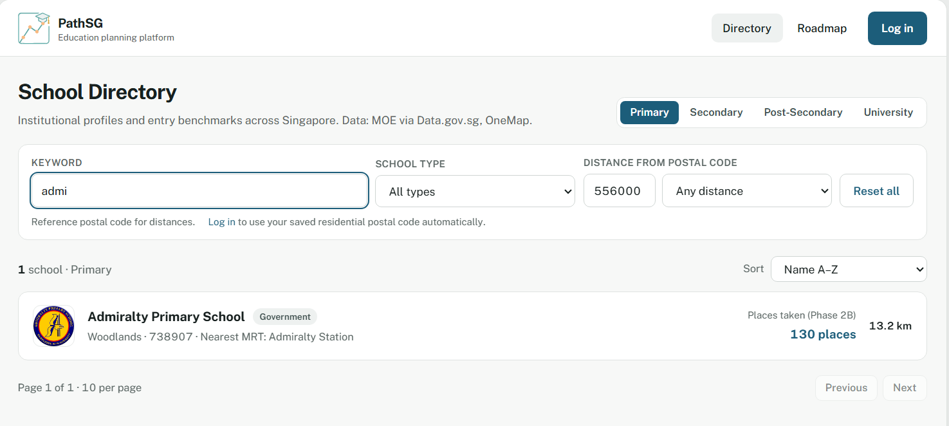
[Figure 4: The Directory with a level selected, a keyword entered and the filter bar.]

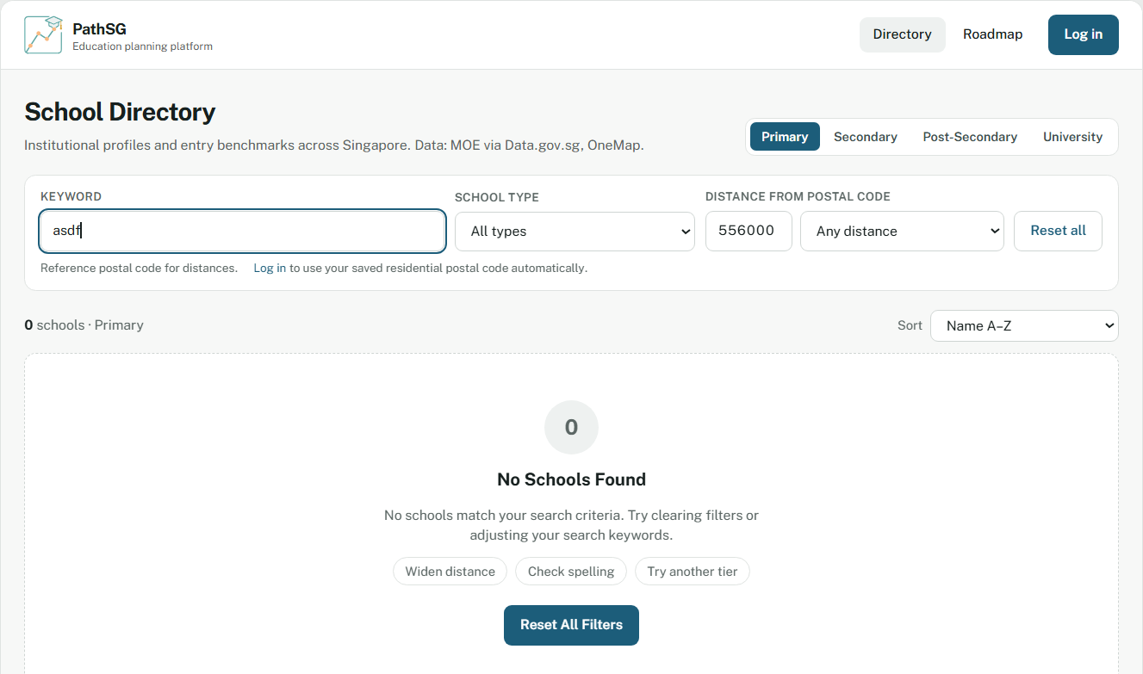
[Figure 5: The "No schools match" message with the Reset All Filters button.]

5. View a school
Click a school’s name or its card. The school profile shows:
- Identity and location: address, nearest MRT, bus services and a map.
- Programmes and fees, by citizenship.
- Entry benchmarks for past years.
- Financial aid and scholarships.
- Subjects and CCAs.
- Reviews from other users.
Click Back to directory to return. If a detail is missing, the page shows Not available. This means the official dataset has no information for it. It is not an error.
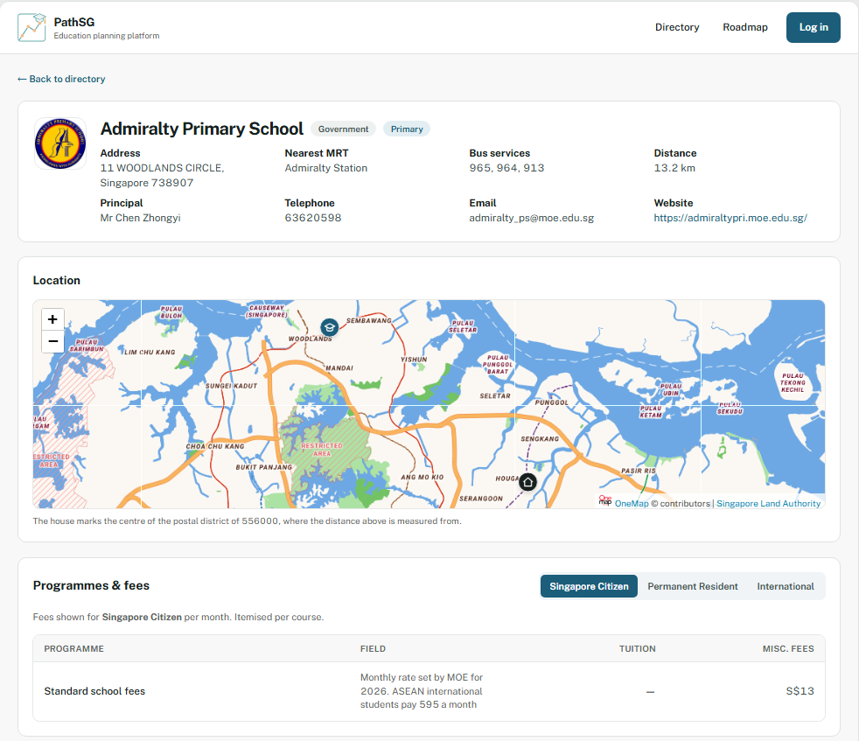
[Figure 6: A school profile page, showing the identity card and fees.]

6. Save schools (account needed)
- Click ☆ Save on a school card or on its profile page. The button changes to ★ Saved.
- Open Saved in the menu. The number beside it shows how many schools you have saved. Distances are measured from the postal code in your profile, so a card says “Add postal code” until you save one. Each card also shows the entry figure the data has: places taken for primary schools and the 2017 PSLE T-score cut-off for secondary schools. Post-secondary and university cards say “Not available”, and their past figures are on the school page.
- To remove a school, click Remove on its card. You can also click ★ Saved on the profile page again.
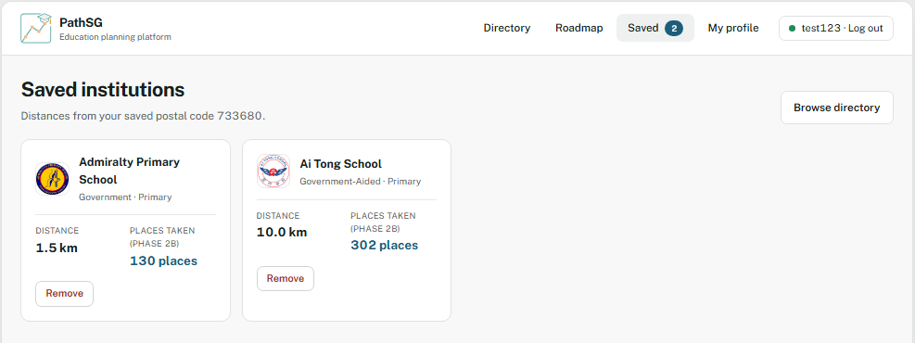
[Figure 7: The Saved page with two schools and their distances from your postal code.]

7. Set up your profile (account needed)
Your profile tells PathSG where you live and which step you are planning for. Open My profile from the menu.
- Enter your 6-digit Singapore postal code. Only digits are accepted. A green note confirms a valid code.
- Click the card for the step you are planning for:
- Preschool placement: your child is about to start preschool.
- P1 Registration: your child is about to enter Primary 1.
- S1 Posting: your child is about to enter Secondary 1.
- JC / Polytechnic / ITE: you are finishing secondary school.
- Autonomous University: you are finishing polytechnic or junior college.
- Enter your result. Only the boxes for your chosen step appear:
- S1 Posting: PSLE Aggregate AL score, a whole number from 4 to 32.
- JC / Polytechnic / ITE: O-Level L1R5 (a whole number from 2 to 54) for JC, or O-Level ELR2B2 (a whole number, 0 or more) for Polytechnic or ITE. Enter either or both.
- Autonomous University: polytechnic cumulative GPA (0.00 to 4.00) and A-Level rank points (0 to 90). Enter either or both.
- P1 Registration: choose None or Kindergarten completion.
- Preschool placement: no result is needed.
- Click Save profile. PathSG saves your details and opens the Roadmap page.
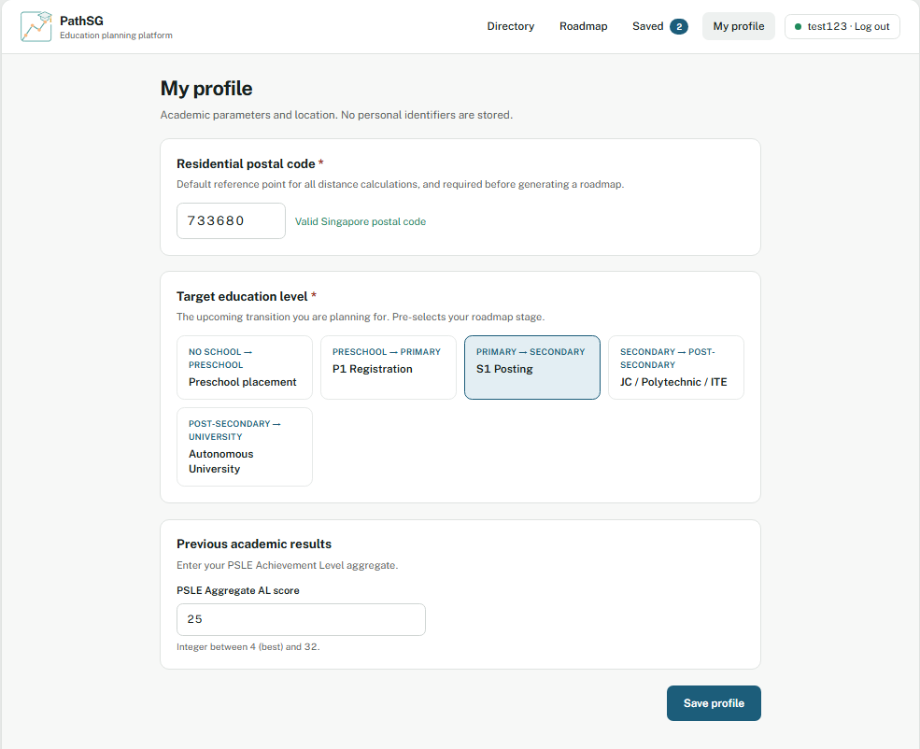
[Figure 8: My profile with a postal code, target step and result filled in.]

8. Generate your roadmap (account and profile needed)
A roadmap has two plans for your chosen step: a Rule-Based Plan and an AI-Generated Plan. You need a postal code in your profile before you can generate a roadmap.
- Open Roadmap from the menu. Your target step is already selected from your profile. If you pick a different step, your saved results are not used for it.
- Click Generate Roadmap.
- Read the Rule-Based Plan. It appears first.
- Read the AI-Generated Plan. It can take a few seconds to appear. If it fails, click Retry AI Generation.
- Click Save Roadmap under the plan you prefer.
- Rank by: once the plans appear, choose Distance or Grade in the Rule-Based Plan panel. The Secondary and Post-Secondary steps let you choose. Primary ranks by distance only.
- Preschool placement and Autonomous University have no Rule-Based Plan, so only the AI-Generated Plan is made for them. PathSG has no preschools in its data yet, so the Preschool plan has no schools to show.
- Acceptable distance: appears when Grade is selected. Move the slider from 1 km to Any distance. Only the Rule-Based Plan changes.
- If no school is within your chosen distance, PathSG asks you to try a larger distance. That plan cannot be saved.
- If you request AI plans many times in a short time, PathSG may stop you. Wait a few minutes and try again.

Edit or delete a saved roadmap
- Edit: click Edit Roadmap, choose a different school for any choice, then click Save Changes. Click Cancel to discard your changes.
- Delete: click Delete Roadmap and confirm.
- Replace: saving a new roadmap replaces the saved one. PathSG asks you to confirm first.
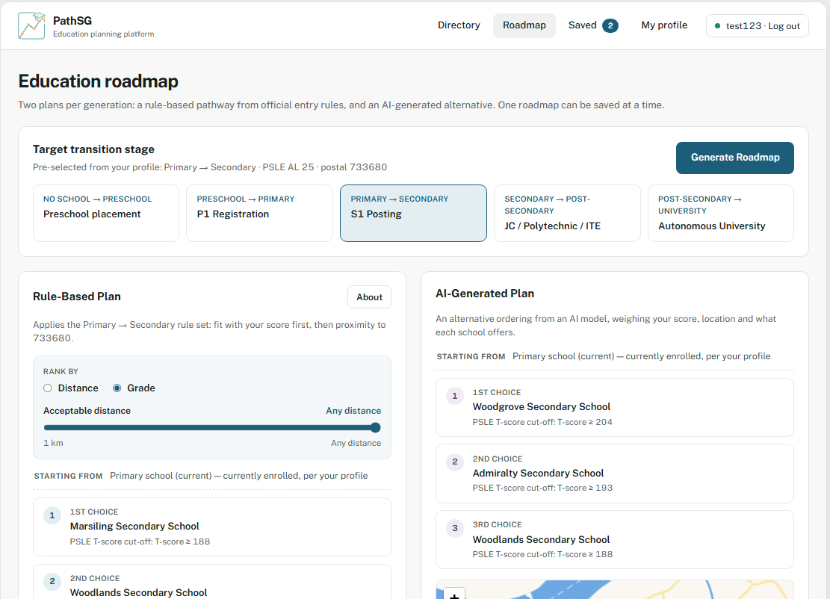
[Figure 9: The Roadmap page with the Rule-Based Plan and the AI-Generated Plan.]

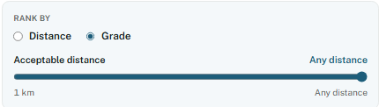
[Figure 10: The Rank by options and the acceptable distance slider.]

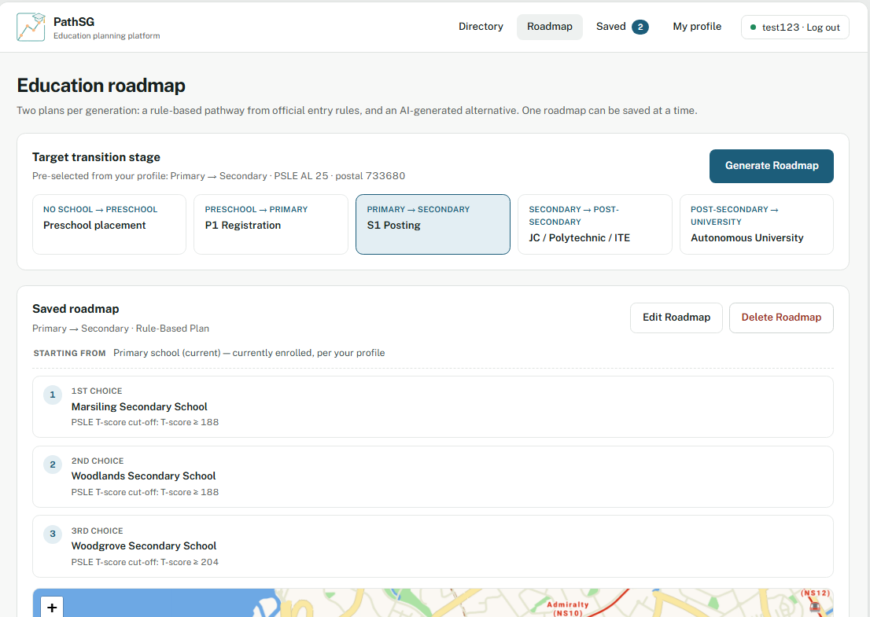
[Figure 11: A saved roadmap with the Edit Roadmap and Delete Roadmap buttons.]

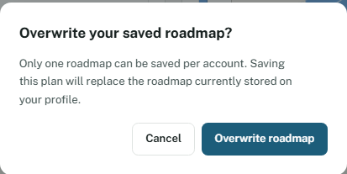
[Figure 12: The confirmation message shown before a saved roadmap is replaced.]

9. Write a school review (account needed)
- Open a school’s profile and scroll to Reviews.
- Type your review. The counter shows your word count, up to 200 words.
- Click Submit Review.
- You can post one review per school.
- To change your review, click Edit Review, change the text and click Update Review. To remove it, click Delete Review and confirm.
- Guests can read reviews but must log in to post one.
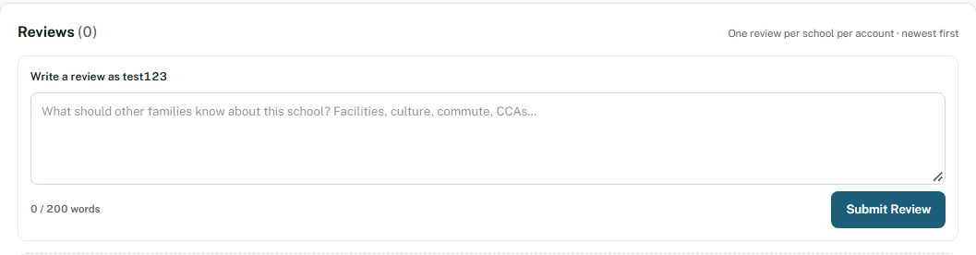
[Figure 13: The review section with the word counter and the Submit Review button.]

10. Common messages
- "Enter at least 2 characters to search." Type at least two characters.
- "Please enter a valid 6-digit Singapore postal code." Check that you have typed six digits.
- "This postal code could not be located." Check the six digits.
- "Missing Profile Information." Enter your postal code in My profile, then generate the roadmap again.
- "Too many login attempts." Wait a few minutes and try again.
- "Your session has expired. Please log in again." Log in again. Your saved information is not lost.
- "Unable to generate AI recommendation at this time." Click Retry AI Generation. If it still fails, try later. The Rule-Based Plan still works.

11. Your privacy
PathSG stores only your username, your password in protected form, your academic results, your postal code, and the schools, roadmaps and reviews you create. It never asks for your real name, date of birth or NRIC/FIN.

