PathSG User Guide
Plan your education journey in Singapore: find schools, set up your profile and generate your roadmap.
- Product: PathSG, Education Planning Platform
- Document: User Guide, Version 1.0
- Prepared by: SC2006 SCSL Team 2
- Date: 25 October 2026
- Based on: Software Requirements Specification (SRS) v1.0, section 2.6 User Documentation
- Open PathSG at: https://pathsg.robothanzo.dev/

Contents
- Welcome to PathSG
- Getting started
- Browse schools
- Create an account and log in
- Set up your profile
- Save schools to your list
- Generate your education roadmap
- Read and write school reviews
- Troubleshooting and questions
- Your privacy
- Appendix A: Administrator guide
- Appendix B: Glossary

1. Welcome to PathSG
PathSG puts information about Singapore schools in one place, so you no longer have to visit many different websites. It also helps you plan ahead: you tell PathSG where you are in your education and where you live, and it suggests a pathway of schools.
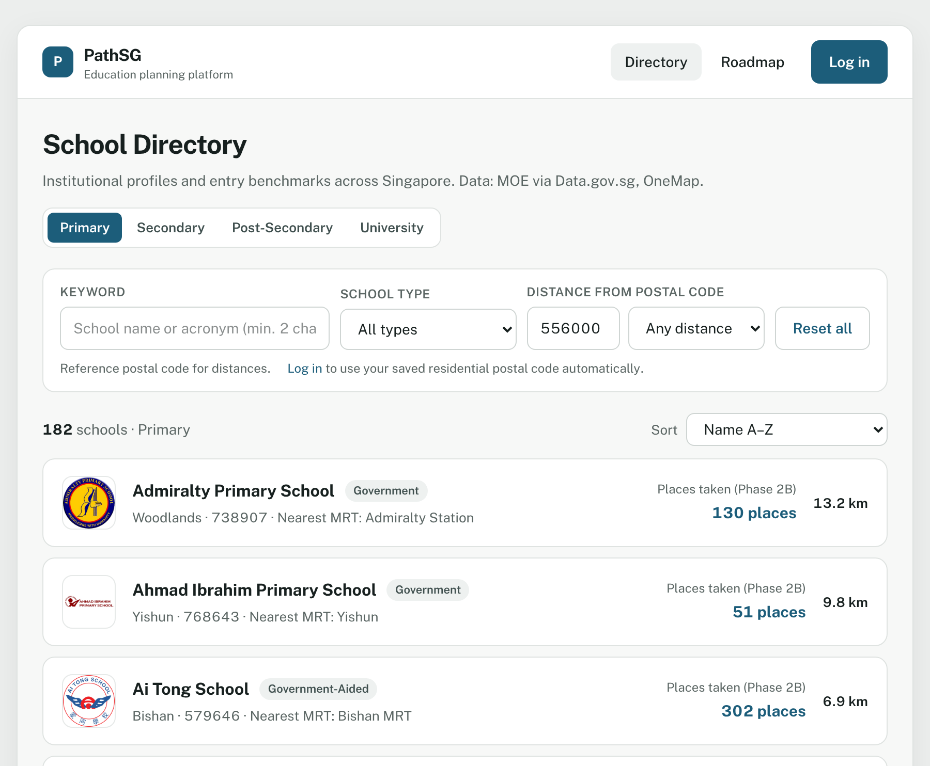
Figure 1 – The School Directory is the first page you see. You do not need an account to use it.

Who is this guide for?
This guide is written for parents and students. It explains every step in plain language. You do not need any technical knowledge.

What can I do?
What you can do | Without an account (guest) | With a free account
Search, filter and sort schools | ✔ | ✔
Open a school’s profile and see its benchmarks, programmes and activities | ✔ | ✔
Read reviews written by other users | ✔ | ✔
Save your postal code, target level and academic results |  | ✔
Save schools to a personal list and see how far they are from home |  | ✔
Generate, save, edit and delete an education roadmap |  | ✔
Write, edit and delete your own school reviews |  | ✔

Quick start: five steps
- Browse the School Directory and open a few schools (section 3).
- Create an account (section 4).
- Set up your profile: postal code, target level and results (section 5).
- Generate your roadmap and compare the two plans (section 7).
- Save the plan you like. You can edit or delete it later.

What you need
- A phone, tablet or computer with the latest Google Chrome, Mozilla Firefox or Apple Safari.
- An internet connection.
- For the roadmap: your 6-digit home postal code and your latest exam result (if your target level needs one).
Good to know: what data you will see. School information comes from the Ministry of Education (MOE) through Data.gov.sg. PathSG shows only what the current dataset contains. Where a detail is missing, the page says Not available. That is normal and not an error. See section 3.6 for what is covered today.

2. Getting started

2.1 Open PathSG
Open your browser and go to https://pathsg.robothanzo.dev/. The School Directory opens. You can start browsing straight away.

2.2 Find your way around: the menu
The menu is at the top of every page.
Figure 2 – The menu for a guest. After you log in, more items appear.
Menu item | What it opens | Who sees it
PathSG logo | Back to the School Directory | Everyone
Directory | Search and filter schools | Everyone
Roadmap | Generate and manage your education roadmap | Everyone (guests are asked to log in first)
Saved (with a number) | Your saved schools. The number is how many you have saved. | Logged-in users
My profile | Your postal code, target level and results | Logged-in users
Admin panel | Update or export the school data | Administrators only
Log in | The log-in and sign-up page | Guests
your name · Log out | Logs you out | Logged-in users

2.3 Using PathSG on your phone
PathSG works on phones, tablets and computers. On a small screen the menu folds into one button.
- Tap the menu button (three lines) at the top right.
- Tap the page you want. The menu closes by itself.
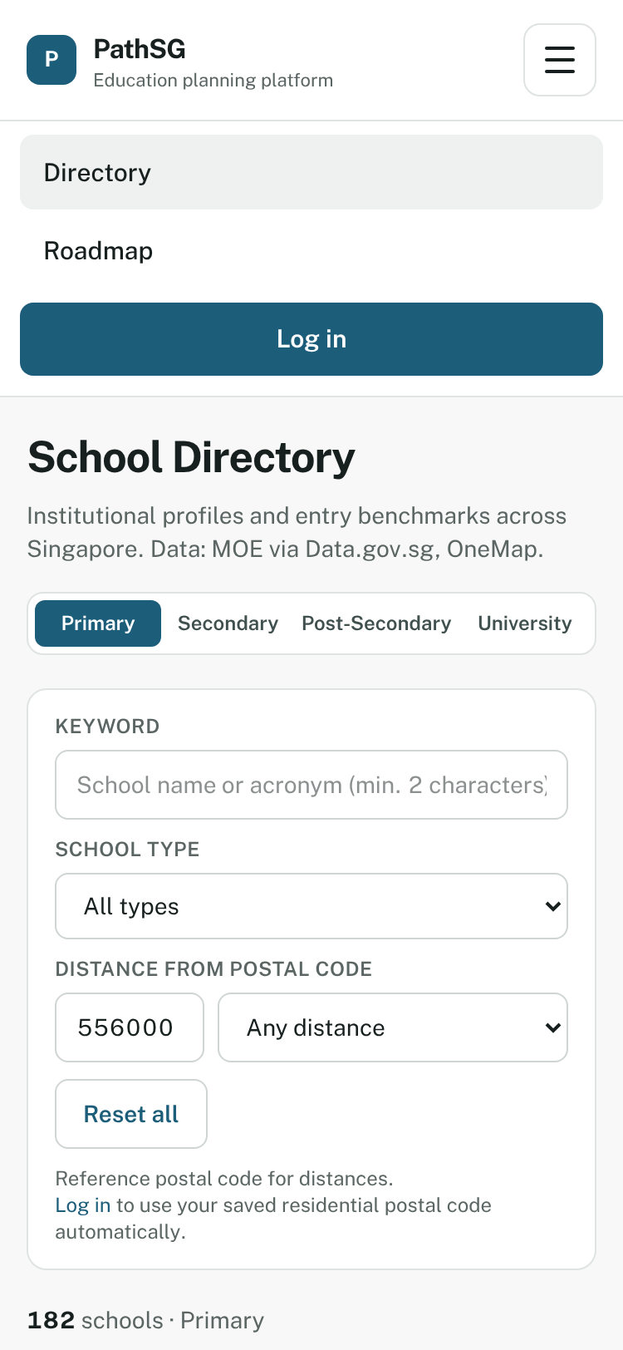
Figure 3 – On a phone, the menu button opens a list of pages. Each item is large enough to tap easily.

2.4 Messages you will see
PathSG talks to you in four ways. Each one looks different, so you always know what is happening.
Message type | Where it appears | Example
Notice banner | A yellow bar just under the menu. It goes away when you open another page, or when you click Dismiss. | “Roadmap saved to your profile.”
Pop-up message | A box in the middle of the screen. It asks you to confirm something, or reports a serious problem. Close it with its button or the Esc key. | “Delete saved roadmap?”
Green pop-up at the bottom | A short confirmation that disappears after a few seconds. | “Profile saved successfully”
Red error message | Next to the box that has the problem. | “Please enter a valid 6-digit Singapore postal code.”
While information loads you will see a small spinning circle.

3. Browse schools (no account needed)
Open Directory in the menu.

3.1 Choose a level
At the top right of the page, pick the level you are interested in:
Primary · Secondary · Post-Secondary · University
The list below changes straight away. Schools are shown 10 per page. Use Previous and Next at the bottom to move between pages. A school that covers more than one level (for example a school with an Integrated Programme) appears under each level it covers.

3.2 Search and filter
Everything in the search box updates the list as you type or choose. There is no Search button to press.
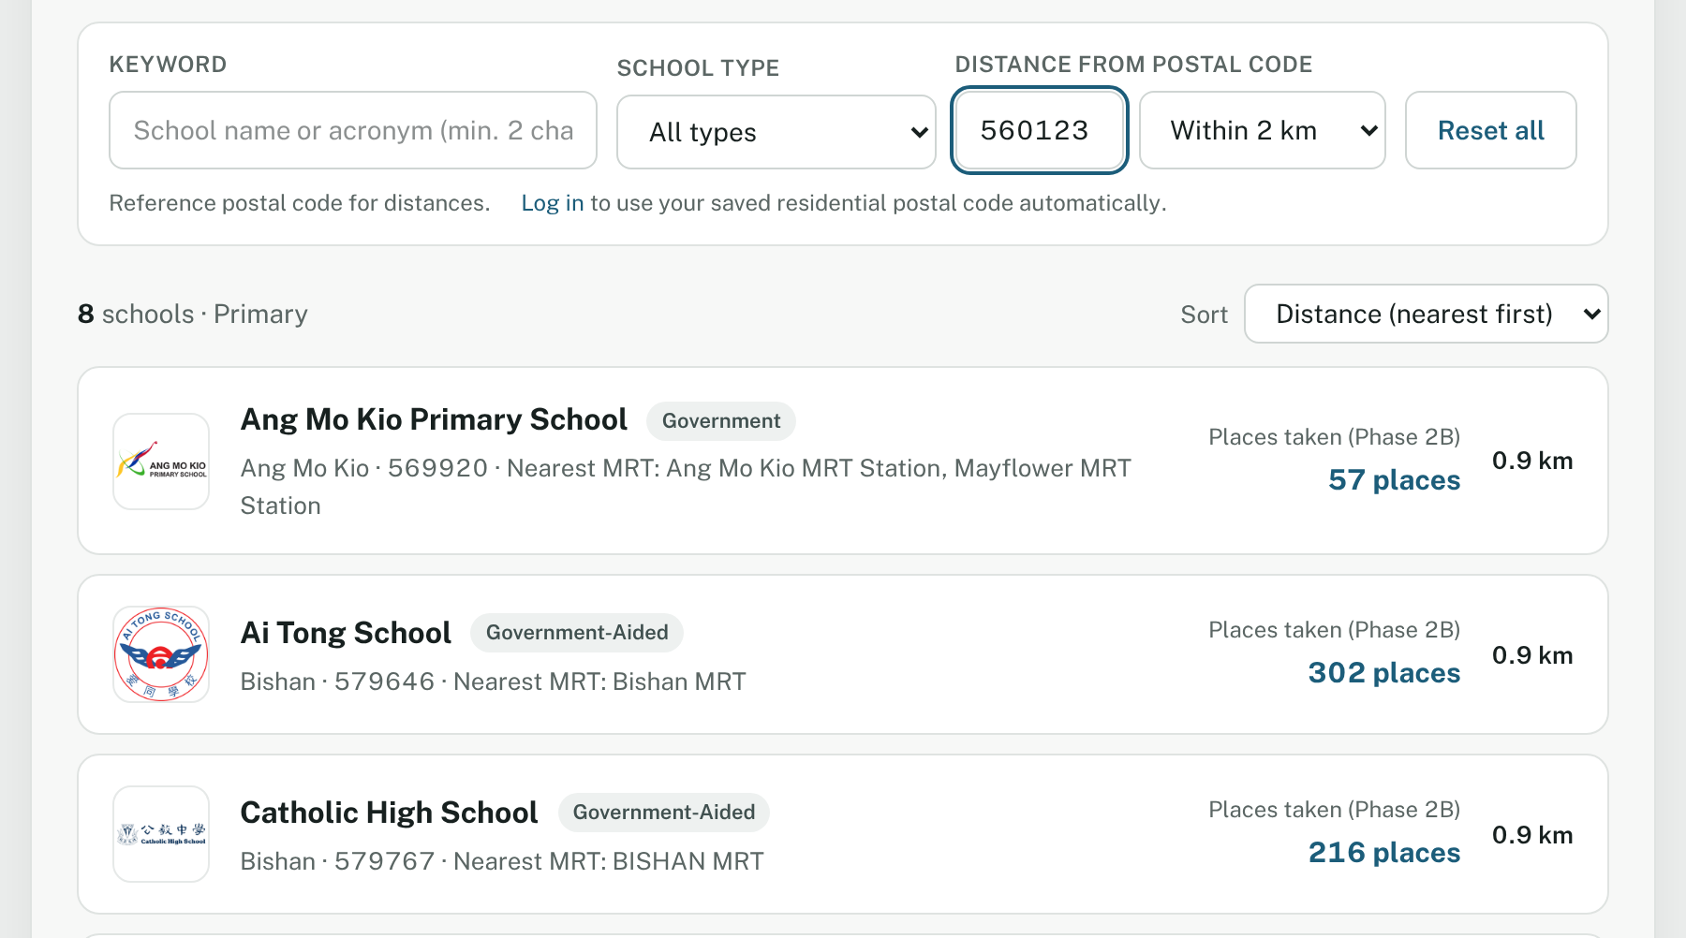
Figure 4 – Here the list is limited to schools within 2 km of postal code 560123, nearest first.
Control | What it does
Keyword | Type part of a school’s name or short name (for example “Raffles” or “RI”). You need at least 2 characters.
School type | Show only one type, such as Government, Government-Aided or Independent. The default is All types.
Distance from postal code | Type a 6-digit postal code in the small box, then choose Within 1 km, Within 2 km or Within 5 km. The default is Any distance.
Sort (above the list) | Name A–Z, Name Z–A or Distance (nearest first).
Reset all | Clears everything and shows the full list again.
Tips
- Logged in? PathSG uses the postal code from your profile automatically. A guest starts with a sample postal code and can type their own.
- In the keyword box you can use letters, numbers, spaces, hyphens (-), full stops (.) and apostrophes (’). Other symbols are removed and PathSG tells you so. If you type only one character it asks you to “Enter at least 2 characters to search.”
- Distances are approximate straight-line distances from the centre of your postal-code area to the school. They are not walking or travel distances.
- If your postal code cannot be found you will see “This postal code could not be located.” Check the six digits.

3.3 Read a school card
Each result is a card. It shows the school’s logo, name, type, area, postal code, nearest MRT station, an entry figure (see section 3.6) and your distance from the school. If you are logged in there is also a ☆ Save button (section 6).

3.4 When no schools match
If nothing matches your search, PathSG shows No Schools Found with suggestions: widen the distance, check your spelling, or try another level.
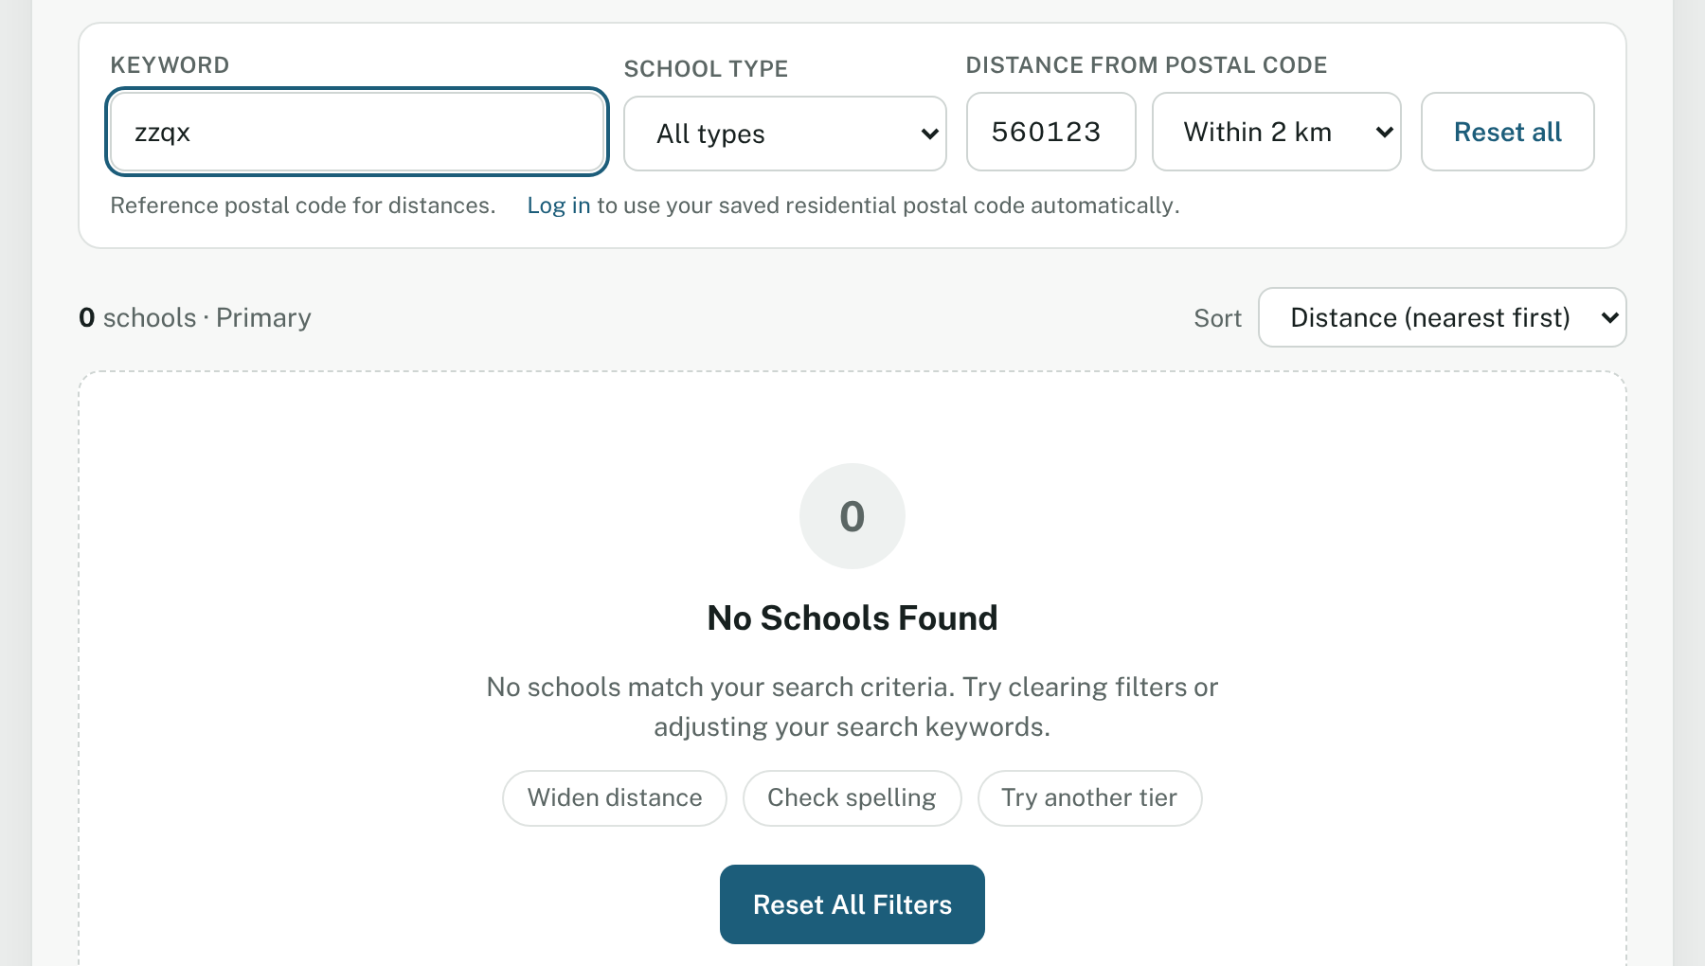
Figure 5 – Press Reset All Filters to go back to the full list.

3.5 Open a school’s profile
Click a school’s name or anywhere on its card. The profile page opens. Use ← Back to directory at the top to return.
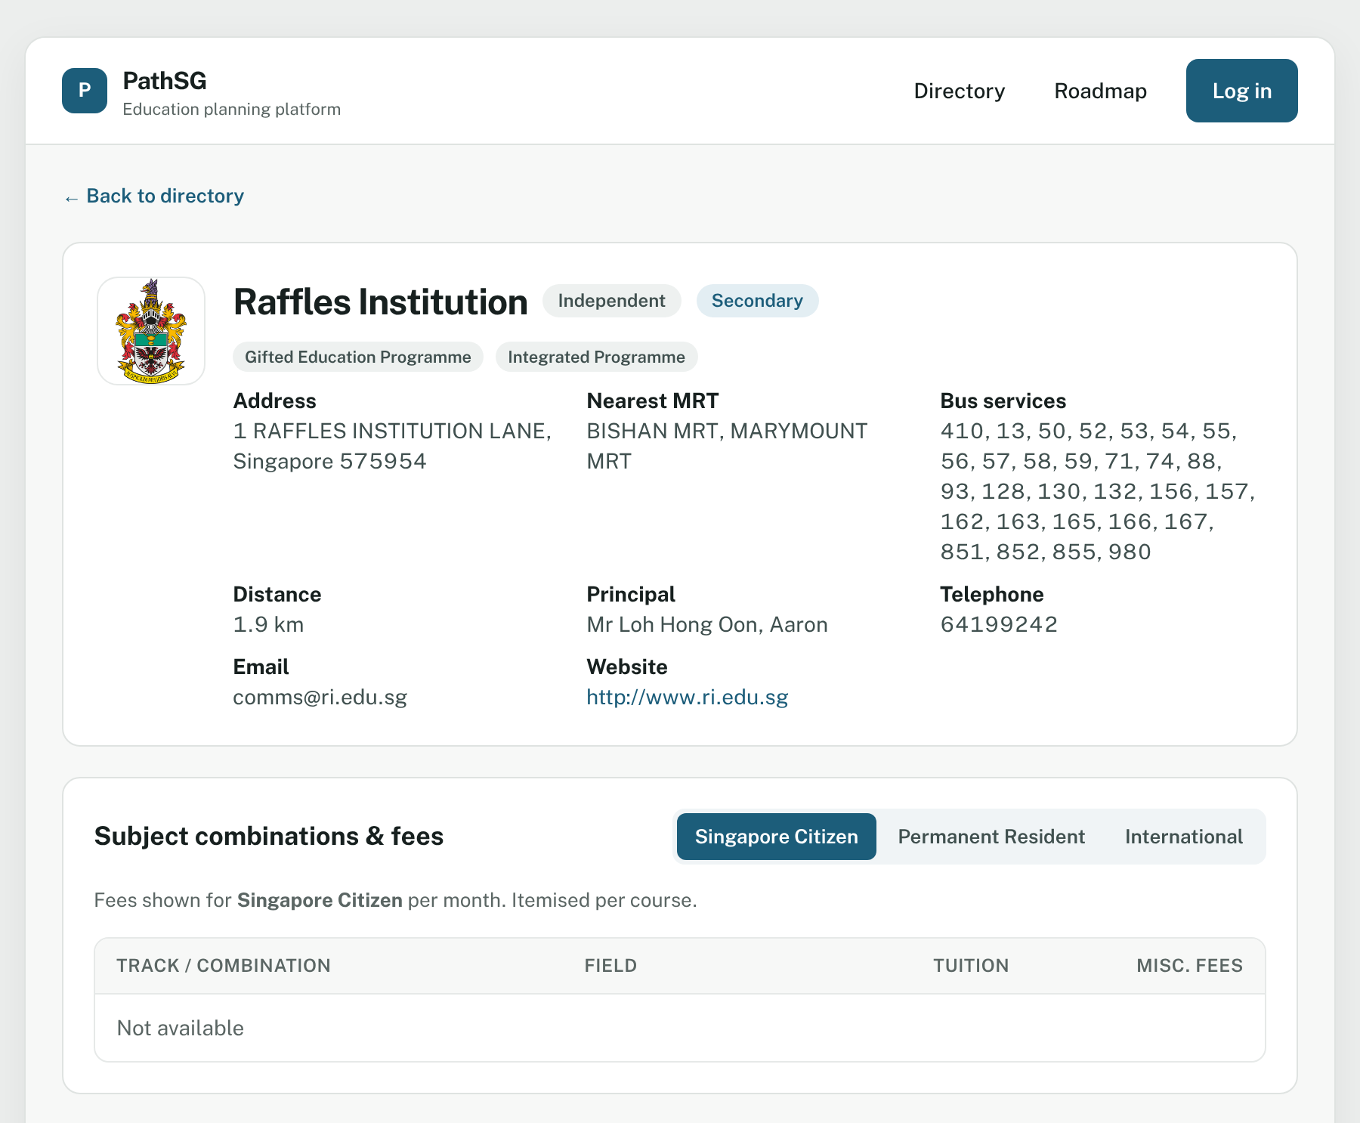
Figure 6 – The top of a school profile: identity, contact details and fees.
The profile has these sections, from top to bottom:
Section | What you will find
Identity card | Logo, name, school type and level, special programmes (such as Integrated Programme or Gifted Education Programme), address, nearest MRT, bus services, distance from your postal code, principal, telephone, email and website.
Courses and fees | Fees by citizenship. Use the switch (Singapore Citizen, Permanent Resident, International) to see each group.
Historical entry benchmarks | The school’s past entry figure, shown as a bar. A note under the heading explains the figure.
Financial assistance and Scholarships | Help available for the school’s students.
Programmes, subjects & CCAs | Special programmes, every subject offered, and co-curricular activities grouped by category.
Reviews | What other users say (section 8).
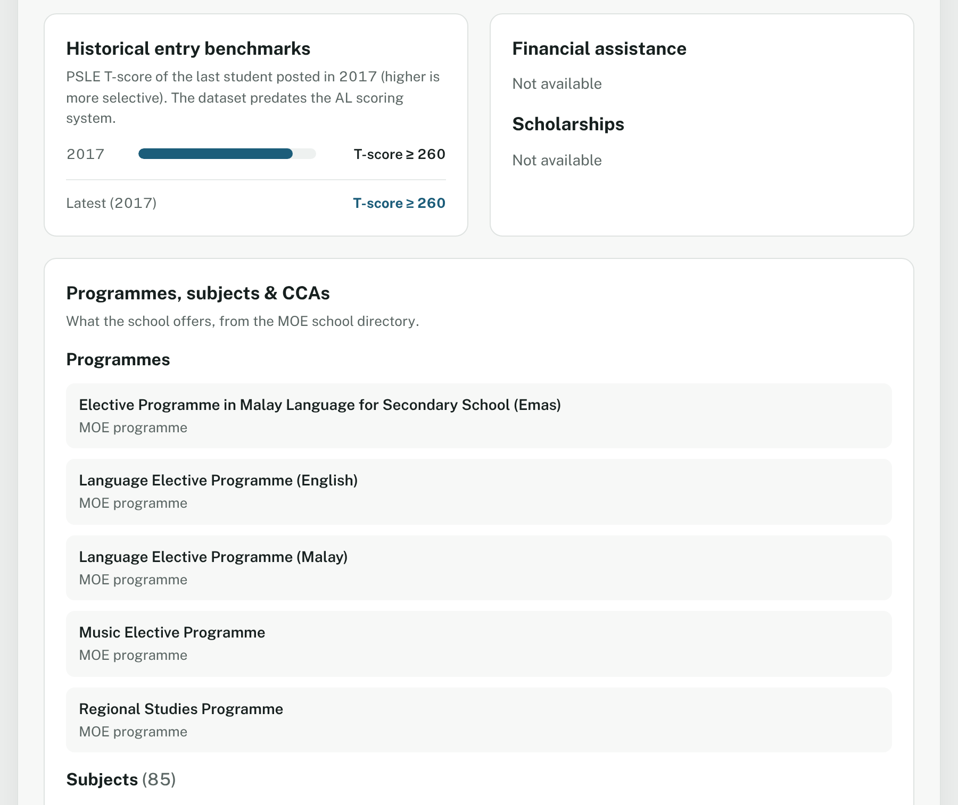
Figure 7 – Further down the page: entry benchmark, financial help, and the programmes the school offers.

3.6 What you will and will not find on a school page
PathSG shows the data it has. At the time of writing:
Item | What the current data covers
Primary schools | Number of places taken up to Phase 2B of P1 Registration (the latest figure available).
Secondary schools | The 2017 PSLE T-score cut-off. This is not the newer AL score, so use it only as a rough guide.
Post-Secondary | Junior colleges and one centralised institute are listed. Their entry figure shows Not available. Polytechnics and ITE are not in the current dataset.
University | No universities are in the current dataset, so this tab says No University schools yet.
Fees, financial assistance and scholarships | These sections are part of every school page but currently say Not available. Please check the school’s own website for fees and aid.

4. Create an account and log in
An account lets you save your profile, your schools, your roadmap and your reviews. It is free, and it needs only a username and a password.

4.1 Create an account
- Click Log in at the top right of the page.
- At the top of the box, choose Create account.
- Type a username: letters and numbers only (A–Z, a–z, 0–9), up to 36 characters. No spaces or symbols.
- Type a password: 8 to 36 characters, with at least one number and at least one special character (for example !, @, #, $).
- Watch the checklist under the password box. Each rule gets a green tick when you meet it.
- Click Create account.
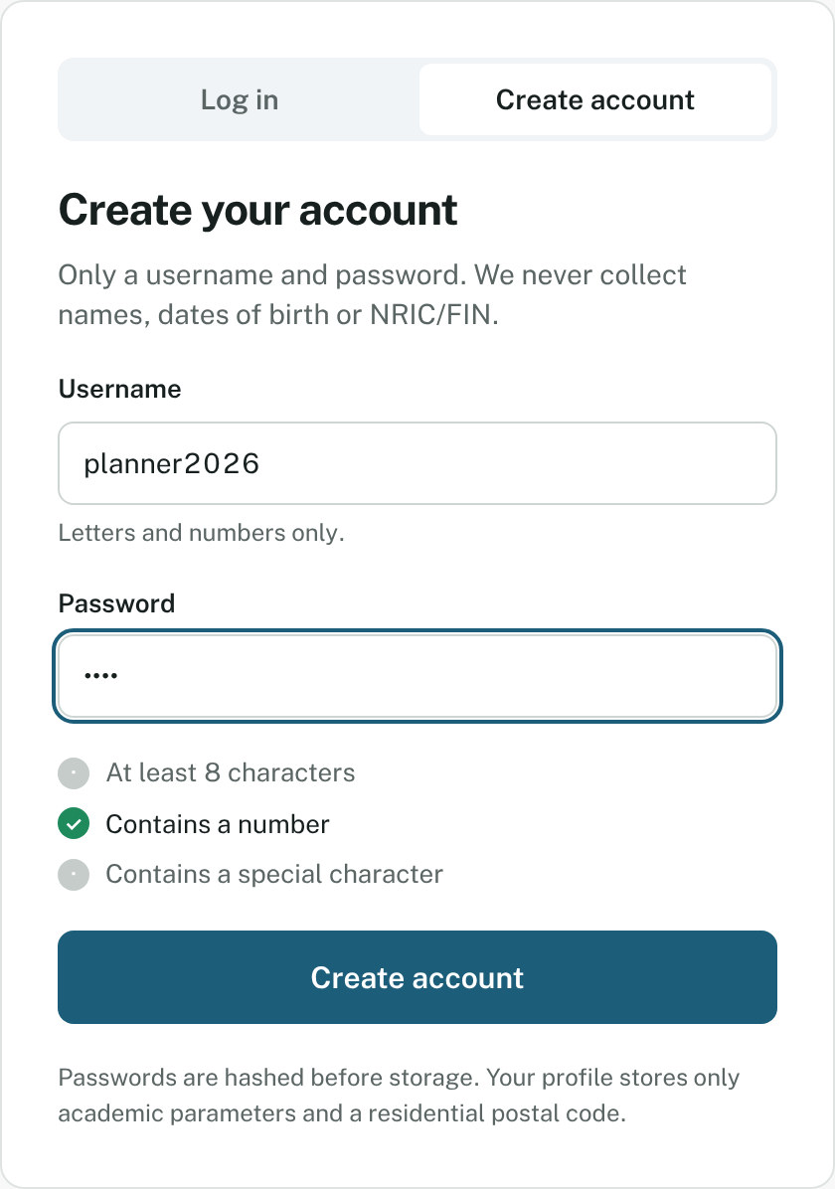
Figure 8 – The checklist shows which password rules are met. Here only “Contains a number” is.
PathSG creates your account, logs you in and opens My profile. A yellow banner says: “Account created. Set your target level and postal code to get started.”
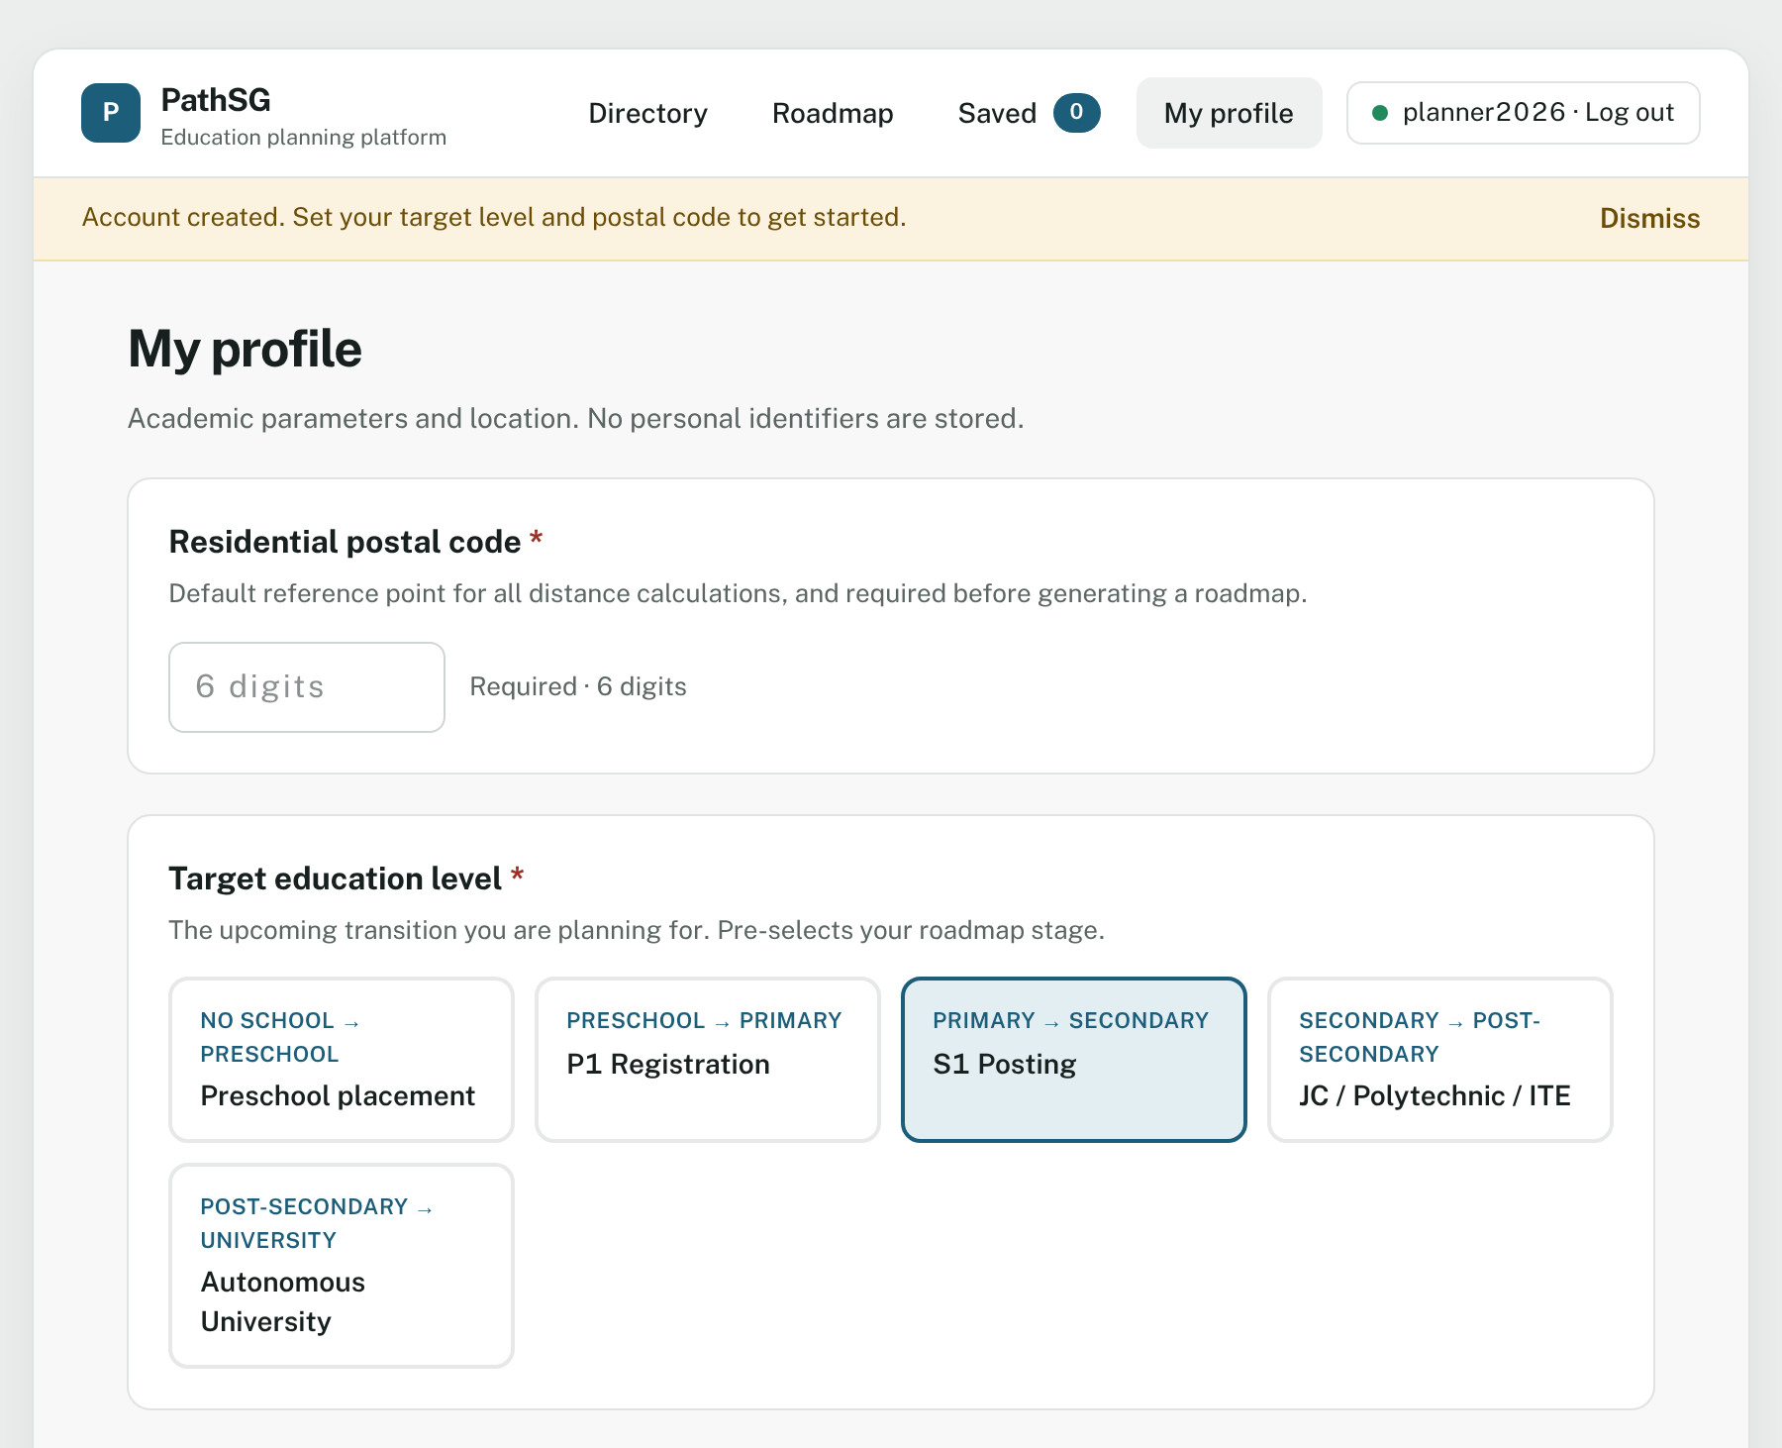
Figure 9 – Your new account opens on My profile, ready to be filled in.
Please note: PathSG will never ask for your real name, age, date of birth or NRIC/FIN. Pick a username that does not reveal who you are.
If something goes wrong
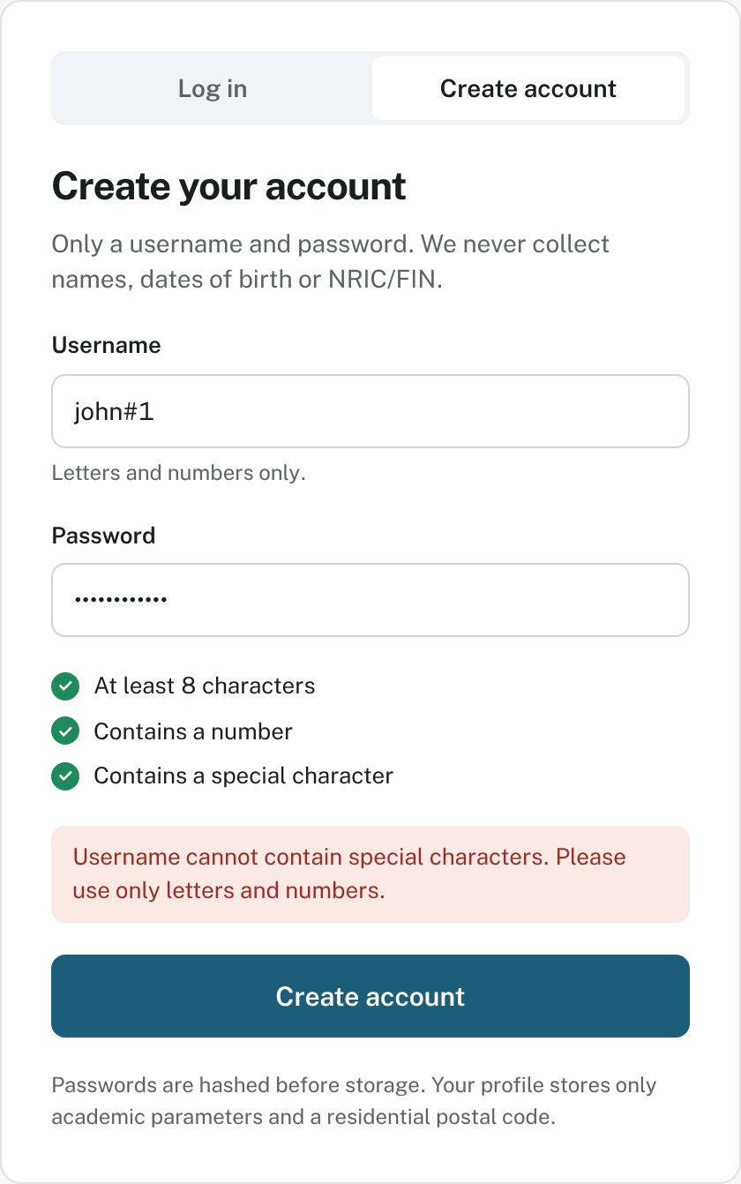
Figure 10 – A red message appears when the username has a symbol such as # or *.
You see | What it means | What to do
Enter a username. | The username box is empty. | Type a username.
Username cannot contain special characters. Please use only letters and numbers. | Your username has a space or symbol. | Remove it.
Password must be at least 8 characters long and contain at least one number and one special character. | The password is too simple. | Follow the checklist.
This username is already taken. Please choose a different username. | Someone already uses that name. | Choose another username.

4.2 Log in
- Click Log in at the top right.
- Make sure Log in is selected at the top of the box.
- Type your username and password.
- Click Log in.
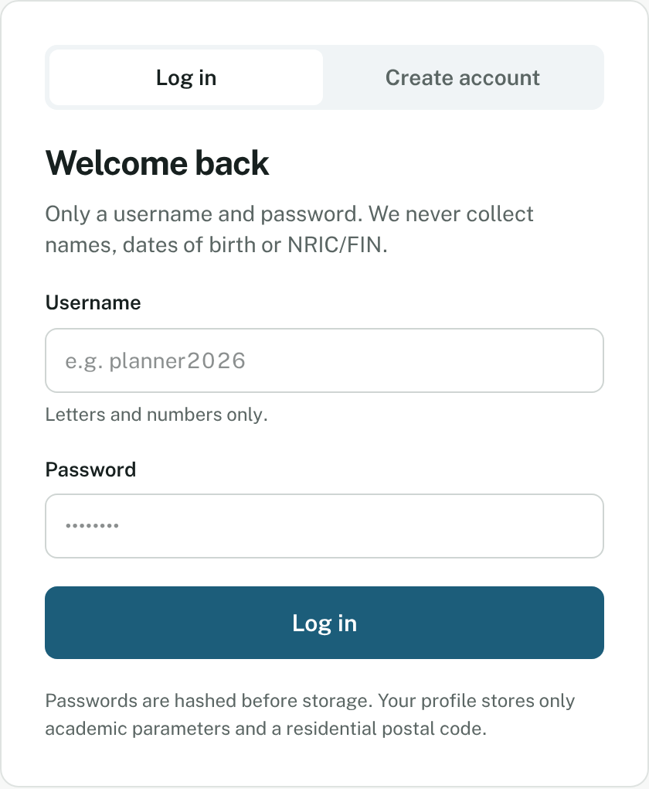
Figure 11 – The Log in box. Use the switch at the top to move between Log in and Create account.
PathSG opens My profile. Your saved profile, saved schools and roadmap load automatically.
You see | What to do
Enter your password. | Type your password.
No account exists with this username. Please check your username or create a new account. | Check the spelling, or create an account.
The password entered is incorrect. Please try again. | Type the password again.

4.3 Log out
Click your name with · Log out at the top right (on a phone, open the menu first). You return to the School Directory.
Staying logged in: you stay logged in while your browser tab is open, even if you refresh the page. If you close the tab you are logged out. If you are away for a long time you may see “Your session has expired. Please log in again.” Just log in again. Nothing is lost.
Using a shared computer? Always click Log out when you finish.

5. Set up your profile
Your profile tells PathSG where you live and which step you are planning for. It is what lets PathSG build your roadmap and measure distances from your home.
Open My profile in the menu. The page has three parts.
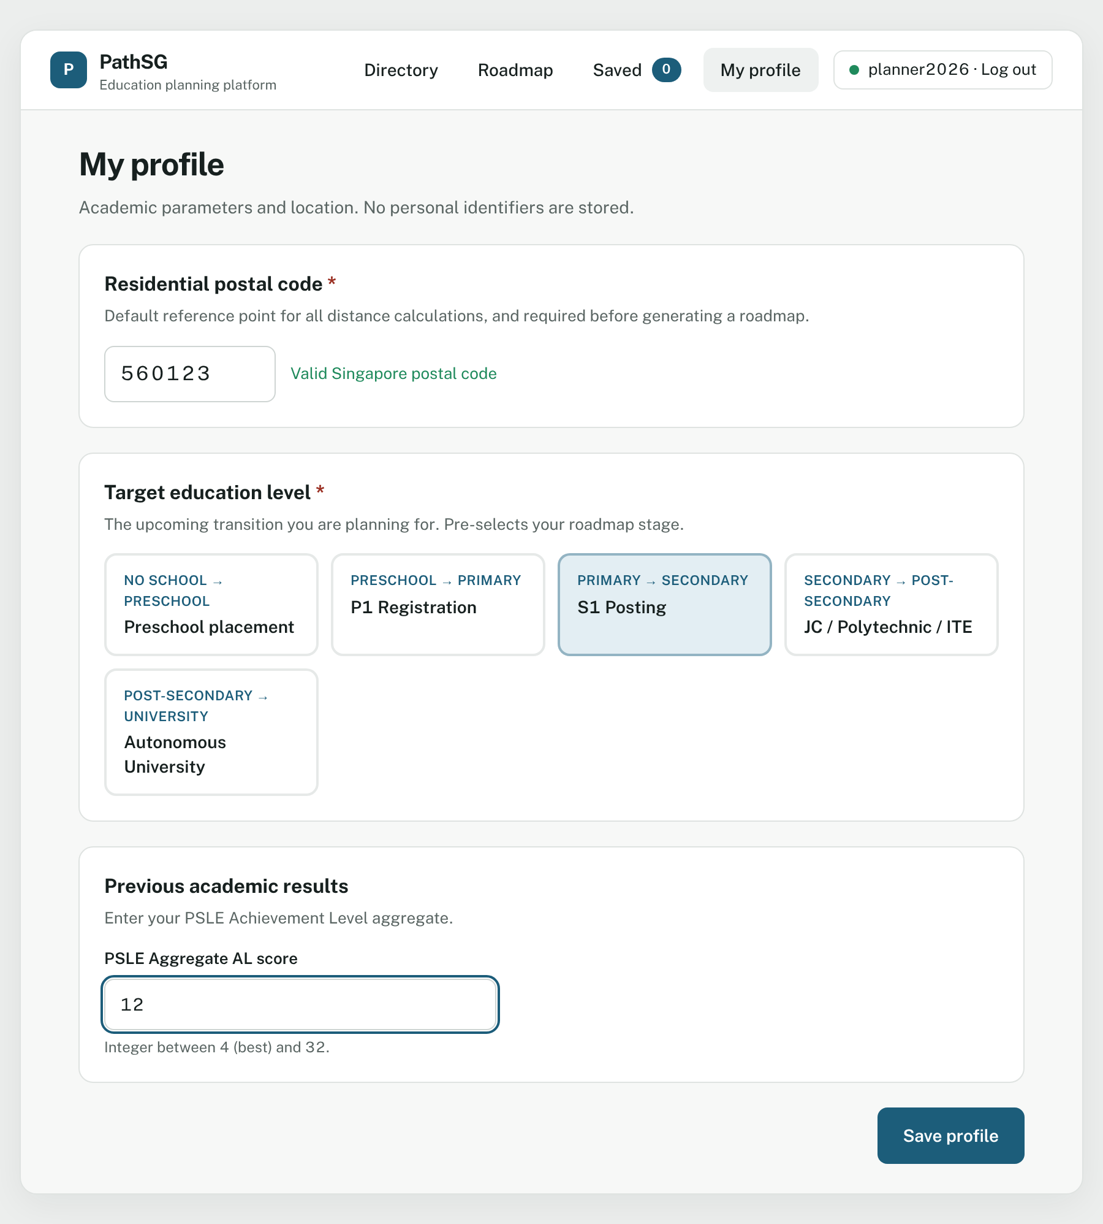
Figure 12 – The My profile page with a postal code, the S1 Posting level and a PSLE score filled in.

5.1 Fill in your profile
Step 1: Residential postal code (required)
- Click the postal code box and type your 6-digit Singapore postal code.
- When it is valid, the note beside it turns green: Valid Singapore postal code.
PathSG keeps only digits and stops at six. This postal code becomes the starting point for all distances in PathSG, and you need it before you can generate a roadmap.
Step 2: Target education level (required)
Click the card that describes the step you are planning for:
Card | Plan this if…
Preschool placement (No school → Preschool) | Your child is about to start preschool.
P1 Registration (Preschool → Primary) | Your child is about to enter Primary 1.
S1 Posting (Primary → Secondary) | Your child is about to enter Secondary 1.
JC / Polytechnic / ITE (Secondary → Post-Secondary) | You are finishing secondary school.
Autonomous University (Post-Secondary → University) | You are finishing polytechnic or junior college.
Step 3: Previous academic results
This box changes depending on the card you chose, so you only ever see the boxes that matter.
If you chose… | You will see… | Allowed values
Preschool placement | Nothing. No results are collected. | –
P1 Registration | Two buttons: None or Kindergarten completion | Choose one
S1 Posting | PSLE Aggregate AL score | Whole number from 4 (best) to 32
JC / Polytechnic / ITE | O-Level L1R5 (net) for JC, and O-Level ELR2B2 for Polytechnic/ITE | L1R5: whole number from 2 to 54. ELR2B2: a whole number. Enter either or both.
Autonomous University | Polytechnic cumulative GPA and A-Level rank points | GPA: 0.00 to 4.00. Rank points: 0 to 90. Enter either or both.
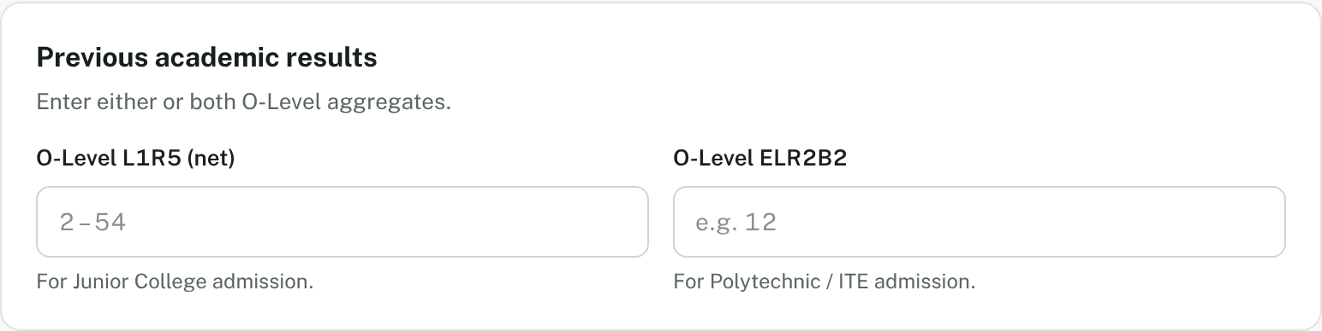
Figure 13 – For JC / Polytechnic / ITE, two boxes appear. Fill in whichever applies to you.
Tip: if you switch to another level and come back, the numbers you already typed for each level are still there.
Step 4: Save
Click Save profile at the bottom of the page. PathSG saves your details and takes you to the Roadmap page. A green message confirms: “Profile saved successfully”.
You can change your profile at any time. Just open My profile, edit it and save again.

5.2 If your profile will not save
PathSG checks your entries and shows a red message beside the problem. Nothing is saved until it is fixed.
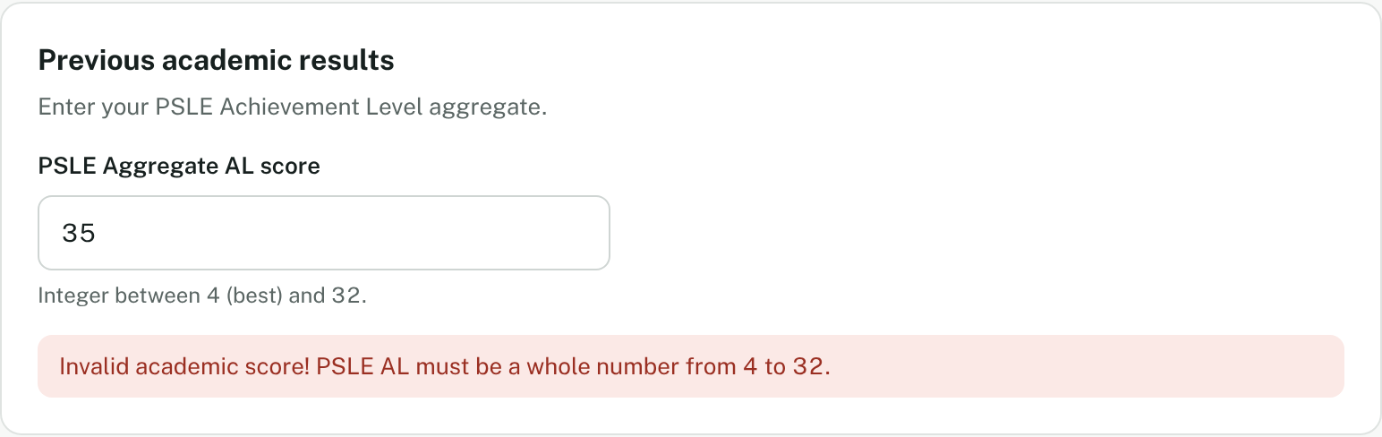
Figure 14 – A PSLE score of 35 is outside the allowed range of 4 to 32.
You see | How to fix it
Please enter a valid 6-digit Singapore postal code. | Enter exactly 6 digits.
Invalid academic score! PSLE AL must be a whole number from 4 to 32. | Enter a whole number between 4 and 32.
Invalid academic score! Enter an L1R5 or ELR2B2 aggregate. | Fill in at least one of the two boxes.
Invalid academic score! L1R5 must be a whole number from 2 to 54. | Check your L1R5 score.
Invalid academic score! ELR2B2 must be a whole number. | Use whole numbers only, with no decimals.
Invalid academic score! Enter a polytechnic GPA or A-Level rank points. | Fill in at least one of the two boxes.
Invalid academic score! GPA must be between 0.00 and 4.00. | Check your GPA.
Invalid academic score! Rank points must be between 0 and 90. | Check your rank points.

6. Save schools to your list
Keep a short list of schools you like and compare them side by side.

6.1 Save a school
You must be logged in. Guests do not see the Save button.
- Find a school in the Directory, or open its profile page.
- Click ☆ Save. The button changes to ★ Saved, and the number next to Saved in the menu goes up by one.
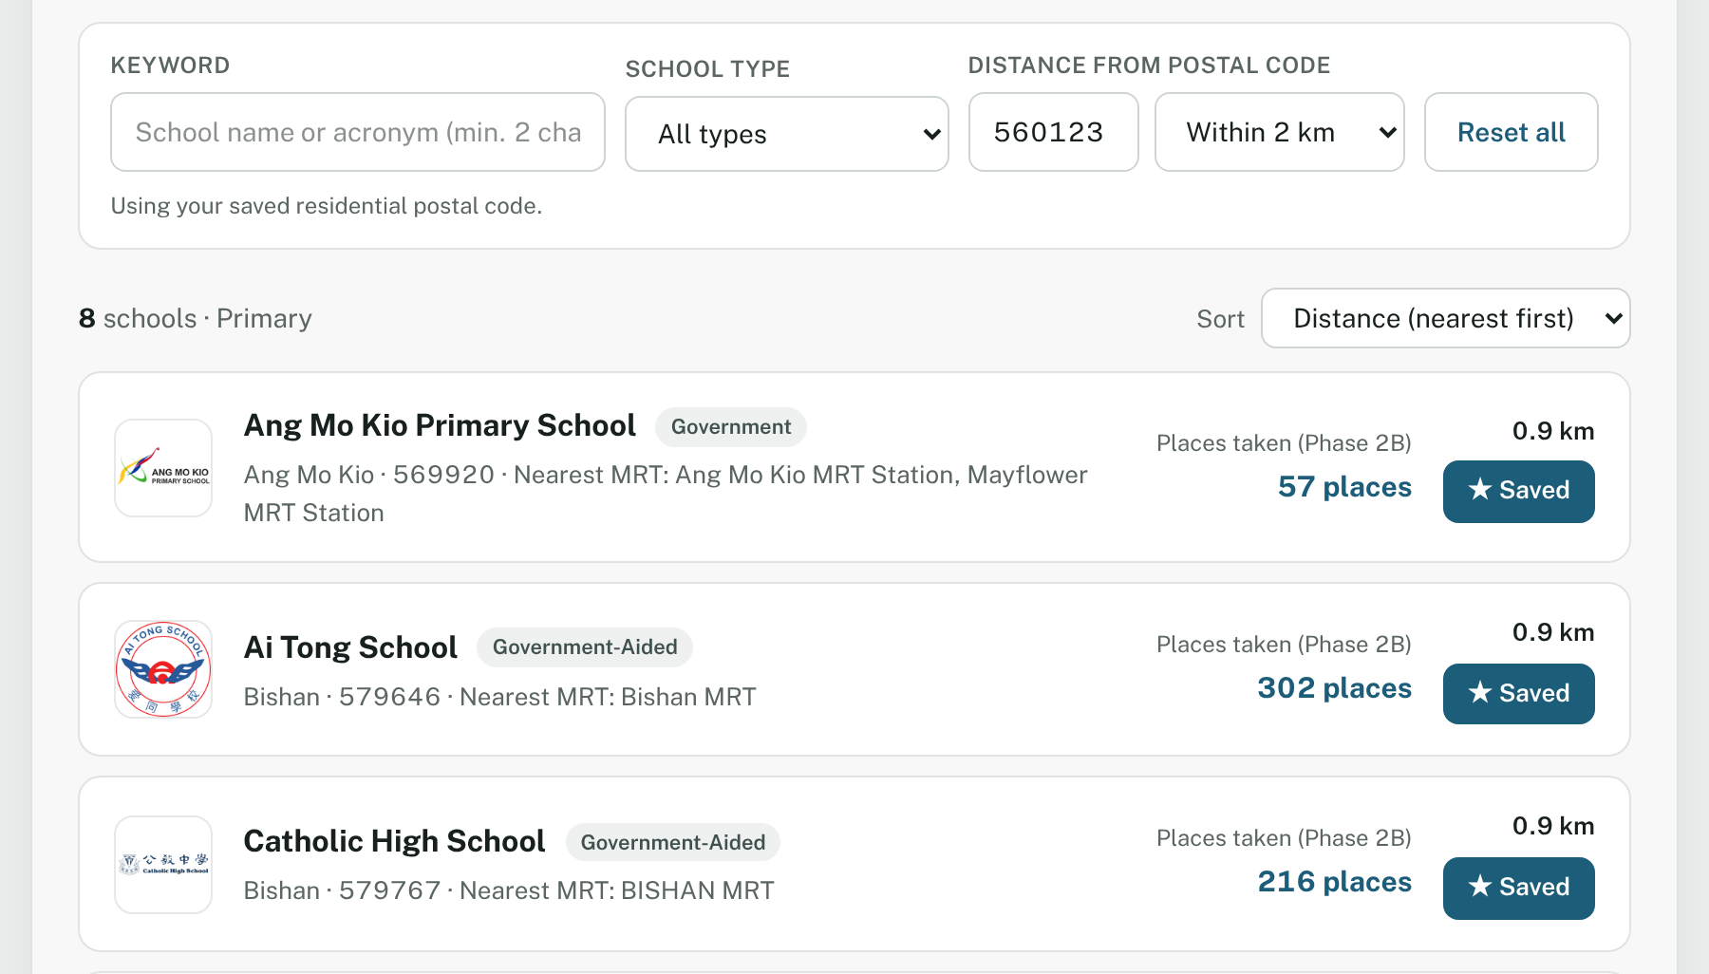
Figure 15 – Schools you have saved show ★ Saved.
To un-save a school, click ★ Saved again.

6.2 View your saved list
Click Saved in the menu. Each school appears on a card with its logo, name, type, level, distance from your postal code and its entry figure.
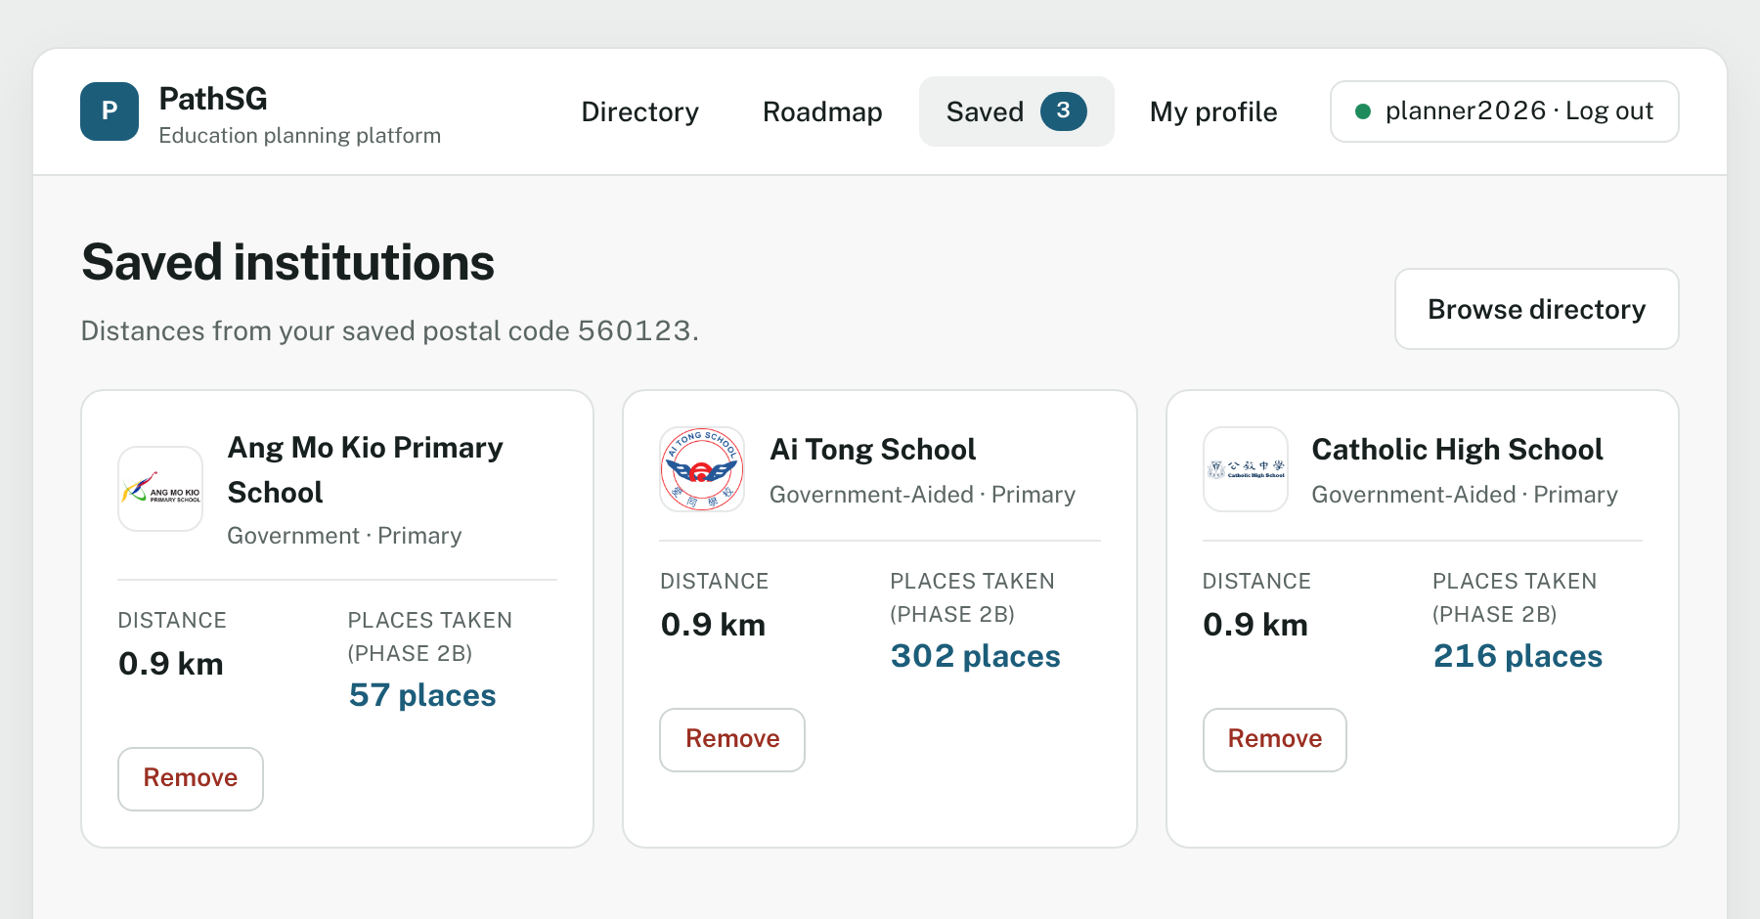
Figure 16 – Your saved schools, with distances from your saved postal code.
- Click a school’s name to open its profile.
- Click Remove to take a school off your list. It disappears straight away.
- Click Browse directory to find more schools.
If you have not saved a postal code yet, the page says “Add a postal code in your profile to see distances.” If your list is empty it says “No saved institutions yet” and shows a Go to directory button.

7. Generate your education roadmap
A roadmap is a short list of schools, in order of preference, for your next step. PathSG creates two plans every time so you can compare them:
Compare | Rule-Based Plan | AI-Generated Plan
How it is made | Fixed ranking rules for your stage, for example how well your score fits a school’s past entry figure and how close the school is to your home. | An AI model suggests an alternative ordering, weighing your score, location and what each school offers.
How long it takes | About 2 seconds | Up to 15 seconds
Colour | Blue | Purple
Each plan lists up to three choices: 1st choice, 2nd choice and 3rd choice.
About the AI plan and your privacy: PathSG sends the AI service only your target stage, your score, your postal code and a list of schools. Your username is never sent.
These are suggestions, not decisions. Always check each school’s own website and official MOE announcements before you apply.

7.1 Before you start
You need to be logged in and to have saved your postal code in your profile (section 5). Add your results too if your level asks for them.
If you open Roadmap without logging in, PathSG takes you to the log-in page with the message “Log in to generate and save an education roadmap.”
If your postal code is missing when you press Generate Roadmap, a pop-up appears:
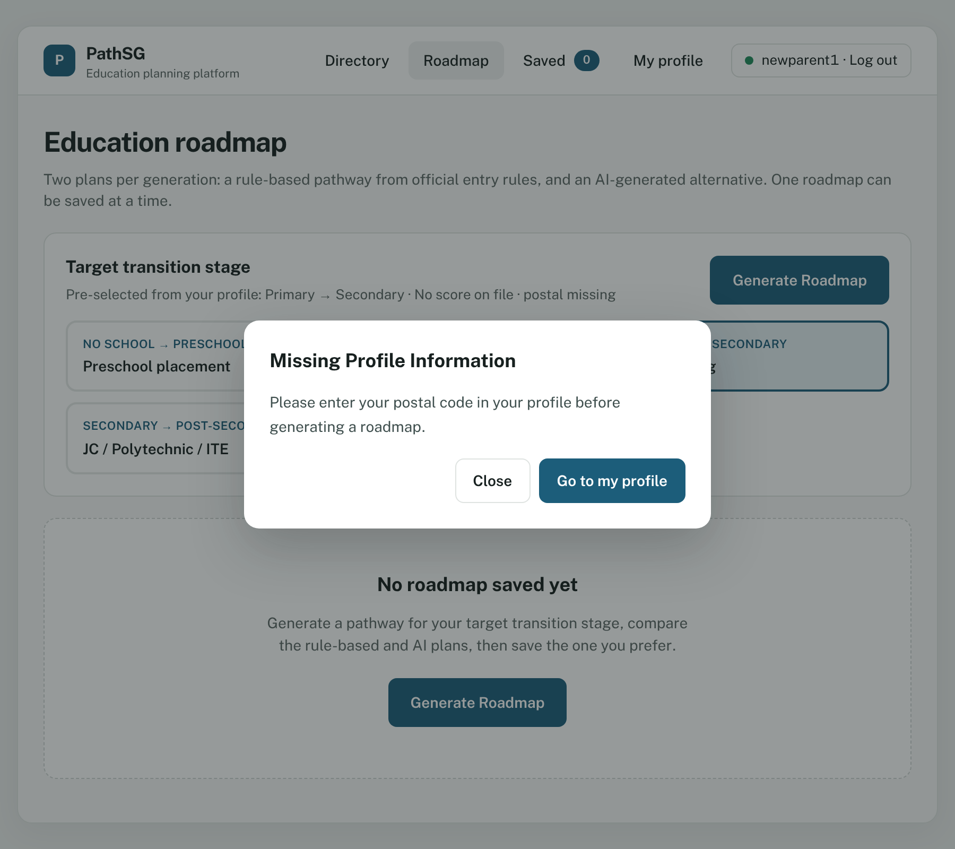
Figure 17 – Click Go to my profile to add your postal code, then come back to Roadmap.

7.2 Generate a roadmap
- Click Roadmap in the menu.
- Look at the Target transition stage box. PathSG has already selected the stage from your profile. A line under the title shows what it used, for example “Pre-selected from your profile: Primary → Secondary · PSLE AL 12 · postal 560123”.
- To plan for a different step, click another card. (Your saved score only applies to the stage in your profile. For another stage PathSG does not use a score.)
- Click Generate Roadmap.
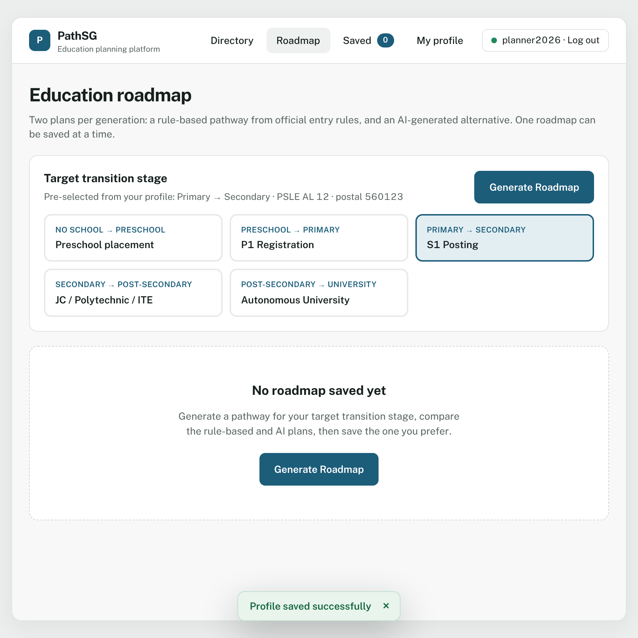
Figure 18 – A new Roadmap page. The message “No roadmap saved yet” reminds you that nothing is stored.
The Rule-Based Plan appears first, usually within 2 seconds. The AI-Generated Plan shows a spinner while it works and fills in when ready.
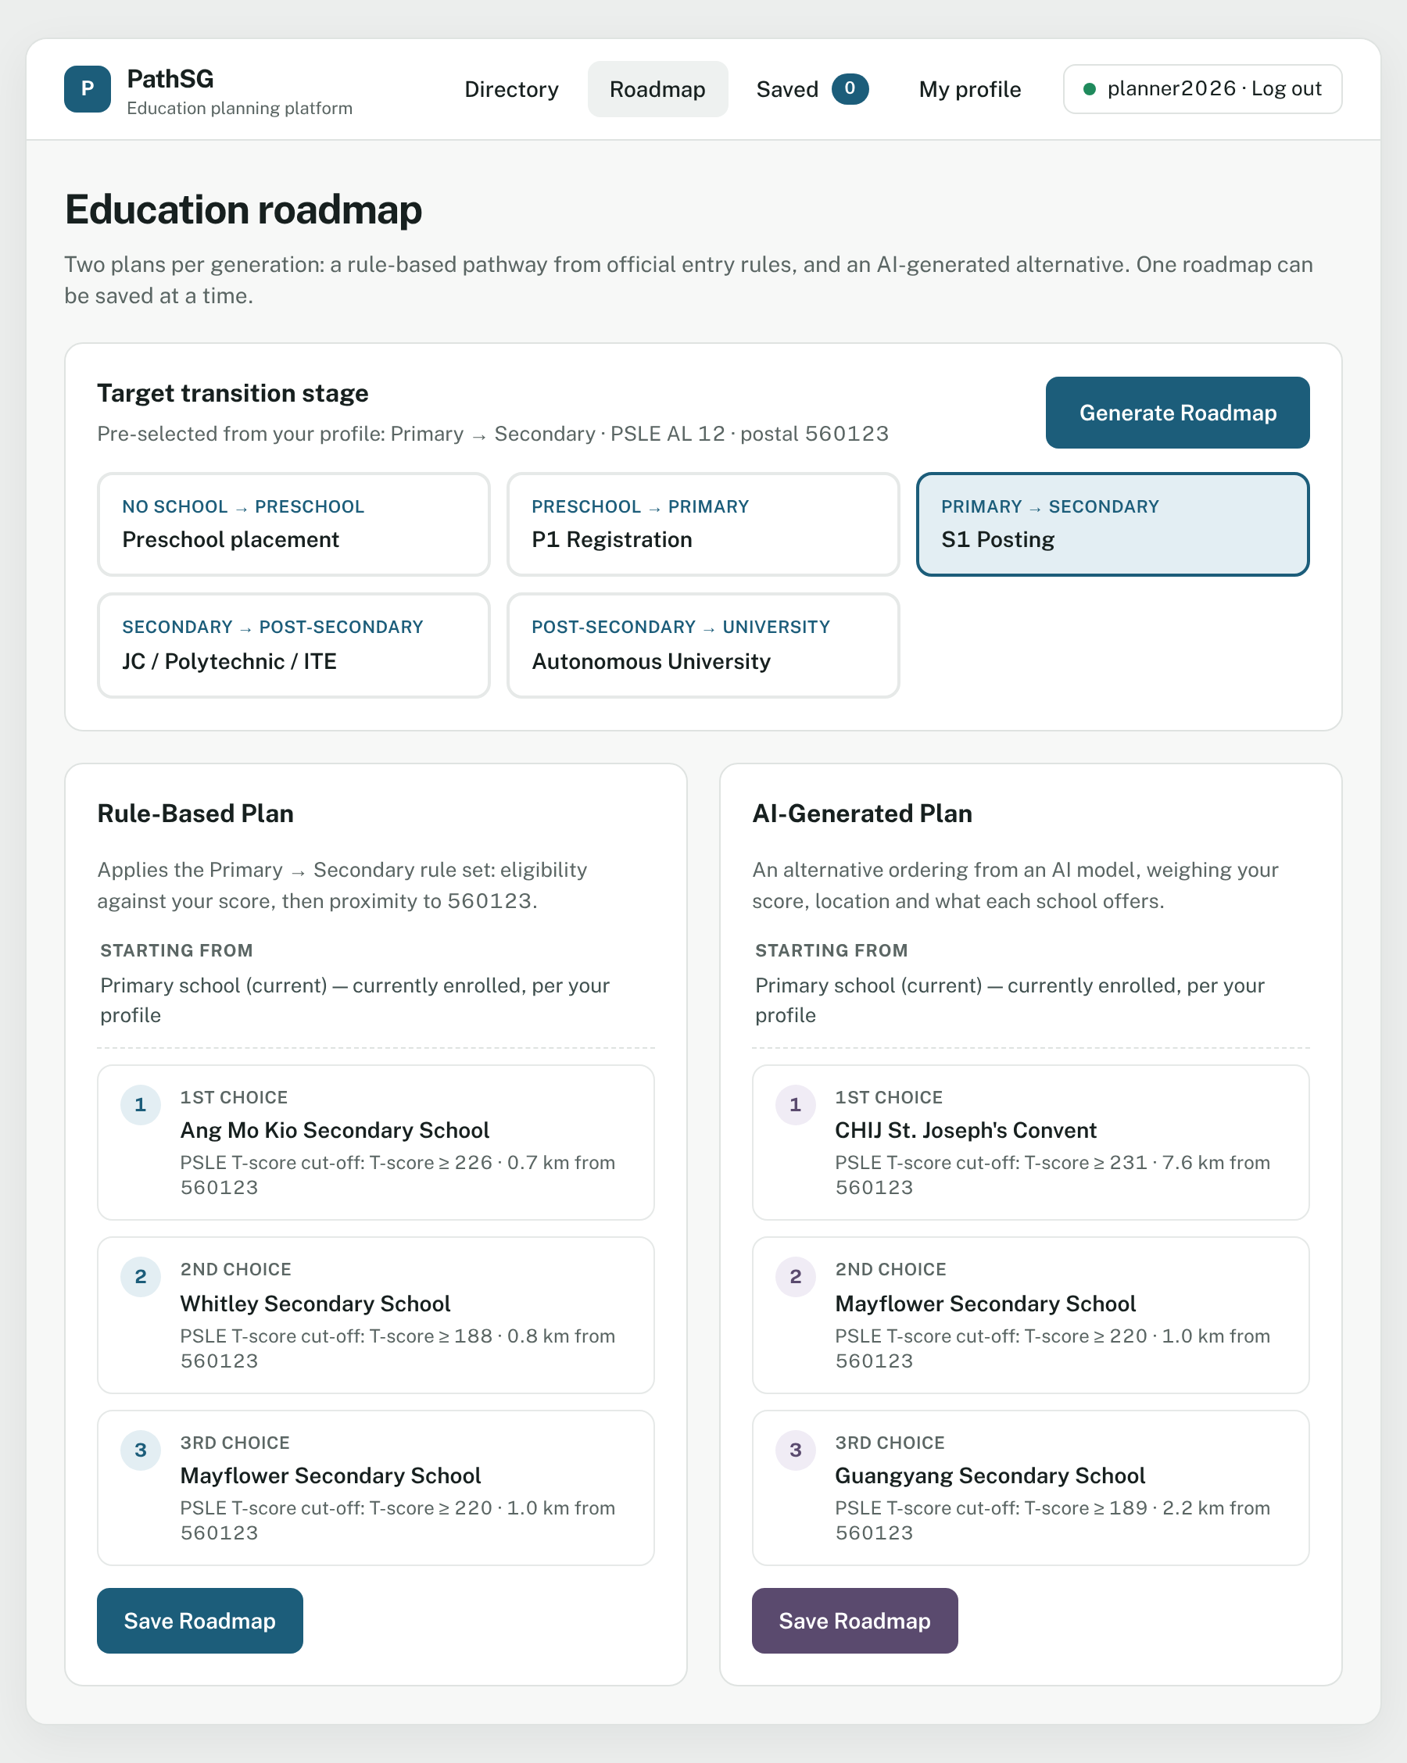
Figure 19 – The Rule-Based Plan (left) and the AI-Generated Plan (right). Each shows three schools with the entry figure and the distance from your postal code.

7.3 Read your plans
Each plan shows:
- Starting from: where you are now, based on your stage.
- 1st, 2nd and 3rd choice: the school’s name, then a line such as “PSLE T-score cut-off: T-score ≥ 226 · 0.7 km from 560123”.
- A Save Roadmap button.
The two plans can be different. That is useful: where they agree, you have more confidence in the choice; where they differ, you have something to think about.

7.4 If the AI plan does not load
Sometimes the AI service is busy or slow. Your Rule-Based Plan is not affected. The AI panel shows a message and a button:
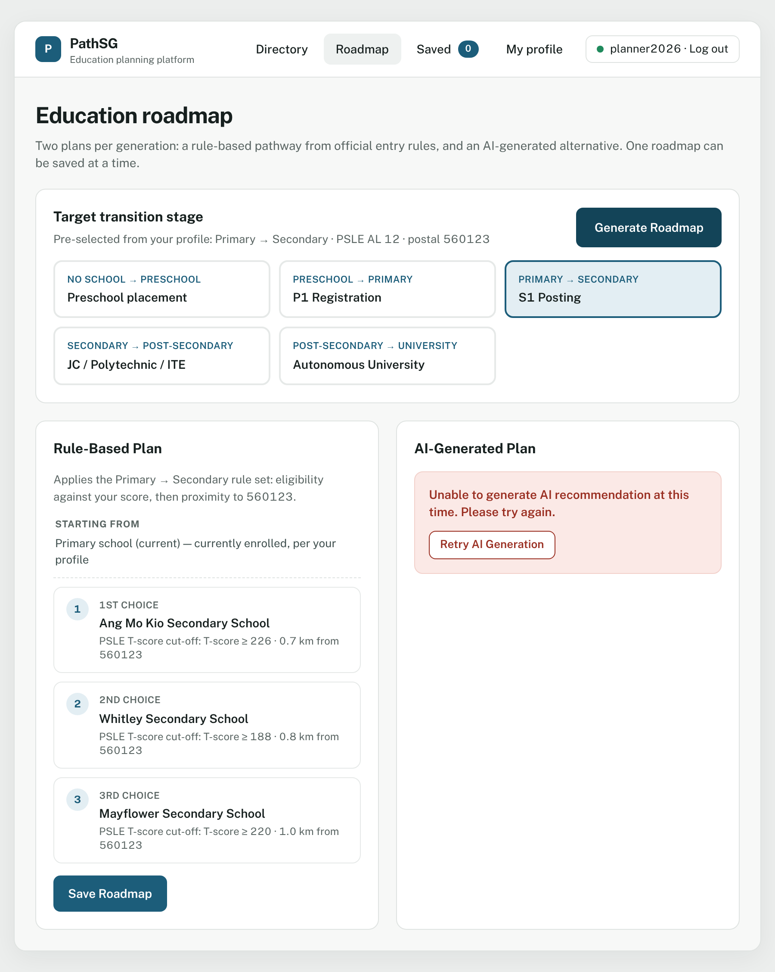
Figure 20 – The error appears only inside the AI panel. The page does not reload.
Click Retry AI Generation to try again. If the Rule-Based Plan cannot be created, its panel has its own Retry button.

7.5 Save the plan you prefer
You can keep one saved roadmap at a time.
- Decide which plan you prefer.
- Click Save Roadmap under that plan.
- A banner says “Roadmap saved to your profile.” and your Saved roadmap appears.
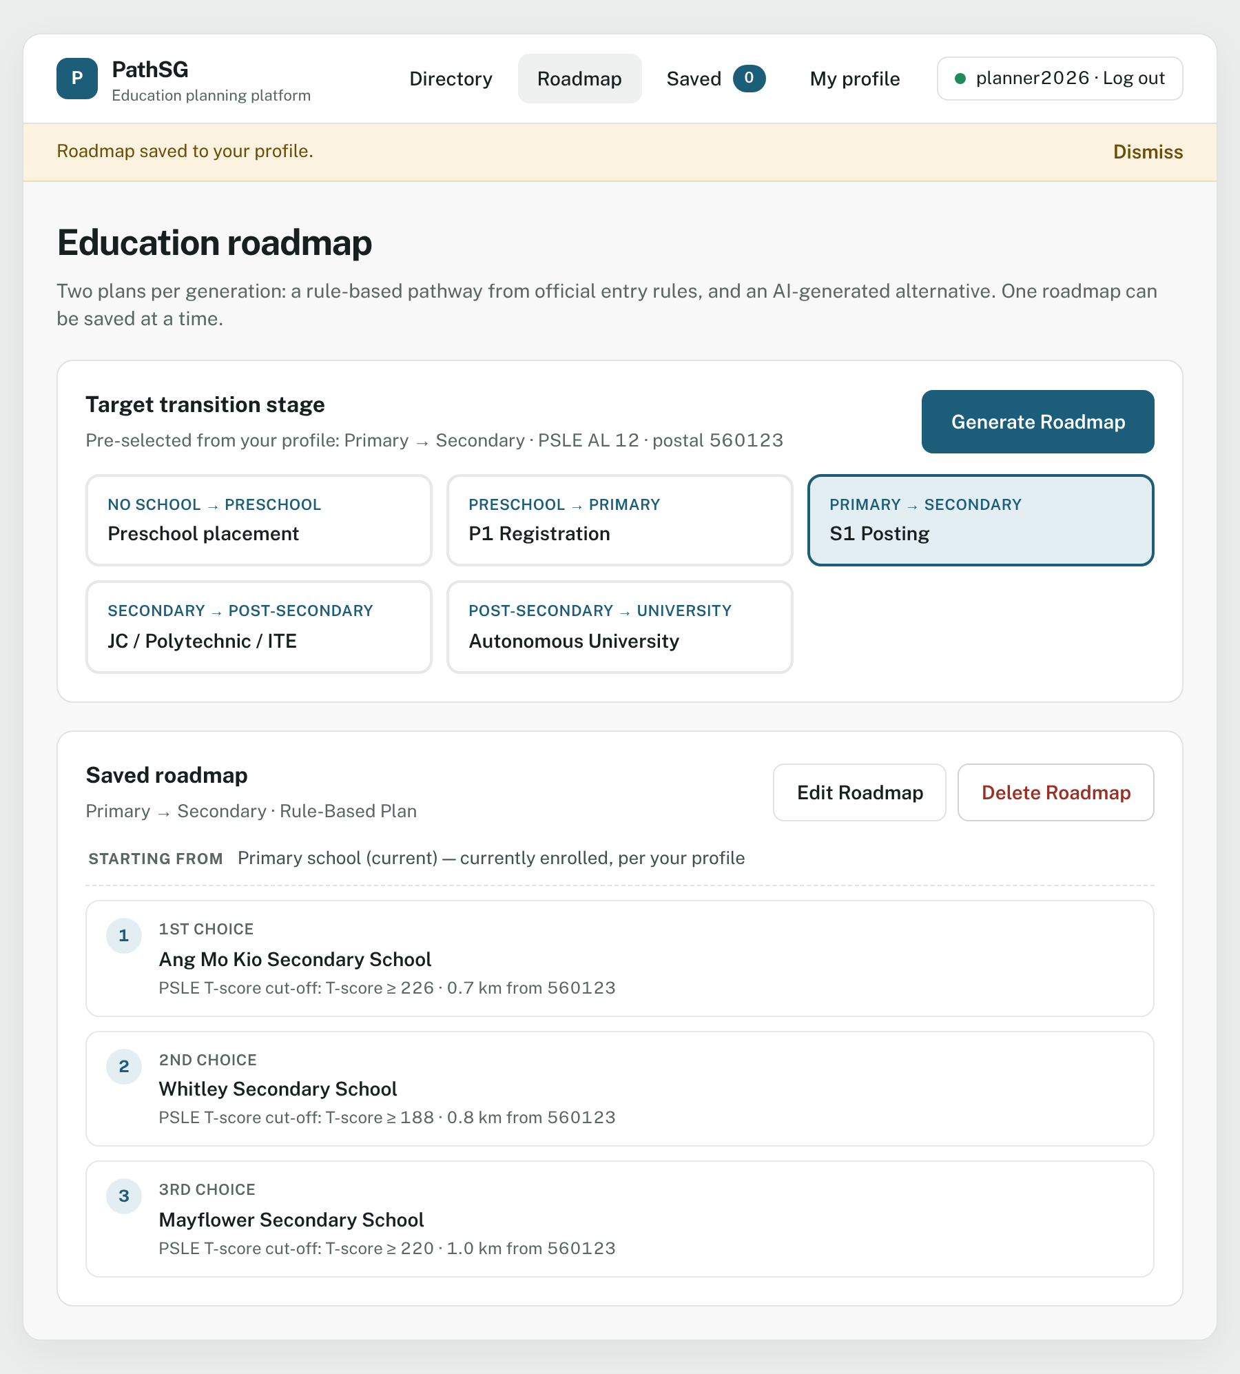
Figure 21 – Your saved roadmap, with the plan type shown under the heading (here “Rule-Based Plan”).
Replacing an existing roadmap. If you already have a saved roadmap, PathSG asks first:
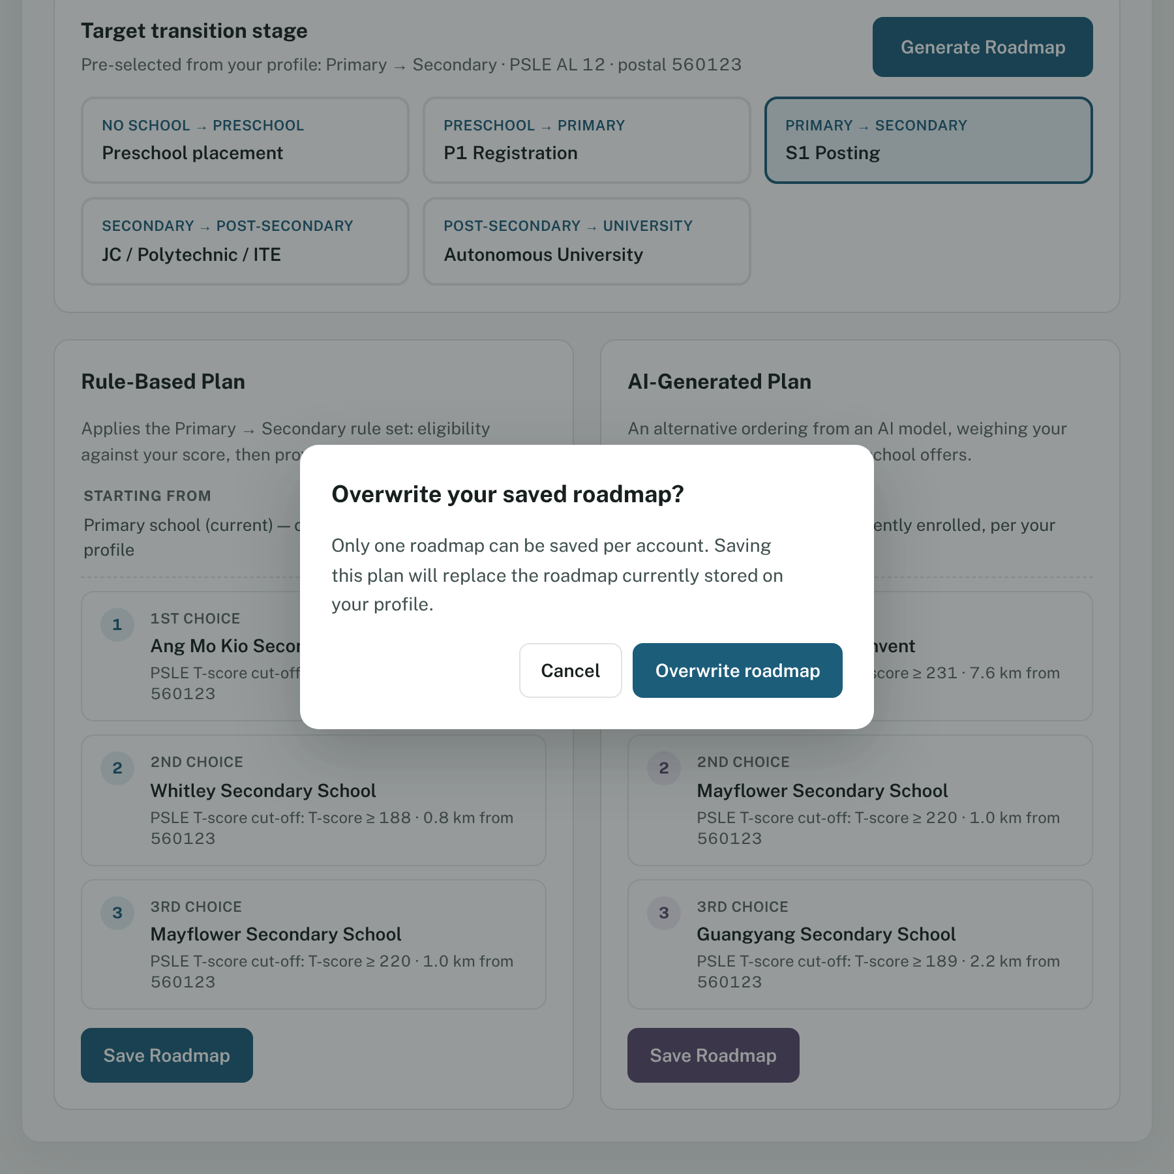
Figure 22 – Click Overwrite roadmap to replace the old one, or Cancel to keep it.
While new plans are on the screen your old saved roadmap is hidden, but it is not deleted. It stays safe until you choose Overwrite roadmap. Pick another stage card to see it again.

7.6 View your saved roadmap
Click Roadmap in the menu. Your saved roadmap shows its stage, whether it was the Rule-Based or AI-Generated plan, and your three choices. If you have none, you see “No roadmap saved yet” and a Generate Roadmap button.

7.7 Edit your saved roadmap
Changed your mind about one school? You can swap it without generating a new plan.
- On the Roadmap page, click Edit Roadmap.
- Each choice becomes a drop-down list. Pick the school you want from the list. Only schools for your saved stage are offered.
- Click Save Changes. A banner says “Roadmap updated.”
To leave without changing anything, click Cancel.
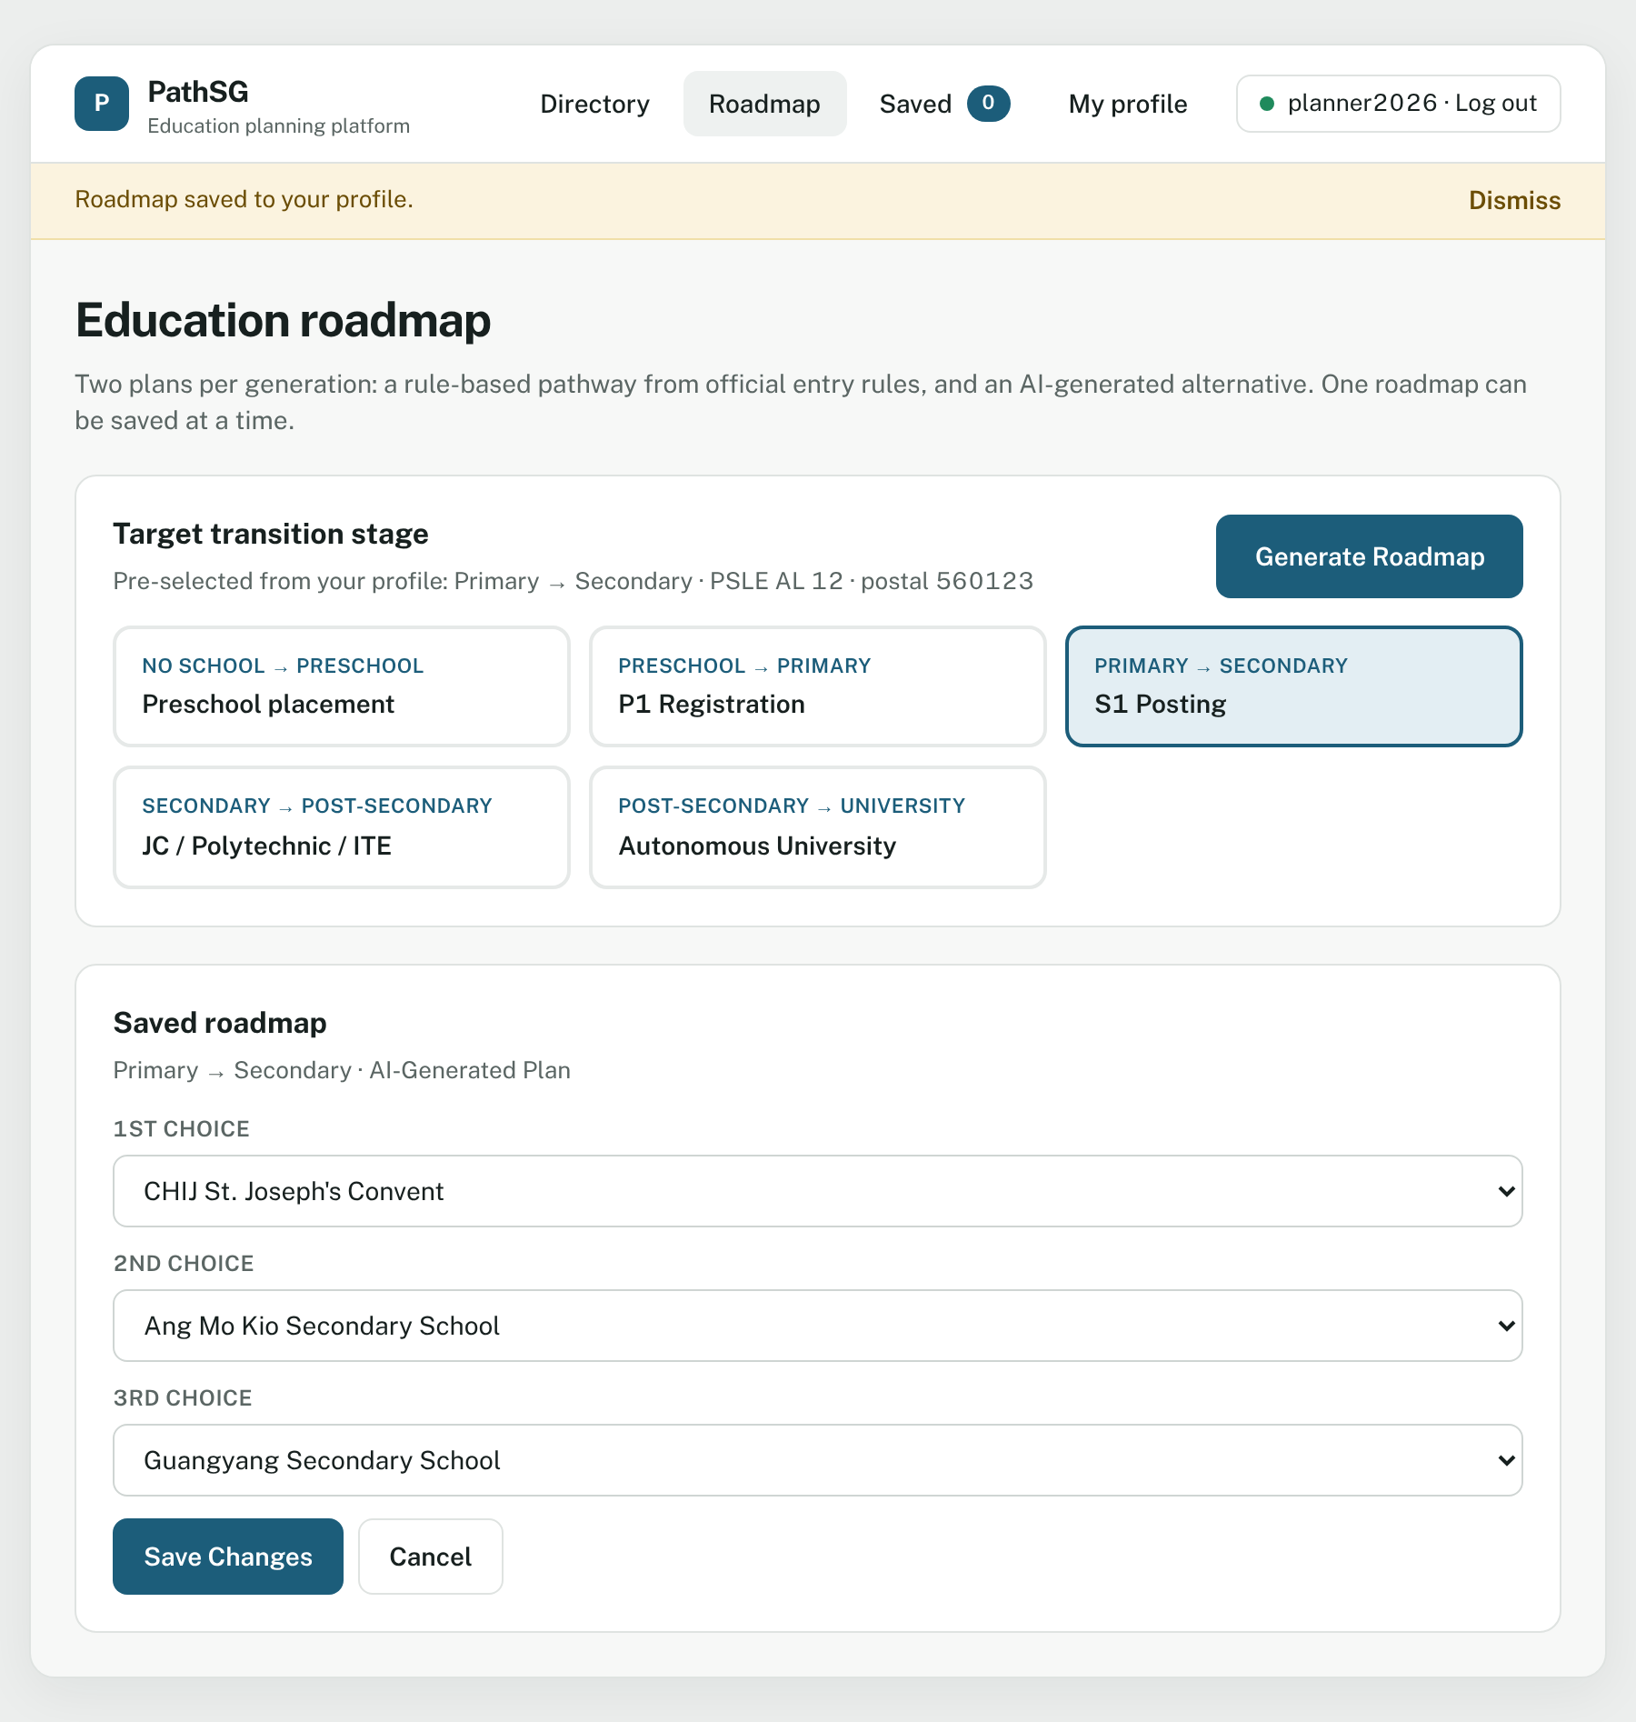
Figure 23 – Each choice has its own drop-down list.

7.8 Delete your saved roadmap
- Click Delete Roadmap.
- A pop-up asks “Delete saved roadmap?” Click Delete roadmap to confirm, or Cancel to keep it.
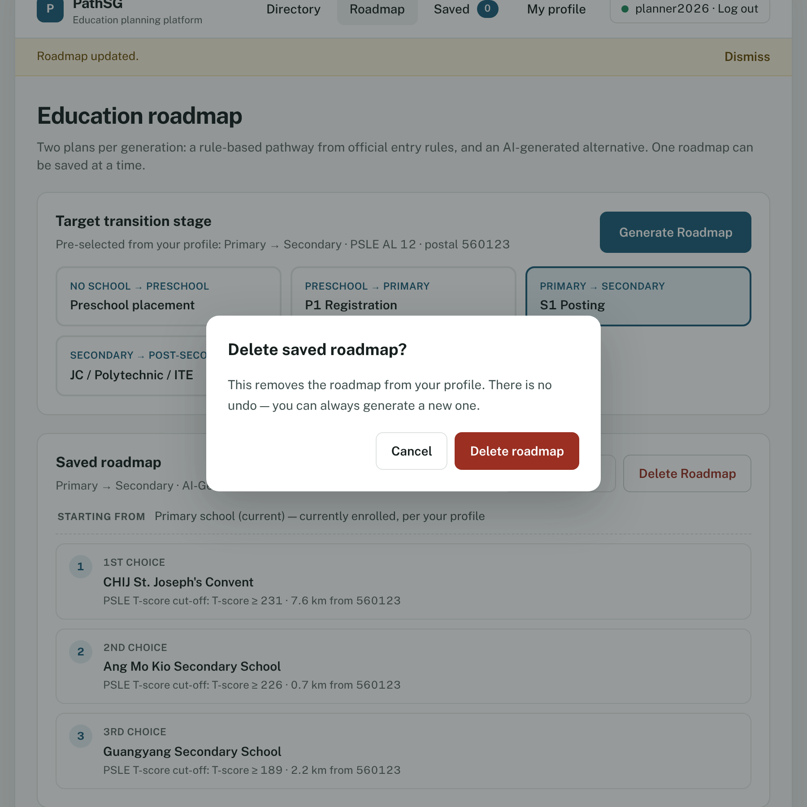
Figure 24 – Deleting cannot be undone, but you can always generate a new roadmap.
A banner says “Saved roadmap deleted.” and the page returns to “No roadmap saved yet”.

7.9 When a stage has no schools yet
Roadmaps can only suggest schools that are in the PathSG dataset. If there are none for the stage you picked, each plan says “No institutions are available for this stage yet.” and Save Roadmap is switched off. At the time of writing this happens for Preschool placement and Autonomous University (see section 3.6).
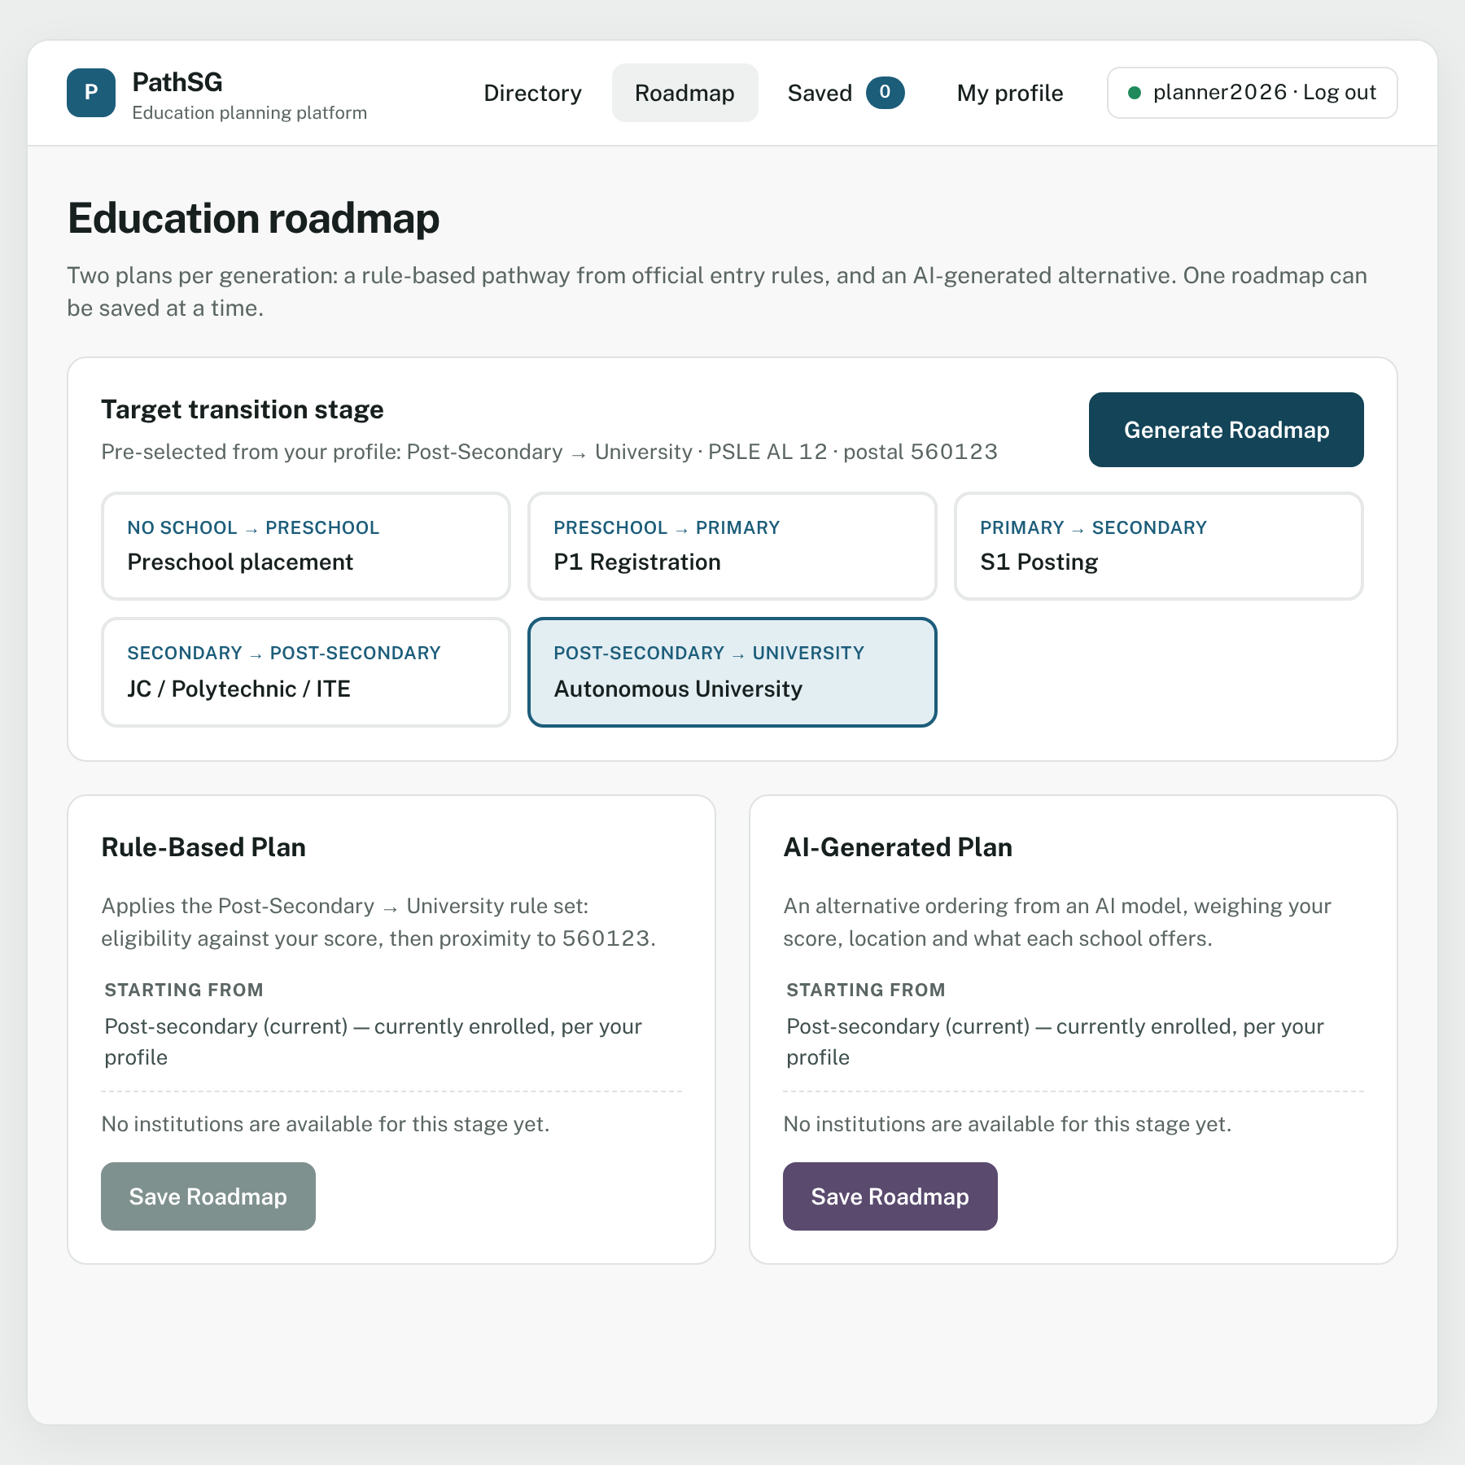
Figure 25 – For a stage with no schools in the dataset there is nothing to save. Choose another stage card.

7.10 Good to know
- If you change your Target education level in your profile, the plans on the Roadmap page are cleared and PathSG starts over from your new level. Your saved roadmap is not touched.
- If a school is removed from PathSG’s database after a data update, its place in your saved roadmap says Not available. Use Edit Roadmap to choose another school.

8. Read and write school reviews
Reviews are short comments from other families and students. You find them at the bottom of every school’s profile page, under Reviews.

8.1 Read reviews
Anyone can read reviews, with or without an account. Each review shows the username, the date and time it was posted, and the comment. The newest are first. If a review has been changed it says (edited). A school with no reviews says “No reviews yet”.

8.2 Write a review
You must be logged in. Guests see “Reviews are open to account holders only.” with a Write a review button. That button opens a pop-up asking them to log in:
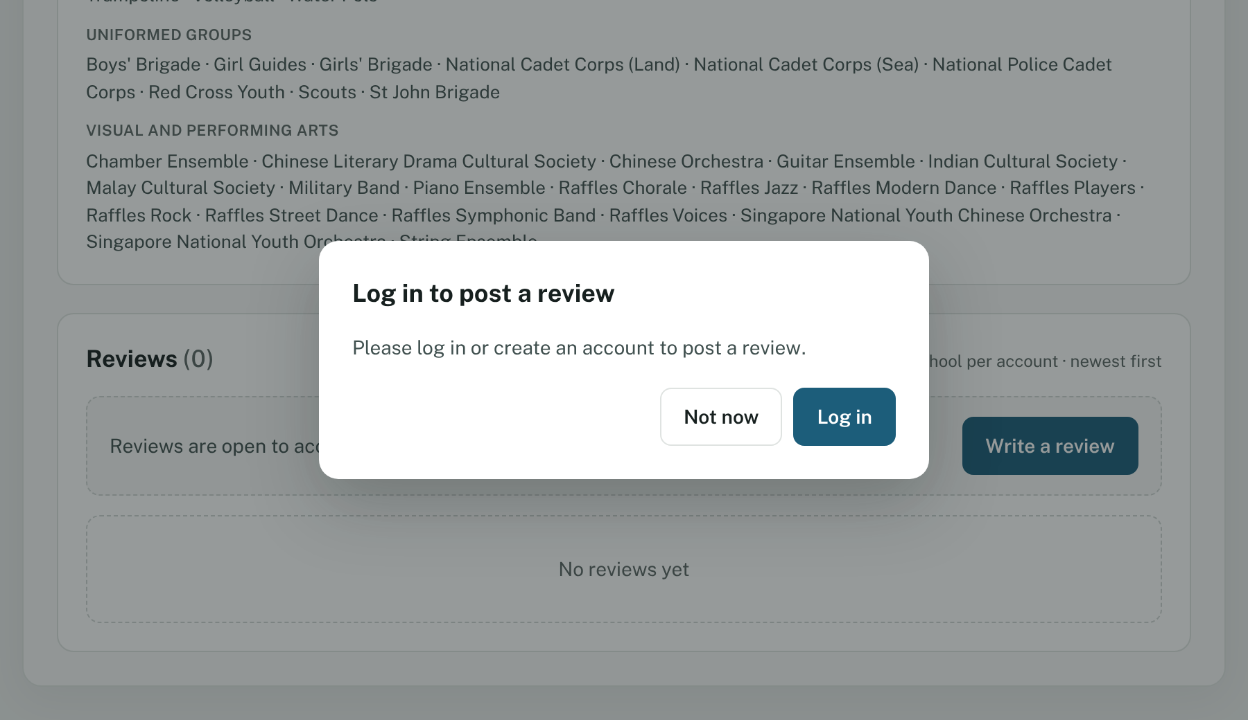
Figure 26 – Click Log in to continue, or Not now to stay on the page.
When you are logged in:
- Open the school’s profile page and scroll down to Reviews.
- Click the box under Write a review as … and type your comment.
- Watch the counter below the box, for example 20 / 200 words. You can write up to 200 words. Typing stops when you reach the limit.
- Click Submit Review.
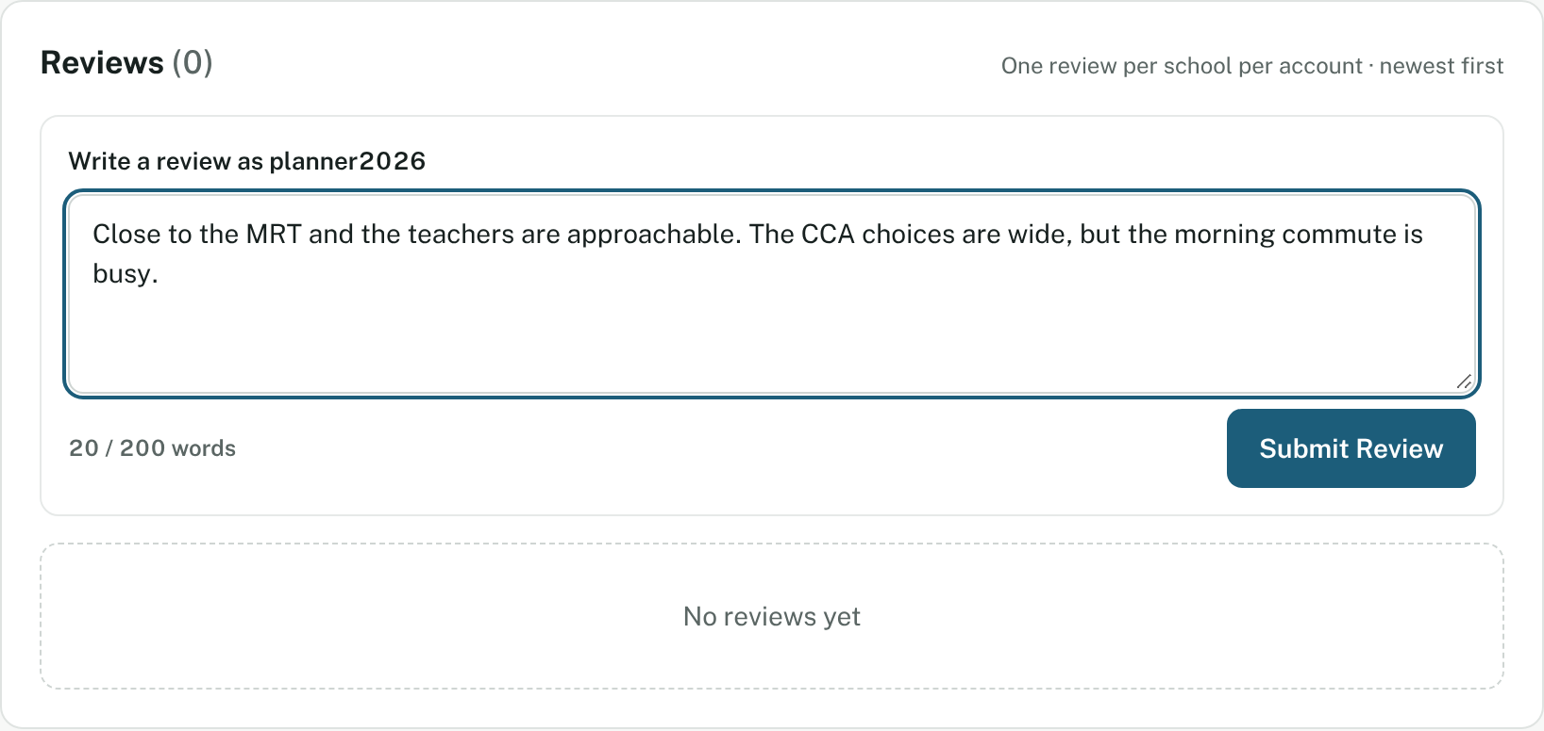
Figure 27 – The live word counter shows how many words you have used.
Your review appears at once with a Your review label:
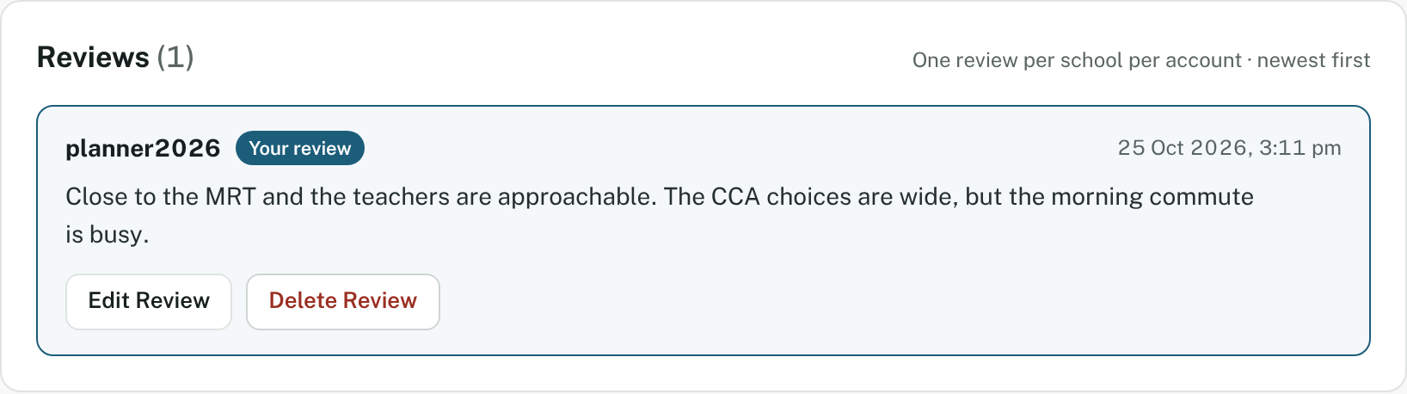
Figure 28 – Only your own review shows Edit Review and Delete Review.
Rules
- You can write one review per school. Once you have posted, the writing box is replaced by your review.
- A review cannot be empty or only spaces. PathSG says: “Review text cannot be blank or consist entirely of spaces.”
- For safety, any HTML or code in your text is removed automatically.
- Please keep reviews honest, respectful and useful to other families.

8.3 Edit your review
- Click Edit Review on your review.
- The box opens with your existing text. Change it.
- Click Update Review. Or click Cancel to throw the changes away and keep your original.
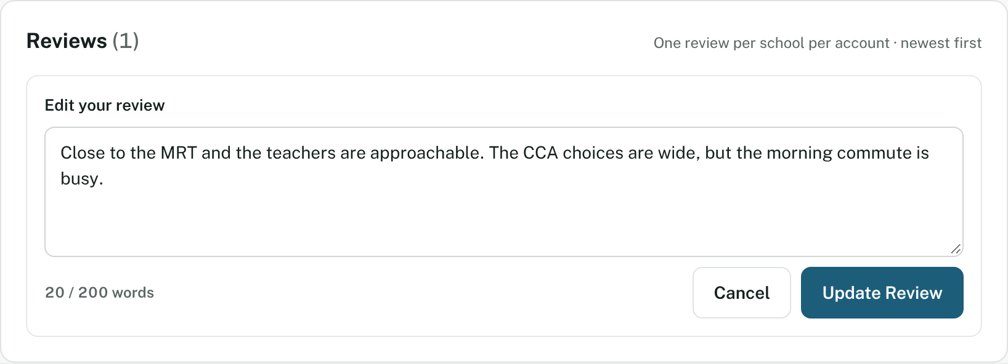
Figure 29 – While editing, the buttons are Cancel and Update Review.

8.4 Delete your review
- Click Delete Review.
- In the pop-up, click Delete review to confirm, or Cancel to keep it.
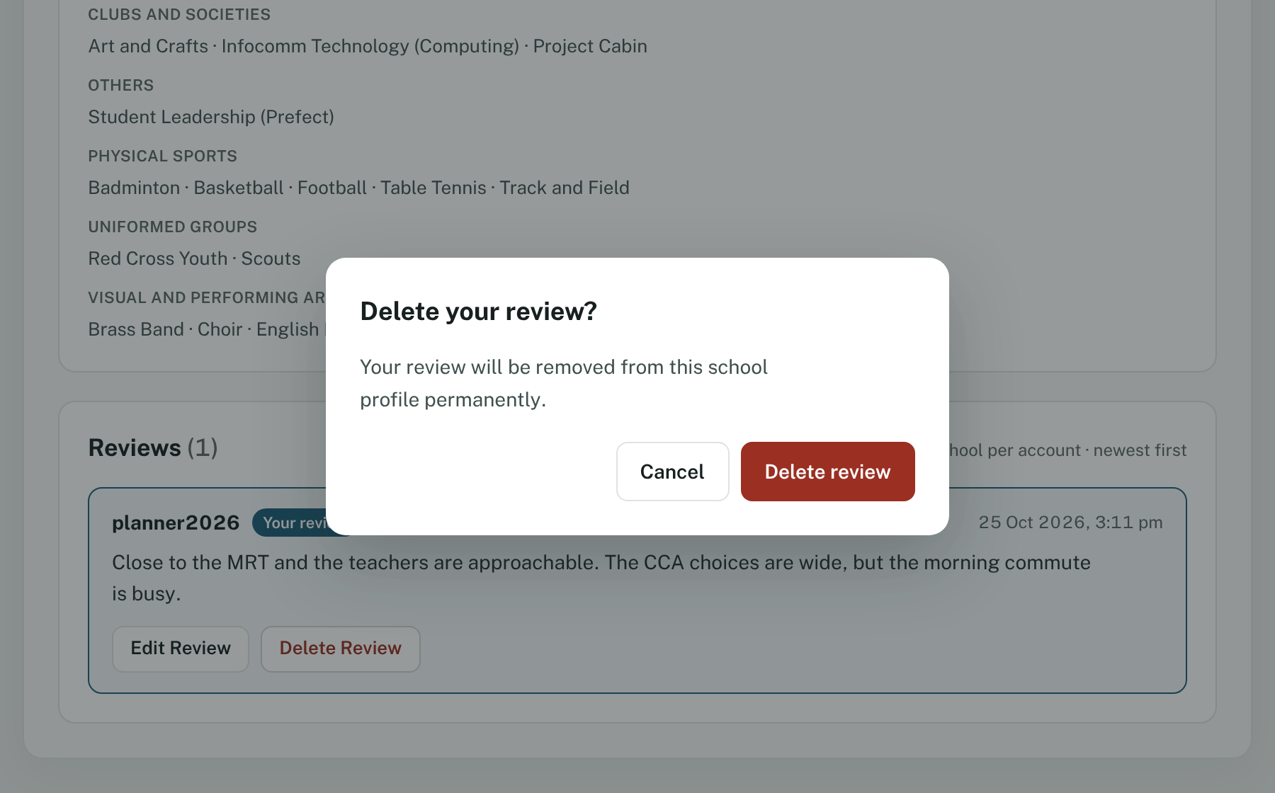
Figure 30 – A deleted review is removed for good. You can then write a new one.

9. Troubleshooting and questions

9.1 Messages and what to do
Message | What it means | What to do
Log in to generate and save an education roadmap. / Log in to view your saved institutions. / Log in to edit your profile. | You opened a page that needs an account. | Log in, or create an account.
Your session has expired. Please log in again. | You were away for a long time. | Log in again. Your saved data is safe.
Unable to load the … schools at this time. Please try again. | The school list could not be loaded. | Click Try again. Check your internet connection.
Unable to load this school at this time. Please try again. | A school page could not be loaded. | Click Try again.
School not found. This school is not in the directory. | The school is not in the database. | Click Back to directory.
No Schools Found | Your search or filters match nothing. | Click Reset All Filters.
No University schools yet | The current dataset has none for this tab. | Choose another level.
Add postal code (where a distance should be) | PathSG does not have a postal code to measure from. | Type a postal code in the Directory, or save one in My profile.
This postal code could not be located. | PathSG cannot find that postal code. | Check the six digits.
Missing Profile Information (pop-up) | You pressed Generate Roadmap without a postal code. | Click Go to my profile and add it.
Unable to generate AI recommendation at this time. Please try again. | The AI service is busy or not responding. | Click Retry AI Generation. Your Rule-Based Plan still works.
Unable to generate the rule-based plan at this time. Please try again. | The Rule-Based Plan could not be made. | Click Retry.
Unable to complete your request at this time. Please try again later. | A temporary problem on PathSG’s side. | Wait a moment and try again.

9.2 Common questions
Why can’t I see the ☆ Save button? You are not logged in. Log in and the button appears.
Why can’t I save a roadmap? Check that you are logged in and that the plan has at least one school. If the plan says “No institutions are available for this stage yet.”, pick another stage.
Can I keep more than one roadmap? No. PathSG keeps one saved roadmap per account. Saving another asks you to confirm before replacing the old one.
The two plans suggest different schools. Which one is right? Neither is “right”. They use different methods. Compare them, look at each school’s profile, and decide with your family. Remember that entry figures change every year.
Why does a school page say “Not available”? PathSG shows only what is in the current school dataset. See section 3.6.
Do I have to give my real name? No. See section 10.
I forgot my password. PathSG has no password-reset page at present, and it cannot recover a password. You can create a new account with a different username.
Which browsers can I use? The latest versions of Google Chrome, Mozilla Firefox and Apple Safari, on a phone, tablet or computer.
Can I use the keyboard instead of a mouse? Yes. Every button and field can be reached with the Tab key and used with Enter or Space. The item you are on has a visible outline. Pop-ups close with Esc.

10. Your privacy
PathSG is designed to know as little about you as possible.
- We never ask for your real name, age, date of birth or NRIC/FIN.
- We store only: your username, your password (scrambled with a one-way method, so nobody can read it), your postal code, target level and academic results, your saved schools, your saved roadmap and your reviews.
- Your postal code is used only to work out distances and to build your roadmap.
- The AI service receives your stage, score, postal code and a list of schools. It never receives your username.
- Your reviews show your username to everyone who views the school page.

Appendix A: Administrator guide
This appendix is for school-data administrators only. Ordinary users cannot open the Admin panel.

A.1 What administrators can do
Task | Where
Update the school database from CSV files | Admin panel → School dataset
Download the whole school database as a CSV file | Admin panel → Export school dataset

A.2 Getting administrator access
Administrator rights cannot be requested from within PathSG. The technical team grants the Admin role to an account that is already registered. After that, log out and log in again; the Admin panel link then appears in the menu, and you land on the Admin panel when you log in.
If an ordinary user opens the Admin panel address, PathSG sends them back to the Directory with the message “The admin panel is restricted to administrator accounts.”

A.3 Update the school database
PathSG does not download school data by itself. You prepare the files first:
- Download the latest school datasets from Data.gov.sg to your computer, as .csv files.
- Log in to PathSG and open Admin panel.
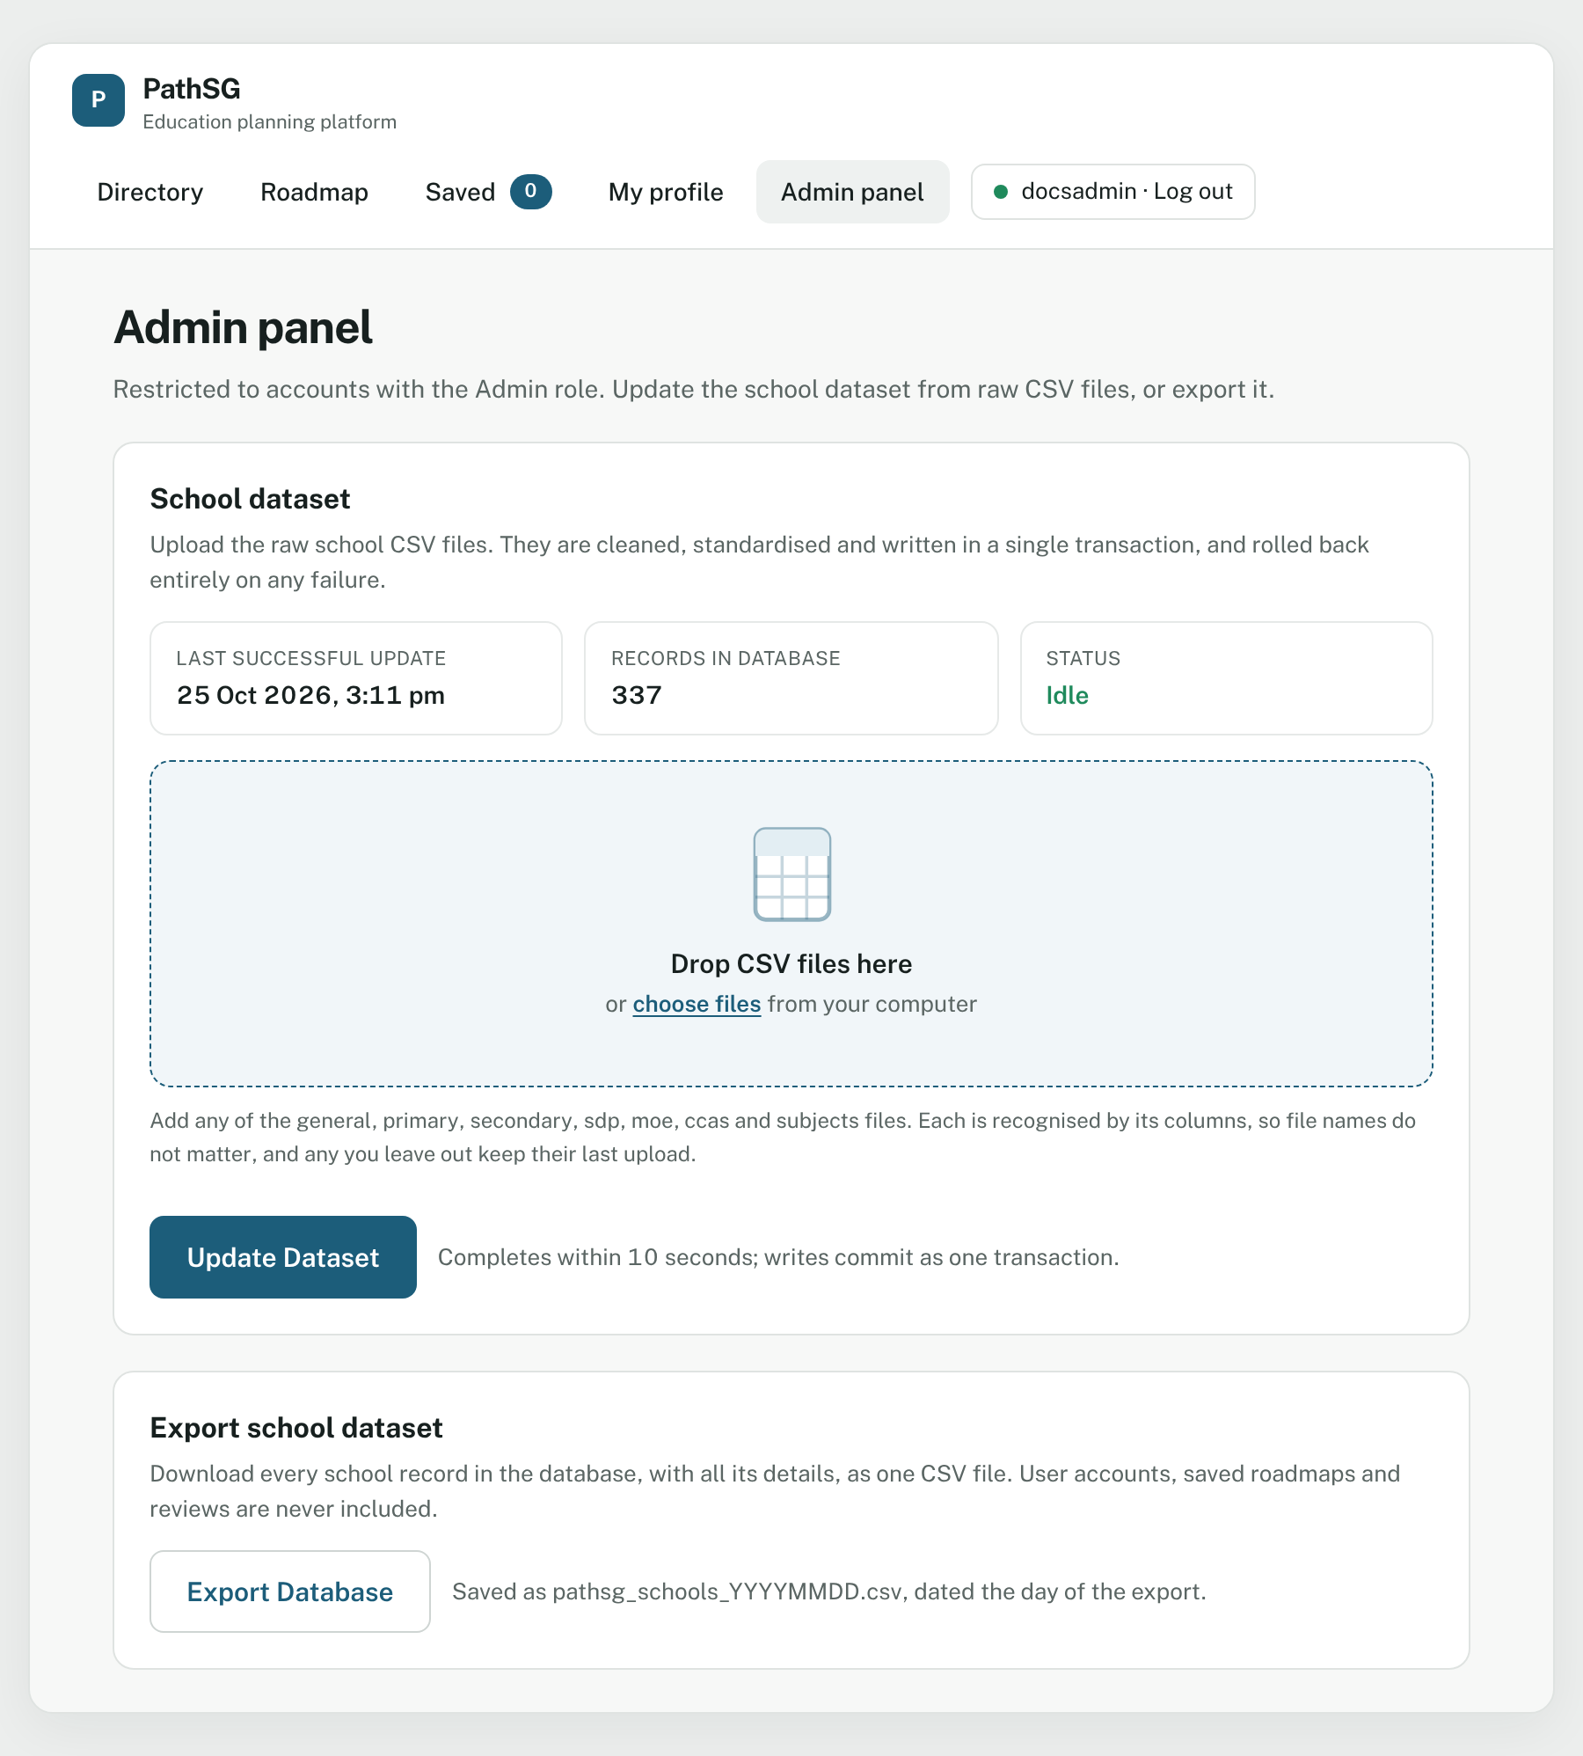
Figure 31 – The Admin panel shows when the data was last updated, how many schools it holds and whether an update is running.
- Add your files. Either drag and drop them onto the dashed box, or click choose files and select them.
  - You can add several files at once. The system recognises each one by its columns, so file names do not matter. The accepted files are: general, primary, secondary, sdp, moe, ccas and subjects.
  - Any file you leave out keeps its last upload.
  - Only non-empty .csv files up to the size limit (20 MB per file unless the technical team has changed it) are accepted.
- Check the list of files and their sizes. To remove one, click the × beside it. To start again, click Clear all.
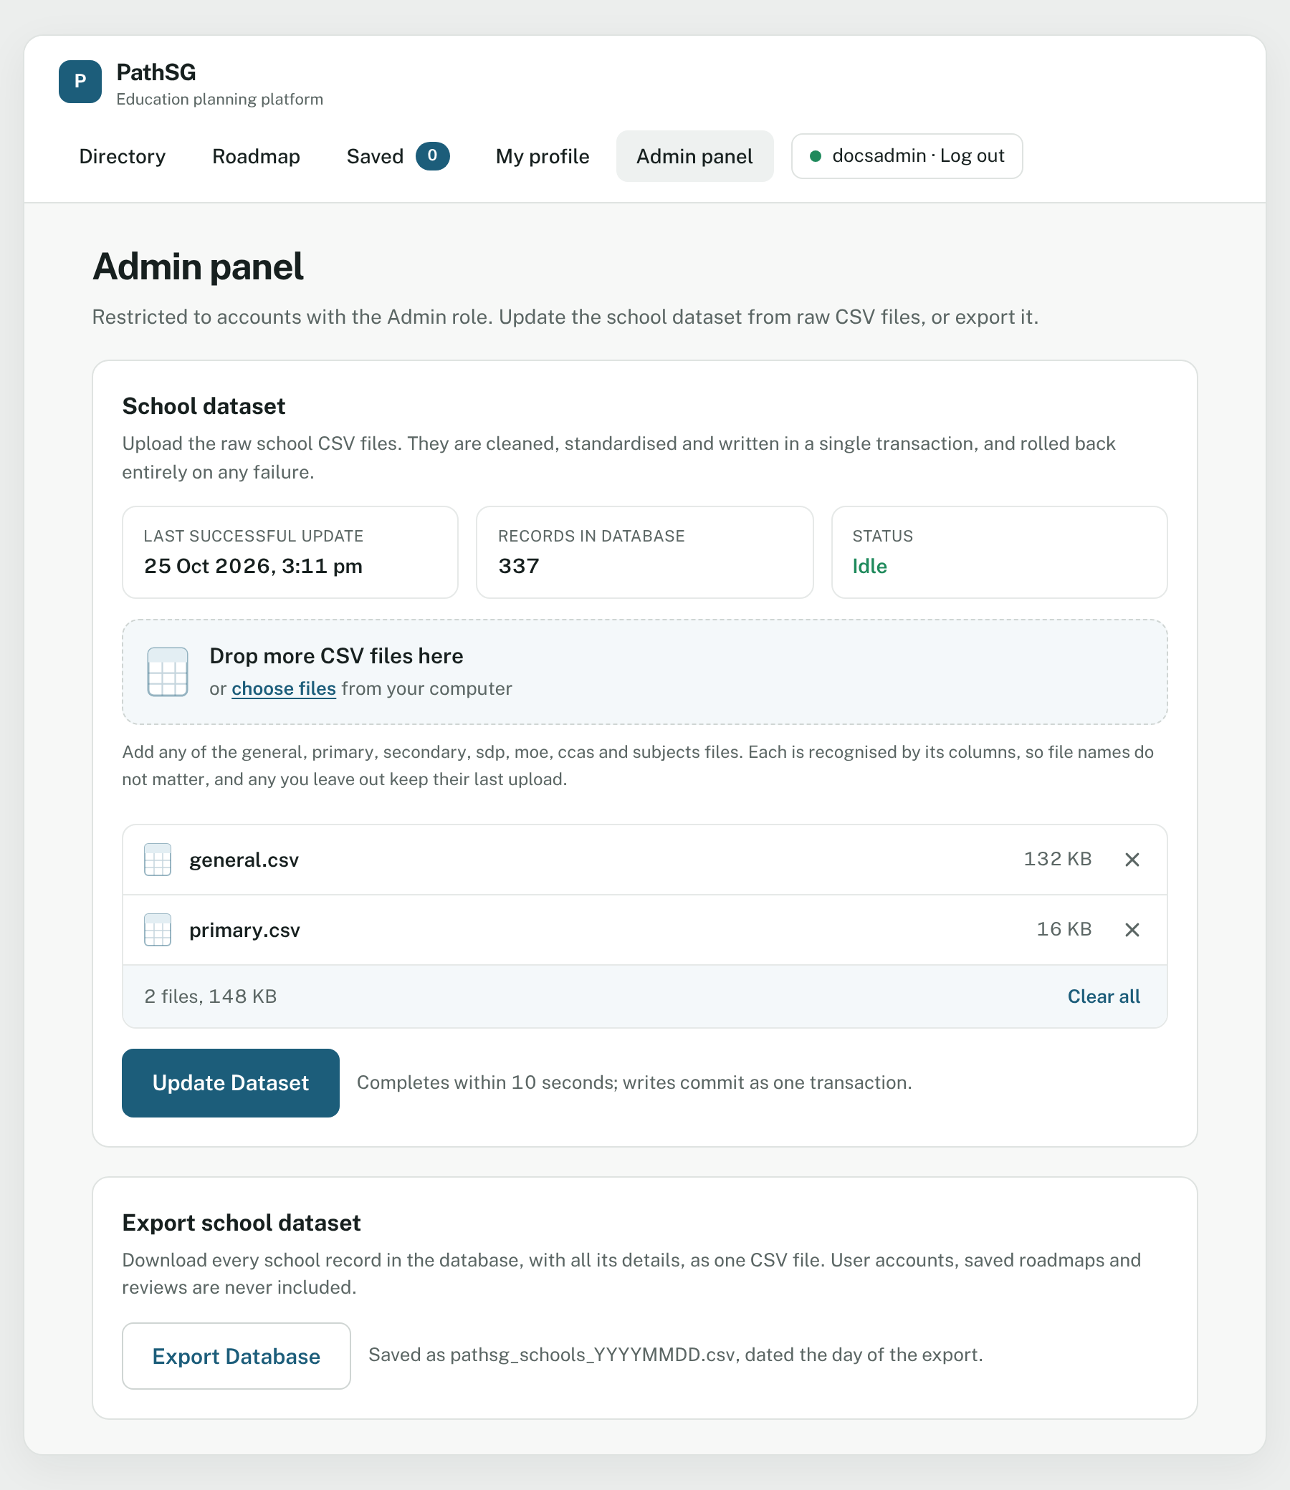
Figure 32 – Two files selected and ready.
- Click Update Dataset.
- While the update runs (usually within 10 seconds) the button reads Updating dataset…, the Status shows Update running, and the files and button are locked so nothing is sent twice.
- When it finishes, a green banner says “Database updated successfully with the latest Singapore school data” and the counters refresh.
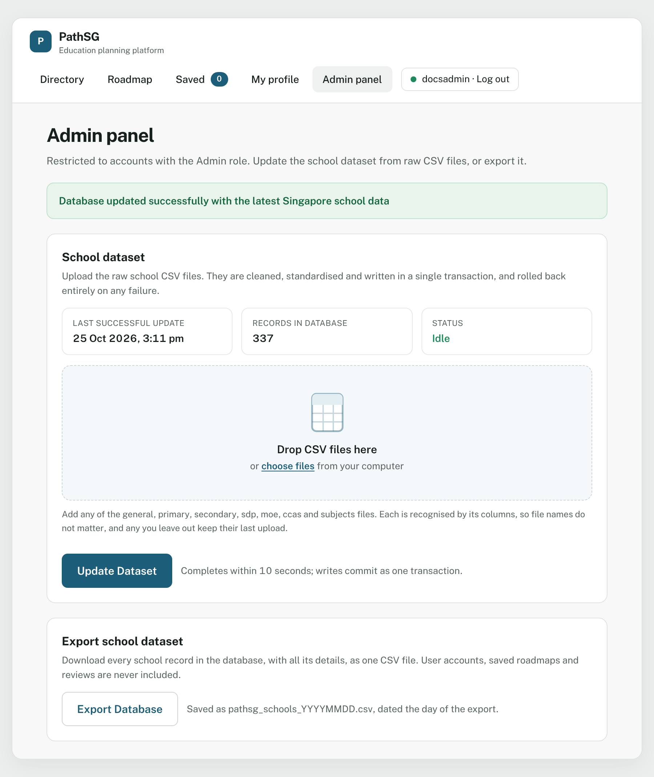
Figure 33 – The success banner at the top.
The update is all-or-nothing. All changes are saved together. If anything goes wrong, nothing at all is changed. New schools are added and existing ones are updated.
If something goes wrong
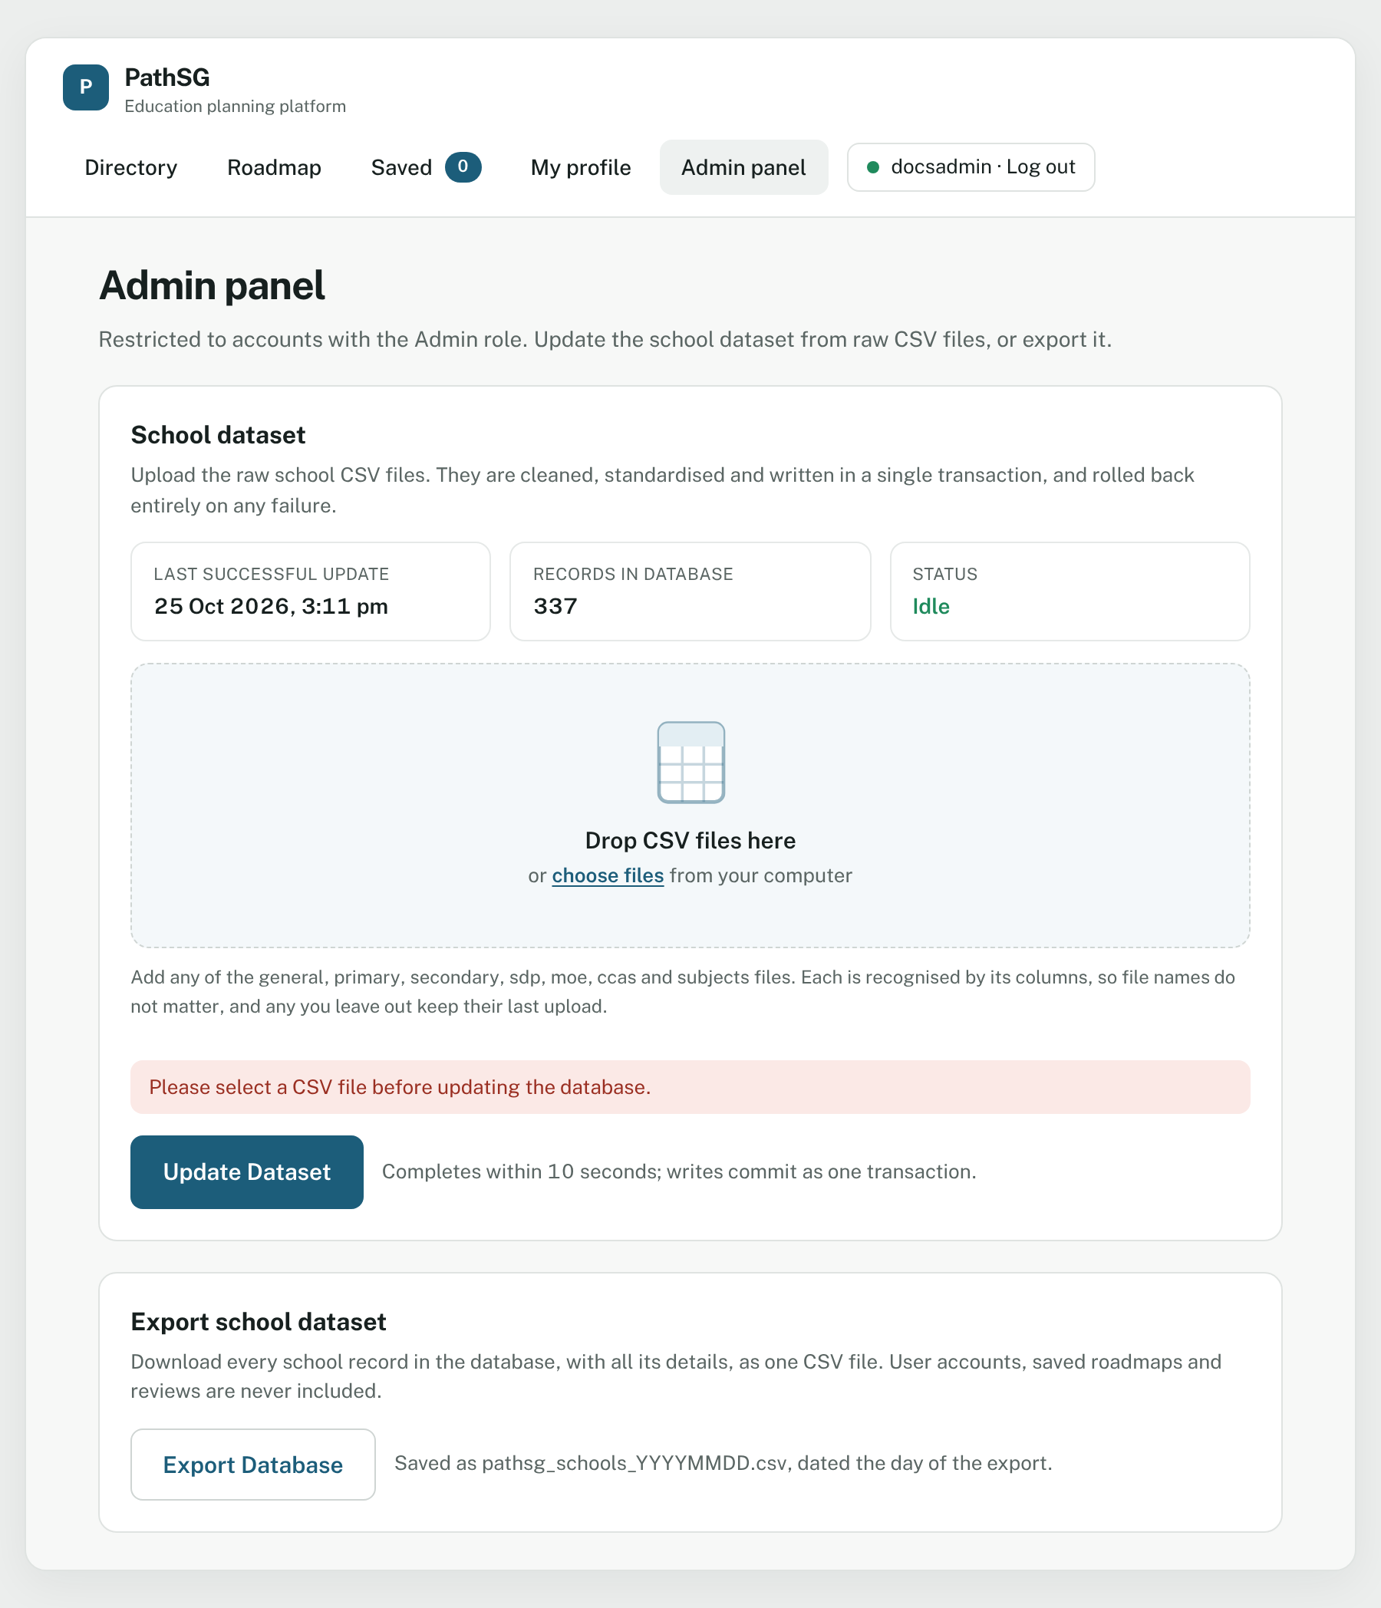
Figure 34 – Clicking Update Dataset with no file chosen shows a message and does not start.
You see | What it means | What to do
Please select a CSV file before updating the database. | You clicked Update Dataset with no file. | Add a file first.
Invalid file. Please upload a non-empty .csv file within the size limit. | The file is not a CSV, is empty or is too big. | Use a proper CSV within the size limit.
…is not a CSV file, so it was left out. / …is empty, so it was left out. | The box skipped a file you dropped. | Check the file and add it again.
Database Update Failed: Unable to process dataset format. Please check source data and try again. | A file is missing required columns, has damaged rows or has unexpected values. | Check the source file. The database was not changed.
Database Update Failed: Unable to connect to local database. Please try again later. | The database was unavailable. | Wait, then try again.
A database update is already running. Please wait for it to finish. | Someone else started an update. | Wait for it to finish.

A.4 Export the school database
- Open Admin panel.
- Under Export school dataset, click Export Database.
- Your browser downloads a file named pathsg_schools_YYYYMMDD.csv, where the numbers are today’s date (for example pathsg_schools_20261025.csv).
The file contains every column for every school. It never contains user accounts, saved roadmaps or reviews.
If the database is empty or cannot be reached, a pop-up says Export Failed: “Unable to retrieve school data at this time.” Click Close and try again later.

Appendix B: Glossary
Term | Meaning
AL (Achievement Level) | The PSLE scoring band. Your PSLE Aggregate AL is the total of your four subject bands. It ranges from 4 (best) to 32.
L1R5 | O-Level score used for junior college admission. It adds up English and five other subjects. Lower is better.
ELR2B2 | O-Level score used for polytechnic and ITE admission. It adds English, two relevant subjects and the best two others. Lower is better.
JAE | Joint Admissions Exercise, the process for entering junior colleges, polytechnics and ITE after O-Levels.
Cut-off point | The score of the last student admitted in a past year. A guide, not a promise.
T-score | The older PSLE scoring scale. A higher cut-off means a more competitive school.
Phase 2B | A stage of Primary 1 Registration. PathSG shows how many places were taken up to this phase.
GPA | Grade Point Average from polytechnic, from 0.00 to 4.00.
Rank Points (RP) | The score from A-Level results, from 0 to 90.
Government / Government-Aided / Independent | The school types, as listed by MOE.
CCA | Co-Curricular Activity, such as a sport, club, uniformed group or performing arts group.
IP / SAP / GEP | Integrated Programme, Special Assistance Plan and Gifted Education Programme. They appear as small labels on school profiles.
Roadmap | An ordered list of up to three school choices for your next education step.
Rule-Based Plan | A roadmap made from fixed ranking rules.
AI-Generated Plan | A roadmap suggested by an AI model as an alternative.
About the pictures in this guide: the screenshots were taken from PathSG with sample accounts and sample entries. The schools in your roadmap, and the dates and counts you see, will differ.

