PathSG Admin Guide
For administrators
Version 2.0 · 9 November 2026 · Prepared by SC2006 SCSL Team 2
Open the Admin Panel at https://pathsg.robothanzo.dev/admin after you log in.

1. Before you start
This guide is for administrators only. Use the Admin Panel to keep the school information up to date, and to export a copy of it.
- Admin access: only accounts with the admin role can open the Admin Panel. The development team gives this role. You cannot give it to yourself in the app.
- Menu: the Admin panel item appears in the menu only for admin accounts.
- Data source: PathSG never fetches school data by itself. You download the CSV files from data.gov.sg and upload them yourself.
[Figure 1: The menu for an administrator, showing the Admin panel item.]

2. Open the Admin Panel
- Log in with your admin account.
- Click Admin panel in the menu.
The page is titled Admin panel. It has two sections: School dataset (update) and Export school dataset.
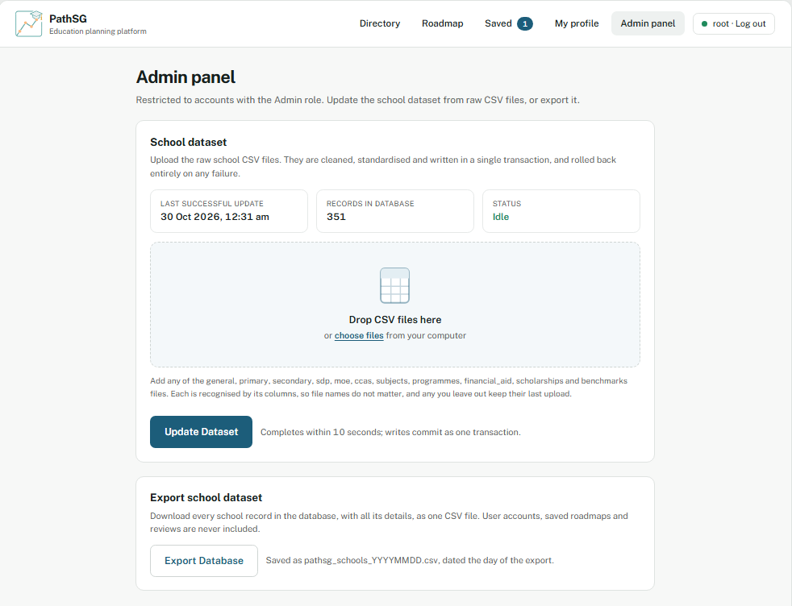
[Figure 2: The Admin panel page with both sections visible.]

3. Check the current status
The School dataset section shows three tiles:
- Last successful update: the date and time of the last successful update. It shows "Not recorded" if there has never been one.
- Records in database: the number of schools in the database.
- Status: Idle when no update is running, or Update running while one is in progress.
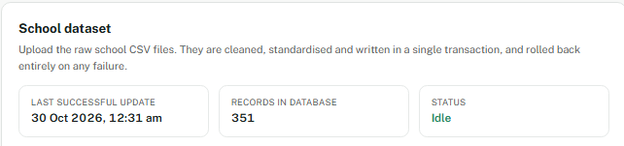
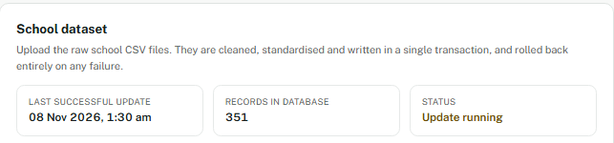
[Figure 3: The three status tiles in the School dataset section.]

4. Update the school dataset

Before you upload
- Download the latest CSV files from data.gov.sg.
- Use the files for these kinds: general, primary, secondary, sdp, moe, ccas, subjects, programmes, financial_aid and scholarships. You can also add the optional benchmarks file.
- File names do not matter. PathSG recognises each file by its column headers.
- Each file must be a .csv file, must not be empty, and must be 20 MB or smaller.
- Any kind you leave out keeps its last upload. You do not need to upload all of them every time.

Upload and update
- Open the Admin panel and go to School dataset.
- Drag your CSV files into the box, or click the box to choose them. You can add more files later.
- Check the file list and the total size. Remove any wrong file from the list.
- Click Update Dataset. The button changes to Updating dataset…, and the file list and button lock until the update finishes.
- Wait for the message Database updated successfully with the latest Singapore school data. The update completes within 10 seconds.
- Check that Last successful update and Records in database have changed.
- All or nothing: the update is saved as one transaction. If any file fails, nothing is changed and the database stays as it was.
- One update at a time: if another update is running, you cannot start a second one. Wait for the first to finish.
- Do not refresh the page while an update is running.
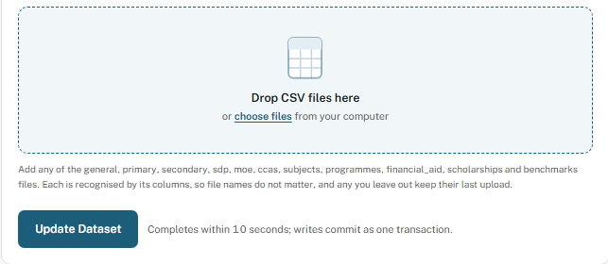
[Figure 4: The CSV drop box with several files listed, and the total size.]

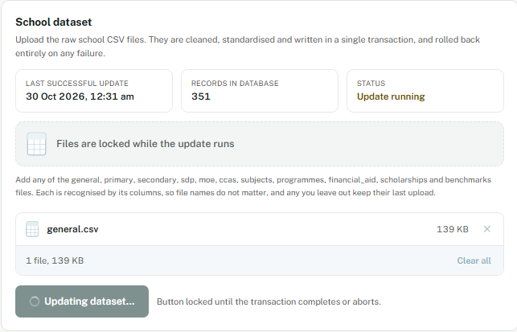
[Figure 5: The Update Dataset button, and the button while the update is running.]

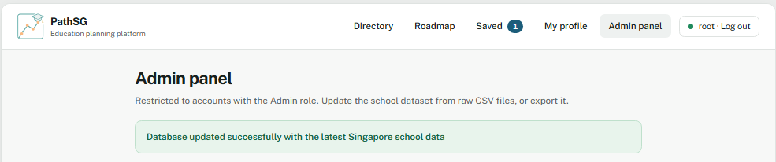
[Figure 6: The success message after a successful update.]

5. If an update fails
PathSG shows a message next to the upload box, or in a pop-up for serious problems. Nothing is changed when an update fails.
- "Please select a CSV file before updating the database." Choose at least one CSV file, then click Update Dataset again.
- "Invalid file. Please upload a non-empty .csv file within the size limit." The file is larger than 20 MB. A file that is not a CSV, or is empty, is left out of the list with a note naming it and never reaches the update. Check the file and replace it.
- "A database update is already running. Please wait for it to finish." Wait for the current update to finish, then check the status.
- "Database Update Failed: Unable to process dataset format." The file is missing required columns, has malformed rows, or has unexpected values. Check that you downloaded the correct file from data.gov.sg.
- "Database Update Failed: Unable to connect to local database." The database is not available. Try again later. If it keeps happening, tell the development team.
- "Unable to reach API. Please try again." The connection to the server failed. Check your connection and try again.
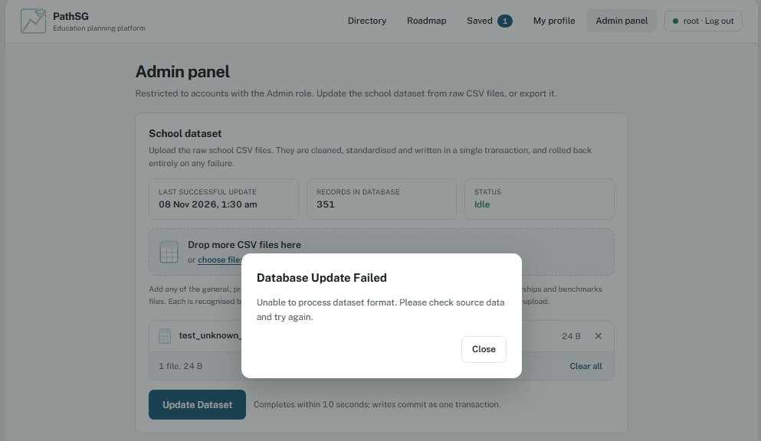
[Figure 7: An example of an error message shown in the Admin panel.]

6. Export the school dataset
- Open the Admin panel and go to Export school dataset.
- Click Export Database. The file downloads automatically.
- The file is named pathsg_schools_YYYYMMDD.csv, with the date of the export in Singapore time.
- It contains every school record and its details. It does not contain user accounts, reviews or saved roadmaps.
- If the export fails, PathSG shows "Export Failed: Unable to retrieve school data at this time." Try again later.
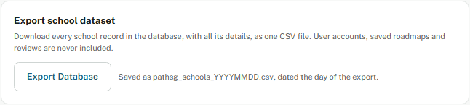
[Figure 8: The Export school dataset section with the Export Database button.]

7. Good practice
- Keep a copy of the CSV files you uploaded, so you can check or restore them later.
- After each update, check the record count and the last update time.
- Export the database before a big update, so you have a copy of the current data.

8. Admin accounts (development team only)
The development team gives the admin role from the server, not from the app. The team runs the following command in the server folder:
python -m scripts.make_admin <username>
To remove the admin role, add --remove to the end of the command. The user must already have registered an account.

