# For Customers

## To Register

1. At first, click “Register” from the navigation bar.

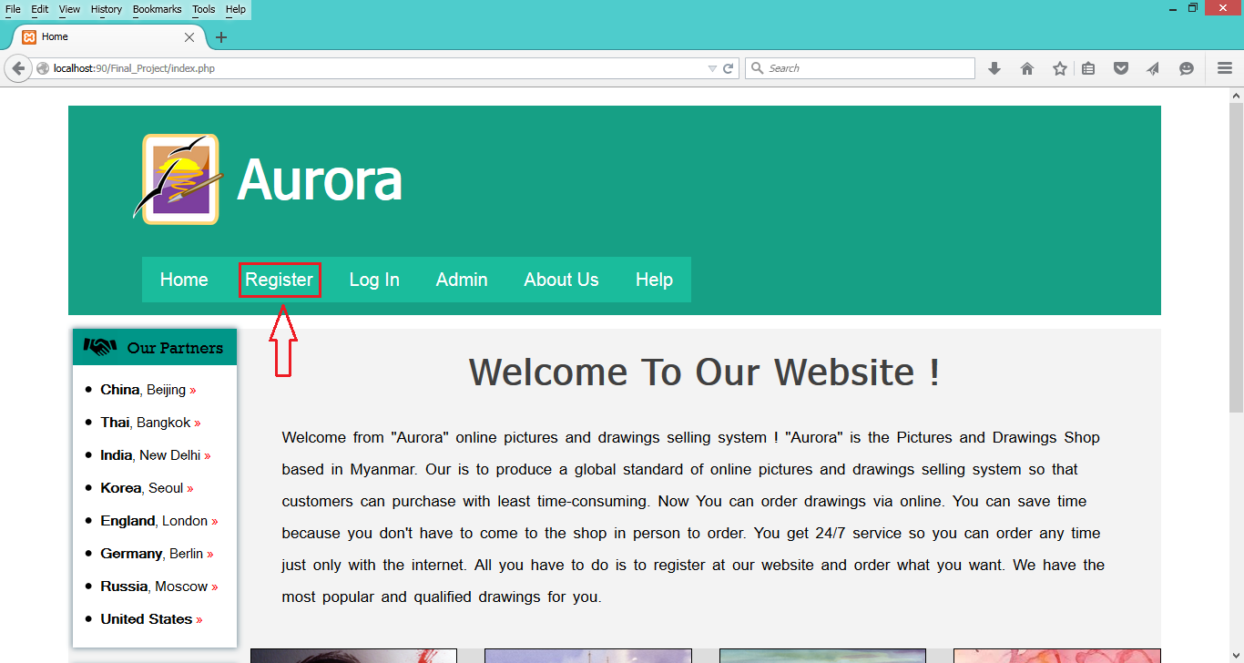

1. Provide all information in the text inputs and click register button.

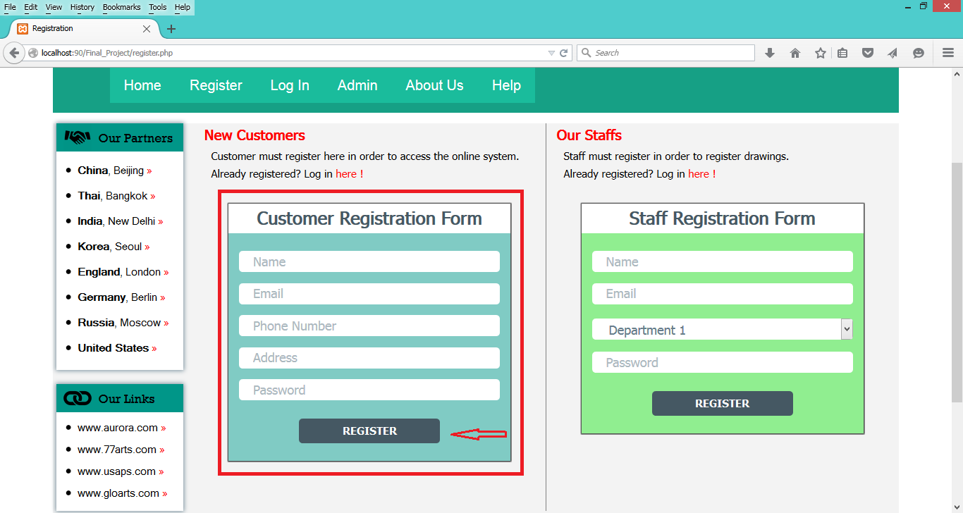

1. An alert box which alerts that you have successfully registered will be appeared.

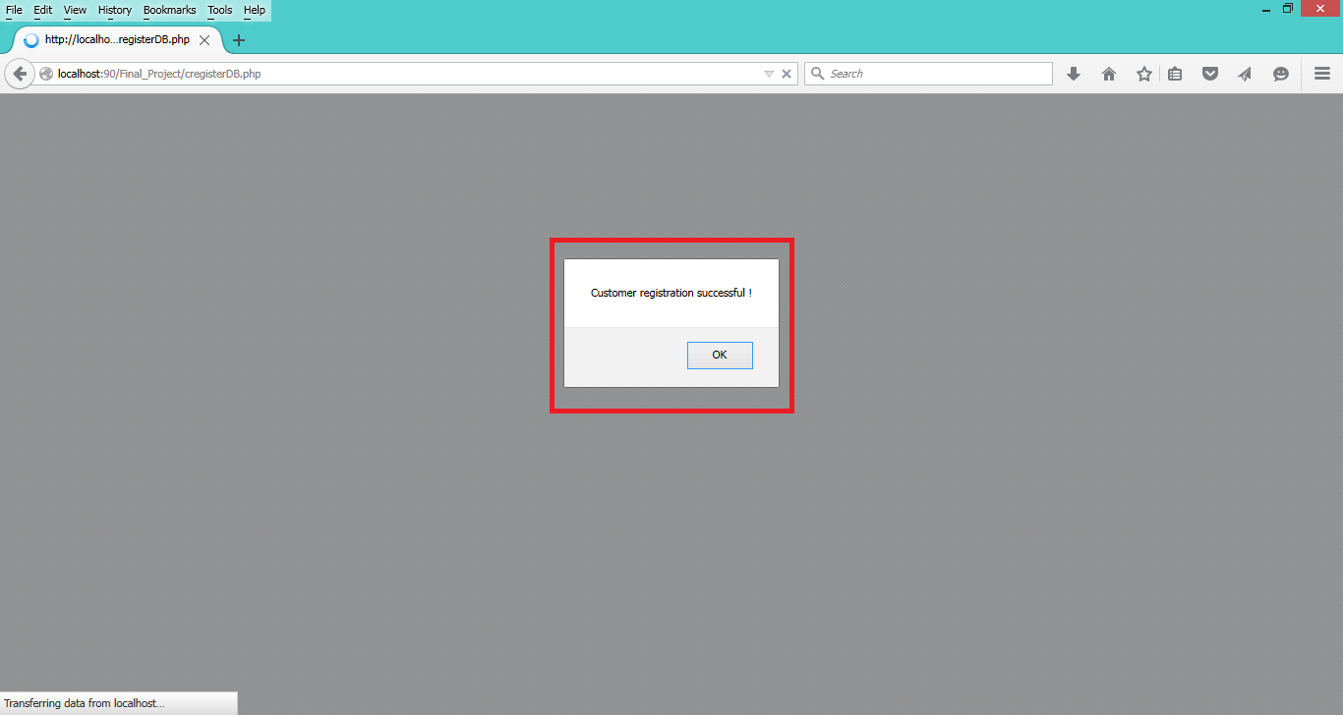

## To Order

1. Log in from the log in page by providing username and password.

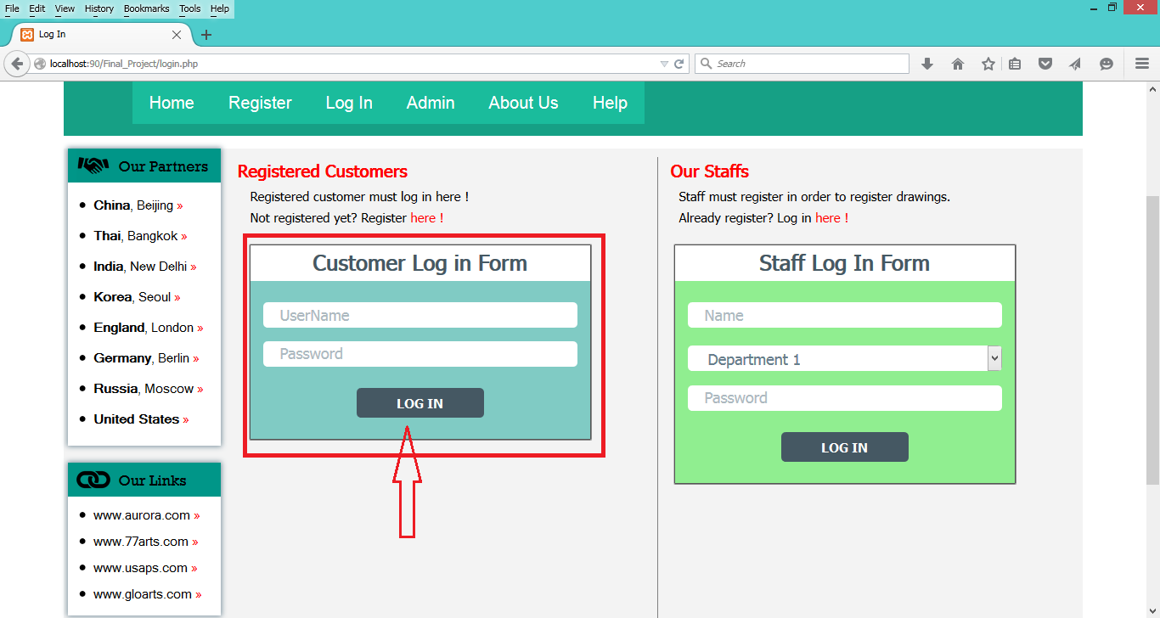

1. Then, the gallery page will be provided.

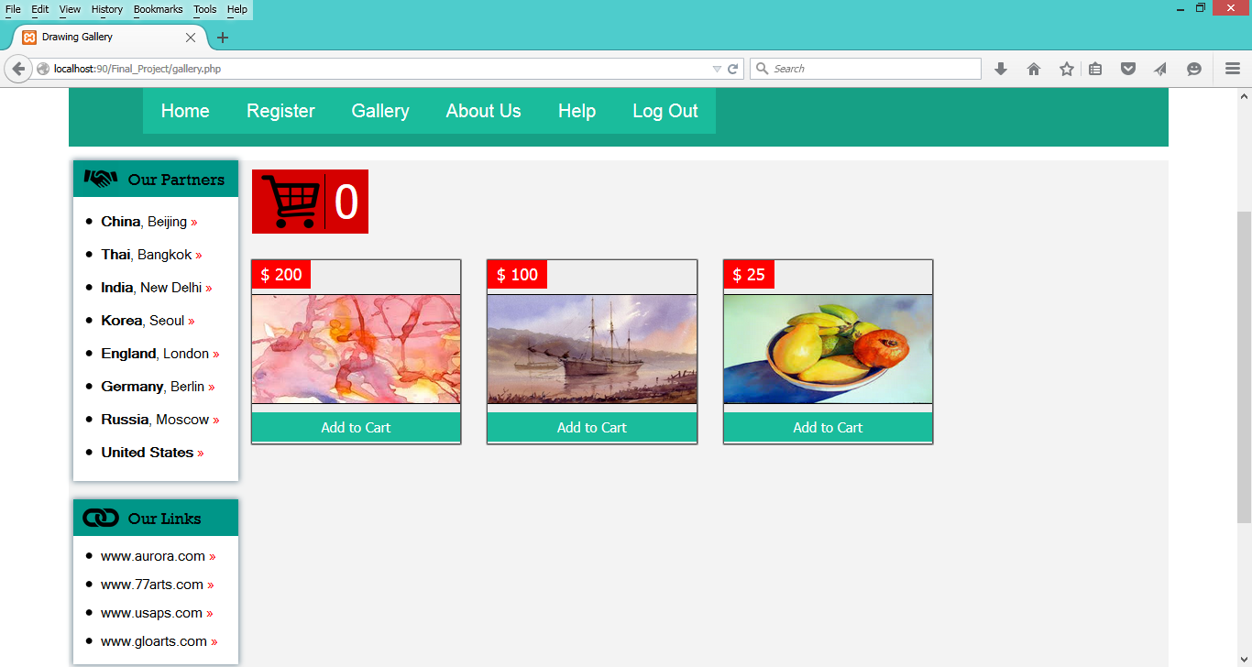

1. Click the “Add to Cart” button to select the drawings and click the cart button to view what you have ordered.

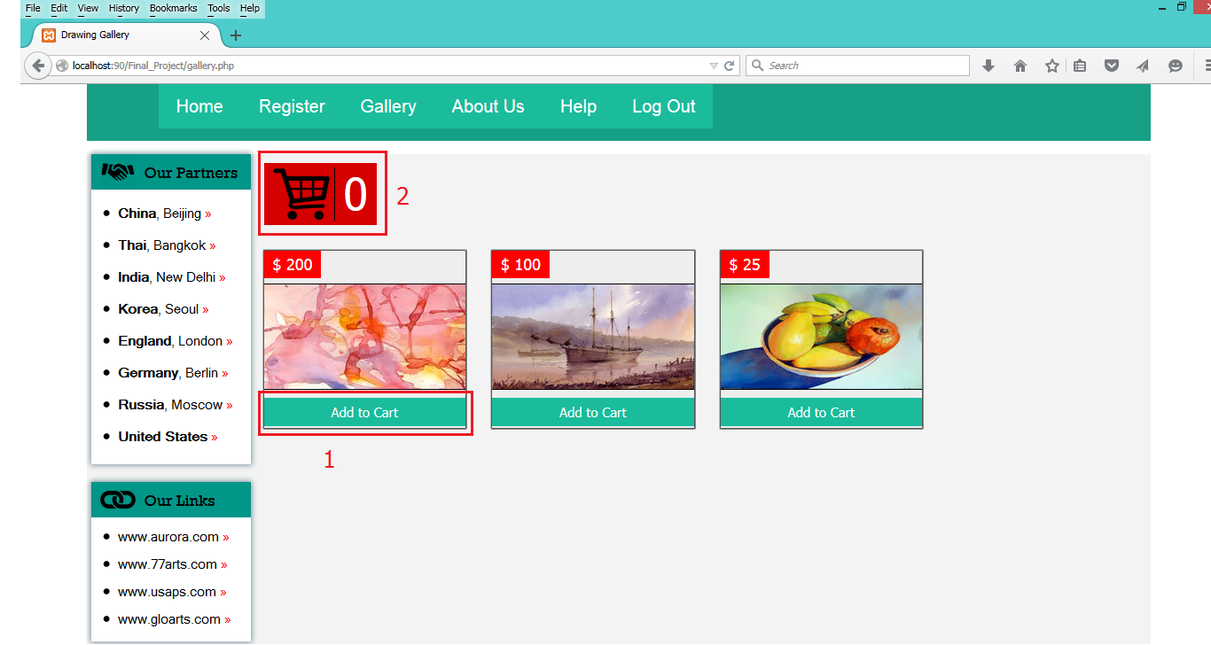

1. Click the “Submit Order” button to order.

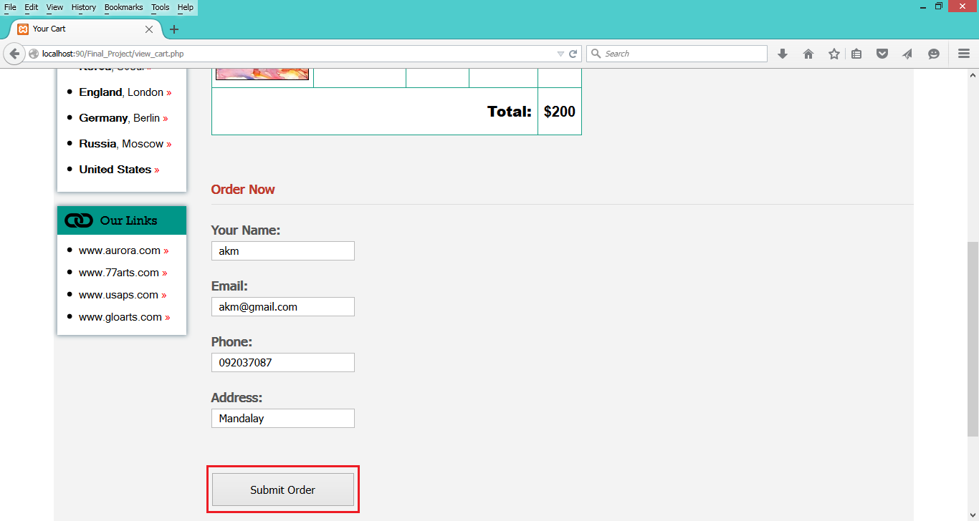

1. An alert box which alerts that your order has been submitted will be appeared.

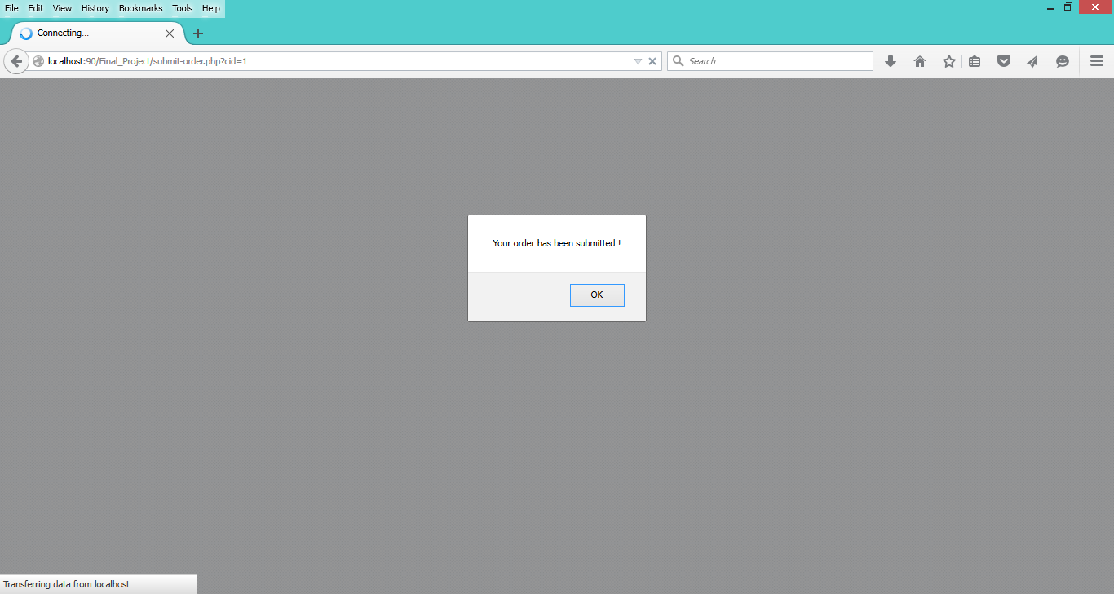

# For Staffs

## To Register

1. Firstly, click registration link from the navigation bar.



1. Provide all information in the text inputs and click register button.

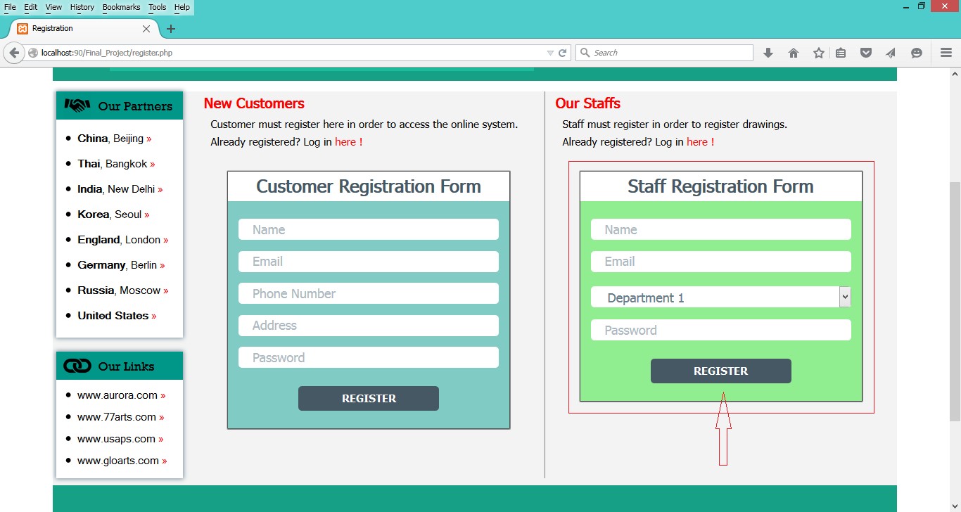

1. An alert box which alerts that you have successfully registered will be appeared.

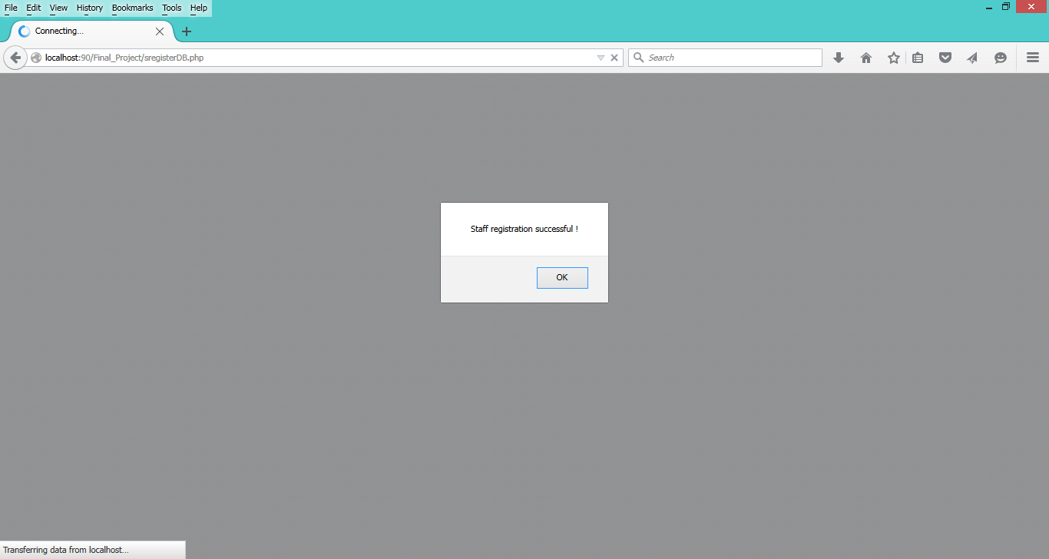

## To Register Drawings

1. First of all, log in from the log in page and the drawing registration page will be provided.

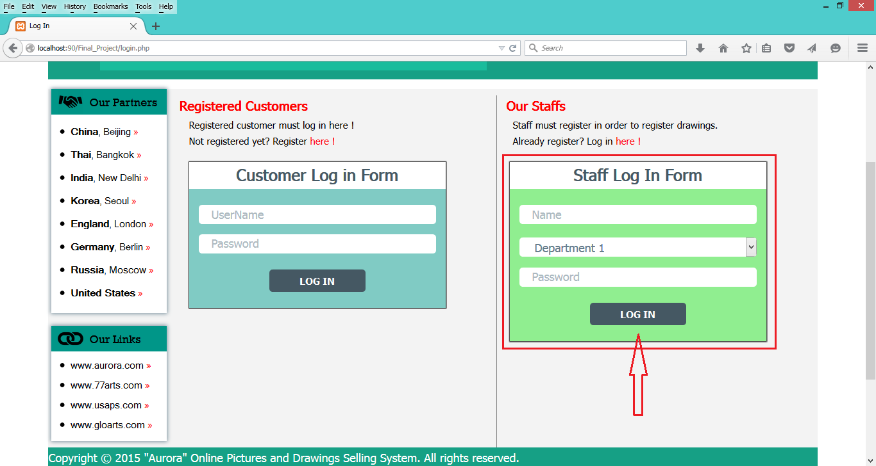

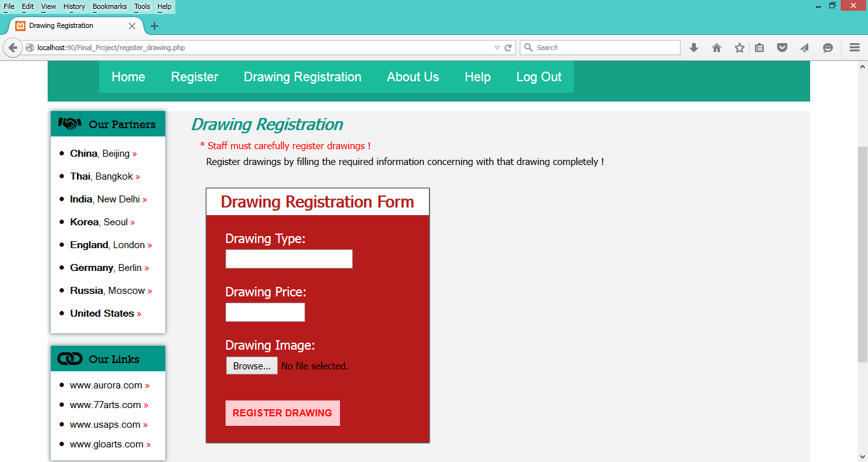

1. Provide information and an image of the drawing and then click “REGISTER DRAWING” button.

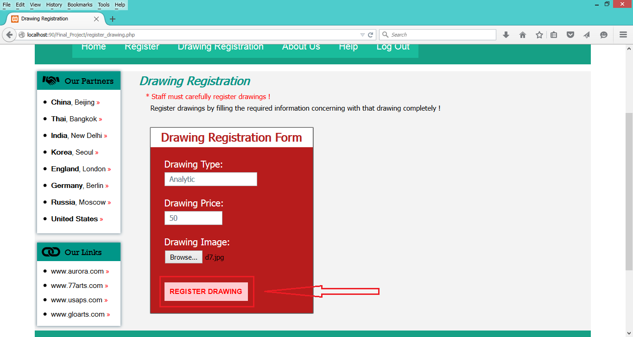

1. Alert box that alerts the drawing is successfully registered will be appeared.

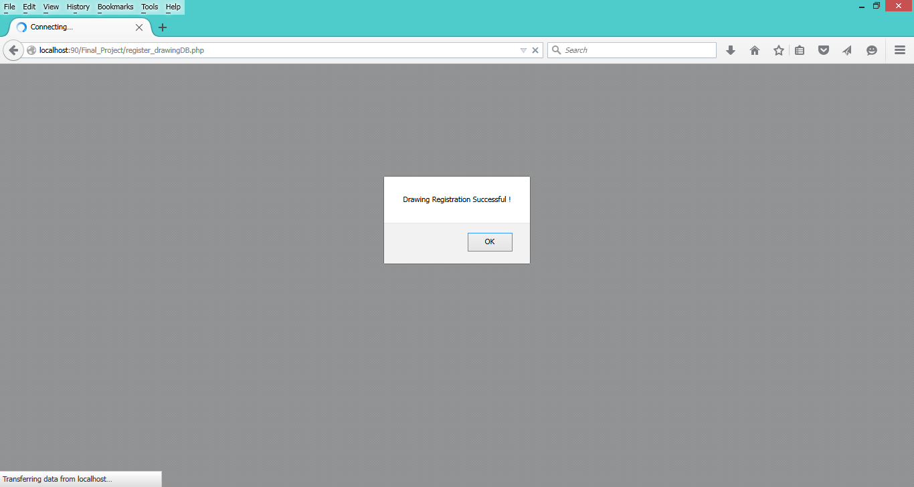

# For Administrator

## To View Reports

1. Click the admin link in the navigation bar and then log in by using administrator username and password.

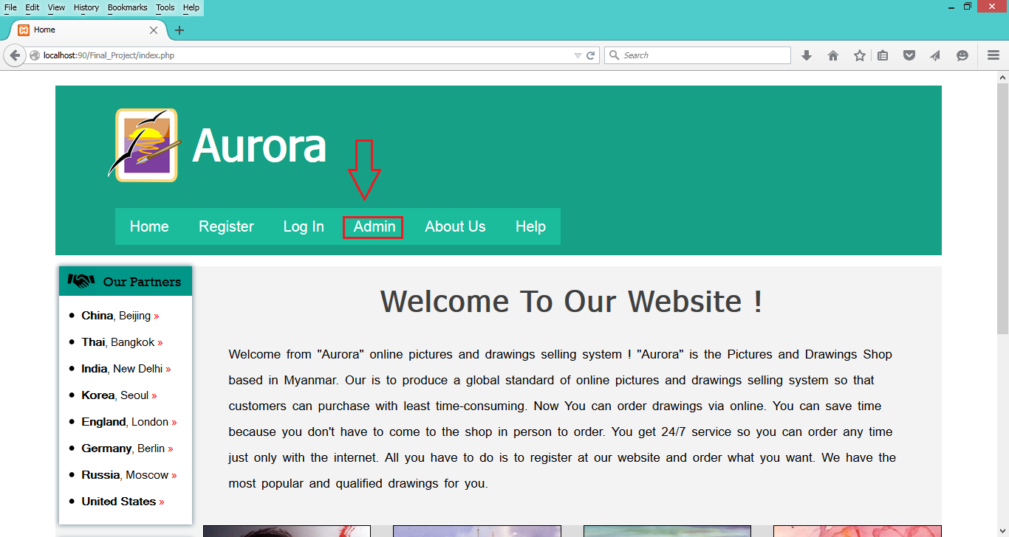

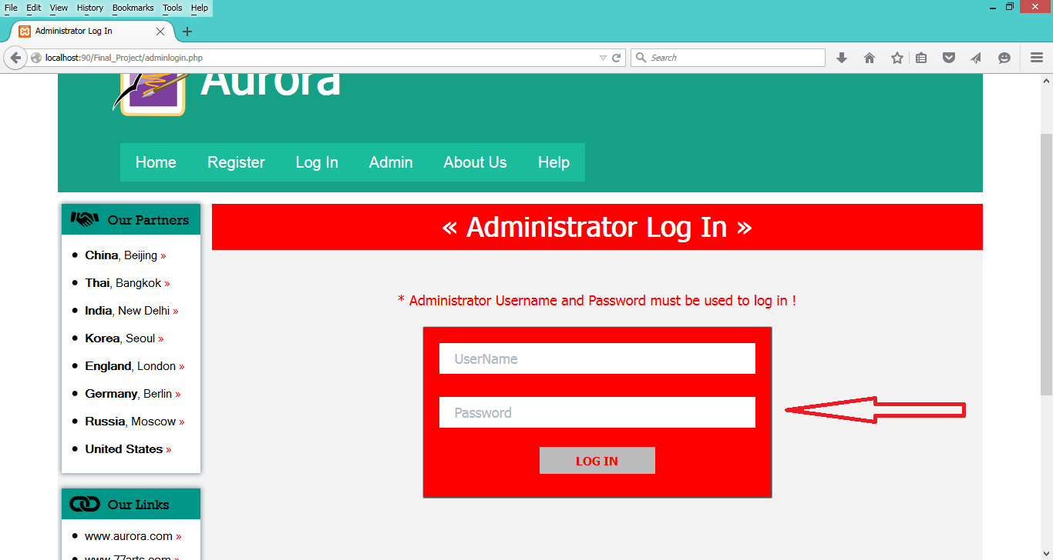

1. Then, the report page will be provided.

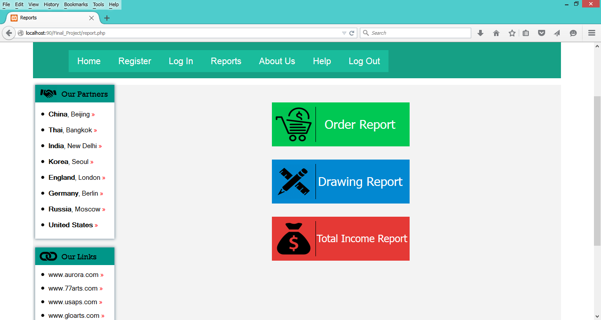

1. Administrator can confirm or remove orders, edit or remove drawings and view monthly total income report.

