Aung Phone Kyaw

19930

CS571

Week 3, Question 13

**Install node js on ubuntu**

For this process, I have already done it for the assignment two so I not be adding them for this time.

**Modify http json api server**

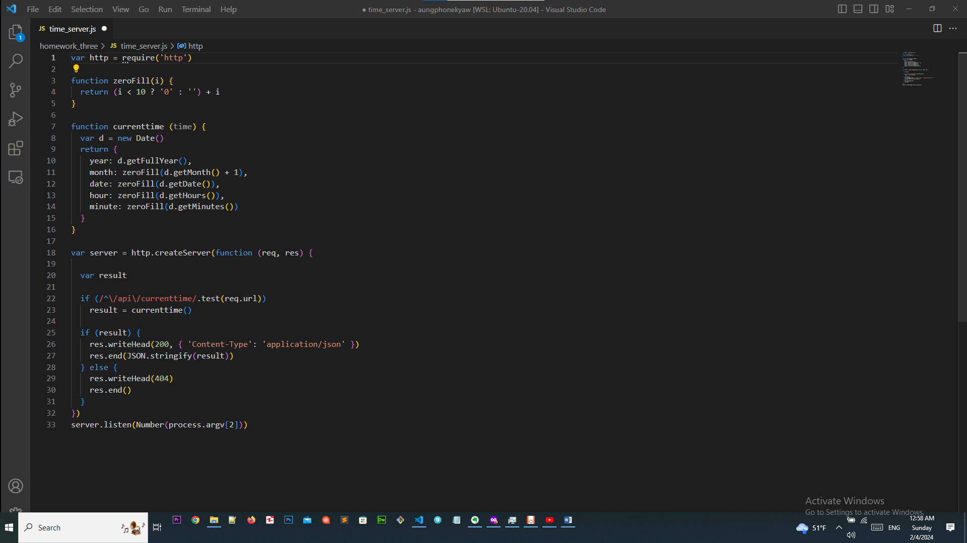

This is my code to get this output format on the browser {"year":2021,"month":09,"date":24,"hour":16,"minute":09}

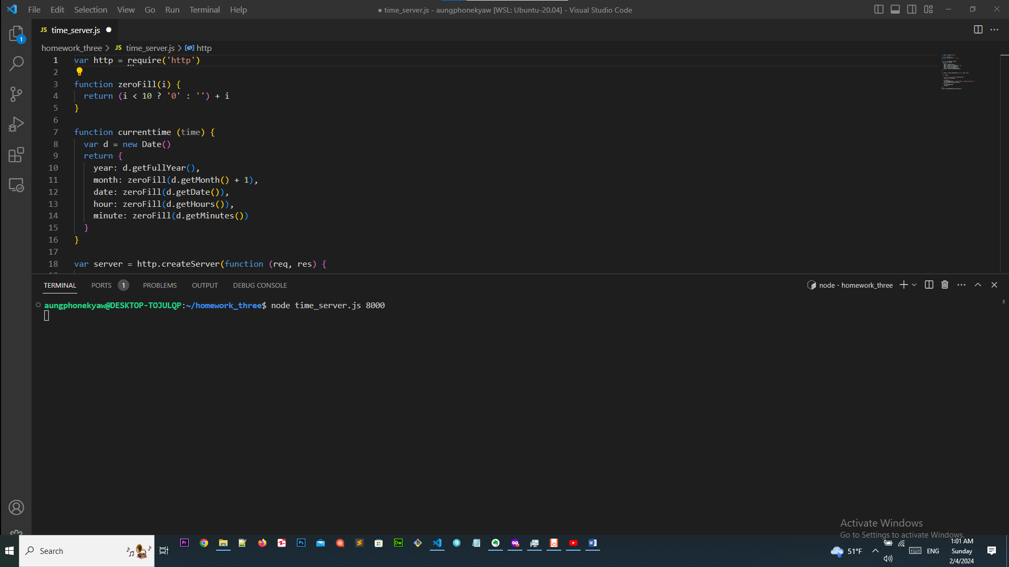

I will run the code using the command node time_server.js 8000

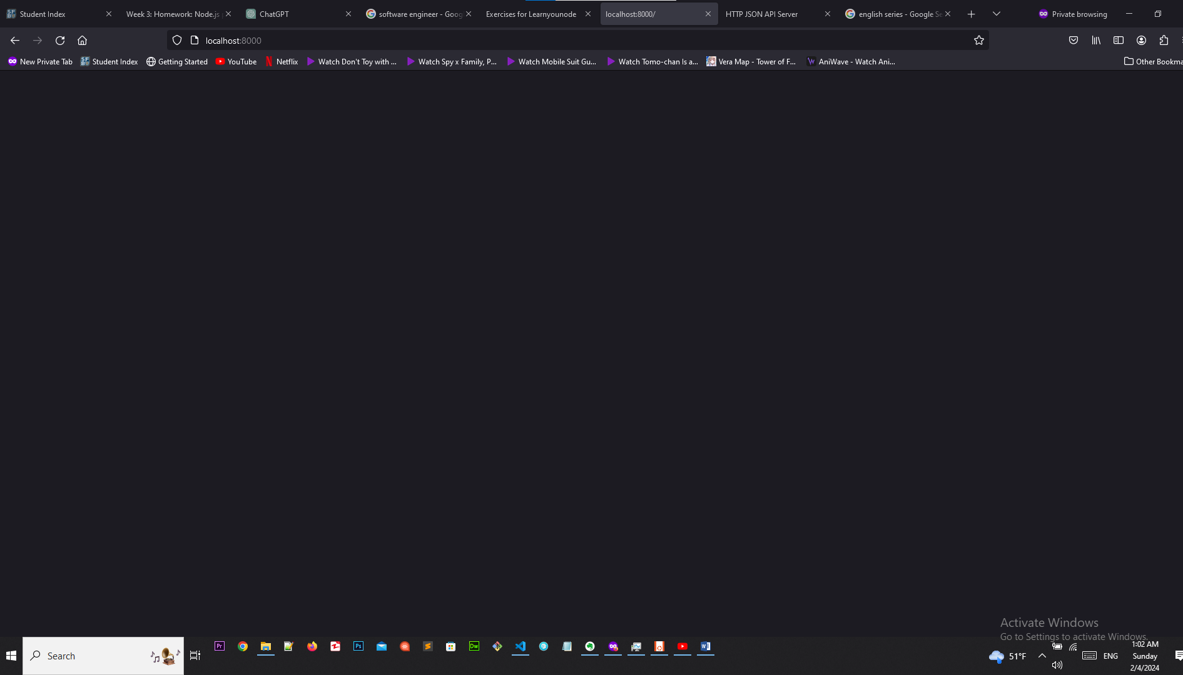

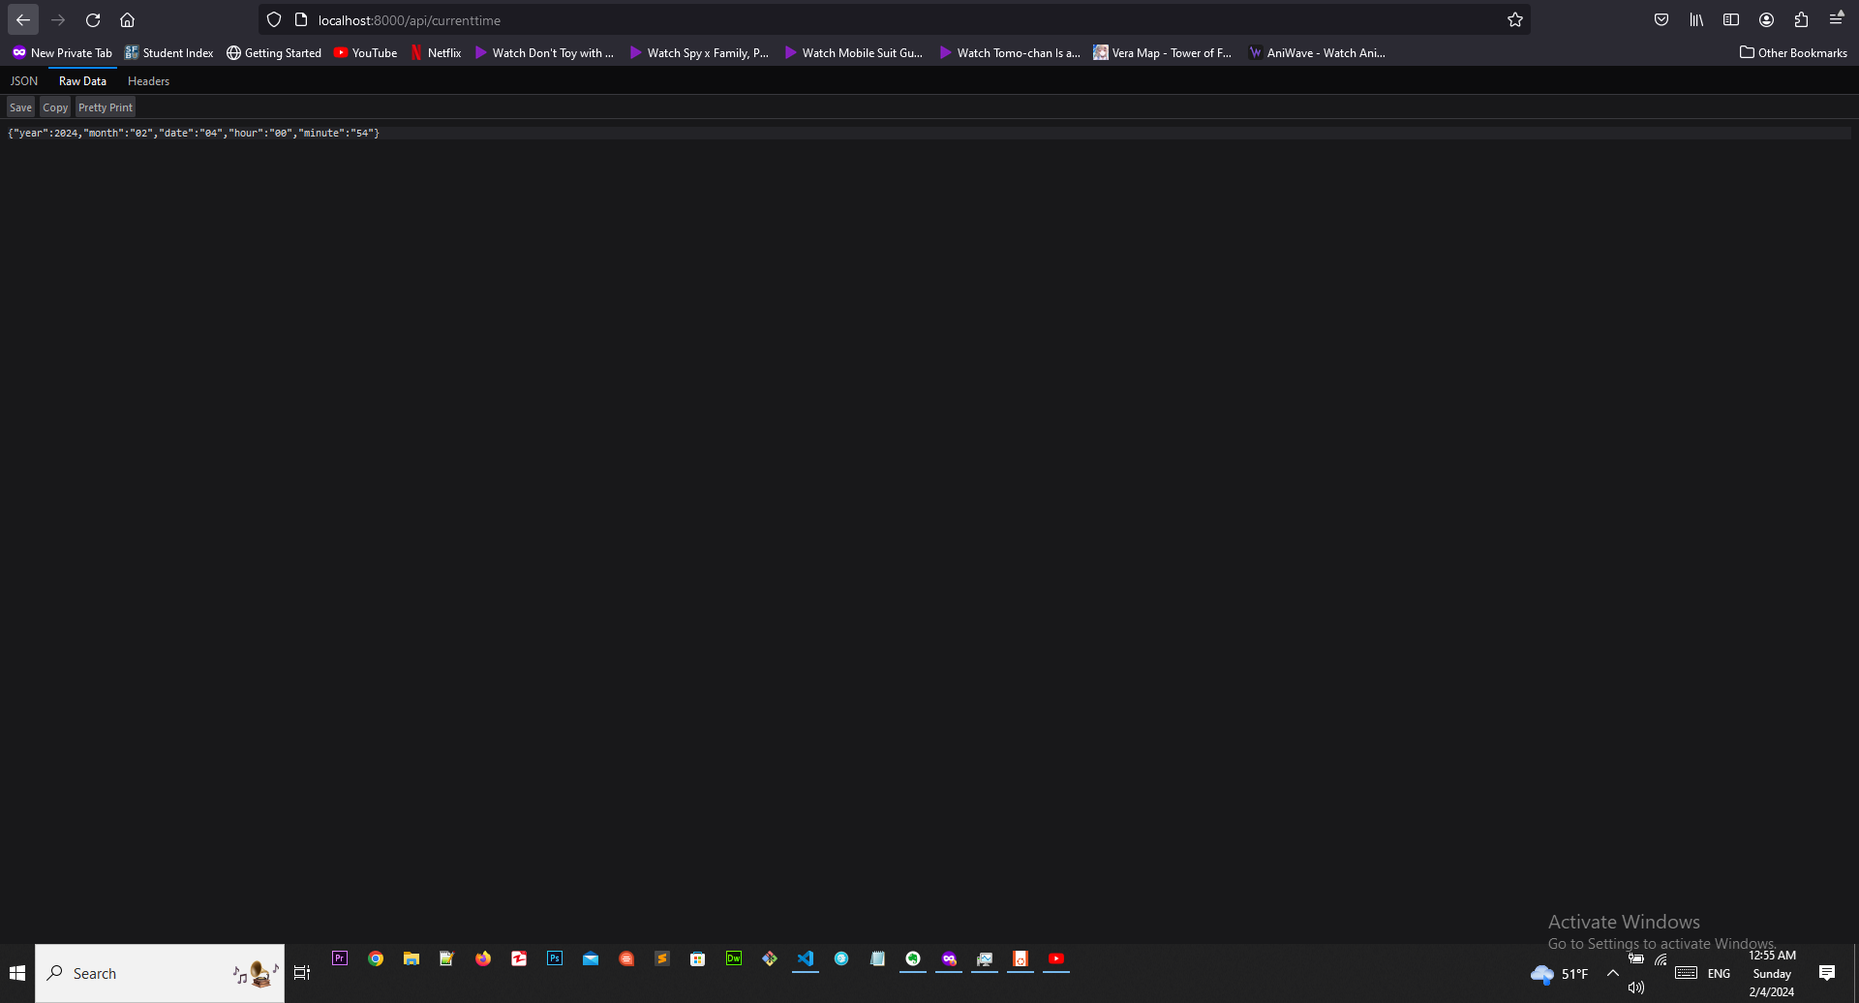

You would not see the output result unless you enter the correct url path localhost:8000/api/currenttime

The output values month, date, hour and minute are in string format since I want these values to be double digits value and I can only get it done in string format. If I convert to integer it will return single digit for the single values.

**Documentation**

**Please create google slide presentation to document the project**

<https://docs.google.com/presentation/d/191J-jykKpywSADPzC3nWzMaLZXweusseR6PozOeF_Ho/edit?usp=sharing>

This is the presentation file link that I have created based on the project.

**Please add your google slides presentation on github**

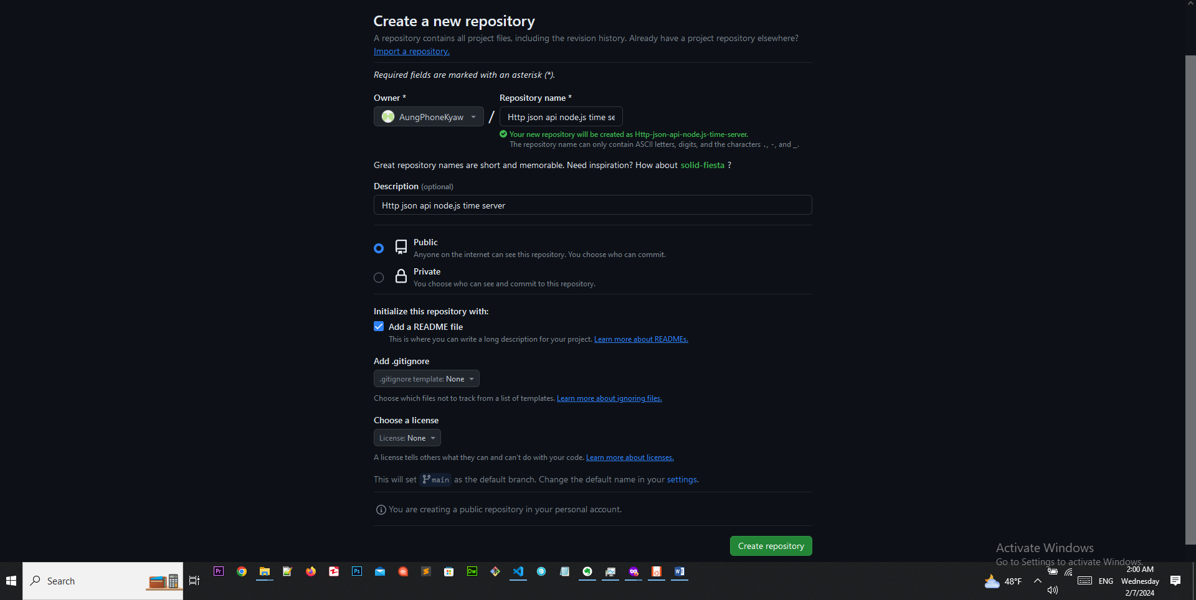

Create the project with the preferred name, description, check add read me file and add create repository.

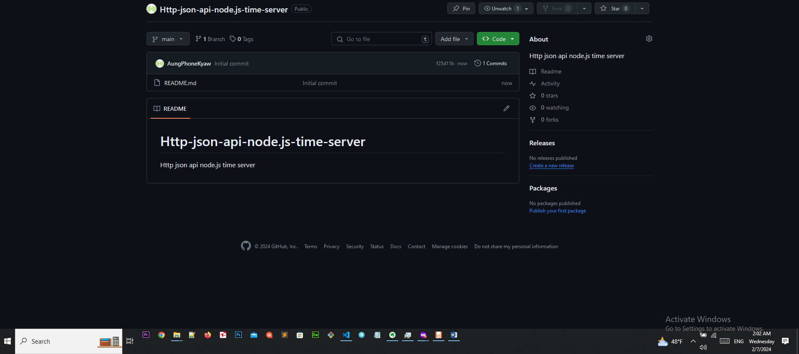

Project repository successfully created.

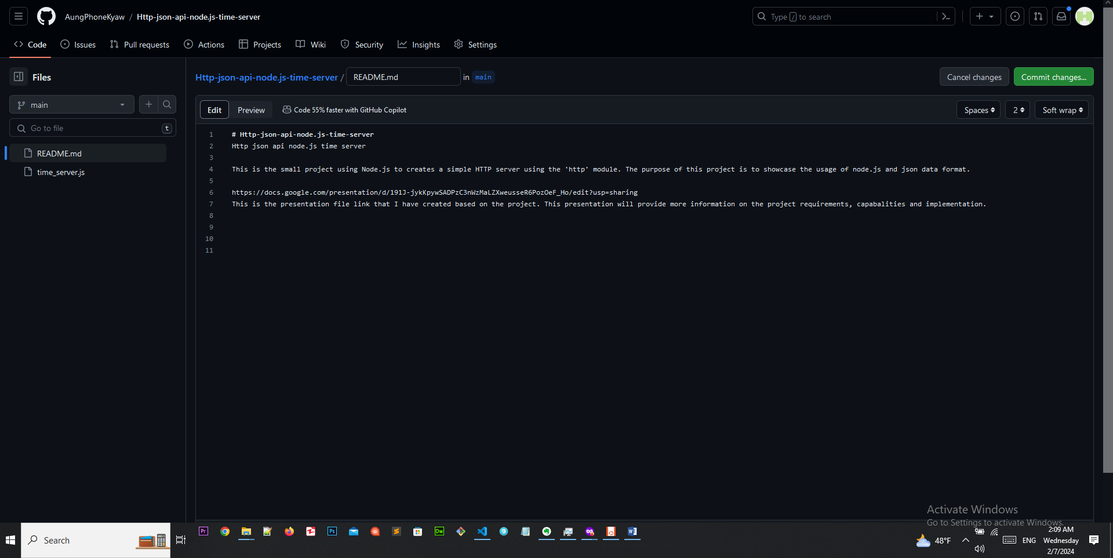

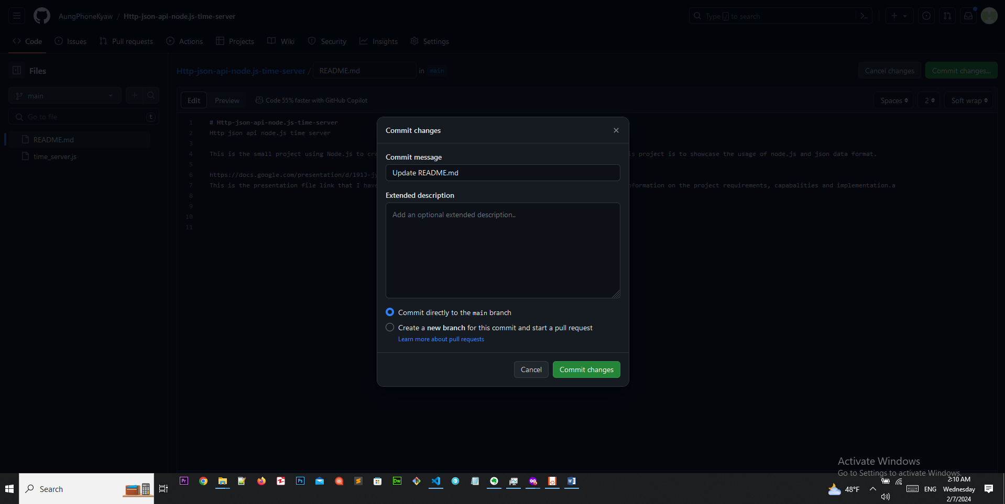

Add more description and presentation file link of the project in read me file.

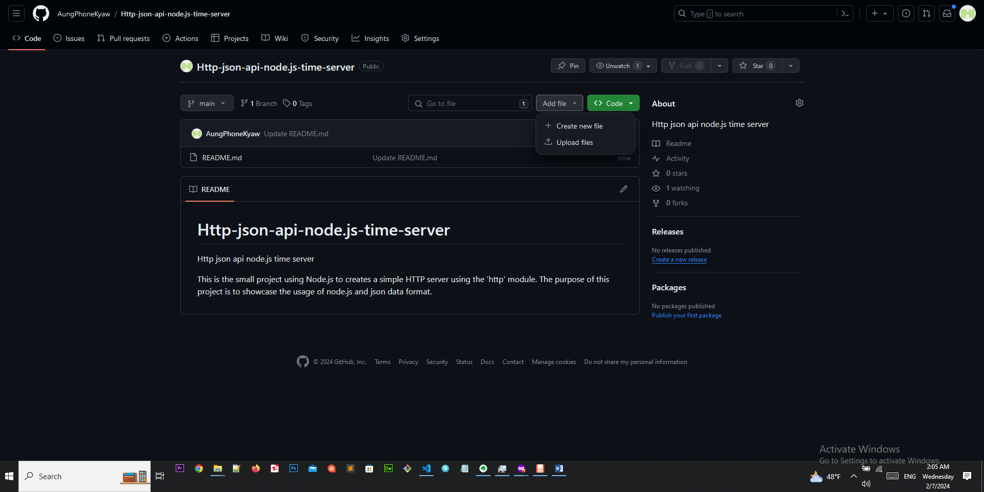

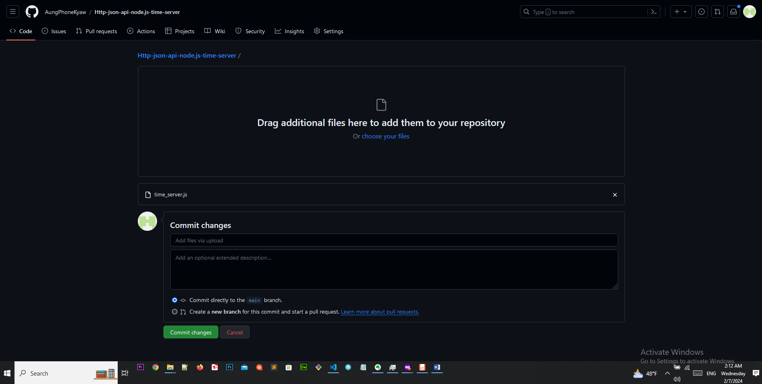

Click upload file to upload your code file.

<https://github.com/AungPhoneKyaw/Http-json-api-node.js-time-server>

This is the link of my project github repository link.

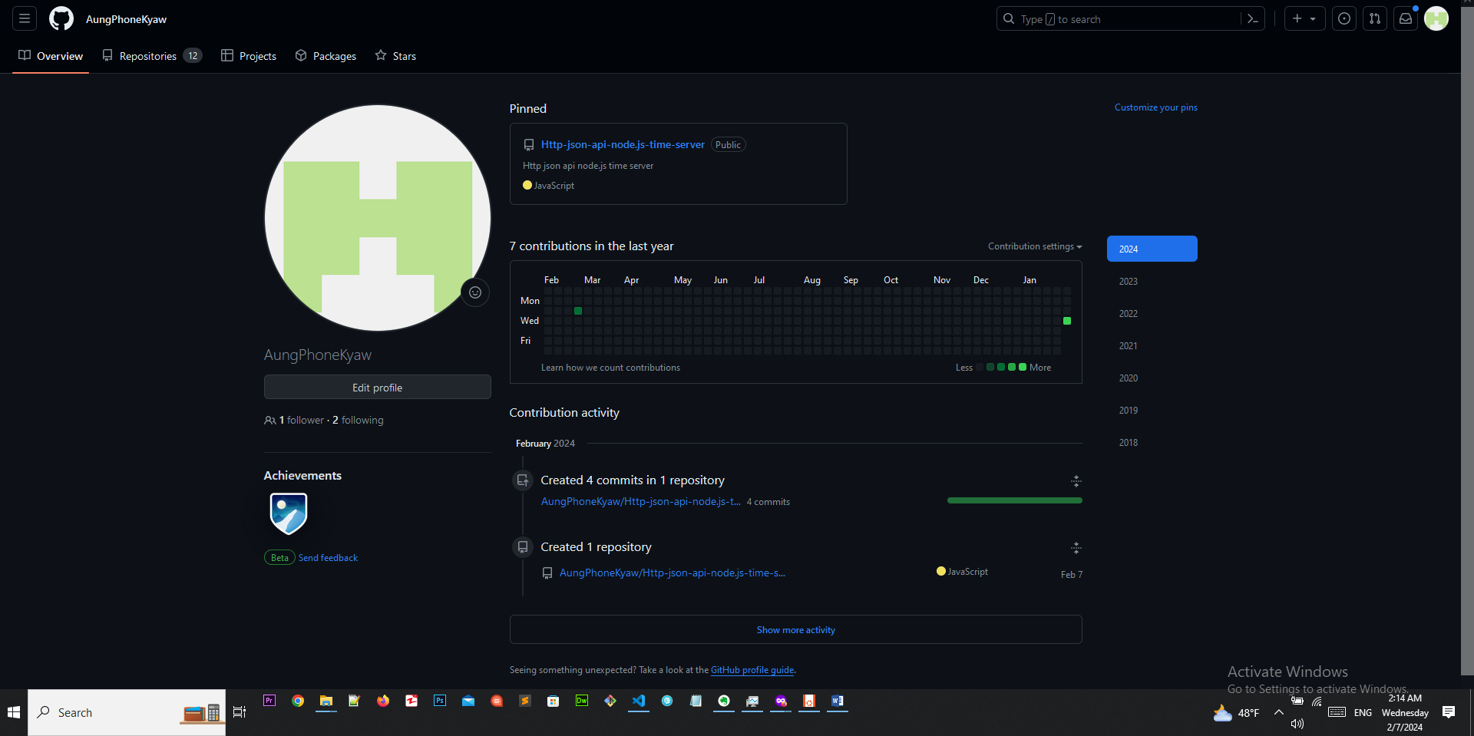

You can check the list of the technology if you go to your profile