I. Architecture & Prerequisites
This deployment architecture uses a traditional LEMP stack optimized for the university's domain.
- Web Server & Gateway: NGINX handles incoming HTTP/HTTPS requests for feedback.ucsh.edu.mm and routes them to the application.
- Application Environment: PHP 8.3-FPM processes the backend logic.
- Database Engine: A native MySQL database stores system data and feedback records.
- Core Utilities: Ensure required tools are installed by running

sudo apt update

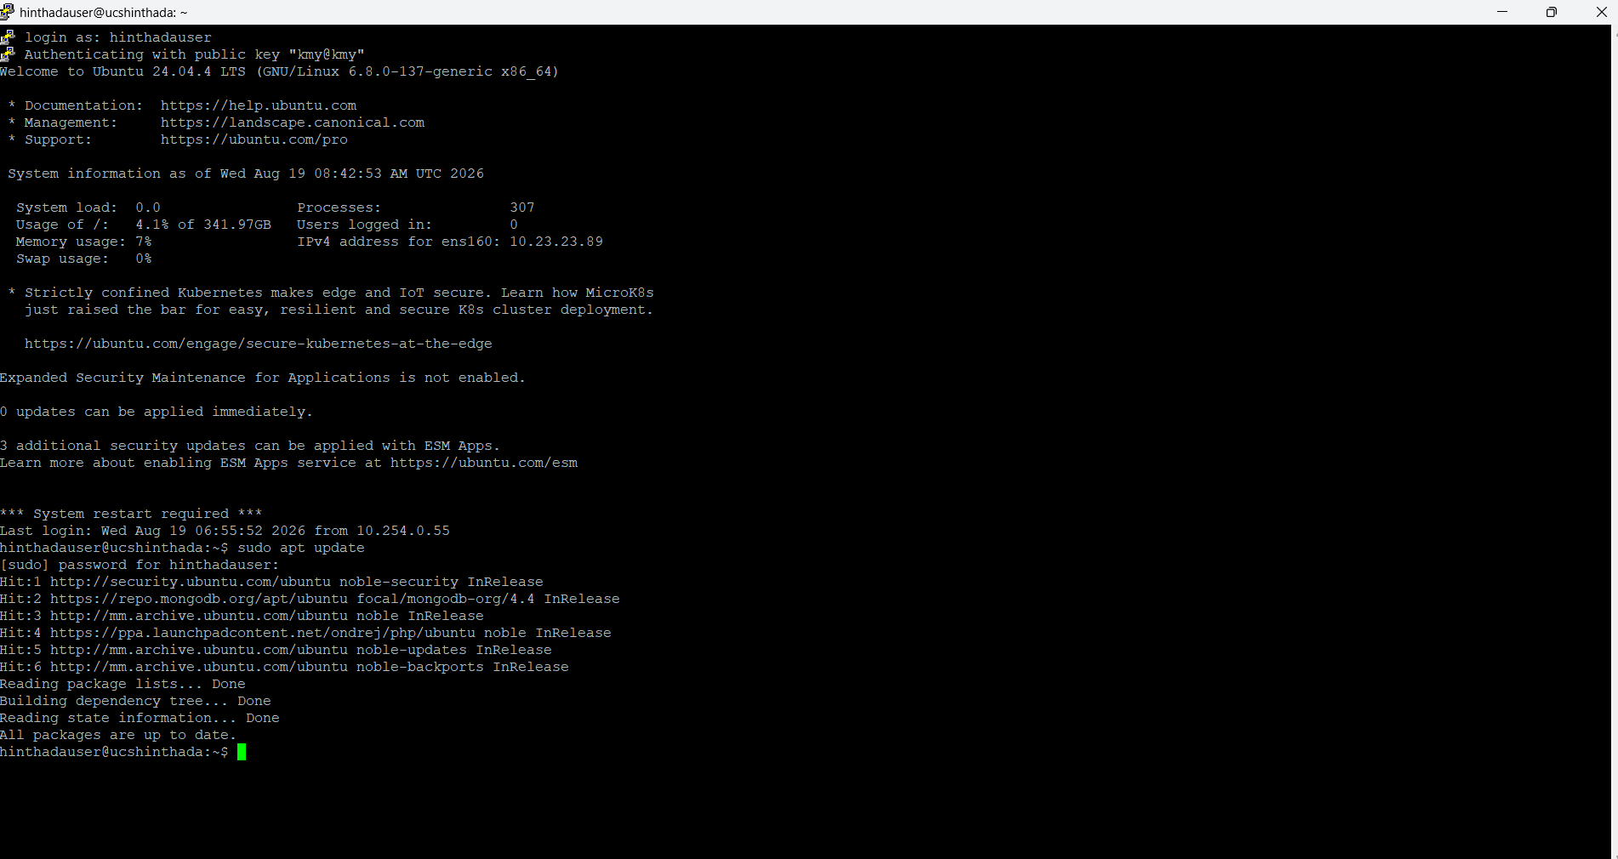

&& sudo apt install -y curl git nano unzip ufw
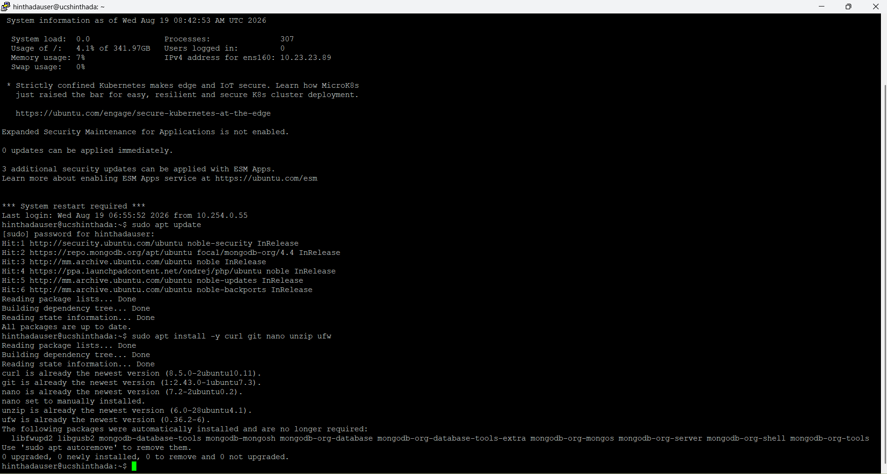.

II. File Deployment & Extraction
Deploying the application requires uploading the packaged source code and extracting it directly into the web root.
- Securely upload your compressed project file (e.g., studentfeedback.zip) to the server.
- Move the archive to the web directory:
sudo mv studentfeedbackinformationsystemforucsh.zip /var/www/html/
- 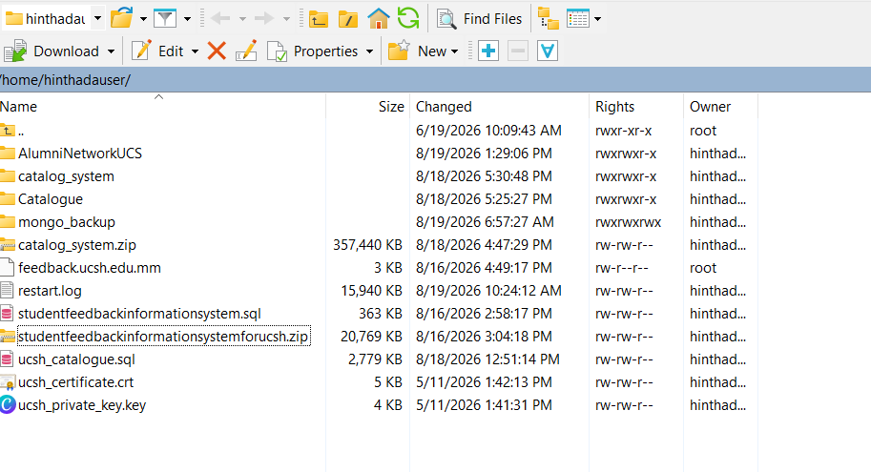
- Extract the files using the unzip utility:
- sudo unzip /var/www/html/studentfeedback.zip -d /var/www/html/studentfeedbackucsh/.
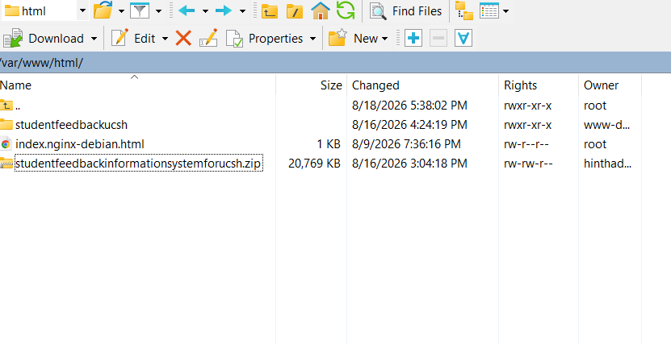

III. Database Configuration
To prevent fatal mysqli_sql_exception access denial errors, the application must connect using a dedicated MySQL user rather than the system root account.
- Log into the database shell (sudo mysql) and create the user: CREATE USER 'sfis_user'@'localhost' IDENTIFIED BY 'YourStrongPassword';.
- Grant necessary permissions to the application database: GRANT ALL PRIVILEGES ON studentfeedbackintern.* TO 'sfis_user'@'localhost'; FLUSH PRIVILEGES;.
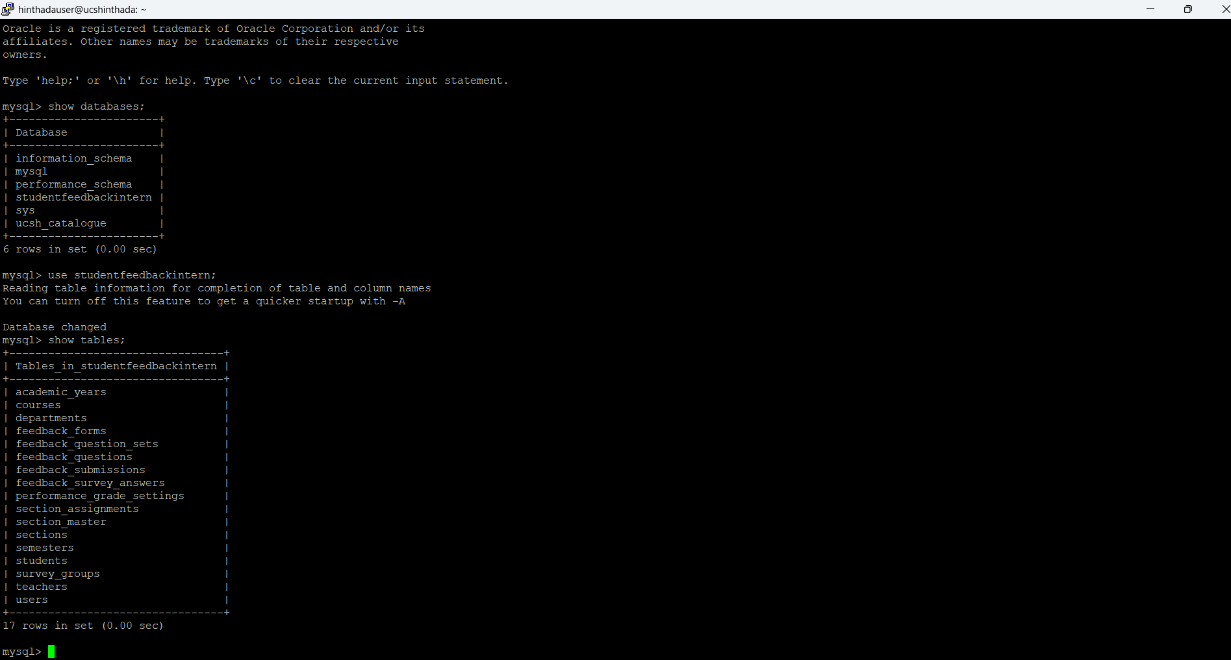

- Update the configuration file using sudo nano /var/www/html/studentfeedbackucsh/config/db.php 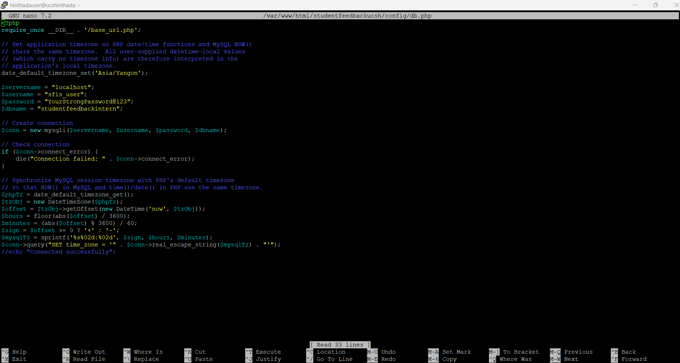

IV. Permissions & Verification
Applying the principle of least privilege ensures security while allowing NGINX and PHP-FPM to read files and accept uploads.
- Assign ownership of the application directory to the web server: sudo chown -R www-data:www-data /var/www/html/studentfeedbackucsh.
- Set standard access permissions for directories (755 / drwxr-xr-x) and files (644 / -rw-r--r--).
- Apply services changes by executing sudo systemctl restart php8.3-fpm followed by sudo systemctl reload nginx.
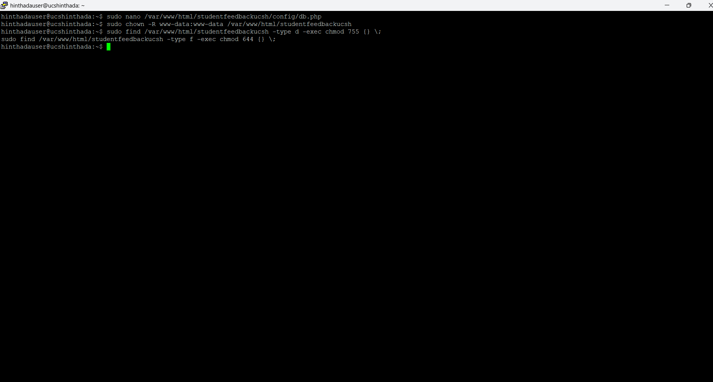
- Verify the deployment by monitoring real-time errors via sudo tail -f /var/log/nginx/feedback_error.log while navigating to [https://feedback.ucsh.edu.mm/admin/](https://feedback.ucsh.edu.mm/admin/).

Open the NGINX configuration file: (Assuming your config file is named after your domain or folder, replace feedback_ucsh with your actual config file name if it's different)
Bash
sudo nano /etc/nginx/sites-available/feedback_ucsh
(Make your necessary edits, like checking the server_name, root directory, and SSL certificates, then press CTRL+O, Enter, and CTRL+X to save and exit.)

