AI CONCEPTS | COMPUTER VISION PROJECT

Receipt Orientation
Classifier
  - Object detection, transfer learning, and OCR verification
for four-way receipt direction

Prepared by: Aung Sann Thit
Course: CSX4201 AI Concepts
Institution: Assumption University
Project version: Draft 3 - deployable hybrid system
Date: August 2026

Document roadmap
Purpose: Explain the complete project from label design and data generation through training, hybrid inference, testing, GitHub packaging, and Streamlit deployment.
• Executive summary and project objectives
• Problem definition and four orientation labels
• Dataset cleaning, canonical orientation, and leakage-safe splitting
• Receipt detection and preprocessing
• Model experiments, selection, and evaluation
• OCR verification and final decision policy
• Streamlit application and real-time prediction flow
• Source-code execution guide
• Results, limitations, and next work
• GitHub and Streamlit Community Cloud deployment

Project at a glance
Item | Implemented choice
Task | Four-class quarter-turn receipt orientation
Selected classifier | Partially fine-tuned MobileNetV3 Small
Receipt localization | YOLO-World proposal plus OpenCV refinement
Polarity verification | Thai and English EasyOCR
Deployment | Streamlit application, local and Community Cloud
Dataset publication | Excluded; only aggregate reports and selected weights are public

1. Executive summary
The project detects how a receipt is oriented in a photograph and assigns one of four labels: upright, tilted right, upside down, or tilted left. The initial classifier performed well on source-group-held-out generated samples but confused opposite directions when receipt shape was symmetric or printed text became small. Draft 3 resolves that weakness with a hybrid pipeline: a visual model chooses the orientation axis and OCR determines which side is the top.
The final application first normalizes EXIF metadata, locates the receipt, refines its paper boundary, creates the same 224 x 224 input used in training, runs MobileNetV3, and compares two opposite OCR directions. Strong OCR evidence may confirm or override the model. Weak evidence returns an explicit uncertain result and prevents automatic rotation.
Main result: The hybrid system reached 98.28% on the 348-sample generated test split, compared with 92.82% for the model-only production path. Two upside-down Thai views of one external receipt were also corrected by OCR after the CNN predicted upright.

Objectives
• Create balanced, consistently labeled quarter-turn classes from unlabeled upright receipt photographs.
• Prevent leakage by splitting on physical source receipt before generating rotations.
• Compare a small CNN with transfer learning and preserve every trained checkpoint and metric artifact.
• Improve camera-photo inference by detecting and cropping the receipt before classification.
• Use OCR only after classification so the target orientation is not normalized away.
• Expose evidence, uncertainty, and correction output in a usable Streamlit application.
• Publish reproducible code and selected weights without publishing the receipt dataset.

2. Problem definition and labels
This is a coarse orientation classification problem rather than exact deskew estimation. The observable target is the direction of the receipt's top edge relative to the camera. A complete 360-degree circle is divided into four 90-degree regions.
Class | Clockwise range | Operational meaning
upright | 315-360 or 0-45 degrees | Text reads normally from top to bottom
tilted_right | 45-135 degrees | Receipt top points toward the right
upside_down | 135-225 degrees | Receipt is inverted
tilted_left | 225-315 degrees | Receipt top points toward the left

Boundary rule: Generated samples use class-centered angles with controlled jitter and avoid exact 45-degree boundaries, where a human label would also be ambiguous.

Why opposite directions are difficult
After a narrow receipt is resized onto a square canvas, its silhouette provides strong vertical-versus-horizontal evidence but much weaker top-versus-bottom evidence. Logos, totals, and text direction carry the polarity signal. If those details are faint, blurred, unfamiliar, or too small, upright and upside down can look nearly identical to the classifier. The same effect appears between left and right.

3. Dataset preparation and labeling
The raw dataset contained upright receipt photographs without orientation labels. The preparation pipeline transformed those sources into a balanced classification dataset while keeping each physical receipt in exactly one split.

Source audit
1. Scan supported image formats and reject unreadable files.
2. Compute SHA-256 for exact duplicate detection.
3. Remove two duplicates from 200 files, leaving 198 unique source receipts.
4. Assign source groups to train, validation, and test before any rotations are generated.
Split | Source receipts | Generated images | Per class
Train | 139 | 1,668 | 417
Validation | 30 | 360 | 90
Test | 29 | 348 | 87
Total | 198 | 2,376 | 594

Canonical top-side verification
Before generating labels, OCR compares possible text directions to verify which edge is the top. Low-score or closely tied cases are blocked for manual review. Auditable corrections are stored in config/orientation_overrides.csv. OCR is appropriate here because it verifies source labels; it is not applied to normalize an uploaded test image before classification.

Balanced rotation generation
Every approved source produces three images in each of the four classes. Rotation uses class-centered random jitter, preserves aspect ratio, and fills exposed regions with the same neutral gray used by inference. This creates 12 samples per source and exact class balance.
• Keep source_group unchanged for all derived images.
• Record generated filename, source filename, split, class, and angle in the manifest.
• Create QA grids for crops, orientations, fallbacks, and review-required sources.
• Never place rotations of one source receipt in multiple splits.

4. Receipt detection and preprocessing
Training and inference share src/receipt_preprocessing.py. This is important because a classifier trained on tightly cropped receipts can fail if production uploads contain hands, tables, or patterned backgrounds.

OpenCV extraction
• Apply EXIF transpose and convert to RGB.
• Build Otsu brightness, low-saturation, neutral-bright, and edge masks.
• Find candidate contours and approximate quadrilaterals.
• Score area, rectangularity, convexity, aspect ratio, centrality, and border contact.
• Perspective-correct the best valid paper boundary.
• Use a full-frame fallback when no contour is trustworthy.

Real-time object detection
Draft 3 adds a persisted YOLO-World checkpoint for receipt and document proposals. The highest suitable box is padded, then the OpenCV extractor runs inside that smaller proposal. The detector's fixed vocabulary is embedded in the checkpoint, so the large CLIP text encoder is not needed at application inference.
Design intent: Object detection solves localization, not top-side recognition. The CNN and OCR remain responsible for orientation after the crop is created.

Model canvas
The extracted receipt is fitted onto a 224 x 224 gray canvas without stretching. The canvas is normalized with the ImageNet mean and standard deviation stored in the selected checkpoint. No quarter-turn correction is applied before the CNN sees the image.

5. Model training and selection
Two architectures and two crop policies were compared. The strict policy excluded full-frame fallback sources; the full policy retained all approved sources. Every experiment used the same grouped evaluation sets.
Experiment | Policy | Best val | Full test | Macro F1 | Size
Simple CNN | Full | 79.72% | 87.36% | 87.31% | 1.22 MB
Simple CNN | Strict | 83.67% | 88.79% | 88.78% | 1.22 MB
MobileNetV3 Small | Full | 93.33% | 92.24% | 92.26% | 5.94 MB
MobileNetV3 Small | Strict | 92.33% | 88.79% | 88.85% | 5.94 MB

Selected model: mobilenet_v3_small_finetune_full_best.pt. Transfer learning outperformed the CNN trained from scratch, and retaining fallback crops added useful appearance variation.

Training configuration
• Seed 4201 and deterministic PyTorch behavior.
• Cross-entropy loss with 0.05 label smoothing.
• AdamW optimizer with cosine learning-rate scheduling.
• ImageNet initialization for MobileNetV3 Small.
• Fine-tune the final three feature blocks and the classifier head.
• Early stopping based on validation performance.
• Store class order, image size, normalization, architecture, and weights in every checkpoint.
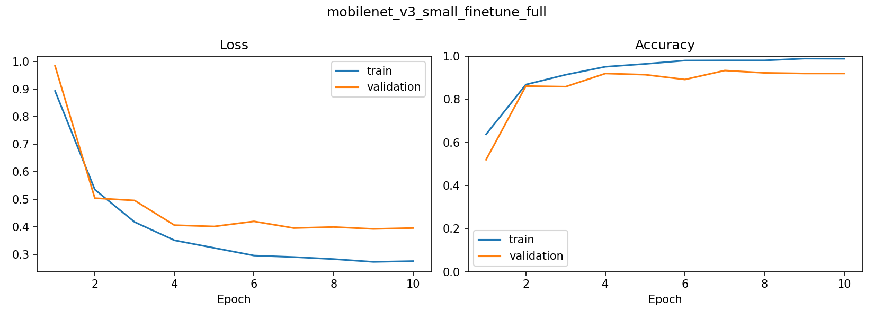
Figure 1. Training and validation curves for the selected MobileNetV3 experiment.

6. OCR verification and final decision
The model's most important residual errors were within opposite pairs. EasyOCR provides an independent text-direction signal after classification, operating on the high-resolution extracted receipt rather than the 224-pixel tensor input.

Pairwise design
Model-selected axis | Candidate rotations | Candidate labels
Vertical | 0 and 180 degrees | Upright, upside down
Horizontal | 90 and 270 degrees | Tilted right, tilted left

The verifier detects text once, keeps the 24 strongest text regions, transforms those boxes for the opposite direction, and recognizes Thai and English in CPU batches. Each direction score combines OCR confidence, readable length, alphabetic content, and receipt keyword matches.
direction_score = sum(confidence * min(text_length, 30)^0.85)
+ alphabetic_bonus
+ 7.5 * receipt_keyword_hits
ocr_margin = (best_score - second_score) / max(best_score, 1)

Runtime decision rules
Rule | Required evidence | Outcome
Strict OCR | Score >= 5.0 and margin >= 0.35 | Confirm or override model
Model + OCR consensus | Same label; OCR score >= 4.0; OCR margin >= 0.50; model confidence >= 0.55; model margin >= 0.15 | Accept shared label
Inconclusive | Neither rule passes | Return Uncertain

• A weak OCR result cannot override a disagreeing model.
• A slightly weaker OCR result may confirm the model only when both sources have adequate evidence.
• Uncertain is a deliberate abstention state, not a fifth orientation class.
• The current thresholds are provisional until a larger grouped real-photo validation set is available.

7. Streamlit application and prediction flow
app.py implements the complete user workflow. Resource-heavy objects are cached with st.cache_resource, and upload-based session keys prevent a tab change from repeating detector, classifier, or OCR work.
1. Validate file type, byte content, pixel count, and EXIF orientation.
2. Run receipt object detection; fall back to full-image contour extraction when needed.
3. Create the classifier input and run four-class softmax inference.
4. Choose the vertical or horizontal OCR pair from the model output.
5. Confirm, override, accept consensus, or abstain according to the configured thresholds.
6. Display final label, decision source, timings, crop evidence, probabilities, and OCR evidence.
7. Rotate only a resolved receipt and provide a PNG correction download.
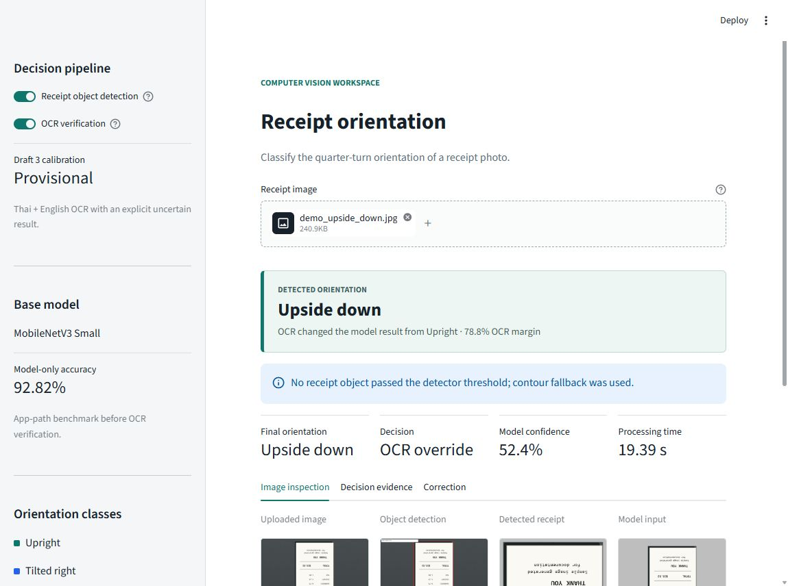
Figure 2. Verified local Streamlit result. OCR corrects an upside-down generated sample after a low-confidence upright model prediction.

User-facing evidence
The interface exposes the uploaded image, detection overlay, extracted receipt, model input, all class probabilities, OCR scores for both candidate directions, decision margin, recognized text preview, corrected receipt, and separate processing times. This allows the user to diagnose whether a wrong answer came from localization, visual classification, or text recognition.

8. Source-code execution guide
The following inventory explains why each file exists and when it runs. Training utilities are retained for reproducibility even though Community Cloud uses only the runtime path.
File | Role | Intention
app.py | Runtime | Streamlit UI, caching, orchestration, evidence, and download
receipt_preprocessing.py | Shared | Contour masks, extraction, perspective crop, canvas, rotation
realtime_receipt_detection.py | Runtime | YOLO proposal, OpenCV refinement, fallback, overlay
inference.py | Runtime | Checkpoint validation, model rebuild, softmax, correction
ocr_orientation.py | Runtime/research | EasyOCR preparation, region reuse, scoring, deskew evidence
hybrid_orientation.py | Runtime | Candidate pairs, thresholds, override, consensus, abstention
prepare_dataset.py | Research | Deduplication, grouped split, canonical checks, generation, QA
build_384_dataset.py | Research | Higher-resolution rebuild and camera augmentation
prepare_real_photos.py | Research | Grouped real-photo intake and detector normalization
train_models.py | Research | Four experiments, early stopping, checkpoints, metrics, plots
train_vertical_direction.py | Optional research | Two-class upright versus upside-down experiment
evaluate_hybrid.py | Research | Validation threshold search and locked test evaluation
evaluate_external_photos.py | QA | Production-path real-photo regression check
preview_fallback_recrops.py | QA | Visual comparison of fallback extraction candidates

Clean environment and app
python -m venv .venv
.\.venv\Scripts\Activate.ps1
python -m pip install --upgrade pip
python -m pip install -r requirements.txt
python -m unittest discover -s tests -v
python -m streamlit run app.py

Full research sequence
python -m pip install -r requirements-training.txt
python src/prepare_dataset.py --source-dir <receipt-image-folder> --overwrite
python src/train_models.py --experiments simple_cnn_full simple_cnn_strict mobilenet_v3_small_finetune_full mobilenet_v3_small_finetune_strict
python src/evaluate_hybrid.py
python src/evaluate_external_photos.py
Execution boundary: The public repository can run inference and tests with included checkpoints. Reproducing training requires a separately supplied receipt dataset because raw and generated receipt images are intentionally excluded.

Configuration files
• config/hybrid_ocr_config.json controls languages, OCR size, batching, thresholds, and abstention.
• config/draft3_training.json records the prepared 384-pixel experiment and real-photo collection policy.
• config/orientation_overrides.csv stores manual canonical-orientation corrections.
• .streamlit/config.toml defines theme, upload size, headless behavior, and telemetry settings.

9. Results and interpretation
Evaluation | Samples | Model only | Pairwise OCR | Hybrid
Validation | 360 | 92.50% | 96.94% | 97.22%
Test | 348 | 92.82% | 96.26% | 98.28%

On the generated test split, the hybrid policy produced 22 OCR overrides. Nineteen repaired model errors, and none changed a correct prediction to an incorrect one under the validation-selected evaluation policy. Nineteen OCR comparisons were inconclusive and retained the model in that historical evaluation.
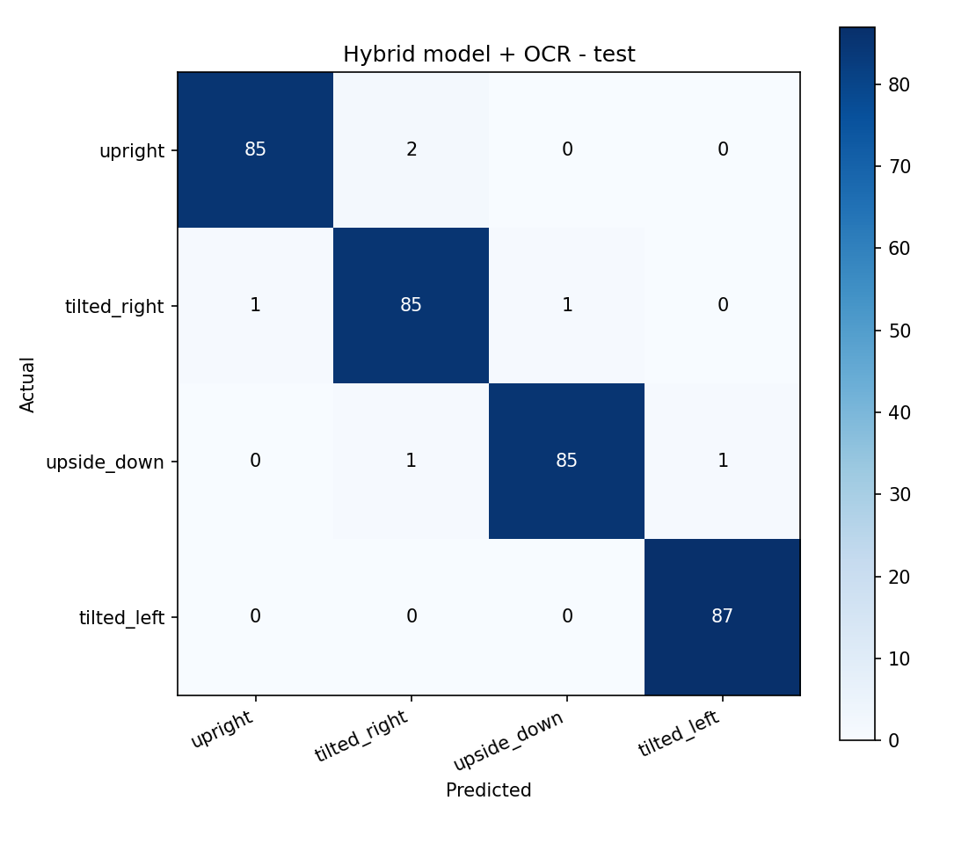
Figure 3. Hybrid confusion matrix on the source-group-held-out generated test set.

Public generated samples
Actual | Base model | Final hybrid | Decision
Tilted left | Tilted right, 44.2% | Tilted left | OCR override
Tilted right | Tilted left, 41.8% | Tilted right | OCR override
Upright | Upright, 48.8% | Upright | OCR confirmed
Upside down | Upright, 52.4% | Upside down | OCR override

External real-photo regression
Two upside-down Thai photographs of one physical receipt were held outside training. Object detection produced useful crops, but the base CNN predicted upright in both views. Thai/English OCR selected upside down and overrode both predictions. This confirms the known failure was repaired for that receipt; it is not a real-world accuracy estimate because there is only one unique physical receipt group.

Limitations
• Training data is dominated by generated rotations of upright English receipts.
• Pairwise OCR cannot repair a model-selected wrong vertical/horizontal axis.
• Thai/English OCR is CPU intensive and adds approximately 15-28 seconds in measured examples.
• Cloud cold start is slower because EasyOCR weights must download and initialize.
• Runtime thresholds are provisional and require grouped real-photo calibration.
• The output is a quadrant, not an exact continuous rotation angle.

10. Verification and deployment

Automated verification
Test module | Coverage
test_inference.py | Checkpoint contract, probabilities, model input, public demos
test_hybrid_orientation.py | Pairs, override, confirmation, consensus, fallback, abstention
test_ocr_orientation.py | Region limits, enhancement path, multilingual scoring
test_realtime_receipt_detection.py | Box selection, coordinate mapping, proposal fallback

Verified result: All 18 unit tests pass, Python compilation passes, and the local app completed the public upside-down demo with the correct OCR override.

GitHub publication boundary
Published | Excluded
Source code and configuration | Raw and generated receipt datasets
Selected classifier and detector weights | Downloaded EasyOCR model cache
Aggregate metrics, histories, and confusion matrices | Per-image OCR text prediction tables
Generated fictional demo receipts | Private real-photo diagnostics
Markdown guides and this DOCX report | Experimental checkpoints not used by the app

Streamlit Community Cloud steps
1. Connect the GitHub account that administers the repository.
2. Create an app from the main branch with app.py as the entrypoint.
3. Choose Python 3.10 in Advanced settings.
4. Deploy without secrets and monitor the dependency build logs.
5. Open the public app and run a generated demo prediction.
6. Expect the first OCR request to download Thai, English, and text-detection weights.

Operational notes
• The classifier and detector checkpoints are committed and load immediately after dependency installation.
• EasyOCR weights are downloaded on first OCR use and cached for the running process.
• If object detection fails, the app uses OpenCV; if OCR fails, the app preserves the model result and displays a warning.
• Uploaded images are processed in memory by application code and are not intentionally persisted.

11. Recommended next work
The next meaningful improvement is not another synthetic-only training run. It is a grouped real-photo dataset that represents the actual deployment domain.
Priority | Action | Acceptance evidence
1 | Collect 50 physical receipts in all four orientations and two scenes | About 400 labeled real photos
2 | Split by physical receipt identity | No group overlap across train/val/test
3 | Fine-tune the prepared 384-pixel MobileNet path | Improved per-class real-photo recall
4 | Recalibrate override and abstention thresholds | Locked policy before untouched test
5 | Report latency and abstention coverage | p50/p95 time, OCR coverage, uncertainty rate

Collection checklist
• Thai and English receipts from different merchants and printers.
• Multiple phones, distances, and camera resolutions.
• Hands, folds, glare, shadows, blur, and perspective distortion.
• Plain and patterned backgrounds.
• One stable receipt_group identifier per physical receipt.
• A final external holdout kept untouched until all thresholds are frozen.

Appendix A. Key files and artifacts
• README.md - repository overview, results, quick start, and documentation links.
• MODEL_CARD.md - intended use, performance, risks, and mitigations.
• docs/METHODOLOGY.md - detailed problem, data, model, and OCR method.
• docs/REPRODUCIBILITY.md - complete training and evaluation sequence.
• docs/DEPLOYMENT.md - Streamlit Community Cloud build and troubleshooting.
• reports/training - aggregate model comparisons, histories, curves, and confusion matrices.
• reports/hybrid - aggregate threshold search, summaries, and hybrid confusion matrices.

Appendix B. References
• Howard, A. et al. Searching for MobileNetV3. ICCV 2019.
• PyTorch and Torchvision documentation: https://pytorch.org/docs/stable/
• OpenCV documentation: https://docs.opencv.org/
• EasyOCR project: https://github.com/JaidedAI/EasyOCR
• Ultralytics documentation: https://docs.ultralytics.com/
• Streamlit Community Cloud documentation: https://docs.streamlit.io/deploy/streamlit-community-cloud
Final note: This report documents an educational computer vision system. It does not validate receipt authenticity, financial values, payment status, or tax compliance.

