1**. Introduction**

**About Project:**

Smart City is an essential whenever we are visiting a particular city. It gives us the valuable information about the city and saves the time. Our project laid a web based platform for the city guide and can search every place in the city without taking the help of any personal guide. You can search a city for its prominent places of the city user, and can get social and political information of the city, city culture, security ,entertainment, Business ,Hotels, Jobs etc.,The main aim of this project services provided to the users who have registered in the site. The services regarding to city political, historical, conventional places, bus routes, business companies profile and jobs details.

Our project title is ‘SMART CITY’, a web-based product used to store the details of particular city and helps all the users who just visit our website. This site also provides all the services like Hotel booking for tourists, Ticket booking, Transport facility providing, business related information, marketing details, city news, shopping detail. The website contains the complete information about particular city like places to be visited, site maps route maps, Business environment, Job portal, information about organization that rovidetransport, Hospitality and total history of the city. This website can be used by any person who is having general knowledge about internet. All the users will be first considered as anonymous user later if he needs any service then he will be treated as registered user.

Overall description consists of background of the entire specific requirement. It also gives explanation about actor and function which is used. It gives explanation about architecture diagram and it also gives what we are assumed and dependencies. It also support specific requirement and also it support functional requirement, supplementary requirement other than actor which is used. It also gives index and appendices. It also gives explanation about any doubt and queries. This system can be used as an application for the handicraft employees and customers of the Handicraft company to manage the product information. Customer logging should be able to upload the information of the any required product. Customers/Company representatives logging in may also access/search any information of product related.

2**. Project Analysis**

**Purpose of the Project:**

The main aim of this project services provided to the users who have registered in the site. The services regarding to city political, historical, conventional places, bus routes, business companies profile and jobs details. **Smart city** is a web-based product used to store the details of particular city and helps all the users who just visit our website. This site also provides all the services like Hotel booking for tourists, Ticket booking, Transport facility providing, business related information, marketing details, city news ,shopping detail. The website contains the complete information about particular city like places to be visited, site maps route maps, Business environment, Job portal, information about organization that provide transport, Hospitality and total history of the city. This website can be used by any person who is having general knowledge about internet. All the users will be first considered as anonymous user later if he needs any service then he will be treated as registered user.

**Existing System:**

In Existing system the person who are visiting a particular city need to gather information from the person who is staying in the city or take the help of the guide in the city. Gather of all these information you need to visit the city. These posses a lot of time and pre-planning. In order to get each piece of information we need to go for help desk.

**Proposed System:**

The Proposed System provides online information about the particular city going to visit. It also provides additional services to the registered user. The development of this new system contains the following activities, which try to automate the entire process keeping in the view of database integration approach.

* User Friendliness is provided in the application with various controls provided by system Rich User Interface.
* The system makes the overall project management much easier and flexible.
* It can be accessed over the Intranet.
* The city information files can be stored in centralized database which can be maintained by the system.

**3. Requirement Analysis**

**3.1 Purpose and Scope**

**Smart City** is website used to provide information regarding the particular city that includes city-map, history-social, political, business news and other services for registered users.

**Scope:**

* It can be accessed by unlimited number of users.
* Each user will be assigned a different set of permissions for each module of the system.
* The user can have access to all the information in the site.
* Every user must have their ID for security purpose.
* Only registered members will be provided with communication between user, experts and general public through poll/chat/mails.
* Administrator is created in the system already.
* The administrator has to generate daily/weekly/Monthly reports, of the business and political news of the city.
* This site is best designed to be useful through internet to people of different places.

**3.2 Users of the System**

* Tourists, Students, Businessmen
* Industrialists, Organizations academicians etc

**4. Specific Requirements**

**4.1 Functional and Non Functional Requirements**

* **Functional Requirements:**
* Complete-map of the city with key markets and places to see marked-preferably usage of static map and live map option.
* Complete history of the city-social, political.
* Complete overview of the Businesses in the city.
* Secure registration of all users including a personal profile-only at the time of transaction providence.
* Complete Search of the entire city for easy access.
* Local language support at user-interface and database-level.
* **Non-Functional Requirements:**
* 24*7 availability
* Better component design to get better performance at peak time
* Flexible service based architecture will be highly desirable for future extension.

**5. System Requirements**

* **SOFTWARE REQUIREMENTS:**
  + Netbeans
  + JDBC ODBC 5.0 drivers installed
  + Database-MYSQL

**6. System Design**

**Data Flow Diagram**

**E-R Diagram:**

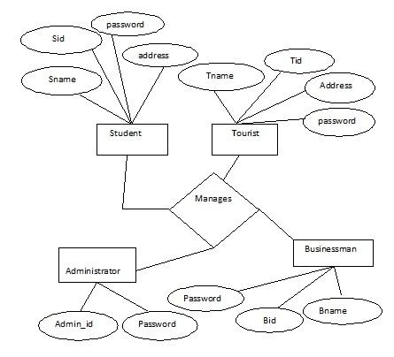

**Figure 6 E-R Diagrams**

**Behavioral Diagrams**

**Use Case Diagrams:**

A use case is a methodology used in system analysis in identify, clarify, and organize system requirements. The use case is made up of a set of possible sequences of interactions between systems and users in a particular environment and related to a particular goal.

**Fig. Use Case Diagram of the System**

**Class Diagram:** A class diagram is an illustration of the relationships and source code dependencies among classes in the unified modeling language. In this context, a class defines the methods and variables in an object, which is a specific entity in a program or the unit of code representing that entity.

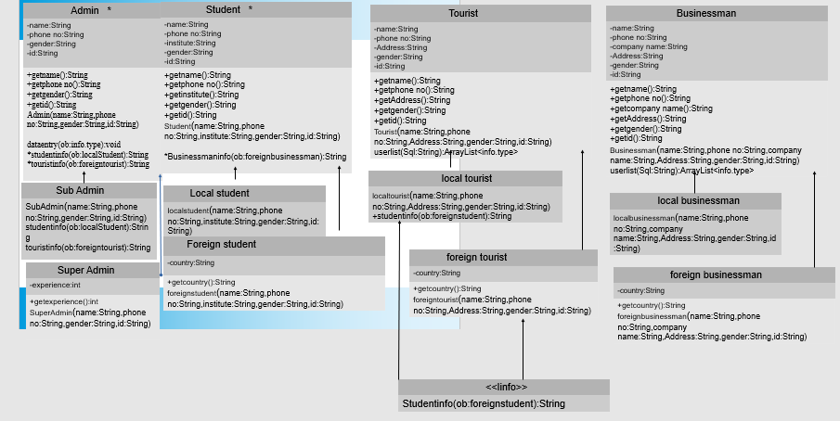

**Fig. Class Diagram of the System**

**System Specific Module**

There are five modules in our project .They are listed below with their description.

1. Administrator Module
2. Tourist Module
3. Student Module
4. Businessman Module

**1.Administrator Module:** The admin module is the major module as it is responsible for carrying out the major operations regarding site updates, business updates ,job alerts etc., It maintains information regarding other four modules. The various software components in administrator module update alerts, update industries, update hotels, view resumes, update ,site information. The details regarding complete history such as political and social is entered by admin and he want he can edit the details once entered. The details regarding business details such as top companies in the city and its information are entered and he wants he can edit the details once entered. The details regarding job details such as job title, vacancies and companies profile is entered by admin and he can edit the details once entered.

The details regarding regarding emergency such as phone numbers of with respect to emergency is entered by admin and he can edit the details one he entered. The details regarding conventional places such as description an,location,address and image of the place entered by him and he can edit the details once entered

The details regarding news papers, city channels such which papers are available in the city entered by admin and he can edit the details once he entered. The details regarding political leaders entered by admin and he can edit the details once he entered.

**2. Tourist Module:** Tourist module is maintaining the information regarding the city tourist spot, hotels in the city entertainment in this city etc.., the user after registration as a tourist is considered as authorized user. The various software components in the tourist module are view theaters, vie hotels, view city map, view ATM locations, view hospitals, view city history, view travel agency, view bus routes.

**3. Businessman Module:** businessman module consists of information regarding various business in the city, industries in the city, with social and political influence of the city. The various software components in the businessman module are view city history, view markets, view alerts, view industries, view hotels, view labour, view hotels, view labour, view jobs.

**4. Student Module:** The student module maintains the various information regarding various institutes in the city. The various components in software are view library, view books, view institutes, view engineering colleges, view coaching centers, view journals.

The list of the software components involved in our project is explained below.

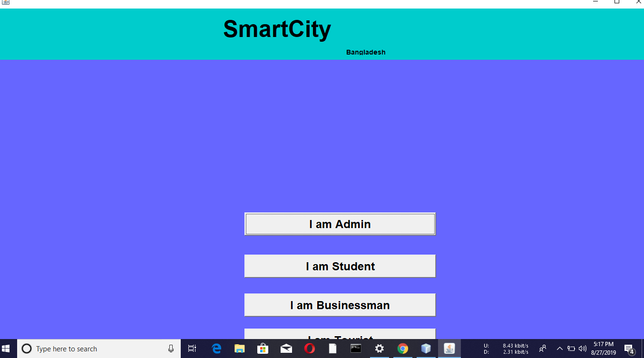

**Fig (a) Home page of the System**

**Description:** The home page provides the necessary information that is accessed by the user and provides login form and registration for registration. The information in the home is open to all the users of the system.

**Super Admin page :**

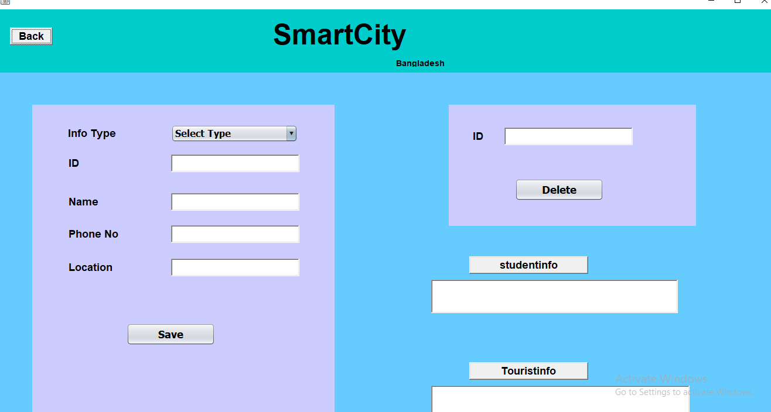

**Fig (b) Super Admin page**

**Description:** The registration page helps the user to register in order to posses the various services offered by the site .The various users of the system are tourist, businessman, student, jobseeker and administrator.

**Student Home Page :**

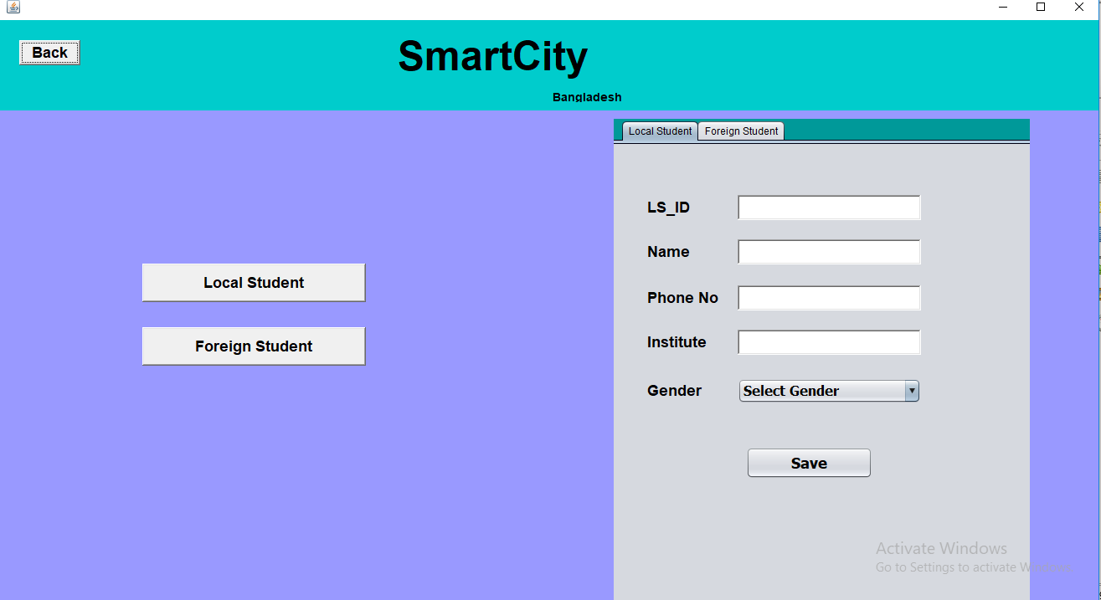

**Fig 6.4(c) Student Home page**

**Description:** The User who is registered as a student and login with his id and password will be provides with various downloaded services and can access other city inforantion . Every user will be provided with various services and maintain communication with other users.

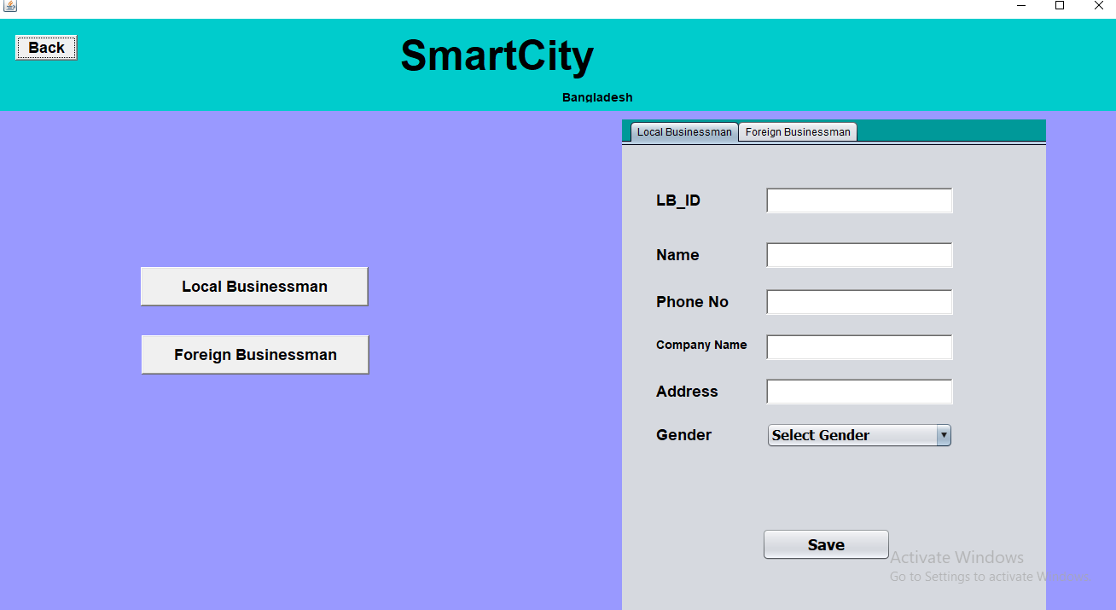

**Businessman Page**

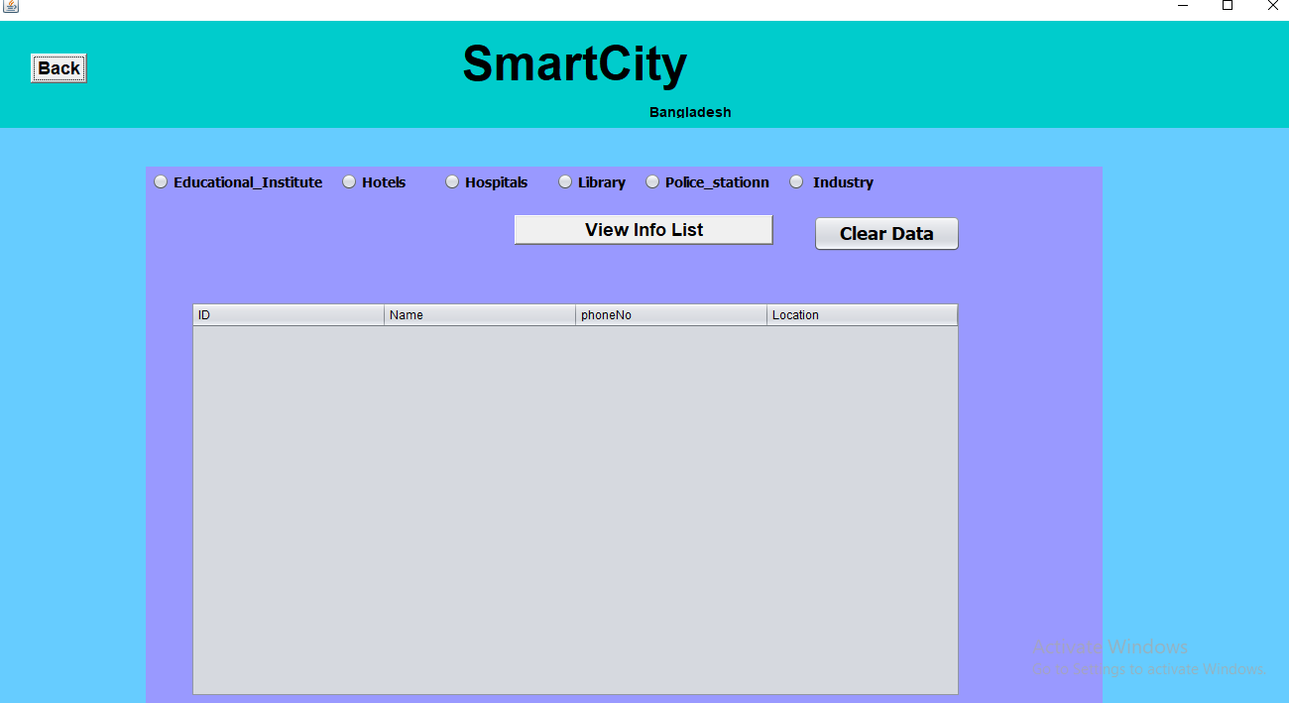

**All Info Page**

***Conclusion:***

The project provides a direct communication between the citizen and the municipal corporation. This will also help in registering the problem that one is facing in particular area by continuously following up them will result in good, clean and peaceful environment .The proposed system will attract the common man to register any complaint otherwise neglect to register complaints since he/she has to personally visit the office and give the complaint in writing. This system reduces the paper work which is required to note down complaint registered by users also maintaining a database is easier than the file system. 

**Website References:**

* + 1. [**www.wikipedia.com**](http://www.wikipedia.com/)
    2. [**www.google.com**](http://www.vizagcity.com/)