**USAP Assignment 2**

Q2.

puppet resource cron puppet-agent ensure=present user=root minute=*/20 command='/opt/puppetlabs/bin/puppet agent --onetime --no-daemonize --splay --splaylimit 60'

To get the puppet agent to check in periodically every 3 times per hour, I created a cron job that ran the ‘puppet agent –t’ command.

This cron command creates a cron resource for the node.

cron { 'puppet-agent':

  ensure  => 'present',

  command => '/opt/puppetlabs/bin/puppet agent --onetime --no-daemonize --splay --splaylimit 60',

  minute  => ['*/20'],

  target  => 'root',

  user    => 'root',

}

As observed above, the command is being performed under root privilege on minutes that occur every 20 minutes from the hour. I.e. {hh:20, hh:40, hh:60}.

The agent parameter –onetime runs the command once.

The agent parameter – no-daemonize , in conjunction with –onetime allows for a single instance of puppet agent to run in the foreground. This prevents an overuse of resources.

The agent parameter –splay is used to ensure that system times are synced. This command was recommended from the puppet documentation

PROOF:

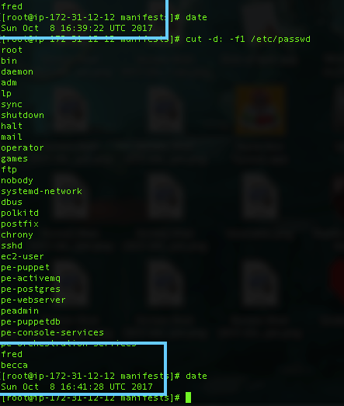

As you can see in the image above. Becca didn’t exist at 16:39, however after 16:40, the user class executed placing Becca back on the system.