**Information and Network Security**

**2CSDE54**

**Practical 7**

**21BCE020**

**Implement the Diffie-Hellman Key Exchange algorithm.**

#include <iostream>

#include <algorithm>

#include <string>

#include <fstream>

#include <math.h>

using namespace std;

int compute_power_mod(int b, int e, int m) {

    int res = 1; // identity element for multiplication

    b = b % m; // avoid overflow

    while (e > 0) {

        if (e % 2 == 1) // odd exponent

            res = (res * b) % m;

        e = e >> 1;

        b = (b * b) % m;

    }

    return res;

}

int primitive_root(int q) {

    for (int i = 2; i < q; ++i) {

        bool is_primitive = true; // track if i is primitive root

        int res = 1;

        for (int j = 1; j < q - 1; ++j) {

            res = (res * i) % q;

            if (res == 1) {

                is_primitive = false; // not primitive root

                break;

            }

        }

        if (is_primitive) {

            return i;

        }

    }

    return -1;

}

int compute_Y(int X, int q) {

    int a = primitive_root(q);

    return compute_power_mod(a, X, q); //Y = a^X mod q

}

int gen_secret_key(int X, int Y, int q) {

    return compute_power_mod(Y, X, q); // K = Y^X mod q

}

int main() {

    ifstream f1("dh_glb_ip.txt");

    ifstream f2("private_keys.txt");

    ofstream f3("secret_key_A.txt");

    ofstream f4("secret_key_B.txt");

    int q; // a = 5

    int Xa, Xb;

    f1>>q;

    f2>>Xa>>Xb;

    int Ya = compute_Y(Xa, q);

    int Yb = compute_Y(Xb, q);

    int Ka = gen_secret_key(Xa, Yb, q);

    int Kb = gen_secret_key(Xb, Ya, q);

    f3<<"User A Public Key: "<<Ya<<endl;

    f4<<"User B Public Key: "<<Yb<<endl;

    cout<<"User A Public Key: "<<Ya<<endl;

    cout<<"User B Public Key: "<<Yb<<endl;

    cout<<"Secret Keys Generated: "<<Ka<<" and "<<Kb<<endl;

}

**sText File Input:**

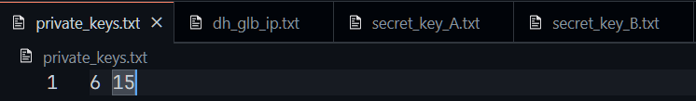 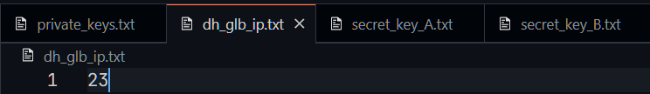

**Text File Output:**

