**Q) How to change the default message of the required field in the popover of form-control in bootstrap?**

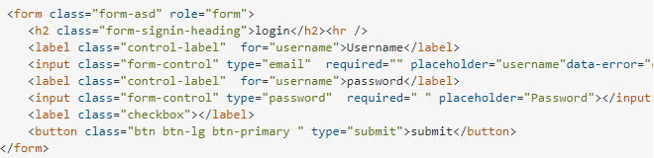

**Solution:-**

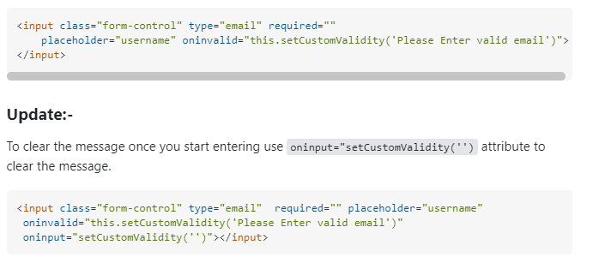

---------------------------------------------------------------------------------------------------------------------------

**Link:-**

https://stackoverflow.com/questions/24391078/how-to-change-the-default-message-of-the-required-field-in-the-popover-of-form-c

**Q) Boostrap Navbar**

<https://colorlib.com/wp/template/website-menu-16/>

<https://colorlib.com/wp/bootstrap-navbar/>

<https://colorlib.com/wp/template/website-menu-08/>

<https://mdbootstrap.com/snippets/standard/mdbootstrap/4686783#>!