Architecture Diagrams
ExpenseMate — Personal Expense Manager
Course: Software Construction & Development
Group Members: Hamza Salahuddin (24K-3065) | Rafay Ansari (24K-3095)
Phase 2 Deliverable

1. High-Level Overview
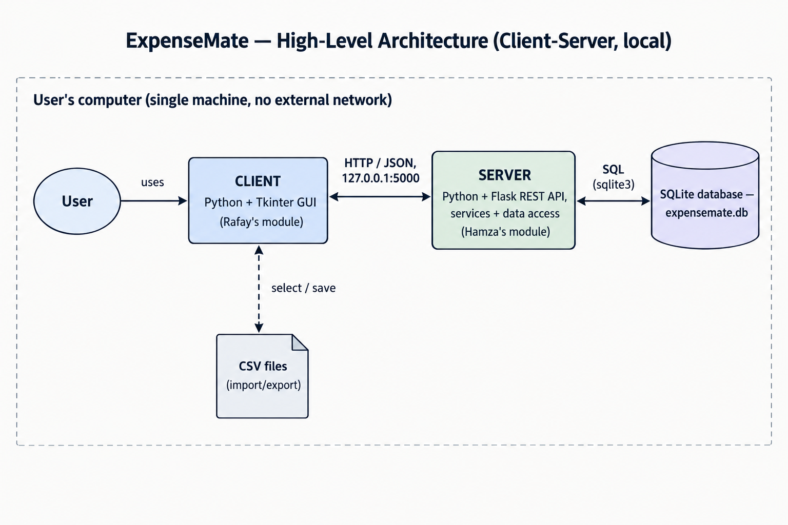

2. Logical View (Module Diagram)
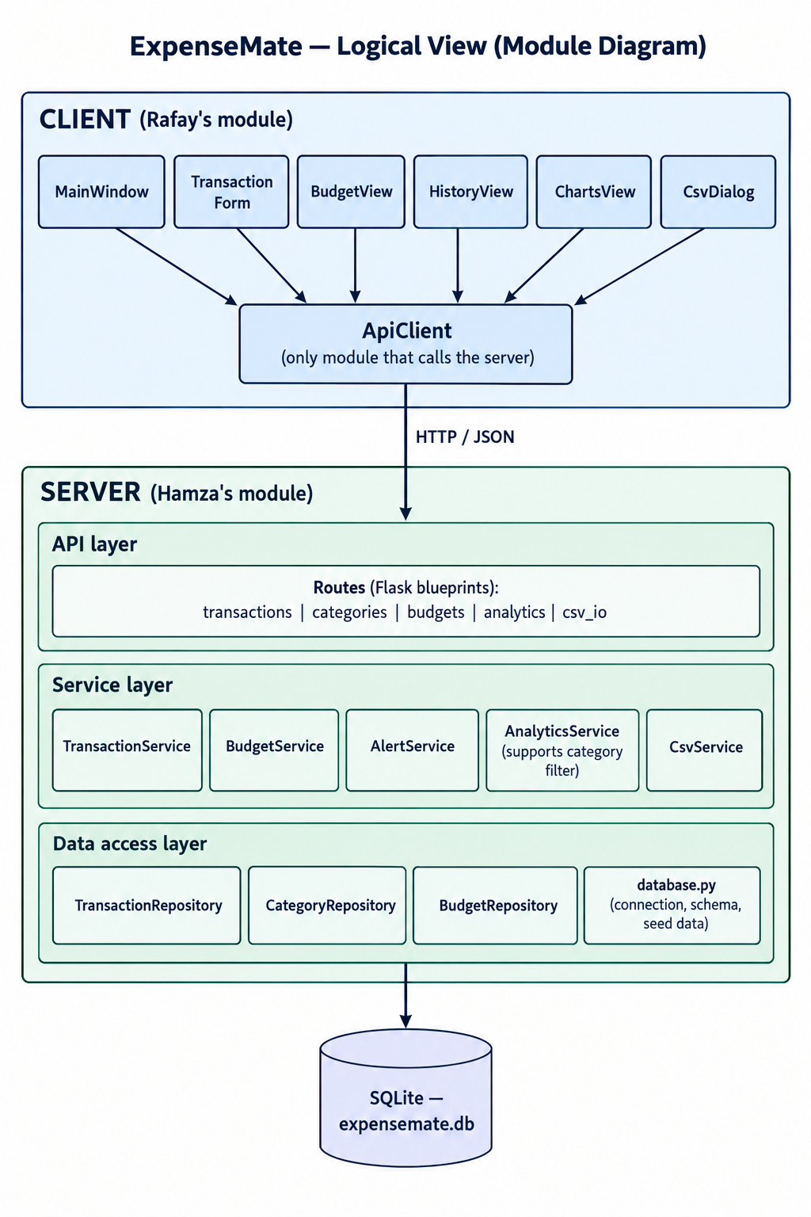

3. Data Model (Entity-Relationship Diagram)
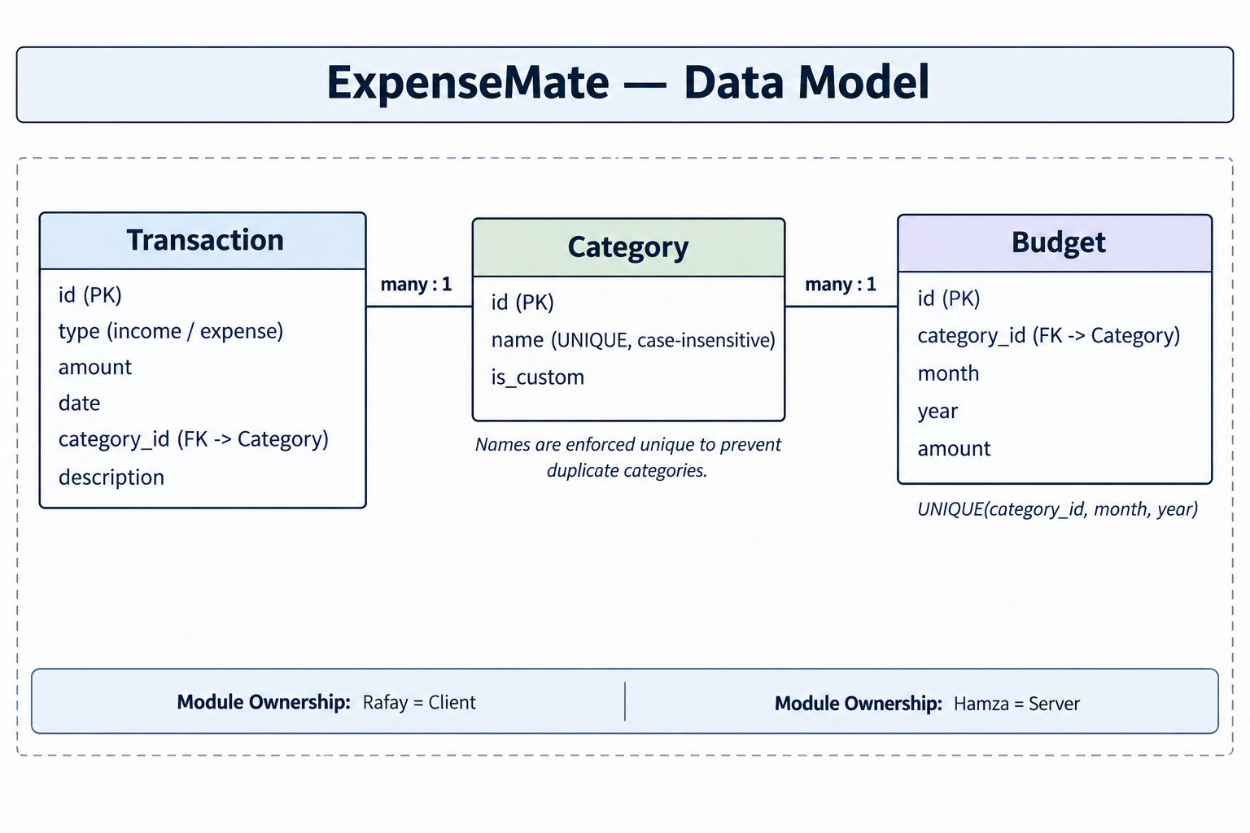

4. Process View (Sequence Diagram)
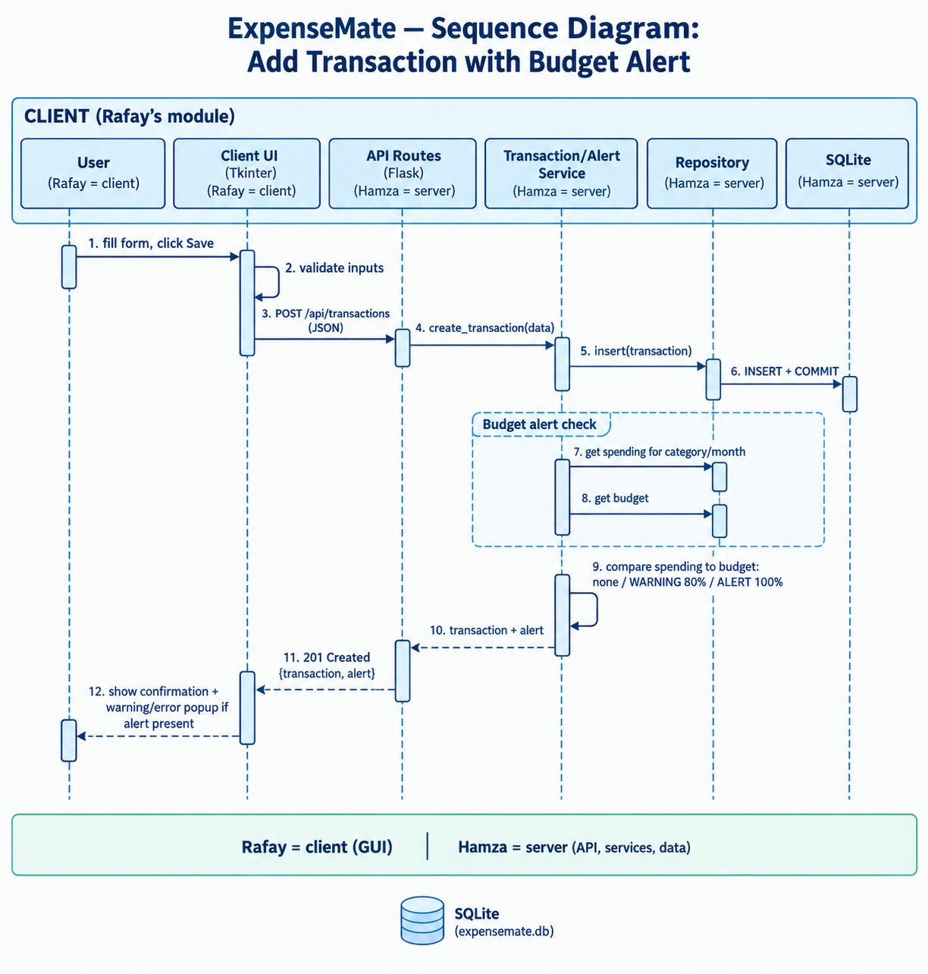

5. Deployment View
