Architecture Document
ExpenseMate — Personal Expense Manager
Course: Software Construction & Development
Group Members: Hamza Salahuddin (24K-3065) | Rafay Ansari (24K-3095)
Phase 2 Deliverable | Version 1.0 | 24 September 2026

1. Introduction

1.1 Purpose
This document defines the architecture of ExpenseMate, a personal expense manager that lets a single user record income and expenses, set monthly category budgets, receive budget alerts, import/export CSV files and view analytics and charts. It is the Phase 2 deliverable and contains the chosen architectural style, the four architectural views (Logical, Process, Physical and Deployment), the coding standards and tools, and the project timeline (Gantt chart).

1.2 Inputs
The architecture is derived from the SRS (functional requirements FR1–FR10, non-functional requirements NFR1–NFR7 and the constraints) and from the Use Case Diagram (one actor, eight use cases). Requirement IDs are quoted throughout for traceability.

1.3 Architectural Drivers
The table below lists the requirements that shaped the architecture and how the design responds to each of them.
Driver | Architectural response
NFR1 Performance  (1,000 transactions in < 2 s) | Totals, filters and history queries are executed in SQL rather than in Python loops; indexes on transactions(date) and transactions(category_id).
NFR2 Usability | One Tkinter window with tabs (Transactions, Budgets, History, Analytics); usable without training.
NFR3 Data integrity | Validation is done twice: in the client (fast feedback) and in the server service layer (authoritative). Database CHECK and FOREIGN KEY constraints act as a last line of defence.
NFR4 Portability | Pure-Python stack with a file-based SQLite database; runs on Windows, Linux and macOS with Python 3.11+.
NFR5 Reliability | Every write is committed before the server replies; CSV import inserts all valid rows in a single database transaction.
NFR6 Maintainability | Client and server are separate; the server is split into API, Service and Data Access layers, each module having one responsibility.
NFR7 Security | The server listens on 127.0.0.1 only, so no financial data leaves the machine; SQL is always parameterised.
Constraints 5.1 and 5.2 | Small, well-known stack (Flask, Tkinter, sqlite3) that fits the short timeline; no database server or external service is needed.

2. Architectural Style

2.1 Styles Considered
Style | Idea | Fit for ExpenseMate | Decision
Layered | Code is organised in layers (UI → logic → data) inside one program. | Good for maintainability, but on its own it does not separate the two members' work into independently running and testable parts. | Used inside the server
Client-Server | A client requests services from a server through a defined interface. | Matches the assignment (“Client-Server (local)”). Member A builds the server and Member B the client against one API contract; each side can be tested separately. | Chosen
Peer-to-Peer | Equal peers exchange data directly with each other. | ExpenseMate is a single-user application with no other peers, so there is no benefit and only extra complexity. | Rejected

2.2 Chosen Style: Client-Server (local) with a Layered Server
ExpenseMate is split into two cooperating processes that run on the same computer. The client (Tkinter GUI) handles user interaction, input checks and chart drawing. The server (Flask) exposes a REST API, applies the business rules (budget alerts, CSV handling, analytics) and is the only component that accesses the SQLite database. They communicate through synchronous HTTP/JSON requests over the loopback address 127.0.0.1:5000. Inside the server the code is organised into three layers — API, Service and Data Access — and each layer depends only on the layer below it.
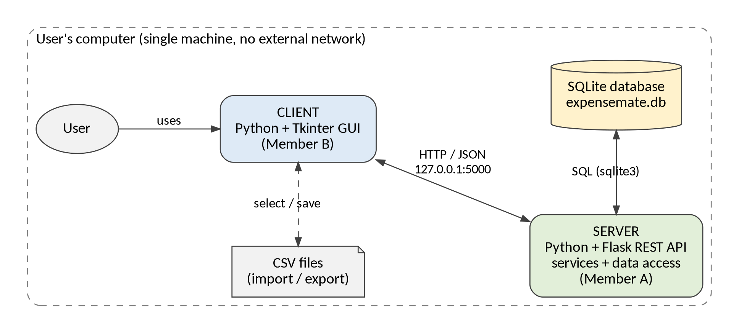
Figure 1: High-level view of ExpenseMate (Client-Server, local)

2.3 Why This Style Fits
- Matches the assignment and the SRS: local client-server, no external network (NFR7) and no separate database server (Constraint 5.2).
- Clear split of work: Member A owns the server (backend), Member B owns the client (frontend); the REST API is the single integration point in Phases 3 and 4.
- Testability: the API can be tested without the GUI (integration testing), and the GUI can be tested against sample JSON responses.
- Evolvability: cloud backup and multi-currency (SRS 5.3, Phase 5 maintenance) can be added as new services and endpoints without rewriting the GUI.
- Trade-off accepted: the extra HTTP layer adds a little overhead and a two-process start-up, but for one user the latency stays far below the NFR1 limit.

2.4 Technology Stack
Component | Technology | Reason
Language | Python 3.11+ | Required by the assignment (Python + SQLite); known to the team.
Server framework | Flask | Lightweight REST API with minimal boilerplate.
Database | SQLite (sqlite3 module) | File-based, no database server needed (NFR4, Constraint 5.2).
Client GUI | Tkinter | Ships with Python, nothing extra to install.
Charts | matplotlib (embedded in Tkinter) | Pie and bar charts for FR9.
HTTP client | requests | Simple JSON calls from the ApiClient module.
Testing | pytest, pytest-cov | Unit, integration and system tests plus coverage.

3. Logical View
The logical view shows the main modules and how they depend on each other. Arrows point from the caller to the module it uses.
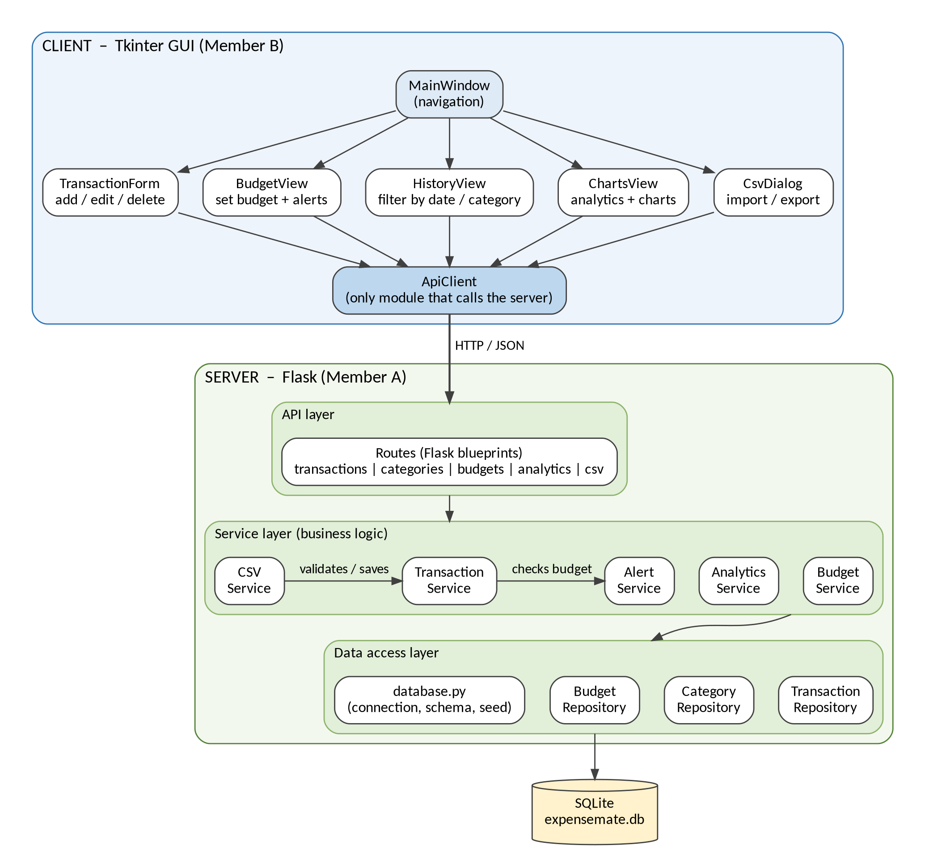
Figure 2: Logical view – client modules and server layers

3.1 Module Responsibilities
Module | Responsibility | Requirements
MainWindow (client) | Application window with tabs; navigation between screens. | All
TransactionForm | Form to add, edit and delete transactions; client-side validation. | FR1, FR2, FR3
BudgetView | Set monthly category budgets; show budget alerts to the user. | FR4, FR5
HistoryView | Table of past transactions with date-range and category filters. | FR10
ChartsView | Monthly category totals and pie/bar charts (matplotlib). | FR8, FR9
CsvDialog | File chooser and result message for CSV import and export. | FR6, FR7
ApiClient | The only client module that talks to the server; wraps HTTP calls and error handling. | All
Routes (server) | Flask blueprints; read the request, call one service, return JSON. No business logic. | All
TransactionService | Business rules for add/edit/delete/list; server-side validation; asks AlertService to check the budget. | FR1–FR3, FR10, NFR3
BudgetService | Create or update a monthly budget for a category. | FR4
AlertService | Compares spending in a category with its budget; returns none / 80% / 100%. | FR5
AnalyticsService | Category totals, percentages and budget-versus-spent for a month. | FR8, FR9
CSVService | Parses and validates CSV rows, imports valid rows, builds the export file. | FR6, FR7
Repositories | TransactionRepository, CategoryRepository, BudgetRepository: the only code that contains SQL (parameterised). | All
database.py | Opens the SQLite connection, creates the schema, seeds default categories. | NFR4, NFR5

3.2 Data Model
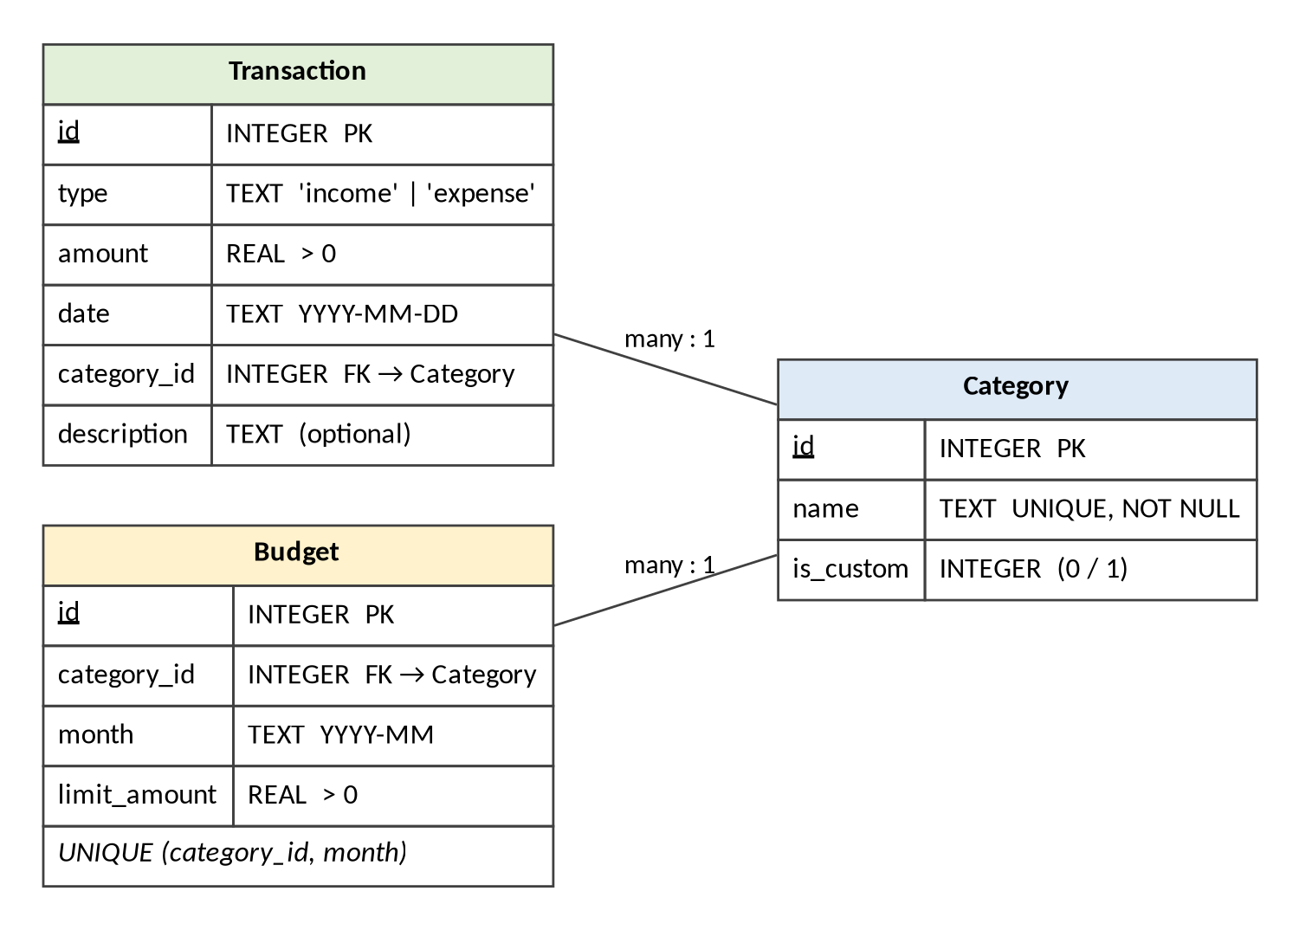
Figure 3: Data model (SQLite tables)
Default categories (for example Food, Rent, Transport, Utilities, Entertainment, Health, Salary and Other) are inserted when the database is first created; users can add custom categories (FR3). A budget is defined per category and per month (FR4), and foreign keys are enabled on every connection.

3.3 REST API Contract
This table is the agreed interface between the client (Member B) and the server (Member A). All request and response bodies are JSON, except CSV upload and download.
Method and endpoint | Purpose | Requirements
POST /api/transactions | Add a transaction; the response includes the budget-alert level. | FR1, FR3, FR5
GET /api/transactions | List transactions; optional from, to, category filters. | FR10
PUT /api/transactions/{id} | Edit an existing transaction. | FR2
DELETE /api/transactions/{id} | Delete a transaction. | FR2
GET /api/categories  POST /api/categories | List categories; add a custom category. | FR3
GET /api/budgets?month=YYYY-MM  PUT /api/budgets | Read budgets for a month; create or update a budget. | FR4
POST /api/csv/import | Upload a CSV file; response is a summary (imported, skipped, errors). | FR6
GET /api/csv/export | Download all transactions as a CSV file. | FR7
GET /api/analytics?month=YYYY-MM | Category totals, percentages and budget-versus-spent for a month. | FR8, FR9
GET /api/health | Used by the launcher to check that the server is ready. | –

4. Process View
The process view describes what runs at run time: the processes, how they communicate and how the main use cases flow through the system.

4.1 Processes and Communication
Aspect | Description
Client process | One Tkinter main loop (single GUI thread). Longer operations, such as CSV import or export, run in a worker thread so the window stays responsive.
Server process | Flask application on 127.0.0.1:5000. There is only one user, so there is no contention between requests.
Communication | Synchronous request/response over HTTP with JSON bodies; CSV upload uses multipart form data and export returns a file.
Start-up and shutdown | run.py starts the server, waits until GET /api/health answers, then starts the client. Closing the client window stops the server.
Data consistency | Each write runs in a SQLite transaction and is committed before the response is sent (NFR5).
Error handling | The server returns {"error": "..."} with status 400 (validation), 404 (not found) or 500 (unexpected). The client shows a message dialog and never a stack trace.

4.2 Key Runtime Flows
Flow 1 – Add transaction with budget alert (FR1, FR3, FR5, NFR3, NFR5). The client validates the form, sends it to the server, the transaction is saved and committed, and only then is the category's monthly spending compared with its budget. The alert level (none, 80% or 100%) is returned with the new transaction so the client can show a pop-up.
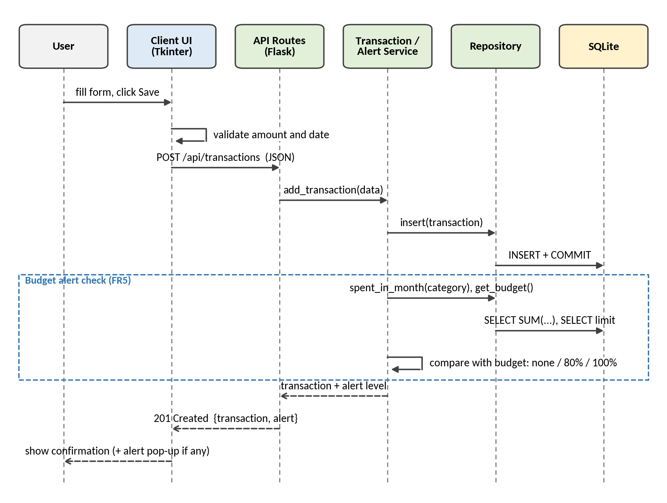
Figure 4: Sequence diagram – add transaction and check budget alert
Flow 2 – CSV import (FR6). The server parses and validates every row, inserts all valid rows in one database transaction and reports how many rows were imported or skipped. CSV export (FR7) is the reverse: the server builds the file and the client saves it.
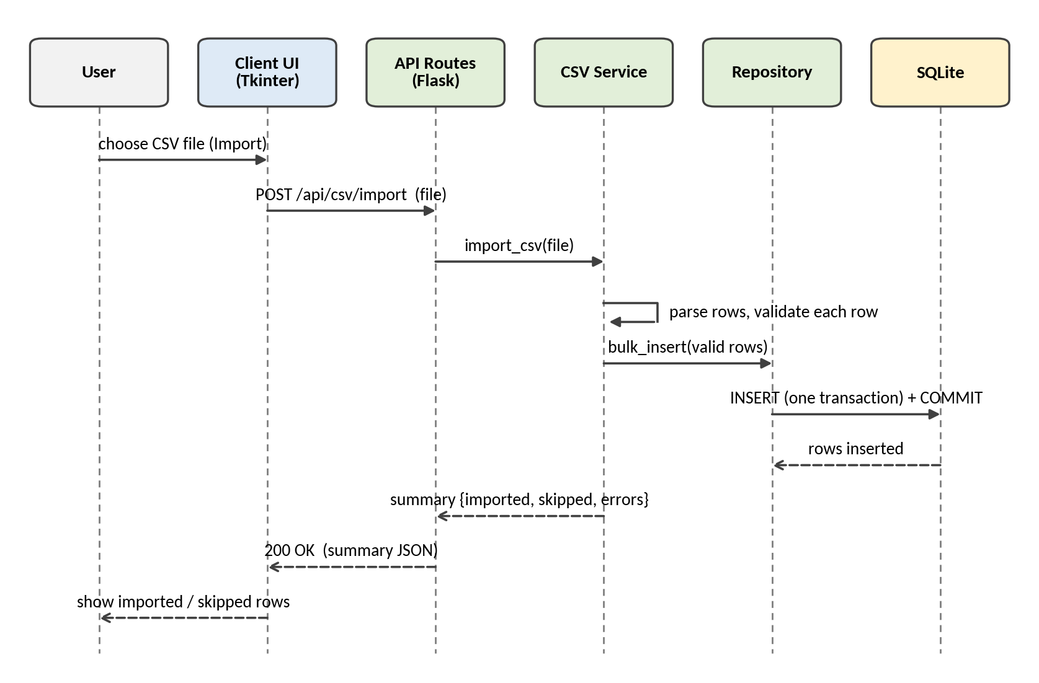
Figure 5: Sequence diagram – CSV import
Flow 3 – Analytics and charts (FR8, FR9, NFR1). Totals per category are calculated by a single SQL GROUP BY query; the client only draws the chart from the returned data.
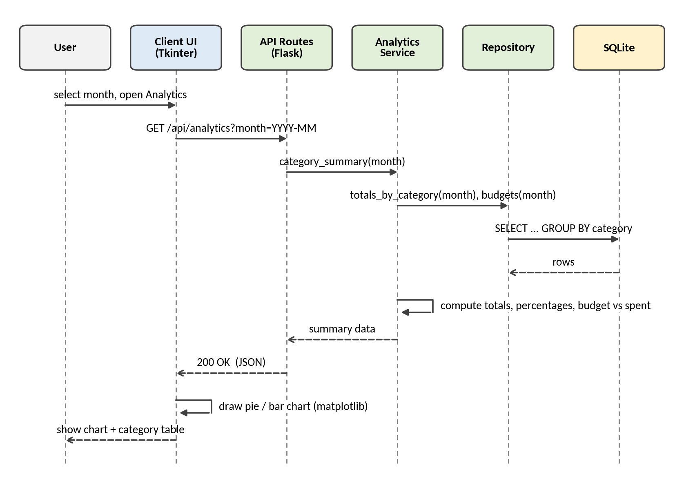
Figure 6: Sequence diagram – view analytics and charts

5. Physical View
The physical view shows the hardware nodes and the connections between them. ExpenseMate needs a single node: the user's own computer.
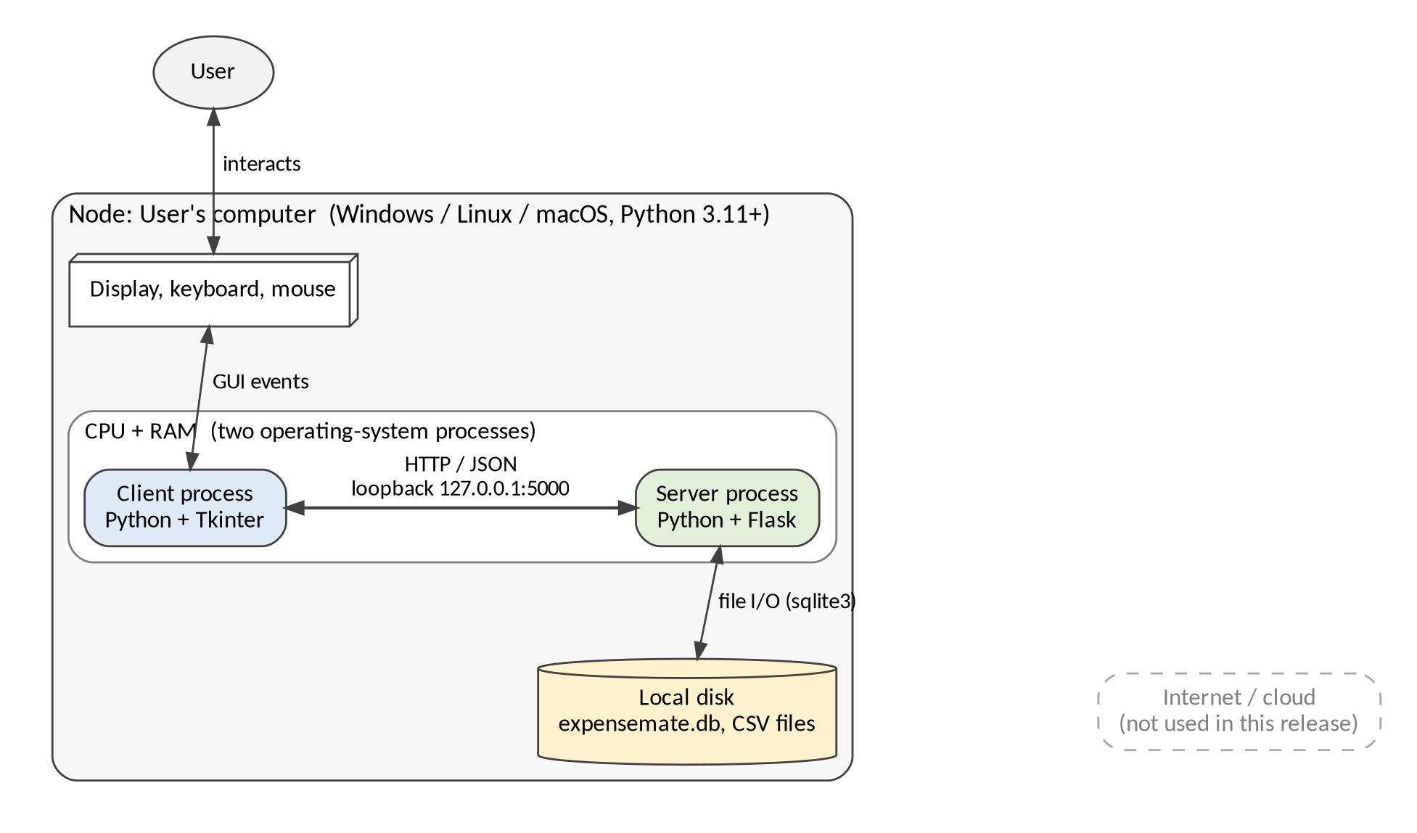
Figure 7: Physical view – hardware node and connections
Element | Description
User's computer | Any desktop or laptop running Windows, Linux or macOS with Python 3.11+. No special hardware is needed; a typical student laptop is sufficient.
Client and server processes | Two operating-system processes on the same computer (see the process view).
Loopback connection | HTTP over 127.0.0.1:5000. The traffic never leaves the machine, so no network or firewall configuration is required (NFR7).
Local disk | Stores the SQLite database file and the CSV files used for import and export.
Internet / cloud | Not used in this release. Cloud backup is a possible maintenance feature (SRS 5.3, Phase 5).

6. Deployment View
The deployment view maps the software artifacts (files) to the node they run on. Everything is deployed to one computer; no hosting or installer is required.
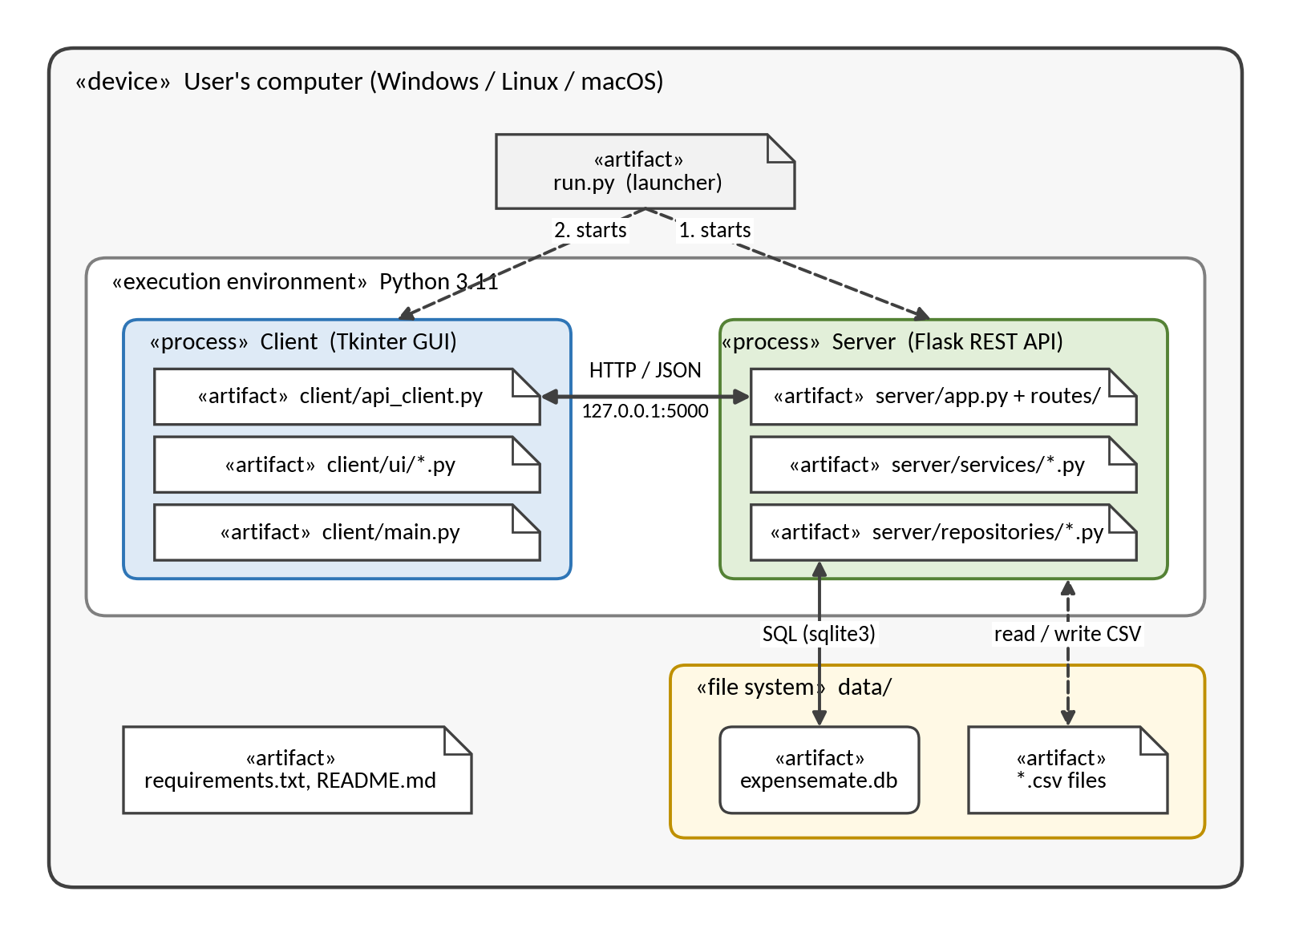
Figure 8: Deployment view – artifacts on the user's computer
Artifact | Description
run.py | Launcher: starts the server, waits for /api/health, then starts the client.
client/ (main.py, api_client.py, ui/) | Tkinter application and the ApiClient module.
server/ (app.py, routes/, services/, repositories/, database.py) | Flask application: API, service and data access layers.
data/expensemate.db | SQLite database file; created automatically on first start.
data/*.csv | CSV files imported into or exported from the system.
requirements.txt | Python packages: Flask, requests, matplotlib, pytest and the quality tools.

Project folder structure
expensemate/
|-- run.py # launcher: starts server, then client
|-- requirements.txt
|-- README.md
|-- client/
| |-- main.py
| |-- api_client.py
| `-- ui/ # main_window, transaction_form, budget_view,
| # history_view, charts_view, csv_dialog
|-- server/
| |-- app.py # Flask application factory
| |-- database.py # connection, schema, seed data
| |-- routes/ # transactions, categories, budgets, analytics, csv_io
| |-- services/ # transaction, budget, alert, analytics, csv
| `-- repositories/ # transaction, category, budget
|-- data/ # expensemate.db, CSV files
|-- tests/ # unit/, integration/, system/
`-- docs/ # SRS, architecture, reports

Running the system
- Install Python 3.11 or newer.
- Install the dependencies: pip install -r requirements.txt.
- Start the application: python run.py.
The system is deployed locally only. Hosting on a cloud platform is out of scope for this release (SRS NFR7 and Constraint 5.2); cloud backup is a candidate feature for the maintenance phase.

7. Coding Standards
These standards apply to both members and are checked during code review and with the tools in Section 8.
Area | Standard
Language and style | Python 3.11+, PEP 8, maximum line length 100. Code is formatted with black and checked with flake8.
Naming | snake_case for functions, variables and modules; PascalCase for classes; UPPER_CASE for constants; test files named test_<module>.py.
Documentation | A docstring on every module, class and public function (purpose, parameters, return value). Type hints on all function signatures. Comments explain why, not what.
Function size and complexity | One responsibility per function; at most about 40 lines; cyclomatic complexity of 10 or less (measured with radon in Phase 4).
Layering rules | The UI calls only ApiClient; routes contain no business logic; services never build HTTP responses; only repositories contain SQL.
Database access | Parameterised queries (? placeholders) only, never string concatenation; foreign keys enabled; schema created by database.py.
Error handling | Validate input in the client and the server; return a JSON error with a proper HTTP status; no bare except:; show friendly messages to the user.
Logging | Use the logging module (INFO for requests, ERROR for failures); no debug print statements in committed code.
Testing | pytest; every public service, repository and ApiClient function has at least one normal-case and one error-case test; target of at least 70% line coverage per module; tests use a temporary test database, never the real one.
Version control | Git with a shared GitHub repository; main always runs; one feature branch per member; small commits with prefixes feat:, fix:, test:, docs:, refactor:; the other member reviews before merging.
Definition of done | Code passes the style checks, has docstrings and tests, all tests pass, a teammate has reviewed it, and the related requirement ID (for example FR5) appears in the docstring or commit message.

8. Tools
Purpose | Tool | Used by
Programming | Python 3.11+, Visual Studio Code | Both
Server and database | Flask, sqlite3, DB Browser for SQLite (optional, to inspect the database) | Member A
GUI and charts | Tkinter, matplotlib, requests | Member B
Unit and integration testing | pytest, pytest-cov, Flask test client (manual API checks with Postman or curl) | Each member (unit); Member A (integration)
Code quality and metrics | black, flake8, radon (cyclomatic complexity) | Both; Member A reports metrics
Version control | Git and GitHub | Both
Fault tracking | GitHub Issues (or a shared Excel sheet): each bug is logged with the date found, severity and date fixed, so fault-find and fault-fix rates can be calculated | Member B
Diagrams | draw.io or PlantUML | Member A
Planning | Excel Gantt chart (ExpenseMate_Gantt_Chart.xlsx) | Member B
Documentation | Microsoft Word | Both

9. Project Timeline

9.1 Assumptions
- The instructor's deadline is Sunday 27 September 2026. The whole project (Phases 1–6) is therefore planned for 23–26 September 2026, and 27 September is kept for the final submission.
- Phase 1 (SRS and Use Case Diagram) was completed on 23 September; Phase 2 (this document) is completed on 24 September.
- Roles follow the assignment: Member A = Hamza Salahuddin (backend), Member B = Rafay Ansari (frontend). Because the schedule is short, both members work in parallel from the first day, and the REST API contract (Section 3.3) is fixed on 24 September.
- The system is built MVP-first: transactions, history and budgets with alerts first, then CSV import/export and charts, and polish last.

9.2 Phases and Deliverables
Phase | Dates (2026) | Deliverable | Responsibilities
1 – Requirements | 23 Sep | SRS + Use Case Diagram (done) | A: requirements. B: use case diagram.
2 – Architecture and planning | 24 Sep | Architecture document + Gantt chart | Both: choose style. A: four views. B: standards, tools, timeline.
3 – Coding and unit testing | 24 – 25 Sep | Source code + unit test reports | A: backend. B: frontend. Each: own unit tests.
4 – Integration and system testing | 25 – 26 Sep | Test cases, bug report, complexity metrics | A: integration tests, complexity. B: system tests, fault tracking.
5 – Maintenance and evolution | 26 Sep | Change log + refactoring report | Both: one small new feature, Lehman's Laws. A: fix 2 bugs. B: improve code quality.
6 – Final report and demo | 25 – 27 Sep | Final report (3 pages), demo, submission bundle | B: report (draft 25 Sep, final 26 Sep). Both: demo and bundle. Team Lead submits on 27 Sep.

9.3 Day-by-Day Plan
Day | Member A (Hamza) – backend | Member B (Rafay) – frontend
Wed 23 Sep | Requirements (SRS) – done. | Use case diagram – done.
Thu 24 Sep | Four architecture views; Flask app skeleton, database.py and schema.  Both: agree the API contract and finish this document. | Coding standards, tools and Gantt chart; Tkinter window skeleton and ApiClient.
Fri 25 Sep | Repositories, services and routes (transactions, budgets + alerts, CSV, analytics); own unit tests; start integration tests. | All screens (transaction form, budgets, history, charts, CSV dialog); own unit tests; start fault log and report draft.  Both: integrate the modules in the evening.
Sat 26 Sep | Integration tests, code complexity, fix 2 bugs.  Both: one small new feature, Lehman's Laws analysis, demo rehearsal, assemble the bundle. | System testing, fault log, code-quality clean-up, final report.
Sun 27 Sep | Final check of the submission bundle. | Final check; the Team Lead submits the bundle.

9.4 Risks and Mitigation
Risk | Impact | Mitigation
The whole project must fit in four days (23–26 Sep) | Features or tests left incomplete | Build the MVP first, then CSV and charts, polish last; work in parallel; short sync at the end of each day; if behind, drop chart extras and keep the Phase 5 feature small.
Members interpret the REST API differently | Integration failures on 25 Sep | Use Section 3.3 as the agreed contract (task 3.1) and share sample JSON responses on 24 Sep.
Tkinter screens and charts take longer than planned | Frontend delay | Build the core screens first (add transaction, history) and the charts last; keep the UI simple.
Database file is lost or corrupted during development | Loss of test data | Keep the database file out of Git; provide a sample-data script; take regular backup copies.
The Gantt chart is on the next page. An editable version with formulas and status tracking is provided as ExpenseMate_Gantt_Chart.xlsx.

9.5 Gantt Chart
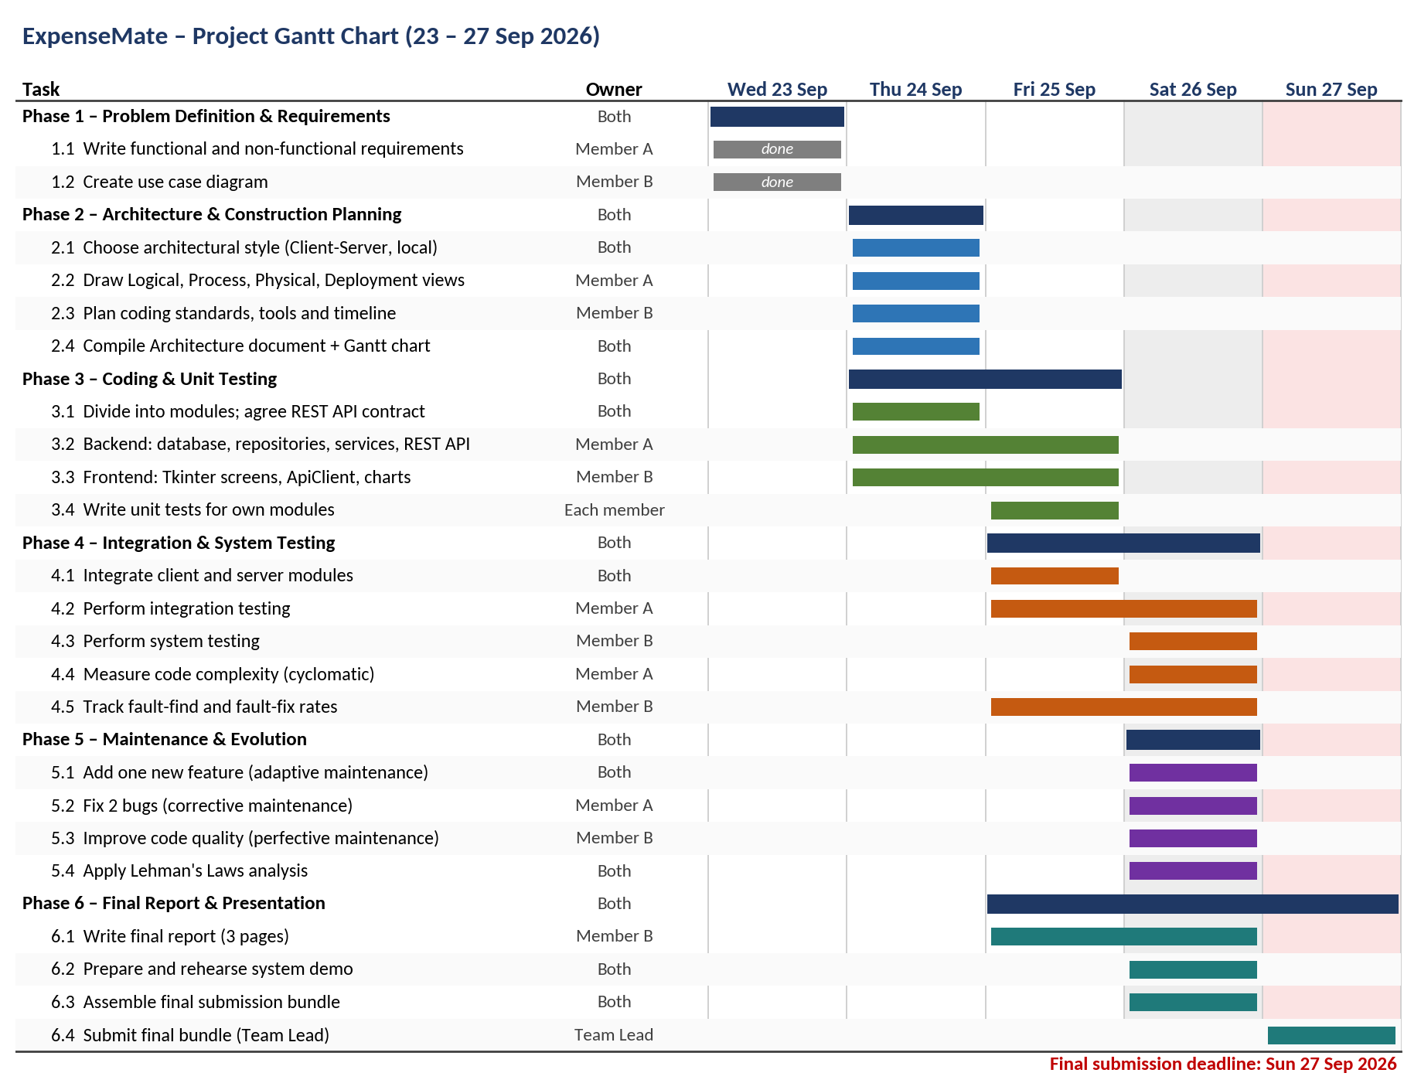
Figure 9: Project Gantt chart (23 – 27 Sep 2026)

