**Additional Supporting Information**

Additional supporting information contains 5 figures (Fig. S1-S5) and 6 tables (Table S1-S6)

**Figure S1. Morphological measurements (a) and functional traits (b) measured on the 9,534 fish species**

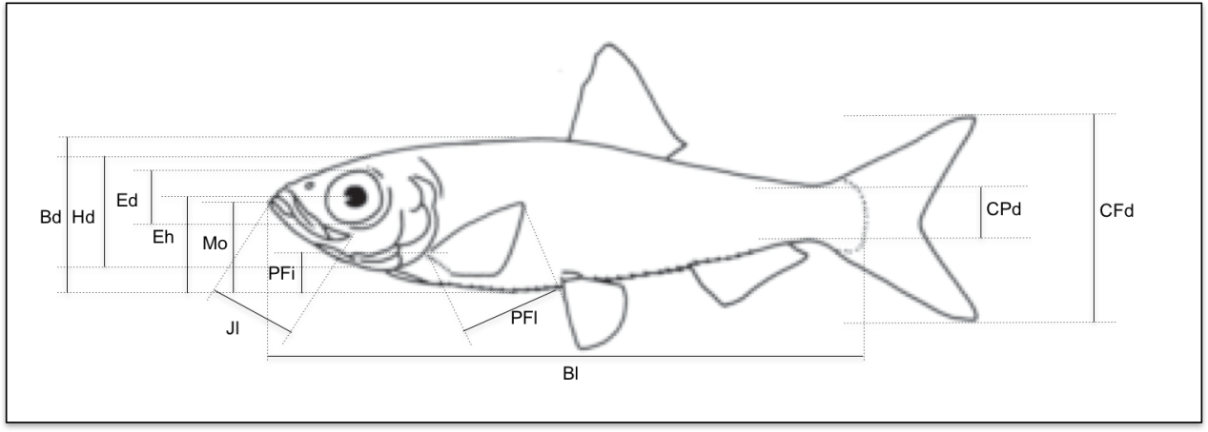

**a. Morphological measurements**

|  |  |  |
| --- | --- | --- |
|  | | |
| Code | Name | Protocol for measurement |
| Blmax | Maximum Body length | Maximum adult length |
| Bl | Body length | Standard length (snout to caudal fin basis) |
| Bd | Body depth | Maximum body depth |
| Hd | Head depth | Head depth at the vertical of eye |
| CPd | Caudal peduncle depth | Minimum depth of the caudal peduncle |
| CFd | Caudal fin depth | Maximum depth of the caudal fin |
| Ed | Eye diameter | Vertical diameter of the eye |
| Eh | Eye position | Vertical distance between the centre of the eye to the bottom of the body |
| Mo | Oral gape position | Vertical distance from the top of the mouth to the bottom of the body |
| Jl | Maxillary jaw length | Length from snout to the corner of the mouth |
| PFl | Pectoral fin length | Length of the longest ray of the pectoral fin |
| PFi | Pectoral fin position | Vertical distance between the upper insertion of the pectoral fin to the bottom of the body |
| All measurements were made on pictures except Blmax values, which were downloaded from Fishbase.org. | | |

|  |  |  |
| --- | --- | --- |
| **b. Functional traits** | | |
| **Functional traits** | **Formula** | **Potential link with fish functions** |
| Body length | *Blmax* | Size is linked to metabolism, trophic impacts, locomotion ability, nutrient cycling |
| Body elongation | $$\frac{Bl}{Bd}$$ | Hydrodynamism  Position of fish and/or of its prey in the water column |
| Eye vertical position | $$\frac{Eh}{Bd}$$ |
| Relative Eye size | $$\frac{Ed}{Hd}$$ | Visual acuity |
| Oral gape position | $$\frac{Mo}{Bd}$$ | Feeding position in the water column |
| Relative maxillary length | $$\frac{Jl}{Hd}$$ | Size of mouth and strength of jaw |
| Body lateral shape | $$\frac{Hd}{Bd}$$ | Hydrodynamism and head size |
| Pectoral fin vertical position | $$\frac{PFi}{Bd}$$ | Pectoral fin use for swimming |
| Pectoral fin size | $$\frac{PFl}{Bd}$$ | Pectoral fin use for swimming |
| Caudal peduncle throttling | $$\frac{CFd}{CPd}$$ | Caudal propulsion efficiency through reduction of drag |
| For species having unusual morphologies (species without tail, flatfishes) preventing the computation of ratios, we applied the same rules as defined in previous studies (Villéger et al. 2010; Toussaint et al. 2016b). Briefly, these rules consisted to assign values for some particular ratio such as Caudal Peduncle throttling set to 1 for species with no visible caudal fins, Oral gape position set to 0 for the species with the mouth positioned under the body, Pectoral fin vertical position set to 0 for the species without pectoral fins and body depth (Bd) refers to the body width for flatfishes. | | |

**Figure S2. Intra-specific trait variability effect on functional diversity indices for river basins in Europe.** Between 3 and 6 individuals were morphologically described for 60 species occurring in 36 European assemblages. All these individuals were included in the 5-dimensional functional space built based on traits values of with the 9,534 species from the global pool. Two functional diversity indices, A) FRic and B) FSpe, were then calculated for each river basin using traits values after one randomly chosen individual of each species with 10,000 iterations. FRic corresponds to the volume of the minimum convex hull that includes all the species in the 5-dimensional functional space. FRic is expressed as a percentage of the maximum FRic calculated with the 9,534 species in the 5-dimensional functional space. FSpe correspond to the mean of the Euclidean distance of the species to the centroid of the 5-dimensional functional space calculated with the 9,534 species. FSpe is expressed as a percentage of the maximal distance between the most extreme species and the centroid of the 5-dimensional functional space calculated with the 9,534 species. Black dots represent the mean of simulated index values and blacks bars the confidence interval at 95%. Correlations between observed and mean of simulated index was tested using Spearman’s rank correlation test and results indicated at the top of each panel.



**Figure S3. Historical and current functional (FRic) and taxonomic (TRic) richness of freshwater fish assemblages for the world river basins.** TRic and FRic of each assemblage were expressed as a percentage of the relative TRic or FRic of the realm to which they belong and these proportions were log-transformed for graphical convenience. Historical values of FRic and TRic are in blue and current values are in red. For each biogeographic realm, upper part of the graph shows the historical (blue) and current (red) FRic for each river basin. The lower part represents the historical and current TRic for the same river basins. For each realm, river basins are ordered according to decreasing current FRic. For each realm, the three river basins experiencing the greatest increase in FRic between historical and current periods are depicted with dotted vertical lines indicating their respective TRic and FRic. These values are also depicted for the five largest river basins of the world (Congo, Amazon, Mississippi, Mekong, Yangtse) with dashed line.



**Figure S4. Distribution of the changes in functional and taxonomic richness.** For each index, the changes were calculated as the ratio between the current and historical situation. A change greater than 1 means an increase of the index whereas a change lower than 1 mean a decrease of the index. Left panel represents the distribution of the changes in taxonomic richness and the right represents the distribution of the changes in functional richness. Only the 887 river basins that experienced at least one introduction or extinction were considered in the analysis.



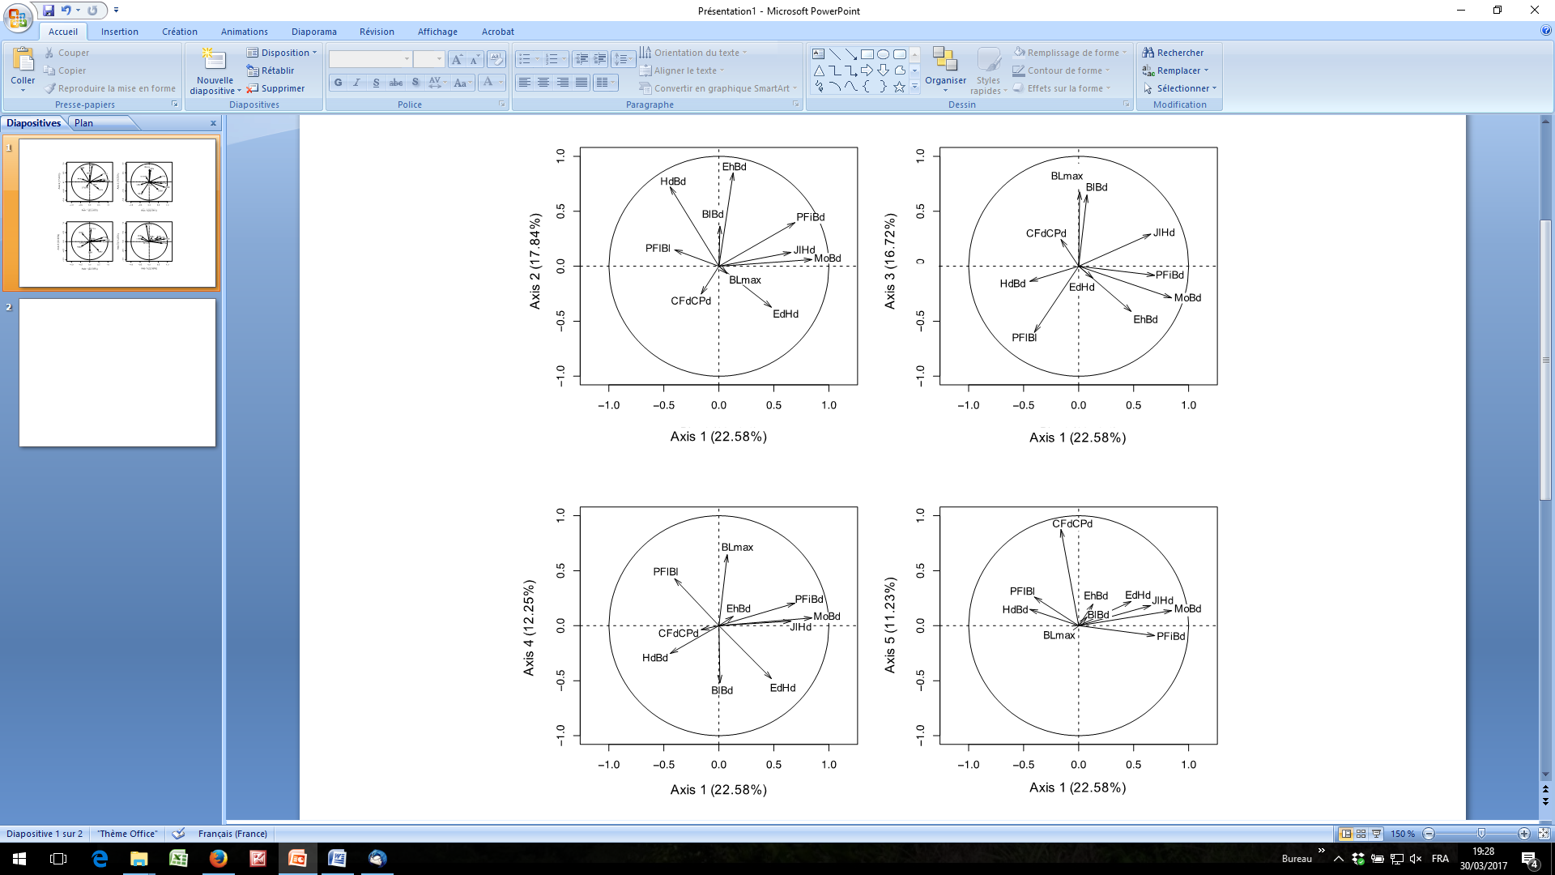**Figure S5. Results of the Principal Components Analysis led on the 10 functional traits measured on 9,534 fish species.** The percentage of variance explained by each axis is indicated under brackets.Signification of each trait is given in Fig. S1.

**Table S1. Results of the Principal Components Analysis led on the 10 functional traits measured on 9,534 fish species.** A. Eigenvalues and percentages of variance explained by each axis. B. Percentage of contribution of each functional trait to each axis.

|  |  |  |  |  |  |
| --- | --- | --- | --- | --- | --- |
| A. | | | | | |
|  | Axis 1 | Axis 2 | Axis 3 | Axis 4 | Axis 5 |
| Eigenvalues | 2.25 | 1.78 | 1.67 | 1.22 | 1.12 |
| Percentage of variance | 22.5 | 17.8 | 16.7 | 12.2 | 11.2 |
| Cumulative percentage of variance | 22.5 | 40.4 | 57.1 | 69.3 | 80.5 |

|  |  |  |  |  |  |  |  |
| --- | --- | --- | --- | --- | --- | --- | --- |
| B. | | | | | | | |
|  | Axis 1 | | Axis 2 | Axis 3 | Axis 4 | | Axis 5 | |
| Relative Eye size | | 10.1 | 7.8 | 10.1 | | **18.9** | 4.8 | |
| Oral gape position | | **31.6** | <1 | 4.9 | | <1 | 1.8 | |
| Relative maxillary length | | **19.1** | <1 | 5.1 | | <1 | 3.3 | |
| Eye vertical position | | <1 | **40.5** | <1 | | <1 | 3.8 | |
| Body elongation | | <1 | 7.4 | **27.3** | | **22.1** | <1 | |
| Body lateral shape | | 8.7 | **29.2** | 1.1 | | 5.2 | 2.1 | |
| Pectoral fin vertical position | | **21.2** | 8.8 | <1 | | 3.4 | <1 | |
| Pectoral fin size | | 7.2 | 1.2 | **21.6** | | 14.9 | 6.7 | |
| Caudal peduncle throttling | | 1.1 | 3.6 | 3.5 | | <1 | **75.8** | |
| Maximum body length | | <1 | <1 | **25.1** | | **34.1** | <1 | |
| The contribution of each functional trait to the first 5 axes is expressed as percentages and values higher than 15% are in bold font. The significance of each functional trait is indicated in the Fig. S1b. | | | | | | | |

**Table S2. Change in fish functional richness (FRic): observed versus expected values given change in taxonomic richness**

|  |  |  |  |  |  |  |  |  |  |  |
| --- | --- | --- | --- | --- | --- | --- | --- | --- | --- | --- |
| **Realm** | **Number of basins** | **Increase in FRic** | | | | **No change**  **in FRic** | **Decrease in FRic** | | | |
|  |  |  | **Higher** | **Not different** | **Lower** |  |  | **Higher** | **Not different** | **Lower** |
| Afrotropical | 51 | 44 (86.27%) |  |  |  | 6 (11.76%) | 1  (1.96%) |  |  |  |
|  |  |  | 7  (15.91%) | 36 (81.82%) | 1  (2.27%) |  |  | 0  (0%) | 0  (0%) | 1  (100%) |
| Australian | 116 | 115  (99.14%) |  |  |  | 0  (0%) | 1  (0.86 %) |  |  |  |
|  |  |  | 0  (0%) | 113 (98.28%) | 2  (1.74%) |  |  | 0  (0%) | 0  (0%) | 1  (100%) |
| Nearctic | 128 | 113 (88.28%) |  |  |  | 2  (1.56%) | 13 (10.16%) |  |  |  |
|  |  |  | 1  (0.88%) | 110 (97.35%) | 2  (1.77%) |  |  | 0  (0%) | 0  (0%) | 13  (100%) |
| Neotropical | 81 | 76 (93.83%) |  |  |  | 4  (4.93%) | 1  (1.23%) |  |  |  |
|  |  |  | 2  (2.63%) | 74 (97.37%) | 0  (0%) |  |  | 0  (0%) | 0  (0%) | 1  (100%) |
| Oriental | 27 | 25 (92.59%) |  |  |  | 2  (2.11%) | 2  (2.11%) |  |  |  |
|  |  |  | 1  (1.10%) | 90  (98.90%) | 0  (0%) |  |  | 0  (0%) | 0  (0%) | 2  (100%) |
| Palearctic | 416 | 411 (98.80%) |  |  |  | 0  (0%) | 5  (1.20%) |  |  |  |
|  |  |  | 3  (0.73%) | 407  (99. 03%) | 1  (0.24%) |  |  | 0  (0%) | 6  (0%) | 5  (100%) |
| World | 887 | 850 (95.83%) |  |  |  | 14 (2.74%) | 23 (2.59%) |  |  |  |
|  |  |  | 10  (1.18%) | 830 (97.65%) | 10 (1.18%) |  |  | 0  (0%) | 0  (0%) | 23  (100%) |

The first column indicates the number of basins experiencing changes in taxonomic richness (i.e. introduction and/or extinction) in each biogeographic realm and over the world. For each realm, the first row lists the number of basins and the percentage of basins from the realm experiencing an increase, no change or decrease of FRic. The second row shows number and percentage of basins with FRic values significantly higher, significantly lower or not significantly different than expected given number of species introduced and/or extinct and the traits values of non-native and threatened species from each realm (i.e. if species identity were sorted at random among non-native and threatened species pools). Randomizations of non-native and/or extinct species were repeated 999 times for each fish assemblage. The significance of the difference from null expectations (p) was tested using a two-tailed test (α < 0.05). “Higher” means a change in FRic significantly higher than expected under randomization (p>0.975). “Lower” means a change in FRic significantly lower than expected (p<0.025). “Not different” means a change in FRic not significantly different than expected (p=[0.025;0.975]). Only the 887 river basins that experienced at least one introduction or extinction were considered in the analysis.

**Table S3. Functional specialization of native, non-native and extinct freshwater fish species.**

|  |  |  |  |  |  |  |  |  |  |  |  |  |  |
| --- | --- | --- | --- | --- | --- | --- | --- | --- | --- | --- | --- | --- | --- |
| Biogeographic realm | Species type | | N | | | | Functional specialization (FSpe) | | | | | Difference between FSpe native and FSpe of each group | |
|  |  | |  | | | | Mean ± SD | | CI95 | | |  | |
| Afrotropical | | |  | | | |  | |  | | |  | |
|  | | Native | | 2287 | | 1.83 ± 1.04 | | | | [0.72-3.22] | | | | |
|  | | Extinct | | 28 | | 1.30 ± 0.60 | | | | [0.70-2.32] | | | *** | |
|  | | Non-native | | 48 | | 2.03 ± 0.76 | | | | [0.88-3.27] | | | * | |
|  | | Translocated | | 26 | | 1.89 ± 0.90 | | | | [0.71-3.77] | | | ns | |
|  | | Exotic | | 22 | | 2.20 ± 0.51 | | | | [1.61-2.81] | | | ** | |
| Australian | | |  | |  | | |  | | |  | | |
|  | Native | | 377 | | 2.27 ± 1.40 | | | [0.72-4.14] | | | | | |
|  | Extinct | | 4 | | 1.99 ± 1.37 | | | [1.10-3.65] | | | ns | | |
|  | Non-native | | 53 | | 2.16 ± 0.62 | | | [1.11-3.15] | | | ns | | |
|  | Translocated | | 19 | | 2.24 ± 0.73 | | | [1.16-3.45] | | | ns | | |
|  | Exotic | | 34 | | 2.12 ± 0.56 | | | [1.19-2.82] | | | ns | | |
| Nearctic |  | |  | |  | | |  | | |  | | |
|  | Native | | 682 | | 1.82 ± 0.98 | | | [0.70-3.31] | | | | | |
|  | Extinct | | 54 | | 1.86 ± 1.12 | | | [0.70-3.43] | | | ns | | |
|  | Non-native | | 239 | | 1.91 ± 0.86 | | | [0.70-3.33] | | | * | | |
|  | Translocated | | 182 | | 1.85 ± 0.86 | | | [0.70-3.12] | | | ns | | |
|  | Exotic | | 57 | | 2.08 ± 0.84 | | | [0.70-3.47] | | | ** | | |
| Neotropical | | |  | |  | | |  | | |  | | |
|  | Native | | 3829 | | 2.01 ± 1.18 | | | [0.70-3.89] | | | | | |
|  | Extinct | | 11 | | 1.37 ± 0.64 | | | [0.70-2.13] | | | * | | |
|  | Non-native | | 78 | | 2.08 ± 0.92 | | | [0.79-4.07] | | | ns | | |
|  | Translocated | | 50 | | 1.82 ± 0.85 | | | [0.70-2.93] | | | ns | | |
|  | Exotic | | 28 | | 2.54 ± 0.87 | | | [1.65-4.37] | | | *** | | |
| Oriental |  | |  | |  | | |  | | |  | | |
|  | Native | | 1649 | | 2.00 ± 1.19 | | | [0.70-3.76] | | | | | |
|  | Extinct | | 24 | | 2.32 ± 1.57 | | | [0.73-4.01] | | | ns | | |
|  | Non-native | | 67 | | 2.15 ± 0.68 | | | [1.09-3.18] | | | ** | | |
|  | Translocated | | 35 | | 2.10 ± 0.73 | | | [0.96-3.31] | | | ns | | |
|  | Exotic | | 32 | | 2.21 ± 0.62 | | | [1.34-2.92] | | | * | | |
| Palearctic |  | |  | |  | | |  | | |  | | |
|  | Native | | 1003 | | 1.88 ± 0.95 | | | [0.70-3.61] | | | | | |
|  | Extinct | | 24 | | 2.36 ± 1.12 | | | [0.89-4.42] | | | * | | |
|  | Non-native | | 176 | | 2.14 ± 0.94 | | | [0.81-3.73] | | | *** | | |
|  | Translocated | | 147 | | 2.17 ± 0.99 | | | [0.81-4.00] | | | *** | | |
|  | Exotic | | 29 | | 1.98 ± 0.56 | | | [1.29-2.83] | | | ns | | |

For each biogeographic realm, we tested whether the non-native and the extinct species have more extreme functional trait values than native species that have not been extinct nor translocated. For each species, we calculated its functional specialization (FSpe) as the Euclidean distance to the centroid (i.e. the hypothetical average position in the functional space) of only the native species not extinct and not translocated). We tested for differences in functional specialization between those native species and (*i*) native species that have been extinct (Extinct), (*ii*) all non-native species (Non-native), and (*iii*) only translocated (Tanslocated) or (*iv*) only exotic non-native species (Exotic), using non-parametric Wilcoxon tests. ns: non-significant; * *P* < 0.05 ; ** *P* < 0.01 ; *** *P* < 0.001. The number of species considered in each group (N) is indicated. CI95: 95% confidence interval. SD: Standard Deviation.

**Table S4. Correlation between change in functional richness and change in functional identity between historical and current situations.**

|  |  |  |  |  |  |  |  |  |  |  |  |  |  |  |  |  |  |  |  |  |  |  |  |  |  |  |  |  |  |  |
| --- | --- | --- | --- | --- | --- | --- | --- | --- | --- | --- | --- | --- | --- | --- | --- | --- | --- | --- | --- | --- | --- | --- | --- | --- | --- | --- | --- | --- | --- | --- |
|  |  | Rho | | P value | | | |  | | | | |  | | | | |  | Rho | | | | | P value | | | | | | |
| Afrotropical (n=51) | | | | |  | | | |  | | | | | Neotropical (n=81) | | | | | | | |  | | | | |  | | | | |
|  | PC1 | 0.565 | | <0.001 | *** | | | | |  | | | | |  | PC1 | | | | | -0.146 | | | | | 0.19 | | | | ns | | | | |
|  | PC2 | -0.260 | | 0.07 | ns | | | | |  | | | | |  | PC2 | | | | | -0.424 | | | | | <0.001 | | | | *** | | | | |
|  | PC3 | -0.193 | | 0.17 | ns | | | | |  | | | | |  | PC3 | | | | | 0.352 | | | | | <0.01 | | | | ** | | | | |
|  | PC4 | 0.444 | | <0.01 | ** | | | | |  | | | | |  | PC4 | | | | | 0.604 | | | | | <0.001 | | | | *** | | | | |
|  | PC5 | 0.077 | | 0.59 | ns | | | | |  | | | | |  | PC5 | | | | | -0.349 | | | | | <0.01 | | | | ** | | | | |
| Australian (n=116) | | | | |  |  | | | | | | Oriental (n=95) | | | | | | | | | | |  | | | | |  | | | | |
|  | PC1 | -0.677 | | <0.001 | *** | |  | | | |  | | | | | | PC1 | | | 0.025 | | | | | 0.81 | | | | ns | | | | |
|  | PC2 | -0.639 | | <0.001 | *** | |  | | | |  | | | | | | PC2 | | | -0.287 | | | | | <0.01 | | | | ** | | | | |
|  | PC3 | 0.198 | | <0.05 | * | |  | | | |  | | | | | | PC3 | | | 0.005 | | | | | 0.96 | | | | ns | | | | |
|  | PC4 | 0.664 | | <0.001 | *** | |  | | | |  | | | | | | PC4 | | | 0.584 | | | | | <0.001 | | | | *** | | | | |
|  | PC5 | 0.104 | | 0.27 | ns | |  | | | |  | | | | | | PC5 | | | -0.517 | | | | | <0.001 | | | | *** | | | | |
| Nearctic (n=128) | | |  | |  |  | | | | | | Palearctic (n=416) | | | | | | | | | | |  | | | | |  | | | | |
|  | PC1 | 0.179 | | <0.05 | * | |  | | | |  | | | | | | PC1 | | | 0.182 | | | | | <0.001 | | | | *** | | | | |
|  | PC2 | -0.447 | | <0.001 | *** | |  | | | |  | | | | | | PC2 | | | -0.298 | | | | | <0.001 | | | | *** | | | | |
|  | PC3 | 0.186 | | <0.05 | * | |  | | | |  | | | | | | PC3 | | | -0.244 | | | | | <0.001 | | | | *** | | | | |
|  | PC4 | 0.654 | | <0.001 | *** | |  | | | |  | | | | | | PC4 | | | 0.473 | | | | | <0.001 | | | | *** | | | | |
|  | PC5 | -0.256 | | <0.01 | ** | |  | | | |  | | | | | | PC5 | | | -0.148 | | | | | <0.01 | | | | ** | | | | |

Spearman’s rank correlation tests were performed between change in FRic (δFRic) and relative change in functional identity for each of the 5 functional axes (PC1 to PC5). Only the 887 river basins that experienced at least one introduction or extinction were considered in the analysis.

The number of assemblages considered in each realm (n) is indicated under brackets. ns: non-significant; *P*<0.05: *; *P*<0.01:**; *P*<0.001:***.

**Table S5. Correlation between historical functional richness (FRic) and historical taxonomic richness (TRic), or historical functional divergence (FDiv).**

|  |  |  |  |
| --- | --- | --- | --- |
| Biogeographic realm | N | FRicHistoric *vs.* TRicHistoric | FRicHistoric *vs.* FDivHistoric |
| Afrotropical | 129 | 0.963*** | -0.088ns |
| Australian | 212 | 0.888*** | -0.144* |
| Nearctic | 203 | 0.962*** | -0.478*** |
| Neotropical | 275 | 0.941*** | -0.477*** |
| Oriental | 166 | 0.960*** | -0.335*** |
| Palearctic | 534 | 0.873*** | -0.294*** |
| World | 1,519 | 0.904*** | -0.288*** |

Spearman’s correlation coefficients (Rho) are provided for the six biogeographic realms and the world. For each biogeographic realm, the number of basins (N) considered in the analysis is indicated.

**Table S6. Number of introductions, extirpations and proportion of exotic species between rivers which experienced an increase in functional richness and an increase in functional divergence (δFDiv>1) or a decrease in functional divergence (δFDiv<1) in the six biogeographic realms.**

|  |  |  |  |  |  |  |  |  |  |  |  |
| --- | --- | --- | --- | --- | --- | --- | --- | --- | --- | --- | --- |
|  | Nb. of introductions | | | Nb. of extirpations | | | | Proportion of exotic species | | | |
|  | δFDiv>1 | δFDiv<1 |  | | δFDiv>1 | δFDiv<1 |  | | δFDiv>1 | δFDiv<1 |  |
| Afrotropical | 3.00 [2.00-7.00] | 1.00 [1.00-4.00] | *** | | 0.00 [0.00-0.00] | 0.00 [0.00-0.00] | ns | | 0.00 [0.00-0.27] | 0.00 [0.00-0.00] | * |
| Australian | 2.00 [1.00-4.00] | 2.00 [1.00-4.25] | ns | | 0.00 [0.00-0.00] | 0.00 [0.00-0.00] | ns | | 0.75 [0.33-1.00] | 0.78 [0.43-1.00] | ns |
| Nearctic | 3.00 [2.00-7.00] | 1.00 [1.00-4.00] | *** | | 0.00 [0.00-0.00] | 0.00 [0.00-0.00] | ns | | 0.00 [0.00-0.27] | 0.00 [0.00-0.00] | * |
| Neotropical | 4.00 [2.00-6.00] | 1.00 [1.00-2.00] | *** | | 0.00 [0.00-0.00] | 0.00 [0.00-0.00] | ns | | 1.00 [0.81-1.00] | 1.00 [1.00-1.00] | ** |
| Oriental | 3.00 [2.00-7.00] | 1.00 [1.00-4.00] | *** | | 0.00 [0.00-0.00] | 0.00 [0.00-0.00] | ns | | 0.00 [0.00-0.27] | 0.00 [0.00-0.00] | * |
| Palearctic | 3.00 [1.00-6.00] | 2.00 [1.00-3.50] | ns | | 0.00 [0.00-0.00] | 0.00 [0.00-0.00] | ns | | 0.64 [0.33-1.00] | 0.41 [0.00-0.88] | ns |

For each realm the median and 1st and 3rd quartiles in brackets of the distribution of the number of introductions, extirpations and proportion of exotic species. Only the river basins which experienced an increase in functional richness were considered. The difference between the distribution was tested using Wilcoxon test. Ns: non-significant. *: P<0.05; **: P<0.01; ***: P<0.001.