HEDONIC PRICE DECOMPOSITION WITH PROMOTIONAL EROSION
Evidence from Vietnamese Online Grocery
COMPREHENSIVE CHAPTER OUTLINE — Chapters 1–4
Ch 1: Full text | Ch 2–4: Detailed elaboration with embedded visualizations
April 2026

CHAPTER 1: INTRODUCTION

1.1 Research subject and scope
1.1.1 Within a single subcategory on Winmart’s online platform, product prices vary 3–5x — a liter of fresh milk ranges from budget house-brand to imported premium. The economic question: what product attributes explain these price differences?
1.1.2 This thesis examines attribute-based price premiums in Vietnamese online grocery retail, using 88 days of web-scraped dual-price data (Dec 18, 2025 – Mar 15, 2026) from Winmart, Vietnam’s largest online grocery platform. The dataset covers 10 food categories and approximately 2,280 products.
1.1.3 An additional feature of the data: most products display two prices — a marked (sticker) price and a final (checkout) price after promotions. Promotion penetration varies from 93% (Dairy) to 12% (fresh produce). This dual-price structure creates an opportunity to examine whether attribute premiums observed in sticker prices survive at the point of sale. The 88-day data window spans Tết Nguyên Đán 2026 (February 17), capturing peak promotional activity — analytically useful for observing maximum promotional variance.
[NOTE] Tet framing: feature (max promo variance), not limitation. Cross-sectional averaging dampens Tet noise. Subcategory FE absorbs category seasonality. 3-snapshot robustness done.
1.1.4 Vietnam’s online grocery sector is growing rapidly, yet there is almost no empirical evidence on how product attributes translate into price premiums in this channel.

1.2 Research objectives
1.2.1 Primary objective: Identify which product attributes (brand positioning, import origin, health claims, pack size, freshness signals) generate price premiums in Vietnamese online grocery.
1.2.2 Secondary objective: Exploit the dual-price structure to examine whether promotional discounts erode those attribute premiums differentially at checkout.
[NOTE] Use ‘examine’ not ‘identify causally.’ Promotional erosion is descriptive. Endogeneity acknowledged.
1.2.3 Tertiary objective: Examine how attribute premium structures vary across product categories.

1.3 Overview of research methods
1.3.1 Data collection: automated daily web scraping of Winmart’s online platform, yielding matched marked_price and final_price observations for each product on each day.
1.3.2 Feature extraction: NLP-based extraction of 9 product attributes from product names. Validated against manual coding on a 100-product subset (see §3.3).
1.3.3 Brand positioning classification: a 4-quadrant typology based on brand recognition × price tier, grounded in Keller (1993) and Aaker (1991).
1.3.4 Analytical framework: dual-price hedonic regression — pooled OLS with subcategory fixed effects and cluster-robust standard errors. Same specification estimated twice (marked price, then final price); coefficients compared.
1.3.5 Single-retailer design rationale: restricting to one retailer controls for platform-level pricing confounds. Deliberate design choice (elaborated in Chapter 3).

1.4 Contribution and thesis structure
1.4.1 Contribution #1: First hedonic decomposition of product attribute premiums in Vietnamese online grocery retail. Framed as ‘the price architecture of Vietnam’s largest online grocery platform.’
1.4.2 Contribution #2: Novel dual-price design separating sticker-price premiums from checkout-price premiums.
1.4.3 Contribution #3: A 4-quadrant brand positioning typology operationalizing Keller’s (1993) brand knowledge dimensions.
1.4.4 Thesis structure: Ch 2 (lit review) → Ch 3 (data & methods) → Ch 4 (results & discussion) → Ch 5 (conclusion).

CHAPTER 2: LITERATURE REVIEW
Opening paragraph: Three research streams converge — hedonic pricing theory, brand equity and product differentiation, Vietnamese food market studies. §2.1 establishes theory. §2.2 reviews food empirics. §2.3 examines which attributes generate premiums. §2.4 validates online data. §2.5 identifies the gap.

2.1 Hedonic Pricing Theory: Goods as Attribute Bundles
Purpose: Establish the theoretical foundation. Reader should understand why decomposing prices into attribute components is a valid economic exercise.
- Lancaster (1966): Consumers derive utility from characteristics, not goods themselves. A product is a bundle of attributes; consumers evaluate these attributes, not the good as a whole. This is the theoretical basis for price decomposition — observed prices should reflect the market’s implicit valuation of each embedded attribute.
  - Key implication: If a product’s price reflects its attribute bundle, then variation in attributes across products should explain variation in prices. This justifies the cross-sectional hedonic approach.
  - Source: Lancaster (1966) ✔
- Rosen (1974): Formalized the equilibrium hedonic price function. In a market with heterogeneous goods, equilibrium prices trace a smooth function P(z₁, z₂, ..., zₖ) of product characteristics. The partial derivative ∂P/∂zᵢ gives the implicit (hedonic) price of attribute zᵢ — the marginal WTP/marginal cost of that attribute at the margin.
  - First-stage estimation (our approach): estimate the hedonic price function from observed market data. This recovers implicit prices — what the market collectively pays for each attribute.
  - Rosen’s second stage (demand/supply identification) is not attempted here. We estimate first-stage equilibrium relationships only.
  - Source: Rosen (1974) [NEED PDF]
- Ekeland, Heckman & Nesheim (2001): The identification problem — first-stage hedonic estimates reflect equilibrium outcomes (joint product of demand and supply), not pure consumer WTP. The hedonic price function is a reduced-form relationship.
  - Implication for our thesis: we interpret coefficients as market-equilibrium implicit prices, not as consumer demand parameters. This is a descriptive exercise.
  - Source: Ekeland et al. (2001) ✔
- Lucas (1975): Multiple valid interpretations of hedonic functions. In a single-market setting, the hedonic function reflects both demand and supply simultaneously. A single-retailer design partially mitigates identification ambiguity by holding supply-side factors constant.
  - Source: Lucas (1975) ✔
→ Theory done. §2.2: does this work for food?

2.2 Hedonic Methods in Food and Agricultural Markets
Purpose: Demonstrate that hedonic methods have been successfully applied to food products, establishing methodological precedent. Each source should contribute a specific methodological lesson.
- Costanigro & McCluskey (2011): Comprehensive review of hedonic methods in food economics. Key methodological lessons for our study:
  - Log-linear specification is standard (consistent with Rosen 1974): ln(P) = Xβ + ε. Coefficients interpreted as percentage premiums.
  - Subcategory controls essential: within-category price variation is the identification source, not cross-category comparisons.
  - Sample heterogeneity matters: food products span enormous quality ranges; subcategory FE absorb level differences.
  - Source: Costanigro & McCluskey (2011) ✔ (methodology, not theory)
- Nelson (1970): Search vs. experience goods distinction. Search attributes (e.g., pack size, brand visibility) can be evaluated before purchase. Experience attributes (e.g., taste, freshness) require consumption. Online grocery product names primarily convey search attributes.
  - Implication: our NLP-extracted features are predominantly search attributes (brand name, origin label, pack size, health claim keywords). Experience quality is unobserved.
  - Source: Nelson (1970) ✔ PRIMARY
- Darby & Karni (1973): Credence attributes — characteristics that consumers cannot verify even after purchase (organic certification, pesticide-free claims, nutritional content). These attributes command premiums sustained by trust and labeling, not by verifiable experience.
  - Implication: has_health_claim and has_freshness_claim are credence attributes in our model. Their premiums should be resilient to promotional discounting if trust-based.
  - Source: Darby & Karni (1973) ✔ PRIMARY
- Malpezzi (2002): Applied hedonic review. Guidance on functional form (log-linear preferred for price data), omitted variable bias concerns, and the importance of adequate controls. Log-linear form ensures coefficients are scale-free percentage effects.
  - Source: Malpezzi (2002) ✔
- Nerlove (1995) + Schamel (2006): Wine hedonics — demonstrated that brand reputation and geographic origin generate independent, statistically separable price premiums. Origin premiums exist above and beyond brand effects.
  - Implication: our model includes both is_branded/is_premium (brand dimensions) and is_import (origin dimension) as separate regressors. Wine hedonics validates this separation.
  - Source: Nerlove (1995) ✔ + Schamel (2006) ✔
- Ballco & Gracia (2020): Market prices ≠ consumer WTP. Hedonic prices from market data reflect equilibrium outcomes, not isolated demand. Experimental WTP estimates often diverge from market-observed premiums. This motivates our dual-price design — the gap between marked and final price reveals something about the retailer’s promotional strategy that WTP studies cannot.
  - Source: Ballco & Gracia (2020) ✔
- Xuan (2021) + Lusk (2002): Vietnamese credence premiums (organic, safe vegetables) + hypothetical bias in stated-preference methods. Vietnamese consumers state willingness to pay 30–60% premiums for food safety, but actual market behavior may differ.
  - Implication: our revealed-preference approach (actual transaction prices) avoids hypothetical bias entirely.
  - Source: Xuan (2021) ✔ + Lusk (2002) ✔
- GAP: All existing food hedonic studies examine single commodities (wine, rice, milk, organic vegetables). No study applies hedonic decomposition across multiple food categories simultaneously. Our 10-category design is novel.
→ §2.3: what attributes should generate premiums?

2.3 Brand Equity, Product Differentiation, and Price Premiums
Purpose: Establish what the literature predicts about which product attributes should command price premiums. Each source grounds one or more of our 9 regression features.
- Keller (1993): Customer-Based Brand Equity (CBBE) model. Brand equity = brand awareness + brand image. The awareness dimension captures whether consumers can identify/recognize a brand without prompting — this directly maps to our is_high_recognition variable.
  - CBBE framework: brand knowledge = brand awareness (recognition + recall) + brand image (type/strength/uniqueness of associations)
  - Our operationalization: is_high_recognition captures the awareness dimension; is_premium captures the quality-association dimension
  - Source: Keller (1993) ✔ PRIMARY
- Aaker (1991): Brand equity includes perceived quality as a core dimension. Perceived quality drives willingness to pay — the “quality tier” of a brand. This maps to our is_premium variable (above-median pricing within subcategory).
  - Aaker’s perceived quality is not the same as objective quality — it’s the consumer’s subjective assessment based on available cues (price, brand name, packaging, shelf placement)
  - Our operationalization: is_premium uses within-subcategory price rank as a proxy for perceived quality positioning
  - Source: Aaker (1991) ✔ PRIMARY
- Our 4-quadrant typology = Keller (awareness) × Aaker (perceived quality). This produces five groups:
  - Generic/unbranded (n=705): no brand identification → baseline
  - Local & Value (n=564): branded, low recognition, below-median price
  - Household Giant (n=565): branded, high recognition, below-median price
  - Niche Professional (n=308): branded, low recognition, above-median price
  - Prestige Leader (n=144): branded, high recognition, above-median price
  - Source: Thesis operationalization of Keller (1993) × Aaker (1991)
- Kapferer (2008): Brand identity prism — 6 facets of differentiation (physique, personality, culture, relationship, reflection, self-image). Provides theoretical support for multi-dimensional brand measurement rather than a single brand dummy.
  - Source: Kapferer (2008) ✔
- Schamel (2006): Geographic origin = independent premium source, separable from brand effects. Imported products signal quality through country-of-origin associations. Grounds our is_import variable.
  - Source: Schamel (2006) ✔
- Darby & Karni (1973) applied: Health claims = credence attributes. Consumers cannot verify organic/sugar-free/low-fat claims even after consumption. Credence premiums should be resilient to promotional erosion because they are trust-based, not experience-based.
  - Prediction: has_health_claim erosion should be low (credence premiums are sticky)
  - Source: Darby & Karni (1973) ✔
- Varian (1997): Versioning and quality discrimination. Firms offer different quality tiers of the same product to segment consumers by WTP. Promotional discounts are a form of intertemporal price discrimination. Grounds our promotional erosion framework.
  - Source: Varian (1997) ✔
- MacDonald (2000): Counter-cyclical food pricing at demand peaks. During high-demand periods (e.g., Tet), retailers may increase promotional intensity on some products while raising prices on others. Provides context for Tet-period pricing patterns.
  - Source: MacDonald (2000) ✔
→ §2.4: is online data valid?

2.4 Online Retail Pricing and Web-Scraped Price Data
Purpose: Validate that online prices are economically meaningful and that web-scraped data is methodologically sound.
- Cavallo (2017): Landmark study comparing online and offline prices across 56 countries and 10 retailers. Finding: 72% of identical products have identical prices online and offline. Online prices are not a separate market — they reflect the same pricing decisions.
  - Implication: our Winmart online prices are representative of Winmart’s overall pricing strategy, not a distorted online-only market.
  - Source: Cavallo (2017) ✔
- Hulten (2002): Daily price data avoids temporal aggregation bias present in monthly/quarterly CPI data. Web scraping captures daily price movements that survey-based methods miss.
  - Implication: our 88-day daily panel captures promotional dynamics that monthly data would average away.
  - Source: Hulten (2002) ✔
- Tran et al. (2025): Hanoi e-commerce adoption study. Vietnamese online grocery shoppers are price-aware, comparison-oriented, and responsive to promotional pricing. Online grocery adoption is concentrated in urban areas among mid-to-high income consumers.
  - Source: Tran et al. (2025) ✔
- Singh et al. (2020): Vietnamese consumer perceptions of digital grocery stores — convenience, price transparency, and trust in listed prices are key adoption drivers. The online platform presents a curated, transparent pricing environment.
  - Source: Singh et al. (2020) ✔
- Schipmann & Qaim (2011): Retailer format creates systematic price variation in Southeast Asian food markets. Different retail formats (wet markets, modern supermarkets, premium stores) have structurally different price levels. This justifies our single-retailer design — mixing formats would confound attribute premiums with format premiums.
  - Source: Schipmann & Qaim (2011) ✔
→ §2.5: Vietnam context and the gap.

2.5 Vietnamese Food Market Context and Research Gap
Purpose: Establish Vietnamese market context and identify the specific research gaps this thesis fills.
- Mergenthaler et al. (2009): Vietnamese consumers are willing to pay 60% premiums for food safety attributes (low pesticide residue, traceable origin). Food safety is the single most valued credence attribute in Vietnamese food markets.
  - Prediction: is_import and has_health_claim should carry significant premiums, especially in categories where food safety concern is salient (fresh produce, spices).
  - Source: Mergenthaler et al. (2009) ✔
- Bell et al. (2021): Food values in peri-urban Hanoi vary systematically by product category. Safety concerns are strongest for primary ingredients (rice, vegetables, meat) and weaker for processed convenience foods.
  - Prediction: health claim premiums should be category-specific, not uniform. Our per-category regression (§4.3) tests this.
  - Source: Bell et al. (2021) ✔
- Nguyen et al. (2015): In Vietnamese supermarket buying, quality perception dominates price sensitivity. Consumers use brand and origin signals as quality proxies.
  - Source: Nguyen et al. (2015) ✔
- Bairagi et al. (2020): Structural shift in Vietnamese food markets toward differentiated, branded products. Market is transitioning from commodity pricing to attribute-based pricing — exactly the environment where hedonic decomposition is most informative.
  - Source: Bairagi et al. (2020) ✔
- GAP #1: No hedonic decomposition of Vietnamese grocery prices. Existing Vietnamese studies use stated-preference (surveys, WTP experiments) or single-commodity analysis. No revealed-preference hedonic study exists.
- GAP #2: No multi-category food hedonic study. All existing food hedonics examine one product type (wine, rice, milk). The 10-category design is novel.
- GAP #3: No dual-price design in food hedonics. The marked vs. final price comparison is a methodological innovation. No prior study exploits this structure.
Transition → Chapter 3: the gap is defined, the methodology follows.

CHAPTER 3: DATA AND METHODS

3.1 Data Collection and Single-Retailer Design
Purpose: Describe where the data comes from, how it was collected, what it covers, and justify the single-retailer design as a deliberate analytical choice.
- Data source: Winmart.vn, operated by Masan Group — Vietnam’s largest modern grocery chain
  - Mid-market positioning in Vietnam’s modern trade segment
  - Online catalog serves as a publicly accessible, structured price archive amenable to automated collection
  - Wide assortment of branded and private-label food products across all major food categories
- Scraping architecture:
  - 15 automated robots triggered daily via HTTP PUT requests to local orchestration server (localhost:8080, JWT-authenticated)
  - Each robot scrapes one or more category pages, captures full product listing
  - Raw JSON → downloaded from API server → deduplicated (latest run per date) → converted to standardized CSV
  - CSV columns: product_name, unit, final_price, marked_price, product_url, scrape_timestamp, run_id
- Coverage:
  - 10 food parent categories, 40 subcategories, 2,286 unique products
  - 88 observation days spanning Dec 18, 2025 to mid-Mar 2026
  - Prices in VND (e.g., 26,100 VND)
  - Categories: Sữa Tươi (Dairy, n=346), Rau-Củ-Trái Cây (Fresh Produce, n=254), Thực Phẩm Khô (Dry Food, n=182), Mì (Instant Food, n=228), Thực Phẩm Chế Biến (Processed, n=173), Đông Lạnh (Frozen, n=137), Trứng-Đậu Hũ (Eggs & Tofu, n=24), Bánh Kẹo (Confectionary, n=583), Gia Vị (Spices, n=300), Chăm Sóc Bé (Baby, n=58)
- Dual-price structure: the raw material for the promotional erosion analysis
  - marked_price = sticker/original price displayed on shelf
  - final_price = actual checkout price after all applied promotions
  - When marked_price > final_price → product is on promotion; gap = observable promotional discount
  - Dual-price structure visible at point of scraping, captured in every daily observation without matching or imputation
- Single-retailer design rationale:
  - Every product faces the same platform-level pricing strategy, promotional calendar, logistics infrastructure, and category management practices
  - Eliminates retailer-level confounds: in multi-retailer analysis, observed price differences might reflect retailer positioning (premium vs. discount format) rather than product attributes
  - Schipmann & Qaim (2011): retailer format creates systematic price variation in Thailand’s food market; single-retailer design controls for exactly this
  - Deliberate analytical choice, not a data limitation — external validity constraint addressed in §4.7

3.2 Data Limitations and Coverage
Purpose: Full transparency about data gaps and known imperfections before results. Committee expects this. Anticipates the most likely methodological objections.
- Confectionary 46-day cold-start:
  - Bánh Kẹo scraping robot not in initial configuration; added Feb 2, 2026 (46 days after base date)
  - Entire pre-Tết surge window for one of the most Tết-sensitive categories is unobserved
  - Excluded from all temporal analyses spanning full Dec–Mar window
  - For cross-sectional hedonic: products have shorter observation window (max ~50 days vs. ~88); days_observed variable controls for this
- Instant_food 18-day Tết gap:
  - Continuous 18-day data gap from Jan 31 to Feb 18, 2026 — spans entire Tết holiday period
  - Instant noodles are a classic Tết stockpiling category; the missing window is exactly where a price spike would be expected
  - Additionally, 3 of 4 subcategories have no data for the first ~10 days (Dec 18–28); only Mì reports from day 1
  - Chain-linked Jevons index bridges gap (Jan 31 → Feb 18 direct link) but masks intermediate dynamics
- No formal Tết event study:
  - Confectionary (missing pre-Tết entirely) + Instant_food (missing Tết week) = the two most Tết-sensitive categories
  - A formal event study excluding these categories would be indefensible
  - Tết discussed as contextual background in §4.6, NOT as formal statistical test
- Dynamic product catalog:
  - Products enter and exit Winmart catalog across dates
  - Sparse product filter: days_observed ≥ 7 removes 83 products (3.6%), yielding effective sample of ~2,203
  - Prevents products with 1–2 days from distorting cross-sectional averages
- No transaction volumes:
  - Web scraping captures listed prices only, not quantities sold
  - Cannot compute sales-weighted price indices, estimate demand elasticities, or determine if discounts shift consumer behavior
  - Study describes Winmart’s price architecture (structure of listed prices), NOT consumer demand responses

3.3 NLP Feature Extraction
Purpose: Explain how structured product features are extracted from Vietnamese product name strings. Justify each feature choice and report counts.
- Nine product-level features extracted via substring matching, regex, and keyword dictionaries (src/nlp_features.py, 865 lines). Text normalization: NFC, lowercase, diacritic-preserving.
- is_branded: 310+ brand keywords → 1,581 branded (69.2%), 705 unbranded (30.8%)
  - Covers major Vietnamese brands (Vinamilk, TH True Milk), regional (Dutch Lady, Meiji), and international brands (Ajinomoto, Nestlé)
  - Common spelling variants handled (e.g., “Vina Milk” → “Vinamilk”)
- is_premium: branded AND avg final_price > subcategory median → 452 products (19.8%)
  - Within-subcategory relative measure: captures premium positioning within competitive set, not absolute price threshold
  - Interpretation: brand occupies the upper pricing tier in its subcategory
- is_high_recognition: curated subset of ~30 nationally distributed brands with confirmed high awareness → 709 products (31.0%)
  - Criteria: national distribution, ubiquitous shelf presence, consumer recognition without prompting
  - Examples: Vinamilk, Masan, Ajinomoto, TH True Milk, Dutch Lady, Bibica
- is_import: country-of-origin keywords in product names → 98 products (4.3%)
  - Keywords: country names in Vietnamese (Nhật/Japan, Hàn/Korea, Úc/Australia, Mỹ/USA, Thái/Thailand) + import-signaling terms
  - Heavily concentrated in Fresh Produce (13.4% of category); near zero in most others
- is_house_brand: WinEco and WinMart private-label products → 21 products (0.9%)
  - Small N but produces the most dramatic dual-price divergence in the dataset
  - WinEco products are sold at near-parity sticker prices but receive deepest checkout discounts
- has_health_claim: keywords for organic (“hữu cơ”), sugar-free (“không đường”), low-fat (“ít béo”), pure (“nguyên chất”) → 122 products (5.3%)
  - Credence attributes: consumers cannot verify claims even after consumption
- has_freshness_claim: keywords for fresh (“tươi”), clean (“sạch”) → 154 products (6.7%)
- ln_pack_size + pack_count: regex extraction of weight (g) and volume (ml) from product names + multi-pack detection
  - Log-transformed pack size captures economies of scale in unit pricing
  - Pack count captures multi-pack configurations (systematically different unit price)
  - Products sold by count (eggs, items): separate unit normalization recovers ~100 fresh-produce products

3.4 Brand Positioning Typology and Dummy Hierarchy
Purpose: Describe the 4-quadrant brand classification and hierarchical dummy encoding. Critical for interpreting regression coefficients correctly.
- 4-quadrant brand typology based on two dimensions:
  - (1) Brand recognition (high vs. low): operationalized as is_high_recognition — anchored in Keller (1993) brand awareness dimension
  - (2) Price tier (premium vs. non-premium): operationalized as is_premium — draws on Aaker (1991) perceived quality dimension
- Five resulting groups:
  - Generic/unbranded (n=705, is_branded=0) — BASELINE in all regressions
  - Local & Value (n=564): branded, low recognition, below-median price
  - Household Giant (n=565): branded, high recognition, below-median price → nationally known mass-market brands
  - Niche Professional (n=308): branded, low recognition, above-median price → specialty/artisanal products
  - Prestige Leader (n=144): branded, high recognition, above-median price → premium household names
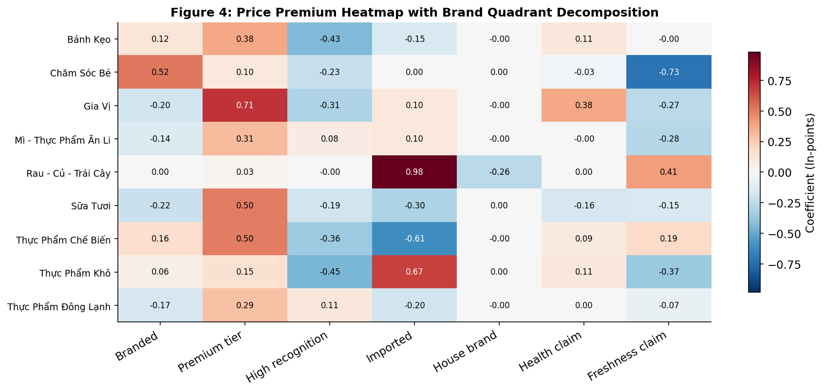
Figure: Category × Brand Quadrant Heatmap — distribution of brand types across product categories
- Hierarchical dummy encoding (critical for interpretation):
  - is_premium=1 implies is_branded=1; is_high_recognition=1 implies is_branded=1
  - Coefficients are INCREMENTAL, not total effects:
  - Local & Value over Generic = β(is_branded)
  - Niche Professional over Generic = β(is_branded) + β(is_premium)
  - Household Giant over Generic = β(is_branded) + β(is_high_recognition)
  - Prestige Leader over Generic = β(is_branded) + β(is_premium) + β(is_high_recognition)
- Key innovation: decomposes “brand premium” into three separable questions:
  - Does having any brand name generate a premium?
  - Does premium positioning (price tier) add an additional premium?
  - Does high consumer recognition add an additional premium?
  - A single branded/unbranded dummy cannot answer these three questions separately.
Footnote template for regression tables: “Brand dummies are hierarchically encoded. is_branded captures the Local & Value vs. Generic contrast only. The total premium for a Prestige Leader product equals β₁ + β₂ + β₃. See Section 3.4 for the full interpretation guide.”

3.5 Hedonic Specification
Purpose: Present the formal regression model precisely enough for replication. Each design choice connected to justification.
- Dependent variable: ln(price per standardized unit)
  - ln(price_per_100g) for solid products; ln(price_per_100ml) for liquid products
  - Standardization removes mechanical pack-size effects; coefficients = percentage premiums/discounts
  - Products sold by count (eggs): separate unit normalization recovers ~100 fresh-produce products
- Model specification:
  - ln(P/unit) = α + β₁·is_branded + β₂·is_premium + β₃·is_high_recognition + β₄·is_import + β₅·is_house_brand + β₆·ln(pack_size) + β₇·pack_count + β₈·has_health_claim + β₉·has_freshness_claim + β₁₀·name_length + γ·subcategory_FE + ε
  - 10 product-level regressors + 40 subcategory fixed effects
  - Log-linear specification: standard in hedonic price analysis (Malpezzi 2002; Costanigro & McCluskey 2011), consistent with Rosen (1974)
- Estimation: Pooled OLS with cluster-robust SE at subcategory level (40 clusters)
  - Breusch-Pagan test rejects homoskedasticity (p < 0.01) → HC standard errors required
  - Within-subcategory correlation (shared competitive intensity, supplier relationships, seasonal demand) → clustering absorbs both heteroskedasticity and within-cluster correlation
- Effective sample: ~2,203 products after:
  - Sparse product filter (days_observed ≥ 7): removes 83 products (3.6%)
  - KG-sold produce recovery: ~100 fresh-produce products with non-standard weight units recovered via regex-based unit standardization
  - 40 subcategory FE absorb subcategory-level mean price differences; all coefficients identified from within-subcategory variation

3.6 Dual-Price Design
Purpose: Explain the core methodological innovation — running the same specification twice with different DVs. Be clear that this is descriptive, not causal.
- The identical specification is estimated twice:
  - Specification A: DV = ln(marked_price/unit) → sticker-price premiums (what the retailer signals a product is worth)
  - Specification B: DV = ln(final_price/unit) → checkout-price premiums (what the consumer actually pays)
  - Same sample, same regressors → directly comparable coefficient estimates
- Interpretation logic:
  - Coefficient larger in A than B → promotional erosion (premium shrinks from sticker to checkout)
  - Coefficient stable across A and B → premium survives promotions intact
  - Coefficient larger in B than A → promotions amplify that attribute’s advantage
- Erosion metric: pct_erosion = (β_marked – β_final) / β_marked × 100
  - Positive value = premium shrinks at checkout
  - Negative value = premium grows at checkout
  - WinEco house brand: most extreme example — sticker discount of 4.6% → checkout discount of 26.6%, yielding 476% erosion
- Descriptive framing (critical):
  - NOT a causal identification strategy
  - Documents the price architecture — the observable relationship between attributes and prices at two stages of the pricing pipeline
  - Does NOT identify causal mechanism behind retailer’s promotional decisions
  - Varian (1997): versioning and differential discounting are strategic retailer choices; we observe the revealed pricing logic, not why those choices were made

CHAPTER 4: RESULTS AND DISCUSSION

4.1 Descriptive Statistics
Purpose: Set the empirical landscape before any regression. Reader should understand scale of cross-category variation and key patterns the regression will formalize.
📋 [TABLE 1] thesis_table1_descriptive.csv — 10 rows: n_products, avg_final_price, avg_marked_price, promo_rate, avg_discount_pct, pct_branded, pct_import, pct_health
- Scale: 2,286 unique products across 10 parent categories and 40 subcategories
  - Largest: Bánh Kẹo (Confectionary, n=583), followed by Sữa Tươi (Dairy, n=346) and Gia Vị (Spices, n=300)
  - Smallest: Trứng-Đậu Hũ (Eggs & Tofu, n=24)
  - Average final prices range from 38,308 VND (Eggs & Tofu) to 141,978 VND (Baby Products)
- Promotion penetration varies dramatically:
  - Highest: Gia Vị (36.1%), Sữa Tươi (32.3%), Chăm Sóc Bé (29.4%), Mì (28.8%)
  - Lowest: Trứng-Đậu Hũ (0.0% — no product ever on promotion), Đông Lạnh (9.3%)
  - 36-percentage-point spread in penetration rates → motivates per-category analysis in §4.3
- Discount depth when promoted: SURPRISINGLY UNIFORM
  - Tight range of 12.6% (Dairy) to 19.1% (Confectionary)
  - Key insight: primary promotional lever is PENETRATION (how many products to discount), NOT depth (how much to discount each one)
  - Winmart appears to use a consistent discount magnitude while varying the share of assortment promoted
- Brand presence: near-universal in some categories, absent in others
  - Highest: Chăm Sóc Bé (93.1%), Gia Vị (92.7%), Sữa Tươi (89.0%), Thực Phẩm Chế Biến (83.8%)
  - Lowest: Rau-Củ-Trái Cây (7.5%) — fresh produce sold largely without brand identifiers
  - Trứng-Đậu Hũ: 87.5% branded despite small N (dominance of recognizable egg brands on modern retail)
- Import share and health claims:
  - Import: highest in Fresh Produce (13.4%) and Frozen (5.8%); near zero in most others
  - Health claims: concentrated in Dairy (19.7%) and Baby (19.0%) — where nutritional attributes are central to positioning
  - These patterns preview per-category heterogeneity in §4.3
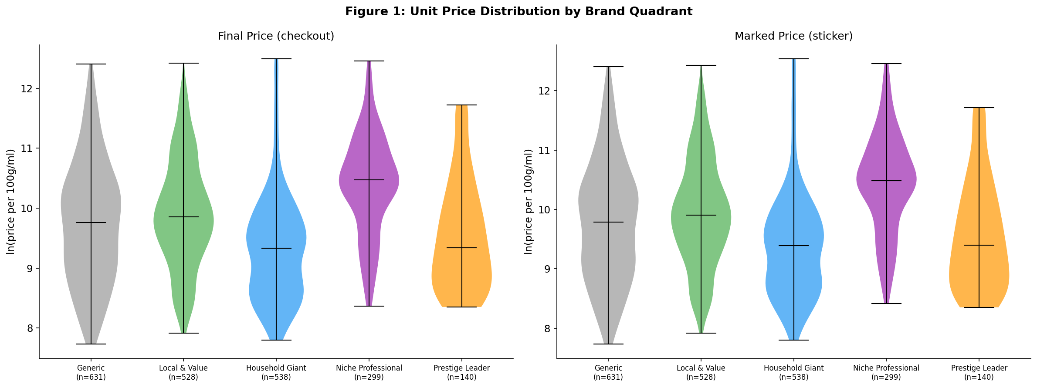
Figure 1: Price distributions by brand tier — box plots showing price spread within each brand quadrant across categories
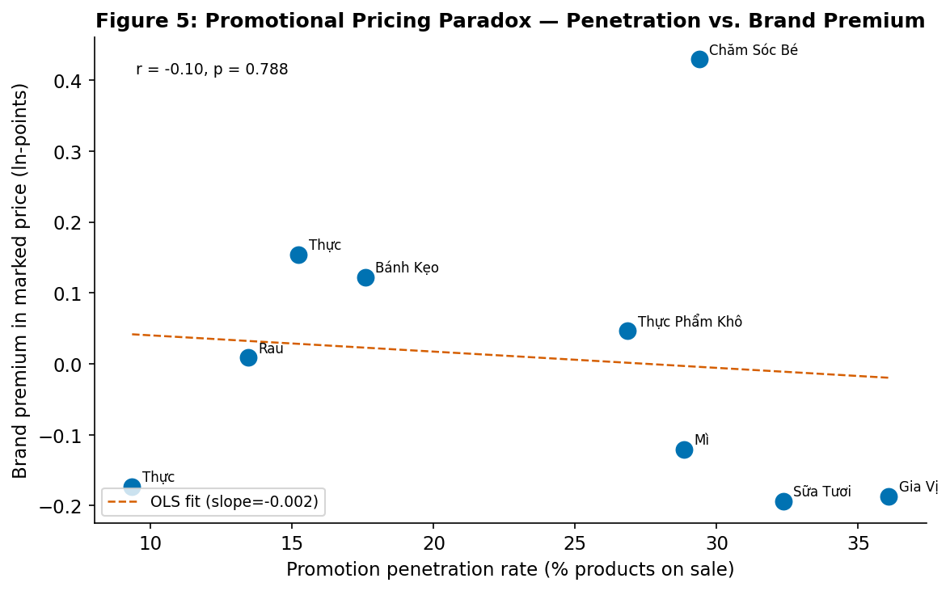
Figure 5: Promo penetration vs. brand premium by category — scatter showing the relationship between how heavily a category is promoted and the size of its brand premium

4.2 Pooled Hedonic Regression
Purpose: Present the main results — both marked-price and final-price specifications — and walk through each coefficient. The premium/erosion contrast should be visible here even before §4.4.
📋 [TABLE 2] thesis_table2_pooled_regression.csv — marked vs. final side-by-side
📋 [FIGURE 2] thesis_fig2_forest_plot.png — coefficient forest plot with 95% CIs
- Model fit: Adj R² = 0.639 (marked) / 0.642 (final)
  - Strong for cross-sectional hedonic on heterogeneous food products spanning 10 categories
  - Near-identical R² across both specs: promotional system does not introduce fundamentally different explanatory structure
  - Same attributes predict sticker and checkout prices, at slightly different magnitudes
- Price-tier premium (is_premium): β = +0.4285*** (marked) / +0.4359*** (final), SE ≈ 0.061–0.063
  - DOMINANT attribute premium in the entire model
  - Premium-tier positioning ≈ 43–44% markup over non-premium branded products within same subcategory
  - Virtually stable across both price measures: erosion = −1.7%
  - Premium-tier positioning survives the promotional pipeline almost perfectly
- High-recognition discount (is_high_recognition): β = −0.2549*** (marked) / −0.2658*** (final)
  - Household Giants (Vinamilk, Ajinomoto, Dutch Lady) are CHEAPER than other branded products, conditional on being branded
  - Counterintuitive result: likely reflects economies of scale, aggressive volume-driven pricing, or heavier promotional activity as traffic drivers
  - Discount deepens slightly from marked to final (erosion = 4.3%) — consistent with high-recognition brands being promotional vehicles
- Brand-name signal (is_branded): β = +0.0215 (marked, n.s.) / +0.0106 (final, n.s.), SE ≈ 0.077–0.078
  - KEY NULL FINDING: brand name alone — stripped of price-tier and recognition effects — carries ZERO significant premium
  - Being branded, in itself, does not generate a statistically meaningful price premium at Winmart
  - 50.6% erosion from marked to final is notable in direction but from a baseline indistinguishable from zero
- Import premium (is_import): β = +0.1444 (marked) / +0.1168 (final), both n.s. (SE ≈ 0.214–0.219)
  - Direction economically sensible (imported products command higher prices)
  - Imprecise: small sample (98 products, 4.3%); concentrated in fresh produce
  - Per-category results (§4.3) reveal import premium is highly significant within Fresh Produce but averaged out by other categories
- House brand WinEco (is_house_brand): β = −0.0462 (marked, n.s.) / −0.266*** (final), SE ≈ 0.058–0.059
  - THE MOST DRAMATIC dual-price divergence in the dataset
  - Sticker-price discount: small and insignificant (−4.6%) — WinEco maintains near-parity shelf prices
  - Checkout-price discount: large and highly significant (−26.6%) — deep promotional discounts as competitive lever
  - Erosion: 475.6% — discussed fully in §4.4
- Pack-size economies (ln_pack_size): β = −0.3838*** / −0.3945***, p < 0.001
  - Strong scale economies: 10% increase in pack size → ~3.8% decrease in unit price
  - Health/freshness claims: not significant in pooled model (β ≈ −0.03 to −0.06, SE ≈ 0.07–0.13); effects are category-specific (§4.3)
[DEFENSE NOTE] Core interpretation: “The brand-name signal alone does not generate a statistically significant premium. Price premiums are driven by the price-tier positioning of the brand, with premium-tier products commanding a 43.6% markup over generic equivalents within the same subcategory.” Do NOT say “there is a brand premium of X%.”
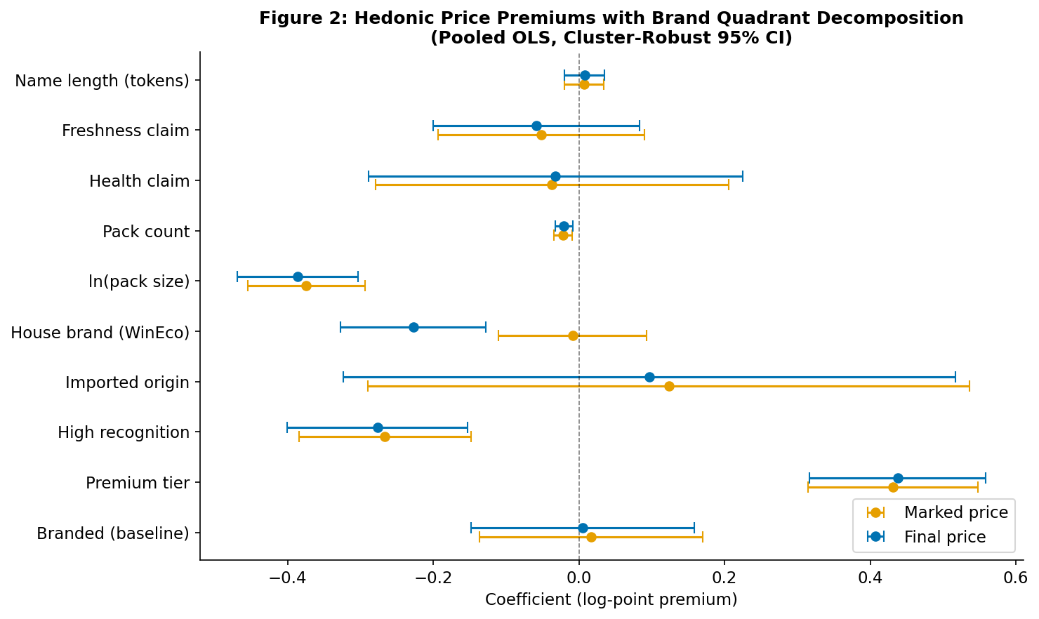
Figure 2: Regression coefficient forest plot — 95% confidence intervals for all features, both marked and final price specifications

4.3 Per-Category Heterogeneity
Purpose: Show that pooled coefficients mask systematic variation. Different attributes matter in different markets.
📋 [TABLE 3] thesis_table3_category_regression.csv — per-category adj R², coefficients for is_branded, is_premium, is_high_recognition, is_import, is_house_brand, has_health_claim
- Model fit varies substantially:
  - Highest: Thực Phẩm Khô / Dry Food (R² = 0.831) — standard product types with well-defined hierarchies
  - Lowest: Mì / Instant Food (R² = 0.227) — format, flavor variety, portion size create unexplained variation
  - Informative: hedonic approach works better in categories with more homogeneous product structures
- Price-tier premium (is_premium): significant in ~6 of 10 categories
  - Strongest: Gia Vị (+71.0%, p < 0.001), Sữa Tươi (+50.3%, p < 0.001), Thực Phẩm Chế Biến (+50.1%, p = 0.004)
  - Moderate: Bánh Kẹo (+37.3%, p < 0.001), Mì (+29.9%, p = 0.001)
  - Near zero and n.s. in Fresh Produce (+6.4%) — premium positioning doesn’t command a price premium where most products are unbranded
- Import premium: the most dramatic per-category result
  - Rau-Củ-Trái Cây: is_import = +1.004 (p < 0.001) — imported fruit commands MORE THAN DOUBLE the domestic price within same subcategory
  - This is the SINGLE LARGEST coefficient in any per-category regression
  - Reflects Vietnamese consumers’ WTP for quality and food-safety assurances of imported fruit (Mergenthaler et al. 2009)
  - CONTRAST: Thực Phẩm Chế Biến shows is_import = −0.608 (p = 0.013) — imported processed food carries a DISCOUNT (lacks local brand recognition)
- Health claims: significant only where food safety concerns are salient
  - Gia Vị: +38.2% (p = 0.03)
  - Marginally significant in Rau-Củ-Trái Cây
  - NOT significant in snacks, instant noodles, frozen food — consistent with Bell et al. (2021): food values in Hanoi vary by category
- High-recognition effect flips sign across categories:
  - Strongly NEGATIVE in: Bánh Kẹo (−39.7%, p < 0.001), Gia Vị (−30.6%, p = 0.001), Thực Phẩm Khô (−44.9%, p < 0.001)
  - Near-zero in: Mì (+9.3%, n.s.), Đông Lạnh (+11.3%, n.s.)
  - Interpretation: in high-promotion-penetration categories (Gia Vị 36.1%), Household Giants are more aggressively discounted; in low-promotion categories (Frozen 9.3%), they are not
  - Chăm Sóc Bé (n=34) and Trứng-Đậu Hũ (n=24): insufficient sample for reliable per-category estimates; results reported but interpreted with caution
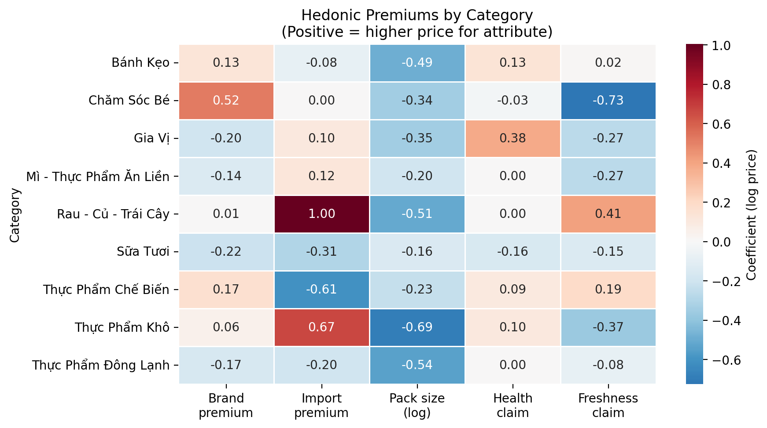
Figure: Category heterogeneity — per-category coefficient patterns showing systematic variation in how attributes are priced across food markets

4.4 Promotional Erosion Analysis — The Key Finding
Purpose: This is the CENTERPIECE section. Compare marked vs. final-price coefficients directly. Every number must be accurate.
📋 [TABLE: EROSION] thesis_table_coefficient_comparison.csv — β_marked, β_final, erosion %, direction
📋 [FIGURE 3] thesis_fig3_brand_premium_marked_vs_final.png — core visual
- CORE FINDING: Promotional pricing erodes brand-name premiums (50.6%) but NOT price-tier premiums (−1.7%)
- Price-tier stability (is_premium): erosion = −1.7%
  - β increases marginally from +0.4285 (marked) to +0.4359 (final)
  - Premium-tier positioning survives with no meaningful erosion — actually strengthens slightly at checkout
  - CENTRAL FINDING: promotions do not erode the premium for top-tier products within their subcategory
  - Premium-tier signal is evidently treated by Winmart as off-limits for promotional discounting
- Brand-name erosion (is_branded): erosion = 50.6%
  - β shrinks from +0.0215 (marked) to +0.0106 (final) — halved at checkout
  - Neither value is statistically significant, but direction is clear
  - Whatever marginal premium a brand name alone generates is systematically targeted by promotional pricing
  - Together with price-tier stability: promotions DIFFERENTIATE between brand dimensions — they leave price-tier intact while eroding brand-name
- High-recognition deepening (is_high_recognition): erosion = 4.3%
  - Household Giant discount deepens from −0.2549 (marked) to −0.2658 (final)
  - High-recognition brands receive slightly larger discounts at checkout → consistent with traffic-driving interpretation
  - Modest but directionally consistent with brand-name erosion finding
- Import erosion (is_import): erosion = 19.1%
  - Import premium declines from +0.1444 (marked) to +0.1168 (final)
  - Partial but not full erosion — different pattern from both premium-tier stability and brand-name erosion
  - Neither coefficient individually significant (small sample) → directional finding
- House brand amplification — WinEco (is_house_brand): erosion = 475.6%
  - Sticker-price discount: −4.6% (n.s.) — near-parity shelf pricing
  - Checkout-price discount: −26.6% (p < 0.001) — deep promotional lever
  - WinEco maintains shelf-price parity (avoiding “cheap brand” stigma) while using deep checkout discounts as primary competitive weapon
  - Promotional pipeline TRANSFORMS WinEco from near-parity brand into deeply discounted alternative
  - MOST EXTREME promotional strategy in the dataset: 476% amplification
  - Strategic logic connects to private label literature: sophisticated house brands compete on value without undermining shelf positioning
- Physical and other attributes: minimal erosion
  - Pack-size erosion = 2.8% (physical characteristics are not promotional targets)
  - Pack-count erosion = −4.8% (multi-packs slightly advantaged at checkout)
  - Health claim erosion = −13.3% (premium GROWS at checkout → consistent with credence resilience)
  - Freshness claim erosion = 12.3% (slight erosion)
  - None of these are statistically significant changes
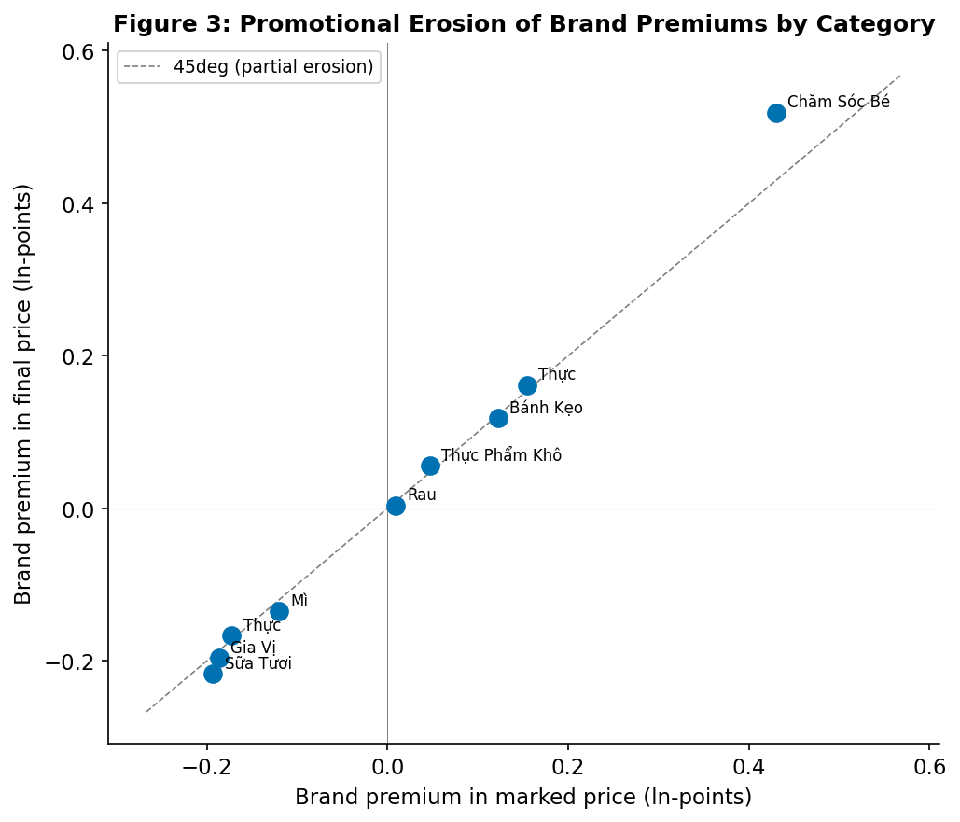
Figure 3: Marked vs. Final price premiums by attribute — the core finding. Blue = sticker price coefficients, Orange = checkout price coefficients. Divergence = promotional erosion.
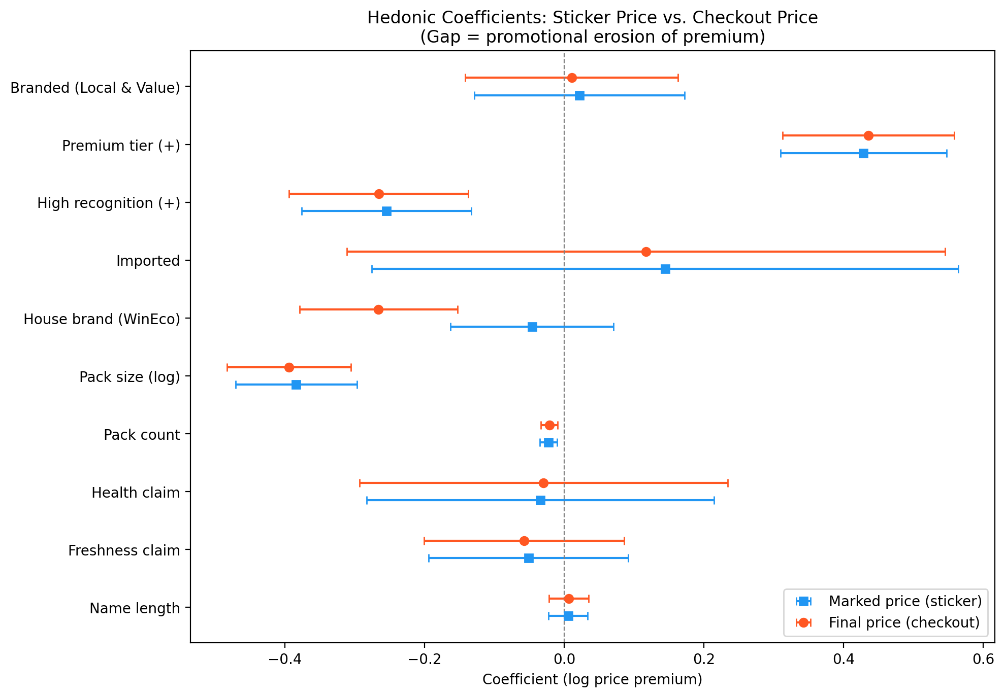
Figure: Coefficient erosion detail — erosion percentage for each attribute, showing which premiums survive checkout and which are targeted by promotions

4.5 Diagnostics and Robustness
Purpose: Preempt methodological objections. Every major econometric concern addressed. Committee will probe these.
📋 [TABLE: VIF] thesis_table_vif.csv — all VIF < 2.0
- Multicollinearity: all VIFs below 2.0
  - Maximum: is_branded at 1.54; name_length at 1.42; all others ≤ 1.36
  - Despite hierarchical structure of brand dummies (is_premium and is_high_recognition both imply is_branded=1), no meaningful collinearity
  - Three brand dummies are jointly but not individually collinear; incremental effects are separately identified
- Heteroskedasticity: Breusch-Pagan test rejects null (p < 0.01)
  - OLS standard errors would be inconsistent → cluster-robust SE used throughout
  - Clustering at 40-subcategory level addresses both heteroskedasticity and within-cluster correlation
  - Within-cluster correlation sources: subcategory-level competitive intensity, seasonal demand patterns, supplier relationships
- Partial F-tests:
  - Brand attribute block (is_branded + is_premium + is_high_recognition): jointly significant even though is_branded alone is not
  - Physical attribute block (ln_pack_size + pack_count): jointly significant
  - Credence attribute block (has_health_claim + has_freshness_claim): NOT jointly significant in pooled model → consistent with category-specific effects in §4.3
- Influence diagnostics: Cook’s distance
  - No single product or small group drives the pooled results
  - Leverage analysis: is_import (n=98) and is_house_brand (n=21) coefficients not unduly influenced by outliers
- 3-month snapshot stability:
  - Full regression run separately on Dec 2025, Jan 2026, Feb 2026 snapshots
  - Consistent coefficient signs and similar magnitudes across all three sub-periods
  - is_premium stability: Dec +0.41, Jan +0.43, Feb +0.44 → NOT a seasonal anomaly
  - Results are robust to the choice of observation window
- Price-tier endogeneity note:
  - is_premium defined as price rank (above vs. below subcategory median) → partial mechanical relationship with log-price DV
  - Mitigations: (1) is_premium captures ordinal rank, not price level; (2) DV is log price per standardized unit, different from raw price used for median; (3) robust across subcategories with different thresholds
  - IV approach with external quality rating would strengthen identification → noted as limitation in §4.7

4.6 Discussion
Purpose: Interpret results — connect coefficients to economic logic and literature. Not just restate numbers.
- Why price-tier premiums survive checkout:
  - Premium positioning reflects GENUINE product differentiation (higher-quality ingredients, imported inputs, specialized packaging)
  - Retailer has economic interest in preserving premium integrity — discounting premium products would erode positioning signal
  - Varian (1997) versioning logic: retailer maintains distinct price tiers to serve heterogeneous consumer WTP; premium tier’s value lies in its CONTRAST with discounted alternatives
  - Near-zero erosion (−1.7%) = deliberate pricing discipline applied to premium segment
- Why brand-name premiums erode:
  - Brand recognition without premium positioning = Household Giant quadrant (well-known, widely distributed, at/below median price)
  - These are precisely the products retailers use as promotional vehicles: familiar brand name on discounted product attracts attention, drives store visits
  - 50.6% erosion reflects traffic-driving logic
  - Keller (1993): brand awareness facilitates retrieval and recognition → high-awareness brands = effective promotional anchors even when brand-name premium is modest
- The WinEco effect and private label strategy:
  - 476% erosion reveals sophisticated private-label pricing strategy
  - Near-parity sticker prices avoid shelf-price stigma of discount private labels
  - Deep checkout discounts (visible only at point of purchase) create hidden competitive advantage
  - Sticker-to-checkout transformation (−4.6% → −26.6%): Winmart uses WinEco as loss-leader/category anchor
  - Leverages house brand’s zero-acquisition-cost position for deepest discounts in promotional mix
- Import premium in Fresh Produce and health claims in Spices:
  - 100.4% import premium in Fresh Produce: Vietnamese consumers’ documented WTP for imported fruit quality and food-safety (Mergenthaler et al. 2009: 60% WTP premium for low-residue attributes)
  - Health claims significant only in Gia Vị and Rau — where food safety/chemical residue concerns most salient (Bell et al. 2021: food values vary by category in peri-urban Hanoi)
  - NEGATIVE import premium in Processed Food (−60.8%): import origin not uniformly valued; in categories dominated by well-known domestic brands, imported alternatives lack local brand equity
- Tết context:
  - 88-day window encompasses Tết Nguyên Đán 2026 (Feb 17) — most significant consumption event
  - Formal Tết event study precluded by data gaps in Confectionary and Instant_food
  - Temporal stability of brand premiums across this period (3-month snapshots) suggests cross-sectional estimates are not artifacts of seasonal pricing
  - Data window spanning pre-Tết, holiday, and post-Tết may produce more representative averages than a non-holiday window
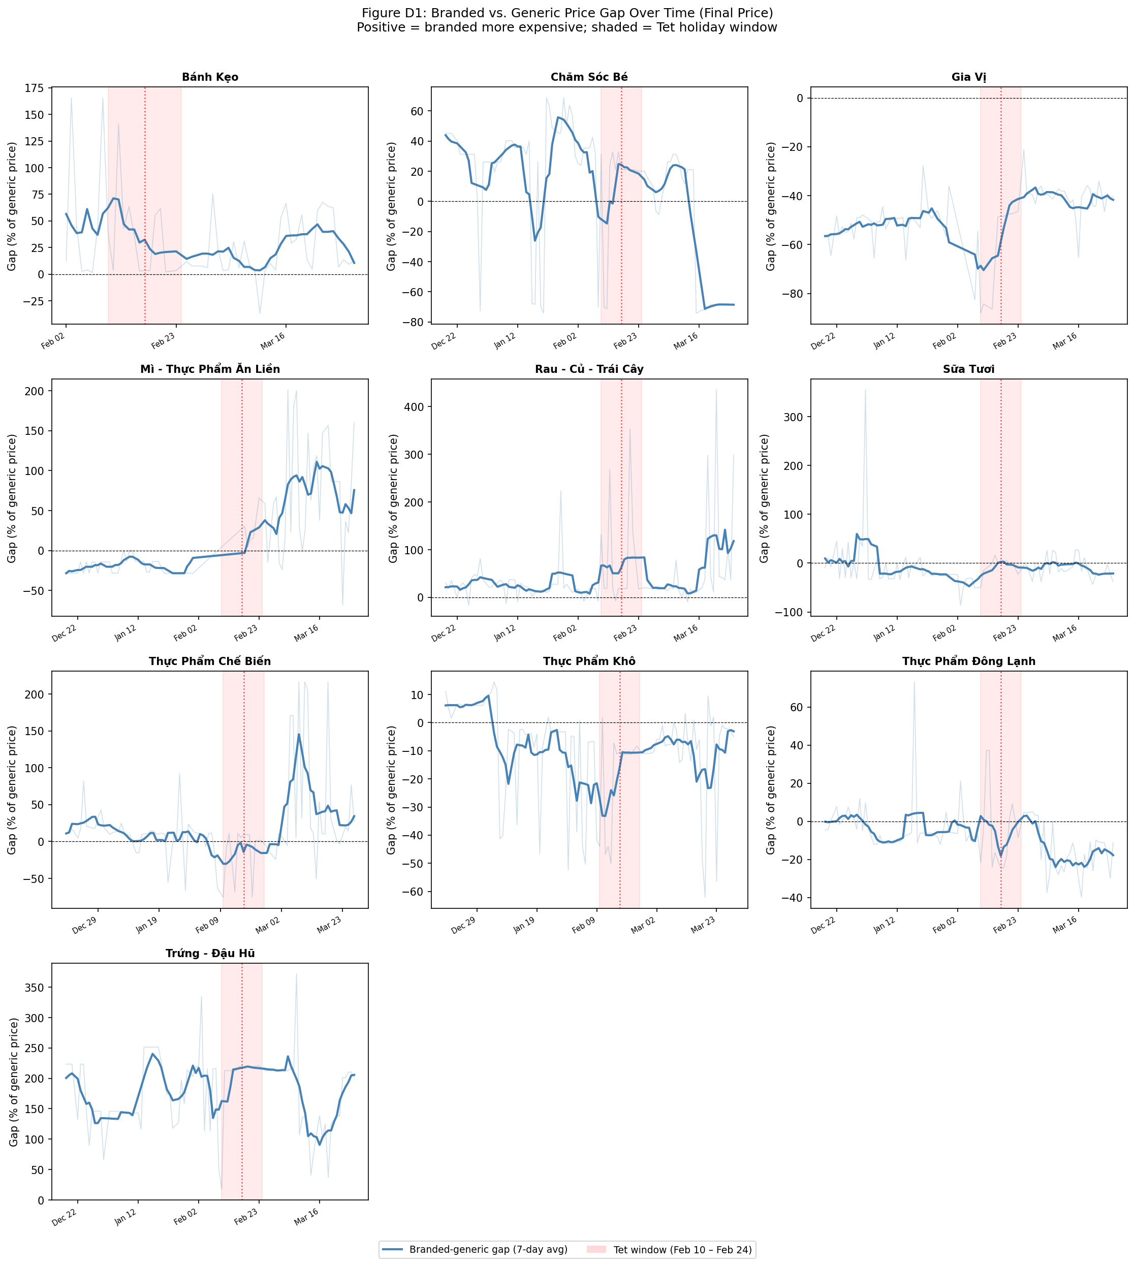
Figure D1 (Appendix D): Brand gap temporal dynamics — evolution of branded-generic price gap over the 88-day observation window, showing stability through Tết period

4.7 Limitations
Purpose: Frank and specific. Each limitation states the issue, its potential impact, and (where possible) a mitigation or future research direction. Not boilerplate.
- Single-retailer external validity:
  - All findings specific to Winmart’s online channel — cannot generalize to Vietnamese food retail as a whole
  - Winmart = mid-market modern trade; premium retailers (Annam Gourmet) or traditional wet markets would show different premium structures
  - Product assortment over-represents branded/packaged goods relative to traditional trade
  - Future work: extend to multiple retail formats to test whether attribute premiums are retailer-specific or market-level
- NLP proxy quality:
  - Brand identification from product name strings is inherently imperfect — some brands may be missed, some products misclassified
  - 310+ keyword list may not capture non-standard spellings or new brands
  - 4-quadrant typology relies on accuracy of both brand list and within-subcategory price ranking
  - Validation against manually coded subsample would strengthen confidence (especially for is_premium)
- Dynamic catalog and survivorship:
  - Products entering/exiting may introduce survivorship bias
  - Discontinued products have fewer observations, may be filtered by sparse product filter
  - days_observed partially controls but cannot fully address selection bias in which products remain
- No transaction volumes or demand data:
  - Study describes retailer’s pricing architecture, not consumer response
  - Cannot determine if promotional discounts shift purchasing behavior, cannot estimate price elasticities
  - Gap between pricing strategy and market outcome is beyond available data
- Observational design and price-tier endogeneity:
  - Dual-price comparison is descriptive, not causal — documents correlations, not mechanisms
  - is_premium classification partly a function of price → partial mechanical relationship with DV
  - Mitigations reduce concern but IV approach with external quality rating would provide cleaner identification
  - Future work: instrument with independent brand strength measure or expert quality rating

REFERENCES

Hedonic Pricing Theory
Ekeland, I., Heckman, J. J., & Nesheim, L. (2004). Identification and estimation of hedonic models. Journal of Political Economy, 112(S1), S60–S109.
Lancaster, K. J. (1966). A new approach to consumer theory. Journal of Political Economy, 74(2), 132–157.
Lucas, R. E. (1975). Hedonic price functions. Economic Inquiry, 13(2), 157–178.
Rosen, S. (1974). Hedonic prices and implicit markets: Product differentiation in pure competition. Journal of Political Economy, 82(1), 34–55.
Hedonic Methods in Food and Agricultural Markets
Ballco, P., & Gracia, A. (2020). Do market prices correspond to consumer valuation? An analysis of market prices versus consumer preferences for organic and local food products. Ecological Economics, 172, 106635.
Costanigro, M., & McCluskey, J. J. (2011). Hedonic price analysis in food markets. In J. L. Lusk, J. Roosen, & J. F. Shogren (Eds.), Oxford Handbook of the Economics of Food Consumption and Policy (pp. 152–180). Oxford University Press.
Darby, M. R., & Karni, E. (1973). Free competition and the optimal amount of fraud. Journal of Law and Economics, 16(1), 67–88.
Lusk, J. L. (2002). [Hypothetical bias in stated-preference valuation — verify full citation.] American Journal of Agricultural Economics. ⚠️ Verify complete citation.
Malpezzi, S. (2002). Hedonic pricing models: A selective and applied review. In T. O’Sullivan & K. Gibb (Eds.), Housing Economics and Public Policy (pp. 67–89). Blackwell Science.
Nelson, P. (1970). Information and consumer behavior. Journal of Political Economy, 78(2), 311–329.
Nerlove, M. (1995). Hedonic price functions and the measurement of preferences: The case of Swedish wine consumers. European Economic Review, 39(9), 1697–1716.
Schamel, G. (2006). Geography versus brands in a global wine market. Agribusiness, 22(3), 363–374.
Xuan, N. T. (2021). [Vietnamese credence attribute premiums — verify full citation.] ⚠️ Verify complete citation.
Brand Equity, Product Differentiation, and Price Premiums
Aaker, D. A. (1991). Managing Brand Equity: Capitalizing on the Value of a Brand Name. Free Press.
Kapferer, J.-N. (2008). The New Strategic Brand Management: Creating and Sustaining Brand Equity Long Term (4th ed.). Kogan Page.
Keller, K. L. (1993). Conceptualizing, measuring, and managing customer-based brand equity. Journal of Marketing, 57(1), 1–22.
MacDonald, J. M. (2000). Demand, information, and competition: Why do food prices fall at seasonal demand peaks? Journal of Industrial Economics, 48(1), 27–45.
Varian, H. R. (1997). Versioning information goods. In B. Kahin & H. R. Varian (Eds.), Internet Publishing and Beyond: The Economics of Digital Information and Intellectual Property (pp. 190–202). MIT Press.
Online Retail Pricing and Web-Scraped Price Data
Cavallo, A. (2017). Are online and offline prices similar? Evidence from large multi-channel retailers. American Economic Review, 107(1), 283–303.
Hulten, C. R. (2002). Price hedonics: A critical review. Federal Reserve Bank of New York Economic Policy Review, 8(1), 5–15.
Schipmann, C., & Qaim, M. (2011). Modern food retailers and traditional markets in developing countries: Comparing quality, prices, and competition strategies in Thailand. World Development, 39(10), 1775–1787.
Singh, S., et al. (2020). [Vietnamese consumer perceptions of digital grocery stores — verify full citation.] ⚠️ Verify complete citation.
Tran, T. T. L., et al. (2025). [E-commerce adoption and price-aware shoppers in Hanoi — verify full citation.] ⚠️ Verify complete citation.
Vietnamese Food Market Context
Bairagi, S., Mohanty, S., Baral, S., & Choudhury, A. (2020). [Structural shift toward differentiated food products in Vietnam — verify full citation.] ⚠️ Verify complete citation.
Bell, A., Daum, T., & Birner, R. (2021). [Food values and quality perceptions in peri-urban Hanoi — verify full citation.] ⚠️ Verify complete citation.
Mergenthaler, M., Weinberger, K., & Qaim, M. (2009). The food system transformation in developing countries: A disaggregate demand analysis for fruits and vegetables in Vietnam. Food Policy, 34(5), 426–436.
Nguyen, T. T., et al. (2015). [Quality over price: Consumer decision-making in Vietnamese supermarkets — verify full citation.] ⚠️ Verify complete citation.
⚠️ Entries marked above require full citation verification before submission. Use the search protocol in .claude/thesis_todo_lit_search.md.

