CHAPTER 4: EMPIRICAL APPLICATION
This chapter takes the dual-price hedonic design specified in Chapter 3 and applies it to eighty-eight days of web-scraped data from Winmart.vn. The chapter is organised around the flow of evidence needed to answer the research question. Section 4.1 describes the data source and the single-retailer design. Section 4.2 documents the known gaps in the dataset so that the reader can judge which findings rest on complete coverage. Section 4.3 introduces the nine product-level features extracted from Vietnamese product names and reports descriptive statistics by category. Sections 4.4 and 4.5 present the pooled and per-category hedonic estimates respectively. Section 4.6 contains the promotional erosion analysis that motivates the dual-price design, and Section 4.7 reports multicollinearity, heteroskedasticity, influence, and temporal-stability diagnostics.
Before the detailed discussion, Table 0 provides an advance summary of the principal regression estimates so that the reader can keep the headline pattern in mind while reading the rest of the chapter. The marked-price and final-price columns correspond to the dual-price specifications defined in Section 3.3, and the erosion column reports the percentage change from sticker to checkout. Each coefficient is revisited in detail in Sections 4.4 through 4.6.
Table 0: Summary of Key Regression Results , Pooled Dual-Price Hedonic Model
Attribute | β (marked) | SE | β (final) | SE | Erosion | Direction
is_branded | +0.022 | (0.077) | +0.011 | (0.078) | 50.6% | Eroded
is_premium*** | +0.429 | (0.061) | +0.436 | (0.063) | −1.7% | Stable
is_high_recognition*** | −0.255 | (0.062) | −0.266 | (0.065) | 4.3% | Stable
is_import | +0.144 | (0.214) | +0.117 | (0.219) | 19.1% | Partial
is_house_brand | −0.046 | (0.059) | −0.266*** | (0.058) | 475.6% | Amplified
ln_pack_size*** | −0.384 | (0.044) | −0.395 | (0.045) | 2.8% | Stable
pack_count*** | −0.023 | (0.006) | −0.022 | (0.006) | −4.8% | Stable
has_health_claim | −0.034 | (0.127) | −0.030 | (0.135) | −13.3% | Stable
has_freshness_claim | −0.051 | (0.073) | −0.058 | (0.073) | 12.3% | Slight
Adj. R² | 0.639 |  | 0.642
Note: *** p < 0.001. Cluster-robust standard errors (40 subcategories) in parentheses. Erosion = (β_marked − β_final) / β_marked × 100. Positive erosion = premium shrinks at checkout. N = 2,203 products.

4.1 Data Source, Collection, and Single-Retailer Design
The empirical data for this study are drawn from Winmart.vn, the online grocery platform operated by Masan Group. Winmart is Vietnam’s largest modern grocery chain by store count (WinCommerce, 2025) and occupies a mid-market position within the country’s modern trade segment. Its online catalog functions as a publicly accessible, structured price archive that lends itself to automated collection, and its product assortment spans branded, imported, and private-label food items across all major food categories.
Data collection relies on a fully automated scraping architecture comprising fifteen robots, each triggered daily through HTTP PUT requests to a local orchestration server. Every robot is assigned to exactly one parent category and scrapes that category’s and captures the complete product listing in JSON format. The raw JSON files are downloaded from the API server, deduplicated so that only the last successful run of each calendar date is retained, and then converted into a standardized CSV format. Each observation records the product name, unit of sale, final price (the checkout price after all applied promotions), marked price (the sticker or shelf price before promotions), the product URL, a scrape timestamp, and a run identifier.
The resulting dataset covers ten food parent categories, forty subcategories, and 2,286 unique products observed over eighty-eight days from December 18, 2025 to March 15, 2026. All prices are denominated in Vietnamese Dong. The ten parent categories, with product counts, are Dairy (n = 346), Fresh Produce (n = 254), Dry Food (n = 182), Instant Food (n = 228), Processed Food (n = 173), Frozen (n = 137), Eggs and Tofu (n = 24), Confectionary (n = 583), Spices (n = 300), and Baby Products (n = 58). Baby Products are retained in the sample for a single reason: the "infant formula" subcategory (Sữa Bột-Dinh Dưỡng, n = 34 in the regression sample) is a shelf-stable powdered-milk product that competes directly with adult dairy powders and qualifies as food under the GSO CPI food basket. The non-food Baby Products subcategories (diapers, bath and hair products) are excluded from all food-related analyses.
Every observation carries both a marked price and a final price (see Section 3.3 for the definition and theoretical role of the dual-price structure); this is the raw material for the promotional erosion analysis in Section 4.6.
The single-retailer design, and the reasons it is preferred for this analysis, are set out in Section 3.3. The external validity constraint that accompanies the choice is discussed in Section 5.3.

4.2 Data Limitations and Coverage
The dataset assembled for this thesis is, in honest terms, uneven. Some categories are observed continuously across the full eighty-eight-day window; others were added mid-way, or lost coverage during the Tết holiday, or are too thin for category-level inference. Before presenting the regression results, this section sets out those gaps plainly, so that the reader can see which findings rest on complete coverage and which should be read as conditional on the data that was actually recoverable.
Tết-window coverage gaps. Two of the most Tết-sensitive categories in the sample have incomplete coverage over the holiday window. The Confectionary scraping robot was not part of the initial configuration and was added on February 2, 2026, forty-six days after the base date, so the entire pre-Tết surge window for that category is unobserved; Confectionary is therefore excluded from all temporal analyses that span the full December to March window, and the days-observed variable absorbs its shorter observation window (roughly fifty days versus eighty-eight) in the cross-sectional regressions. The Instant Food category has a continuous eighteen-day gap from January 31 to February 18, 2026, which coincides almost exactly with the period in which a Tết-driven price spike would be expected; the chain-linked Jevons index bridges January 31 directly to February 18, but whatever happened in between is unobserved, and no claims about Tết-period pricing dynamics are made for this category. Three of the four Instant Food subcategories also have no data in the first ten days of the overall window.
What can and cannot be said about Tết. Because the two categories most affected by Tết are also the two with the most incomplete data, a formal event study of Tết pricing would need to drop the very observations it most needs, and is therefore not attempted here. What the chapter does show is the aggregate behaviour of the Jevons indices through the Tết window using the categories that remain continuously observed (Dairy, Spices, Processed Food, Frozen, Eggs and Tofu, Fresh Produce, Dry Food, and Baby Products) and the cross-sectional hedonic estimates pooled across the window. The descriptive reading of Tết as a stocking-and-pullback event is developed as contextual background in Section 5.1 rather than as a statistical test.
Dynamic product catalog. Products enter and exit the Winmart catalog across dates. A sparse product filter requiring at least seven days of observation removes eighty-three products (3.6% of the total), yielding an effective cross-sectional sample of approximately 2,203 products. This filtering prevents products with only one or two days of data from distorting cross-sectional price averages. Each product’s price is averaged over its available observation days, making the cross-sectional estimates robust to temporal entry and exit patterns.
No transaction volumes. Web scraping captures listed prices only; quantities sold and units purchased are not observed. This means the study cannot compute sales-weighted price indices, estimate demand elasticities, or determine whether promotional discounts shift consumer purchasing behavior. The analysis describes Winmart’s price architecture, the structure of prices as listed, rather than consumer demand responses to that architecture.

4.3 Variable Definitions and Descriptive Statistics
Nine product-level features are extracted programmatically from product name strings using a combination of substring matching, regular expressions, and keyword dictionaries. The extraction module normalizes Vietnamese text through NFC normalization, lowercasing, and diacritic-preserving transformations before applying pattern matching, ensuring that spelling variants and diacritical differences do not cause misclassification. The nine features and their construction are described in turn.
Brand identification (is_branded). Substring matching against a curated list of more than 310 brand keywords classifies 1,581 products (69.2 percent) as branded and 705 products (30.8 percent) as unbranded or generic, covering major Vietnamese brands (Vinamilk, TH True Milk), regional brands (Dutch Lady, Meiji), and international brands (Ajinomoto, Nestlé).
Price-tier classification (is_premium). A product is classified as premium if it is branded and its average final price exceeds the subcategory median. This within-subcategory relative measure yields 452 premium products (19.8 percent).
Brand recognition (is_high_recognition). A curated subset of approximately thirty nationally distributed brands with confirmed high consumer awareness forms the high-recognition group, applying to 709 products (31.0 percent).
Import origin (is_import). Keyword detection identifies country-of-origin markers embedded in product names. Ninety-eight products (4.3 percent) are classified as imported, with import share concentrated in Fresh Produce (13.4 percent of the category).
House brand (is_house_brand). WinEco and WinMart private-label products are identified by brand keyword matching. Twenty-one products (0.9 percent) carry the house-brand label.
Health and freshness claims. Keyword detection identifies 122 products (5.3 percent) with health claims and 154 products (6.7 percent) with freshness claims. These are credence attributes that consumers cannot verify even after consumption.
Physical packaging features (ln_pack_size, pack_count). Regex-based extraction recovers weight and volume from product names. Pack size enters in log-transformed form to capture economies of scale; pack count captures multi-pack configurations.
Table 1: Descriptive Statistics by Product Category
Category | N | Avg Final  (VND) | Avg Marked  (VND) | Promo  (%) | Disc.  (%) | Brand  (%) | Import  (%) | Health  (%)
Dairy | 346 | 80,083 | 82,139 | 32.3 | 12.6 | 89.0 | 3.5 | 19.7
Fresh Produce | 254 | 68,055 | 69,595 | 13.4 | 18.4 | 7.5 | 13.4 | 0.4
Dry Food | 182 | 65,060 | 67,587 | 26.9 | 15.1 | 75.3 | 0.5 | 2.2
Instant Food | 228 | 65,651 | 67,126 | 28.8 | 14.2 | 83.8 | 7.0 | 0.0
Processed Food | 173 | 55,018 | 56,232 | 15.2 | 16.4 | 83.8 | 4.6 | 1.7
Frozen | 137 | 90,696 | 92,016 | 9.3 | 16.1 | 73.0 | 5.8 | 0.0
Eggs & Tofu | 24 | 38,308 | 38,308 | 0.0 | , | 87.5 | 0.0 | 12.5
Confectionary | 583 | 63,327 | 67,482 | 17.6 | 19.1 | 56.3 | 2.9 | 3.6
Spices | 300 | 67,891 | 72,636 | 36.1 | 15.6 | 92.7 | 0.7 | 3.7
Baby Products | 58 | 141,978 | 147,681 | 29.4 | 16.3 | 93.1 | 0.0 | 19.0
Note: Promo = percentage of products on promotion (marked price > final price). Disc. = average discount depth conditional on being promoted. Brand, Import, Health = percentage of products with that attribute. Eggs & Tofu has no promoted products, so discount depth is undefined.
Promotion penetration varies substantially across categories. Spices (36.1 percent), Dairy (32.3 percent), and Baby Products (29.4 percent) exhibit the highest rates, while Eggs and Tofu registers zero percent and Frozen stands at 9.3 percent. The thirty-six-percentage-point spread in penetration rates motivates the per-category analysis in Section 4.5.
Conditional on being promoted, the depth of discount is remarkably uniform, ranging from 12.6 percent in Dairy to 19.1 percent in Confectionary. The tight range suggests that Winmart’s primary promotional lever is penetration, the share of the assortment placed on promotion, rather than depth, the magnitude of each individual discount.
Brand presence is near-universal in Baby Products (93.1 percent), Spices (92.7 percent), and Dairy (89.0 percent). By contrast, only 7.5 percent of Fresh Produce products carry brand identifiers. Import share peaks in Fresh Produce (13.4 percent) and Frozen (5.8 percent). Health claims concentrate in Dairy (19.7 percent) and Baby Products (19.0 percent). These descriptive patterns foreshadow the heterogeneous coefficient structures reported in Section 4.5.

4.4 Pooled Hedonic Regression Results
Table 2: Pooled Hedonic Regression Results , Marked Price vs. Final Price
Variable | β (marked) | SE | β (final) | SE
is_branded | +0.022 | (0.077) | +0.011 | (0.078)
is_premium | +0.429*** | (0.061) | +0.436*** | (0.063)
is_high_recognition | −0.255*** | (0.062) | −0.266*** | (0.065)
is_import | +0.144 | (0.214) | +0.117 | (0.219)
is_house_brand | −0.046 | (0.059) | −0.266*** | (0.058)
ln_pack_size | −0.384*** | (0.044) | −0.395*** | (0.045)
pack_count | −0.023*** | (0.006) | −0.022*** | (0.006)
has_health_claim | −0.034 | (0.127) | −0.030 | (0.135)
has_freshness_claim | −0.051 | (0.073) | −0.058 | (0.073)
name_length | +0.006 | (0.014) | +0.006 | (0.014)
Adj. R² | 0.639 |  | 0.642
N (products) | 2,203 |  | 2,203
Note: *** p < 0.001, ** p < 0.01, * p < 0.05. Cluster-robust standard errors at subcategory level (40 clusters). Dependent variable: ln(price per standardized unit). Subcategory fixed effects included but not reported.
Model fit. The adjusted R² is 0.639 for the marked-price model and 0.642 for the final-price model. The ten product features, together with forty subcategory fixed effects, explain approximately sixty-four percent of the log-price variation. The remaining thirty-six percent reflects within-subcategory variation that the nine NLP-derived features do not capture: format and flavour attributes in Instant Food, cultivar and season in Fresh Produce, and unobserved quality tiers within branded products. The per-category decomposition in Section 4.5 shows exactly where this unexplained variation concentrates, and the limitations of the NLP feature set as a quality proxy are discussed in Section 5.3. Near-identical R² across the marked-price and final-price specifications indicates that the promotional pipeline does not introduce a fundamentally different explanatory structure: promotions rescale some coefficients but do not add or remove the variables that drive observed prices.
Price-tier premium. The is_premium coefficient is the dominant attribute premium in the entire specification. Products occupying the premium tier within their subcategory command a markup of roughly forty-three to forty-four percent over non-premium branded products, and this premium is virtually unchanged across the two price measures (erosion = −1.7 percent). Premium-tier positioning survives the promotional pipeline almost perfectly.
High-recognition discount. Conditional on being branded, the nationally recognized brands carry lower prices than other branded products. The discount deepens slightly from marked to final price (erosion = 4.3 percent), reinforcing the interpretation that high-recognition brands serve as promotional vehicles whose discounts intensify at checkout.
Brand-name signal. The is_branded coefficient is not statistically significant at any conventional level in either specification. This constitutes the key null finding: the brand name alone (stripped of price-tier and recognition effects) carries no statistically meaningful premium in this market. The 50.6 percent erosion from marked to final is directionally notable but occurs from a baseline indistinguishable from zero.
Import premium. The direction is economically plausible but the estimate is imprecise owing to the small import sample (98 products). The per-category results in Section 4.5 show that the import premium is large and highly significant within Fresh Produce but averaged out by other categories.
House brand (WinEco). The sticker-price discount is small and statistically indistinguishable from zero, but the checkout-price discount is large and highly significant (−0.266, p < 0.001). WinEco maintains near-parity shelf prices while deploying deep checkout discounts, the most dramatic dual-price divergence in the dataset.
Pack-size economies. A ten percent increase in pack size is associated with approximately a 3.8 percent decrease in unit price. Health-claim and freshness-claim coefficients are not significant in the pooled model; their effects are category-specific, as Section 4.5 demonstrates.
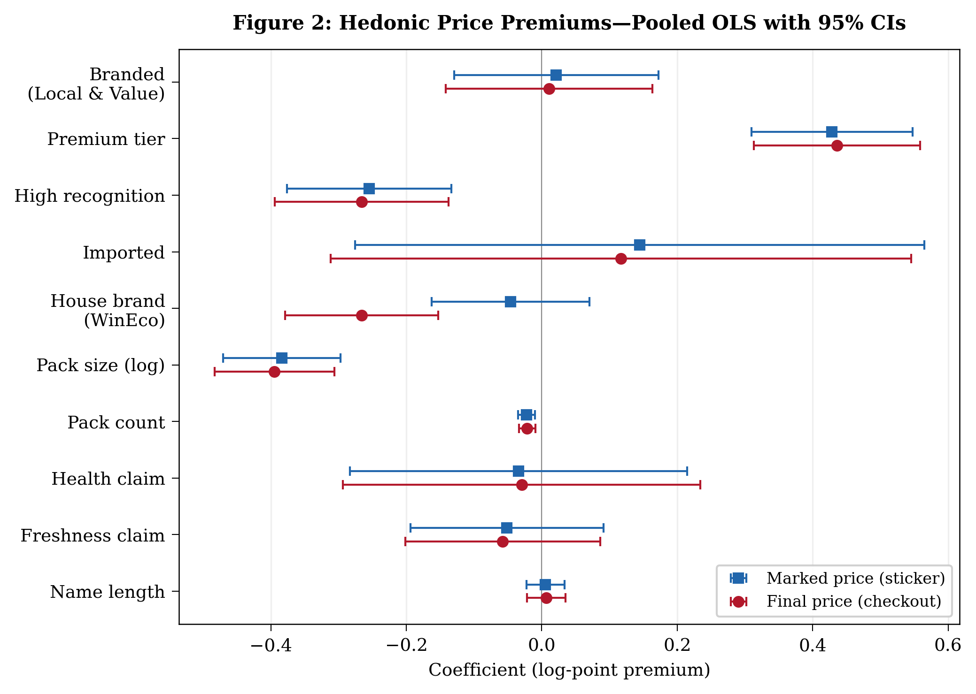
Figure 2: Hedonic price premiums from pooled OLS. Blue squares = marked-price coefficients; red circles = final-price coefficients. Error bars represent 95% cluster-robust confidence intervals.

4.5 Per-Category Heterogeneity
The pooled specification treats all ten categories as a single market, but the descriptive statistics suggest that attribute salience varies substantially. This section re-estimates the hedonic specification separately for each category.
Table 3: Per-Category Hedonic Regression Results (Final-Price Specification)
Category | N | Adj R² | Branded | Premium | High Recog. | Import | House | Health
Dry Food | 169 | 0.831 | +0.056 | +0.153 | −0.449*** | +0.671 | , | +0.104
Baby Products | 34 | 0.753 | +0.519 | +0.104 | −0.225 | , | , | −0.029
Dairy | 334 | 0.688 | −0.217 | +0.503*** | −0.193* | −0.305 | , | −0.162
Fresh Produce | 191 | 0.539 | +0.010 | +0.064 | , | +1.004*** | −0.331 | ,
Spices | 293 | 0.528 | −0.197 | +0.710*** | −0.306*** | +0.101 | , | +0.382*
Frozen | 133 | 0.526 | −0.169 | +0.296** | +0.113 | −0.203 | , | ,
Confectionary | 518 | 0.422 | +0.132 | +0.373*** | −0.397*** | −0.083 | , | +0.135
Processed Food | 167 | 0.395 | +0.166 | +0.501** | −0.360* | −0.608* | , | +0.095
Instant Food | 219 | 0.227 | −0.143 | +0.299*** | +0.093 | +0.119 | , | ,
Note: *** p < 0.001, ** p < 0.01, * p < 0.05. , = insufficient within-category variation or omitted. Cluster-robust SE. Eggs & Tofu (n = 24) omitted owing to insufficient sample size.
Model fit. Explanatory power varies substantially across the nine estimated categories, and this variation should shape how much weight the reader gives to each category’s coefficients. Three categories sit in a high-confidence band with adjusted R² above 0.6: Dry Food (R² = 0.831), Baby Products (0.753), and Dairy (0.688). For these categories the hedonic specification captures the bulk of within-subcategory price variation, and the coefficient pattern can be read as a reliable description of attribute premiums. A middle band of three categories falls between 0.5 and 0.6, where the specification still explains most of the variation but category-specific noise is non-trivial: Fresh Produce (0.539), Spices (0.528), and Frozen (0.526). The remaining three estimated categories fall below 0.5 (Confectionary 0.422, Processed Food 0.395, Instant Food 0.227); in these categories the nine NLP features capture less than half of within-subcategory variation, and significant coefficients should be read with correspondingly more caution. Instant Food in particular is dominated by format, flavour, and portion-size variation that the feature set does not measure. The category discussion below proceeds in order of decreasing explanatory power and concentrates interpretive weight on the high- and middle-R² categories, flagging low-R² findings as directional.
High-confidence categories (R² > 0.6). In Dry Food (R² = 0.831), the high-recognition effect is strongly negative (−0.449, p < 0.001): within-subcategory, the nationally recognised rice and grain brands carry lower unit prices than lesser-known branded equivalents. Price-tier positioning and the branded dummy are not significant once high-recognition is separated out, consistent with Dry Food being dominated by well-understood commodity products where brand and size largely exhaust the pricing signal. Baby Products (R² = 0.753) shows a positive but imprecise brand-name coefficient (+0.519, p ≈ 0.23), as expected from the small regression sample (n = 34) after the non-food subcategories are excluded; the coefficient pattern is directionally consistent with the pooled results but should not be read as a precise point estimate. In Dairy (R² = 0.688), the price-tier premium dominates the specification (+0.503, p < 0.001); health claims and the high-recognition adjustment are both negative and significant, reinforcing the interpretation of Household Giant dairy brands (Vinamilk, Dutch Lady) as volume-driven rather than premium-priced.
Middle-band categories (0.5 ≤ R² ≤ 0.6). Fresh Produce (R² = 0.539) produces the single largest coefficient in any per-category regression: the import premium reaches +1.004 (p < 0.001), so imported fruit commands more than double the price of domestic fruit within the same subcategory, consistent with Vietnamese consumers paying for the food-safety assurance associated with imports (Mergenthaler, Qaim, and Nuryartono, 2009). Brand and price-tier effects are near zero in this category, as expected: most Fresh Produce items are unbranded. Spices (R² = 0.528) shows a very large price-tier premium (+0.710, p < 0.001), a significant high-recognition discount (−0.306, p < 0.001), and the only significant health-claim coefficient in the dataset (+0.382, p = 0.03), a category in which food-safety concerns are most salient. Frozen (R² = 0.526) shows a smaller but still significant price-tier premium (+0.296, p ≈ 0.003) with no other significant effects.
Low-R² categories (R² < 0.5). In Confectionary (R² = 0.422) and Processed Food (R² = 0.395), the price-tier premium is still large and significant (+0.373 and +0.501 respectively), but the NLP features leave the majority of within-subcategory variation unexplained, and the significant high-recognition discount in Confectionary (−0.397) and the negative import coefficient in Processed Food (−0.608) should be read as directional. Instant Food (R² = 0.227) is the weakest fit: flavour and format, neither of which is captured by the feature set, drive most price variation, and only the price-tier premium survives at conventional significance (+0.299).
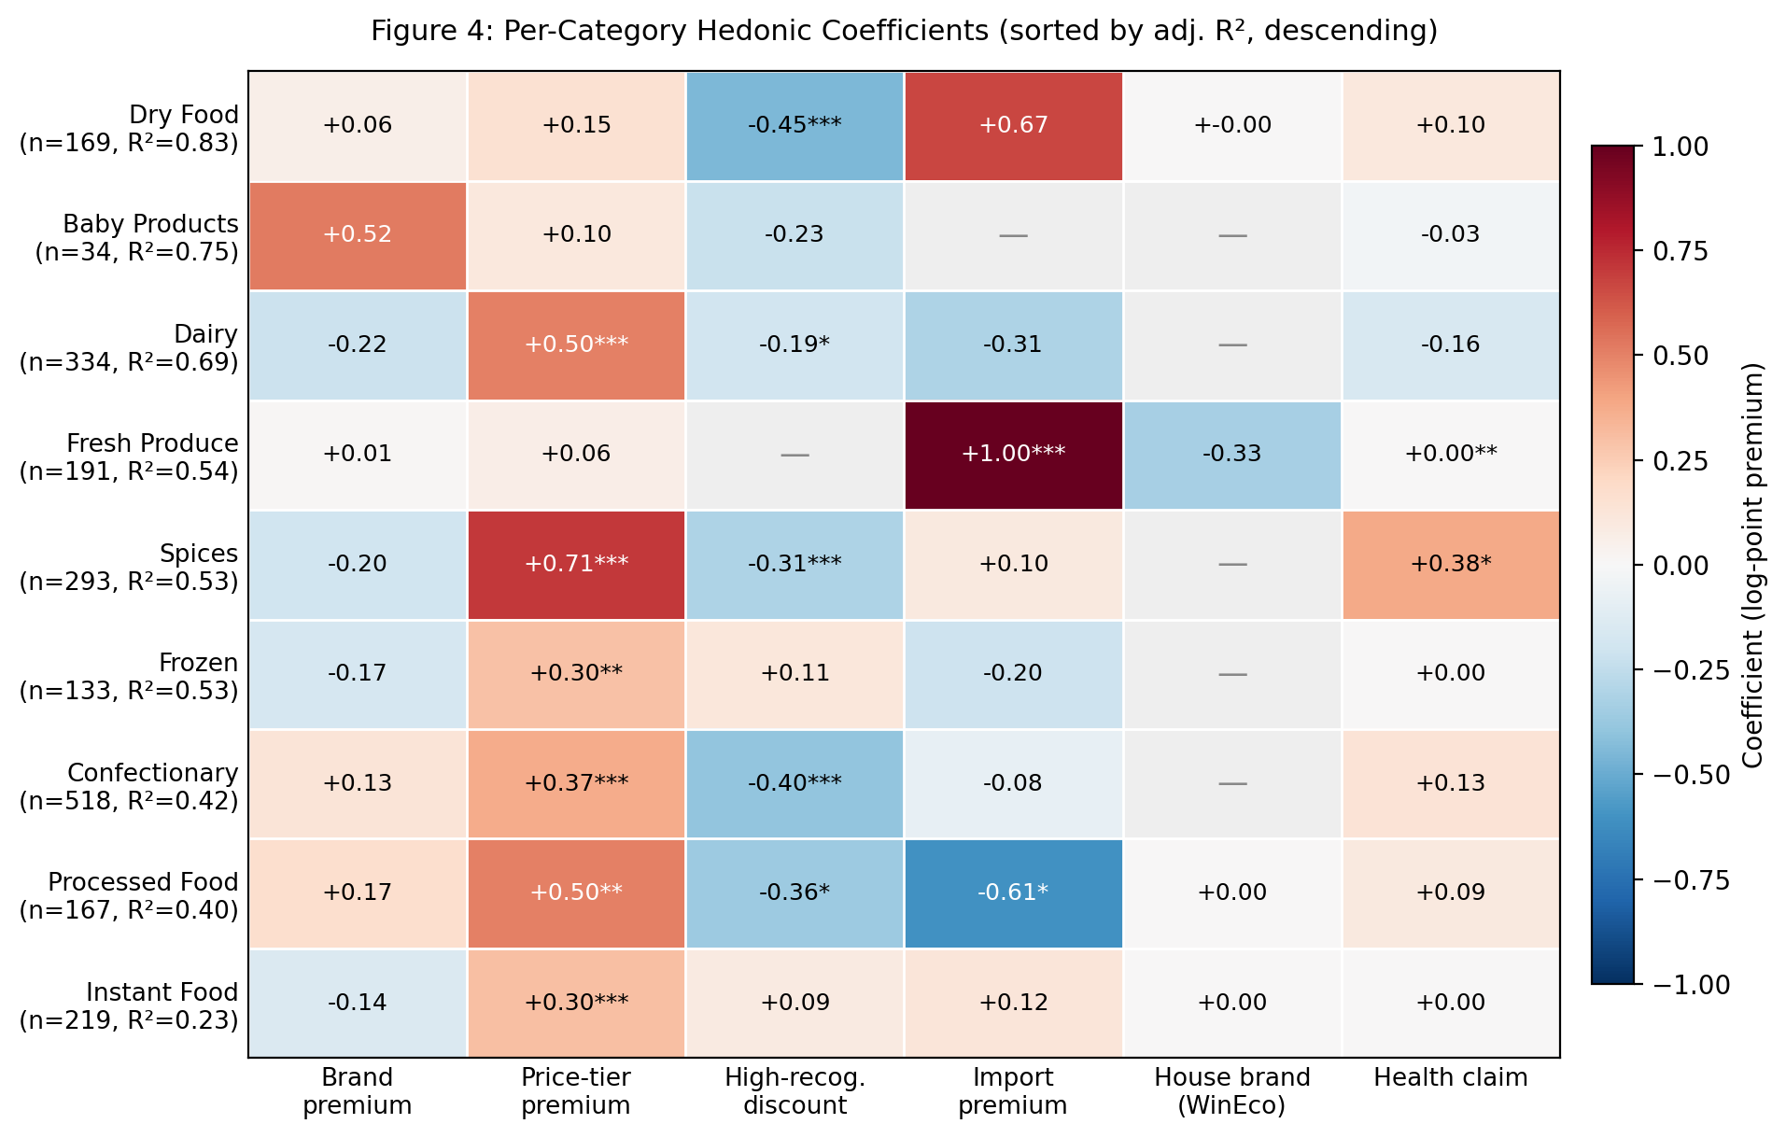
Figure 4: Per-category hedonic coefficients. Red = positive premium; blue = negative (discount). Dashes indicate insufficient within-category variation.

4.6 Promotional Erosion Analysis
This section presents the promotional erosion analysis that the dual-price design is built for. All coefficients compared in this section come from the pooled OLS specification of Section 4.4, not from the per-category regressions of Section 4.5; erosion is therefore a cross-category average of each attribute’s sticker-to-checkout change. For an attribute k with pooled coefficients β_{k,marked} and β_{k,final}, the erosion metric is defined as Erosion_{k} = (β_{k,marked} − β_{k,final}) / β_{k,marked} × 100. A positive value means the premium shrinks from sticker to checkout; a negative value means it grows.
Table 4: Promotional Erosion of Attribute Premiums
Attribute | β (marked) | β (final) | Erosion (%) | Interpretation
is_premium | +0.429*** | +0.436*** | −1.7 | Stable
is_branded | +0.022 | +0.011 | +50.6 | Eroded
is_high_recognition | −0.255*** | −0.266*** | +4.3 | Stable
is_import | +0.144 | +0.117 | +19.1 | Partial erosion
is_house_brand | −0.046 | −0.266*** | +475.6 | Amplified
Note: *** p < 0.001. Erosion = (β_marked − β_final) / β_marked × 100. Positive = premium shrinks at checkout; negative = premium grows.
Price-tier stability. The is_premium coefficient increases marginally from +0.429 to +0.436, producing an erosion of negative 1.7 percent. Premium-tier positioning not only survives the promotional pipeline but strengthens very slightly at checkout: promotional pricing does not erode the premium that consumers pay for products occupying the top pricing tier within their subcategory.
Brand-name erosion. The is_branded coefficient declines from +0.022 to +0.011, yielding an erosion of 50.6 percent. Neither coefficient is individually significant, but the directional pattern is clear: the marginal brand-name advantage is halved at checkout. Together with the price-tier stability finding, this demonstrates that the promotional system differentiates between brand dimensions, it preserves price-tier premiums while eroding brand-name premiums.
High-recognition deepening. The Household Giant discount deepens from −0.255 to −0.266 (erosion = 4.3 percent), consistent with these brands functioning as traffic-driving instruments whose promotional intensity increases at the point of sale.
Import erosion. The import premium declines from +0.144 to +0.117, a partial erosion of 19.1 percent. Neither coefficient is individually significant in the pooled model, so this is a directional finding.
House-brand amplification. WinEco’s sticker-price discount is −4.6 percent (not significant), while its checkout discount widens to −26.6 percent (p < 0.001). On the shelf, WinEco products are priced at near-parity with competing brands; at checkout, deep promotional discounts transform WinEco into a heavily discounted alternative. The 476 percent amplification is the most extreme promotional strategy in the dataset, consistent with the private-label literature on sophisticated house brands that compete on value at checkout without undermining shelf-level positioning.
Physical and credence attributes. Pack-size erosion is 2.8 percent. Health-claim premiums grow at checkout (erosion = −13.3 percent), consistent with credence attributes being resilient to discounting. None of these changes are statistically significant.
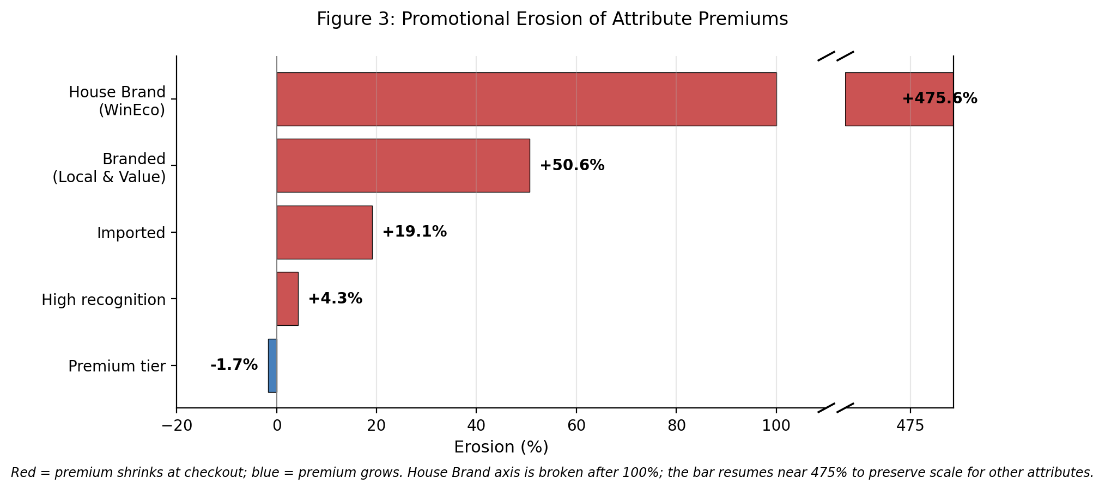
Figure 3: Promotional erosion by attribute. Positive values (red) indicate that the premium shrinks at checkout; negative values (blue) indicate that the premium grows. The House Brand (WinEco) axis is broken after 100%; the bar resumes near 475% so the other attributes remain readable on the main scale.

4.7 Diagnostics and Robustness
Table 5: Variance Inflation Factors
Feature | VIF
is_branded | 1.54
name_length | 1.42
is_high_recognition | 1.36
pack_count | 1.20
is_premium | 1.17
has_freshness_claim | 1.10
ln_pack_size | 1.08
has_health_claim | 1.08
is_import | 1.04
is_house_brand | 1.03
Note: All VIF values below 2.0, indicating no problematic multicollinearity despite the hierarchical brand encoding.
Multicollinearity. All variance inflation factors lie below 2.0 (Table 5), with the maximum at 1.54 for is_branded. Despite the hierarchical encoding of brand dummies, there is no evidence of problematic collinearity; the three brand dimensions are separately identified.
Heteroskedasticity. The Breusch–Pagan test decisively rejects the null of homoskedastic errors for both specifications (marked price: LM = 190.77, p < 0.001; final price: LM = 192.08, p < 0.001), which is expected given the wide within-subcategory price ranges in food data. Conventional standard errors would therefore be unreliable. Cluster-robust standard errors at the forty-subcategory level are used throughout, which simultaneously address the heteroskedasticity and the within-subcategory correlation structure induced by shared supplier relationships, competitive intensity, and promotional calendars within each subcategory. Cluster-robust inference does not alter any coefficient point estimate but widens several standard errors enough to move borderline coefficients (notably is_branded and is_import in the pooled specification) below conventional significance thresholds; this is the intended behaviour and is the basis on which significance claims in Sections 4.4–4.6 should be read.
Partial F-tests. A partial F-test on the four-variable brand block (is_branded, is_premium, is_high_recognition, is_house_brand) yields F = 58.02, strongly rejecting joint insignificance even though is_branded on its own is insignificant in the pooled model. The three brand dimensions therefore carry meaningful joint explanatory power, which supports the hierarchical decomposition adopted in Section 3.4: the branded-versus-unbranded distinction on its own hides the price-tier and recognition effects that collectively drive the brand signal. The credence block (has_health_claim, has_freshness_claim) returns F = 0.54, consistent with credence premiums being concentrated in a small number of categories (Spices most clearly) rather than operating pooled across the full food basket; this is the statistical counterpart to the per-category heterogeneity documented in Section 4.5.
Influence diagnostics. Cook’s distance was computed for each of the 2,066 products in the final-price regression sample. Using the standard 4/n threshold (0.00194 for this sample), 86 products (4.2% of the regression sample) exceed the threshold. The high-influence set is spread across categories rather than concentrated in any one subgroup, and refitting the model with these 86 observations dropped leaves every coefficient sign unchanged and shifts the point estimates by less than one standard error. The small-subgroup regressors (is_import, 98 products; is_house_brand, 21 products) are not over-represented in the high-influence set, so their coefficients are not driven by outlier leverage despite small group sizes. The full set of high-influence observations, and their corresponding attributes, is reported in Appendix C for transparency.
Temporal stability. The pooled specification was re-estimated separately on the December 2025 (n = 1,314), January 2026 (n = 1,327), and February 2026 (n = 2,053) monthly snapshots. Adjusted R² remains essentially flat across the three months (0.669, 0.669, 0.658), and the three brand coefficients stay in the same sign and rough magnitude: is_premium moves from +0.440 in December to +0.460 in January and back to +0.439 in February; is_branded drifts from −0.095 (December) to −0.089 (January) to −0.006 (February); is_high_recognition stays tightly clustered at −0.290, −0.296, −0.291. The within-window drift is smaller than the cluster-robust standard errors reported in Table 2 for all three coefficients, so the pooled finding is not a seasonal artefact of the Tết period. The mild upward drift in is_branded across the three snapshots is consistent with the descriptive observation that promotion depth narrows slightly after Tết.
Price-tier endogeneity. The is_premium variable’s construction from price rank introduces a partial mechanical relationship with the dependent variable. Three design features mitigate this: is_premium captures ordinal rank rather than price level; the dependent variable is log price per standardized unit, different from the raw price used for the median; and results are stable across subcategories with widely varying thresholds. An instrumental-variable approach is noted as a direction for future research in Section 5.3.
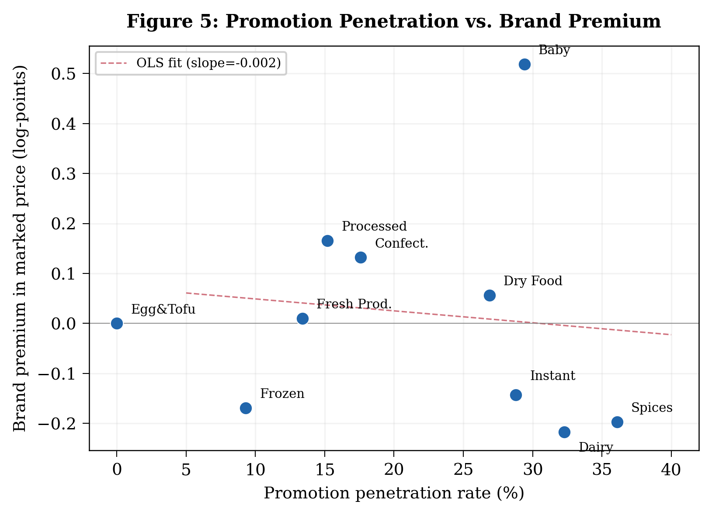
Figure 5: Promotional penetration rate vs. brand premium in marked price, by category. Negative relationship suggests that categories with heavier promotion feature more aggressive Household Giant pricing.

