A Dark Moon

Use-Case Specifications

Version 1.0

Revision History

|  |  |  |  |
| --- | --- | --- | --- |
| **Date** | **Version** | **Description** | **Author** |
| 02/10/22 | 1.0 | First Draft | Vance Muzangu |
|  |  |  |  |
|  |  |  |  |
|  |  |  |  |

Table of Contents

1. Use-Case Model 5

2. Screen 1 6

2.1 Brief Description 6

2.2 Flow of Events 6

2.2.1 Basic Flow 6

2.2.2 Alternative Flows 6

3. Screen 2 6

3.1 Brief Description 6

3.2 Flow of Events 6

3.2.1 Basic Flow 6

3.2.2 The player Selects to move to screen 3 6

4. Screen 3 6

4.1 Brief Description 6

4.2 Flow of Events 6

4.2.1 Basic Flow 6

4.3 Preconditions 7

4.3.1 Player must collect a certain number of materials before advancing to screen 2 7

4.4 Postconditions 7

4.4.1 Save 7

4.5 Use-Case Diagrams 7

Figures

Figure 1 Use-Case Diagram 4

Use-Case Specifications

# Use-Case Model

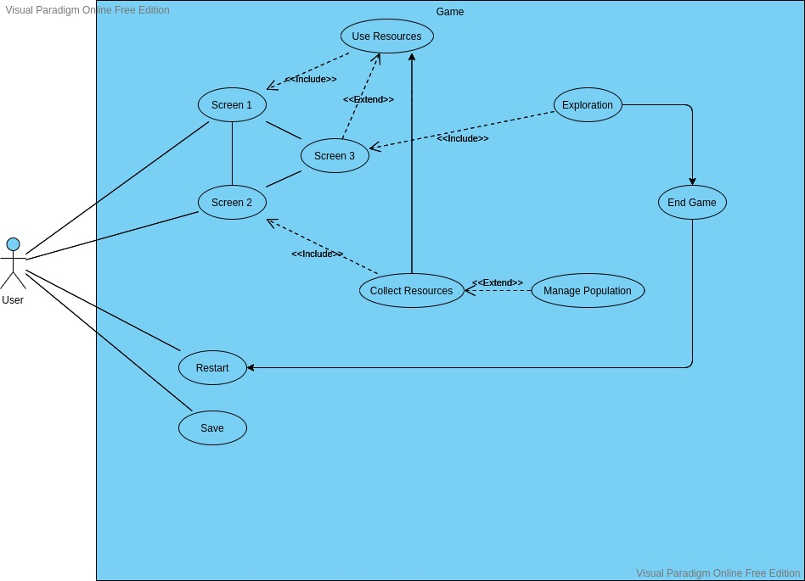

Figure 1. Use-Case Diagram

# Screen 1

## Brief Description

The User opens the game in browser and is prompted with tasks.

## Flow of Events

### Basic Flow

This use case starts when the player opens the game

The game presents the player with dialog on the first entry

The game reloads previous save on returning entry

The game presents a list of interactions to the user

### Alternative Flows

#### Player uses resources

The player can choose to use their resources on various buildings and upgrades

The resources must have been previously collected in screen 2

The game applies each upgrade and displays available resources

Screen 3 is unlocked due to the use of the resources

#### *Player selects Screen 2*

The Player can choose to move to screen 2

# Screen 2

## Brief Description

The user has collected enough resources to move on to Screen 2

## Flow of Events

### Basic Flow

The player can choose to click buttons to collect resources

The player can also manage their population to passively collect resources on a timer

### The player Selects to move to screen 3

The player can move on to screen 3

# Screen 3

## Brief Description

The Player begins to explore.

## Flow of Events

### Basic Flow

The player can choose to begin an expedition

Expedition leads to a map for the player to explore

Movement on the map consumes resources

The player can choose to take resources with them on the expedition

The player will encounter random combat

The end of the game is reached through exploration

## Preconditions

### Player must collect a certain number of materials before advancing to screen 2

*3.3.2 Player must complete several builds and have enough materials before advancing to Screen 3*

## Postconditions

### Save

Player selects save

An export save window will appear

Player will choose where to save file on clients’ computer

## Use-Case Diagrams

Refer to Figure 1.