Introduction
While a lot of studies focused on above-ground communities and their dynamics through time and space, the below-ground part of the ecosystems still remain poorly studied (Vaněk 1975) (Nielsen et al. 2010). The reasons are multiple, for instance, complexity of the system (Turner 2021), difficulties to account all of taxas : “(…) we only know at best a tiny fraction of the existing species diversity, and (2) our knowledge of both the distribution and abundance of many known species remains very poor” (Wilson & Barker 2019). ?? verifier (Decaëns 2010) also stated that a very little is known about soil organisms taxonomy, systematics and biogeography.
Nevertheless, the soil constitutes the base for every terrestrial ecosystem, therefore, it is the habitat of multiple forms of life. Thus, it is very important in mountain, where the soil formation is quite recent (Egli et al. 2014). Actually, soil hosts a huge amount of diversity, as well as it contains a lot of terrestrial fauna families (Gongalsky 2021), and enormous unique microbial communities (Griffiths & Philippot 2013). In addition, its role in ecosystems functioning and biogeochemical cycles is essential, thanks to micro and macro fauna, putting compounds into movement, accelerating decomposition and mineralization (Bradford et al. 2002). Soil is the major compartment that is sequestering carbon (Lal et al. 2015), which is relevant in a global warming context. As every habitat on Earth, the soil experience human activities, mostly pollution, land uses, depletion of nutrients, loss of organic matter and changes in pH balance (Geisen et al. 2019), (Tibbett et al. 2020).
Understanding how ecological communities are organised across space scales is a long-standing question in community ecology with a well-established conceptual framework. (Decaëns 2010).
However, understanding the relative part of spatial process, environmental filtering and biotic interactions in multi-trophic community assemblage still deserve much works [REF]
The filters don’t affect the diversity with the same intensity [ref]. It’s prevalent to identify, in a given context, which spatial scale encompass the most the diversity and in a second time, quantify the reciprocal part of factors.
Theses information about limiting factors, environmental influences are relevant in order to guide preservation and protection of biodiversity (Whittaker et al. 2001). In a context of global warming and modifications of land uses, predictions of how soil biodiversity changes over time could help us to forecast the impact of climate and land changes on soil fauna, and consequently on ecosystems. According to
Several researches have used attitudinal gradient as complex factor, structuring soil’s fauna (Fischer et al. n.d.), (Peters et al. 2016), (Yin et al. 2017). It has the advantage to imply a lot of different parameters such as pH, temperature, water deficit, incident light. The number of variables involved in an altitudinal gradient makes this system very unique.(Körner 2007). Nevertheless, theses researches are focusing on a gradient that controls a lot of directs and indirect factors, also playing a role in fauna and vegetation communities. It might be possible that elevation gradient masks a stronger factor, unidentified. [ref] In order to understand how species are distributed in space, it’s also quite relevant to work on theses factors, in addition with altitude, to highlight respective contributions to communities(Perrigo et al. 2020). In previous researches, [IRENE CALDERON], it was found that along altitude gradients, the factors impacting trophic groups aren’t the same, as they can be grouped into four main hypothesis (Habitat heterogeneity, Energy, Abiotic Tolerance and Ressource Heterogeneity).
Nevertheless, as Gongalsky 2021 supported, soil macro fauna is very diverse and includes a lot of animal families. In other words, interactions between living forms and abiotic and biotic parameters are multiple, but their role in ecosystem aren’t equal.[REF]. The trophic network is a great proxi to fauna communities, because it highlights consumption interaction, as observed in the study conducted by [CALDERON]. Its evolution through time and space gives information about how a community changes [REF]. Finally, it gives precision about trophic niches of animal [REF].
Thus, focusing on trophic guilds helps us to better understand the foodweb structure of a given site.[CALDERON]. Then they were able to link the main environmental factors with trophic guild composition. Moreover, trophic guilds could be linked together by organic matter (which is the main comportment from foodweeb balance) in which case a perturbation at a lower trophic level could have consequences at higher levels (Bradford et al. 2002).
Concerning how to measure biodiversity, [refS] showed that a large amount of metrics are possible/ If biodiversity metrics are diverse, they also have advantages, drawbacks, and habitat or scales preferences (Pulleman et al. 2012),(Dopheide et al. 2020), (Willis 2019). Alpha taxonomic diversity informs about a single and target location. This is why, since 1960, beta diversity index are used in order to complete information given by alpha diversity (Tuomisto 2010). Beta diversity metrics measures three index : The spatial turnover (replacement rate), the nestedness-resultant dissimilarity, and the total dissimilarity between two samples, two plots, or at high scale. It’s an additional way to understand how species are distributed or how they are replaced. It can be paired with alpha diversity, mostly in an aim of previous description.
Just like alpha diversity, beta diversity is under influences of many factors, such as geographic distance, environmental variables or biotic interactions (Rodriguez-Artigas et al. 2016).
As (Steiner & Leibold 2004) supported, the beta biodiversity isn’t equally influenced across spatial scale. It means that the filters limiting or increasing biodiversity are not the same if we look at a small scale like between two sample units (local) or between two mountains, in our case (regional).
Here, we drew inspiration from [CALDERON], work and linked beta biodiversity pattern on various scales with factors belonging to biotic interactions, geographic distance or habitat composition.
The main hypothesis states that, geographic distance is the main factor driving communities at larger spatial scales. In other terms, colonization abilities and biogeography should be the principal obstacles in organism spreading, as (Drake 1990) already supported. In addition at intermediate scale, we suspect a role of habitat variable, like climate, or the vegetation opening (Beaugrand 2023). At a lower spatial scale, biotic interactions such as vegetation composition, nutrient availability, predations, competitions should drive communities beta-diversity. [CALDERON]
Finally, we make the assumptions that factors influencing every trophic guild are not totally the same, because each trophic guild respond to their own pressure factors [CALDERON].
M&M

Sampling

Sampling sites
All the sampling sites belong to Orchamp Observatory (https://orchamp.osug.fr). The 11 studied altitudinal gradients were located in the Alps and the Pyrenees mountains, both in France :Argentière (Chamonix Mont-Blanc - 45.985496, 6.947277), Armenaz (Ecole – 45.625926, 6.228909), Cauterets (Cauterets – 42.831, 0.174), Chaillol (Chaillol – 44.721, 6.187555), Forêt du Bout (Pinsot – 45.324, 6.107), Lac Vert/Vallée du Lys (Saint Mamet - 42.72073, 0.5675), Mounier (Beuil – 44.142, 6.983), Pécloz (Ecole – 45.638226, 6.217314), Ristolas (Ristolas – 44.724622, 7.031392), Saint-Barthélémy (Montségur – 42.838705, 1.797797), Tania(Courchevel – 45.414, 6.601), Valloire(Valloire – 45.126224, 6.397591), and Ventoux Nord(Beaumont du Ventoux – 44.177, 5.251). Samplings have been realized in 2021 and 2022 during early Automn (September to October).
Plots

The plots measures 900m², and are spaced from each other by a minimum altitude of 200m, for every gradient. The lowest starts at 1130 meters (Ventoux Nord), and the highest one is placed at 2940 meters (Chaillol). In average, four plot are placed in every gradient. Every plot has the same orientation, has a homogeneous topography, don’t include water stream, are far from paths but can include pasture.

Sampling methods
As every organism isn’t present at the same depth of the soil, don’t have the same physical niche, and the same moving pattern, we need to use multiple methods to capture them.

Pitfall traps
In every plot, six pitfall traps have been placed 15 m apart in two lines at the edges of the ‘permanent placette’. A pitfall trap was made of a 125 ml plastic pot, buried up to its superior border and filled with about 40 ml of vinegar over saturated in salt. This solution killed organisms, avoided consumption and conserved individuals. To limit additional organic matter and water filling by rain, a cap was placed 5 cm over the pot. The traps were collected 1 month after their setting. Back at the laboratory, organisms were desalted into tap water during two days and then stored in 98° alcohol.

Soil hand sorting
In every plot, four soil monoliths were excavated outside the corners of the ‘permanent placette’. Before digging, vegetation was removed and animals in plant litter were hand sorted. Soil blocks were 25 x 25 cm in surface and up to 20 cm in depth. Then, macrofauna was hand sorted from soil blocks and stored in 98° alcohol.

Identification
Lumbricinae, Carabidae, Isopoda and Diplopoda have been identified precisely to species (or at least to genus) by specialists in laboratory (See Acknowledgements part). Here are the identification keys used : Lumbicinae : Bouché, M. (1972). Lombriciens de France. Ecologie et Systématique, Institut National de Recherches Agronomiques, Paris. Araneae : Nentwig, W., Blick, T., Gloor, D., Hänggi, A. & Kropf, C. (2014) Spiders of Europe. www.araneae.unibe.ch. Version of access date. araneae Version 02.2014. Isopoda : Vandel, A. (1960). Faune de France [Tomes 64 et 66, Isopodes terrestres], Lechevalier. Paris. Carabidae : Coulon, J., Pupier, R. et al. (2011). Faune de France 94 et 95 : Coléoptères Carabiques Compléments et mise à jour. Fédération française des sociétés de sciences naturelles. Paris Jeannel, R. (1941). Faune de France 39: Coléoptères Carabiques - Tome I. Lechevalier. (Papier + PDF) Jeannel, R. (1942). Faune de France 40: Coléoptères Carabiques - Tome II. Lechevalier. Myriapoda : Brolemann, H.W. (1930). Eléments d’une faune des Myriapodes de France – Chilopodes. Imprimerie toulousaine. Demange, J.M. (1981). Les milles-pattes, Myriapodes Boubée Paris.
All theses individuals account for 60% of macro fauna diversity in average.
The other individuals (accounting for 40% of total species identified) have been proposed for identification by citizen science through to the web-application Inaturalist. All observations can be found here: https://www.inaturalist.org/projects/orchamp_global
Individuals were grouped in morphotypes in each sample. On average two pictures, namely dorsal and ventral view, have been taken for each morphotype. Photographs of small organisms are obtained under binocular magnifier equipped with a Monochroma Camera. The software Capture V2.4 stacks a live video at different focal distances to get a stacked photo. Larger organisms are placed under a Panasonic Lumix 25-600 at ~30 cm from the device.
A unique ID was attributed to each individuals that has been photographed. Then photographs were posted on Inaturalist, with metadata (spatial coordinates, date of sampling) and a proposed identification that was then challenged and improved by INaturalist participants. The present dataset corresponds to an extraction from INaturalist the 02/06/2023. and that was merged with identification made in the lab thanks to the unique ID attributed to each photographs.
Trophic Guilds creation
In order to create trophic guilds, we looked after the species database composition. We decided to group Chrysomelidae family and Orthoptera order together as representatives of Herbivores group or green chain. We associated with this group the “Pitfall Trap” method, because it’s mostly species that walk on the ground. Predators group is composed by Carabidae family. The “Pitfall Trap” is also chosen. Detritivores were represented by Clitellata and diplopoda class, Isopoda order and Geotrupidae family. As they belong to multiple order and diverse movement into the soil, we selected the 3 methods together : pitfall trap and soil hand sorting. Finally, parasitoid trophic guild are composed by all the Hymenoptera we gathered, except the Formicidae family. They can be captured thanks to the “pitfall trap” method. [REF]

Environmental data
For Alps : Monthly mean temperatures, monthly mean precipitations, soils composition, pH are available at https://shiny.osug.fr/app/orchamp_download. For Pyrenees sites we asked Orchamp Team in order to complete the environmental factors database, with all the variables we hypothetised driving each trophic guild variance. The variables used for analysis, for all the groups are the following 1) Physical stressing variables : Annual mean temperature (TmeanY.mean), mean temperature at 1cm above ground and mean temperature at 4 cm above ground (TG1.degres.mean and TG4.degres.mean), snow thickness (DSN_T_ISBA.mean) annual mean precipitations (PtotY.mean), the mean of pH (pH mean). 2) Variables related to energy : The mean of NDVI index (ndvi.mean), the minimum of NDVI index (NDVImin), the maximum of NDVI index (NDVImax), organic matter content in %(PRCTMOmean). 3) Ressource heterogeneity : A dissimilarity vegetal matrix (matrix_1), vegetal Specific richness (Rveg), the macro fauna Specific Richness (Resp), 4) Complex Habitat variables : the opening of the environment (Forest or Open : called “Milieu”), the altitude (Alt). Geographic variables are represented by geographic coordinates (X_L93 and Y_L93).
For Detritivores, we added this pool of variables, in line with [REF] : Nutrient content (included into Energy related variables) : Nigrogene (Nmean), Aluminium (Almean), Calcium (Camean), Iron (Fermean), Magnesium (mgmean), Manganese (Mnmean), Phosphorus (Phosmean), Potassium (Kmean) and Sodium (Namean). We also included in Habitat heterogeneity group : Clay content (Argilemean) , Calcalerous content (Calcmean), the proportion of fine silt (Limfinmean), coarse silt (Limgrosmean), fine sand (Sablefinmean) and coase sand (Sablegrosmean).
The selection of variables groups has been done regarding [CALDERON] work. Physical Stressing variables come from Physical Tolerance Hypothesis, Variables related to energy are inspired from Energy Hypothesis, Ressource Heterogeneity come from Ressource heterogeneity Hypothesis. Complex driving factor and geographic factor have been added, from our own choice, in order to observe the potential hidden effect of theses kind of variables. [ref citee plus haut]. We decided not to include Habitat heterogeneity group else where than in Detritivores groups, because it’s composed of soil characteristics, less important for other trophic groups. [ref]
Scales of analysis
Spatial scales of study targeted was the sample scale, plot scale, gradient scale, and mountains scale.

Statistical analysis
Additive Diversity Partitioning
We performed an additive partitioning of species diversity to quantify differences in species composition at various nested spatial scales. Mean values of species diversity at lower spatial scale (α diversity, sample) of a sampling hierarchy (β diversity between plots, gradients, …) are compared to the total diversity in the entire data set (γ diversity, Alps+Pyrénnées). Beta1 is the diversity between sample, that is to say, between pit traps, or between monoliths of soils.
Beta 2 is the diversity between plot, a place, ie, a site and altitude. Beta 3 represents the difference between two sampling sites.
We used the function adipart() from the vegan package. We inquired two data base : the species database, and the database that regroups the different scales of study (Alpha1, Beta1, Beta2, Beta3). We also computed 3 diversity index (Specific Richness, Shannon and Simpson) to evaluate diversity. We specified the argument ‘prop’ for weighting diversity index by abundance, and performed 150 permutations.
Then, we performed a hierarchical null model with the function hiersimu() from the package vegan. The results informed about which beta diversity scale is different from a null model, created by permutations where species are randomly distributed. We inquired the same data bases as additive variance partitioning. We let other arguments by default and we also performed 150 permutations.

Global Dissimilarity Model (GDM)
The Global Dissimilarity Model analyses biodiversity patterns. Here, it allows us to identify the main predictors influencing beta diversity, “Specifically by relating biological dissimilarity between sites to how much sites differ in their environmental conditions (environmental distance) and how isolated they are from one another (geographical distance)” (https://mfitzpatrick.al.umces.edu/gdm/).
For the four trophic guild, we have created a main dissimilarity matrix between samples, between plots and between gradients (depending on the study scale) using the function vegdist() from the package vegan. The distance used was Bray-Curtis. We call is community matrix.
Then, we created the dissimilarity matrix for plant species (matrix_1, biotic variable) to compare with main community matrix, also with vegdist. The distance used was also Bray-Curtis distance.
Then we created an object with the function formatsitepair() (from gdm packages). We inquired the community matrix, the environmental data, the plant dissimilarity matrix and precised geographic coordinates column. Finally, we performed a GDM on this object, with the function gdm(), from ‘gdm’ package. We precised geo=TRUE to include geographic distance between plots.
For every GDM performed, we tested the significativity of Predictors thanks to the function gdm.crossvalidation. We decided to take the top three variables playing a role in targeted dissimilarity. We then extracted predictors from the created object and associated coefficients for each trophic guild. Finally, we extracted from the gdm function the observed dissimilarity of the community, in relation with the predicted ecological distance. We compared these relationships between trophic guilds for a fixed observation level.
All the analyses were performed on RStudio version 4.2.3.1. Scripts, data and figures are available at https://github.com/Aurelien-Navarro/Macrofauna
Results
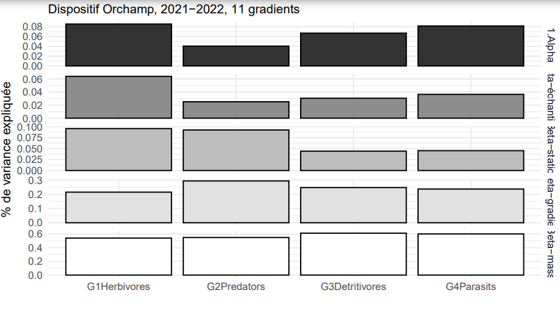
The figure I is a plot of the variance partitioning, showing which level of study encompass the most the taxonomic diversity, for each trophic guild.
As we can see, for herbivorous, most of the diversity is explained by difference between mountains, for more than 50% while the difference between gradients explain 20% of the biodiversity observed.
The main two levels explaining predator’s diversity are also mountains and gradient, for respectively almost 60% and 30% of total variance.
Detritivore’s and parasitoïds’s diversity is explained mostly by the same scale (mountains), for 60% in average, and a little bit by gradient, with 25% of variance.
The sample scale explains more Herbivores diversity than other Trophic Groups.
We can easily see that Herbivorous and Predators are influenced similarly, while Detritivores and Parasits seem to equally respond to the scale of the study.
This results helps to decide at which level of study we should apply the GDM model in order to reveal the main environmental variables influencing taxonomic dissimilarity.
Regarding the influence of Mountains and Gradients we decided to focus on gradient or site dissimilarity. Indeed, we split the mountains into North Alps, South Alps and Pyrénées.
GDM
For the following figures, coefficients haven’t any unite, they are relatives.
[Figure II]
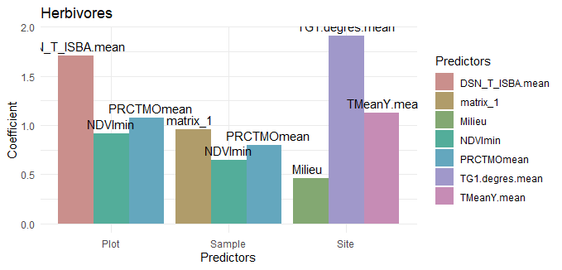
The figure II is a plot of the relative importance of the three main environmental variable in taxonomic dissimilarity between sites for the Herbivores. It helps to understand which variable are predominant in beta diversity.
As we can see, at sample level, the vegetation plays a major role, with the maximum value for the vegetal matrix associated (matrix_1). Then, the percentage of organic matter in the soil (PRCTMOmean) plays an important role. Then comes the NDVImin with a coefficient of 0,65. Theses three factors belong to the same biotic categorie.
Between plots (intermediate level), Snow cover (DSN_T_ISBA) plays a major role, explaining 1,5% of variance. Then biotic variables (organic matter and NDVImin) explain 0,6 of dissimilarity.
Between sites, air temperature above 1cm of soil and mean annual temperature drive herbivores community for respectively 1,5 and 1 of explained dissimilarity. They both belong to habitat variables (climatic variables). Finally, the opening (Forest or meadows) environment explain herbivores dissimilarity with a coefficient of almost 0,5.

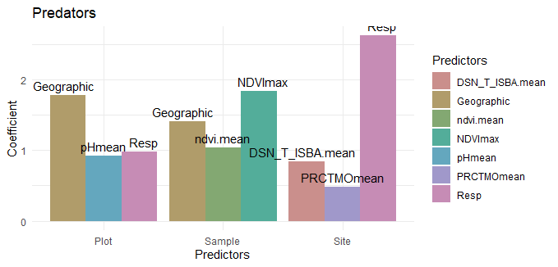
Figure III
The figure III is a plot of the relative importance of the three main environmental variable in taxonomic dissimilarity between sites for the Predators.
At sample level, NDVImax is the most important predictor, accounting for 1,75 of dissimilarity. Then, Geographic distance account for almost 1,5. NDVI account for almost 1.
Between plots, the geographic distance highly influence predator turnover (1,6), while the environment opening (Milieu) and macrofauna species richness (Resp) influence only with a coefficient below 1.
Suprisely, between sites, the main predictor is Species Richness, with a coefficient of 2,3 followed by snow cover and organic matter(0,8 and 0,5). Considering the fact that we observe predators (and not herbivores).
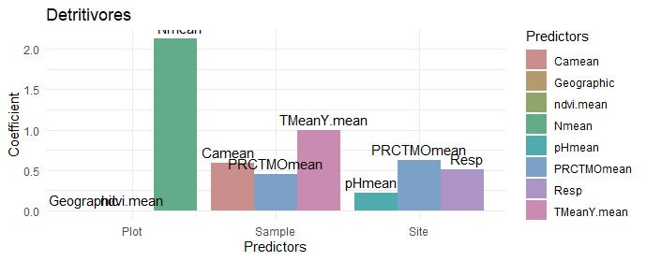
Figure IV
The figure IV is a plot of the relative importance of the three main environmental variable in taxonomic dissimilarity between sites for the Detritivores.
At sampling level, the three main variables play a similar role. They are the organic matter, the calcium content and the annual temperature. Organic matter and calcium content more likely belong to biotic or trophic categorie, in a detritivore context. Annual temperature is an abiotic, habitat categories.
At a plot level, nitrogen concentration (Nmean) is the only predictor of beta diversity for Detritivores (coefficient = 2,1)
Finally, between sites, the three main variables are pretty similar in terms of contribution (coefficient between 0,5 and 0,8). They are : the pH, the fauna specific richness, and the main, the organic matter content.
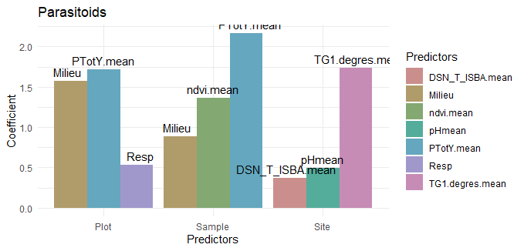
Figure V
The figure V is a plot of the relative importance of the three main environmental variable in taxonomic dissimilarity between sites for the Parasitoïds.
Here, the GDM was performed on Parasitoïds wasps genders, because of the lack of statistical individuals at a species level.
At sample level, the main predictor is the annual precipitation, accounting for a coefficient of 2,2.
Then the NDVI account for 1,3 and the opening of environment for 0,85.
At a plot level, annual precipitations and the environment opening still play a major role, but the species also influence dissimilarity with a coefficient of 0,05.
Between sites, Parasitoïds beta diversity is mostly explained by air temperature at 1cm above the soil (coefficient=0,75), and pH and snow cover explain diversity for a coefficient less than 0,5.

[Figure X – Splines – ecological distances]
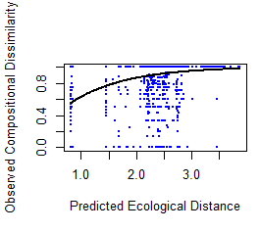

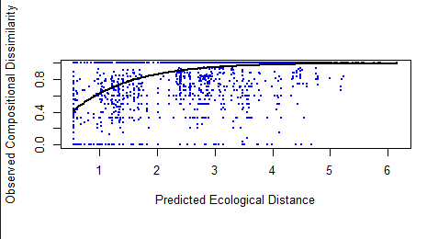

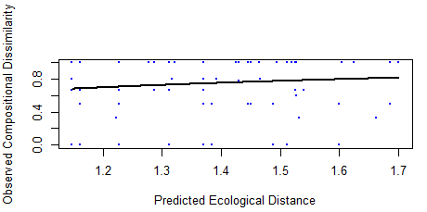
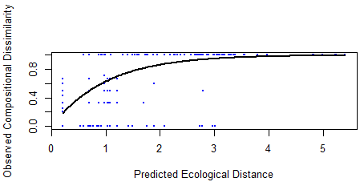

The figure X represents the observed Compositional Dissimilarity by the Predicted Ecological Distance for 1) Herbivores, 2) Predators, 3) Detritivores, 4) Parasitoids, between samples (Beta1).
We can see that Herbivores maximum dissimilarity (1) is observed for an Ecological Distance of 3,5. Maximum Dissimilarity is observed for an Ecological Distance of 5 for Parasitoids and 6 for Predators. The three fitted splines have the same log function look.
For Detritivores, the maximum dissimilarity isn’t reached with this Predicted Ecological Distance available. The minimum is a dissimilarity of 0,6 and the maximum of 0,8.Nevertheless, the look is closed from a linear model.

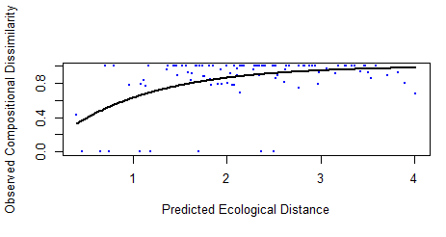
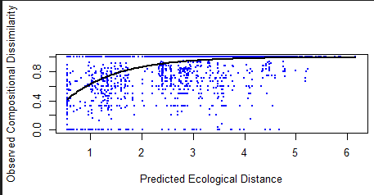

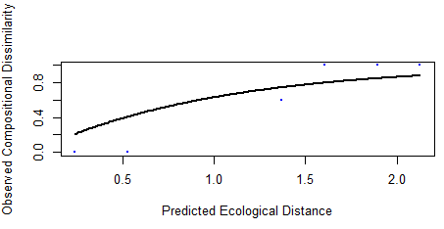
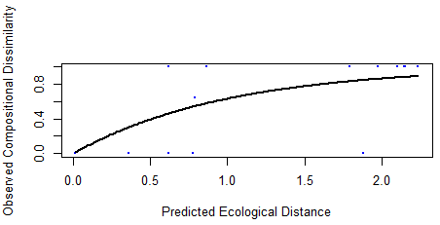

The figure Y represents the observed Compositional Dissimilarity by the Predicted Ecological Distance for 1) Herbivores, 2) Predators, 3) Detritivores, 4) Parasitoids, between plots (Beta2).
Parasitoïds and Detritivores are reaching a maximum dissimilarity for an Ecological Distance of 2. The look of the splines are quite similar.
The other two trophic guilds reach their maximum dissimilarity (=1) for a distance of 4. For Predators, the look is more precise thanks to the great amount of statistical individuals. The look is similar with a dissimilarity between site at 0,3 for an ecological distance of 0.

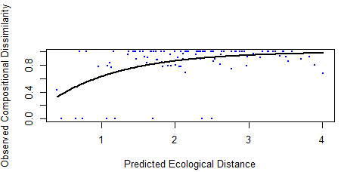
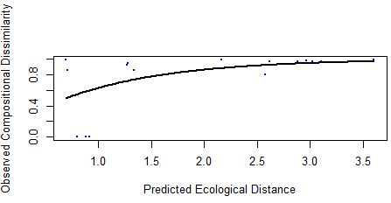
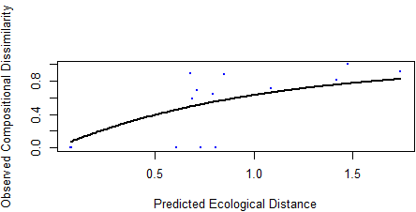
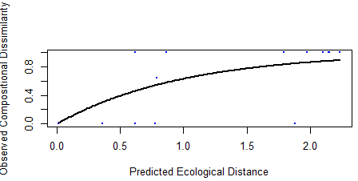

The figure Y represents the observed Compositional Dissimilarity by the Predicted Ecological Distance for 1) Herbivores, 2) Predators, 3) Detritivores, 4) Parasitoids, between sites. (Beta3).
Herbivores and Predators dissimilarity splines are similar, with a dissimilarity max reached for an Ecological Distance of respectively 3,5 and 4.
Detritivores and Parasitoïds have a spline with an asymptote at 1,5 for Detritivores and 2,4 for Parasitoïds.

Discussion
Variance partitioning
Pyrenees, North Alps and South Alps are three different climatic localization (Blanchard 1921).
The following explained differences between Northern and Southern Alps come from (Blanchard 1921)’s work.
North Alps are under continental influences while South Alps are under Mediterranean influences. In Northern Alps, the altitude effect is important, but in Southern Alps, the Mediterranean context has a great impact on mountains, in terms of lower precipitations and higher temperatures. There is also less snow in this region, the dry season is more pronounced. Northern Alps have an association of rough and smooth rocks, while Southern Alps mostly possess rough bare rocks. Limestone and clay mostly compose Northern Alps. Southern Alps is principally composed by clay.
North Alps are also older and more homogeneous, in structure, than South Alps.
As elevation is correlated with the age of the mountain, gradients in the North are lower than gradients in the South. In this sense, because of climate, vegetation is more abundant and diverse in Northern Alps than in South. Indeed, the drought selected tolerant and adaptive vegetation species.
On the other side, Pyrenees mountains are far from Alps chains, at a regional scale, and have a lower elevation. Theses mountains are under both Atlantic and Mediterranean influences, with a drier and warmer climate in the East than in the West. (S0277379113001728.htm). The climate is far different from Northern Alps but closer (because of Mediterranean influences) to southern Alps (Plesnik 1971). It can be explained by the fact that latitude modifies more widely than longitude does (Plesnik 1971; Beaugrand 2023).
Theses differences can explain why mountains scale is the first level influencing beta diversity. This three localities offer really different habitats, thanks to their climate, their soil and vegetation composition and their history. As [CALDERON], and (Decaëns 2010), previously state, a high habitat heterogeneity hosts more biodiversity, in which case differences in habitat involves differentiation in community pattern, by the niche partitioning effect.

The second scale of study that encompassed biodiversity was gradient. It means that the difference between sites influences more the diversity than differences between plots, or between sample.
Indeed, the regional or landscapes scale more likely modifies diversity, than local, according with (Steiner & Leibold 2004), (Beaugrand 2023). Moreover, (Decaëns 2010) precised that at a global scale, we observe more alpha diversity but also nested effect, that is to say, dissimilarity (high beta diversity). It might be caused by dispersal capacities, colonization and history (Drake 1990) or, as (Steiner & Leibold 2004) said: “stochastic variation in invasion history can enhance compositional dissimilarity among local communities, increasing beta diversity.“.

The next results allowed us to validate or nuance (Drake 1990) theory at regional scales and [CALDERON] hypothesis at a local scale.
For herbivores, we observe that at a local scale (sample scale), factors playing a role in beta diversity are related to energy and resource categories, both including biologic variables. Theses results are in line with [REF]. At an intermediate scale (Beta 2), influences are both trophic and abiotic. As [CALDERON] showed, with figure 3, Physiological tolerance hypothesis (here, represented by Snow cover), explains biodiversity with a great relative importance. It can be explain by three mecanisms explained by (Stein et al. 2014) : “First, an increase in environmental
gradients and in the amount of habitat types, resources and structural complexity should increase the available niche space and thus allow more species to coexist […]. Second, environmentally heterogeneous areas are more likely to provide shelter and refuges from adverse environmental conditions and periods of climate change, which in turn should promote species
persistence […]. Third, the probability of speciation events resulting from isolation or adaptation to diverse environmental conditions should increase with higher EH.” The influence of energy variables is less in line with [CALDERON], figure 2, where macrofauna phytophagous are influenced by Ressource Hetereogeneity as a second factor. Nevertheless, [CURIE] stated the fact that the available energy is the first factor influencing biological patterns, in addition with precipitations and temperature.
The fact that physical stressing variables explain beta 3 diversity is in accordance with (Beaugrand 2023), figure 2, showing that at a regional scale, factors that influence diversity are climate factors, and sometimes biogeographical (like we can explain by the importance of the opening of the environnement in our case). If Herbivorous tend to be impacted by biological variables at a little scale, in regional context, it’s more environmental climatic variables which influence vegetation and indirectly, Herbivorous.
Focusing on predators group, at local scale, the importance of energy variables is in accordance with [CURIE] paper, but the distance limit is more supported in (Drake 1990) work. This results means that it’s possible for predators species to be isolated by distance. In this case, we can observe a higher endemism than for other trophic groups. This is what (Moret 2009) showed in their study, but it mainly concern a Beta 2 equivalence. At a plot scale (Beta 2), the geographic distance is supported by (Drake 1990) and (Moret 2009) results. We can make similar conclusion to sample scale, concerning possible endemism, but the impact of pH valids [CALDERON] results about macro fauna predators, mostly impacted by Habitat Heterogeneity. The impact of species richness illustrates (Steiner & Leibold 2004) Scale Dependant Productivity, Diversity Relationships. As (Steiner & Leibold 2004) showed, at higher scale (Beta 3), fauna is still under the Scale Dependant Productivity Diversity Relationship, explaining why two variables belong to Ressource Heterogeneity category. The importance Physical Stressing Variable (here : Snow depth) is supported by (Beaugrand 2023). It’s difficult here to draw a general framework on predators, because of the difference in variables category, along the space gradient. We still can suggest that because of their trophic web place, they are subject to lower trophic level variations, themselves under multiple influences.
Detritivores’s case is simplier. At a local (Beta 1) scale and between plots (Beta 2), available energy and nutrient contents influence biodiversity, as demonstrated by [CALDERONE](Beta 2) and [CURIE] (Beta 1 and 2). Detritivores depends mostly on organic matter and nutrients to survive, as (Tiunov & Scheu 2004) showed, adding carbon into earthworms experiment fields. We still can add that the temperature plays a major role as it influences soil aggregation[ref], available water for theses organisms [ref], and temperature optimum. [ref]. The treeline effect could also explain detritivores pattern “both by the effect of environmental heterogeneity and of trophic resource quality which increases at the ecotone level” (Gabriac et al. 2022). Here, the trophic resource quality is approached by Energy available, and Environmental Heterogeneity by Annual Temperatures. Further studies may be able to model and correlate the Treeline with detritivores beta diversity.
At Beta 3 (site scale), energy related variables still play a role, as predicted by [CURIE], and (Gabriac et al. n.d.).

References
Beaugrand, G. (2023). Towards an Understanding of Large-Scale Biodiversity Patterns on Land and in the Sea. Biology, 12, 339.
Blanchard, R. (1921). The Natural Regions of the French Alps. Geogr. Rev., 11, 31.
Decaëns, T. (2010). Macroecological patterns in soil communities: Soil community macroecology. Glob. Ecol. Biogeogr., 19, 287–302.
Drake, J.A. (1990). The mechanics of community assembly and succession. J. Theor. Biol., 147, 213–233.
Egli, M., Dahms, D. & Norton, K. (2014). Soil formation rates on silicate parent material in alpine environments: Different approaches–different results? Geoderma, 213, 320–333.
Gabriac, Q., Ganault, P., Barois, I., Aranda-Delgado, E., Cortet, J., Gautier, M., et al. (n.d.). Environmental drivers of earthworm communities along an altitudinal gradient in the French Alps.
Körner, C. (2007). The use of ‘altitude’ in ecological research. Trends Ecol. Evol., 22, 569–574.
Moret, P. (2009). Altitudinal distribution, diversity and endemicity of Carabidae (Coleoptera) in the páramos of Ecuadorian Andes. Ann. Société Entomol. Fr. NS, 45, 500–510.
Nielsen, U.N., Osler, G.H.R., Campbell, C.D., Neilson, R., Burslem, D.F.R.P. & van der Wal, R. (2010). The Enigma of Soil Animal Species Diversity Revisited: The Role of Small-Scale Heterogeneity. PLoS ONE, 5, e11567.
Plesnik, P. (1971). Différenciation verticale et horizontale des formations forestières des Pyrénées. Comparaison avec les Alpes, les Carpates et le Caucase. Rev. Géographique Pyrén. Sud-Ouest, 42, 31–48.
Stein, A., Gerstner, K. & Kreft, H. (2014). Environmental heterogeneity as a universal driver of species richness across taxa, biomes and spatial scales. Ecol. Lett., 17, 866–880.
Steiner, C.F. & Leibold, M.A. (2004). CYCLIC ASSEMBLY TRAJECTORIES AND SCALE-DEPENDENT PRODUCTIVITY–DIVERSITY RELATIONSHIPS. Ecology, 85, 107–113.
Tiunov, A.V. & Scheu, S. (2004). Carbon availability controls the growth of detritivores (Lumbricidae) and their effect on nitrogen mineralization. Oecologia, 138, 83–90.
Turner, B. (2021). Soil as an Archetype of Complexity: A Systems Approach to Improve Insights, Learning, and Management of Coupled Biogeochemical Processes and Environmental Externalities. Soil Syst., 5, 39.
Vaněk, J. (Ed.). (1975). Progress in Soil Zoology: Proceedings of the 5th International Colloquium on Soil Zoology Held in Prague September 17–22, 1973. Springer Netherlands, Dordrecht.
Wilson, R.A. & Barker, M.J. (2019). Biological Individuals. Stanf. Encycl. Philos., 1.

