Results

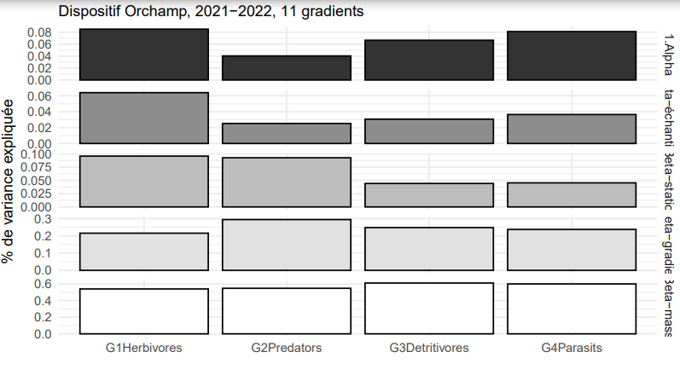

The figure I is a plot of the variance partitionning, showing which level of study encompass the most the taxonomic diversity, for each trophic guild.
As we can see, for herbivorous, most of the diversity is explained by difference between mountains, for more than 50% while the difference between gradients explain 20% of the biodiversity observed.
The main two levels explaining predator’s diversity are also mountains and gradient, for respectively almost 60% and 30% of total variance.
Detritivore’s and parasit’s diversity is explained mostly by the same scale (mountains), for 60% in average, and a little bit by gradient, with 25% of variance.
The sample scale explains more Herbivores diversity than other Trophic Groups.
We can easily constat that Herbivorous and Predators behave similary, while Detritivores and Parasits seem to equally respond to the scale of the study.
This results helps to decide at which level of study we should apply the GDM model in order to reveal the main environemental variables influencing taxonomic dissimilarity.
Regarding the influence of Mountains and Gradients we decided to focus on gradient or site dissimilarity. Indeed, we split the mountains into North Alps, South Alps and Pyrénées. Nevetheless, we did not have access to a lot of Pyrénées variables, which biase the model, putting in comparison only North and South Alps.

GDM

For the following figures, coefficients haven’t any unite, they are relatives.
[Figure II]
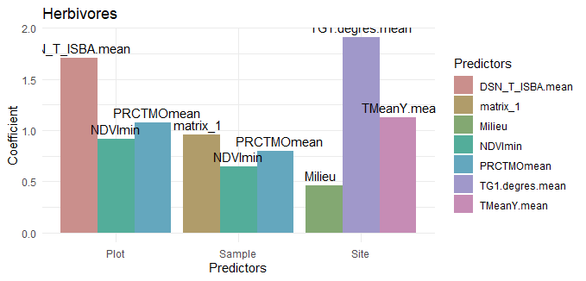
The figure II is a plot of the relative importance of the three main environmental variable in taxonomic dissimilarity between sites for the Herbivores. It helps to understand which variable are predominant in beta diversity.
As we can see, at sample level, the vegetation plays a major role, with the maximum value for the vegetal matrix associated (matrix_1). Then, the percentage of organic matter in the soil (PRCTMOmean) plays an important role. Then comes the NDVImin with a coefficient of 0,65. Theses three factors belong to the same biotic categorie.
Between plots (intermediate level), Snow cover (DSN_T_ISBA) plays a major role, explaining 1,5% of variance. Then biotic variables (organic matter and NDVImin) explain 0,6 of dissimilarity.
Between sites, air temperature above 1cm of soil and mean annual temperature drive herbivores community for respectivly 1,5 and 1 of explained dissimilarity. They both belong to habitat variables (climatic variables). Finally, the opening (Forest or meadows) environment explain herbivores dissimilarity with a coefficient of almost 0,5.

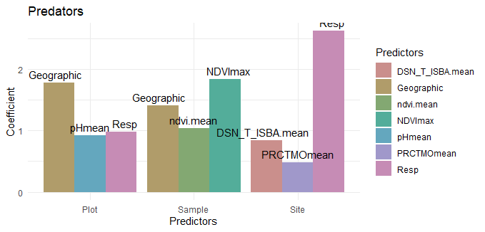
Figure III
The figure III is a plot of the relative importance of the three main environmental variable in taxonomic dissimilarity between sites for the Predators.
At sample level, NDVImax is the most important predictor, acounting for 1,75 of dissimilarity. Then, Geographic distance acount for almost 1,5. NDVI account for almost 1.
Between plots, the geographic distance highly influence predator turnover (1,6), while the environment opening (Milieu) and macrofauna species richness (Resp) influence only with a coefficient below 1.
Suprisely, between sites, the main predictor is Species Richness, with a coefficient of 2,3 followed by snow cover and organic matter(0,8 and 0,5). Considering the fact that we observe predators (and not herbivores).

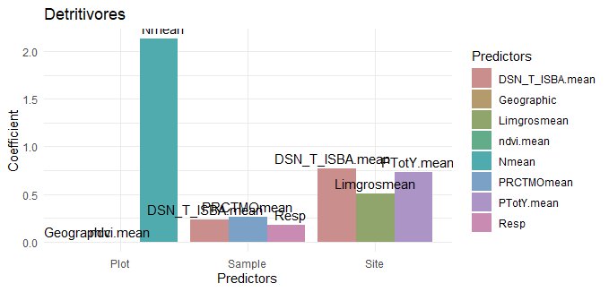
Figure IV
The figure IV is a plot of the relative importance of the three main environmental variable in taxonomic dissimilarity between sites for the Detritivores.
At sampling level, the three main variables play a similar role. They are the organic matter, the snow cover and the macrofauna species richness. Organic matter and species richness more likely belongs to biotic or trophic categorie, in a detritivore context. Snow cover is a abiotic, habitat categorie.
At a plot level, nitrogen concentration (Nmean) is the only predictor of beta diversity for Detritivores (coefficient = 2,1)
Finally, between sites, the three main variables are pretty similar in terms of contribution (coefficient between 0,5 and 0,8). They are : Coarse silt, Annual Precipitations (PtotY.mean) and snow cover.
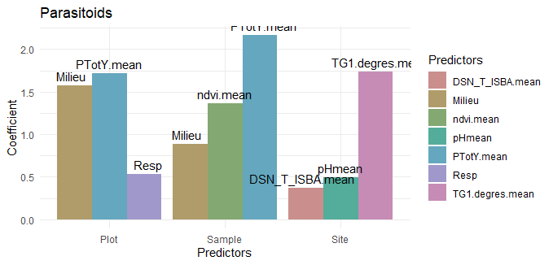
Figure V
The figure V is a plot of the relative importance of the three main environmental variable in taxonomic dissimilarity between sites for the parasitoïds.
Here, the GDM was performed on parasitoids wasps genders, because of the lack of statistical individuals at a species level.
At sample level, the main predictor is the annual precipitation, accounting for a coefficient of 2,2.
Then the NDVI account for 1,3 and the opening of environnement for 0,85.
At a plot level, annual precipitations and the environment opening still play a major role, but the species also influence dissimilarity with a coefficient of 0,05.
Between sites, parasitoids beta diversity is mostly explained by air temperature at 1cm above the soil (coefficient=0,75), and pH and snow cover explain diversity for a coefficient less than 0,5.

[Figure X – Splines – ecological distances]

