Sampling

Sampling sites
All the sampling sites belong to Orchamp Observatory (https://orchamp.osug.fr). The 11 studied altitudinal gradients were located in the Alps and the Pyrenees mountains, both in France (figure Ia-b)
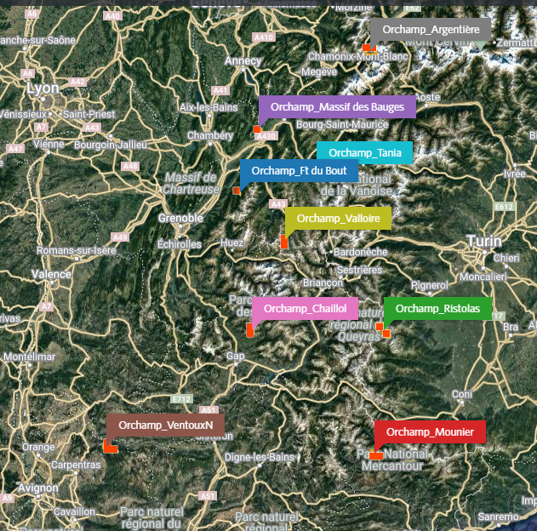
.

Figure Ia : Cartography of Alps sites localisation (https://www.inaturalist.org/projects/orchamp_global)
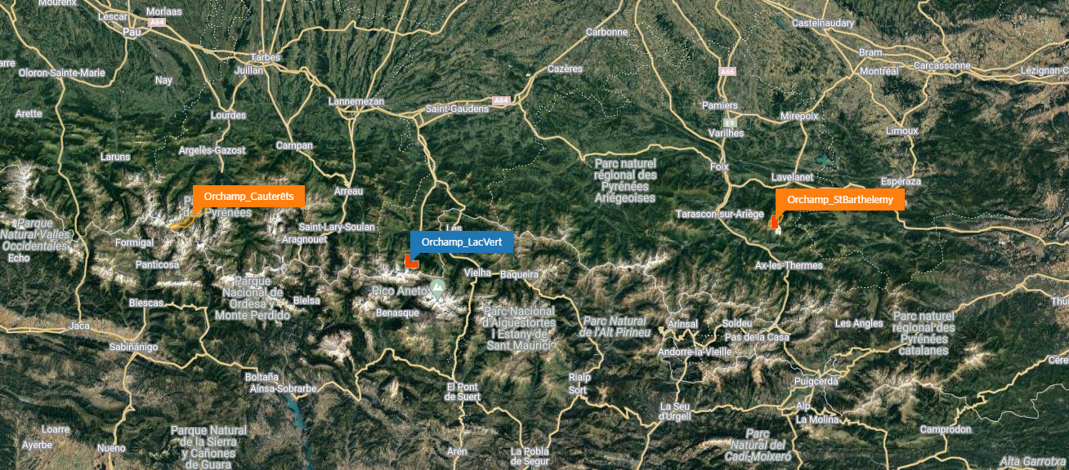

Figure Ib : Cartography of Pyrenees sites localisation. (https://www.inaturalist.org/projects/orchamp_global)
Their exact coordinates can be found at https://orchamp.osug.fr/sites. Samplings have been realized in 2021 and 2022 during early Automn (September to October).
Placettes
placettes

Sampling methods
As every organism isn’t present at the same depth of the soil, don’t have the same physical niche, and the same deplacement pattern, we need to use multiple methods to capture them.

Pitfall traps
In every plot, six pitfall traps have been placed 15 m apart in two lines at the edges of the ‘permanent placette’. A pitfall trap was made of a 125 ml plastic pot, buried up to its superior border and filled with about 40 ml of vinegar over saturated in salt. This solution killed organisms, avoided consumption and conserved individuals. To limit additional organic matter and water filling by rain, a cap was placed 5 cm over the pot. The traps were collected 1 month after their setting. Back at the laboratory, organisms were desalted into tap water during two days and then stored in 98° alcohol.

Soil hand sorting
In every plot, four soil monoliths were excavated outside the corners of the ‘permanent placette’. Before digging, vegetation was removed and animals in plant litter were hand sorted. Soil blocks were 25 x 25 cm in surface and up to 20 cm in depth. Then, macrofauna was hand sorted from soil blocks and stored in 98° alcohol.

Identification
Lumbricinae, Carabidae, Isopoda and Diplopoda have been identified precisely to species (or at least to genus) by specialists in laboratory (See Acknowledgements part). All theses individuals account for 60% of macro fauna diversity in average.
The other individuals (accounting for 40% of total species identified) have been proposed for identification by citizen science through to the web-application Inaturalist. All observations can be found here: https://www.inaturalist.org/projects/orchamp_global
Individuals were grouped in morphotypes in each sample. On average two pictures, namely dorsal and ventral view, have been taken for each morphotype. Photographs of small organisms are obtained under binocular magnifier equipped with a Monochroma Camera. The software Capture V2.4 stacks a live video at different focal distances to get a stacked photo. Larger organisms are placed under a Panasonic Lumix 25-600 at ~30 cm from the device.
A unique ID was attributed to each individuals that has been photographed. Then photographs were posted on Inaturalist, with metadata (spatial coordinates, date of sampling) and a proposed identification that was then challenged and improved by INaturalist participants. The present dataset corresponds to an extraction from INaturalist the 02/06/2023. and that was merged with identification made in the lab thanks to the unique ID attributed to each photographs.

Environmental data
Environmental measures are partly available at https://shiny.osug.fr/app/orchamp_download. For the rest of them, we asked Orchamp Team in order to complete the environmental factors database, with all the variables we suspect driving in each trophic guild trait variance. The variables kept for analysis are the following : [METTRE VARIABLES]. You can have access to all protocoles online here : https://orchamp.osug.fr/Protocoles
Scales of analysis
Spatial scales of study targeted was the sample scale, plot scale, gradient scale, habitat scale and mountain scale.

Statistical analysis
Additive Diversity Partitioning
We performed an additive partitioning of species diversity (ref) to quantify differences in species composition at various nested spatial scales. Mean values of species diversity at lower spatial scale (α diversity, sample) of a sampling hierarchy (β diversity between plots, gradients, …) are compared to the total diversity in the entire data set (γ diversity, Alps+Pyrénnées). [c’est ici qu’il faut que tu décrives tes échelles spatiales].
We used the function adipart() from the vegan package (ref). We inquired the community database and a level sampling hierarchy database. We also asked 3 diversity index to compute together, the argument ‘prop’ for weighting by abundance, and performed 150 simulations.
Then, we performed a hierarchical null model with the function hiersimu() from the package vegan. The results informed about which beta diversity scale is different from a null model where species are randomly distributed. We inquired the same data bases as additive variance partitioning. Other arguments was by default and we performed 150 simulations.

Global Dissimilarity Model (GDM)
For the four trophic guild, we have created a Bray-Curtis dissimilarity matrix between samples, between plots and between gradients, using the function vegdist() from the package vegan.
Then, we created a dissimilarity matrix for plant species, to compare with the fauna community matrix, also with vegdist. The distance used was also Bray-Curtis distance.
We also took into account the environmental variables. Then we created an object with the function formatsitepair() (from gdm packages). We inquired the community matrix, the distance used, the environmental data, the plant dissimilarity matrix and precised geographic coordinates column. Finally, we performed a GDM on this object, with the function gdm(), from ‘gdm’ package. We precised geo=TRUE to include geographic distance between plots.
For every GDM performed, we tested the significativity of Predictors thanks to the function gdm.crossvalidation. We decided to take the top three variables playing a role in targeted dissimilarity. For studied scales, we refered to our Variance Partitioning results and the data available (see : Results – Variance Partitioning.). We then extracted predictors and associated coefficients for each trophic guild. Finally, we extracted from the gdm function the observed dissimilarity of the community, in relation with the predicted ecological distance. We compared these relationships between trophic guilds for a fixed observation level.
All the analyses were performed on RStudio version 4.2.3.1. Scripts, data and figures are available at https://github.com/Aurelien-Navarro/Macrofauna

