Description:

If your export of time series shall happen as part of the job that runs the scenario, the easiest way to get to the location of the simulation is to us the output variable og the RunScenario task in the job. This will give you the Full Path in Scenario manager to the simulation.

With this path in a variable in the Job you can pass it as input to a script run by the RunScript task, and the script shall fetch all the output time series you need to export and run the ToFile tool.

 1.     To get the path of the simulation from RunScenario task in a job you

a.     Add RunScenario task

b.    Specify the path of the scenario to run

c.     Click the Add button again on the task to add the output parameter – and specify a name for it (or accept the default)  
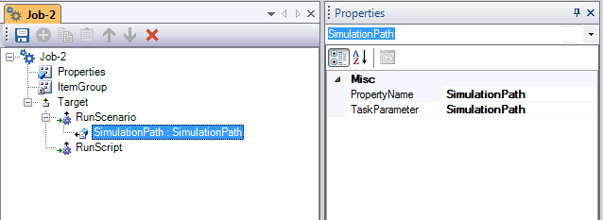

2.     To use the SimulationPath in a RunScript task you

a.     Make a script with a string as argument (see below)  
the script shall

                                          i.    fetch the simulation and loop over the SimulationOutputTimeseriesList to retrieve the actual timeseries into a list

                                         ii.    call the ToFile tool to perform the save

b.    Add the RunScript task to the job

c.     Specify the script path to as the script to run

d.    Give the variable name with the simulation path as argument

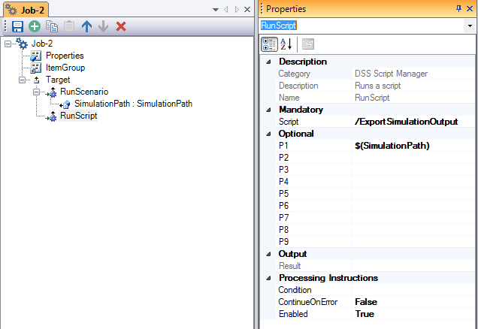

 The **TimeseriesExportTool** function code is generated using the “Insert > Tool wrapper …” right-click menu in Script Editor

