Why

If a scenario has the selection rule for Initial conditions set to “Latest” or “Latest warm” the candidate are those covering Start Of simulation. If more than one exist the system will pick the one with the latest end date.

This means that an initial conditions created by a simulation with a long forecast period may be picked over the latest initial conditions created, and that is not always desirable.

Usually initial conditions are cleaned up in a Database Maintenance job with a date criteria, but below script will enable delete of a specific single initial condition – if it is not referenced by a scenario.

 How to use the script:

DeleteInitialCondition deleted a specific initial conditions and works as such:

1. Pick the modelsetuppath by right-clicking the model setup nod in Scenario Manager Explorer and select “Copy Full Path”
2. Pick the guid from the UI – the part after the # in the drop-down for specific selection  
   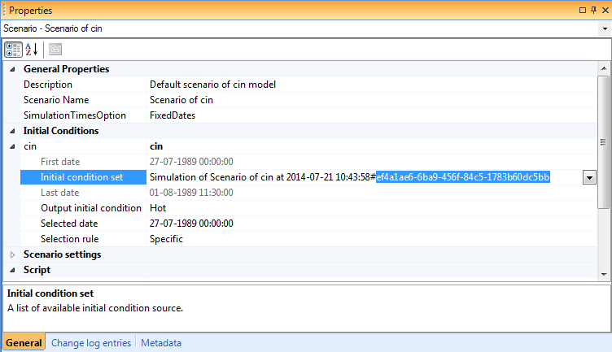

1. Make sure the initial condition is not referenced by the scenario when you run the script ( - shift Selection rule to Latest).
2. Once removed the scenario will pick the (now) latest that covers start of simulation