|  |
| --- |
| CEA LIST |
| Composite Diagram |
| [Tapez le sous-titre du document] |

|  |
| --- |
| TESSIER Patrick |



Sommaire

Display properties of applied Stereotypes as a « Comment » 1

Use Cases 3

1. Papyrus shall enable to show stereotypes values in a comment symbol. 3

1.1 Creation of the comment symbol used to show stereotype values 4

2.1 Deletion of the comment symbol used to show stereotype values 4

3.1 Creation of the Link 4

4.1 Deletion of the link 4

5.1 Move the comment symbol showing the stereotypes values 4

Solution proposition 5

Test Use case 8

2. *To create the symbol comment from the stereotyped element*: 8

3. For the deletion: 8

4. For the move : 9

# Requirements

**CompositeDiagram001** :

Composite structure diagram editor shall support the behavior port notation (<https://bugs.eclipse.org/bugs/show_bug.cgi?id=399865>)

To explain that, I quote the text from UML:

“A behavior port is indicated by a port being connected through a line to a small state symbol drawn inside the symbol representing the containing classifier. (The small state symbol indicates the behavior of the containing classifier.) Figure 9.17 shows the behavior port p, as indicated by its connection to the state symbol representing the behavior of the Engine class. Its provided interface is powertrain. In addition, a required interface, power, is shown also.”



# Use Cases

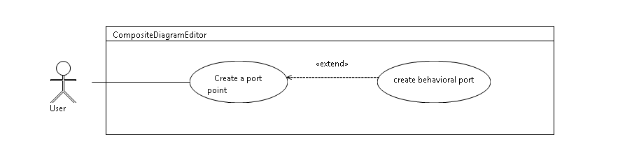

## Create a port

In the composite diagram, the user can create a port on a classifier or on a part

### Create a behavior port

The user can create a behavior port

# Solution proposition

# Test Use case

Create a behavior port

Delete from diagram a behavior port

Move a behavior port

Hide or display a behavior port