|  |
| --- |
| CEA LIST |
| Constraint Generation from the profile Developper Guide |
| [Tapez le sous-titre du document] |

|  |
| --- |
| TESSIER Patrick  12/04/2013 |



Sommaire

Requirements 3

Use Cases 3

1. Generate constraints directly into the definition 3

2. Generate constraints as EMF validation plugins 3

2.1. Constraint in OCL 3

2.2. Constraint in Java 3

Solution proposition 4

Test Use case 5

# Requirements

**ValidationReq001**: Papyrus shall validate constraints from profiles on models

**ValidationReq002**: User can precise on constraint if it can be validate live or batch, the associated error message, if it is activated by default

# Use Cases

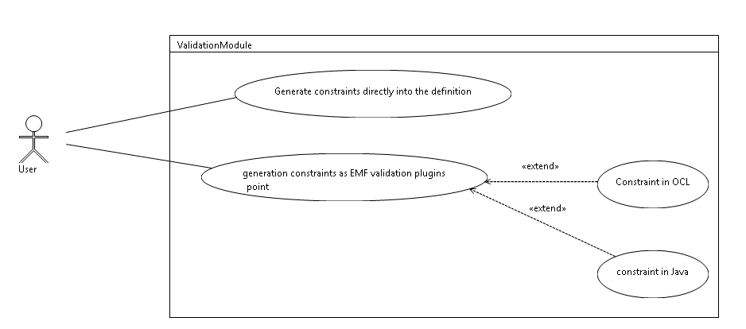

Figure 1: use cases overview

## Generate constraints directly into the definition

## Generate constraints as EMF validation plugins

## Constraint in OCL

## Constraint in Java

# Solution proposal

# Test Use case